An in-depth analysis of e-procurement use in UK CONSTRUCTION ORGANISATIONS

Robert Eadie,
School of the Built Environment, University of Ulster
email:r.eadie-r@ulster.ac.uk

Srinath Perera,
School of the Built Environment, Northumbria University
email: srinath.perera@northumbria.ac.uk

George Heaney,
School of the Built Environment, University of Ulster
email: sg.heaney@ulster.ac.uk

Abstract
Eadie et.al (2007) show that there are many advantages in the adoption of e-procurement within a construction organisation. However, its uptake within the construction industry has been inadequately researched. Martin (2003, 2008) investigated e-procurement use across quantity surveying organisations in United Kingdom. However, the picture is not complete as other disciplines within construction are not considered. This paper seeks to address this issue. Martin (2003, 2008) does not seek to identify the sizes or spend on procurement activities by those quantity surveying organisations who have adopted the use of e-procurement. This paper investigates the correlations between size, procurement spend and adoption of e-procurement.

A survey was conducted in two parts: the initial survey looked at 70 contractors in Northern Ireland which had carried out e-procurement. This was followed by the main survey, which contained a telephone survey followed by a web-based survey. The telephone survey of 775 organisations identified the amount of e-procurement in construction within the United Kingdom. This was followed by a web-based questionnaire survey of the identified organisations on e-procurement for construction based activities. These produced a breakdown of e-procurement use and spend on completion of pricing documentation across the construction industry.

Keywords: e-procurement, Use of e-procurement

INTRODUCTION

In his investigation of construction e-procurement Rankin (2006) defines e-procurement as commercial organisations acquiring and selling of products and services by electronic means (primarily through the internet). Hore et al (1997) classified tendering as “a procedure to select a suitable contractor, at a time appropriate to the circumstances, and obtain from him at the proper time, an acceptable offer upon which a contract can be let.” IDEA (2008) defines the scope of the electronic tendering process (e-procurement) as “an electronic tendering solution that facilitates the complete tendering process from the advertising of the requirement through to the placing of the contract”. Procurement in construction was determined as being different than that in the goods and services industries by the English courts (Eastern v. EME Developments 1991 55 BLR 114). This is further emphasized when Eadie (2009) shows that the drivers and barriers to e-procurement in construction act differently than those in the goods and services industries.

Martin (2003, 2008) investigated e-procurement use in construction across the United Kingdom from the standpoint of quantity surveying organisations. This left a knowledge gap in the published literature regarding the use of e-procurement by other disciplines within construction. This paper seeks to address this issue by investigating cross disciplinary views on e-procurement. Martin (2003, 2008) does not seek to identify the sizes or spend on procurement activities by those quantity surveying organisations who have adopted the use of e-procurement. This paper investigates the correlations between size, procurement spend and adoption of e-procurement.

methodology

The research methodology followed can be summarized to the following six stages:

1. Pilot Survey
2. Sample identification within the pilot survey
3. Main Survey
4. Sample identification within the main survey
5. Telephone and web-based surveys
6. Analysis of results

These are explained in detail in the forthcoming subsections.

Pilot Survey

The pilot study focused on construction contractors. A list representing Contractors who had registered interest in or tendered for Roads Service contracts in Northern Ireland over the previous four years was obtained. As Roads Service had adopted an e-procurement system in late 2001 this ensured that the information gained would be from those familiar with e-procurement in construction. The pilot survey served the purpose of testing the methodology adopted and the nature of questions posed.

Sample identification within the Pilot Survey

The Roads Service sample contained 70 contractors, out of a total of 114 civil engineering contractors registered with the Construction Industry Training Board (CITB) in Northern Ireland. This was regarded as being more representative of the Northern Ireland Construction Industry contractors than a random sample. This ensured this sample was homogeneous with all members having shared convictions and beliefs, thus reducing ambiguity (Naoum, 1995).

Main Survey

The main survey was used to investigate e-procurement use across all parts of the United Kingdom, namely England, Scotland, Wales and Northern Ireland. To ensure that the knowledge gap identified in the introduction was addressed a variety of disciplines within construction were surveyed. These included quantity surveyors, public sector clients, architects, private sector clients and consulting engineers.

Sample identification within the Main Survey

A total of 775 construction organisations were identified and surveyed from January to March 2008: namely, 483 surveyors, 42 Public Sector clients, 172 Architects, 35 Private sector clients and 43 Consulting Engineers. A total of 42 Public Sector Clients were identified from published sources such as the “Local gov” website and the yellow pages for Central Government departments. A further 35 private sector clients were identified from a list of clients who had carried out housing scheme work. The study included all 172 architects listed on the Royal Institute of British Architects, Northern Ireland. All 43 consulting engineers who were members of the Association of Consulting Engineers, Northern Ireland were also included in the study.

Telephone and web-based Surveys

All the organisations mentioned in section 2.4 were contacted by telephone to confirm they had e-procurement experience and were willing to partake in the survey. Once these conditions were met they were then asked to complete the web-based survey. The study provided statistics for use of e-procurement within the United Kingdom across the disciplines. A breakdown of the response rates for the telephone survey is included in Table 1. Martin (2008) shows that less than 20% of the Quantity Surveying organisations said that they carried out e-procurement in construction. The current research produced a similar result showing a slight increase with 25% of Quantity Surveying organisations surveyed using e-procurement. It further shows that public sector clients are the leaders in relation to e-procurement adoption with 47% adopting e-procurement. The industry average value from Table 1 is 27%.

Table 1 Sample Valid Response Breakdown by Discipline
Discipline | Total Number of Organisations | % valid response | Number using  E-Procurement / percentage using  E-Procurement | Number of not using E-Procurement | Number not contactable, no longer trading or unavailable for comment
Quantity  Surveyors | 483 | 68% | 83 / 25% | 247 | 153
Public Sector  Clients | 42 | 93% | 29 / 47% | 10 | 3
Architects | 172 | 98% | 12 / 19% | 156 | 4
Private Sector  Clients | 35 in sample |  | 0 / N/A | 35 | Not applicable
Engineers | 43 | 67% | 4 / 15% | 25 | 14
 | 775 | 77% | 128 / 27% | 473 | 174

Table 1 shows the number of organisations contacted during the telephone survey and the percentage valid response from the total sample. These results show that a good level of response was achieved; it is above the 50% threshold suggested for external validity (OIG, 1997). They further indicate the extent of the survey and show that the results can be generalised across the industry.
The organisations identified through the telephone survey as being involved in e-procurement were asked if they were willing to partake in the web-based survey. Limesurvey™ was used to conduct the survey via the Internet. This software package gathered responses from the organisations through a web-based interface and stored these in an on-line MySQL™ database.

Analysis of results

The web-based survey investigated and allowed analysis on expenditure on pricing documents and the sizes and staffing involved in the organisations involved. The Data collected for both web-based surveys was exported directly into SPSS™ for analysis. This ensured that there were no transcription errors.

E-Procurement in Construction

The pilot study of Northern Ireland Contractors was first used to determine the size of contractors who were adopting e-procurement. This was followed by the UK-wide survey which detailed electronic contract use for other disciplines.
The sample by its composition incorporated all sizes of companies. Figure 1 shows a breakdown of respondents by organisation size based on the number of employees within the organisation. It can be seen that the category containing 35% of the sample consisted of companies who employed 21-50 people. An even percentage of organisations were represented for those employing over 100, employing between 51-100 and employing between 11-20 categories containing 20%, 21% and 20% of the sample respectively. The last category employed between 1-10 people. These very small organisations were specialist in nature and are unusual with regard to winning public sector work. This accounted for the sample representation to equate to only 4%.

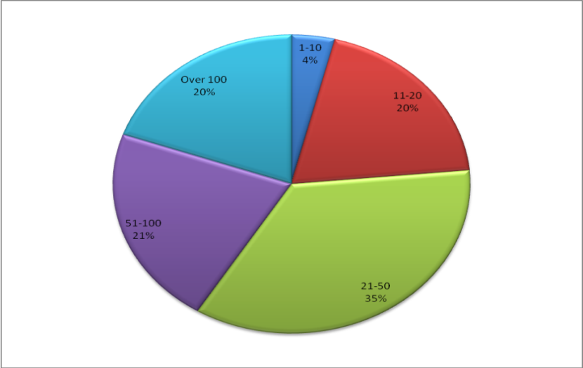
Figure 1 Breakdown by organisation size in the pilot study
The organisations represented in Figure 1 were then asked to supply data on the amount of electronic contract documentation received in comparison with paper based tenders.

USE OF ELECTRONIC CONTRACT DOCUMENTATION IN NORTHERN IRELAND FROM PILOT STUDY

Figure 2 demonstrates that 47% of contractors within the sample received only 1-10% of their Schedules of Rates/Bill of Quantities in electronic form. Out of the remaining 53% of the sample, 26% received between 11% and 30% of documentation in electronic form. The 6% who received 91-100% of documentation in electronic form worked solely for the Roads Service. This was due to the fact that Roads Service carries out the majority of their procurement electronically on write-once CDs.

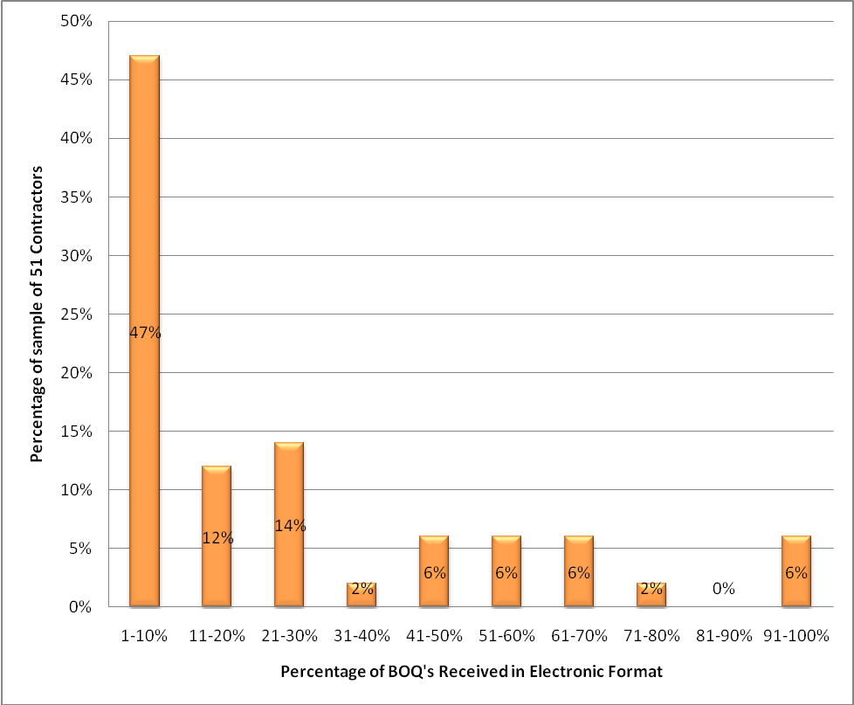
Figure 2 Percentage of BOQ received in Electronic Form by Contractors in Northern Ireland

In order to fill the knowledge gap regarding usage versus organisation size, during analysis of the pilot study, the percentage of contracts received in electronic format was compared to the size of the companies. The organisation sizes analysed are 11-20, 21-50, 51-100 and over 100. These organisation sizes were asked to assess the percentage of electronic contract documentation received by their organisation relative to the total amount. Organisations within the four previous bandings were then assessed separately and the median value used as an indicator of the amount of contract documentation for organisations of that size. The organisation size of 01-10 was not analysed as only two responses from contractors were received from this group and a median value would have produced a false non representative value. Figure 3 identifies that contractor size was not a factor in receiving electronic contract documentation. This would be expected as the tender documentation is more likely to be produced from the clients design team in traditional forms of contract. The median percentage of contract documentation received electronically was around 25% for all sizes of contractor (Figure 3). Further data was gathered in the main study to see if this level was carried across the complete industry.

The median percentage of contract documents received in electronic format was also examined against organisation procurement spend. It can be seen from Figure 4 that the contractors that spend least and most on procurement, use more e-procurement than those who spend between £1000 and £50,000 on procurement per annum. These findings were substantiated through comparison with the main study findings.
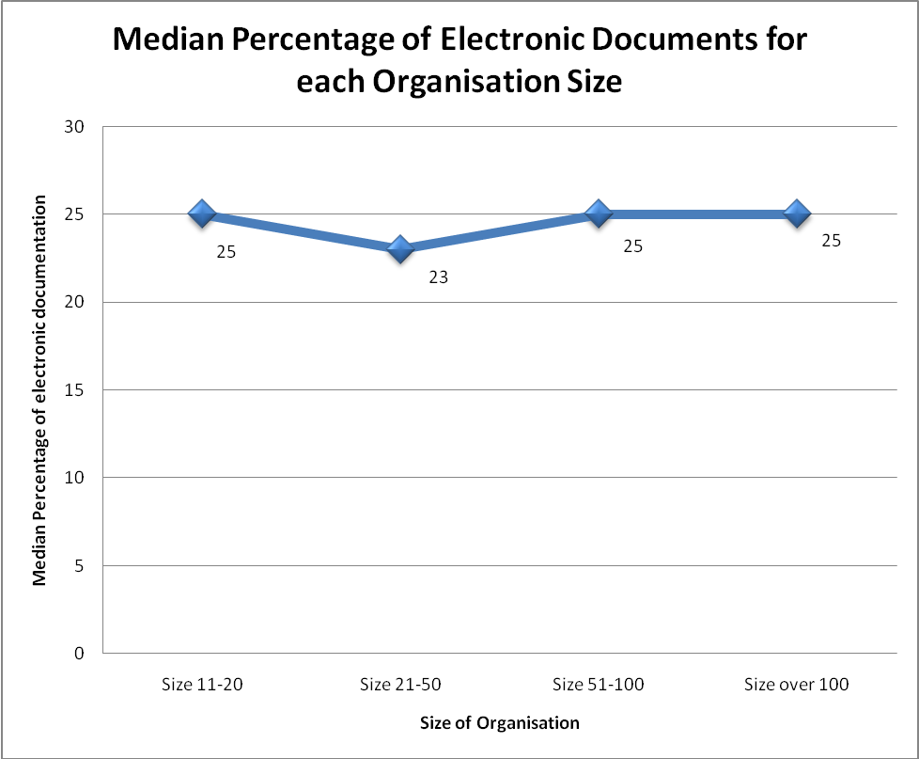
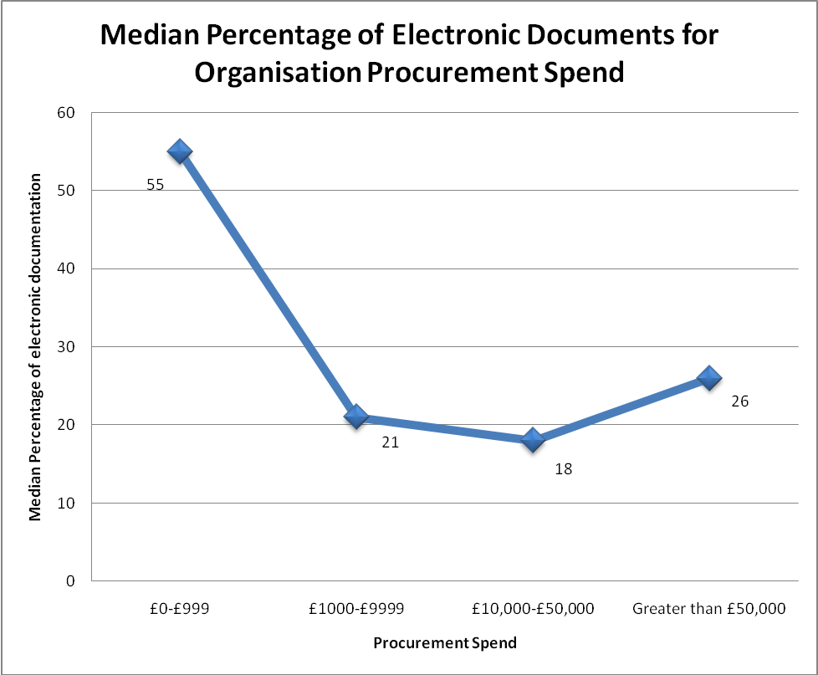
Figure 3 Median Percentage of Electronic Contract documentation by Northern Ireland contractor size
Figure 4 Median Percentage of Electronic Documents for Organisation Procurement Spend (Pilot Study)
The conclusions that can be drawn from Figure 4 are that smaller firms that rely on efficiency for survival and larger firms that have identified the cost savings that e-procurement in construction brings, have led the way in implementation of e-procurement. Smaller firms may only be tendering for work which is being provided electronically by government departments which may be reflected in the results shown in Figure 4.

USE OF ELECTRONIC CONTRACT DOCUMENTATION (UK WIDE) FROM MAIN STUDY

This section presents the main study results and investigates e-procurement usage among professionals from the following disciplines, quantity surveyors, public sector clients, architects, private sector clients and consulting engineers. Following the phone survey, it was found that 135 organisations out of the 795 carried out e-procurement equating to 17% use UK-wide. This is similar to and corroborates the findings of Martin (2008) who showed that 20% of Quantity Surveyors used e-procurement.

The overall percentage response to the survey is 68%. Looking at external validity, Rubin and Babbie (2004) suggested a 60% response rate for electronic surveys as good for generalisation, 70% as very good and 75% and above as excellent. It can be seen that the survey is between the good and very good categories and therefore the results can be generalised across the UK.

Organisations using e-procurement were asked to give their size by number of employees. This was compared with the percentage of Bills of Quantities produced in electronic form by organisation size. A similar breakdown of organisation size was used in the main study to that of the pilot study. This allowed comparison of the two studies with regards to the amount of e-procurement use by organisation size.
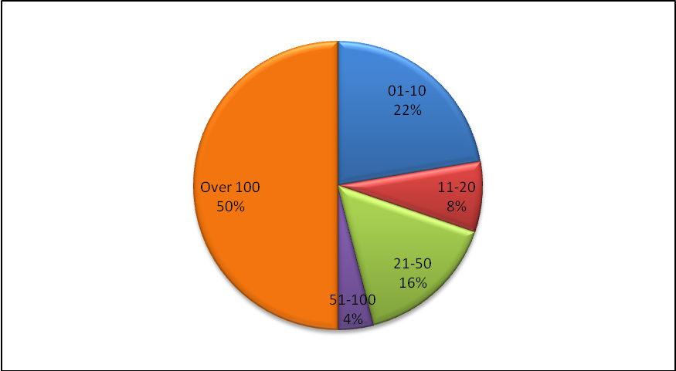
Figure 5 Breakdown by organisation size in the Main Study sample returns
It can be seen that the organisation size in the main study contained 30% more large organisations with over 100 employees. This is to be expected as it contained many government departments which have a large number of employees.

percentage OF ELECTRONIC CONTRACT DOCUMENTATION IN MAIN SURVEY
The complete main survey sample was analysed with regards to organisation size, amount of documentation received in electronic form and procurement spend. Figure 6 demonstrates that within the main UK sample, a similar pattern emerges to the contractors in the pilot study with the majority of organisations across the disciplines in the UK, principally only receiving 1-10% of their Schedules of Rates/Bill of Quantities in electronic form. Forty-one percent (41%) of the 76 organisations are in this category. Similarities exist again in the following category where the next 22% are between 11-30% employee numbers.
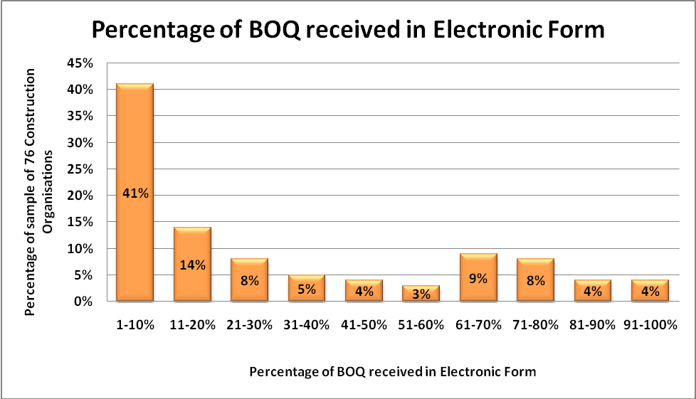
Figure 6 Percentage of BOQ received in Electronic Form by Construction Organisation size (UK)

Figure 7 show that the median percentage of electronic documentation as previously described in section 4.0 when the results are combined shows a very different picture to that of the contractors. Figure 3 showed the median value remaining constant, the combined disciplines show that organisations with between 21-50 employees are the most likely to use e-procurement.
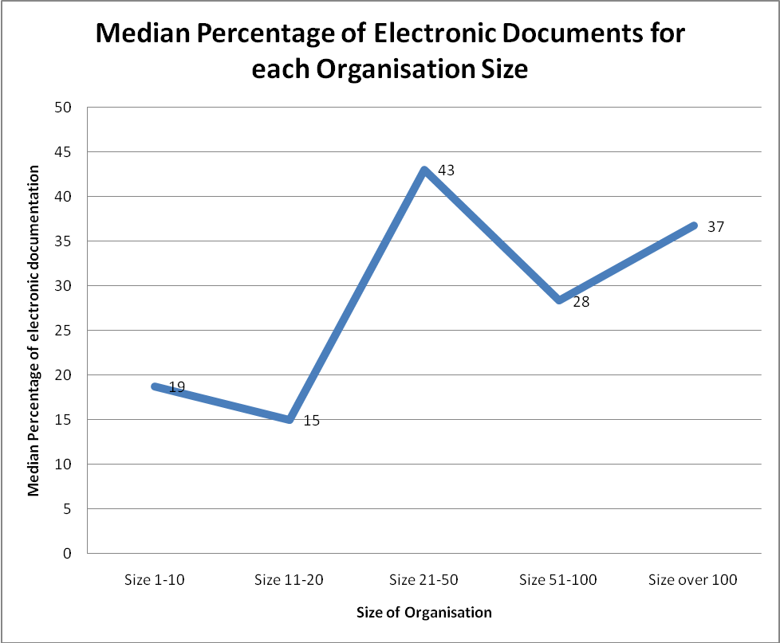
Figure 7 Median Percentage of Electronic Contract documentation by organisation size
A similar examination was carried out to the pilot study in regard to the median percentage of electronic documents against procurement spend. It showed organisations that spend most and least on procurement have the greatest median percentage of e-procurement. Figure 8 shows a very large median percentage (76%) for those organisations with procurement spend greater than £50,000. It can be seen from Figure 5 that 50% of the sample are companies with over 100 employees. These are more likely to have spent large amounts on procurement.

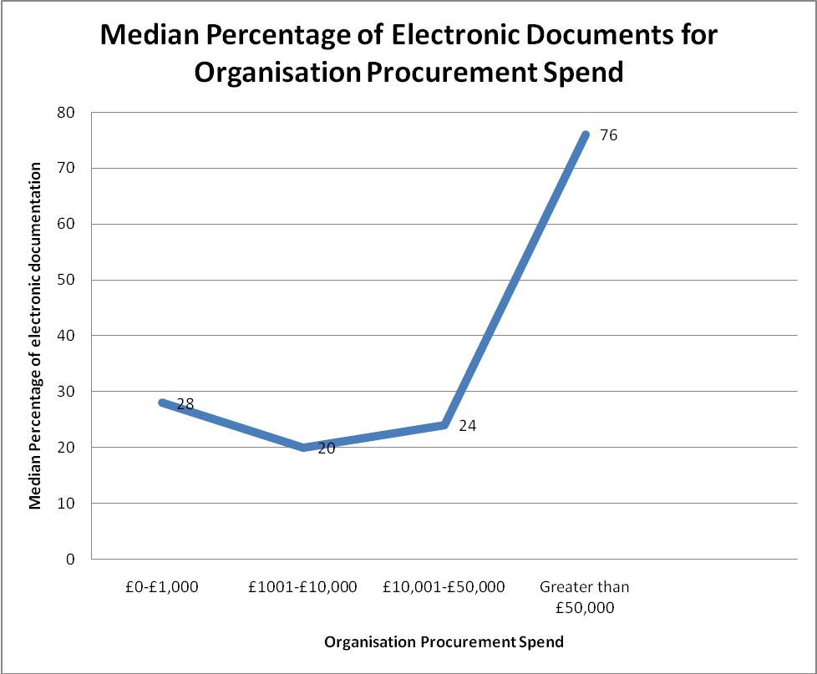
Figure 8 Median Percentage of Electronic Documents for Organisation Procurement Spend (Main Study)

The testing by breaking the main study sample down into the different disciplines did not fully reflect a similar correlation between the sizes of companies. It did give an overall suggested median percentage for the amount of e-procurement for each of the disciplines. While the sample size is small for many of the disciplines it gives a guide to the e-procurement usage within each part of the industry.
Table 2 Median Percentage of Electronic Documentation for each organisation type
Organisation Type | Median Percentage of Electronic Documentation for those who use e-procurement | Sample Size
Government Procurement Officials | 47% | 12
Project Managers | 45% | 5
Contractors | 34% | 14
Quantity Surveyors | 26% | 25
Consultant (Other) | 25% | 5
Architect | 19% | 5
Clients | 18% | 9
Structural Engineer | 15% | 1
 | Total Sample | 76
Table 2 shows the sample size and median percentage of electronic documentation. It shows that the public sector is leading the way as far as the amount of e-procurement is concerned. The sample of five project managers are split into three who work for the public sector (who were under the public sector clients’ section but choose project manager as their personal role) and two who are in private sector practices (both were multi-disciplinary organisations with quantity surveying/cost consultancy as their main forte). Within the project management grouping, it is the public sector project managers who use e-procurement to a greater degree thus moving the median percentage towards the figure shown for the Government Procurement Officials. The private sector lags behind the public sector by 10% in its use of e-procurement according to the survey findings.

Conclusions

This study corroborated the Martin (2008) findings which showed that less than 20% of the Quantity Surveying organisations said that they carried out e-procurement in construction. The current research showed only a slight increase to 25% of Quantity Surveying organisations surveyed. The average adoption rate across the industry is 27%, with government clients most likely to adopt e-procurement.

The size of organisations which have implemented e-procurement was identified. The results show that contractor size was not a factor for implementing e-procurement. However, on the client side in traditional contracts company sizes of 21-50 employees making most use of e-procurement, followed by large companies (Over 100) then smaller companies (1-10). Companies between these sizes (11-20, 51-100) make less use of e-procurement in construction. The study also revealed that the public sector is leading in the use of e-procurement and that the private sector is lagging behind by 10%. This can be attributed to the efforts of the public sector promoting e-procurement as an efficiency boosting greener technology with various initiatives such as the Modernising Government White paper (1999) with Best Value Indicator 157 (BV157), The Glover Report (2009) with its sustainability agenda promoting full electronic contract use within government by 2010 and EU legislation. Often private sector is cautious in adopting new technology due to inherent risks, unfamiliarity and cost to adopt. This study therefore, clearly indicates the need for actively promoting e-procurement within the UK private sector construction organisation.

A further section of the study examined the amount spent on document preparation against the percentage of electronic documentation. It found that those who spent most and least on pricing documentation were the most likely to have adopted e-procurement. This suggests that the smaller organisations that tend to spend less concentrate on e-procurement to increase efficiency by allowing fewer staff to complete a similar amount of work. The organisations that spent most on e-procurement tend to use e-procurement to bring efficiency to the process.

References
Eadie, R., Perera, S., Heaney, G., Carlisle, J. (2007) Drivers and Barriers to Public Sector e-procurement within Northern Ireland’s Construction Industry, ITcon Journal, Vol. 12, 103-120, http://www.itcon.org/2007/6
Egbu C. Vines M. and Tookey J. (2004). The Role of Knowledge Management in E-Procurement Initiatives for Construction Organisations, Proceedings of ARCOM Twentieth Annual Conference 2004, September 1-3, Heriot Watt University, (Khosrowshami,F Editor), Vol. 1, Arcom, University of Reading, Reading, 661 – 671.
Hore A. O’Connell L. and West R. (2006). Efficiency Gains to be Won through the Introduction of Electronic Tendering in the Construction Industry, available on-line at http://www.irbdirekt.de/daten/iconda/CIB7413.pdf [assessed December 2008]
Improvement and Development Agency (IDEA)(2004). The Benefits of e-Procurement, Office of the Deputy Prime Minister, HMSO, UK, available on-line at http://www.idea.gov.uk/idk/aio/70780 [assessed December 2008]
Martin J. (2008). E-Tendering about time too, RICS paper (Available online http://www.rics.org/NR/rdonlyres/5B41E38D-2433-4AEE-A3DC-5B3C3BB84FB5/0/EtenderingabouttimetooJoeMartin.pdf [accessed December 2008].
Martin J. (2003). E-Procurement and extranets in the UK Construction industry, Conference paper given at FIG Working Week, April 13th-17th 2003, Paris, France. (Available online http://www.fig.net/figtree/pub/fig_2003/TS_6/TS6_4_Martin.pdf [accessed December 2008].
Office of the Inspector General(OIG) (1997). Audit of the Office of Program and Integrity Reviews` Special Studies, available on-line at http://www.ssa.gov/oig/ADOBEPDF/audit_htms/96-51142.htm [assessed December 2008]
Rubin A, Babbie E (2004), Research Methods of Social Work, Thomson Wadsworth, UK, 288-289.

