Poetics of Play; Touch and Movement in Garment Design with Sheepskin, Silk and Lace

Sarah Morehead
Northumbria University
Newcastle upon Tyne
NE1 8ST UK
sarah.morehead@northumbria.ac.uk

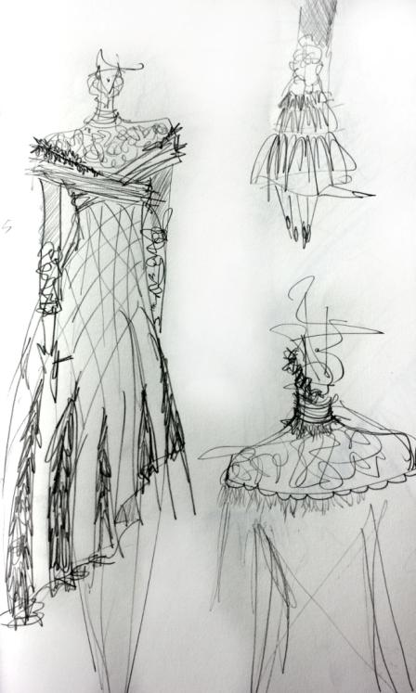
Figure 1 Initial sketch
Abstract
This is a start to an area of research into both the somaesthetic responses and dialogue the fashion designer has with materials, in particular sheepskin, silk and lace but also the envisioned somaesthetic response the designer aims to elicit from the user in the wearing of a styled artefact in these fabrications. Richard Shusterman’s philosophical concept of the importance of the soma, the body as an object of ‘knowing’ through sensory aesthetic understanding informs this work. This research will explore how a garment feels to the body and our relationship with materials. A key interest is how the somaesthetic qualities personal to us might contribute to the psychological attachment to an item and how this in turn may correlate to how we then treasure and keep these items of clothing.The intention to create new processes and practice in structuring sheepskin, silk and lace will start with a representative human frame in the form of a mannequin. Sculptural structures that emulate the frozen physicality of human action will be added to the mannequin and the designs will be based around this new silhouette from which a pattern will be taken and a garment constructed. Once completed the added structure will be withdrawn and allow the new garment silhouette to hold itself or fall to the body frame. The garment will be a result from a physical dialogue by the designer with the differing breeds and varieties of sheepskin that explore constraint, flow, drape, volume, loft, tactility, and the somatic presence of how the user will both feel the differing surfaces in some element but also potentially be made more aware of the negative or 'silent' areas where material does not touch the body but rather frames or ‘captures’ air.

Author Keywords
Somaesthetics; Touch; Interaction Aesthetics; Materials Exploration; Physical Dialogue

Research Imperatives
This research was motivated to explore the material qualities of sheepskin, silk chiffon and guipure lace in the context of Somaesthetics.
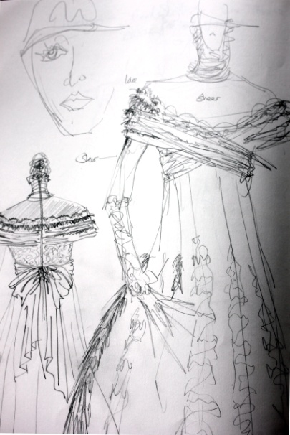
Figure 2.
Exploratory sketch to inform construction
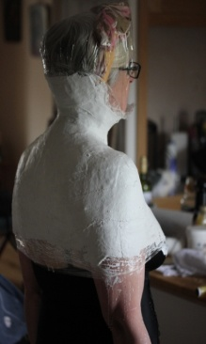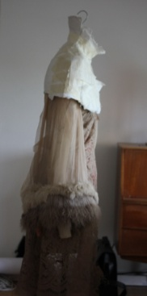
Figures 3&4.
Plaster cast of shoulder area

‘Somaesthetics is a form of reflective bodily awareness intended to show the importance of paying serious attention to the body’s role in enhancing knowledge, improving performance, and increasing the pleasures of living. It considers the body as our primary means of engaging with the world, including structuring of our mental life, and is intended to fill a gap in the philosophical and practical understanding of the body’s role in experience, including the making and experiencing of the arts.’ (Carter 2008)

This is an inquiry into sheepskin, silk and lace and their handle and capacity to be manipulated and crafted into a fashionable garment that would feel good to wear as a multimodal sensory experience.
‘Fabric hand, or handle as it is often called, is deﬁned as the human tactile sensory response towards fabric, which involves not only physical but also physiological, perceptional and social factors; this very fact complicates the process of fabric hand evaluation tremendously.’ (Pan.N. 2007)

The research details how I, as the crafts person ‘Think through the Body’ (Shusterman 2012) and, use my own somatic experiences in the making of the garment. The thread of both user and maker are intertwined through difference and commonality in bodily experience that could be said to be an aspect of empathy in design.

Much has been documented on ‘Tacit’ Skills in the design process. Polanyi ‘Personal Knowledge’ (1998) gives credence to the personal involvement of the knower in their understanding of the world. He considers that we are able to recognise that we believe in more than we can prove to be true and at the same level know more than we can say. This design practice is an exploration of bodily knowledge and thinking through the body. The body that informs the mind and can enables a greater capacity for unspoken learning in how we use materials.Somaesthetics gives a philosophical understanding as to how tacit skills are imbibed into our physique, our soma.

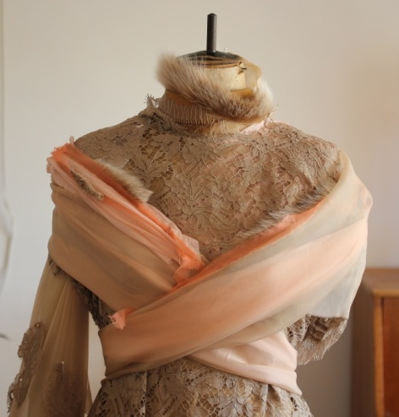
Figure 5. Torso Development from plaster shoulder cast

Research Process
As a kinaesthetic learner, I use my body to learn and absorb new knowledge and to understand the world more fully, a process of constant movement to cause triggers in my thinking, my prioperceptive self. Prioperception meaning the ‘sense of orientation and awareness of one's surroundings; innate sense of the relationship of body parts with one
another via sensory input from prioperceptive nerve endings in muscles, tendons and joint capsules’(Shusterman 2012). It is for me and many designers the actions that inform my knowledge that then through reflection and new synthesis inform my doing and creation in the use of new materials to create new products. The tactile processes of feeling through my body and fingers inform my sensations on what the fabrics can do, in other words their potential to bend, yield, explode, crack, flex, drape, and mould to my expectations to create something new. It is this thinking through feeling, thinking through my body that has informed this garment and how it will encourage awareness of the users own body through restriction and play.
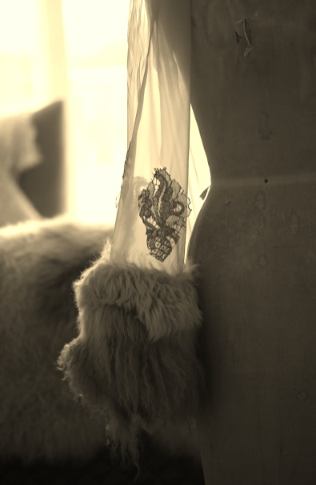
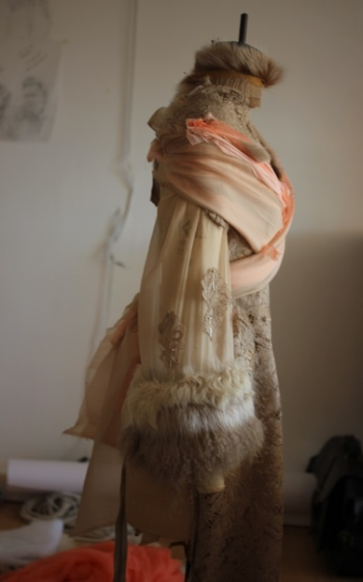
Figure 6. Sleeve cuff in stretch chiffon with welded sheepskin cuff structure
Figure 7. Development of the silhouette on the mannequin

Figure 5
Japanese Bamboo Tools

Figure 8
Contemporary Pistol Flatware

Design and making process
Physiotherapists encourage clients to undertake specific exercises to maintain an S bend in their spine that supports the body’s core muscular structure. Standing with your arms by your side and palms of your hand facing forward forces your shoulders back and places your spine into a gentle healthy ‘S’ shape. I have used this posture to make a plaster cast of the shoulders and take a pattern to from the upper torso of the dress. (Figures 3, 4 & 5) It is hoped that the user will be conscious of allowing the fabric to lie flat across the front area of the garment. Slouching forward would give stress to the back bodice and cause a wrinkled affect on the front area. The neck line has Toscana sheepskin inside the neck and a trim meeting the inside facing. This has been placed to inform the wearer of the tactile soft hair and air as they move their neck. The main body of the dress has layers of lace and chiffon. The chiffon allows air to permeate around the body. The layering affords both privacy and a building of subtle colour changes. Both the hems of the dress and sleeve are constructed with fluted cut chiffon sections welded to sheepskin. The chiffon intersections allow the cuff and hem greater articulation to swing around the arms and legs. Texel, Mongolian and Truscana sheepskin have been used between each section of chiffon. The differing sheep breeds have specific qualities of touch and handle in both the skin support and wool fleece.
The initial sketches (Figures 1&2) were diverse and explored the different properties of each material. The stretch silk chiffon was chosen to enable a flow and lightness over the skin, its ability to flutter in air currents that form eddies around the body and its strength as a platform to mount other fabrics upon. I use a heavy Guipure Lace for its decorative quality embroidered with cornelli cord over the top of more complex woven micro structure with different densities of designed hole structures. It has a sturdy construction that allows appliqué, cutting raw edges and defining areas of garment.

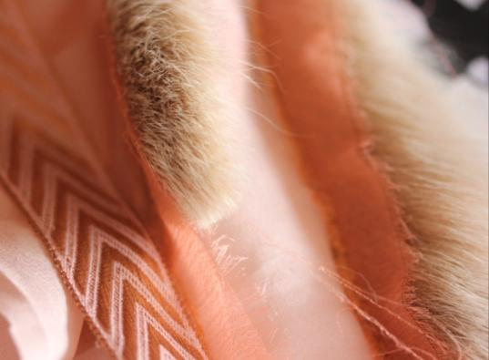
Figure 8. Frayed chiffon braid and Toscana sheepskin

Research Outcomes
This garment results from an approach that foregrounds an attention to somaesthetics in the making process. The subsequent mental and physical knowledge from the creative process informs the next phase of making and creating a product. Perception informs movement and movement informs knowledge. The knowledge impacts on perception and thus new creative actions, thoughts and understanding ensue. This forms a spiral of creative physical and mental action. The sensory feedback from realising different iterations in prototyping informs our thinking in re-examining and re-creating new iterations. Thinking through our bodies is an important part in how we recognise multimodal aspects of the creative process. Our understanding of our own soma has the potential to make an important contribution to feelings of empathy with the end users of our creativity.
The process in designing this garment has been a considered act of doing, thinking through my body to create an item that when worn could resonate with another through the felt experience of wearing the dress. The way the garment restricts and allows movement, the textures felt against the glabrous hairless skin (palms and soles) and with hair skin of the user somatically inform the user of how they wear the item. The somaesthetic response of wearing a garment could be said to be an empathic response of the design process and vice versa. Our bodies are a key focus in how we learn and the vehicle, the physical container of our worldly experiences and knowing.
Complex personal emotions arise in designing and re examining one’s own bodily experiences in the design process that are also informed by watching other people and how they wear their clothing. Not what they wear but how they stand, move and perform in their bodies. Our interactions with materials that cover our physique inform our sensitivities to ourselves and others.Clothing is more than a shield, decoration or status emblem; it allows us to learn and play through our soma in different scenarios. The connections between person, space and clothing is connected to our thinking bodies. Shusterman says a person can have different somatic style, way of being, on different occasions and at different times of the day. This adds to the complexity of designing garments across varying times and locations. Shusterman talks about the mirror neuron system as providing a neurological basis for empathic experience. ‘As seeing the movement would activate not only relevant visual neurons but also motor neurons associated with performing that action’ (Shusterman 2012). We would try to emulate the movements, copy them, to understand how it feels/felt to perform in a particular way. It is this thinking through feeling, thinking through my body that has informed this garment and how it will encourage awareness of the users own body through restriction and play. Garments have a performative quality, how we perform in our garments will depend on situation, place and social circumstances. This garment highlights our relationship of our bodies as the key locus of these performances. It highlights the position of the designer and their understanding of their own soma styles and design processes.
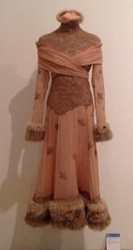
Figure 9 Final Garment

This garment has been constructed by consciously exploring prioperceptive, kinaesthetic movement of this designer’s body in learning to manipulate and mould fabrics playfully, poetically and sympathetically to the human frame. The dress is the start of exploring somaesthetics and materials in the processes of design. It has been through examining my thinking body that new observations about my practice have become more transparent and other connections to the importance of how we use our bodies in a changing material landscape.

References
Carter, C 2008 http://www.fau.edu/humanitieschair/pdf/Carter_Review_of_Body_Consciousness_from_JAAC.pdf Accessed 26th June 2013

Pan.N. 2007 Int. Journal of Design & Nature. Vol. 1, No. 1
http://ningpan.net/publications/101-150/136.pdf
Accessed 26th June 2013

Polanyi,M. 1998 Personal Knowledge. Towards a Post Critical Philosophy. London: Routledge
Shusterman,R. October 2000. Somaesthetics and care of the self: The case of Foucault. The Monist Vol.83,No.4, Philosophy as a way of life. Hegler Institute. JSTOR. Accessed 20thMarch 2013 : http://www.jstor.org/stable/27903703

