Surface consolidation of natural stone materials using microbial induced calcite precipitation
Authors:
Alan Richardson (corresponding author) Northumbria University, Newcastle upon Tyne, UK email alan.richardson@northumbria.ac.uk
Kathryn Coventry, Northumbria University, Newcastle upon Tyne, UK
Alan M Forster, Heriot Watt University, Edinburgh, UK
Chris Jamison, Northumbria University, Newcastle upon Tyne, UK

Abstract
Purpose - Deterioration in natural stone is associated with many decay mechanisms and often the inherent composition of the materials themselves. Sandstone varies considerably but they all require a cementing matrix to bind amongst others the silica (SiO₂) particles together (Reading, 1989). In calcareous sandstones and limestones this binding matrix is principally calcium carbonate based (Muir, 2006; Reading, 1989; McMillan et al, 1999) in the form of calcite (CaCO₃). Friable sandstone substrates and stones suffering from ‘surface dissolution’ or disaggregation (Muir, 2006; Smith et al, 1992) have been traditionally consolidated utilising a host of chemical compounds that had, in many cases negative effects on their long term performance (Muir, 2006). A principle issue amongst many was moisture entrapment and irreversibility of the consolidants adopted.

Methodology - This paper investigates the effect of microbial induced calcite precipitation as a natural treatment for the conservation of historic natural stone substrates. Sporosarcina pasteurii has been proven as a bacterium that can perform microbial induced calcite precipitation (MICP) effectively in extreme conditions making it the preferred bacterium for the MICP process within this study. Surface treatment experiments were analysed by measuring the mass increase and surface changes using scanning electron microscopy (SEM).

Findings - The surface treatments showed a noticeable mass increase and observable deposition when viewed using a SEM microscope. Bio cementation of loose sand particles was observed and the degree of cementation was determined using a Mohs hardness test.

Originality – This paper investigates a safe, natural process for stone repair.

Paper type – Research paper

Key words
Sporosarcina Pasteurii, microbial indicted calcite precipitation, bacteria, nutrient broth urea, cementation, calcium carbonate, hydrolysis, urease.
- Introduction
Stone has been the dominant material for building for millennia (Maxwell, 1999). The prevalence of the use of natural stone has formed the architectural character of the many world cities and the UK alike (Clifton-Taylor, 1987; Brunskill, 1978). Conservation of the historic built environment is an important component of the construction sector and contributes significantly to Gross Domestic Product (GDP). It has been estimated that 50% of national wealth across Europe is contained within the existing built environment. (Forster & Kayan, 2009; Balaras et al., 2005). Like any material, aging and decay are the major factors in stone deterioration (Melo et al., 1999). Compounding this previous incorrect and inappropriate repair interventions have caused significant problems for those entrusted with the conservative repair of stone built structures and have led to widescale latent building defects. Poor repair solutions have led to incompatibility between the original stone and the repair material causing severe degradation at an accelerated rate (Collepardi, 1990).

Compounding this many historic, architecturally significant cities such as Rome have showed a steep rise in accelerated stone decay over the last 50 years due to chemical degradation caused by environmental pollutants and remedial repair techniques (Dobbs, 1983; Smith et al, 1992). The influence and study of pollutants, soiling and decay mechanisms have been undertaken by various investigators (Smith et al, 1992; Rodriguez-Navarro and Sebastian, 1996) and they have shown to adversely affect the material. Conservation of stone is clearly complex with the assessment of multiple interrelated variables being required to ensure the appropriate materials selection and compatibility of the substrate (Pinto and Rodrigues, 2008). One significant deteriorolgical mechanism in natural stone is degradation of the binding matrix. The cementing matrix varies depending upon the nature of the stone but can be broadly classified into calcareous, siliceous and argillaceous (Muir, 2006; McMillian, 1999). Those stones that are calcareous in nature are bound by calcite (Muir, 2006) and are the principal focus of this work.

This paper aims to investigate the effects of surface applied bacteria to reduce the rate of environmental weathering and other deteriorological processes though microbial calcite precipitation. Consolidation adopting precipitated calcite has a natural affinity for calcareous sandstone and limestones potentially making these techniques more philosophically defensible (Forster, 2010) and technically appropriate than alternative approaches.

1.1 Causes of decay
Sedimentary rock including sandstone and limestone are prone to loss of integrity from environmental weathering and chemical decay processes (Honeyborne, 1998; Lewins, 1983). A significant deteriorological mechanism is associated with the dissolution of the mineral cementing matrix binding the stone particles together (Torraca, 1976). This is known as ‘surface dissolution’ (Smith et al, 1992).

Several factors cause deterioration in sedimentary stone types but water is the main influence leading to structural weathering due to its ability to aid chemical processes and when subject to phase change (Liquid to solid), creates tensile forces, leading to major and minor spalling (Smith et al, 1992; Melo et al., 1999). It is clear that durability is correlated with exposure and environmental conditions and it is likely that most northern regions can expect a minimum of one freeze thaw cycle every year (Bayram, 2012; Met Office, 2013; BS8104, 1992; BRE, 1998).

Moisture movement and moisture handling capability of porous materials has a direct relationship on wetting and drying characteristics (Hall et al, 2010). The ability of a natural stone and associated surrounding mortar to readily accommodate moisture movement is essential for long term durability of stone buildings. That said, the pore size and pore distribution plays an important role in the materials ability to resist moisture related deterioration. Micro fissures and the pore structure within a stone’s surface allows for the ingress of water into the materials matrix (Basheer et al., 2001). It is well understood that water experiences a 9% increase in volume during freezing, thus exerting tensile stress within the materials capillaries (Bayram, 2012).The hydraulic pressure exerted on the pore walls eventually causes internal micro cracks throughout the surface matrix (Basheer et al., 2001) and failure of the stone. In addition to freeze thaw, salt crystallisation (Young, 2008) is also a major cause of deterioration in natural stone materials and is associated with drying zones and contaminated water. The crystal growth induces tensile stresses in the pore walls overpowering the binding capacity of the stone, causing surface dissolution.

Environmental pollutants are also well understood to lead to accelerated masonry decay. NO_{x} and SO_{x} gases are particularly damaging to carbonate stone types with the conversion of CaCO₃ in to gypsum (CaSO₄) and associated ‘crusts’. (Ashurst et al., 1998; Schiavon, 1992; Grossi and Murray, 1999).

Microorganisms have been shown to cause stone surface damage through (i) formation of biofilms, (ii) chemical reaction with the stones constituents through creation of nitrates and (iii) production of pigments that change the surface colour (Cappitelli et al., 2007).

1.2 Current methods of stone consolidation:
Attempts have been made to reduce deterioration in historic masonry substrates with the traditional use of four different material agents. These groups are broadly classified as; inorganic materials, synthetic organic polymers, waxes, and silanes (Clifton, 1980; Price, 2006). Today these treatments have been ostensibly discredited or are viewed with extreme caution by practitioners (Pinto and Rodrigues, 2008; De Muynck et al., 2010; Muir, 2006). Major concerns associated with long term performance of treated surfaces have arisen especially with ‘pore blocking’ agents that have lead to an inability of the materials to breathe (Hughes, 1986; Ashurst et al, 1998). Broader philosophical incompatibility issues are also pronounced with these materials as they cannot conform to the major principles of ‘like for like’ materials replacement or reversibility (BS7913, 1999).

1.2.1 Inorganic stone consolidates
Acrylic polymer emulsions ‘Methylmethacrylate’ and ‘butylmethacrylate’ can be used to consolidate stones surfaces. The solvents in a polymerized form are applied in situ (Clifton, 1980). The acrylic molecules are deposited into the surface pores creating a continuous film which in turn improves surface cohesion (Karatasios et al., 2009). Research has shown that acrylic resins are susceptible to UV radiation causing the compounds to deteriorate (Benedetti et al., 2000), which may not be a long term solution in providing protection to the stone surface.

1.2.2 Calcium hydroxide treatment
Aqueous calcium hydroxide better known as limewater (Ca(OH)₂) has the ability to precipitate calcium carbonate when in the presence of carbon dioxide (CO₂). This technique has been shown to create a micro-metre thick layer of calcite per application, therefore requiring multiple coats to prove effective (Navarro et al., 2003; Clifton, 1980). This process only forms thin superficial layers with low penetration capacity (Pinto and Rodrigez, 2008) and the formation of submicron calcite deposits; that fail to provide sufficient surface protection (Rodriguez-Navarro et al., 2003; Price, 2006).The relatively low solubility of Ca(OH)₂ in water creates issues with limited solute being held in the solvent. This situation theferfore requires large quantities of water to be introduced into the porous substrate which should be generally avoided.

1.2.3 Silane sealers
Silane is a common man made sealer popularly used on concrete. Silane sealers are water repellent agents that penetrate the surface pores of concrete reacting with the hydrated cement particles, this creates a barrier to stop further water ingress through absorption (Dai et al., 2010). This is not a treatment without environmental concerns and should not be used in conjunction with porous buildings materials such as natural stone etc.

2.0 Microbiological precipitation of CaCO₃
Calcite precipitation occurs in microbial metabolic activities when in the presence of a nutrient rich and alkaline environment (Stocks-Fischer et al, 1999). There are three main groups of organisms that can induce microbiological carbonate precipitation (MCP) through their metabolic activity. The first heterotrophic pathway (organisms that cannot synthesize their own food source) comprises of bacteria that use a single metabolic pathway causing the dissimilation of sulphate reduction. The second heterotrophic pathway involves passive bacterial precipitation through the nitrogen cycle by the means of (i) ammonification of amino acids, (ii) dissimilation of nitrates and (iii) the hydrolysis of urea. The third involves photosynthetic organisms such as cyanobacteria that precipitate by removing CO₂ (Hammes and Verstraete, 2002; Castainier et al., 1999).

The simplest mechanism for MCP, and used by bacillus type bacteria, is through the hydrolysis of urea by the enzyme urease. Calcite can also be induced without the need for an organic producer. Ureolysis can be induced in a laboratory environment by adding urea to the urease enzyme (urea amidohydrolase) which is produced by many organisms (Mortensen et al., 2011; Siddique and Chahal, 2011; Stocks-Fischer et al.,1999).

The most studied pathway of calcite production is through urea hydrolysing bacteria. Urea (CO(NH₂)₂) is hydrolysed in water (H₂O) by urease to produce ammonia (NH₃) and carbonic acid (H₂CO₃) (Siddique and Chahal, 2011; Parks, 2009).
It has been recognized in previous work that the optimal temperature for bacterial carbonate precipitation is between the range of 22°C and 32°C (Zamarreńo et al 2009). Stocks-Fisher et al., (1999, p.1568) commented that “As pH in the reaction mixture increased from 6.0 to 10.0, the enzyme activity increased at a relatively fast rate, peaking at pH around 8.0, and then decreased slowly at higher pH levels”. The percentage of urease produced by each bacterium is diverse depending on their characteristics and conditions, but a general perception has shown that the level of urease rises, reaching maximum activity at 120 hours (Achal et al, 2011).

3.0 Materials
The construction materials evaluated in this work, were sandstone and limestone. It must be emphasised that concretes were also evaluated but this is outwith the scope of study for this publication. Silica sand was used to test for particle cementation and Sporosarcina pasteurii was used to promote MICP using a NBU mix.

Sandstone and limestone 75mm core samples were used. Each sample was cut into four equal circular sections with one sample being retained as a control.

3.1 Cell cultivation and NBU production - Micro-organisms and growing conditions
One colony of Sporosarcina pasteurii Culture was obtained from a -80°C stock culture and incubated at 28°C for 24 to 48 hours on a shaker set at 100 rpm until a constant optical density (OD₆₀₀) of 0.9 was achieved after a time period of 36 hours (Dejong et al., 2006). Cultures were grown in liquid culture media consisting of 20 g L⁻¹ yeast extract and 20 g L⁻¹ of urea with a pH of 7 or above. Starter culture media was made by autoclaving 20 g L⁻¹ yeast extract in 950mls of distilled water for 21 minutes at 120°C 20 g L⁻¹ urea was diluted in 50mls of distilled water and then filter sterilized through 0.33 µm sterile filters before being added to the 950mls of medium to produce 1ltr quantities. The media was then divided into 100ml aliquots (sub samples) and 1 colony of Sporosarcina pasteurii cells were added to each vial under aseptic conditions. Cell suspension media was stored at 4°C no longer than 24 hours before use.

3.1.1 Nutrient broth urea
Nutrient broth urea (NBU) medium was produced consisting of 20g L⁻¹ urea and 50g L⁻¹ CaCL₂.H₂O (calcium chloride) with a pH of 7 or above. Liquid media excluding urea was made by autoclaving 50g L⁻¹ CaCl₂ in 950mls of distilled water. 20g L⁻¹ urea was diluted into 50mls of distilled water and filter sterilised separately then added to the 950mls of medium to produce 1 litre of nutrient broth urea. Culture suspension was only added to NBU immediately prior to testing to ensure the reaction did not take place outside the experiment parameters. All culturing was performed under sterile conditions. NBU was stored at 4°C up to a month prior to use.

3.1.2 Bacterial suspension monitoring - Optical density (OD₆₀₀)

During the growth of Sporosarcina pasteurii cells, the optical density of the biomass concentration was recorded between the initial incubation and the stationary growth phases. The optical density was measured using a spectrophotometer set to a wavelength of 600 nm. Measurements were recorded every 4 hours.

4.0 Methodology

The focus of the test procedure was to coat test specimens with a bacterial broth solution and determine the amount of calcite deposition that occurred upon two commonly used construction materials. Deposition of calcite was the main focus of the test, however silica sand was used to determine the degree of surface bonding that calcite deposition would achieve in adhering the loose surface material to the firmer substrate.

The test comprised of creating a bacterial culture and nutrient broth to act as a food source for the bacteria. The application rate was 0.69 litres per m². 3ml of bacterial suspension was applied per coat, for a total of three coats to the stone materials.

Prior to testing, all samples were stored in a dry, indoor environment for one month, thus ensuring a minimal free water content and dry surface condition. Each stone sample was labelled prior to testing. Experiments were carried out at room temperature above 12°C with an average of 16°C in a static and non-sterile environment. One 100ml aliquot of cells was mixed in a 500ml beaker with 100ml of urea and stirred constantly for 20 seconds. The NBU- bacteria solution was measured out using a pipette and transferred into a measuring flask prior to treatment. The brush was soaked in NBU then shaken prior to application to ensure equal saturation of each sample by avoiding absorption from the brush. The samples were coated with the measured quantity of NBU using brush strokes in two directions until all NBU was absorbed into the samples surface. Following the surface applications, the calcite deposit was determined after each application. The dry weight of each material was recorded before any treatment was applied. Each test sample was prepared separately ensuring all contents were transferred onto the samples. Post treatment, the samples were dried at 80°C until constant mass was achieved. The post treatment samples were weighed and the weight increase was calculated.

Silica sand was placed into a polystyrene mould and subject to three applications of bacterial suspension. For each test cube, two 100ml aliquots of cells were mixed in a 1000ml beaker with 100ml of nutrient broth urea (NBU) and this was stirred constantly for 20 seconds. Bacteria NBU was then poured into the silica sand at a steady rate during constant mixing. Each sample was stored on an angle of 15 degrees within a protective sample tray, with the drainage gap on each mould facing down the slope as to allow excess fluid to flow without obstruction. The whole curing apparatus was covered in clear plastic to avoid contamination within the lab. Fresh NBU was added within the moulds at 1 and 2 hours then again at a 24 hour interval until liquid flow through the sample was reduced. Using the Mohs hardness test, the sand was examined for surface hardness as a measure of particle bonding.

5.0 Results

5.1 Cell Optical density
During the growth of Sporosarcina pasteurii cells, the cell concentration was measured using the optical density (OD) at 600nm wavelength. A lag phase of around 4-6 hours was observed during which time no cell multiplication took place. The log phase began after 4-6 hours from initial incubation which continued for around 20-22 hours until the maximum OD of 0.9 was achieved as displayed in Figure 1. The maximum OD observed can be affected by the specific growing conditions, environment and the bacterial strain used (De Jong et al., 2006). Researches have been able to achieve an OD₆₀₀ of 2.88 with Sporosarcina pasteurii bacterium (Whiffin et al., 2007). This higher OD would provide a greater rate of hydrolysis and more nucleation sites for calcite formation, but is beyond the scope of this test.
Figure 1 - Growth curve profile for S. pasteurii.

5.2 MICP observation
Two NBU and bacteria solutions were mixed (see Figure 2) and an instant reaction was observed. The hydrolysed urea from the growth culture reacted with the introduced calcium ions to form microscopic calcite crystals in the measuring cylinders (Figure 2). The bacteria hydrolysed the new urea solution while the calcium ions were drawn to the cells providing a nucleation site for new growth through the bacteriogenic reaction. As time passed the level of new calcite formation decreased as the reactants provided in the NBU were consumed and the ammonia levels within the solution became too high for bacterial activity to continue.
Moments after the suspended bacteria was mixed with the nutrient broth urea the formation of white crystals in the cylinder was observed. These crystals were filtered from the unused bacterial NBU mixture and dried on a petri dish. To test if the white crystals were calcium carbonate, hydrochloric acid was introduced. On contact a typical effervescent reaction was noted confirming the likelihood of an alkaline based material such as calcium carbonate.

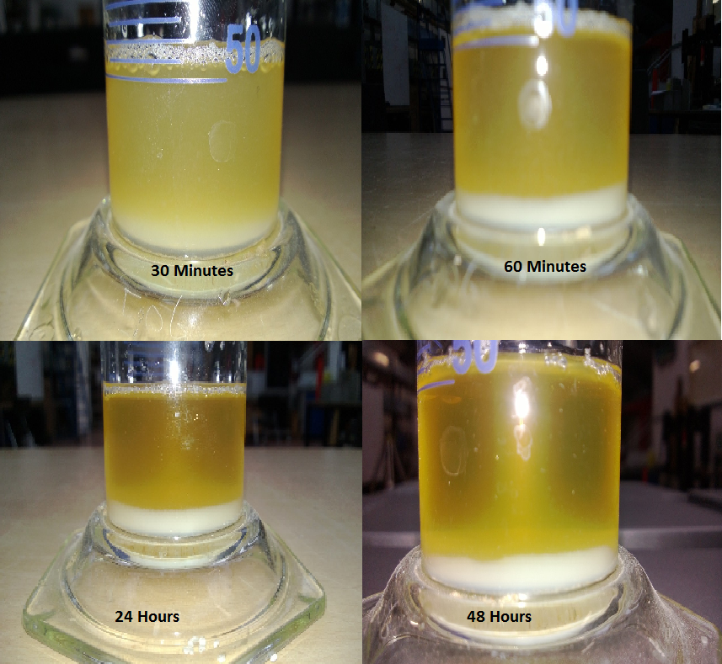
Figure 2 - The sequence of calcite precipitation from the two reactants.

Figure 2 illustrates the colour change observed over time which is due to the formation of white calcite crystals within the solution. As time progresses the heavier calcite mass sinks to the bottom leaving the spent solution at the top. These observations demonstrate the immediate effect created when bacteria is introduced to the NBU.

5.3 CaCO₃ yield analysis
Table 1 and Figure 3 display sample data from the cores and cubes, identifying the mass gained due to the surface application of a bacterial suspension.

Material | Key | Treatments | Initial weight (g) | Final weight (g) | Weight increase (g) | Area m² | Quantity (g) per 1m²
Sandstone | S1 | 0 | 353.30 | 353.3 | 0 | 0.00442 | 0.0
 | S2 | 1 | 330.29 | 330.41 | 0.12 | 0.00442 | 27.16
 | S3 | 2 | 308.67 | 309.24 | 0.51 | 0.00442 | 122.23
 | S4 | 3 | 302.20 | 302.86 | 0.66 | 0.00442 | 149.40
Limestone | L1 | 0 | 465.11 | 465.11 | 0 | 0.00442 | 0.0
 | L2 | 1 | 448.10 | 448.21 | 0.11 | 0.00442 | 24.90
 | L3 | 2 | 411.90 | 412.11 | 0.21 | 0.00442 | 47.54
 | L4 | 3 | 412.25 | 412.69 | 0.44 | 0.00442 | 99.60

Table 1 – Mass increase dataset and conversions for samples (g/m²).

Figure 3 – Comparison of calcite deposition

When comparing the materials it was evident that a weight increase per sample was noted after each treatment. For all samples the first treatment showed the lowest weight increase compared to the respective control sample. The second treatment provided the greatest weight increase of up to 550% in the case of sandstone. The surface application of calcite was lower in the case of the limestone which exhibited a near linear deposition over the three coatings, however sandstone displayed the highest calcite coating.

5.4 Scanning electron microscope imagery
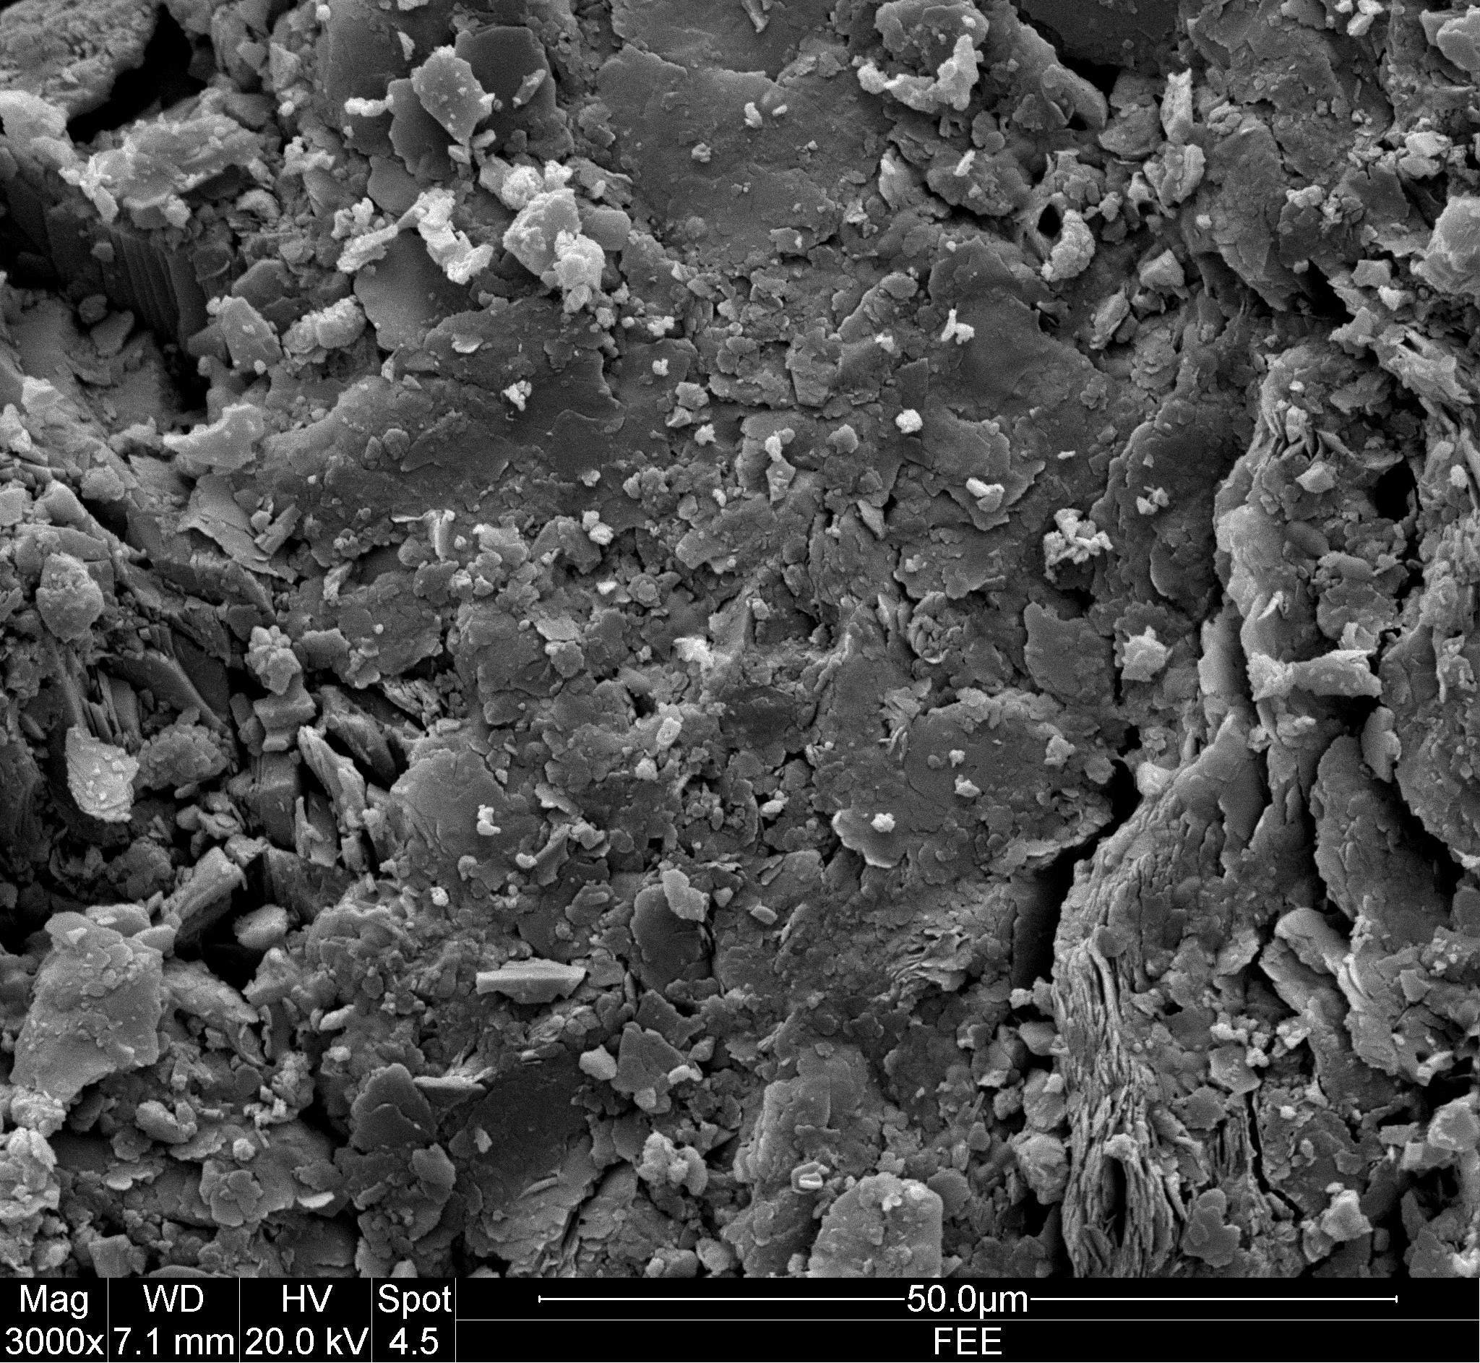
Examination of the sandstone control sample as displayed in Figure 4, show smooth fractures of material typically 10µm in length and less than 1µm in depth that were predominately orientated on a horizontal plane when viewed at magnification of three thousand. The loose surface debris tended to settle within the fractures or fall away under gravity when in low concentrations. Calcite deposition is displayed in Figure 4 and 5.

Figure 4 – Untreated sandstone control sample (3000 x magnification)

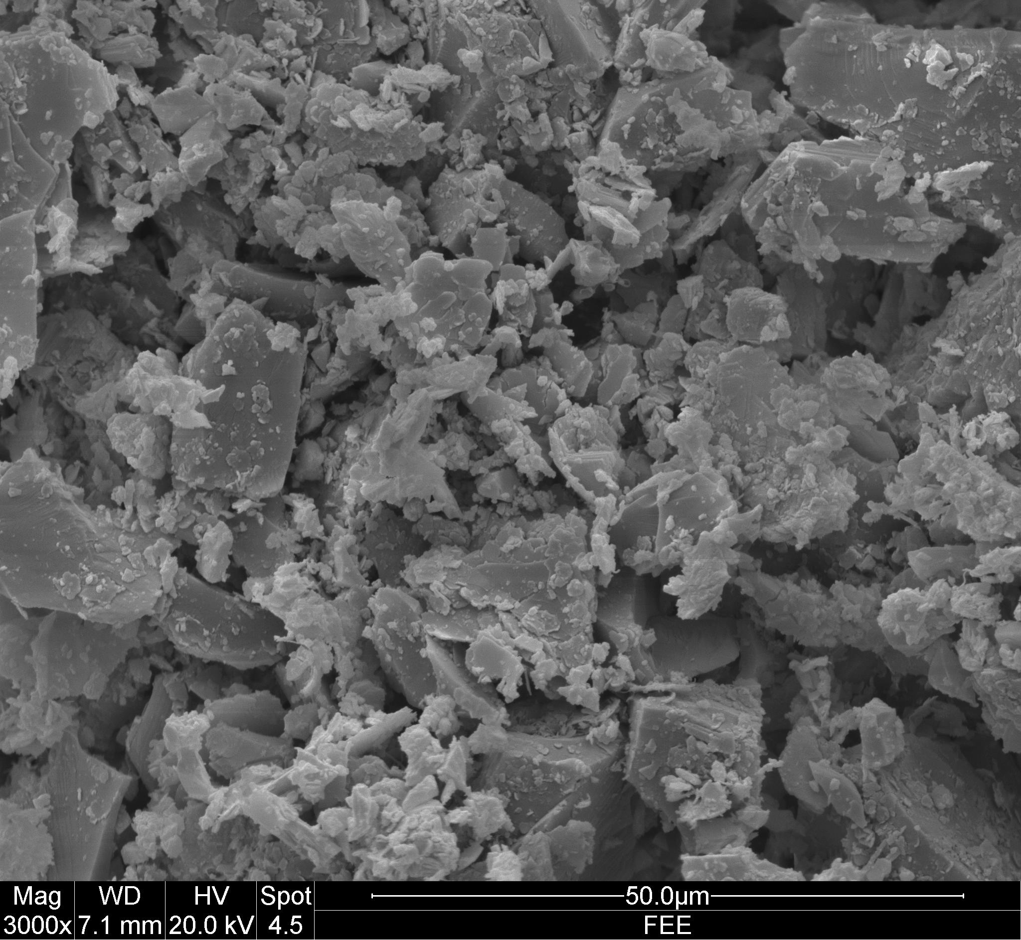
Figure 5 – Sandstone displaying calcite deposition after three surface applications (3000 x magnification).

Figure 5 clearly illustrates silica aggregates that are angular in nature with both crystalline and amorphous relatively small calcite crystallite agglomerations adhered to the surface. The dark regions denote pore structure that is relatively open and interconnected in nature. A characteristic observed in all the materials, was a whitening of the surface. It is likely that this was deposited from the chloride residue in the nutrient broth feed which is unavoidable consequence of the process. Another observation on every sample was that calcite principally formed at the aggregate edge boundary regions. It is not too unrealistic to assume that precipitation in these locations would create favourable consolidation effects enhancing silicate interface connectivity. The relatively low concentration of calcite formation on the surface of the silica grains concurs with work undertaken by Lewins (1982) who indicates that calcite generally has a low affinity for silica substrates. In all materials tested, calcite was not clearly visible until the third treatment. This can be attributed to the gradual development and growth of the calcite crystals.

5.5 Bacterial cement
Silica sand was placed into polystyrene moulds and solid sand formation occurred where the flow of the cementation fluid would have been at its slowest, allowing for bio-cementation to take place without the S. pasteurii cells being flushed from the mould. A small fracture of cemented sand was used for testing. The hardness of calcite (H=3) is known and therefore the sample was tested against this value. When the specimen was tested with a fingernail in accordance with the Mohs surface hardness test, abrasion resistance was observed. Small sand particles were removed from the samples surface due to poor bonding between the calcite and the silica sand surface. A second test was conducted using a 1 pence piece (UK) which has the same abrasion resistance as calcite. The test showed a slight whitening of the specimen which indicated that some abrasion had occurred. The results show that the sample had a hardness level of between 2.5 and 3 (+-0.1) which was an indication of the sample containing calcite. There was an observable degree of bonding and this was due to the application of bacteria mixed with NBU.
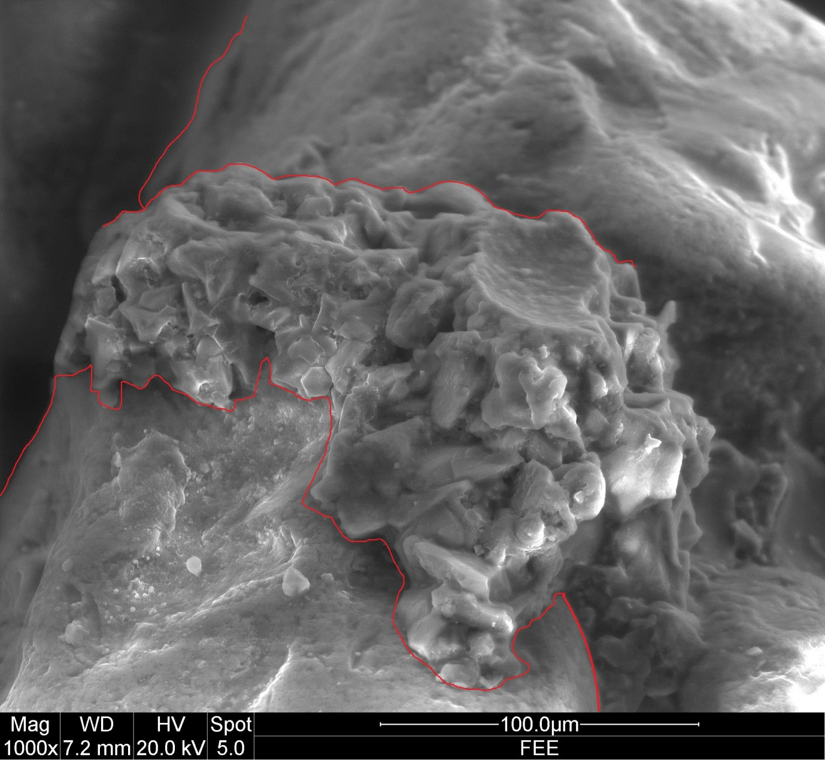
Silica sand
Silica sand
1
2
3

Figure 6 Calcite formation bonding sand grains 1000 x magnification).

Figure 6 displays the calcite formation acting as a binder between the grains of sand. Within Figure 6, detail 1 displays the bond between the sand and the calcite, detail 2 shows the calcite formation, and detail 3 shows a pull out failure where a sand grain has debonded from the surrounding calcite.

6.0 Conclusion
This study has shown that stone particle cementation is possible using microbial precipitation when fluid recirculation is not employed. MCP has been presented as a possible repair agent when used in surface repair of calcareous sandstone and limestone alike.
Multiple coats of bacteria were more beneficial than a single application and this was due to the increase in surface coated mass observed. It is likely that the calcite formations in the micro cracks would reduce the propagation of damage caused by natural weathering actions on exposed stone.

The cell growth to 0.9 optical density was adequate for the surface treatment experiment with minor cementation properties. Sporosarcina pasteurii has shown to be a highly active bacterium for the production of calcite through hydrolysis but the cell quantity could be increased to produce more effective deposition and cementation.

A method for obtaining optimal results in terms of surface treatment would involve reducing the time between mixing and application, this would require having the two reaction constituents mixed only seconds before use. Using a late mix spray application system has the potential to allow the two mixtures to combine in the spray nozzle whilst exiting the apparatus. An additional benefit may occur from this process in so much as it may prevent calcite formation building up within the spray system that would damage the equipment and stop operations.

Conservation of stone masonry substrates may be possible through the application of calcite derived MICP for external surface treatment of friable surfaces.
The application of a microbial based surface treatment may reduce the rate of decay of stone based materials. These treatments could be argued to have a higher degree of compatibility with the calcitic bound stone substrates when compared with traditional approaches due to the natural affinity with the primary cementing matrix. It must however be emphasised that this is a preliminary investigation and the implications of introducing one bacteria culture into often complex existing biological systems (Palmer, 1992; Bluck, 1992) requires further investigation.

7.0 References
Achal, V., & Pan, X. (2011) ‘Characterization of urease and carbonic anhydrase producing bacteria and their role in calcite precipitation’, Current microbiology,62(3), pp.894-902.

Ashurst, J., Dimes, Francis G. (1998) ‘Conservation of Building and Decorative Stone’, Butterworth-Heinemann Series in Conservation and Museology. [Online]. Taylor & Francis. Available from:<http://lib.myilibrary.com?ID=107136> 14 December 2012

Balaras, C.A., Droutsa, K., Dascalaki, E., Kontoyiannidis, S. (2005) Deterioration of European apartment buildings, Energy and Buildings, 37, pp. 515-527.
Basheer, L., Kropp, J. and Clealand, D.J. (2001) ‘Assessment of the durability of concrete from its permeation properties: a review’, construction and building materials, 15 (2-3), pp.93-103

Bayram, F. (2012) ‘Predicting mechanical strength loss of natural stones after freeze–thaw in cold regions’, cold regions science and technology, 83-84, pp.98-102

Benedetti, E., D'Alessio, A., Zini, M. F., Bramanti, E., Tirelli, N., Vergamini, P., & Moggi, G. (2000) ‘Characterization of acrylic resins and fluoroelastomer blends as potential materials in stone protection’, Polymer international, 49(8), pp.888-892.

Bluck, B (1992) ‘The composition and weathering of sandstone with relation to cleaning’. In Webster, R.G.M (eds.) Proceedings of the International Conference of Stone Cleaning and the Nature, Soiling and Decay Mechanisms of Stone. April 1992, Robert Gordon Institute of Technology, Aberdeen, Donhead Pub

BRE Building Research Establishment (1998) Good Repair Guide 20 Part 2 ‘Repairing frost damage: Walls’

Brunskill, R.W, (1978) ‘Illustrated handbook of vernacular architecture’ Faber & Faber, London

BS 8104 (1992) Assessing exposure of walls to wind driven rain, BSI.

BS 7913, (1998) ‘The principles of the conservation of historic buildings’ BSi

Cappitelli, F., Principi, P., Pedrazzani, R., Toniolo, L., & Sorlini, C. (2007) ‘Bacterial and fungal deterioration of the Milan Cathedral marble treated with protective synthetic resins’, Science of the Total Environment, 385(1), pp.172-181.

Castanier, S., Le Métayer-Levrel, G., & Perthuisot, J. P. (1999) ‘Ca-carbonates precipitation and limestone genesis—the microbiogeologist point of view’, Sedimentary Geology, 126(1), pp.9-23.

Clifton, J. R. (1980). Stone consolidating materials: a status report.

Cifton-Taylor, A (1987) Patterns of English Architecture 4th Ed Faber and Faber, London

Collepardi, M (1990) ‘Degradation and restoration of masonry walls of historical buildings’, Mater. Struct. 23(134), pp.81–102.

Dai, J. G., Akira, Y., Wittmann, F. H., Yokota, H., & Zhang, P. (2010) ‘Water repellent surface impregnation for extension of service life of reinforced concrete structures in marine environments: the role of cracks’. Cement and Concrete Composites, 32(2), pp. 101-109.

DeJong, J. T., Mortensen, B. M., Martinez, B. C., & Nelson, D. C. (2010) ‘Bio-mediated soil improvement’, Ecological Engineering, 36(2), pp.197-210.

De Muynck, W., De Belie, N., & Verstraete, W. (2010) ‘Microbial carbonate precipitation in construction materials: A review’, Ecological Engineering, 36(2), pp.118-136.

Dobbs, M, (1983). Rome Losing Glamour as Monuments Decay. The Washington Post , May 16. 1.

Grossi, C. M., & Murray, M. (1999) ‘Characteristics of carbonate building stones that influence the dry deposition of acidic gases’, Construction and Building Materials, 13(3), pp.101-108

Forster A.M, ‘Building conservation philosophy for masonry repair: Part 2 ‘Principles’ Journal of Structural Survey Vol 28, No.3, 2010 Pp. 165-188

Forster A.M, Kayan B. (2009) Maintenance for historic buildings: a current perspective, Structural Survey Vol 27, No. 3, 2009, Pp.210- 229

Hall, C, Hamilton, A, Hoff, W.D, Viles, H.A, Eklund, J.A (2010) ‘Moisture dynamics in walls: response to micro-environment and climate change’ Proc R Soc Aug 2010

Hammes, F., & Verstraete, W. (2002) ‘Key roles of pH and calcium metabolism in microbial carbonate precipitation’, Reviews in Environmental Science and Biotechnology, 1(1), pp.3-7.

Honeyborne, D B ‘Weathering and decay of masonry’ in Ashurst, J., Dimes, Francis G. (1998) ‘Conservation of Building and Decorative Stone’, Butterworth-Heinemann Series in Conservation and Museology. [Online]. Taylor & Francis. Available from:<http://lib.myilibrary.com?ID=107136> 14 December 2012

Hughes, P. (1986) ‘The need for old buildings to ‘breathe’. (SPAB News Spring 1986). P1-3

Karatasios, I., Theoulakis, P., Kalagri, A., Sapalidis, A., & Kilikoglou, V. (2009) ‘Evaluation of consolidation treatments of marly limestones used in archaeological monuments’, Construction and Building Materials, 23(8), pp.2803-2812.

Lewin, S.Z. (1983) ‘forward’ in Amoroso, G G & Fassina, V Stone decay and conservation: atmospheric pollution, cleaning, consolidation and protection, Elsevier, New York

Lewin, S.Z., ‘X-Ray Diffraction and Scanning Electron Microscope Analysis of
Conventional Mortars’, in Mortars, Cements and Grouts Used in the Conservation of
Historic Buildings, ICCROM, Rome, proceedings of a conference held 3–6 November
1981 (1982), p. 106.
McMillan, A A, Gillanders, R J, Fairhurst, J A (1999) Building Stones of Edinburgh 2nd Ed. Edinburgh Geological Society

Maxwell, I, The use of lime mortars in the context of dry stone build, Proceedings of the International RILEM workshop (PRO 12), Historic Mortars: Characteristics and tests, 1999, Pp 3-13

Melo, M. J., Bracci, S., Camaiti, M., Chiantore, O., & Piacenti, F. (1999) ‘Photodegradation of acrylic resins used in the conservation of stone’, Polymer degradation and stability, 66(1), pp.23-30.

Met Office (accessed July 2013) http://www.metoffice.gov.uk/climate/uk/
Muir, C (2006) ‘Sandstone’ in Henry (eds). Stone Conservation: Principles and practice Donhead Pub

Palmer. R Jr. (1992) ‘Microbiologcal damage to building stone: analysis and intervention’. In Webster, R.G.M (eds.) Proceedings of the International Conference of Stone Cleaning and the Nature, Soiling and Decay Mechanisms of Stone. April 1992, Robert Gordon Institute of Technology, Aberdeen, Donhead Pub

Parks, S. (2009) ‘Kinetics of calcite precipitation by ureolytic bacteria under arobic and anaerobic conditions’, Master of Science Thesis. Montana State University.

Pinto, A. P., & Rodrigues, J. D. (2008) ‘Stone consolidation: The role of treatment procedures’, Journal of Cultural heritage, 9(1), pp.`38-53.

Price, C (2006) ‘Consolidation’ in Henry (eds). Stone Conservation: Principles and practice Donhead Pub

Reading, H G (1986) Sedimentary Environments and Facies 2nd Ed. Blackwell Scientific Publications, London

Rodriguez-Navarro, C., & Sebastian, E. (1996) Role of particulate matter from vehicle exhaust on porous building stones (limestone) sulfation. Science of the total environment, 187(2), pp.79-91.

Rodriguez-Navarro, C., Rodriguez-Gallego, M., Ben Chekroun, K., & Gonzalez-Muñoz, M. T. (2003) Conservation of ornamental stone by Myxococcus xanthus-induced carbonate biomineralization. Applied and Environmental Microbiology, 69(4), pp.2182-2193.

Schiavon, N (1992) ‘Assessment of Building Stone Decay: A Geomorphological Approach’. In Webster, R.G.M (eds.) Proceedings of the International Conference of Stone Cleaning and the Nature, Soiling and Decay Mechanisms of Stone. April 1992, Robert Gordon Institute of Technology, Aberdeen, Donhead Pub

Siddique, R. and Chahal, N.K. (2011) 'Effect of ureolytic bacteria on concrete properties', Construction and Building Materials, 25 (10), pp.3791-3801

Smith, B, Whalley, B & Magee, R. (1992) ‘Assessment of Building Stone Decay: A Geomorphological Approach’. In Webster, R.G.M (eds.) Proceedings of the International Conference of Stone Cleaning and the Nature, Soiling and Decay Mechanisms of Stone. April 1992, Robert Gordon Institute of Technology, Aberdeen, Donhead Pub
Whiffin, V. S., van Paassen, L. A., & Harkes, M. P. (2007) ‘Microbial carbonate precipitation as a soil improvement technique’, Geomicrobiology Journal, 24(5), 417-423.

Young, D (2008) Salt attack and rising damp: a guide to salt damp in historic and older buildings

Zamarreño, D. V., Inkpen, R., & May, E. (2009). ‘Carbonate crystals precipitated by freshwater bacteria and their use as a limestone consolidant’, Applied and environmental microbiology, 75(18), pp.5981-5990.

