The conceptual design changes triggered by timber boards.

S. Costa Santos, PhD. Architect

University College Dublin, C.E.S.U.G.A., Feáns 152, 15090 A Coruña, Spain; PH (+34) 981 137346; FAX (+34) 981 137347; e-mail: sandra.costa@ucd.ie

Abstract
After the introduction of timber boards as diaphragms in light-frame construction opened the way to modern timber construction, three major design changes would follow: the elements become multifunctional, they can work structurally in two directions, and they can be prefabricated as surface components in a non modular way. In other words, the multifunctional panel becomes the design unit of modern timber architecture. This work looks at various types of composite timber panels with a view to show the evidence of typological and tectonic changes caused by the new design unit.

Keywords: light frame construction, timber boards, optimised section panel, timber architecture.

Introduction
Two major events happened at the beginning of the XIX century that revolutionized timber construction: the arrival of the industrial nail (which meant important reductions in nail manufacturing costs) and the steam-operated sawmills [1]. Both innovations made George Washington Show’s constructive proposal possible. The proposal was the balloon frame, a light-weight construction system that used small section timber studs (5 x 10 cm approx.) at 50 cm centres and up to two-storey high. The timber floor joists and roof rafters rested on sleeper beams nailed to the studs. The walls, built with linear elements, were load-bearing and the overall structure was stiffened against horizontal actions using timber sections diagonally between the studs. Light frame structures achieved stability, at the beginning, by means of diagonals in the plane of the walls. This type of bracing was followed, later on, by timber boarding nailed to the studs. At this moment in time appears a conceptual change, and when the bonding technology allowed the use of adhesives instead of nails, timber boards and studs become one single component that lead to true typological changes.

Light frame construction.
Light frame structures work as three-dimensional structures with load-bearing planes in all three main axes. They use small section elements at close centres. The walls use a frame of timber studs (verticals) and dwangs (horizontals), stiffened by diagonal sections or, later on, boards. There are two types of light frame structures: balloon frame and platform frame. Both are systems of great flexibility.

Balloon frame is now widespread in America and uses timber sections of standard sizes. The module is based on a 2 x 8 inch section (5 x 20 cm approximately), allowing more room for insulation between the timber sections. If, for structural reasons, larger cross sections are needed, these are made by just nailing many smaller squared sections together. The construction is nailed together on site and generally rises over two or more storeys. Nowadays, solid timber boarding or timber-based boards attached diagonally assure stability. The system is very simple: any additional members are just nailed to the main framework as required. This allows, despite very little prefabrication, fast erection with unskilled workmanship. A great degree of design freedom (layout, volume and position of openings) also characterises the system. Since the structure is over-rigid, openings can be cut out subsequently. However, the fact that the system is over-rigid leads to high material consumption. That is a disadvantage compared to more recent systems. Timber stud construction is the equivalent in Europe to balloon frame in America [2]. It also uses closely spaced squared sections of standard sizes extending over two or more storeys. But there is less standardisation and the connections are not limited to nailing (as in the case of balloon frame). Another difference is a more economic use of material. External and internal cladding are generally solved with timber boards and gypsum boards respectively. There is no thermal insulation in the cavity; however, a thick foil layer is used to improve air-tightness of the façade, an important aspect given the amount of dry joints in this system.

Platform frame is a further development of timber stud construction. Known by its high degree of prefabrication, it is very popular nowadays. The structural elements are storey-high pre-assembled frames of squared sections. Platform frame construction is based on the principle of stacking storeys one upon another. The walls, roofs, and floors then have a series of layers, added like clothing. There is vapour barrier and plaster board and insulation inside, plywood sheathing, weatherproof membrane and a wide range of finishes. In America, all this was facilitated by the nationwide use of pre-surfaced timber, already machined to a finished surface. Platform frame construction consists of 5 x10 cm approx. timber studs at 40 cm approx. centres in 2.42 m high wall panels of varying widths based upon the stud centres. Rafters and ceiling joints have long since been replaced by trussed rafters, very light timber sections plate-nailed and erected at two foot centres to a range of roof pitches. Floor joists of 5 x 20 cm at 40 cm approx. centres are usual. Because it has become highly standardized around a few dimensions it is now more used than the balloon frame. The system is based on a small module, although the spacing of the elements can be varied as required to accommodate the infill or the openings. The linear elements are braced by diagonal sections or, nowadays, by timber boards. The main advantage of this system is its versatility: it can address many different design specifications. It is also straight forward and economic since it uses identical sections wherever possible. The sections are small sized, and therefore easy and cheap to manufacture. Another advantage of this system is the simple nailed and screwed connections.

Using composite joists (made up with an OSB web and timber flanges, for example) instead of sawn timber sections is a relatively recent constructive development. Light frame construction has evolved through time: timber boards (working as diaphragms) are being used instead of the diagonal sections; thermal insulation has been added to the air cavity; a vapour barrier has been added next to the inner face to minimize condensation; the external cladding has been moved away from the structure creating a rain screen, the assembly methods have been improved, the section of the timbers has changed through years. However, the development of the system not necessarily involved a real alternative to it if it kept the same typological essence. Clearly, one of the most important innovations has been the addition of the timber board. This would lead to the assembly in the workshop of linear stud and timber board making a new construction unit that could be clad and taken to site as a self-contained component.

Composite panels.
After the introduction of timber boards as diaphragms in light-frame construction opened the way to modern timber construction, three major design changes would follow: the elements become multifunctional, they can work structurally in two directions, and they can be prefabricated as surface components in a non modular way. And, although the introduction of the board in frame construction seemed to blur the line between traditional and modern construction, it can be said that the developments of the bonding technology defined the difference [3]. Glue, instead of traditional nailing, can achieve a homogeneous bond that minimizes deformation and improves the shaping (modelling) possibilities of the elements. Then, with the new bonding technology, boarded light-frame systems led to composite section panels. Composite panels rely on the optimisation of the section once a certain panel thickness has been achieved. They are generally made up with two boards and an inner structure to which they are bonded. This inner structure, with ribs and cross-ribs, will tend towards isotropy. The inner structure of these panels is not homogeneous. The internal build-up of the panel dictates where loads, supports and cuts should be located. However, this inner structure is easily modified in the workshop to suit different situations: there is much scope for flexibility within the internal layer [4]. The non-homogeneous inner structure of the panel means that although the cuts can be virtually anywhere in its surface, their perimeter has to be occupied by structural elements. Optimised section panels require planning because although they can be freely manufactured without following a module, they should not be adjusted on site but treated as finished elements. The cavities can be filled with insulation or used to conduct services, thus making complete constructive units.

Structural Insulated Panels (SIP)
Structural Insulated Panels (SIP) are prefabricated products made up with an insulated core (generally from synthetic foam materials) between two timber boards. This is the basic definition, but there are many different types [5]. They can include a vapour barrier or timber battens to fix the roofing material. Some panels are reinforced with sawn timber sections between the boards to achieve a higher bending strength. There are also very simple types with only one board and insulation. Panel construction is the generic name for the use of SIP. Buildings can be manufactured completely off-site using internal and external wall, roof and floor panels, thus reducing the construction time on site to a few days. Structural Insulated Panels are mainly used as roof panels and usually follow board sizes (1.20 x 2.40 m); however, reinforced panels can be manufactured in bigger sizes, spanning from eaves to ridge (these panels are also known as roof plates). First used in the 1950s in the US, they have been considered as a cost-effective way of mass-producing prefabricated building elements.

3.2 Box, hollow or ribbed section panels and folded panels
Optimised section panels can have box, hollow or ribbed sections. Their hollow section can easily accommodate services or insulation materials such as mineral wool, cellulose and wood fibres (high thermal insulation values can be achieved). Thus, the elements are multifunctional (synthetic) and provide a solution to structural needs, acoustic and thermal insulation, thermal inertia and have positive hygroscopic properties. They can be exposed or finished with other materials and the lower covering slat can be perforated to improve room acoustics. When they constitute the external envelope of the building, these panels challenge the traditional build-up of the wall as a series of mono-functional layers. Industrial making ensures a precise assemble process and allows computer-aided treatment in the workshop. The design process is not restricted by a given module because the elements can be modified in the workshop for each particular project. Construction times are short because the panels can be entirely prefabricated. Given their profiled section, they can achieve large spans under high load conditions with a low weight and small structural depth. Many types of structural elements can be made with stacked board planks, and they can also be combined with other laminated timber solutions. Optimised panels of the K-Multibox type can be made using LVL, LSL, or other timber by-products but the standard material is the three-ply K1 Multiplan panel. These by-products are fixed using glue, or glue and screws, to glulam members. The mechanical resistance depends on the components used but, with ordinary live loads, floor elements can span 8 metres and roof components can span 30 metres. The type of panel and the box sections can be adapted to individual solutions, thus the system allows variants. The Passive-Energy Housing project in Dornbirn (Austria) is an example of the use of prefabricated surface box components. In this case the openings are integrated in the box panels. Prefabricated box section structural elements were used by the architect Johannes Kaufmann for the walls of the Passive-Energy Housing in Dornbirn. The scheme consists of a row of nine terraced houses with a communal unit at the end. Low production costs and a short construction period were ensured by the use of prefabricated timber elements. Each individual two-storey house has a floor area of about 80 m² and allows a flexible use of the internal spaces. The only fixed elements are kitchen, WCs and bathroom. All the units were erected in a dry form of construction, as completely finished prefabricated synthetic components. The 28 cm thick panels are fully insulated and include door and window openings. They were clad to the outside with larch boarding on site. We can see in this example how the space-making process of traditional timber architecture (based on several stages) is hugely simplified. The space-defining role of the structure, the enclosing of the interior space by material planes, the establishment of an immediate relationship with the exterior space by the opening, and the symbolic meaning expressed by the cladding are all simultaneous actions. At the same time, this relationship between interior and exterior space has more flexibility due to the structural characteristics of the panel. The visual integrity of the plane can be challenged because the continuity of its material boundaries can be easily broken. In the passive-energy housing in Dornbirn, the space-making process is simplified at construction stage mainly by the surface element’s capability of performing various functions. This simultaneity of phases translates into a greater control of the design unit at project stage.

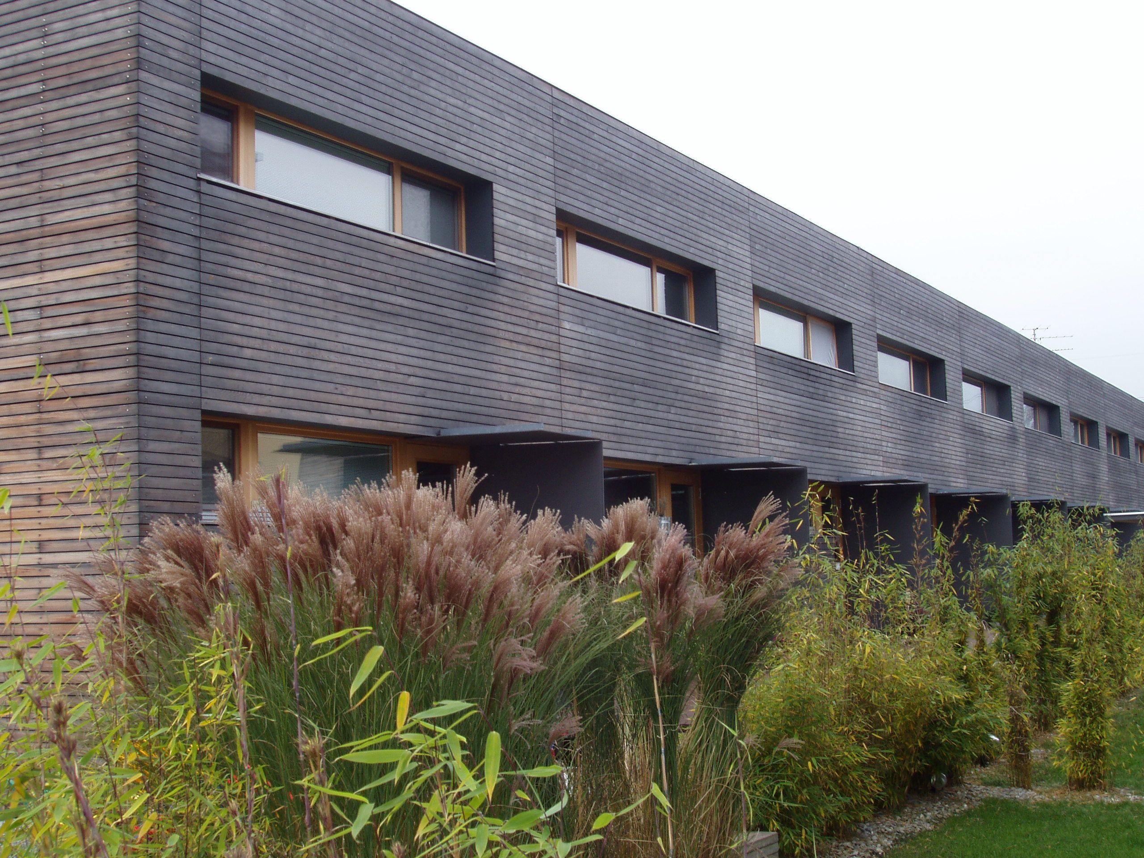
Fig. 1. Passive-energy housing in Dornbirn.
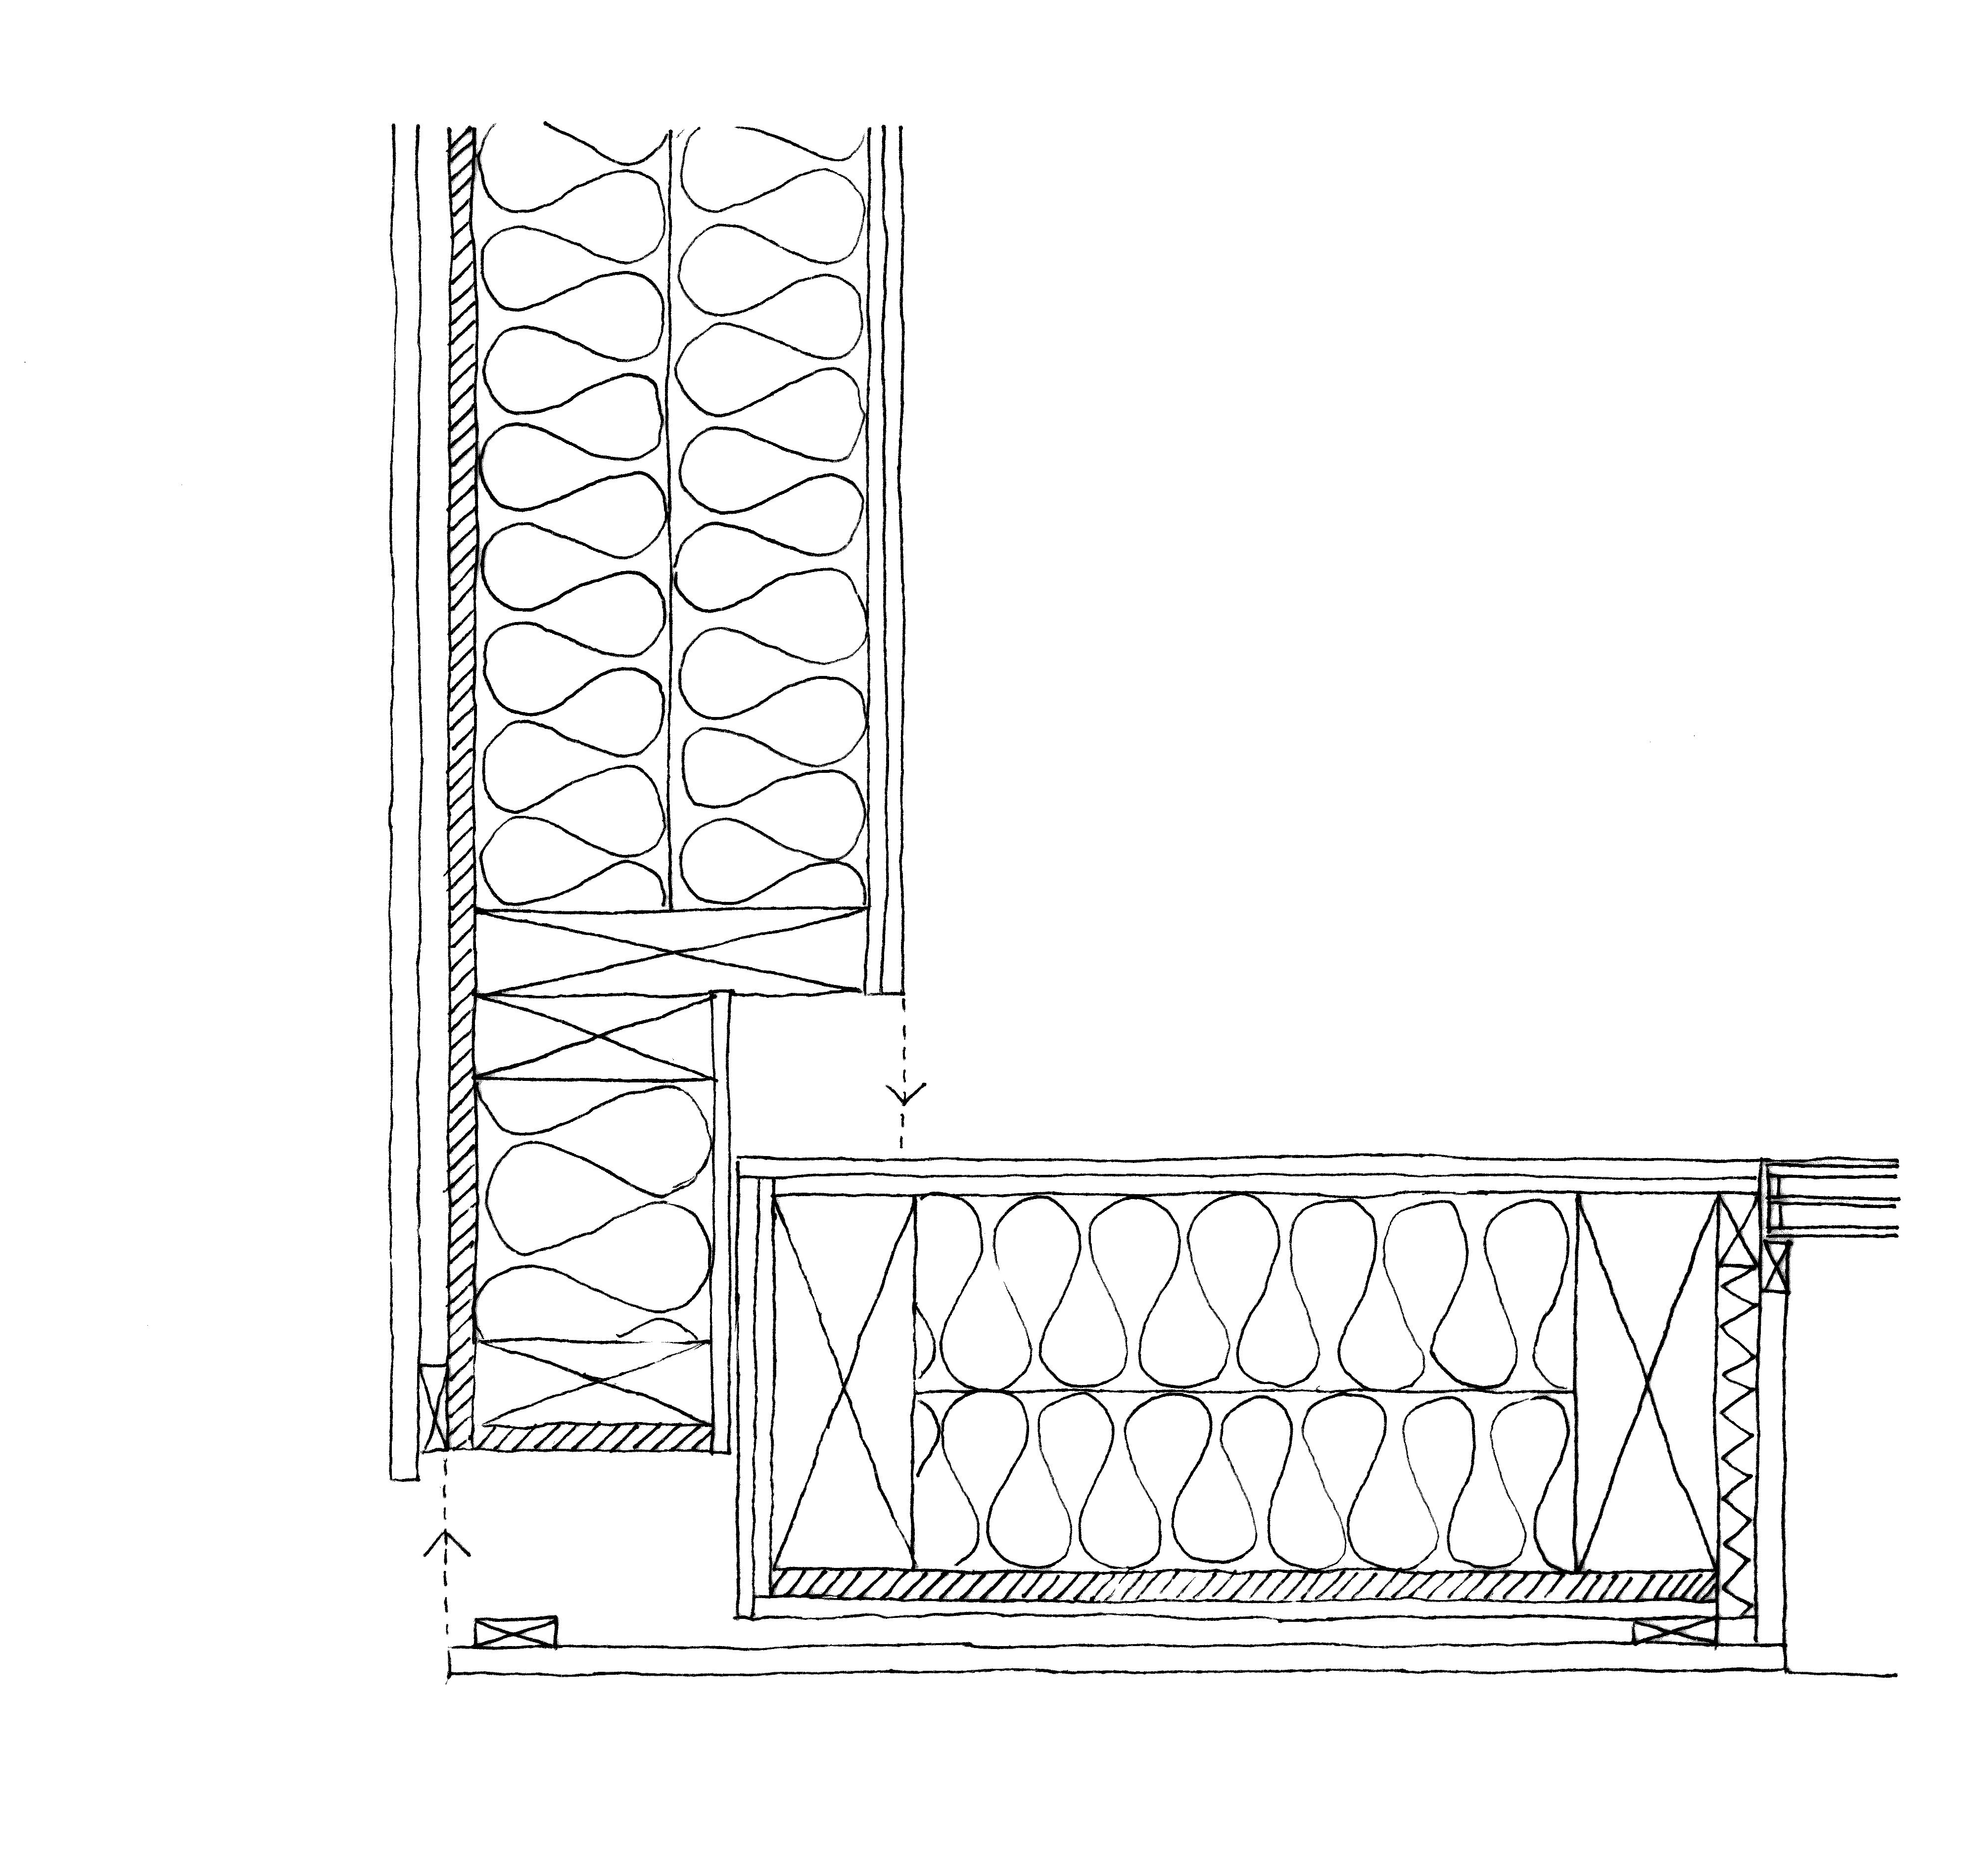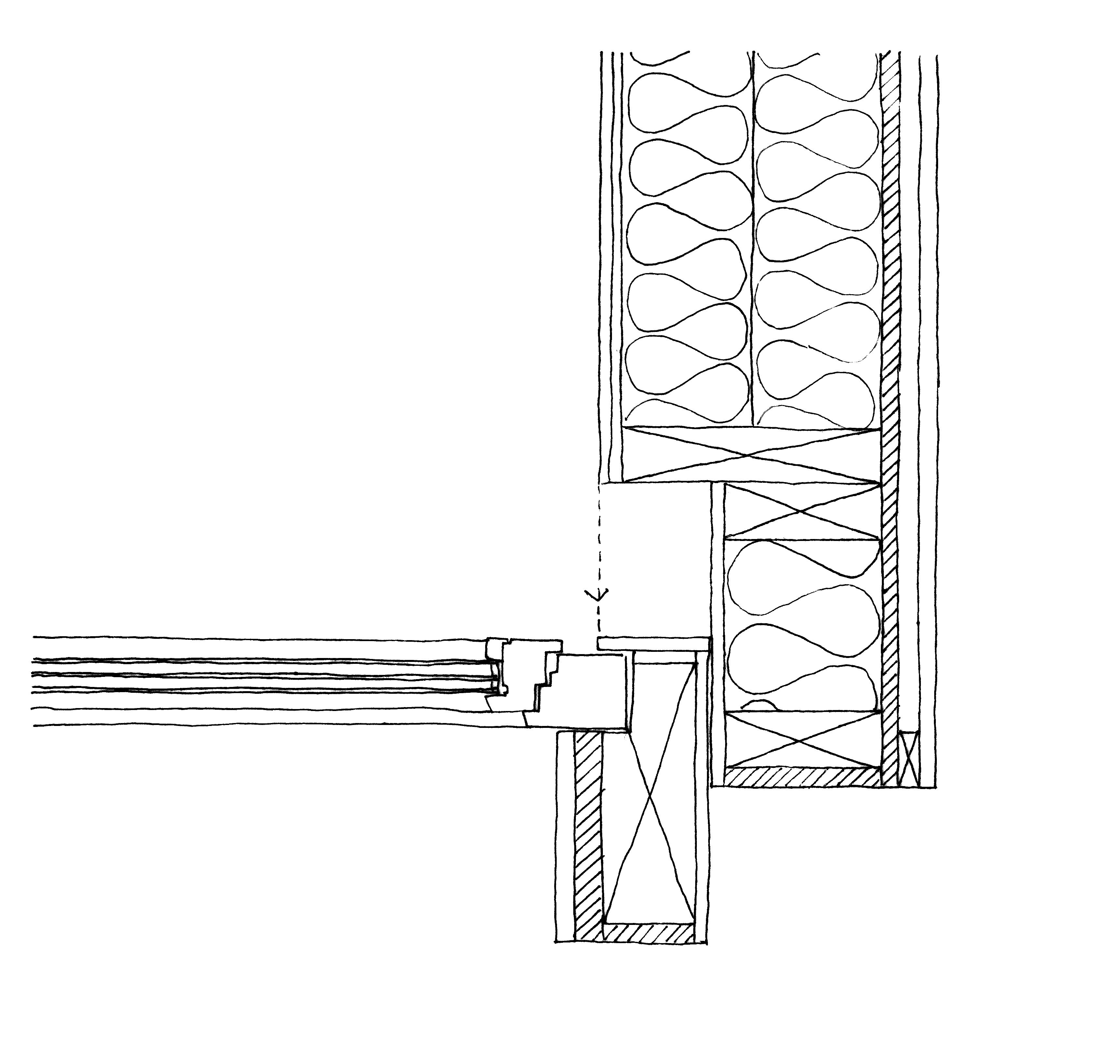
Fig 2. Passive-energy housing in Dornbirn: sections showing assembly between panels.

3.3 Board systems panels
These panels consist of between three and seven cross-banded softwood plies. There are gaps of several centimetres between the individual pieces of the inner layers. Only side boards or low-strength timber are used as raw material. The wall elements come in widths up to 62.5 cm and lengths up to 18 m. These components can be joined together by means of timber plates and frames. Mechanical fasteners are the joining method between individual elements or between walls and floors or roofs. A very little shrinkage and swelling of the panel is the result of the cross-banded arrangement of the layers. The movements are taken by the joints. The panels cannot be shaped. Although there is a production module of 12.5 cm, the design is not necessarily determined by it. This is because the project can be designed more or less freely with the standard panels and then divided into elements in conjunction with the manufacturer. Openings can be cut virtually anywhere in the panels and electrics can be routed through the voids without having to cut or drill the panel any further. Structurally, the direction of span is irrelevant and they can be used as walls, floors or roofs. The boards are very rigid and perform very well as stiffeners. It is possible to build a compact building skin without the need of adding a vapour barrier, depending on the type of element chosen. The voids can be filled with insulating material, but this is very labour-intensive. Depending on the type of element, a fair-faced finish is possible.

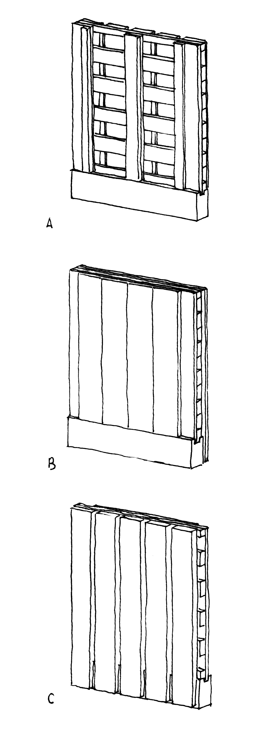
Fig 3. Board-system wall elements: A: open both sides, B: closed on both sides, C: closed on one side.
.

4 Conclusion: open multifunctional surfaces.
The development of a constructive system does not necessarily trigger a typological change. The evolution of timber construction and the various building techniques that appeared hardly changed the fact that the structural and constructive unit was a linear element. However, after the introduction of timber boards as diaphragms in light-frame construction appears a conceptual and typological change based on three fundamental issues.

The structural plane gains a clear space-enclosing function, being even able to work as a finished surface. Therefore, talking in constructive terms, this is now a multifunctional element. The multifunctional nature of the constructive unit moves away from the traditional construction based on a series of mono-functional layers that are assembled in several consecutive stages, such as in light frame construction. Not only the assembly process is simplified and reduced, but the build-up of the building skin is made more compact with the use of layers that can perform various functions. Now the architect is forced to work with interlocked materials that cannot be divided into assembly stages: modern timber elements are compact and synthetic packages in which the load-bearing structure, building physics, services and exposed surfaces fuse with each other. However, the potential of this new design unit extends to more areas than energy-efficient multifunctional architectural elements. The composite panels also allow the abstract plane to be expressed as monolithic and homogeneous.

Secondly, prefabrication was previously limited to the manufacture of linear elements, but by using timber boards, manufacturing load-bearing surface elements that work structurally in two ways is a possibility. This new possibility introduces a fundamental difference with the traditional light frame construction, because the architectural and structural unit that the architect has to deal with will be a surface with potentially no predefined direction associated to it. This is a most important structural change from the structural hierarchy of traditional timber architecture where primary and secondary linear elements defined the directions of construction and the space created by it.

And, finally, the fact that these components do not rely on a structural module, means that they can be prefabricated in a non modular way and the degree of standardization is decreased. Modern components are now generally open systems that offer flexibility. The opening in light frame construction was closely related with the structural module or span between studs; although it could be modified, all opening out of the module meant a particular solution for an irregularity.

The work concludes that these three typological changes mean that the multifunctional non-modular surface system becomes the design unit of modern timber construction and a point of departure from traditional timber construction.

References

[1] Avellaneda, J. (2000). La construcción en madera hoy. Tectónica 11. ATC Ediciones.

[2] Kolb, J. (2008). Systems in timber engineering. Birkhäuser
[3] Merz, Ch. ,Kaufmann-Merz Engineering (2005). Personal communication, Dornbirn.

[4] Grohe, G. (2001). El futuro de la construcción con madera. Tectónica 13. ATC Ediciones

[5] Building Design (2004). Solid timber panels vs structural insulated panels. Building Design Issue 1650. 12 Nov 2004. United Business Media

Bibliography

Argenti, M. (2001). Wood in contemporary architecture. Materia 36. Wood architecture. Sept-Dec 2001.
Arriaga Martegui, F (2001). Estructuras de madera. Tectónica 13. ATC Ediciones.

Camacho Atalaya, A. (2008). Diccionario de la Madera y su Entorno. AITIM Publicaciones.

Deplazes, A. (2001). Wood: indifferent, synthetic, abstract- man-made. Translation by Michael Robinson. Werk, bauen + wohnen 1-2 2001.

Deplazes, A. (2005). Wood: indifferent, synthetic, abstract-plastic. Prefabrication technology in timber construction in Constructing architecture. Materials, processes, structures. A handbook. Birkhäuser.

Detail (2009). Review of Architecture and Construction Details. Timber Construction. Detail. Vol 2009-1

De Vries, K. (2003). A new life with wood. Building Europe 1. Nov 2003.

Gabriel, A. (2000). Timber construction today. Detail Serie 2000-1. Timber construction. Jan-Feb.

Herzog, Th., Natterer, J., Schweitzer, R., Volz, M. Winter, W. (2004). Timber Construction Manual. Birkhäuser Edition Detail.

Kaufmann, H. (2004). Timber- a universal building material. Detail Serie 2004. Timber Construction. Jan-Feb.

Korvenmaa, P. (1997). Timber construction in Finland- from housing manufacture to universal systems. Detail Serie 1997-1. Timber Construction. Jan-Feb.

Krippner, R. (2001). Building with systems- learning from the 1960s? Detail Serie 2001-4. Modular Systems. Jun-Jul.

McLeod, V (2010). Detail in Contemporary Timber Architecture. Laurence King Publishing.

Moser, K. (2000). New timber construction. Detail Serie 1997-1. Jan-Feb

Orbe, A; Cuadrado, J; Rojí, E; Maturana, A. (2010). Arquitectura y Madera. Colección LUR, no.15, Servicio Central de Publicaciones del Gobierno Vasco.

Radovic, B. (2000). Composite wood products and their use in building. Detail Serie 2000-1. Timber construction. Jan-Feb

Russell, B. (1981). Building systems, industrialization and architecture. John Wiley & Sons.

Schittich, Ch. (2001) Open and closed systems- an interview with Helmut Schulitz. Detail Serie 2001-4. Modular Systems. Jun-July.

Schweitzer, R. (2005). Timber in the art of building. Techniques & Architecture no. 476: Bois 1 structure. Feb-March 2005. Editions Jean Michel Place.

Sekler, E. (1963). Structure, Construction and Tectonics in Kepes, G: Structure in Art and in Science, 1965.

Wang, W. (1999). The constancy of wood in Timberwork. Selected projects, wood technolgoy. The timber award 1961-1999. Edited by Beate Hølmebakk. Arkitekturforlaget.

