Impact Resistance of Concrete – Using Slit Rubber from Tyres
Kathryn Coventry,
Northumbria University, Engineering and Environment, Newcastle upon Tyne, UK email Kathryn.coventry@northumbria.ac.uk

Alan Richardson (corresponding author)
Northumbria University, Engineering and Environment, Newcastle upon Tyne, UK.
Alan.richardson@northumbria.ac.uk

Jamie Rogers,
Northumbria University, Engineering and Environment Newcastle upon Tyne, UK
j.rogers@northumbria.ac.uk

Abstract: This paper examines recycled tyre rubber, which was machine cut into slits and these were added to Portland cement concrete mixes in different percentages, based on specimen volume. They were then tested to determine the impact performance of each mix in comparison to a plain non-rubberised mix.
The results indicated that concrete samples containing recycled rubber, exhibited a loss in compressive strength when compared to the plain concrete mix, however, the rubber modified samples were shown to outperform the plain mix in most areas when tested for impact performance. This rubber slit product may prove beneficial in providing enhanced energy absorption of concrete and has many practical applications ranging from the construction of motorway barriers, airport runways, precast concrete blast barriers and rail system infrastructure.
Key words: Rubber slit tyres, impact, concrete, toughness.
1.0 Introduction
This paper examines the benefits of using rubber slit tyres in concrete to enhance energy absorption. Fibres have a known energy absorbent qualities and display greater toughness than plain concrete. (Richardson et al 2015). A hybrid fibre/rubber slit concrete was tested along with varying doses of rubber slit tyres with regard to impact performance.
Energy saving and carbon reduction has become a global issue over the last decade. However, the rapid growth of the automobile industry and the increasing use of the car as the main means of transportation has had a considerable, adverse effect on these reductions, and has subsequently led to increasing numbers of stockpiled waste rubber tyres (Yung et al, 2004).As well as carbon emissions created in the manufacturing and the use of automobiles, the rubber tyres used on the vehicles pose an equally large problem to the planet. The waste tyres stockpiled, presents a significant environmental, human health and aesthetic problem, meaning that innovative solutions are required to be developed, in order to solve the problem (Li et al, 2004). Several studies have been carried out in order to find ways in which to re-use scrap rubber tyres. Currently, the main percentage of scrap rubber is used in a variety of rubber and plastic products, as well it being incorporated into asphalt for road surfaces and pavements. Some studies have researched and looked into the incineration of the waste tyres for the production of electricity, as well as fuel for burning in cement kilns. However, because of high capital investment involved in this process, using tyres as fuel is technically feasible but economically not very attractive (Siddique et al, 2004).Concrete is one of the most widely used materials in civil engineering and the construction environment, If positive results can be obtained from this research, the economic benefits would provide a significant long-term benefit to society.
2.0 Tyre disposal
According to Reschner, (2003) it is estimated that there are approximately 2-3 billion tyres stockpiled in the US alone, with similar figures replicated in many countries across the world. Due to the lack of ready available disposal/storage space throughout the US and other countries, including the United Kingdom, the disposal of scrap tyres in to landfill sites is now becoming increasingly unavailable.
2.1 Recycling of tyres
270 million tyres are manufactured annually, 10 million are recycled into new products, 125 million are used as tyre-derived fuel, 20 million are processed in to ground rubber and 30 million are used in civil engineering applications, meaning that only 27% of tyres are available to be reused (Siddique et al, 2004). At this present moment, the main uses for recycled ground rubber are rubber products such as floor mats, carpet underlay, vehicle mudguards as well as in some plastic products. In some cases, recycled rubber has been used as a fine aggregate addition in the dry process of asphalt courses. In addition, crumb rubber has been known to be used as an asphalt binder in the wet process of hot mix asphalt (Naik et al, 1995).
2.2 Classification of recycled tyres – (Slit rubber)
Once the tyres have reached the end of their life cycle they can be managed in a number of different ways depending on the desired size and texture for the future use of the material. Slit rubber particles are produced in tyre cutting machines, all of the threads are removed from the rubber, as well as the sidewalls of the tyre. The rubber resembles fibrous materials often used in concrete, ranging in many different sizes and shapes (Siddique et al, 2004).
2.2.1 Rubber type
Slit rubber particles are produced in tyre cutting machines, with all of the steel threads removed from the rubber as well as completely removing the sidewalls of the tyre. The way in which the rubber is cut leaves some of the individual particles resembling fibrous materials, similar to those that often used in concrete for improving impact, and crack control capabilities. Slit rubber is produced in many different sizes and shapes from 2mm wide by 20mm long, up to 20mm wide by 20mm long and this means that each particle is irregular when compared to one another (Siddique et al, 2004).
2.2.2 Rubber dosage
The amount of rubber used in each mix design, (rubber dosage), was determined by calculating the volume of each batch by weight and then calculating the percentage of rubber needed by weight also. The rubber particles did not replace any of the aggregate as in some studies; the basic concrete mix remained the same throughout the five different batches, and the amount of rubber was changed as required. This had the effect of changing the volume which in turn affected the density.
2.2.4 Steel fibres
The steel fibres used for testing in this study were obtained from the shredding process of the waste tyres, with the steel beads separated from the rubber by an electromagnetic separator. The steel fibres were of different lengths, diameters and shapes and they also presented irregular shapes
The steel fibre diameters varied between 0.18mm and 3mm, with the length varying between 14mm and 25mm.
2.3 Pre-treatment of rubber
Pretreatments may vary from washing the rubber in warm water to acid etching, plasma pretreatment and various coupling agents (Naik and Singh, 1991).
With alkaline pretreatment, the recycled rubber particles are left to soak in an alkaline solution (NaOH) for any time over 5 minutes and then thoroughly rinsed with water to discard any of the remaining alkaline solution. This treatment is carried out to enhance the strength of the of the concrete containing rubber particles. This process created a very small increase of the roughness pertaining to the surface texture of those particles (Siddique and Naik 2004). Eldin and Senouci (1993) washed the rubber with water and then thoroughly soaked the rubber particles in a NaOH solution to remove all contaminants. Similarly Rostami et al (1993) used water with a carbon tetrachloride solvent as well as water with a latex admixture cleaner to pre-treat the rubber particles before they were to be added to the concrete mix.
Serge and Joekes (2000) investigated the use of rubber tyre particles as an addition to cement paste. Among the many different treatments given to the rubber particles to enhance the hydrophilicity when mixed with the concrete, sodium hydroxide or NaOH provided the most efficacious results. Those results showed that the NaOH solution enhanced the adhesion of the tyre rubber particles to the cement paste, and mechanical properties such as flexural strength.
2.4 Impact resistant properties of rubber modified concrete
There have been a number of investigations into the impact resistance of rubber-modified concrete using a number of different variables, such as, different sizes and amounts of recycled rubber, within a m³ of concrete. Khatib and Bayomy, (1999) reported that, as the rubber content is increased within the test specimens, there was a corresponding increase in strength reduction. A specimen with a rubber content as high as 60%, by total aggregate volume, shows elastic like deformations, which are retained even after unloading. Raghvan et al, (1998) reported that the concrete beam specimens with rubber shreds or slit rubber were able to withstand an additional load after peak load. They report that this was a consequence of the rubber shreds bridging the cracks.
According to Tantala et al, (1996) the toughness (energy absorption capacity, generally defined as the area under the load-deflection curve of a flexural specimen) of a rubber modified concrete beam with 5% shredded rubber by volume of coarse aggregate, exhibited greater toughness than that of a plain control beam. However, the specimen with 10% by volume shredded rubber did not perform to the same level and showed results lower to the 5% rubber specimen. This appears to indicate that there is an optimum addition of rubber slits to a concrete product.
2.5 The effect of rubber upon compressive strength
Son et al, (2011) investigated the impact of rubber crumb in reinforced concrete columns. They reported that by utilizing waste tyre particles at sizes of 0.6mm and 1.0mm with a weight fraction of rubber 0.5% to 1%, there was an average reduction of 12% to 20% compressive strength. They also reported that the compressive load-carrying capacity of the column specimens decreased with the increase of rubber content. It was discovered that by utilizing 1% rubber content this could produce an 18% reduction in compressive load-carrying capacity of columns constructed with 24 and 28 MPa concrete. Atahan and Yucel (2012) reported that the compressive strength decreased with the increase in the amount of rubber added to the mix. They suggest that the strength of 100% of the specimens was 93% less than the strength of the control specimens. Ganjian et al, (2009) carried out an investigation in which scrap tyre rubber was used as a replacement for aggregate in concrete. Concrete containing 5%, 7.5% and 10% chipped and ground rubber by weight of coarse aggregate, showed that the strength of the concrete samples containing chipped rubber was reduced. This informed the mix design as used herein.
3.0 Concrete mix design
The concrete used in the batching process for this study was chosen because the cement content was sufficient to coat the recycled rubber and steel particles. Table 1 displays the mix design as used.
Table 1 – Concrete mix design
Material | kg/m³
CEM 1 (PC) 42.5 | 360
Sand <4mm coarse | 700
Aggregate 20mm graded down marine aggregate | 1150
Rubber (slit) | Variable
Steel fibres | 30
Water cement ratio 0.5 | 180
The aggregates are UK sourced, and the cement type is defined within the BS EN 197 British Standards Institution (2000). The water used, described as potable, was supplied from Northumbrian water and contained the following chemicals:
Average of 78.750 mg/l dissolved sulphates
- Sodium content in the water ranged between 13 & 17 mg/l (average of 15mg/l) which when in form of sodium sulphate can be harmful to concrete (Darby et al 2002)
- Chloride with an average of 14.75mg/l
(Richardson et al, 2011).
Workability of fresh concrete containing slit rubber particles does not decrease when percentage of rubber is 10% and under, however additional water is needed in order to thoroughly surface coat all of the additional rubber particles prior to batching.
3.1 Test Programme
The rubber slit particles were pre-treated with sodium hydroxide NaOH at a dilution rate of 2kg of NaOH to 7 litres of water. The batching and manufacturing process entailed the use of 15 No 150mm concrete cubes for compression testing, the variables were five different amounts of rubber used in each batch, 0%, 2%, 5%, 10% and a hybrid mix containing 2% rubber and steel fibres.
In addition 15 No, 400mm x 100mm x 75mm concrete beams for impact testing were batched, again with different amounts of recycled rubber included in the mix. Three beams were used for each concrete type.
3.2 Impact test
Using the Instron CEAST 9340 drop hammer apparatus, a load was applied to the sample beams through a three point loading frame.
The Instron CEAST 9340 is essentially a drop hammer test, which works by releasing a half round striker bar (tup) at a defined force. The tup then hits the concrete beam and generates data from the impact of the collision.
For the purpose of this experiment the span of the two roller supports was set to 300mm, with the falling height of the striker bar increased to 150mm to allow more energy to be released than was being absorbed, this creating visible cracking on the sample beams. Total mass of the unloaded tup hammer was 8.73kg with an additional mass of 5.000kg.
3.3 Compression test
After the 28-day curing period, the compression strength tests were undertaken to BS EN 12390-3:2002 standard. The ELE Autotest 3000 compression apparatus was used to test the sample concrete cubes, with the addition of a clock gauge placed within the machine in order to measure compression movement in mm.
4.0 Impact Results
All impact tests were carried out using the Instron CEAST drop hammer apparatus; in total, five different mixes were tested, all with the different percentages of rubber particles. The control mix, was the plain concrete mix, containing no rubberised materials. From the three tests carried out, an average was taken from the results to compare with all other values, and most importantly to compare with the plain control mix. It is an important fact to note that during the impact testing, using the same testing set up, all three of the plain concrete samples were broken due to the impact.
The mean value results from the concrete impact test can be seen in the Table 2.

Table 2 – Impact results from plain concrete
Reference | Time to peak load (m.s.) | Peak load (N) | Area under chart to peak load | Peak load to break time (m.s) | Peak maximum deformation  (mm) | Deformation at break (mm)
Plain | 0.74 | 19948 | 3496.9 | 0.34 | 1.29 | 1.72
2% Rubber | 0.50 | 26120 | 4346.2 | 0.31 | 0.60 | 0.65
5% Rubber | 0.72 | 20182 | 3751.9 | 0.59 | 0.83 | 1.14
10% rubber | 1.03 | 13585 | 5277.4 | 0.70 | 1.72 | 2.33
Hybrid | 0.68 | 22805 | 4203 | 0.31 | 0.91 | 1.07
Using the the plain beams as a benchmark, the results obtained from the test were plotted onto a chart in order to compare the different respective performance of each beam type. The average impact force and deformation is displayed in Figure 1.
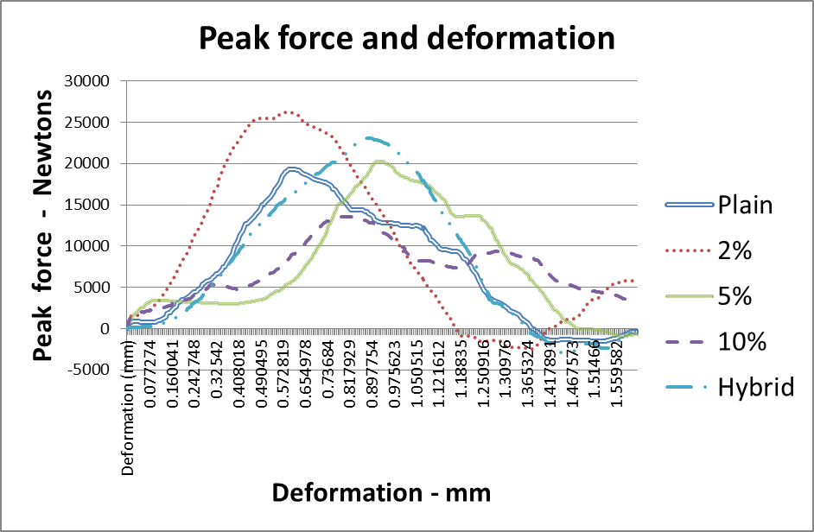
Figure 1 – Average impact data (Force/deformation)
Examining Figure 1, and data Table 2, it was determined that even though the 10% mix had the lowest energy in terms of peak force, the deformation carried on for a much prolonged period of time when compared to the others mixes. This meant that it exhibited the highest energy absorption results of all mixes. The overall toughness (energy absorption capacity, generally defined as the area under the load-deflection curve of a flexural specimen) of the 10% mix, when compared to the control mix, was calculated at 50.92% higher, even though it showed a 31.90% loss in peak force, when compared to the plain beams.
The data taken from tests, as documented in Tables 3-6, and the area under the force deformation curve on Figure 1, show that all of the rubber-modified concrete exhibited a greater toughness than the plain mix. The 2% mix exhibited a 30.94% increase in peak force and 24.29% increase in deformation. The 5% rubber mix gave a 1.17% higher value in peak force and a 7.29% greater deformation value. The hybrid steel and rubber mix peak force was an increase of 14.32% with the deformation also increasing by 20.19%.
4.1 Compressive test results
All of the sample concrete cubes were tested after 28 days of curing in a ELE Autotest 3000 compression machine to BS EN 12390-3:2002. When analysing the results it can be seen that the data obtained replicates that of several authors, such as; Rostami et al.,1993, and Eldin and Senouci, 1993. As expected the partial inclusion of the rubber particles to the concrete mixture caused a progressive loss in compressive strength for all the tested rubber modified specimens. When compared to the control plain concrete mix, all of the tested specimens, on average, compressed to a greater value under a lower applied pressure. As illustrated in Table 7, all of the three rubber-modified concrete mixes, and the hybrid mix, exhibited predictable rubberised characteristics.
The concrete mix that had a 2% rubber content, exhibited and increase in strain of 20.72% when loaded in compression and compared to the plain mix. The same concrete displayed a reduction in compressive strength of 4.79 N/mm². The 5% rubber concrete mix exhibited a 4.19% increase in strain and 9.75 N/mm² less stress (Ultimate compressive strength).
The 10% concrete specimens gave an average value of 13.17% increase in strain when compared to the plain control mix, however this was obtained with a reduction in compressive strength of 13.17 N/mm^{2,} compared to the plain mix.
The hybrid mix containing 2% rubber and recycled steel fibres gave the largest compression value. It was tested at an average of a 38.74% greater strain than the control mix. This mix also gave the highest stress value of the 4 modified mixes, the average being taken at 29.28 N/mm², 3 N/mm² less than the control mix but still an improvement on the previous values. Figure 2 shows the percentage comparison for the strain values.
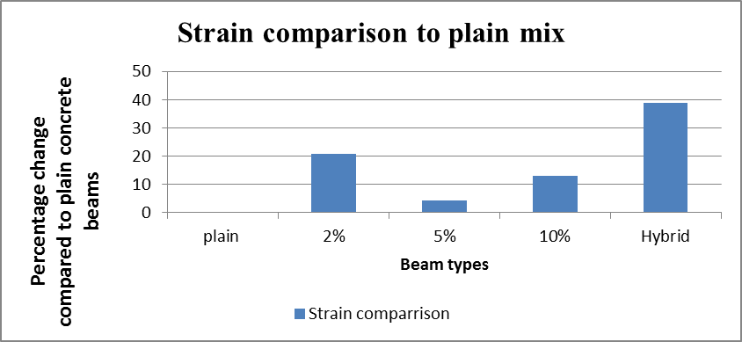
Figure 2 – Strain comparison

The plain concrete mix was abrupt from the moment of maximum force. In contrast to this, the rubber modified specimen’s failure duration was far more gradual due to the concrete becoming more flexible and rubberised with the increasing inclusion of the rubber particles. All of the tested rubber modified specimens were able to withstand loads beyond the initial failure. Failure of the plain concrete samples was characterised by the separation of pieces of the concrete face from the sample. In contrast to the plain control specimens; samples containing rubber particles were not characterised at failure by detachment of the concrete face due to the bridging of the cracks by the rubber slits. Despite having a lower strength when compared to the plain mix, pieces of concrete had to be forcibly removed by hand in order to observe the damage, and in some cases this proved to be too difficult as the rubber particles were bridging over the cracks in high numbers.
5.0 Conclusion
This paper presents the results of an investigation, carried out to determine whether the addition of slit rubber particles from recycled tyres would improve the impact qualities of Portland cement concrete. The findings are as follows:
- The concrete specimens containing rubber slit pieces display greater degrees of toughness when compared to plain concrete. The hybrid mix composed of slit rubber particles, and steel fibres, does have an enhanced effect of improving the impact capabilities of concrete.
- The addition of the slit rubber particles prevented the concrete from breaking into two pieces whilst subject to impact forces, as well as preventing pieces of concrete from separating off whilst under slow compressive loads. This was due to the cracks being bridged by the rubber within.
- The density of the rubber-modified samples was less than that of the plain concrete samples. This is due to the lower unit weight of the rubber particles and the air that they entrap with the rough surface texture.
- The addition of slit rubber particles provided a reduction of compressive strength when compared to plain concrete, which may limit the use of the material in many construction and structural applications.
- The positive properties as detailed herein, could be advantageous for a number of construction applications such as, driveways and motorway barriers. If the demand for rubber-modified concrete were to increase, it would decrease the need for disposal of used rubber tyres.
6.0 References
Atahan AO, Yucel AO, (2012), “Crumb rubber in concrete: Static and dynamic evaluation”, Construction and building materials, Vol 36, pp 617-622.
British Standards Institution, BS EN 197-1(2000), Cement – Part 1: Composition, Specifications and conformity criteria for common cements.
British Standards Institution BS EN 1008:2002, Mixing Water for concrete – specification for sampling, testing and assessing the suitability of water, including water recovered from processes in the concrete industry, as mixing water for concrete
Eldin NN, Senouci AB,(1993),”Rubber-tire particles as concrete aggregates”, ASCE Journal of materials in civil engineering, Vol 5(4), pp 478-496.
Ganjian E, Khorami M, Maghsoudi AA, (2009), “Scrap-tyre-rubber replacement for aggregate and Filler in concrete”, Construction and building materials, Vol 23, pp 1828-1836.
Khatib ZH, Bayomy FM,(1999),”Rubberized Portland Cement concrete”, ASCE Journal of materials in civil engineering, Vol 11(3), pp 206-213.
Li G, Stubblefield MA, Garrick G, Eggers J, Abadie C, Huang B,(2004), “Development of waste tire modified concrete”, Cement and concrete Research, Vol 34, pp 2283 – 2289.
Naik TR, Singh SS, (1991), “Utilization of discarded tires as construction materials for transport facilities”, UWM Centre for By-Products utilization, Report number CBU-1991-02, pp 16.
Naik TR, Singh SS, (1995), “Effects of scrap-tire rubber on properties of hot mix asphalt concrete – a laboratory investigation”, UMW Centre for by-products utilization, Report No. CBU-1995-02, pp 93.
Papakonstantinou CG, Tobolski MJ, (2006), “Use of waste steel beads in Portland cement concrete”, Cement and concrete research, Vol 36, pp 1686 – 1691.
Reschner K, (2003),”Scrap tyre recycling”, Waste management world, Available at: http://www.waste-management-world.com/articles/2003/07/scrap-tyre-recycling.html (Accessed 13/11/13)
Richardson AE, Coventry KA, Ward, (2011),”Freeze thaw protection of concrete with the optimum rubber crumb content”, Journal of cleaner production.
Richardson A E, Coventry K, (2015), “Dovetailed and hybrid synthetic fibre concrete – impact toughness and strength performance”, Construction and Building Materials, DOI 10.1016/j.conbuildmat.2015.01.003
Rostami H, Lepore J, Silverstraim T, Zundi I,(1993), “Use of recycled rubber tires in concrete”, Proceedings of the international conference on concrete 2000, University of Dundee, Scotland, UK, pp 391-399.
Serge N, Joekes I, (2000), “Use of tire rubber particles as addition to cement paste”, Cement and Concrete Research, Vol 30 (9), pp 1421-1425.
Siddique R, Naik TR, (2004),”Properties of concrete containing scrap-tire rubber – an overview”, Waste Management, Vol 24, pp 563-569.
Tantala MW, Lepore JA, Zandi I, (1996),”Quasi-elastic behavior of rubber included concrete. In: Ronald Mersky (ED)”, Proceedings of the 12th international conference on solid waste technology and management.
Yung WH, Yung LC, Hua LH,(2003),”A study of the durability properties of waste tire rubber applied to self-compacting concrete” Construction and building materials, Vol41, pp 665-672.

