Fine-Tooning for World Machines
Jo Briggs
Media and Communication Design
Northumbria University, UK
jo.briggs@northumbria.ac.uk

ABSTRACT
This paper discusses an assemblage of research and practice commissioned to map out the space of UK crowdfunding. Activities involved a mixture of quantitative and qualitative methods, including explorative workshops with participants recruited from small and medium size enterprises (SMEs). Most of these were small social enterprises operating in the North East region of England, including in Newcastle-upon-Tyne, known locally as the ‘Toon’ (slang for ‘town’). The paper describes a research approach that aims to go beyond participatory or co-design to facilitate knowledge coproduction through social, creative and economic collaboration. The paper outlines fundamental issues to be productively addressed in enabling wider participation in shaping the proposed world machines, in ways that go beyond merely reinforcing and extending social- and geographically determined privilege.

Author Keywords
Regional sustainability; collaboration; crowdfunding; cross-sectoral research.

Introduction: World machines in context
The North East region of England was once renowned for the scale and productivity of its heavy industries, boasting of the largest ship building yards and extensive coal mining. But towards the end of the last century the region was in rapid economic decline [5]. Among those now living in the region’s most socially deprived neighbourhoods, digital technology take-up has been found to have a significant if limited influence over life experiences and prosperity. With employment providing access to tools and training, those in more ‘middle-class’ jobs enjoy enhanced experiences from technology use, while for those from lower occupational groups, the benefits they experience in their social lives – through entertainment or the use of social media – do not necessarily extend to education, employment or civic participation [5].

Research
As a mechanism for online fundraising, crowdfunding platforms connect those seeking resources for a cause, product or service, with widely distributed individuals prepared to ‘pledge’ in return for a tangible or more altruistic reward. Participation in UK crowdfunding practice has been growing very rapidly [10], as individuals seek ‘non-bank’ alternatives to raising capital. London has been hailed as the emergent global centre for equity crowdfunding [8], enabled by the light regulation, millions of pounds of Government investment, and incentives for both investors (i.e. tax relief) and community fundraisers (match funding schemes [3]). Meanwhile a review of existing academic- and industry ‘grey’ crowdfunding literature revealed a complex but under researched area dominated by US-focused studies, and where the emphasis on economic measures of ‘success’ and ‘failure’ obscures the wider non-commercial social and relational processes and potential.

‘More than Money’
This short paper is framed by research into the ‘more than money’ aspects of online crowdfunding platforms among social change and cultural organisations in the North East. Research methods involved interviews and the deployment of an online crowdfunding survey, designed to capture perceptions of trust as mediated through the online crowdfunding process across the various crowdfunding models (e.g. typically, ‘donation’, ‘rewards’, ‘equity’ and ‘peer-lending’) from the perspectives of both funders and fundraisers. In addition, the research comprised extensive engagement and knowledge exchange activities involving stakeholders from the voluntary, civic, and business sectors. Indeed, in an emerging area such as UK crowdfunding, where some areas of practice are developing much more rapidly than any associated research, part of the enquiry was founded and reliant on knowledge exchange. It soon became apparent that regional ‘engagement’ had to refocus on aspects of non take-up and use, and to address low levels of awareness and to try to disambiguate the complexity of techno-cultural models and business terminology, for interested but confused potential users.
The researchers organised a week-long series of workshops and events under the auspices of ‘NE Crowdfunding Week’ that included a policy round table meeting to bring senior people from regional business support agencies, voluntary sector organisations and local authorities together with a panel of crowdfunding experienced ‘experts’. The aim here was to encourage discussion and raise awareness among those operating in large organisations at an influential and strategic level.
Crowdcube, one of the largest UK equity platforms, has to- date, raised more than £85m for 258 companies [6]. Yet when invited to speak at NE Crowdfunding Week its representatives couldn’t produce one NE-based campaign that had been successfully launched on the platform. Indeed, geographically, activity of both fundraisers and funders is heavily weighted towards London [e.g. 6], which in turn benefits from net inward investment from the rest of the UK.
Meanwhile, the NE has amongst the lowest (with Northern Ireland) levels of participation, across all the different models of crowdfunding [10] (see Table 1).

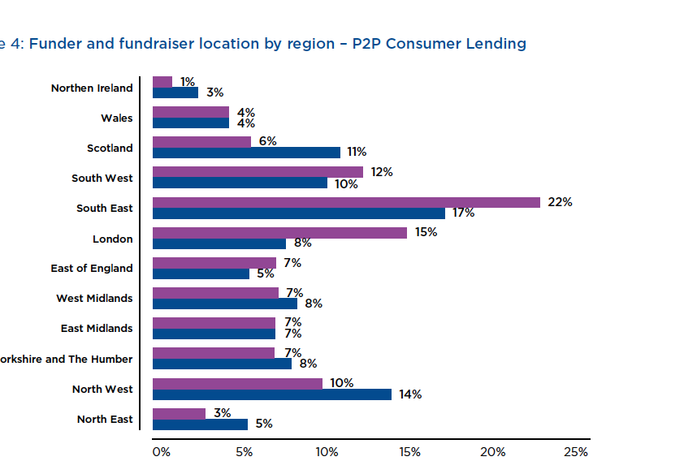 | 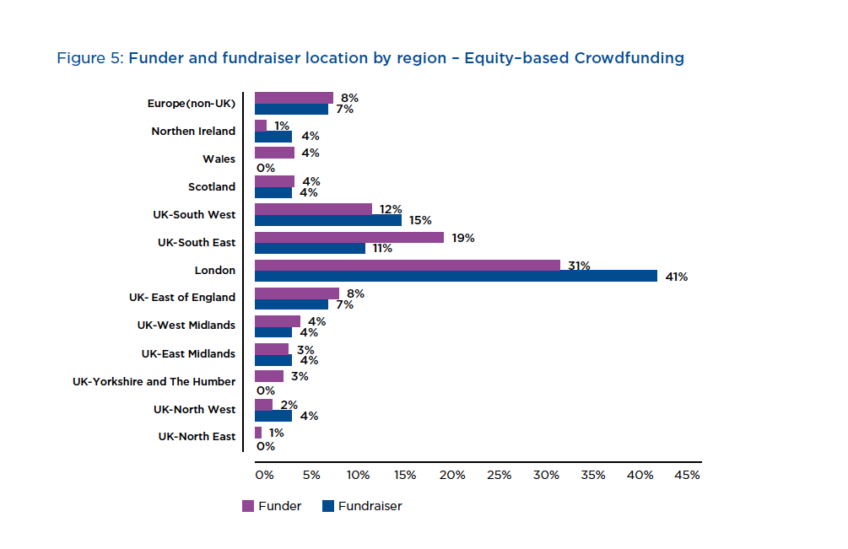 | 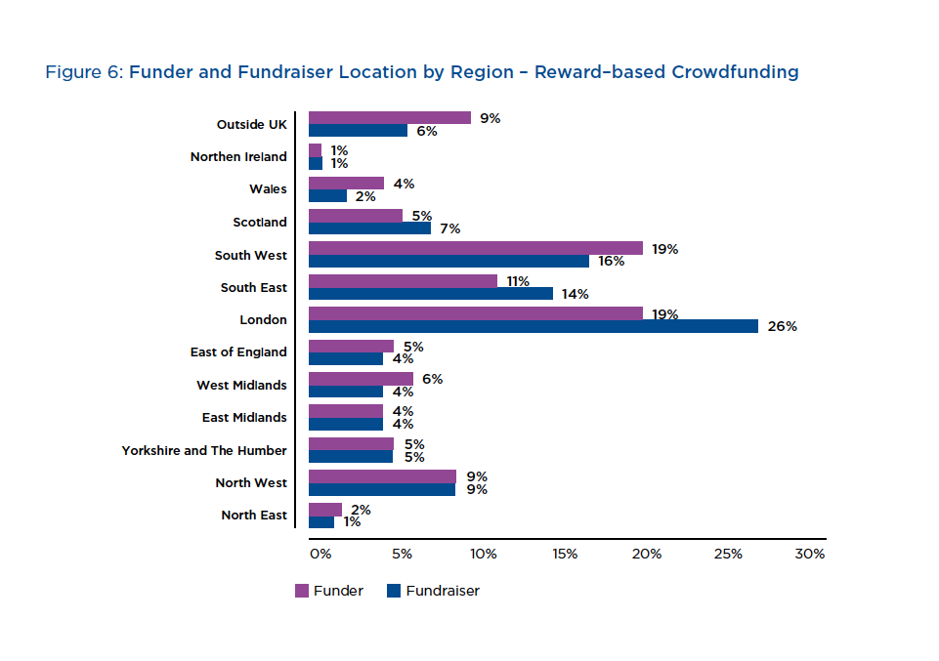
Table 1: % of funders/fundraisers by region across (from left) rewards-based, equity and peer-to-peer crowdfunding. The NE region is at the bottom of the chart (displaying 2/1, 1/0, 3/5) with London spiking towards the middle.

Fine Tooning Collaboration
Making use of a European Regional Development Fund (ERDF) university-SME scheme aiming to economically benefit the company and the wider region, the researchers spent 30 or so days across a number of social enterprises. This enabled more embedded ways of exploring various approaches to integrating new techno-economic practices (with the emphasis on using crowdfunding for developing an online presence, engagement and new publics etc.; as well as raising money) into existing SME operations. The scheme in fact opportunely serves dual important purposes in this small social enterprise context: of co-producing knowledge, including in the form of useful and replicable case studies, and by practically contributing to human resources. Ultimately of course, it is hoped that there are transformational outcomes.
Through the scheme, an ongoing series of workshops was held. The sessions began with an overview of crowdfunding basics before a design fiction technique was introduced. Large printed storyboards (Figure 1) describing fictional scenarios based on actual campaigns comprised exemplars of the ‘crowdfunding journey’. These invited participating groups not only to envision their own potential campaigns, but also to reflect upon their group or organisation’s existing operations, strategies and goals (Figure 1). Blank storyboard sheets were then used to capture ideas as they emerged; in one or two cases, these represented the beginning of a prospective campaign.
With the regional creative and cultural industries increasingly excluded from public cultural investment, a successful crowdfunding campaign has valuable advocacy currency among supporters and other investors/funders. Meanwhile London said be "eating up" limited public cultural funding [9]. Clearly, there are many practical motivations for SMEs and groups in the regions to engage in new ways of generating money and wider support.
However, the workshop storyboarding activity clearly proved challenging for many participating groups. Some struggled to articulate their aspirations and it was apparent that many had been motivated to come along to the well-attended workshops due to having recently lost out on civic or other public grants. Yet in the project-led culture of crowdfunding, raising money to finance ongoing operational costs is evidently very difficult.
This work is ongoing and we are still working with individual organisations with the aim of contributing to emerging regionally-focused research on the uses, barriers to use and potential future uses of techno-economic platforms among cultural communities of creative production and wider social change organisations.

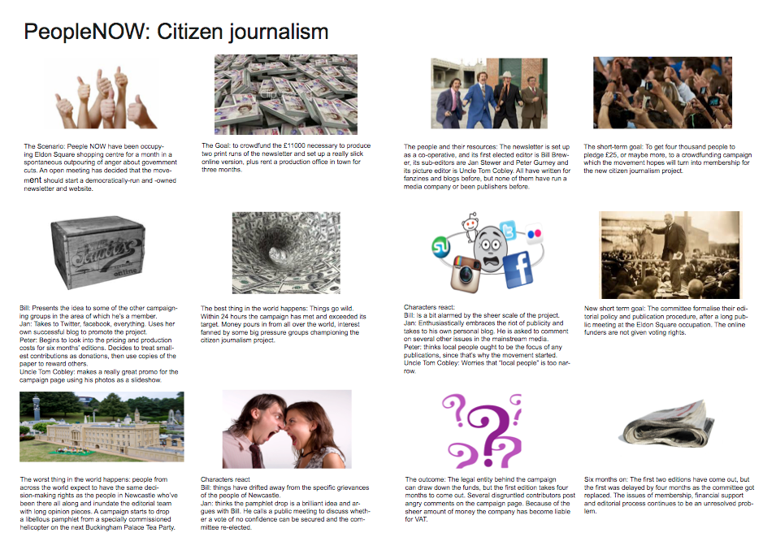
Figure 1: A workshop storyboard based on a Kickstarter project by Occupy Wall Street Media (OWSM) which ran into difficulties delivering promised newspaper rewards, and generating emotive commenting.

Crowdfunding for an Arts Commissioning Agency
A well-established arts organisation was keen to be, and to be seen to be, at the forefront of new ways of commissioning, producing and distributing art. So while the ERDF project to explore crowdfunding generated some tensions, primarily around determining that they now very publically participate in ‘the market’, the organisation’s staff were very excited about crowdfunding’s creative transformational potential.

Emerging Findings: Digital Skills and Telling Tales
Interviews with experienced crowdfunders and participants in the workshops who were keen to consider launching an online campaign, all pointed to the vital necessity of communications and ‘soft’ marketing and social media skills. Indeed, the primary reason that the OWSM project (Figure 1) generated such hostility, was the group’s breakdown in communication with their campaign backers, who then took to the commenting board to express their frustration. These skills, in addition to the ability to tell a compelling story relatively simply, and communicate the campaign’s main aim, while at the same time inviting individual funders to envision the vital role that they would play in helping to bring the project to fruition, are vital. Being able to clearly express that this will not happen without you in personal messaging is key.
However, of all the SMEs and more informal groups that engaged h in the range of research and enterprise activities, it was only the well-established arts organisation which seemed to have the necessary drive and human capacity to envision, plan and manage a successful and fruitful campaign. Crowdfunding is clearly very hard work.
Further, telling a simple story well, and then accessing the digital production skills to produce an online campaign were aspects of crowdfunding that would-be fundraisers encountered during all the events and activities most struggled with. Even among those organisations that had access to communications and marketing resources, even with whole teams, these areas revealed low levels of confidence, and perhaps even lower capacity for risk. It was those participants with experience in storytelling, and particularly digital storytelling who were evidently most ready to make use of crowdfunding’s various visual, social and wider marketing tools.
The co-director of a video games company described how she utilised the company’s available IP in the form of existing stories, the company’s design team and 30 years of business know-how to successfully deliver a risky but ultimately professionally successful campaign.
The "UK’s biggest social crowdfunding platform" was created in July 2014 [4]. More than a means of fundraising online, crowdfunding brings together human relations, ubiquitous networked and mobile technologies and online forms of representation and communications with the potential to raise capital and/to enact social change. Clearly, crowdfunding platforms offer new ways of promoting and inviting support for a whole range of products, services and causes; but the process demands a relatively high level across a wide range of competencies.
The generation of digital pioneers who developed powerful tools and resources as part of the open-source software movement further enabling independent creative producers. Gunther Kress has described these non-hierarchical collective activities as part of an ideological shift away from consumption, commodities and capitalism, towards design [7]; design here refers not only to tangible products, but to services that facilitate collective, if temporary, group identities.
However, to thrive in this online creative context one must maintain and manage social and identity ‘capital’ at the same time as continuously design and re-presenting new identities [see 2], in a process that Zygmunt Bauman describes as self commodification [1]. In an individualised society, Bauman says, one must continuously make and remake the self. Gina Neff meanwhile criticises ‘risky’ professional behavior associated with ‘dot.com’ era, where job loyalty was sacrificed to try to capitalise on short term ventures, albeit with the potential for a rapid return [9]. This she sees as part of a broader shift in society, where economic risk is no longer shouldered collectively but is transferred onto the individual. Clearly, these ideas have relevance to the project-based culture of crowdfunding, especially in relation to the ethics of potentially mobilising campaigns within cross-sectoral research.

Conclusion
To help make sense of the complexity within emerging phenomenon such as crowdfunding, working with ‘stakeholders’ from the very beginning of the research proposal and with non-academics as active contributors and even financial beneficiaries lays the foundations for more transformational outcomes. Collaboration as opposed to participation necessitates active and ongoing engagement but is also inherently risky. As the conceptual understanding of and practical potential of crowdfunding becomes more familiar, the people of the Toon and wider North East will have access to an ever widening range of tools for helping to sustain and further mobilise cultural exchanges and economies. Further, there are many opportunities for new forms of collaborative research and even co-funding, which can be used to help enable wider engagement and empowerment through the shaping of new world machines.

REFERENCES
- Bauman, Z. (2007) Consuming Life Cambridge: Polity.
- Benkler, Y. 2005. 'Coase's Penguin, or, Linux and the Nature of the Firm'. In: R. A. Ghosh (ed.) Code: Collaborative Ownership and the Digital Economy Cambridge MA: MIT, pp. 169–206.
- Buzzbnk 'Crowdmatch Challenge' http://crowdmatch.buzz bnk.org/ how-does-it work/4580214310
- Buzzbnk blog http://bit.ly/1pBZHci
- Clayton, J. and Macdonald, S. 'The Limits of Technology', Information, Communication & Society. Volume 16 (6), 945-966, 2013.
- Infographic Crowdcube https://www.crowdcube.com/infographic
- Kress, G. 2008. New Literacies, New Democracies. At: http://bit.ly/1FSxZM0 [Accessed 01.07.15].
- Moules, R 'London emerging as world leader in crowd-funding' FT 15 August 2014 http://on.ft.com/1uJ5ujJ
- Neff, G., Venture Labor: Work and the Burden of Risk in Innovative Industries. MIT, 2014.
- Powell, Gordon and Stark (2013) Rebalancing Our Cultural Capital: A contribution to the debate on national policy for the arts and culture in England.
- Zhang, Z., Collins, L., Baeck, P. Understanding Alternative Finance: The UK Alternative Finance Industry Report 2014: Nesta and Cambridge University

A pilot scheme from the UK’s Arts and Humanities Research Council enables collaborating partners to be registered and remunerated as ‘community investigators’.

