Solutionism, the Game: Design Fictions for Positive Aging
Mark Blythe, Jamie Steane  Northumbria University  Newcastle, UK  mark.blythe / jamie.steane  @northumbria.ac.uk | Jenny Roe  Stockholm Environment Institute  University of York,  York, UK  jenny.roe@york.ac.uk | Caroline Oliver  COMPAS  University of Oxford  Oxford, UK  caroline.oliver@compas.ox.ac.uk

ABSTRACT
http://dx.doi.org/10.1145/2702123.2702491

This paper reports a qualitative study of thriving older people and illustrates the findings with design fiction. Design research has been criticized as “solutionist” i.e. solving problems that don’t exist or providing “quick fixes” for complex social, political and environmental problems. We respond to this critique by presenting a “solutionist” board game used to generate design concepts. Players are given data cards and technology dice, they move around the board by pitching concepts that would support positive aging. We argue that framing concept design as a solutionist game explicitly foregrounds play, irony and the limitations of technological intervention. Three of the game concepts are presented as design fictions in the form of advertisements for products and services that do not exist. The paper argues that design fiction can help create a space for design beyond solutionism.

Author Keywords
Design fiction, well being, older people.

ACM Classification Keywords
H.5.m. Information interfaces and presentation

DESIGN FICTION
The speed of technology development is now such that directors like Terry Gilliam feel that their science fiction films are already dated by the time they come out [20]. It feels as if we are “living in the future” (ibid) and it is perhaps for this reason that there is so much interest around Design Fiction [e.g 29, 43, 7, 26, 24, 13, 2]. But there are many questions as to the value of design fiction and speculative design. Although Dunne and Raby insist that their critical and speculative designs are not art, Bardzell and Bardzell [2] point out that if there is a difference it is not evident in the designs themselves but rather in the surrounding discourse. However there are also similarities in the discourse around art and speculative design. An analysis of fifteen years worth of art gallery press releases by Rule and Levine identified a distinctive argot they characterize as International Art English where “an artist’s work inevitably interrogates, questions, encodes, transforms, subverts, imbricates, displaces” [35]. Similarly speculative design according to Dunne and Raby’s latest book seeks to question, challenge, provoke, expose, explore, trouble, disturb and disrupt [13]. The evaluations in Dunne and Raby’s speculative design are presented in terms of refined taste, the examples cited are either “close” or distant to their “interests”. Timothy Archibald’s Sex Machines for instance, are praised but the authors note “it is a shame the machines are so phallic and so mechanical” [13, p. 162] the criteria for approval or legitimacy then is that expert practitioners such as themselves do or do not like it. Much as early literary critics constructed canons of the best that has been thought and said Dunne and Raby in this book are the arbiters of what is provocative and what is cliché.
Bardzell et al propose a range of interpretive strategies for close readings of critical and speculative designs [3]. But there is little agreement about how to evaluate design fiction and definitions of what design fiction is are still forming. The first use of the term appears in science fiction writer Bruce Sterling’s 2005 book Shaping Things where he remarks that he has been “making design fiction for years”, going on to define it in terms of plausibility: “the core distinction is that design fiction makes more sense on the page than science fiction” [38.p30]. Julian Bleecker developed the notion of a diegetic prototype where a design is understood in the context of a story [1]. Wakkary and colleagues propose design fiction as a “material reflection” where scenarios, sketches and illustration are “materials of thought for design” [47]. Sterling most recently defined it “as the deliberate use of diegetic prototypes to suspend disbelief about change.” [40]. This places an emphasis on artifacts that belong to imagined worlds, examples include the steampunk artifacts discussed by Tanenbaum et al [43].
Design fiction is a still evolving form but the various definitions agree that it allows for a greater emphasis on social and political contexts than traditional concept design or scenario development. This paper employs design fiction to mitigate against the tendency towards what Morozov has called “solutionism” in HCI. Solutionism has been characterized as solving problems that don’t exist or proposing technological quick fixes for complex social, political and environmental problems [31]. Design fictions have been used previously as a means of responding to solutionism through “imaginary abstracts” which frame concept designs in fictional academic studies to consider whether actually building prototypes would answer any research questions or not [7]. This paper reports findings from a study of thriving older people and approaches the findings through a “solutionist game”. The game was devised to generate design concepts in response to data while stressing that there is no technological “silver bullet” for any of the issues addressed. The final section presents research based design fictions in the form of advertisements for products and services that do not exist.

FLOURISHING EIGHTY AND NINETY YEAR OLDs
For the first time in human history the old are beginning to outnumber the young and in the UK there are now more people over sixty than under eighteen [1]. A sixty five year old today can look forward to around twenty more years of life (ibid). The oldest “baby boomers” (those born between 1946 and 1964) have already begun to retire and the youngest are in their fifties so this generation can anticipate a longer retirement than any other. This is often treated as a crisis but the starting point for this project was not needs or problem centered. Over the past twenty years there has been a remarkable shift of focus in the field of Psychology. Many academics and practitioners have begun to study not mental illness but mental health. This kind of focus on positive affect and emotion is relatively new.
Perhaps the most familiar concept in Human Computer Interaction (HCI) from this emerging field is Csikszentmihalyi’s “flow”. This state of intense absorption and the conditions in which it occur have been cited in many studies. But Csikszentmihalyi also studied creativity and motivation and this work has informed more general theories of wellbeing and happiness. In 2002 Martin Seligman became the President of the American Psychological Association and pointed out that psychologists had been studying psychosis, neuroses, depression and other forms of anguish for over a hundred years with little success in developing treatments. He argued that the field should focus attention on people who were thriving and happy and see what could be learned from them. Seligman called this approach “positive psychology”. This is perhaps an unfortunate term as it connotes “positive thinking” and snake oil salesman. There are a great many scams which suggest that thinking positive thoughts will result in good things happening: if we believe we are going to be successful then we will be, if we imagine ourselves owning some fabulous object then somehow the universe will deliver it to our door. This kind of “positive thinking” is nothing whatever to do with positive psychology, nevertheless there is much skepticism around the new approach. Psychologists like Czikszentmihalyi, Gottman and Seligman have all written popular self help books that can arouse the suspicion of academics. Findings on the benefits of optimism have been caricatured as “cheer up and you’ll be happier” and Seligman has been attacked in journalistic polemics that argue positive thinking is ruining America [15]. So it must be stressed that positive psychology is not positive thinking, A range of empirical studies have been undertaken over the last decade which have deepened our understanding of well being [36,37]. Researchers in HCI are increasingly applying these theories of well being in their work [e.g. 44, 30].
Seligman’s P.E.R.M.A. theory provides an overarching framework which summarizes current understandings of well being as constituting more than just happiness [37]. The PERMA acronym breaks down like this: P, is for positive affect such as optimism; E, is for engagement in Csikszentmihalyi’s sense of flow; R is for relationships, Seligman often challenges audiences to think of the last time they were happy, suggesting that they probably were not alone; M is for meaning, this is something larger than oneself, it might be a faith tradition, a political cause or the march of science; and finally A is for achievement and mastery [37]. Seligman advocates PERMA as a model for flourishing and thriving. Our study follows the broad approach of positive psychology in studying older people who are not lonely or depressed but rather flourishing.
This study then is in the vanguard of work which overturns the notion of old age as pathology. Definitions of successful ageing have been articulated to include: physical health and independent functioning, life expectancy, mental and psychological health and cognitive function, as well as a variety of psycho-social factors to capture life satisfaction and wellbeing, including psychological characteristics, resources and social networks [2, 6]. The study extends work on the psychosocial aspects of successful ageing, adding to lay perspectives [33] by learning from self-identifying ‘flourishing’ older people.

the STUDY
We recruited fourteen people over eighty who self identified as being happy e.g. “Yes, I’m a happy soul.” (Roger) . We used a combination of targeted sampling and snowballing techniques [32] in order to recruit thriving individuals. Following the insight that strong relationships are important to wellbeing [37] we specifically targeted institutions where strong communities might be expected - a home for retired actors, a nunnery and a Jewish care home. Within specific care home contexts, we began by interviewing managers and asking them to identify thriving residents. The manager and staff of the Jewish care home immediately identified Theo. “Oh, Theo is brilliant. [...] he strides out down the corridor, a big grin on his face saying hello to absolutely anybody and everybody, passing the time of day. (Manager). In this way we recruited from a range of residencies including: independent home owners, residents of care homes, a nunnery and visitors to a day care centre. There was a mix of backgrounds in terms of both ethnicity, gender, religious and socio-economic group. This then was a deliberately unrepresentative, targeted sample [34] of diverse but thriving individuals.

Location | Participants and Ages
Private Residences | Vera (91 and Eric 89); Doris (89) Bill (80) Stephen (96) Elizabeth (84) Lillian (96)
Home for Retired Actors | Annabel and Phyllida (Manager and Trustee) Mildred (93) Howard (79) Roger (87)
Enclosed Nunnery | Extern Nun and Mother Abbess (interviewed) 6 resident nuns aged (59-104)
Jewish Care Home | Manager, 2 staff (interviewed) and Theo (93)
Day Care Centre | Alvita (86), Jacinta (93), Rosi (89)
Table 1: Location of Interviews, Participants and ages
We conducted in-depth interviews lasting between one and two and a half hours. The interview was semi structured and questions attempted to elicit “a day in a life” and also “a life in a day” focusing on the participants biography. Questions began with daily, weekly and yearly routines and then worked backwards through the decades to the participants’ earliest memories.
The data analysis was conducted within the broad tradition of grounded theory. The two most common forms of qualitative data analysis in social science are content analysis and grounded theory [34]. In a content analysis data are sorted into categories drawn from existing theory, for example it would have been possible to sort the data into the PERMA categories. Grounded Theory approaches rather generate categories by summarizing data, grouping those summary categories and attempting to identify connections, There is much confusion in HCI about grounded theory [16] and naïve reviewers sometimes declare that an approach is or is not an application of it although there is no single agreed method. Following the publication of The Discovery of Grounded Theory [21] there was an academic spat between its authors - Glaser and Strauss - that resulted in two camps [45]. Strauss with Corbin proposed a prescriptive set of coding procedures involving open, axial and selective coding [40]. They also allowed for the use of existing theory and literature as “sensitizing concepts”. Glaser was less prescriptive about coding but insisted that no other theory should be consulted [45]. But social scientists recognize a range of approaches under the broad umbrella term of grounded theory [9]. Another aspect of the approach which may cause misunderstanding in HCI is the word “theory”. The “theory” generated by this approach is seldom if ever a predictive model, it is rather a rich description of phenomena [9]. The data here were analyzed using a grounded theory approach with Seligman’s work included as sensitizing concepts – things to look out for.
FINDINGS: POSITIVE AGING
All interviews were transcribed and coded into the following “axial codes” or broad themes – attitudes, ties, challenges, agency, little worlds. All italicized quotes are from audio transcriptions of interviews. All names have been changed in order to preserve anonymity.

Attitudes: Tradition, Values, Standards, and Work
Each of the participants conveyed a strong “attitude” in the sense of a broad orientation to life. This was most obvious with the nuns whose orientation to the world was a matter of religious faith. The Actors were also very serious about their vocation, taking acting so seriously it was not possible to provide amateur dramatics “if you did that here, they would be crucified!” (Phyllida). Amongst the participants who lived alone there was also strong attitudes based on tradition and continuity. Doris, a widowed working class woman living in her own terraced home, ran the Darby and Joan club as her Mother had done till she died at the age of 86. Doris’s sister, Vera also felt her Mother’s values and lasting influence, saying she would “do for anybody”. For many of the participants, voluntary work was very important. Vera did voluntary work for a York Cancer charity until ill health prevented such a regular time commitment. Elizabeth volunteered her time and skill in knitting and sewing for friends and neighbours. Doris annually baked over fifty Christmas cakes for various friends and charities. Bill, a retired builder, had renovated, with a retired joiner, the working man’s club they belonged to. There were then strong attitudes and values throughout the cohort.
When Howard first arrived at the actor’s home he had been “self neglecting” - neither washing nor looking after his own basic needs. The manager of the Actors Home pointed out that it was the other residents who helped him recover from this decline by saying. ‘You know, you can’t come downstairs in your jamas and your boxer shorts, we have a code of dress in this house”(Annabel). Howard had transferred from another care home which he described as “a prison”, the improvement in health and appearance was immediate and marked on joining the Actor’s home. Eric had early onset dementia but his wife Vera was also determined that standards of dress would not slip telling him he couldn’t go out “in those trousers and that jumper”. Standards were shared and important across the groups.
Many of the participants were fastidious about housework and undertook it with a sense of the values instilled in childhood. Alvita washed her curtains with the same regularity her grandmother had. Many of the participants upheld what might be described as a rigorous work ethic. The nuns’ schedule involved punishingly early starts and days where every hour was accounted for. Though Bill was in his eighties he did odd jobs for his friends and neighbors such as cutting their lawns. These acts reflected a philosophy of life, evident in this reflection on what happened to a friend of his who used to help him with jobs at the weekend: “he was a very fit bloke, but once he moved that was it, he just deteriorated and within a very short time he was in a nursing home. […] he just deteriorated because he didn’t do anything (Bill). There is an almost causal relationship in Bill’s narrative between stopping work and decline. But this work ethic was not considered as punishing, Bill enjoyed work: “I do, I love it,” Many of the retired actors continued to do paid work, taking parts in film, TV and radio. Bill and many of the other participants might agree then with Noel Coward that “work is more fun than fun”.
Although the participants upheld quite strict values and traditions they were not necessarily solemn. Here Mildred describes breakfast in the Actor’s home: “it’s absolutely disgraceful, somebody of my age giggling, but I’m afraid we do see the funny… And the gentleman who is the other side of the table, he is very bad tempered at times and it absolutely kills us! [Laughter]. Their attitude to life and work was serious but they did not take themselves seriously.

Challenges: Conflict, Change Trauma and Achievement
Although we have described the participants as thriving this is not to say that they were in good health or that they suffered no disability. Howard had undergone surgery on his spinal column. Roger had Parkinson’s disease and suffered from tremors, he was sighted in only one eye and struggled to read. Stephen was registered blind, Lillian suffered severe arthritis in her hands and could also only see from only one eye. Theo describes his various ongoing health issues in typically comic fashion here: “You see, I’m like an old car and the tyres go and then the engine pops and then the steering doesn’t exactly work and then eventually the headlights go, and that’s it. [Laughter].”
Stephen’s wife had suffered from dementia before she died. He described the care she received as “horrific”. Elizabeth reported ongoing conflict with her carers: “I don’t let them put me to bed, I don’t want to be going to bed when they can come, which can be any time”. Some participants had experienced loneliness. Howard noted that “it’s not easy to get to know somebody of 94”. Lillian, who had recently moved into warden controlled sheltered housing observed that it becomes harder to make friends as you get older because people get set in their routines. And yet the participants were remarkably resilient in the face of difficulty and change.
The most dramatic change in the lives of the nuns came the year before when they left the abbey where their order had been based for over a hundred and fifty years. The six surviving nuns left a large Victorian abbey in seven acres of grounds to move into a six bedroom detached house. Most of the nuns in the order are over eighty and it is sometimes argued that moving the very elderly can be extremely traumatic if not fatal though there is little evidence for this. The extern nun observed that the oldest sister who is 104 coped with the move “brilliantly”. She had lived in the abbey for eighty years and the last day was traumatic “as she was leaving she said “oh the last time I’ll see this statue” or whatever” But she settled into the new house quickly, Sister Peter noted that she still had the same people around her, the “bits and pieces she had before” and she was enjoying a new view of the front garden and the people coming and going. Although the built environment is clearly very important to any older person, life for the nuns continued in the modern detached house much as it had done before in the grand and imposing abbey.
Perhaps the most traumatic change endured by these participants was bereavement. Stephen had recently lost his wife: “After 59 years, waking up in a lonely bed is perhaps the worst” (Stephen). Since his wife died Stephen had not undertaken the long journey to visit their children, Doris had also lost her husband though he died when she was just forty-five and she never remarried. “No… Never been kissed or cuddled since [laughter].” Many of the participants had endured some form of trauma in the form of serious illness and abrupt change of circumstances. But all participants were resilient in the face of change. The trustee of the Actors studio thought actors were particularly “good at change”. During a rebuild the residents were moved about the building as work was done and they complained that they didn’t know where things were. One of the residents remarked to another: ‘Oh darling come on, it’s like being on tour. You go to another town and you’ve got to get the hairdresser’s and you’ve got to find the theatre, the manager’s office, it’s pretty much like that.’ And the person said, ‘Well, I wouldn’t know, I only every played the West End! [laughter]’ (Phyllida). In the face of change then there was a strong sense of community and identity but also resilience and agency.

Agency: Stubbornness, Abstinence, Exercise, Routine
When Mildred was a child recovering from Tuberculosis she began a lifelong habit of walking every single day which she kept up as a resident of the Actors home. When Stephen found himself isolated after the death of his much loved wife he started going to cafes so that he wouldn’t be alone. After a fall Theo was told that he would not walk again, he grinned as he declared “But I do!” taking evident delight in proving the doctors wrong through his determined engagement in physiotherapy. There was then a strong sense of personal agency in all of the participants.
Many of the participants could be described as “stubborn” in one way or another and exhibited this quality in both the questions they answered and the questions they avoided. At the end of the “day in the life” biography the participants were asked to rate themselves on a scale of one to ten on terms drawn from the positive psychology literature. Several of the participants avoided these questions or answered without giving numbers. Theo best expressed his determination to engage with the research on his own terms when he told us we were too young too really understand, “you don’t think about 1 to 10s and things, you just live! You just carry on living!” Some participants also self identified as stubborn but it should be emphasized that this was considered to be a positive trait.
The Manager of the Actors Home was well aware of how stubborn the residents were. When a Health visitor advised that a resident needed a walking frame Annabel said: ‘Look for an alternative, it is not going to happen.’ The Health visitor subsequently explored alternatives. Doris was persisting with Donna Tartt’s eight hundred page novel The Goldfinch even though it was: “blooming awful; me niece brought me it. I’ve been trying since Christmas and it’s supposed to be a bestseller. [...] I want to finish it and it’s all about this blooming painting” According to polls The Goldfinch was one of the most unfinished books of that year making Doris’s determination all the more remarkable. Lillian also carried on reading when the reading got tough. She was partially sighted in one eye only and could no longer read the text in paper books. However she bought a kindle and found she could enlarge the text and turn pages with arthritic hands more easily.
Strong self determination was evident in the life stories of many of the participants. Bill had emigrated from Ireland to London as a young man and gone to Kings Cross wishing to leave the capital but not knowing where he should go. “I saw up in print, ‘York’, and I’d never even heard of it, but I went over to the ticket place and said, [… ], ‘I’ll have a single ticket to York.” Strong will was also evident in health regimes. Eric. Bill and Roger had all been smokers as younger men but quit around forty years ago, all of them said it was “easy”. As well as being self disciplined around cigarettes and alcohol most of the participants exercised regularly. Bill began his day by doing leg kicks, jogging on the spot and touching his toes twenty times, he happily demonstrated this regime for the first author who, though about half his age, was entirely unable to match it.
Many of the participants observed very regular routines. Even where participants denied having a routine it was clear that there was much order and repetition of activity: “I don’t have a routine as such, I just have different things to do nearly every day” [Bill]. Such routines have been seen as creating structure and purpose during the week to avoid ‘stagnation’ in free floating time [32].

Ties: relationships, family, community and class
Each of the participants described strong ties to family, friends and larger communities. Bill’s son lived in the house next door to him. Jacinta’s son was cleaning her house while she was being interviewed in the day care centre. Jacinta noted: “it’s their duty to take care of me now”. [Jacinta}. But this was exceptional, none of the other participants spoke of duty and stressed that they did not want to be “a burden” on their relatives. The network of family and friends was clearly important to all of them but the relationships were framed as being of reciprocal benefit.
The nuns formed their own enclosed community but they were visited regularly by family so they had “good friends, good family, and God” (Sister Peter). The nuns were perhaps the strongest community, sharing the same beliefs and backgrounds. In the Jewish community there was also shared “common ground”; many of the residents were not religious but nevertheless shared important cultural referents. Similarly the actors shared a professional ethos and had often worked together in the past. The relationships then were resonant and meaningful.
Vera and Eric had been married for over fifty years. Gottman notes that all marriages entail conflict but successful ones are defined by effective strategies of “repair”, e.g. an apology or even something silly like pulling a face [22]. After an argument Eric would “put his arm around me and say - come on let’s forget about it.” [Vera] This repair strategy no longer worked as Eric would forget that they were having an argument. Vera said she got irritable because of this and also regretted the decline in their sex life over the last two years. However she knew he didn’t “mean it” and the relationship remained strong.
Vera’s sister Doris had lived on the same street of terraced houses for fifty years but the character of the neighborhood had changed dramatically with most houses now primarily temporary student accommodation. The turnover of residents was high and most people did not know their neighbors. Doris however would make a point of saying hello and getting to know new people. This meant that should she need a letter posting or a loaf of bread picking up she could ask passing neighbors. Many of the participants made a point of going out and talking to people, if only by sitting outside their houses.
In some respects each of the participants lived in their own “little world”. In a recent biography the actor Simon Callow reflects on Charles Dickens’ characterization of the theatre as a “little world” noting “his stress is on the noun, not the adjective: he sees the theatre as an entire world, consistent with itself.” [8p.82]. We use the phrase in that sense in the following final section and stress the vital importance of the networks that make up such little worlds.

Little Worlds: Religion, Sport, Work
The research team was struck by the ways in which the Actor’s home and the Jewish Retirement home did and did not look like other care homes they had visited. There were certain institutional features common to both: handrails on stairs, stair lifts, long corridors with doors at either side. But in the Actor’s home the walls were decorated with old playbills, black and white publicity shots of movie stars who were past or present residents; the library contained three shelved walls of books all about acting and actors - with many of the biographies about the people living there. In the dementia wing there were “memory boxes” full of mementos of previous plays, films and TV shows that the residents had been in. There were Jewish symbols and names on all of the doors to rooms. There was a synagogue and a “tree of life” sculpture in the garden. The managers of the Jewish care home described it as a “community within a community” with support from Jewish schools and synagogues. Similarly the house that had become a nunnery was both like and unlike an ordinary domestic residence. There were religious icons all over the house, the front room was furnished with chairs facing an alter, the kitchen featured a huge cross at one end of the room, the table was laid with the simple provisions that the nuns ate daily. These sites were in Dickens’ sense “little worlds” complete and consistent with themselves.
Sport could also function as a self contained little world. Stephen was an expert on cricketing history and had been a member of the Yorkshire County Cricket club for over sixty watching games from a box with eight to ten friends. Similarly Bill was a boxing enthusiast with a dedicated boxing TV channel and an encyclopedic knowledge of the sport. He also watched fights in the working man’s club he went to and, like Stephen, discussed the “greats” of past and present sporting figures. Doris was similarly passionate about sport “I love sport on the telly, any sport, any. Rugby…I always sit up on a Saturday night and watch Match Of The Day, always.” These sporting enthusiasms were inherently social, even when watched alone, and part of the pleasure was, of course, discussing the matches with other fans. Although the researchers knew little to nothing of any of these sports the participants enthusiasm was infectious.
For some participants religious ritual was a deeply important aspect of their world: “[prayer] and Mass are the things that we hang our whole life on,” (Sister Peter). Some participants observed religious practice although they did not necessarily believe in God: “I used to go to the synagogue with my two grandsons a lot, every Saturday morning, and it was like a social there and it was very good, but I don’t go now”. (Theo). Others found meaning in church attendance though they were not necessarily orthodox, as with Bill: “to me, all churches are the house of God, and they are all talking about the same person, so I don’t mind.” (Bill). Doris volunteered to clean the church every weekend; even though she did not consider herself “right religious” faith endured: “I think whatever you do in this world is God, anything that you do that’s nice.” In this sense there was a meaning to her activities, to use Seligman’s terms, larger than herself.
Many of Seligman’s PERMA characteristics were evident in the lives of the participants but they were embedded in a range of complex “little worlds”. The grounded theory resulted in what might be described as a Little Worlds theory of Positive Aging. This does not contradict Seligman, it confirms previous studies but emphasizes the complex contexts in which well being occurs. As Bruno Latour notes: “An individual is not an atom but extends as far as all the entities that it perceives and with which it is in relation.” [28]. Well being is not a property of an isolated individual, it is a phenomenon that occurs in a network or, a little world.

SOLUTIONISM: THE BOARD GAME
In recent years there has been a move away from broad and general “implications for design” [11] towards the development of research prototypes [16], concept designs e.g. [42] and design fictions [1, 39]. However Morozov [31] recently castigated HCI for “solutionism” i.e. devising solutions for problems that don’t exist or proposing technological “silver bullets’ for complex social, political and environmental problems (ibid). The “BinCam” is Morozov’s favorite example of solutionism. This research prototype featured a phone in the lid of a bin that sent photographs of the contents to Facebook so the user’s friends could see if recycling was happening or not. The idea was pilloried in the press as Orwellian and generated a furious media and academic backlash not least form Morozov. The goal of a research prototype is not to produce new products but rather new knowledge. The controversy then makes BinCam more rather than less interesting as a research prototype. Morozov argues that “the geeks” think “the internet” will save the world, an understandable though ungenerous caricature [31]. It is unlikely that the makers of Bincam ever thought it would save the world, more likely they thought it would be interesting, and it was. The term “impressionism” was initially a pejorative used to dismiss the paintings it described. But it was adopted as a general description of the school perhaps because it indicated the strengths as well as the limitations of the style. Similarly “solutionism” is a derogatory term but perhaps it should also be embraced to indicate very clearly an acknowledgement of the limitations of HCI work.
While acknowledging that ageing populations present complex social, political and environmental problems we nevertheless see value in relating findings from studies like this to questions of design. The following sections propose concepts and design fictions derived from a “solutionist” game. We adopt the label “solutionist” to indicate that we are very well aware that they will not solve the complex issues around ageing populations and to acknowledge that the design fictions may, like many real consumer products, address problems that do not really exist.
Card games are very frequently used to generate design ideas. Brian Eno’s “Oblique Strategies” cards for example ask provocative questions like “what would your best friend do?” to inspire new thinking. Inspiration cards have also been used in HCI research [e.g. 23, 27]. Cards developed by Vines et al featured data quotes and “questionable concepts” – provocative concept designs to elicit feedback during participatory design sessions with older people. A card game called “solutionism” was developed for student brainstorms by the first author. The cards consisted of four “suits” representing: an issue, a user, a motive and a technology, which players combined in order to “solve the world’s problems and make everybody happy” [42]. For this project the first author developed a solutionist board game to encourage players to move from data to design.
The game consisted of a board that players moved tokens around featuring various age associated predicaments and occasional positive qualities, e.g: arthritis, boredom, deafness, isolation, heart condition, regret, wisdom and so on. Players then took data quotation cards from five different stacks based on the categories described in the last sections: attitude, challenges, agency, ties and little worlds.
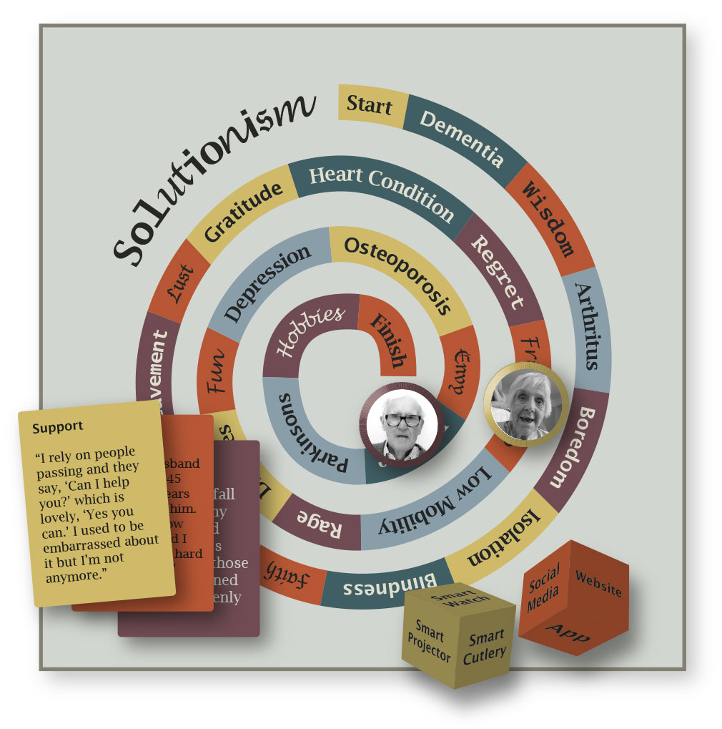
Figure 2. Solutionism, The Board Game
To move around the board players threw a technology dice. One contained general technologies like apps or robots, the other suggested technologies around the “internet of things” e.g. smart chair, smart crockery and so on. To reach the finish, players had to generate ideas and draw them on postcards, they then pitched the ideas to the other players and moved one space for each idea they came up. Players were awarded bonus points if other players liked the idea. In presenting each idea the players first read out the quote and specified the technology and the challenge. In this way the team became more familiar with the data than they would have if it were presented in more traditional formats like a slideshow.
The game was intended to stress that the team were creating fictions rather than proposals and the focus was on questions rather than solutions. The board game emphasized play and irony, underlining the fact that there is no quick “technological fix” for the complex social, political and environmental phenomena surrounding aging populations
The games were played by the project team which included a sociologist, a psychologist, designers and an entrepreneur. As with most brainstorming activities, quantity was stressed over quality and the rule of thumb that it takes 93 bad ideas to produce 3 good ones [40] was observed to apply here. The game was played twice and on both occasions a large number of ideas were generated. Although two of the team members were unfamiliar with this kind of brainstorming activity some of the most interesting ideas came from them and the competitive element seemed to spur players on. Some of the ideas were frivolous but some were considered worth developing further. The game was fun and we suggest it could be adapted for play with any qualitative data set. The following section illustrates the range of solutionist concepts that emerged.

Solutionist Concept Designs
The following ideas were rejected but perhaps retain some value in illustrating the findings. For example: a “homing walking stick” was suggested in response to Mildred’s insistence on walking every day and the care staff’s fears that she might leave the grounds and get lost. In response to a quote about the importance of ties a “biographical mirror” was proposed to augment the user’s reflection with images of people who are important to them. In response to a quote from Phyllida on the importance of small daily “light touch” interactions in the actor’s home “Anonyment” was suggested as a system which allowed the delivery of anonymous compliments e.g. nice scarf! “Skill share” was a response to the many quotes about voluntary work, here Chinese students of English would Skype over iPads with care home residents to practice English. One response to Stephen’s enthusiasm for talking to strangers in cafes was a “conversation cup” for cafes where users could indicate their interests and look for matches. A quote from Doris saying that people in care homes would “get up and about” if someone just “gave them a duster” prompted the notion of a “time limited chair” that would register the length of time a person had spent sitting and gradually tip them up onto their feet. Instances of isolation and neglect prompted a “rate your relations” system that would allow older people to rate carers, family and friends. An “instant timebank” would allow people to volunteer for ten or fifteen minutes at a time.
Three of the concepts were chosen for further development as design fictions in the form of advertisements for services and products that don’t quite exist yet.

DESIGN FICTIONS
Two recent Interactive Media Design graduates were briefed to create advertisements for “The Pavillion” a “Social Watch” and “Vintage Volunteers”.
More and more care homes are being set up around communities of interest. There are for instance, homes for retired academics, vicars, army personnel and homes for gay and lesbian people [24]. The Pavillion was imagined as a themed care home for cricket fans. Amongst the “little worlds” described was Stephens group of eight to ten people in their seventies and eighties who would book a box at a local cricketing venue where they would watch four day long cricket matches. Stephen stressed that it was important to him “because they are kindred spirits in so much as they’re all retired businessmen of one kind or the other and we get on very, very well together and we have a lot of laughs.” (Stephen). It was not simply the pleasure of watching the sport that was important but the company of similarly minded friends who could discuss the play and the history of the game. Similarly Bill was a boxing enthusiast who lit up when talking about classic fights and fighters “I’ve been to Manchester, The Barbican, seen him box there, seen him fight for the World Title in Manchester and the pictures there of him there… [points to pictures on mantlepiece]. That’s him up there with Mickey Duff; he used to be, he was a big man in boxing.” These self referential little worlds of sport suggested sport themed care homes as well as other specialized institutions.
The Pavillion was imagined as a specialist home aimed at cricketing fans like Stephen. A large video screen or projection would be displayed on one wall of a communal area made up to look like a box at a cricketing ground. Clearly this home would not be for everybody and hellish to those uninterested in sport.

Figure 3. The Pavillion
We consider the Pavillion a useful fiction because it indicates a large design space, based not on age, but “homophily”, the tendency to be drawn to and bond with people who are similar to ourselves. The design fictions here took the form of adverts in order to suggest a wide sector of themed care catering to many specialized tastes, e.g. Sherlock Holmes enthusiasts, KISS fans and so on.
Many of the participants remarked that it was harder to make new friends the older they got. Stephen had developed the strategy of going to cafes to combat loneliness after his wife’s death, but it was not always easy to strike up or maintain conversations “You can’t have long conversations with total strangers really in cafes because they’re usually in twos or threes anyway and being on your own, you’re a bit of an oddball.” Quotes such as this led to ideas like the Social Watch. The earlier “conversation cup” idea was rejected because it was recognized that the odds of two people eager to talk about cricket being in the same cafe were probably slim. But the “social watch” was conceived as a smart watch app where users could register interests and find like minded people in a city. A user might, for example, discover that there is a poker club about to meet in the park. It is possible that such a system might serve as a “ticket to talk” or at least to make an approach easier.

Figure 4 . Social Watch
The fiction, though undoubtedly solutionsist was considered useful because it illustrates homophily, as a useful concept for independent older people as well as those in care settings.
Voluntary work was important to many of the participants. Vera volunteered for a cancer charity for 22 years noting that she “got great pleasure out of it because my mum had cancer and that gave me interest.” Ill health meant she had given up this regular commitment but she helped friends and neighbours where she could. Similarly Elizabeth could not engage in regular voluntary work anymore but “if somebody said, ‘Will you shorten these trousers for me?’ or something, then if I could I would. Somebody would ring up and say, ‘Can you make me a cake? We’re having a stall…’ I do.” Although Bill had slowed down and was not “doing points” for neighbours, as he had done, or large projects like the club renovation, he remained happy to work “if you’re outside I will come out and if there’s something I can do to help you then I will.”. Comments such as these led to a range of “solutionist” concepts, amongst them, Vintage Volunteers.
This built on the idea of the instant timebank but added the twist that it should be exclusively aimed at older people. The fictional advert for the Vintage Volunteers service shows a digital notice board with various time dependent requests for help. For example – Can someone go to the shop for me? Could someone walk my dog? The passing older person accepts the job by activating the screen with their bus pass (in the UK those over sixty five get a free bus pass).
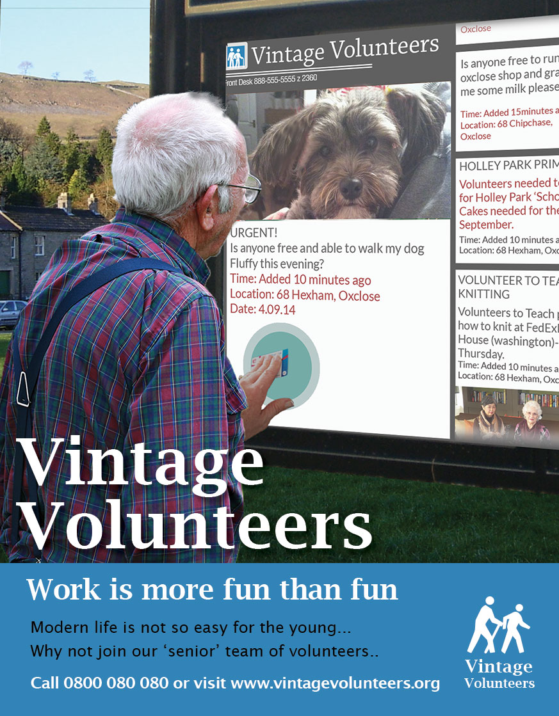
Figure 5: Vintage Volunteers
This was considered to be a useful fiction not because it was provocative or critical but because it is a resonant illustration of the findings around the vital importance of meaningful work in positive aging.

DISCUSSION
It is sometimes claimed that provocative concept designs, questionable concepts or design fictions are just “bad designs”. But to insist on “good design” in such contexts is to demand a truly solutionist approach. To solemnly suggest purely design based solutions for ageing populations is clearly preposterous. Nevertheless the challenges around ageing populations are real and it is important to explore the emerging design space.
Although the Solutionist games were played with a degree of irony they ensured that the research team incorporated findings and insights from the fieldwork into their thinking. During the game the designers became players who knew very well they were engaged in make believe: producing fictions. Sterling suggests that we are going to see more and more design fictions and it is certainly becoming more and more popular in HCI. Why design fiction and why now? Fiction has been defined as a means of providing resolution for conflicts at the level of fantasy that cannot be resolved in real life [14]. Perhaps what makes “design fiction” such a useful term is the insistence on its status as fantasy. In this sense design fiction may mitigate against the tendency towards solutionism and the hope that there are technological quick fixes for the challenges we face.

CONCLUSION
This paper makes three contributions. The first is the study of thriving ninety year olds which suggests that well being is not the property of an individual but rather achieved within networks. The second is the “solutionist” board game which we suggest could be applied to any qualitative study as a means of generating design concepts informed by data and research insights. The third contribution takes the form of research based design fictions addressing the challenge of positive aging. We consider their value to be in indicating the broad shape of the design space to be explored. We have argued that fiction can create a space for design beyond solutionism.

REFERENCES
- AgeUK (2014) Later Life in the United Kingdom. http://www.ageuk.org.uk/Documents/EN-GB/Factsheets/Later_Life_UK_factsheet.pdf?dtrk=true
- Baltes P., & Baltes M., (1990). Successful aging: perspectives from the behavioral sciences. New York: Cambridge University Press.
- Bardzell, J., and Bardzell, S. (2013). What is “critical” about critical design? Proc. of CHI’2013. ACM:
- Bardzell J., Bardzell S., and Stolterman E., (2014). Reading critical designs: supporting reasoned interpretations of critical design. In Proc. of (CHI '14).
- Bleecker, J.( 2009). “Design Fiction: A Short Essay on Design, Science, Fact and Fiction”. webeditionpdf
- Bowling, A. and Dieppe, P. (2005). "What is successful aging and who should define it?" British Medical Journal. 331 (7531): 1548–1551.
- Blythe M. (2014) Research through design fiction: narrative in real and imaginary abstracts. In Proc of (CHI '14). ACM, New York, NY, USA, 703-712
- Callow S., (2012) Charles Dickens and the Great Theatre of the World.. Harper press
- Charmaz, K. (2006) Constructing Grounded Theory. Sage, London, 2006.
- Csikszentmihalyi M. (2014) Flow and the Foundations of Positive Psychology: The Collected Works of Mihaly Csikszentmihalyi. Springer.
- Dourish, P. (2006) Implications for design. In Proc. CHI ’06, ACM , 541-550.
- Dourish, P. & Bell, G. (2013). “Resistance is futile”: Reading science fiction alongside ubiquitous computing. Personal Ubiq. Comput., Springer-Verlag, May
- Dunne A., and Raby F. (2013). Speculative Everything: Design, Fiction, and Social Dreaming. The MIT Press.
- Eagleton, T. (1996) Literary Theory (2nd ed.). Wiley Blackwell, Hoboken, NJ,
- Ehrenreich B., (2010) Bright-sided: How Positive Thinking is Undermining America, Picador USA.
- Furniss D., Blandford A., and Curzon P.. (2011). Confessions from a grounded theory PhD: experiences and lessons learnt. In Proc of (CHI '11). ACM
- Gaver W. (2012) What Should We Expect from Research Through Design. CHI 2012 pp 937-946
- Gaver , W., Beaver, J., and Benford, S. (2003) Ambiguity as a resource for design. In Proc. CHI ’03, ACM (2003), 233-240.
- Gaver, W., Boucher, A., Pennington, S. and Walker, B. (2004). Cultural probes and the value of uncertainty. Interactions, 6 (5), 2004, 53-56.
- Gilliam T. (2014) http://www.sfx.co.uk/2014/03/14/the-zero-theorem-terry-gilliam-interview/
- Glaser, B. and Strauss, A. (1967) Discovery of Grounded Theory: Strategies for Qualitative Research. Aldine Publishing Company, Chicago, 1967.
- Gottman J and Silver N (2000) The Seven Principles for Making Marriage Work. An Onion Paperback
- Halskov, K. and Daslgaard, P. (2006) Inspiration Card Workshops. In Proc. DIS ’06, ACM Press (2006), 2-11.
- Kirman B., Linehan C., Lawson S., and O’Hara D., (2013) CHI and the Future Robot Enslavement of Humankind: a retrospective. In Proc of CHI’13 ACM
- Independent. The. The Only Gay (Retirement home) in the village. 31.6.2013
- Linehan C., Kirman B., Reeves S., Blythe M., Tanenbaum J., Desjardins A., and Wakkary R., (2014). Alternate endings: using fiction to explore design futures. In Proc of CHI '14 ACM
- Lucero, A. and Arrasvuori, J. (2010) PLEX Cards: A Source of Inspiration When Designing for Playfulness. In Proc. Fun and Games ‘10, ACM Press (2010), 28-37.
- Latour B (2013) From Aggregation to Navigation. A few Challenges for Social Theory. CHI 13 Keynote address. Paris. 2003
- Markussen T., and Knutz E. (2013). The poetics of design fiction. In Proc of DPPI '13. ACM
- Marshall K., Thieme A., Wallace J., Vines J., Wood G., and Balaam M., (2014) Proc of DIS 14 Vancouver.
- Morozov E. (2013) To Save Everything Click Here: Technology, Solutionism and the Urge to Fix Problems That Don’t Exist. Allen Lane Penguin Books.
- Oliver, C. 2008. Retirement Migration. Paradoxes of Ageing. New York: Routledge
- Phelan E., Anderson L., Lacroix A., Larson E. (2004) Older adults' views of “successful aging”—how do they compare with researchers' definitions? J Am Geriatr Soc;52: 211-6
- Robson C. (2002) Real World Research. Blackwell Publishing, Oxford.
- Rule A. and Levine D., (2014) International Art English. http://canopycanopycanopy.com/contents/international_art_english
- Seligman M.E.P. (2002) Authentic Happiness: Using the New Positive Psychology to Realise Your Potential for Lasting Fulfillment Simon and Schuster
- Seligman M.E.P. (2011) Flourish: A Visionary New Understanding and Well Being. Nichoals Brealey Publishing
- Sterling B. (2005) Shaping Things. MIT Press. Cambridge Massachusetts
- Sterling B. (2009) Design Fictions. Interactions. Vol 16. Issue 3.
- Sterling B. (2013) Patently untrue: fleshy defibrillators and synchronised baseball are changing the future. Wired (2013, Oct. 11).
- Strauss, A., Corbin, J., (1990): Basics Of Qualitative Research: Grounded Theory Procedures And Techniques. London, Sage.
- Steane J. (2014) The Principles and Processes of Interactive Design. Bloomsbury.
- Tanenbaum, J Tanenbaum K., and Wakkary R. (2012). Steampunk as design fiction. In Proc of CHI '12. ACM, New York, NY, USA, 1583-1592
- Thieme, A., Balaam, M., Wallace, J., Coyle, D. and Lindley, S. Designing wellbeing. Proc. DIS '12. ACM (2012), 789-790.
- Thulesius H.,(2005) Grounded Theory. Wikipedia. http://en.wikipedia.org/wiki/Talk:Grounded_theory
- Vines J., Blythe M., Lindsay S., Dunphy P., Monk A., and Olivier, P. (2012). Questionable concepts: critique as resource for designing with eighty somethings. In Proc of CHI '12.
- Wakkary R., Desjardins A., Hauser S., and Maestri L. (2013). A sustainable design fiction: Green practices. TOCHI. Volume 20 Issue 4, September 2013

