The addition of synthetic fibres to concrete to improve impact/ballistic toughness
Authors:
Alan Richardson
Northumbria University, Newcastle upon Tyne, NE1 8SA, UK.
Email: alan.richardson@northumbria.ac.uk Telephone: 044 191 243 7305

Kathryn Coventry, Northumbria University, Newcastle upon Tyne, NE1 8SA, UK.

Thomas Lamb, Northumbria University, Newcastle upon Tyne, NE1 8SA, UK.

David Mackenzie, Northumbria University, Newcastle upon Tyne, NE1 8SA, UK.

Abstract
Concrete is relatively weak in tension and may require some form of reinforcement to cope with tensile forces. Steel reinforcing bar is often used to cater for tensile and compressive forces. However, current research shows that the use of steel reinforcing bar does not afford concrete protection against impact. Alternatively it has been shown that where fibres are added to concrete mixes protection is afforded through increased energy absorption. It would appear that the dispersion of fibres throughout a concrete mix affords a degree of toughness between the reinforcement bar spacing.
This research investigates the use of Type 1 micro synthetic fibres, Type 2 macro synthetic fibres and steel fibres used as post crack reinforcement in concrete samples when subject to a variety of stress induced states and compares the performance of these fibre mixes to that of a plain concrete mix. The test program adopted, subjected cube specimens to compressive strength tests, beam samples to both three point flexural bending and single point impact loading, and concrete slab sections to shot gun fire. The parameters investigated under test were: compressive strength, flexural strength, load deflection analysis, energy absorption and impact performance/resistance. Modelling the impact of shot fire on the test specimens was carried out using Finite Element Analysis, to inform slab design. The results of this investigation are of particular significance to the resilience of concrete structures under terrorist attack.

The results show that the adoption of Type 2 macro synthetic fibres as concrete post crack reinforcement provide the greatest toughness when compared with the other fibre types and offer the greatest protection from spalling of the back face of the concrete slab, being the main consideration with regard to the performance of the slab on testing with shotgun fire. Damage containment after ballistic testing was also noted where Type 2 fibres were used. The Finite Element Analysis models were successful at predicting the damage recorded to the concrete slabs, when subject to the shotgun fire performance test.

Key words: Impact, flexural strength, toughness, ballistic, spall, containment

- Introduction
Combatting terrorism remains significant to the agendas of many governments of the developed world. However, fibres may be used to improve the impact resistance of concrete (Coughlin et al. 2010). Coughlin et al. (2010), concluded that fibre reinforced concrete performed better than plain reinforced concrete when subjected to external forces. Performance enhancement is achieved through changing the concrete’s characteristic failure mode, from brittle to that of a pseudo-plastic nature through the addition of fibres (Lou et al., 2000).
On consideration of the fibre types added to concrete, synthetic fibres exhibit similar functional characteristics to that of steel fibres by bridging cracks formed in concrete due to external actions, however the mechanical properties of steel and synthetic fibres are very different and this is pertinent when considering the post crack performance of fibre concrete. This performance difference between fibre types accounts for the need to individually proportion fibre quantities to achieve equitable post crack flexural performance (Richardson et al. 2010). This research builds on the performance data comparison of steel and synthetic fibres when subject to impact forces (Richardson et al 2015). Predicting how a concrete element will perform when subject to impact, still remains an area which is not well understood (Coughlin et al., 2010). The plain concrete slabs within this test were set as a base line for performance. The fibre concrete performance was a measured change from the established baseline measurements This paper seeks to contribute to the understanding of the most effective fibre mix available to provide impact/ballistic protection.

1.1 Impact analysis on concrete structures

Impact by a high speed point load, such as a bullet, has similarities with a small standoff blast (Millard et al., 2009) and this has informed the test methodology. An explosion near a concrete wall causes a high speed compressive stress wave to load the front face of the wall (Millard et al., 2009), resulting in initial front face spalling Almansa and Canovas (1999). A significant proportion of the energy will travel through the wall as a compressive stress wave (Millard et al., 2009) and a small proportion of this energy will be reflected, causing a tension rebound from the back face. It is this tension rebound that can cause the back face to spall (Millard et al., 2009).

Back face spalling is an important consideration in protection of the public against shrapnel injuries occurring from concrete fragmentation and spall when explosive forces act on concrete structures (Elsayed and Atkins, 2008). The extent of injuries resulting from spall has been investigated by Gutierrez de Ceballos et al. (2005) who found that 36% of injuries in the Madrid Metro Bombings in 2004 were shrapnel wounds, caused by projectile material. Irrespective of whether explosions produce projectiles that ultimately penetrate a structural concrete and compromise its integrity (demonstrating back-face spalling on penetration through the back face), initial spall is promoted by tension exerted on the back face under the speed of the compressive stress wave. The equilibrium response to this impact forces concrete particles to be ejected from the back face of the structure. This is shown in Figure 1. (adapted from Millard et al., 2009).
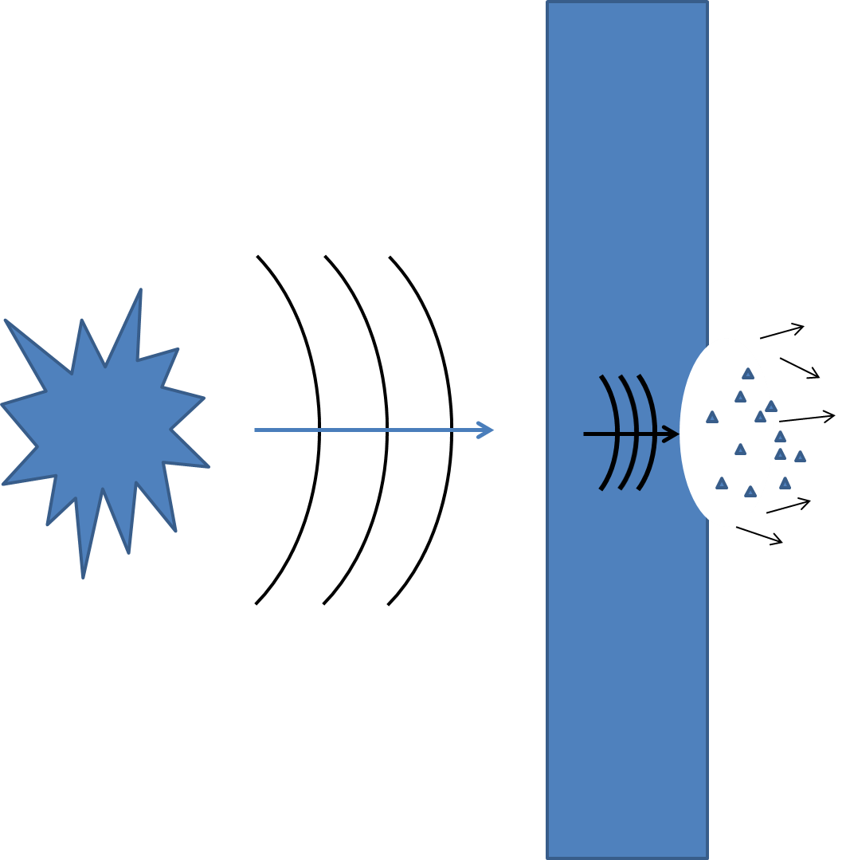

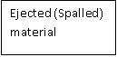

Figure 1 – Compressive stress wave causing spalling to rear face (adapted from Millard et al., 2009).

Coughlin et al. (2010) note that while concrete is commonly used for blast resistance due to its high mass per unit cost, the brittle nature of concrete means it is prone to spalling and fragmentation. Normal reinforced concrete does not perform well when subject to impact or explosion loading (Millard et al., 2009) as it is inherently weak in tension (Concrete Society, 2014). Sukontasukkul et al. (2013) define concrete as a quasi-brittle material, which when subject to loading beyond its tensile strength, usually fractures. Concrete is often reinforced with steel, to cater for the tensile strength deficiencies. However, Coughlin et al. (2009) note that blast loads can still damage both reinforced and unreinforced areas of the concrete structure. Millard et al. (2009) suggest that when failure occurs at the surface of a concrete wall subject to blast, the presence of conventional steel reinforcement will generally not prevent the wall from material spalling.

Conventional steel reinforcement bars do not prevent the concrete failing from the stress force induced by the tension rebound, as these bars merely act as obstructions within the dominance of the concrete matrix and are therefore inherent areas of weakness (Millard et al., 2009). It is suggested that fibre concretes, produced by randomly dispersing thin fibre elements throughout the concrete matrix, may offer a more viable solution.

Force from blast or bullet
This paper considers fibre concretes and examines the performance of these materials in the context of their relative ability to constrain back face spalling and protect the public.

- Materials
The fibre concretes used were manufactured from concrete adopting a plain base mix design with the variation of fibres only.

2.1 Plain Base Concrete mix design
A C50 plain concrete mix shown in Table 1 was designed in accordance with BS EN 14845-1:2007. . The cement used complied with BS EN 197-1: 2011 while the aggregate selection was informed from previous research by Richardson et al ( 2015) and utilised crushed/angular dolerite as the main aggregate with a maximum size of 20mm. Earlier tests used a rounded marine sandstone aggregate, which offered little resistance to a high velocity bullet. It was therefore desirable to ascertain how a different aggregate would perform when subject to a ballistic force to potentially improve the concrete performance.
A water/cement ratio of 0.5 was used for the mix design. The water used for the mix was potable water, as stated in BS EN 1008 (British Standards Institution, 2002), this type of water does not need testing prior to use as it will not adversely affect the concrete mix.

Materials | Quantity (kg/m³)
CEM I high strength cement (52.5N) | 410
Coarse sand <4mm | 767
Dolerite aggregate <20mm angular | 937
Water (w/c 0.5) | 205

Table 1 – Concrete mix

2.1.1 Dolerite aggregate
Dolerite is an igneous rock dominated by plagioclase feldspar and pyroxene. The dolerite used in this study was a locally sourced, Cemex quarry dolerite from Middleton in Teesdale, in the United Kingdom. The grading profile of the stone used was 1.42.

2.2 Fibre
BS EN 14889-1 (2006) and BS EN 14889-2 (2006) cover the specification and conformity of steel fibres and synthetic fibres respectively. As noted within these standards, fibres used for structural purposes are fibres which are designed to contribute to the post crack load bearing capacity of a concrete element.

2.2.1 Synthetic fibres
The synthetic fibres used in this research are Type 1a micro synthetic fibres and Type 2 macro synthetic fibres which are commercially available and remain unmodified for the purposes of these tests. The data presented represents their commercially available physicality and classification:
Class 1a – Micro fibres; <0.3mm diameter; mono-filament
Class 2 – Macro fibres; >0.3mm diameter
The Type 2 macro synthetic fibres used in this research are a composite blend of polypropylene (90%) and polyethylene (10%). The fibres had a length of 50mm with a diameter of 1mm. The ratio of length to diameter (aspect ratio) was therefore 50:1. The crimped/wavey form of the fibres resists pull out and allows progressive failure to occur.

The Type 1 micro synthetic fibres had a graded fibre length of 12.7mm and were 32 microns in diameter. These fibres were manufactured from 100 percent virgin homopolymer polypropylene and represent around 30 million fibres per kilogram.

2.2.2 Steel fibres
The steel fibres used in this study were formed from cold-drawn steel wire. The fibres are 50mm long with a diameter of 1mm. The aspect ratio is therefore 50:1, the same as the Type 2 macro synthetic fibres. The steel fibres have a tensile strength of 1,050 N/mm² with a hooked end that allows progressive failure due to the straightening effect of the fibre when under load.

2.2.3 Fibre dosage
Steel fibres were added into the plain base concrete mix at a dosage of 40 kg/m³. The Type 2 macro synthetic fibres were added to the plain base concrete mix at a dosage of 6 kg/m³ ; these dosages were informed by Richardson et al (2010) who demonstrated near equal performance in terms of flexural strength for beams manufactured from these respective fibre concretes . The Type 1 micro synthetic fibres were added into the plain base concrete mix at a dosage of 2 kg/m³. This dosage was informed by earlier work on compressive strength and workability by Richardson (2006).

- Concrete sample production
Concrete specimen production aligned to the demands of the test programm presented in Section 4.0, utilising concrete cubes, slabs and beams.
3.1 Cube production
Cube production was informed by BS 1881:part 125:2013 and the compressive strength tests were carried out in accordance with BS EN 12390-3 2009
3.2 Beam Production
Beam production was informed by BS 1881:part 125:2013 and the flexural strength tests were carried out in accordance with BS EN 12390 – 5: 2000.
3.3 Slab Production
Slab design and production was informed by modelling using Finite Element Analysis (FEA), prior to laboratory testing. The model, created in Ansys 15.0, consisted of a slab of dimensions 400mm x400mm x 75mm, as previously used by Richardson et al., ( 2015) with simulated fixings constraining the top and bottom slab faces. The model simulation assumed the application of a velocity to the slug in the direction of the slab, simulating the impact occurring in the laboratory test procedure.
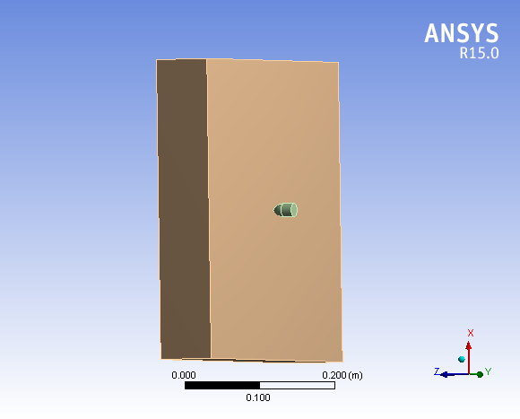
.
Projectile based on shotgun slug.
Constraints.

Figure 2- FEA model for a 400mm x 400mm x 75 mm concrete slab

FEA modelling was employed to inform the slab design by predicting the damage which would be sustained by the concrete sample during ballistic impact. Several assumptions have to be made in order to construct an accurate model with the limited data available. Since the distance the projectile has to travel is only 7m, it is reasonable to assume that energy losses from the bullet due to drag, would be very small. The simulation accounted for standard barrel length of 710mm and took into account the use of ammunition in the form of a standard single lead slug, subject to a muzzle escape velocity of 545m/s. Figure 3 displays the initial impact to the face of the slab. It is anticipated that the slug will be subject to deformation upon impact and break up. Deformation is predicted to form a 50mm radius around the point of impact.
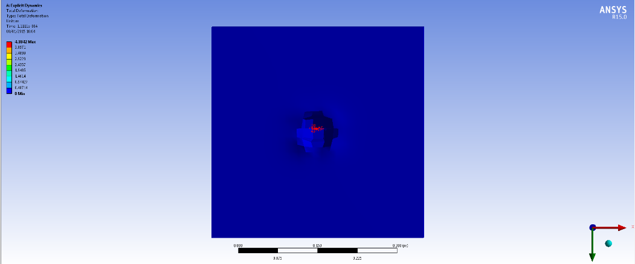
Projectile (in red)
Figure 3 – Simulated deformation after initial impact on a plain base mix concrete slab

Figure 4 displays the anticipated stress wave propagation on the front face of the slab at impact plus 1.111 x10⁻⁴ seconds.
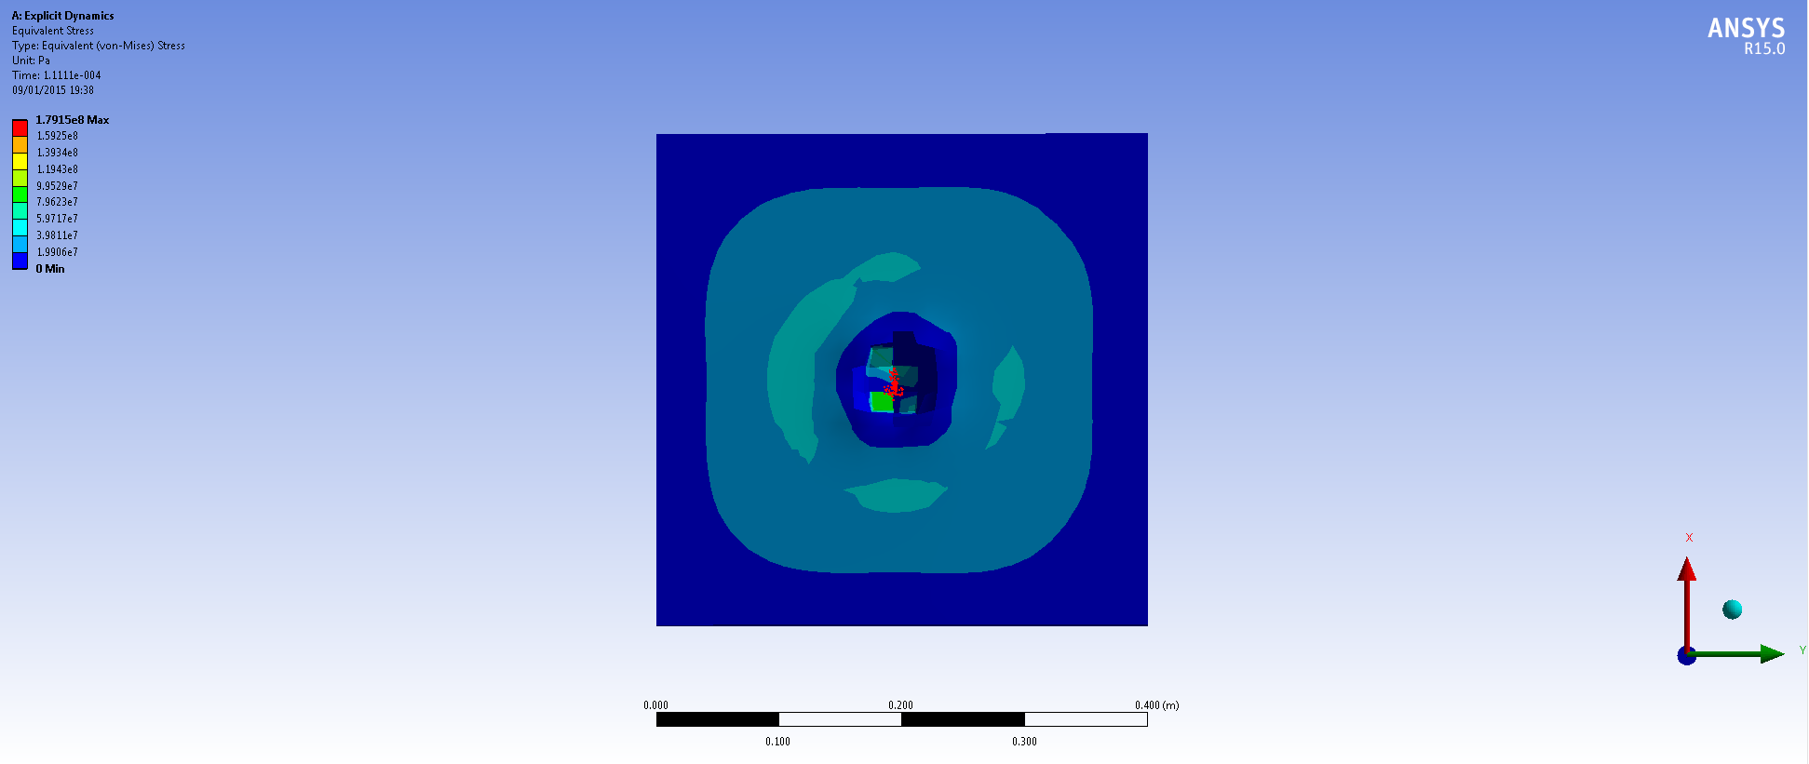
Figure 4 - Stress analysis showing front face of model at T=1.111e-4 s

Figure 5 displays the predicted stress pattern for the rear face of the slab which displays significant damage compared to the front face that receives the impact.

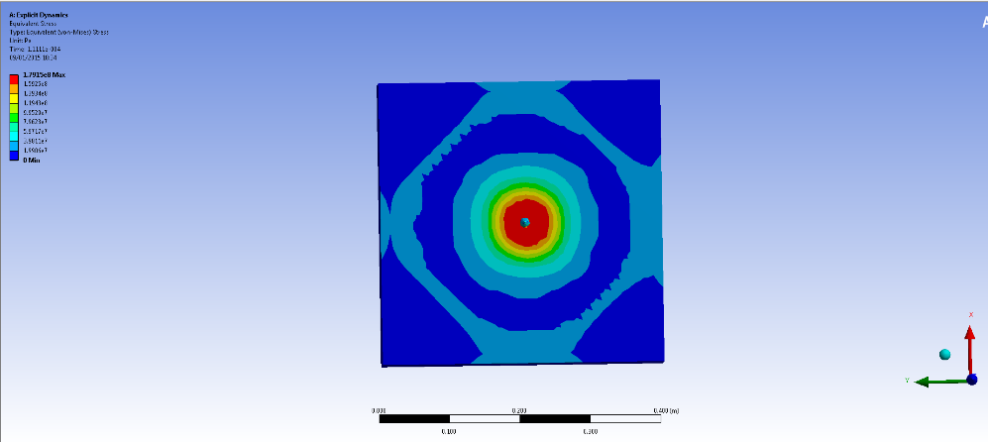
/Figure 5 Stress analysis on rear face of model at T=1.111e-4 s.
Red represents area likely to fragment, due to complete failure.
The FEA modelling demonstrated that failure would occur to slabs formed from the plain base concrete mix from a single shot, indicating the appropriate slab dimensions to be adopted through the test programme.

4.0 Test programme
Figure 6 shows the specimen preparation used in this research, and is designed to compare the performance of the four different sample types: plain base concrete, plain base concrete with Type 1 micro synthetic fibres, plain base concrete with Type 2 macro synthetic fibres and plain base concrete with steel fibres. Three No 100mm x 100mm x 500mm concrete beams for each concrete type were manufactured for the flexural strength and load deflection testing; and 3 No 100mm x 100mm x 400mm concrete beams of each concrete type were manufactured for energy absorption and impact resistance testing. From the plain base concrete batching a quantity of the material was taken to form three 150mm cubes to evaluate the compressive strength of the plain base mix design. To carry out the shotgun-fire performance test, 2 No 400mm x 400mm x 75mm concrete slabs were cast of each concrete sample type.

Batching and Preparation of test of samples

Plain base concrete of characteristic design strength C50, concrete containing dolerite aggregate

Sub-batching of plain base concrete mix

40kg/m³ steel fibre concrete. (Mix reference St)

6kg/m³ of Type 2 macro synthetic fibre concrete (Mix reference T2)

2kg/m³ Type 1 micro synthetic fibre concrete
(Mix reference T1)
Plain base concrete (Mix Reference P)

Production of 6 beams and 2 slabs for each sub-batch , and 28 day curing
Compressive strength test

Test programme

Load deflection 3 point bending test
3 beams per fibre type
Single point impact drop hammer test
3 beams per fibre type

Shotgun fire – performance test
2 concrete slabs per fibre type

Results and analysis

Figure 6–Specimen preparation and Test programme

4.1.1 Compressive strength test
BS EN 12390-3:2009 was adopted to guide determination of compressive strength for the base concrete mix and define the parameters of hardened concrete.

4.1.2 Flexural strength and load deflection test
The 28 day flexural strength testing of the hardened concrete was informed by BS EN 12390-5:2009 . The load was applied through a three point loading frame at an extension rate of 2.2mm/min. All beam sub-mixes were tested to generate the relative data to inform the comparative performance study, which is the basis of this paper. Calculating the flexural strength of each fibre concrete sub mix, facilitates a quantitative comparison between the performances of the different fibre types within a given concrete matrix..

4.1.3 Energy absorption (toughness) and impact resistance test
An energy absorption and impact resistance test was carried out to determine the performance of the different test samples and determine the structural capability of the different samples. The three point bending test to BS EN 14651:2005+A1:2007 was used to determine toughness, whilst the drop hammer test was used to determine impact performance.
The impact performance was determined by subjecting the beams to impact by a drop hammer (Instron CEAST 9340 ) with a half round striker bar (tup). The tup had a total mass of 8.219kg and was released at a height of 150mm. The impact velocity for the test beams was calculated as 1.72 m/s. At this rate of descent, the impact energy was 12.158J.
This energy absorption and impact resistance test used by Richardson et al (2015) allowed for the peak force and total impact energy of each sample type to be ascertained as well as the impact, break point and total break times to be determined, which is a measurement of toughness. Comparisons were drawn between the different beam samples produced from the concrete sub mixes. .

4.1.4 Shotgun fire performance test
Damage to the concrete test samples was induced through the projection of a single shotgun slug as a projectile. Each slug weighs 25 grams and was discharged from a Remington automatic shotgun which was discharged at a distance of 7m. A shotgun was chosen to deliver the projectile over the use of a rifle bullet following previous research by Richardson et al. (2015) where the speed of impact resulted in punching shear and single impact failure. It was therefore considered that the lower velocity of the projectile delivery from the shotgun would allow the shot contained within the slug to scatter across the face of the slab, better simulating a blast stress wave. Shotgun delivery would also present the opportunity to observe and analyse damage over successive impacts when fibres are included in the base mix. The effect of a lower impact velocity projectiles on a test specimen was also tested by Almansa and Canovas (1999). In their research, the powder contents of the cartridges were reduced in order to “assess the effect of a smaller impact velocity on penetration” (Almansa and Canovas, 1999).

Two slabs of each sample type were tested. One slab of each sub-mix concrete received one shot centrally and those that remained un-broken received multiple shots until failure. For those slabs receiving multiple shots, observations can be made to compare slab type failures, thus ascertaining the performance of each concrete mix as a reflection of the fibres adopted therein. .

5.0 Results
5.1 Compressive strength testing
The compressive strength results from the testing of the plain concrete mix are displayed in Table 2. The characteristic strength was 54.2 N/mm² assuming a defective value (k) of 5%. All of the test results provided were classed as satisfactory failure patterns in compliance with BS EN 12390-3:2009.

Cube ref | Side 1 (mm) | Side 2 (mm) | Weight (g) | Maximum load (kN) | Loading Pace rate (kN/sec) | Stress (N/mm²)
C1 | 149.2 | 148.1 | 7963.5 | 1220.9 | 6.8 | 55.25
C2 | 149.6 | 149.7 | 8047.5 | 1296.4 | 6.8 | 57.89
C3 | 149.6 | 147.8 | 7971.5 | 1347.6 | 6.8 | 60.95
 |  |  |  |  |  | Mean = 58.03
 |  |  |  |  |  | Standard deviation = 2.33
Table 2 – Compressive strength test results

5.2 Flexural strength and load deflection test
BS EN 14651:2005+A1:2007 was used to determine the engineering qualities of fibre reinforced beams. The initial break point known as the limit of proportionality (LOP) and four loads at prescribed crack mouth openings were recorded to ascertain the beams post crack performance and the effect of the fibres in transferring loads once the beam has broken across the section. The beam characteristics and flexural strength on initial cracking are displayed in Table 3. There is no apparent difference in the flexural strength of the beams produced from each concrete sub mix. Table 4 and Figure 7 reflect the beams’ post crack performance. The steel and Type 2 fibre beams were very similar in performance at the limit of proportionality (LOP) and crack mouth opening displacement (CMOD) 4, however between CMOD 1 and 3, they differed in performance, with the steel fibre beams outperforming those manufactured using Type 2 synthetic fibres.
Sample Reference | Width d₁ (mm) | Height d₂ (mm) | Length (mm) | Mass (g) | Density (kg/m³) | First crack load (kN) | Flexural strength (N/mm²)
Pl | 91.52 | 99.30 | 500.00 | 10953.50 | 2410.56 | 17.48 | 8.72
P2 | 91.88 | 97.94 | 500.00 | 10981.00 | 2440.57 | 16.58 | 8.47
P3 | 95.31 | 95.56 | 500.00 | 11036.00 | 2423.41 | 17.21 | 8.90
Mean | 92.90 | 97.60 | 500.00 | 10990.17 | 2424.85 | 17.09 | 8.69
St1 | 88.50 | 97.70 | 500.00 | 10823.50 | 2503.57 | 15.09 | 8.04
St2 | 96.20 | 102.10 | 500.00 | 11962.50 | 2435.85 | 20.57 | 9.23
St3 | 95.50 | 97.70 | 500.00 | 11576.50 | 2481.47 | 18.89 | 9.32
Mean | 93.40 | 99.17 | 500.00 | 11454.17 | 2473.63 | 18.18 | 8.91
T1.1
T1.2 | 100.80 | 100.20 | 500.00 | 11892.00 | 2354.81 | 17.72 | 7.88
T1.3 | 100.10 | 99.98 | 500.00 | 12775.50 | 2553.06 | 21.85 | 9.83
 | 101.30 | 103.20 | 500.00 | 12289.00 | 2351.03 | 20.95 | 8.74
Mean | 100.73 | 101.13 | 500.00 | 12318.83 | 2419.63 | 20.17 | 8.81
T2.1 | 98.60 | 103.80 | 500.00 | 11828.00 | 2311.36 | 18.33 | 7.76
T2.2 | 89.00 | 102.00 | 500.00 | 10617.00 | 2339.06 | 19.78 | 9.61
T2.3 | 98.20 | 98.20 | 500.00 | 11817.50 | 2450.94 | 21.25 | 10.10
Mean | 95.27 | 101.33 | 500.00 | 11420.83 | 2367.12 | 19.79 | 9.10

Table – Beam flexural strength data

Sample | Limit of proportionality Flexural strength (N/mm²) | Flexural strength at CMOD 1 (CMOD 0.5mm)  (N/mm²) | Flexural strength at CMOD 2 (CMOD 1.5mm)  (N/mm²) | Flexural strength at CMOD 3 (CMOD 2.5mm)  (N/mm²) | Flexural strength at CMOD 4 (CMOD 3.5mm)  (N/mm²)
Plain | 8.69 | 0 | 0 | 0 | 0
Type 1 micro synthetic | 8.81 | 3.08 | 0 | 0 | 0
Steel | 8.91 | 6.11 | 3.61 | 3.0 | 2.55
Type 2 macro synthetic | 9.10 | 2.33 | 2.6 | 2.5 | 2.33
Table 5 – Crack mouth opening displacement (CMOD)

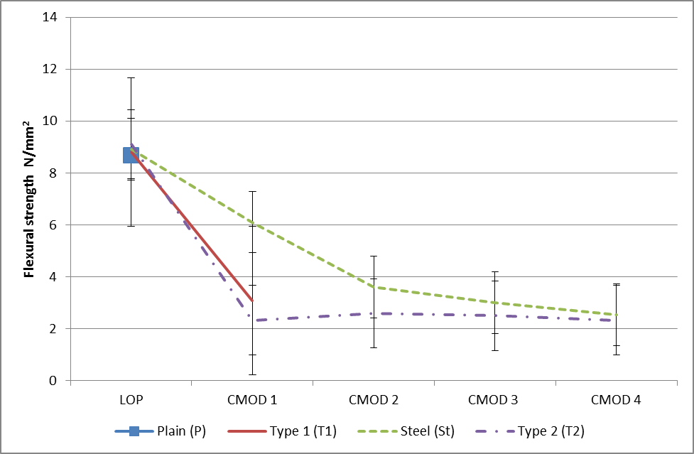
Figure 7 – Crack mouth opening displacement

5.3 Energy absorption and impact resistance test

The mean impact test results are displayed in Table 5. The beams were subject to impact until failure and the number of impacts required to completely break the beams are recorded. The samples were observed between each impact, for signs of damage.

Beam sample type | Number of impacts to failure | Mean peak force (N) | Mean total impact energy (J)
Plain base concrete (P) | 1 | 28900 | 11.5
Steel fibre (St) | 5 | 29108. | 10.6
Type 1 micro synthetic (T1) | 3 | 24788 | 10.5
Type 2 macro synthetic (T2) | 5 | 33118 | 10.9

Table 5 – Beam impact data

The plain base concrete mix beam had no residual structural capability and this was used to benchmark the performance of fibre type addition to the plain base concrete matrix.. The addition of fibres improved the performance of the beams when subject to impact. As shown in Table 6, each of the different samples containing fibres sustained a higher number of impacts prior to complete failure. On average, the steel fibre beams required five impacts, the Type 1 micro synthetic fibre beams required three impacts and the Type 2 macro synthetic fibre beams required five impacts, in order to cause a complete rupture plane through the beam.

Toughness comparison of the beams produced from each sub-mix can also be analysed by calculating the area under the time-force curve. To calculate the total area under the curve between the start of the impact and final point, integration is used by setting the time of initial impact (the start time) and the time of the initial rupture (the final time) as the upper and lower limits. The results are displayed in Figure 8 and these show steel fibres to have the greatest toughness with the Type 2 and Type 1 micro fibres having progressively less toughness and plain concrete having no residual post crack strength.

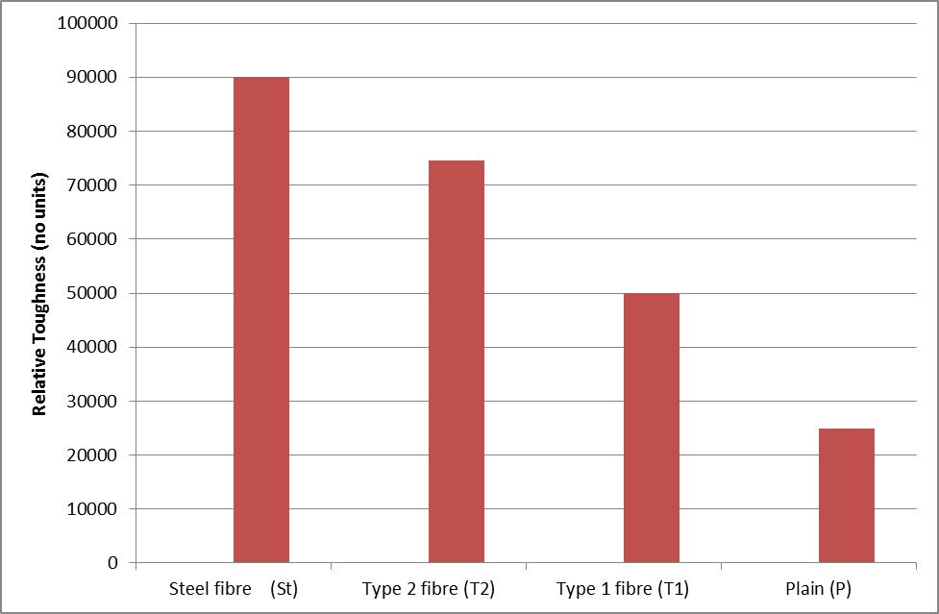
Figure 8 – Toughness for each beam sample type

5.4 Shotgun fire performance test

Table 6 illustrates that the plain slab received one shot and consequently broke into four pieces as illustrated in Figure 9. A diameter measurement was recorded on the impact hole at the surface, centre, and the exit hole at the rear of slab also displayed in Table 6

Table 6 – Shotgun fire performance test results 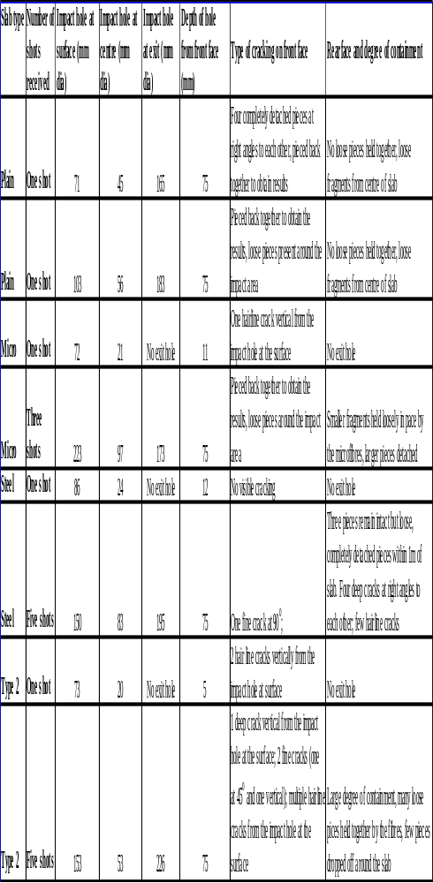

The plain concrete mix slabs (P) suffered the most damage and this is shown in Figure 9. These slabs completely failed after only one shot, with the bullet achieving full penetration of the slab. Thus the slab manufactured from the plain concrete mix afforded little protection from the shotgun slug.

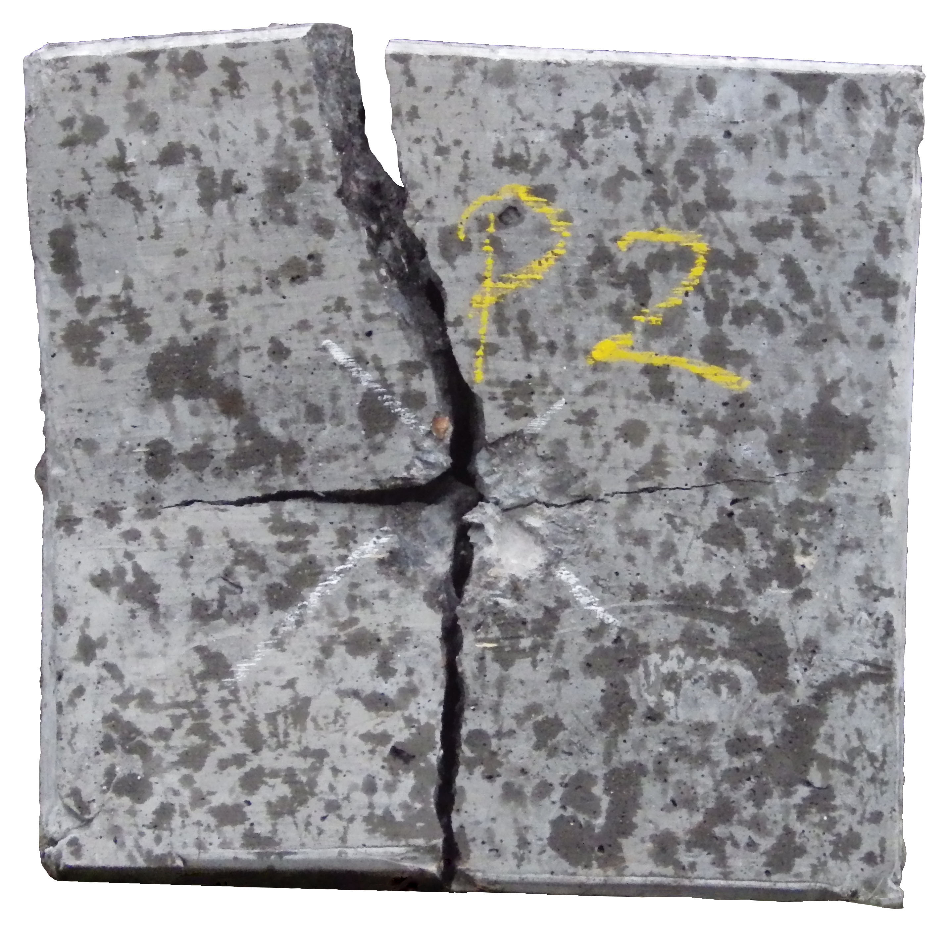
Figure 9 – Plain slab after one shot

The T1 beams subjected to impact testing exhibited very little damage after the first impact and considerably less damage than any other beam type. Sudden failure was observed after the third drop hammer impact, and when the slabs were subjected to three firings from the shotgun. This performance was very different when compared to the steel (St) and Type 2 (T2) macro synthetic fibre slabs. The steel and Type 2 fibre concrete exhibited progressive failure as more shots were fired. This is also supported by the difference in the time from the initial impact to break and break to total failure as displayed in Figure 8.
The slabs containing Type 2 macro synthetic fibres offered the highest degree of concrete containment after multiple shots. Figure 10 shows the rear face of the Type 2 macro synthetic slab after 5 shots and illustrates a high degree of concrete containment. This figure also illustrates areas of fragmented concrete remaining loosely held by the fibre matrix which consequently prevents ejection from the rear face of the slab. However this concrete would not afford further protection from impact.

On comparative observation of the crack pattern matrix of Figures 9- 11, the fibre concretes formed from steel and Type 2 macro synthetic fibres are shown to exhibit an altered crack shear path to that of the base plain concrete and the Type 1 fibre concrete. The plain and Type 1 micro synthetic concrete slabs exhibited a relatively uniform crack pattern distributed at right angles, across the face of the slab. Of the slabs formed from Type 2 macro synthetic and steel fibre concretes, a bridging effect is achieved by the fibre inclusion within these matrices demonstrated by cracking which is less uniform but more dispersed, as shown also in Figure 10.

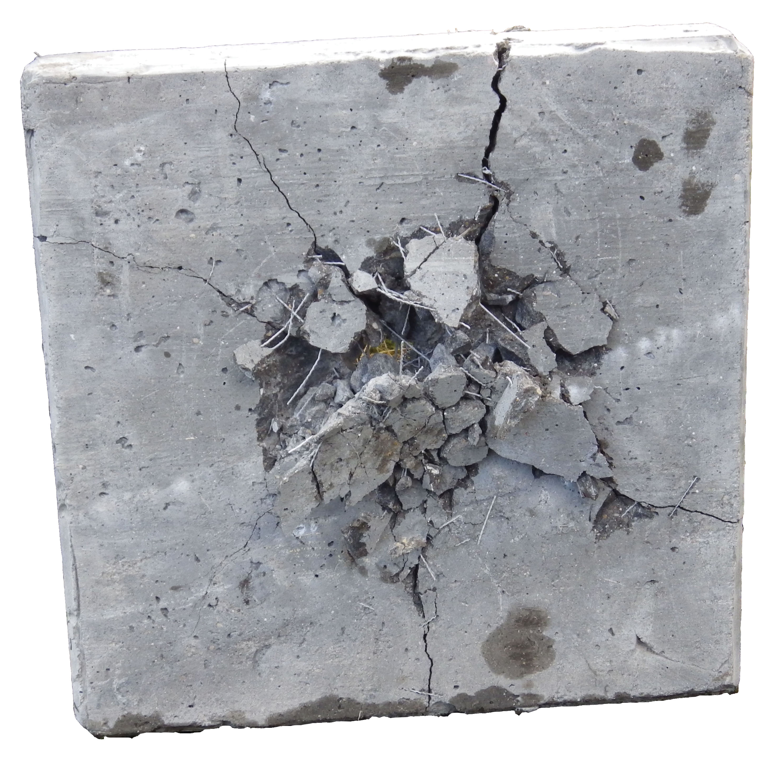
Figure 10 – Rear face of the Type 2 macro synthetic slab receiving multiple shots

In terms of concrete fragment containment from the rear face of the slabs, steel fibre slabs did not perform as well as the Type 2 macro synthetic fibre slabs, as shown in Figure 11. This figure evidences a clean hole through the slab, unlike that observed in Figure 10 where a number of pieces of concrete appear fragmented but contained around the slab. It is concluded that steel fibre slabs as afford less protection to spalling than slabs produced from Type 2 macro synthetic fibres. Both slabs received 5 shots aimed at the centre of the slab.

On observation of the crack patterns of Figures 9- 11, it can be noted that on comparing the fibre concrete to the plain concrete, the steel fibre and Type 2 macro synthetic fibre concretes altered the shear path of the cracks. The basic plain concrete and Type 1 micro synthetic concrete produced slabs that exhibited a relatively uniform crack pattern matrix occurring at right angles across the face of the slab.
Alternatively, Type 2 macro synthetic and steel fibre samples demonstrate crack bridging behaviour across the concrete slab face, with a non-uniform cracks pattern as shown in Figure 10.

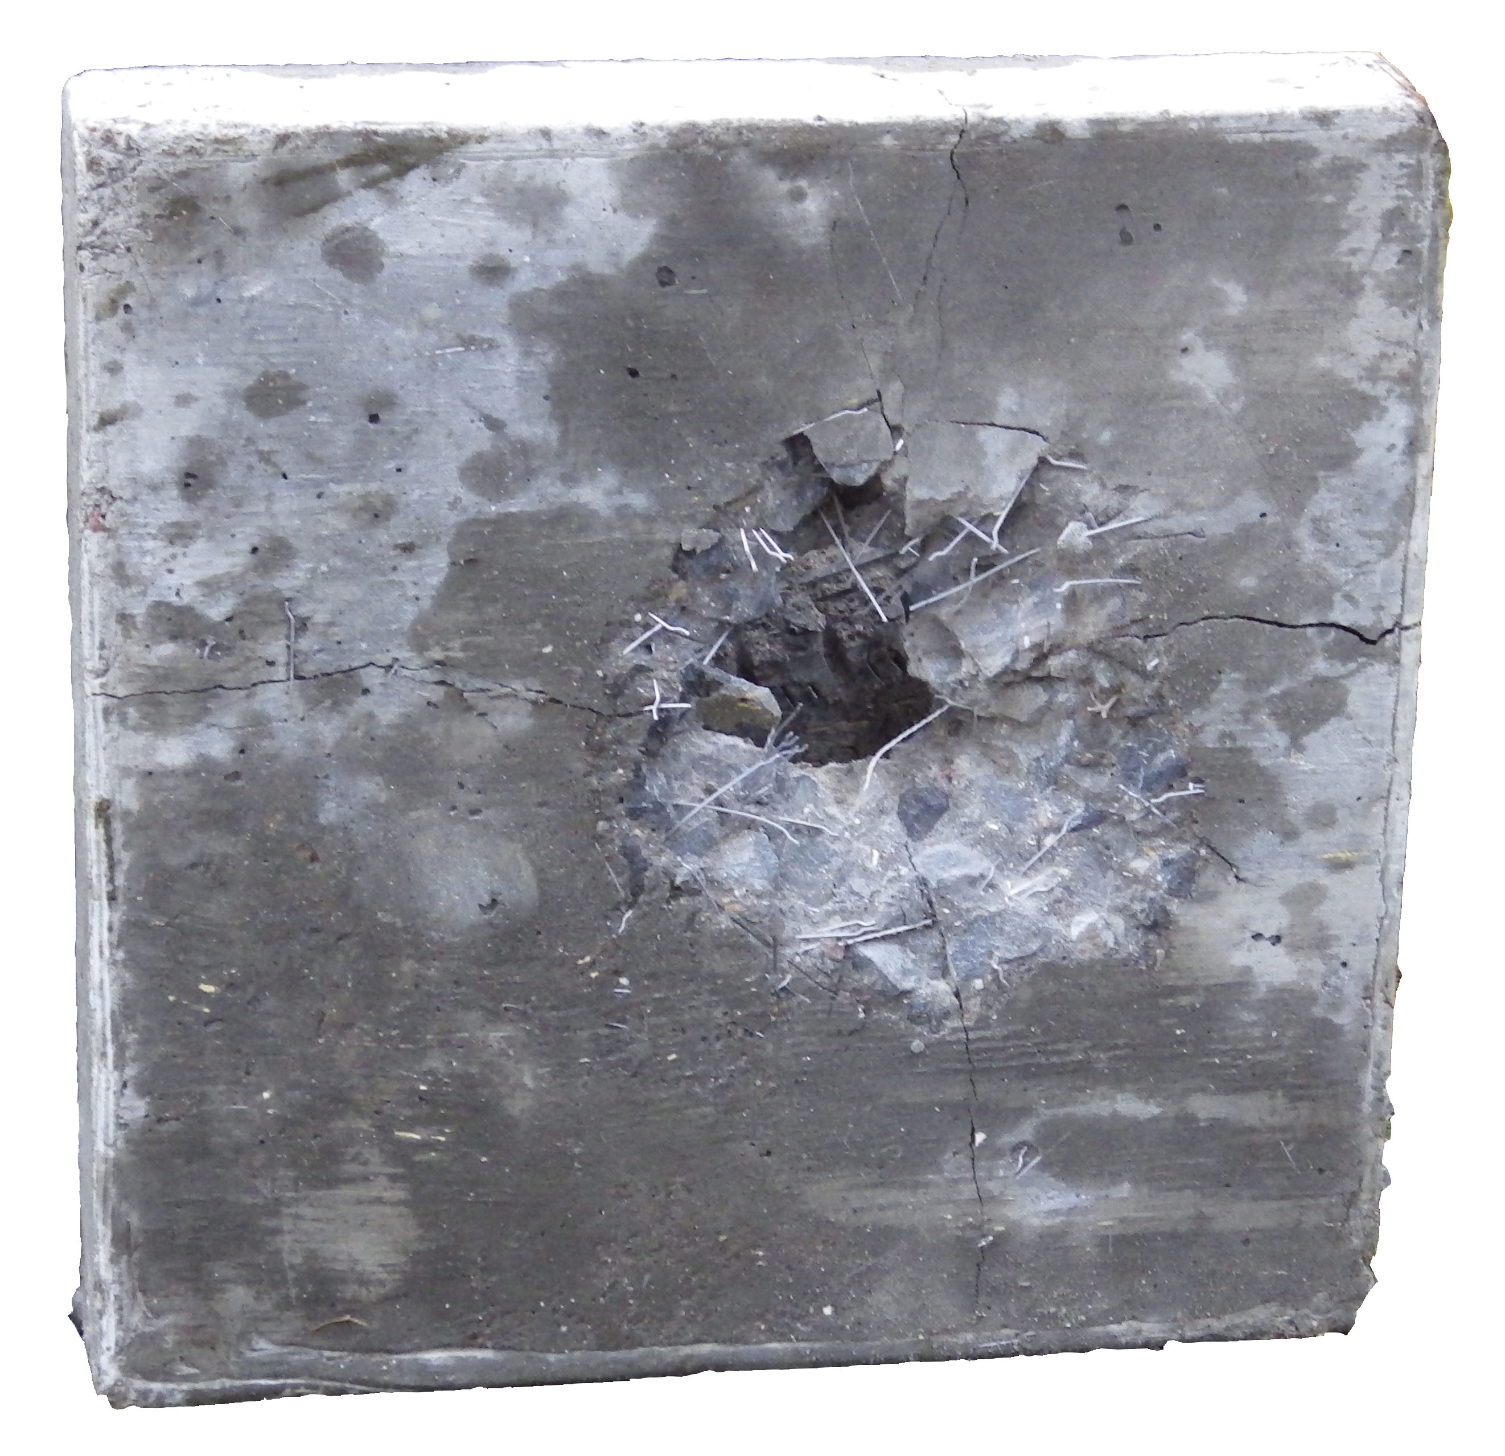
Figure 11 – Rear face of steel fibre slab

The relationship between the impact and shotgun failure was remarkably similar as displayed in Figure 12.

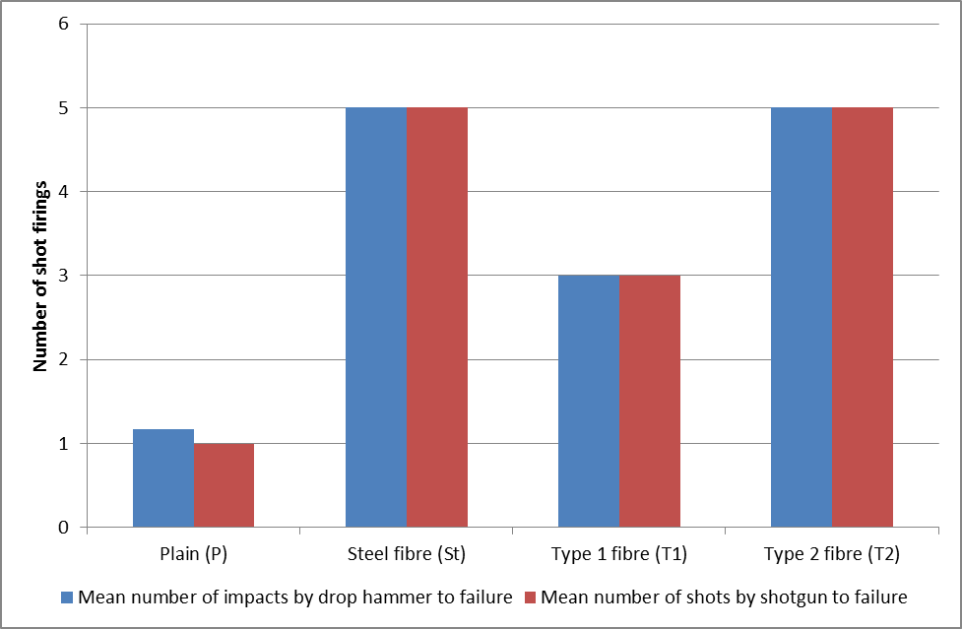
Figure 12 – Comparison between impacts to failure for shotgun and impact resistance test

6.0 Conclusion
The Type 2 macro synthetic fibre samples offered the greatest impact resistance when compared to the other fibre types. They also exhibited the highest flexural strength value and the highest degree of rear face fragment containment when subjected to the shotgun fire performance test. In terms of energy absorption and impact resistance testing, the steel fibres performed better than any of the fibre types.

Due to the apparent correlation between the impact resistance to the shotgun fire performance test, it can be concluded that laboratory testing through impact can be used as an alternative to ballistic performance to gain an understanding of how fibre concretes will perform in field tests.
The Type 1 micro synthetic concrete slabs sustained very little damage upon the first shotgun firing. Similarly, in terms of flexural strength and load deflection the Type 1 micro synthetic beams were able to sustain the greatest load compared to the other fibre types, before the first crack was recorded. However these beams exhibited very little toughness. Type 2 macro synthetic fibre beams exhibited the highest flexural strength, and the highest degree of containment of the concrete when subject to shotgun fire. Determination of the optimal degree of slab containment, was a key objective of this research. It can be concluded that the adoption of Type 2 fibre concrete could potentially prevent human injury through minimising the potential for blast fragmentation.

Finite Element Analysis (FEA) was used to predict the likely damage of the concrete slabs when subject to the shotgun fire performance test. The FEA models successfully reflected the results of the shotgun fire performance tests. High stress areas are shown on the FEA models and these were observed on the slabs as actual damage following impact. The compressive stress wave was observed to be greater on the rear face of the FEA models. This explains why the rear face of each slab shot to failure, exhibited more damage than the front face.
Further work should be carried out using a hybrid fibre mix.

Referenced work
Almansa, E. and Cánovas, M. (1999). “Behaviour of normal and steel fiber-reinforced concrete under impact of small projectiles”. Cement and Concrete Research, 29(11), pp.1807-1814.

Bentur A, Peled A, Yankelevsky D, (1997), “Enhanced Bonding of Low Modulus Polymer Fibres-Cement Matrix by means of Crimped Geometry”, National Building Research Institute, Technion-Israel Institute of Technology, Haifa 32000, Israel, p1099.

British Standards Institution (2009) BS EN 12390-3:2009, Testing hardened concrete – part 3: Compressive strength of test specimens.

British Standards Institution (2000) BS EN 12390-4:2000, Testing hardened concrete – part 4. Compressive strength: Specification for testing machines

British Standards Institution (2007) BS EN 14845-1:2007, Test methods for fibres in concrete – Part 1: Reference concretes

British Standards Institution (2006) BS EN 14889-1:2006, Fibres for concrete – Part 1: Steel fibres – definitions, specifications and conformity

British Standards Institution (2006) BS EN 14889-2:2006, Fibres for concrete – Part 2: Polymer fibres – definitions, specifications and conformity

British Standards Institution (2009) BS EN 12390-5:2009, Testing hardened concrete. Flexural strength of test specimens

British Standards Institution (1964) BS 648:1964, Schedule of weights of building materials

British Standards Institution (2006) BS EN 14845-2:2006, Test methods for fibres in concrete – Part 2: Effect on concrete

British Standards Institution (2007) BS EN 14651:2005+A1:2007, Test method for metallic fibre concrete – measuring the flexural tensile strength (limit of proportionality (LOP) residual)
Concrete Society (2014) Reinforced Concrete. Available at: http://www.concrete.org.uk/fingertips_nuggets.asp?cmd=display&id=7 (Accessed: 03 October 2014)

Concrete Society (2014a) Steel fibres. Available at: http://www.concrete.org.uk/fingertips_nuggets.asp?cmd=display&id=376 (Accessed: 16 November 2014)

Coughlin, A., Musselman, E., Schokker, A. and Linzell, D. (2010). “Behaviour of portable fiber reinforced concrete vehicle barriers subject to blasts from contact charges”. International Journal of Impact Engineering, 37(5), pp.521-529.

Elsayed, N.M. & Atkins, J.L., (2008). ‘Explosion and blast-related injuries: effects of explosion and blast from military operations and acts of terrorism’. Burlington, Elsevier p.46

Gutierrez de Ceballos., (2005), “The terrorist bomb explosions in Madrid, Spain - an analysis of the logistics, injuries sustained and clinical management of casualties treated at the closest hospital”, Critical care, Vol. 9 issue 1 p.107

Imperial College Rock Library (2014) Dolerite. Available at: https://wwwf.imperial.ac.uk/earthscienceandengineering/rocklibrary/viewglossrecord.php?gID=00000000060 (Accessed: 11 December 2015)

Luo, X., Sun, W. and Chan, S. (2000). “Characteristics of high-performance steel fiber-reinforced concrete subject to high velocity impact”. Cement and Concrete Research, Vol 30 Iss6, pp.907-914.

McVay, M.K., (1988), “Spall damage of concrete structures” Department of the Army US Corp of Engineers, US Army, p.1 – 23

MI5, (2015). International Terrorism. [Online] Available at: https://www.mi5.gov.uk/home/the-threats/terrorism/international-terrorism.html [Accessed 11 December 2015].

Millard, S.G., Molyneaux, T., Barnett, S. And Gao, X., (2009), “Dynamic enhancement of blast-resistant ultra-high performance fibre reinforced concrete under flexural and shear loading”, Department of Engineering, University of Liverpool, Elsevier Ltd

Richardson A E, Coventry KA, (2015), “Dovetailed and hybrid synthetic fibre concrete – Impact, toughness and strength performance”, Construction and Building Materials, January, PP 439 – 449. Elsevier.

Richardson A.E., Coventry K., Landless S., (2010) "Synthetic and steel fibres in concrete with regard to equal toughness", Structural Survey, Vol. 28 Iss: 5, Emerald Group Publishing Limited, pp.355 – 369

Richardson A E, 2006, “Compressive Strength of Concrete with Polypropylene Fibre Additions, “Structural Survey, Vol 24, No 2, August, MCB UP Ltd, UK, pp 138 – 153.

Sukontasukkul, P., Jamnam, S., Rodsin, K. and Banthia, N., (2013). “Use of rubberized concrete as a cushion layer in bulletproof fiber reinforced concrete panels”. Construction and Building Materials, Vol 41,April, pp.801-811. Elsevier

Results and analysis
Results and analysis
Results and analysis
Results and analysis

