A critical portrait of hate crime/incident reporting in North East England: the value of statistical data and the politics of recording in an age of austerity
Abstract

This paper contributes to research on the reporting of hate crime/incidents from a critical socio-spatial perspective. It outlines an analysis of third party reporting of hate crimes/incidents in the North East of England, based upon the work of Arch (a third party hate crime/incident reporting system). The data set is one of the largest of its kind in the UK and therefore presents a unique opportunity to explore patterns of reporting across different types of hate crimes/incidents through a system designed to go beyond criminal justice responses. Whilst not downplaying the significance of the harmful experiences to which this data refers, we are very aware of the limitations of quantitative and de-humanised approaches to understanding forms of discrimination. Therefore the paper adopts a critical position, emphaising that interpretation of the data provides a partial, yet important, insight into everyday exclusions, but also cultures and politics of reporting. While the data records incidents across the main ‘monitored strands’, analysis here particularly focuses on those incidents recorded on the basis of ‘race’ and religion. Our analysis allows us to both cautiously consider the value of such data in understanding and addressing such damaging experiences - but also to appreciate how such an analysis may connect with the changing landscape of reporting and the politics of austerity.

Keywords

Hate crime/incidents, third party reporting, data collection, politics of recording, austerity

Introduction

This paper considers the value and limits of third party recording of hate crimes/incidents and its fit with an approach which takes seriously both the social construction of knowledge and the human damage wrought by such incidents. We adopt a post-positivist, critical approach to quantitative data and draw upon recent action research carried out with a third party reporting agency in the North East of England (Arch). Comparatively speaking, the data referred to is substantial; 3908 incidents over the period 2005-2015. The data also references experiences not captured through other data sources. As such it offers a unique opportunity to explore cultures of reporting through an analysis of the patterns in and between different categories of reported incidents in this geographic context. However, we argue that interpretation of such data also needs to be treated with caution given the limitations of quantitative approaches in appreciating the complex socio-spatial dynamics that surround these incidents. We also argue that such data collection, as a standalone exercise loses value if not developed in tandem with more pro-active approaches that look to directly tackle and respond to these incidents. The paper therefore begins to think through how the political context of austerity influences such activity in relation to both the problematisation of hate crime/incidents and possible responses.
The paper begins by setting the conceptual scene of ‘hate studies’ and by taking seriously the complex social and spatial character of such exclusionary practices. We then outline the historical context of third party recording more broadly and in relation to our case study area/project, before setting out our critical approach to the data collected through Arch. Following this we provide an analysis in two forms. Firstly we outline what our statistical analysis might tell us about hate crimes/incidents in this part of the world by highlighting key patterns, relationships and trends in relation to police involvement, incident types, geography, and reporting agencies involved. We then consider how the data may point towards, not just an indication of cultures of reporting, but also the politics of recording. In conclusion we suggest that our research is one illustration of a broader trend to downplay or shift the terms of data collection around issues of inequality and social justice. It is contended that the implications of this go beyond just a more accurate appreciation of societal trends

Approaching hate socially and spatially

Whilst more established within a US context of ongoing civil rights struggles (Green et al, 2001), ‘hate studies’ is a relatively new area of enquiry within the UK (Chakraborti and Garland, 2015). The field broadly recognises the unique character of criminal offences (but also non-criminal incidents) committed against individuals on the basis of ascribed identities in the context of historical power imbalances, what Perry (2001:10) describes as “violence and intimidation toward already stigmatised and marginalised groups”. While the experience of such violence is far from new, the establishment of a hate crime paradigm has emerged in response to more recent high profile events and political/legislative change. In relation to racist hate crime for example, landmark legislation such as the Crime and Disorder Act (1998) established racially aggregated offences and the MacPherson Inquiry (1999) into the murder of Stephen Lawrence (1993), set out the terms of an institutional response. In addition, other notable events such as the neo-Nazi inspired nail bombing campaign in April 1999 by David Copeland, targeting several minority communities in London, drew attention to the victimisation of other historically stigmatised and marginalised groups. The remit of legislation and police powers, as well as the scope of the academic field, has therefore expanded across what are known as the ‘monitored strands’ of religion (Anti-terrorism Crime and Security Act 2001), sexuality and disability (section 146 of the Criminal Justice Act 2003), in recognition of the breadth of victimisation. Contentiously, some have argued for a consideration of hate crime beyond these ‘over-generalised’ groups (Chakraborti and Garland, 2012), illustrating the contested nature of this inter-disciplinary field in both conceptual and more practical terms (Ardley, 2005).

A related feature of ongoing debate is that of conceptual definition and the language of ‘hate’ (Perry, 2006). One dominant critique has been to suggest that the term ‘hate crime’ presents offences as psychological matters of personal prejudice or bias, thus pathologising offenders and their actions (Ray and Smith, 2001). This seems to be a consequence of the prevailing liberal legal discourse where the focus remains on the perpetrator as ‘rational, autonomous, self-contained, self-possessed, self-sufficient’ (Hunter, 2013:13). Seen in such a way, hate is possessed and then expressed by those who hold extreme views and whose actions are de-contextualised from both society and space. Another of the key challenges to the language of hate crime is that it can be seen as experienced in a generic sense, rather than differentiated across the experiences of different social groups (Sherry, 2010). Such a blanket term may also work to obscure the wide spectrum of violence that might constitute hate crimes/incidents (Bufacchi, 2005); but also the contingent and dynamic sense of what counts as a hate crime over time and space (Perry, 2003).

Whilst appreciating these critiques, there have also been efforts to understand the utility of such a term. As Perry (2003: 8) has argued, it is “possible to construct a conceptual definition which allows us to account for the predominant concerns of historical and social context; relationships between actors; and relationships between communities”. This includes recognition of multiple forms of violence which are not necessarily limited to acts committed by ‘extreme’ individuals or even to illegal acts. In this sense violence, through the lens of hate crime, can be viewed as both extreme and shocking but also everyday and pervasive (Iganski and Sweiry, 2016). Perry (2003) also contends that despite the complexities and contingencies of the experiences found under the banner of hate crime, there is uniqueness to such incidents which sets them apart. She suggests that the social relations and ‘damage’ which constitute these experiences go well beyond the incident itself and beyond the individual victims and perpetrators involved. Perry thus conceptualises hate crimes as a social means of not just reflecting differences, but actively constructing difference through a range of affective registers. She therefore refers to hate crimes as ‘message crimes’:

Its dynamics both constitute and are constitutive of actors beyond the immediate victims and offenders. It is implicated not merely in the relationship between the direct “participants,” but also in the relationship between the different communities to which they belong. The damage involved goes far beyond physical or financial damages. It reaches into the community to create fear, hostility and suspicion. (Perry, 2003, 9)

Scholars have extended these arguments to consider how hate crimes/incidents, particularly in relation to ‘race’, may also have key spatial dimensions. In addition to work which emphasises diverse national legislative cultures (Garland and Chakraborti, 2012), the spatial unevenness of recorded incidents (Iganski, 2008) and the situational contexts in which hate crimes/incidents emerge (Clarke, 1995), others have set out in more theoretical terms the socio-spatial dynamics of ‘hate’. Ahmed (2001), for example, highlights how hate as an emotion does not reside within the minds or bodies of individual perpetrators, but rather is part of an unstable emotional economy. As such, hate circulates and gains currency in particular space-times through attachment to particular bodies. In a similar vein to the idea expressed by Hesse (1993) that ‘racism is spacism’, she suggests that through dominant discourses of nationhood and belonging hate works to actively and affectively organise bodies in space. Figures of hate, such as the asylum seeker in Ahmed’s account, are constructed through the stories we are told (by politicians and the media for example) about me/you and against us/them. She argues that “words work to produce ripples that seal the fate of some others, by enclosing them into figures that we then recognise as the cause of this hate” (Ahmed, 2001: 364). While such distinctions are re-produced and may become most apparent through inter-personal and hostile everyday encounters, they are also given legitimacy temporally and spatially beyond such events – those events which may be recorded as hate crimes.

A critical approach to hate/crime incident recording

The spatial, discursive and emotional dimensions outlined by Ahmed (2001) suggest a need to engage in theoretically informed qualitative approaches that focus on the re-production of stigmatisation and marginalisation through discourse and embodied experience. However, much of the research across the social sciences, as well as criminal justice and policy responses are based on what Bowling (1999) has referred to as an ‘events orientation’ – a conceptualisation of hate crimes as isolated incidents with little life outside the event itself. He suggests that such an approach “fails to capture the experience of repeated or systematic victimization; the continuity between violence, threat, and intimidation, or the complex relationships between all the social actors involved.” (Bowling, 1999, p.18). Arguably, in turning to quantification we move further from the complexity of experiences and the significance of power relations that define such exclusionary practices. In addition it may also distract us from the manner in which experiences operate outside the scope of formal data collection practices and have implications that lay outside of the remit of the criminal justice system. Browne et al (2009), for example, suggest that reporting and recording are blunt tools in combatting the normalised abuse experienced by LGBTQ communities in Brighton, England. They argue that the treatment their participants receive in their everyday lives is better combatted through a range of more informal techniques of avoidance, collective security and community safety.

Given that we support an understanding of hate which emphasises such socio-spatial dynamics, yet through this researching were grappling with the potential of statistical data, we were presented with a methodological challenge, but one which allowed us to think through the extent to which the statistical, the experiential and the political are connected. Kwan and Schwanen (2009) set out some of the past and future intersections between quantitative approaches and those, typically more qualitative approaches, which adopt a critical stance towards politics, power and space. Whilst acknowledging the conservative, de-humanised, disembodied and universalising tendencies of the quantitative tradition in human geography, they argue that the conflicting binary between critical and quantitative geography has been falsely constructed. What is required, they suggest, is a re-consideration of the potential for criticality and a progressive politics through the use of quantitative data and methods. From a contrasting feminist and post-structuralist perspective, Lawson (1995) re-considers the dominant qualitative/quantitative binary, whilst distancing herself from the masculinist and positivist tendencies that fail to appreciate the situated nature of knowledge. Lawson argues that while quantitative techniques inevitably ‘freeze’ (1995: 456) the identities of research participants, for certain research questions the value of such approaches lies in revealing something about the pervasiveness of oppression, the construction of difference and the manner in which power relations are embedded within such processes.

More recent debates under the banner of ‘critical data studies’ (Dalton and Thatcher, 2014), have focussed on the opportunities and dilemmas thrown up by the increasing proliferation of ‘Big Data’. However, as Dalton and Thatcher (2014) recognise, these concerns stretch beyond this narrow empirical focus. What is at stake is how we approach any kind of statistical data from a post-positivist vantage point. As Kitchen (2014a) outlines, there seems to be a renewed energy to:

…fully appreciate and uncover the complex assemblages that produce, circulate, share/sell and utilise data in diverse ways and recognize the politics of data and the diverse work that they do in the world.

The socio-spatial contexts of data construction, production and interpretation therefore remind us that ‘raw data is an oxymoron’ (Gitelman, 2013). In relation to the field of hate studies, Hall’s (2005) discussion of differences in reporting patterns between London and New York is illustrative of this. Despite similarities across a wide range of demographic measures, the numbers of recorded hate crimes in New York are significantly lower than in London. He suggests that this can in part be accounted for by the varying definitions employed in these different national and urban contexts, as well as the divergent reporting and recording practices that piece together such statistical profiles. Recorded figures are not an unproblematic and ‘accurate’ reflection of the ‘reality’ of hate crime/incidents, but more a reflection of contexts of reporting, the way in which the boundaries of data collection are established, the manner in which data is mobilised and the processes of transformation that such data goes through before it is ‘put to use’.

Our approach to the study of third party hate crime/incident reporting is that we view the data produced through such practices as constructed, fallible and a broad brush portrait of the experience of these incidents. However, as emphasised above, this does not mean that we in any way dispute the existence and seriousness of hate incidents/crimes or the fact that under particular circumstances the likelihood of becoming victimised increases. For example, we do not subscribe to the view of Jacobs and Potter (2000) who dismiss the significance of increasing levels of hate crime in the US because those statistics have partly been generated through pressure applied by various ‘interest groups’. Recognising both how data comes to be and the work to which it can be put is part of addressing the damage inflicted by hate crimes/incidents.

Third party reporting/recording

Despite some of the contributions mentioned above, a key concern of hate studies continues to be a desire to generate more accurate understanding of the extent and patterning of hate crimes. This is primarily driven by requirements to illustrate the gravity of the problem and to allow for explanation and therefore possible solutions (Green et al, 2001; McDevitt et al, 2002). The recording of hate crime/incidents is not then de-humanised or apolitical, but rather part of broader historical struggle for recognition and problematisation of forms of inequality and oppression (McLaughlin, 2002). As such there are multiple emotional and political investments in this endeavour. While such acts of recording, which always involve forms of simplification, may not straightforwardly represent the lived realities and nuances of what it means to be victimised on the basis of an ascribed social identity, establishing the existence of the problem appears to be an important starting point (Lawson, 1995).

In the UK context researchers have sought to examine data relating to all monitored strands from three main sources: those reported to and recorded by the police, those logged by the Crown Prosecution Service and data collected through victim surveys (British Crime Survey (BCS)/Crime Survey of England and Wales (CSEW)). While the latter source is particularly revealing in highlighting the underestimations of prevalence found through other sources, across the board there are low rates of reporting. According to the BCS approximately half of incidents go unreported (Copsey et al, 2013). This raises the question of the accuracy of this data, but perhaps as important, the basis upon which people are unwilling or unable to come forward concerning such experiences. The literature suggests there are a number of reasons as to why this may be the case. These include: perceptions of seriousness by those constantly targeted on the basis of their presumed/ascribed identities (James, 2014); not naming such violence as a means of coping with normalised abuse (Browne, et al, 2009); issues of (mis)trust especially with the police (Hall, 2005); fear of reprisal and making oneself visible (Perry, 2003); credibility of claims doubted (Sin et al, 2009; Your Homes Newcastle, 2010) and reasonable expectations of limited outcomes for victims (Wong & Christmann, 2008). As Iganski and Sweiry (2016) also recognise, hate incidents are not just matters for the criminal justice system, which often lacks the expertise and/or resources to support victims emotionally and legally. In addition ‘everyday violence’ may not be reported as criminal offences or classified as such by the state.

This is where the value of third party reporting schemes involving trusted and embedded community based agencies is seen to lay (Chakraborti, 2010); a legacy of MacPherson Report (1999) recommendations, that: “all possible steps should be taken by police services at local level in consultation with local government and other agencies and local communities to encourage the reporting of racist incidents and crimes”. Whilst the effectiveness of this form of reporting has been questioned, largely on the basis of lack of public awareness (Chakraborti and Garland, 2009: 119), third party reporting allows individuals to report incidents to known organisations with a degree of agency over whether they wish that incident to be passed onto the police. It also allows those individuals to access more specialised forms of support outside of and prior to criminal justice processes. In the UK these have taken various forms, from national schemes that are more directly linked to the work of the police (True Vision), to national independent campaigning organisations (Stop Hate UK) under which operate more devolved contacts in some parts of the UK, through to more localised networks of reporting centres across the public and third sectors (such as Arch).

Arch, data production and data analysis

We draw here upon an analysis of hate crime/incidents as recorded by Arch – a third party hate crime/incident reporting agency based in the North East of England. The Arch project is funded by four of the local authorities in the Tyne and Wear area of the region (See Map 1). In 2002 the project began as a 24-hour racist incident reporting phone line, but in 2004 partnerships were developed with Northumbria Police, Victim Support and locally based charities to increase the reporting scope. In 2005 ARCH (Agencies against Racist Crime and Harassment) came into being and developed into a community engagement and community intelligence agency with an underlying ethos of identifying areas where incidents were concentrated and developing training around conflict management to deal with this. By 2006 there were 93 reporting centres established regionally. This figure grew from this point to a peak of 140 organisations resulting in a multi-agency team working in partnership with organisations including the police, employment agencies, local councils, schools/colleges/universities, Victim Support, housing associations and locally based third sector organisations. Up until this point the focus for Arch remained racism, but in 2008 the project started to collect information on incidents directed towards those from lesbian, gay bisexual, trans gender and queer (LGBTQ) and disabled communities. Further changes meant that by 2009 ‘Religion’ was also considered as a separate monitored strand recorded by the project.

As part of an ‘action-orientated’ piece of research (Pain, 2003) in partnership with Arch, our study sought to inform the manner in which future data collection could be directed. We were given access to the ‘raw’ data collected by Arch across two of the cities in the region – Sunderland and Newcastle – for all monitored strands over the period 2005-2015. While theoretically there were other local authorities involved with Arch, these two city councils were the only authorities to pro-actively capture and collate this data. Despite this partial and spatially uneven engagement, what emerged was one of the largest data sets of its kind in the UK, comprising 3908 incidents in total. In addition, 22% of reported incidents were repeat incidents – giving us some sense of the scale of the problem in these two cities.

In transforming this data to allow for statistical analysis, there were a number of challenges. One such challenge is illustrated through the decision to re-categorise ‘race’ based and religious based incidents together as one category. This was made for conceptual, processual and practical reasons and reveals the role that the research team played in re-working the data. Conceptually, Chakraborti and Garland (2015) contend that one of the key limitations of available data is that it does not distinguish in detail the identities of victims and portrays them as a homogenous group. There is certainly a danger here in terms of the invisibility of those subjected to religious based incidents, and more generally this was a limitation of the data set due to a lack of data regarding victim identity. However, it is also increasingly recognised that Islamophobia and other forms of religious based discrimination constitute a form of racism (Meer and Modood, 2012), whereby the distinction between ‘race’ based and religious based violence has become considerably blurred (Copsey et al, 2013). Indeed, there is no way of telling from our data whether those incidents interpreted and recorded as ‘race’ based had any element of religious motivation involved. On a processual level, due to the nature of the reporting system, all religious incidents were also classified as ‘race’ based – indicating this intersection and making it difficult to separate out these two categories. Lastly on more practical terms, religious incidents were only collected from 2009 onwards and formed only 4% of all data. As we were interested in examining data found to be statistically significant, combining these categories allowed for such an analysis to take place.

Those overseeing the data collection process in these two cities recognised that they were not specialists in dealing with statistical data, nor were they particularly focussed on that aspect of their work. Although these perceptions did begin to shift over the course of the research, there was an admission, as one member of the Arch team stated that they didn’t “do counting”. While this commitment to systematic data collection did vary between Sunderland and Newcastle, it also reveals the underlying principles of the work that Arch were engaged in from 2005 onwards. The data was in a sense an important bi-product of other processes, concerns and agendas. The primary focus for those still working as part of Arch in 2015 was that of building relationships with communities and enabling the buy in of those communities into the Arch process. On the one hand this mean that Arch were responding to incidents by ensuring that appropriate support and conflict resolution measures were put in place. On the other it meant that the data we worked with suffered from inconsistencies, a lack of standardisation and also a lack of detail. For Sunderland our data was restricted to 3 years (2009-2012), while for Newcastle there was data for all 10 years (2005-2015). While Sunderland’s team collected much more detail on the identity of the victimised person, Newcastle was more concerned with information about the incident itself. This also meant that for Newcastle there were crucial variables, including gender, which were absent as well as other variables such as sexuality and faith that were absent across the whole data set. This made ‘cleaning’ the data more challenging and also limited some of the conclusions we could draw. However, as we will return to later, this context did not just allow us to think through the value of the data itself, but also what we might learn about the contexts through which this data (and our analysis) was being produced.

After ‘cleaning‘ the data into a legible form, we used SPSS and employed a range of descriptive statistics to try and assess similarities and differences for reporting between monitored strands across all available variables. In particular, there was a focus on victims, incident types, the space-times of recorded incidents and reporting agencies. Statistical techniques employed included cross-tabulation tests to examine the frequency distribution of cases when examining the correlation between two or more variables. Two or more variable frequency distributions were analysed using a chi-square statistic (X2) to discover whether variables were statistically independent or whether they are associated (P ≤ .05). In those cases where two or more frequency distributions were examined, only statistically significant data was used. Whilst these techniques were adopted, we were very aware of the dangers of inferring particular sets of generalizable social relations from the outcome of such calculations. As Lawson (1995, p. 454) suggests “for researchers employing a relational ontology and focussing on questions of process, counting can only be descriptive of carefully contextualised relations”. In this vein, the conclusions drawn from the analysis were guarded, partial and interpreted in the light of other existing research, as well as in direct consultation with the remaining members of the Arch team. Having their perspective to help make sense of what the data analysis presented, was not seen as an added bonus – but as a crucial aspect of appreciating the data collection process.

Some findings and reflections on the utility of the data

In what follows we outline some key findings to emerge from analysis of the data, but also point towards what the data may tell us in terms of the context of data collection. While all monitored strands are considered, due to restrictions on space, the main focus will be around those incidents reported on the basis of the ‘race’ and religion of the victimised person. As with the UK Police hate crime figures (Home Office et al, 2013), the vast majority of incidents reported across the period were ‘race’ based (82%).

Police involvement
One of the primary findings that came through our analysis was related to the level of police involvement in reported incidents for all strands. When reporting through Arch, victimised persons have the choice of whether they want the police to be informed - to follow up and investigate the incident – or not. As stated above, this non-criminal justice system approach is seen as one of the defining principles of this form of reporting. This appears to be important for those reporting through organisations connected through Arch. As is shown in Graph 1, while many incidents were reported to the police (‘Record/information’ category) and a much smaller number were either investigated (‘Investigation’ category) or formed the basis for intelligence gathering (‘Intelligence’ category), for all three strands, a considerable proportion were neither reported to or followed up by the police (‘No’ category). This is particularly the case for homophobic/transphobic (36.5%) and racist incidents (36.3%) and slightly less so for disablist incidents (29.5%). Specifically in relation to ‘race’ and religion based incidents, under-reporting to the police continues despite the fact that such incidents are more likely to be followed up with an investigation when compared to incidents for the other strands. Nationally, we know that a considerable proportion of incidents are not picked up by official statistics due under-reporting (Copsey et al., 2013), but we can see here that some of these incidents are deemed to be serious enough to report to other locally based organisations.

Graph 1: Forms of police involvement in reported incidents across monitored strands 2005-2015

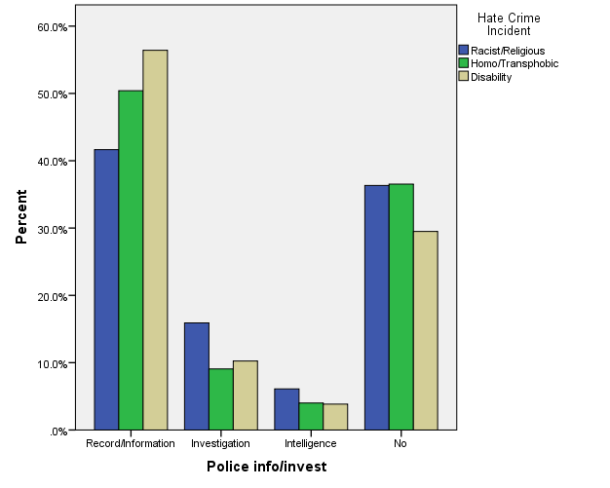

We were interested to find out what kinds of abuse, threat or violence were involved in those incidents that were either not initially entered into the system by the police or not passed onto the police from Arch due to the wishes of the victimised person. Overall, a considerable proportion of these ‘not reported to the police’ incidents (43.7%) involved offensive and abusive language, while 18.1% involved coercive and threatening behaviour – together constituting 61.8% of these incidents. These were then mostly (although certainly not all) non-physical or non-material forms of violence that had by-passed the criminal justice system. While cautious not to go beyond our data without sufficient supporting evidence, it seems that these are the kinds of incidents which, without such reporting systems in place, would perhaps not come to light. Contributing to the established literature on less overt forms of discrimination such as the significance of persistent ‘micro-aggressions’ outlined by Sue et al (2007) and re-considerations of established hierarchies of the ‘seriousness’ of different forms of violence (Morgan and Björkert, 2006), this data seems to highlight the importance of what Iganski (2008) refers to as the ‘everyday’ non-criminalised nature of incidents.

Types of incident
Across the data, reported incidents were evident in a variety of forms. In ‘cleaning up’ we adopted a system of categorisation distinguishing between offensive and abusive language, coercive and threatening behaviour, mediated threats, physical attacks, criminal damage and incitement. The results of this and cross-tabulation with the three strands can be seen in Graph 2, which outlines the proportion of incident type for each of these..

Graph 2: Incident types across monitored strands 2005-2015
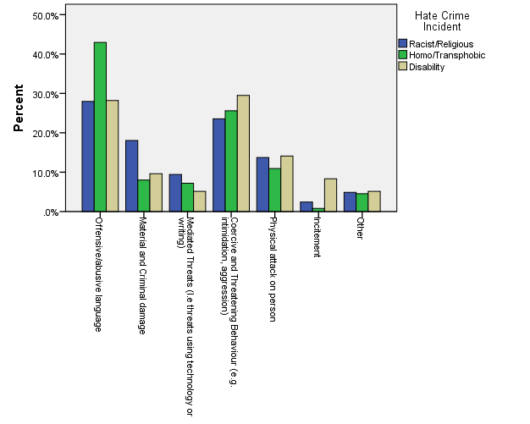

Across the strands, the majority of incidents (54%) fall under either ‘offensive/abusive language’ (29.9%) and ‘coercive/threatening behaviour’ (24.1%), to some extent matching the large proportion of non-police reported incidents falling under these incident types (Graph 1). Again, those acts which may not be criminal, may not be perceived as ‘violent’ or perhaps assumed not to be criminal are those that are most often reported. However, at the same time it is clear that in relation to ‘race’ and religion, it is more likely for incidents to fall under more overtly violent and criminal offences such as ‘material damage’ (18% of incidents for this strand). There are then commonalities across strands, but also some important distinctions.

A few further observations should be made in relation to Graph 2. Firstly the significance of the ‘other’ category should not be dismissed. While only constituting 5% of overall incidents, the fact that some incidents did not fit strict categorisation, shows both the limits of quantification of experience, but also that the Arch system was an evolving and live tool for monitoring the incidents reported, rather than a static snapshot. For example, where details were recorded such incidents included bullying, being turned away from clubs and services, objects being thrown and offensive gestures. Secondly, while the levels of ‘mediated incidents’ appears relatively low, it is worth emphasising that for the ‘race’ and religion strand, this incident type has seen a dramatic rise in reporting between 2012-2015 from 5.7% to 18.2%. This relates to posters, leaflets and graffiti, but also online activity and seems to connect to other trends for the increasing tendency at the national (Copsey, 2003) and global scale (Perry and Olsson, 2009) for online expressions of racism in more and less organised forms. The importance of mediated threats is particularly noticeable when the relatively small number of religion based (also classified as ‘race’ based) incidents are separated out – representing 38% of these incidents. However, the extent to which this is related to societal shifts or the fact that such incidents have only been recorded in more recent years (in line with increased use of the internet), is disputable. Thirdly, the greater predominance of ‘material and criminal damage’ for the ‘race’ and religion strand helps us to think through the geography of different incidents for different groups of victims. Such incidents seem to be more often property based and therefore more likely to also be residence based (Iganski, 2008). Other recent research with newly arrived refugees conducted by a housing association in Newcastle also highlights the close to home nature of many experiences of racism, including many experiences of attacks while the victimised person was at home (Your Homes Newcastle, 2010). As Pain (2000) suggests in relation to gendered violence, and Valentine (2003) in relation to family violence towards LBGT people, the home and the neighbourhood, can be far from the safe spaces they are often presented as.

Geography of incidents
The geographical resolution of the available data from Arch for the ‘race’ and religion strand was not as detailed as data from published police statistics, where more specific location incidents and space typologies can be more clearly discerned (see Craig et al., 2012 for this more fine grained spatial analysis of racist incidents in the North East). In our study, data was made available at ward level across the two cities, and in line with other studies looking at variations within specific cities (see Iganski, 2008 for a study of London boroughs), concentrations of reported incidents were spatially uneven. However, it is also important to note that these incidents were also geographically pervasive – recorded in all wards across the time frame in both cities. To take account of the differences in data collection periods between Newcastle and Sunderland, we calculated proportions of these incidents within rather than across the cities. The results are illustrated in Map 1. Within Newcastle higher concentrations of reported incidents were identified in Byker (14%), Walker (13%), Elswick (12.3%) and Benwell & Scotswood (12.8%). For Sunderland the primary concentrations were in Millfield (city centre) (16%) and Hendon (14.6%). This patterning allowed us to think about the relationship of these trends with other socio-economic indicators, and in conversation with Arch to reflect upon the data in relation to the profiles and histories of these areas.

Map 1

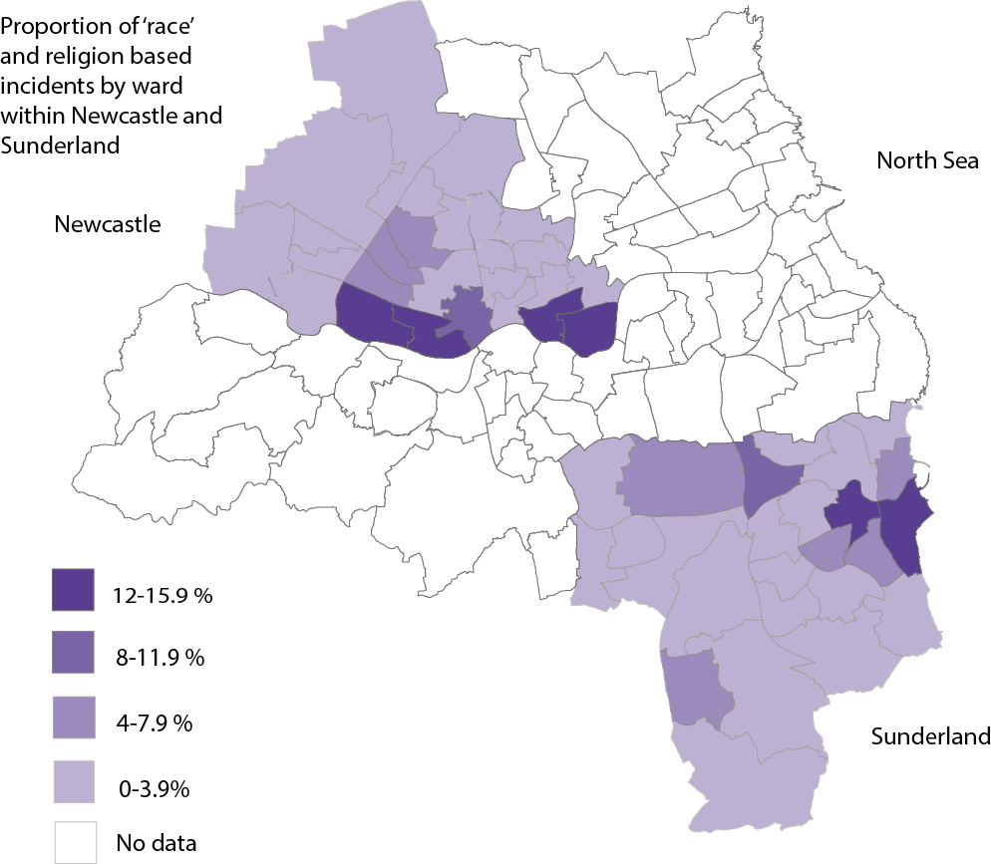

What these areas primarily share is a history of economic decline and subsequently higher than average levels of deprivation. In Newcastle to the east and west of the city centre along the north bank of the River Tyne, these are areas of former industrial activity and home to working class communities that suffered disproportionality from the traumatic transition to a post-industrial economy. The same is true of Hendon in Sunderland which was once the epicentre of thriving port and shipbuilding industries until the 1980s (Ville 1990), but now suffers disproportionately from a range of socio-economic pressures.

Ethnic minority populations are disproportionately exposed to hate crime/incidents in these areas of higher deprivation. However, it is also the case that there is not a perfect correlation with deprivation. For example, while Walker has an average Indices of Multiple Deprivation (IMD) score of 62.2 and Byker 55.8 (2010, IMD) it has a slightly lower recorded level of incidents (see above). We are wary of equating poverty with hate incidents in a mechanistic and sweeping causal relationship that lazily characterises those living in such areas as directly and solely responsible for the patterns outlined, as well as appreciating that data may ‘actually produce spaces, places and landscapes’ (Kitchen and Dodge, 2011). As Poirier (2010) argues, the patterning of such incidents can only be explained through a multi scalar and relational approach. While levels of deprivation and the pressures that come with that are clearly a factor in exacerbating hostility, there also needs to be recognition that these are tensions thrown up when demographic changes occur alongside the ongoing social, economic and cultural marginalisation of these neighbourhoods. In some cases cheaper private sector housing and forced movement into specific housing provision, for example through the dispersal system for those seeking asylum (Bloch and Schuster, 2005), means that newer arrivals in the region have moved into poorly resourced and historically damaged neighbourhoods. The role of external influences including media portrayals of ‘race’ and migration (van Dijk, 1991), the approaches adopted towards these issues by mainstream politicians (Ahmed, 2001), as well as the role and spatially uneven penetration of far-right organisations such as the EDL all contribute to the normalisation of a multitude of racisms in a variety of forms (Frost, 2008).

There are also many differences between and within these areas that need to be highlighted. For example, the central wards of Westgate (11.2%) in Newcastle and Millfield in Sunderland, contain both more deprived residential areas and parts of the commercial city centres. These are levels of complexity not captured here. In addition some wards are far more ethnically and religiously diverse than others. For example, some wards such as Elswick have populations classified as 46.9% ‘non-white’, while others such as Walker have a far less diverse population (7.3% ‘non-white’) resulting in very different dynamics and community relations. In addition, it is worth noting that when compared against the spatial analysis for other strands, there is far less correlation with deprivation (particularly for homophobic and transphobic incidents), suggesting different processes and experiences at work.

Additionally it should be recognised that these are the more visible and overt expressions of violence. In contrast to more institutionalised forms (Bowling, 1999) or those more carefully hidden from view through ‘respectable’ racist narratives (Millington, 2010), these are the incidents that are more often counted. There is a danger therefore of assuming that racism has a set of easily identifiable co-ordinates. While this data does tell us something interesting about where the pressure points may be and therefore form a basis for local intervention and community engagement work, it would be grossly misleading to say that these are the only forms of hate being expressed.

Reporting agencies
Looking at the agencies to which individuals have reported allows us to assess the role of trust but also knowledge as a defining feature of third party reporting. Graph 3 indicates how for different strands, different types of organisations were important. For those incidents reported on the basis of ‘race’ and religion, local council services are considerably more significant that other agency types (37.1%). Unsurprisingly perhaps, given that Arch was originally set up through local authorities as a racist incident recording system, there has, over time, been an increasing engagement by those experiencing racist incidents in this way. Further explanation may be connected to the visibility of local council services – services which are widely drawn upon by those in marginal social groups, such as those from ethnic minority groups (Runnymede, 2015). In the categorisation of reporting agencies we were also able to make observations about where particular agencies fit. For example, although Arch itself may be presumed by many to be a third sector organisation, it is, in fact directly funded by local authorities and therefore is recorded here as a local council service. 14.3% of ‘race’ and religious based incidents were reported directly to Arch. Considering that third party reporting presents alternative non-criminal justice based opportunities for reporting, the level of police involvement still remains important (16.3%); a higher proportion than for those reporting homophobic and transphobic incidents. Again this may be connected to the visibility of the police, or the relationship of trust with the police, but given some of the findings outlined above, may also relate to the presumed seriousness of the incidents being reported.

Graph 3: Type of reporting agencies to Arch across monitored strands 2005-2015
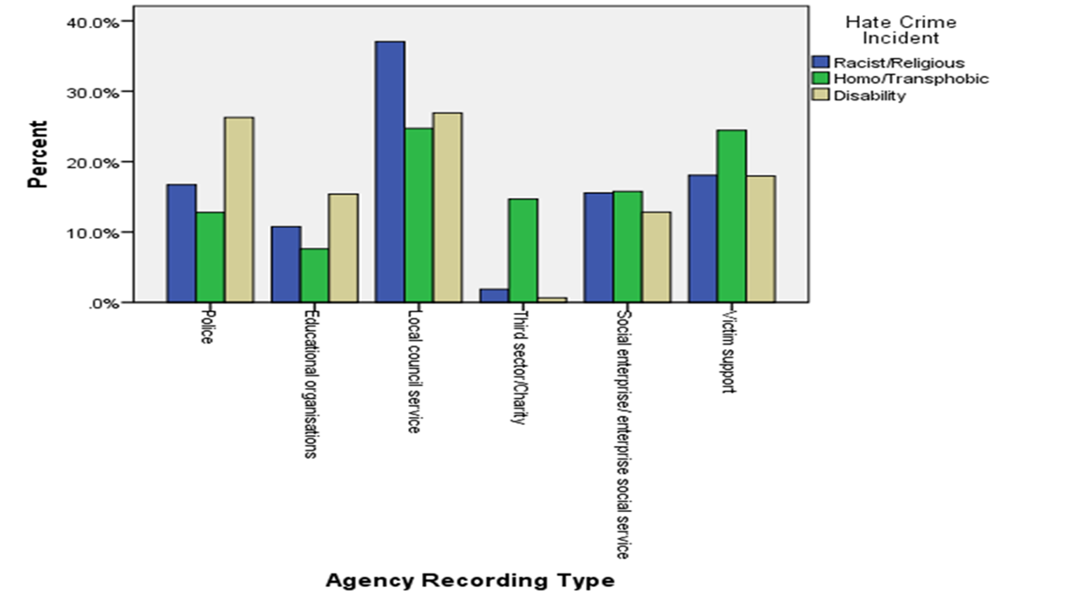
What became apparent was a reliance on a group of agencies based around key public services such as the local council, police, education and housing (particularly social housing and those agencies supporting the needs of asylum seekers and refugees). Despite the focus and efforts of Arch, the role of third sector agencies was limited, especially for incidents reported on the basis of ‘race’ and religion and disability. This can be seen as one area which needs to be developed if there is to be enhanced buy-in and the development of trust amongst communities to come forward.

In addition, it is also clear that Victim Support (VS) – an independent national charity providing advice and support - has played a key role in recording incidents across the strands (18.5% of all incidents), particularly for those reporting homophobic and transphobic incidents (24.2%). Despite this indication of ‘success’, we became aware during the latter stages of the study that VS were increasingly exposed to some of the changes brought about by political changes, in particular the introduction of Police Crime Commissioners (PCCs) in England from 2013. Under devolved powers, decisions over the commissioning of such services were transferred to Commissioners. Controversially, the PCC for the Northumbria Police area chose to commission her own charity ‘Victim’s First’ instead of continuing to fund the work of VS. Not only have questions been raised locally regarding the ethics and credibility of this approach (The Chronicle, 2015a), but also concerning the lack of independence from the PCC and police and the loss of staff, knowledge and experience that this move has entailed (The Chronicle, 2015b). The future existence of some agencies, but also participation in Arch was also increasingly affected by ongoing conditions of austerity in the region.

An ‘age of austerity’ commenced with the arrival of the global economic crisis in the UK in 2008 and policy responses focused around the narrative of an unbearable deficit caused by excessive government spending. In the UK this encompasses unprecedented cuts to state welfare services and funding for local authorities and the voluntary and community sector, alongside periods of increased un(der)employment and reductions in public and private sector pay, pensions, benefits and conditions. From previous research in the region examining the impact of austerity on the public and third sectors (Clayton et al, 2016) and in our work with Arch, it was clear that the ability of organisations (including local authorities) to play an active role was being considerably compromised. We started to then think about how this reporting system was not only a reflection of cultures of reporting and harmful experiences, but also illustrative of the changing landscape of service provision and evolving political agendas.

The politics of reporting

When analysing changes in incidence counts over time a discernible pattern in the rise and fall of reporting became apparent. While numbers are very different, for all strands the variation in levels of reporting follows a broadly similar trend as shown in Graph 4. By 2012 the number of incidents being reported through Arch had risen to 816 per year from a figure of 133 a year in 2005. From 2012, the number of incidents reported declined rapidly to 64 a year in 2015.

Graph 4: Hate incidents as a count for monitored strands 2005-2015

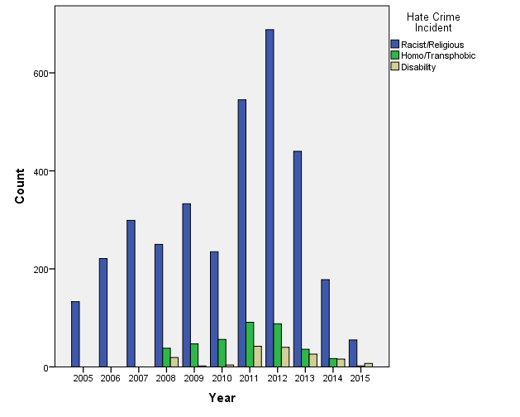
By adopting a multi-scalar approach, we can begin to account for some of these trends. For example, changing legislation and policy discourse around hate crime is not static. In response to some of the changes mentioned at the outset of the paper, Arch only began to count homophobic, transphobic and disablist hate crimes/incidents from 2008 onwards and religious based incidents from 2009. Graph 4 is then partially a reflection of such recording practices as well as indicating the manner in which individuals became increasingly aware that they could report under these categories of hate crime/incident. Cultures of reporting also clearly respond to contexts of increased victimisation, as well as climates that may well discourage individuals from coming forward. These may be localised, but can also be broader in scale and more high profile. For example, the brutal murder of Drummer Lee Rigby in Woolwich in 2013 is a case in point, following which the national anti-Muslim hate crime reporting service Tell MAMA witnessed a 373% increase in one week (Feldman and Littler, 2014). However, more detailed analysis of the data presented in Graph 4 indicates that such a spike is not so clearly observable. Where spikes were observed, for example on 21/10/14 when 12 ‘race’ and religion based incidents were recorded, there are plausible links which could be made to the release of ISIS videos at that time (The Chronicle, 2014). However, attributing such short term trends to particular events is not straightforward and assumes that all incidents can be viewed as rapid reactions to a particular set of external influences.

While these elements are important in framing an interpretation of this data, in conversation with Arch the impact of other factors influencing the level of recording, as opposed to levels of incidence, become significant. These factors in particular, began to help us account for the rapid decline in reporting to Arch since 2012. The local impact of funding changes brought about by the austerity politics of the UK Coalition Government since 2010 seem to offer a more satisfactory account for what is seen here. From this perspective there are two key issues at play. Firstly, in terms of community engagement - without the buy in from external agencies there is no third party reporting system. Although precise figures are not available we know that from a peak of 140 organisations involved in the network that this declined rapidly in the post-2010 era. We also know that the impacts of reduced funding (in the form of local authority funding, but also grants available to the third sector) have had huge implications for service provision. Not only have organisations and individuals disappeared from the service provision landscape, but their capacity to engage in partnership working of all kinds has also been seriously compromised (Clayton et al, 2016).

The other key element is the changing nature of both Arch teams based within Newcastle and Sunderland City Councils, as well as the manner in which Arch is being used in the face of budget constraints at local authority level. At its height in 2011 Arch in Newcastle was comprised of three members of staff, one of whom was solely dedicated to community engagement, to maintain relationships with communities and those agencies involved in reporting and to support them through the conflict management work. In 2011, due to budgetary changes this outreach element was ended with the loss of this member of staff. For similar reasons in 2013 the Sunderland branch of Arch ceased with the loss of the sole member of staff involved in recording incidents there. The overall team across the two cities therefore contracted by 50% in 2 years, radically influencing the capacity of the team as well the model of practice they had honed since 2005. Furthermore, in 2015, the prior expertise, knowledge and emotional investments of the established team have been disposed of completely and replaced to a limited extent with staff from within Newcastle local authority. These staff already have other existing and often unrelated roles and are therefore unable to continue delivering the system in its established form. Arch will now become only a monitoring tool and a database. Similar models, whereby community engagement is removed from the ethos of the work, and data collection becomes central, have already been put in place in other local authorities in the region and the partial evidence thus far suggests that recording rates are extremely low. What this seems to suggest is the distinction between statistical data collection and deep seated affective commitment to these activities is not as clear cut as a simplistic dichotomy between quantitative and qualitative research methodologies would imply.

The experience of researching alongside a group of passionate individuals going through the last throes of their occupation has enabled us not only to see the value in the process of data collection which goes well beyond the bars on the graphs presented above, but also the emotional investments put into this work over the last 10 years. The expressions of sadness and frustration which has come through in these engagements and the sense of loss has been tangible. Although not the primary focus of this discussion – the emotional politics involved here (Clayton et al 2015) – cannot be ignored. The fact that this data can no longer be collected and used in the same way again caused a level of concern, alarm and upset that revealed a great deal about the damage done by tightened budgets and narrowing priorities.

Conclusion

The use of quantitative approaches in understanding experiences of violence that are categorised as hate crimes/incidents is problematic in that through categorisation we achieve simplification. Crucially, our discussion above was far from just a statistical exercise. We made sense of the data in relation to both our wider reading and understanding of the topic, but most significantly in relation to the experiences of those working within Arch and the changing funding landscape. It was this dialogue between the statistical, the experiential and the political which we wish to stress here. While there certainly are limitations to such data and its interpretation, from a critical and post-positivist perspective, the value of both this form of data collection and the analysis we helped to conduct lies in a number of areas.

Firstly, our analysis has helped to assess the reporting landscape in these places by identifying some of the broader patterns of cultures of reporting. This has included an appreciation of similarities and differences between the experiences of different victimised communities, but also who is reporting to whom on the basis of what kind of incident. There are clearly implications here in relation to specialist services and resistance to more generic forms of third party reporting, such as that recently suggested by the previous London Mayor. Secondly, this analysis as a piece of ‘action orientated research’ has been of direct use to Arch and allowed them to think about how they could more effectively understand these incidents through improved recording practices. This includes the now standardised collection of identity based variables such as sexuality and faith that were absent from the original database. Thirdly, this analysis has illustrated the value of this model of response to hate crimes/incidents. While it is acknowledged that there are areas which could be further developed, such as the greater involvement of third sector organisations, it is clear that Arch have helped to support individuals and communities, including (but not limited to) those who do not want to report incidents to the Police. Fourthly, value is seen, not just in the data itself, but how the data has been used by those involved in its collection. That is, as a standalone exercise the recording of this statistical data may become not only meaningless, but also ineffective. Without the outreach and engagement work which has mirrored the collection of the data, the problematisation of various forms of violence targeting stigmatised and marginalised communities may risk disappearing off the local radar. What this discussion has therefore allowed us to see is a relationship and co-dependence between the need for recording and more pro-active, engaged and sustainable responses to hate crimes/incidents. This has led us onto a discussion of the politics of data collection – and the clear threat that declining resource and political change is posing. The role of the PCC in dictating the terms of support put in place for victims and the decisions by previously pro-active local authorities in re-directing resources away from these activities will have an impact on the profile of this agenda and on the kinds of work that can be done to tackle violence and support victims.

Statistics, can be designed, collected, analysed and used for all sorts of purposes – they are never politically neutral (Kitchen, 2014b). Increasingly comprehensive commercial and governmental data collection for purposes of control can be overbearing, step on the toes of various freedoms and be employed as surveillance rather than forming the basis for progressive change. However, at the same time in the UK there are worrying moves to alter the data collection landscape around issues of inequality and social justice. In particular, a problematic move away from data collection as a tool to appreciate to the scale and extent of specific social problems has been highlighted (Radical Statistics Reduced Statistics Working Group, 2012). Recent controversies over the future of the census (Dorling, 2013), possible scenarios for the indices of multiple deprivation as well as changing thresholds for the measurement of poverty are all cases in point. Such moves will arguably hide those problems which are being exacerbated by climates of exclusion and conditions of austerity. On a localised scale this can be seen in our own study, where levels of reporting to Arch have reduced drastically in line with reduced prioritisation and resourcing. As Robertson and Travaglia (2014) suggest, this may well lead “to a future where inequities can be downplayed for lack of systematic evidence”. However, this is not a straightforward defence of counting for its own sake. In the case of Arch, the data only makes sense and is only there because of other practices of commitment and intensities of investment (Clayton et al 2015). With little and dis-located intelligence of both a quantitative and long term experiential variety, it is not possible to make intelligent interventions.

References
Ahmed, S. (2001) ‘The organisation of hate’ Law and Critique, 12(3), 345-365.
Ardley, J. (2005) ‘Hate Crimes: A Brief Review’ International Journal of Social Policy, 25: 54-66.
Bloch, A. and Schuster, L. (2005) At the extremes of exclusion: deportation, detention and dispersal Ethnic and Racial Studies, 28(3), 491-512
Bowling, B. (1999) Violent racism: Victimization, policing and social context. Oxford University Press.
Browne, K., Bakshi, L., & Lim, J. (2011) ‘‘It's Something You Just Have to Ignore’: Understanding and Addressing Contemporary Lesbian, Gay, Bisexual and Trans Safety Beyond Hate Crime Paradigms’ Journal of Social Policy, 40(4): 739-756.
Bufacchi, V. "Two concepts of violence." Political Studies Review 3(2): 193-204.
Chakraborti, N., & Garland, J. (2015) Hate crime: impact, causes and responses. 2nd Edition Sage: London.
Chakraborti, N. (2010) Crimes Against the" Other": Conceptual, Operational, and Empirical Challenges for Hate Studies. Journal of Hate Studies, 8(1), 9-28.
Chakraborti, N. Garland, J. (2012) ‘Reconcepualizing hate crime victimisation through the lens of vulnerability and ‘difference’ Theoretical Criminology, 16: 499-514.
Clarke, R. V. (1995) ‘Situational Crime Prevention’ Crime and Justice 19: 91–150.
Clayton, J., Donovan, C. and Merchant, J. (2015) Emotions of austerity: Care and commitment in public service delivery in the North East of England, Emotions, Space and Society, 14, 24–32
Clayton, J., Donovan, C. and Merchant, J. (2016) Distancing and limited resourcefulness: Third sector service provision under austerity localism in the north east of England, Urban Studies, 53, 4 723-740.
The Chronicle (2014) 17/10/14 ‘ISIS videos leave North East Muslims targeted and blamed say Tyneside campaigners’, http://www.chroniclelive.co.uk/news/north-east-news/isis-videos-leave-north-east-7952276
The Chronicle (2015a) 16/04/15 ‘No investigation over Northumbria crime commissioner's victims' charity cash grant’ http://www.chroniclelive.co.uk/news/north-east-news/no-investigation-over-northumbria-crime-9060424
The Chronicle (2015b) 01/04/15 ‘Tyneside victims of crime will turn to new service as Victims First Northumbria is launched’ http://www.chroniclelive.co.uk/news/north-east-news/tyneside-victims-crime-turn-new-8958172
Copsey, N. (2003) ‘Extremism on the net: The extreme right and the value of the Internet’, in Gibson, R., Nixon, P. and Ward, S. (eds) Political Parties and the Internet: Net Gain (London: Routledge, 2003), pp. 218-233.
Copsey, N., Dack, J., Littler, M., & Feldman, M. (2013) Anti-Muslim hate crime and the far right. Teeside: Teeside University: Centre for Fascist, Anti-Fascist and Post Fascist Studies.
Craig, G., O'Neill, M., Cole, B., Antonopoulos, G., Devanney, C. and Adamson, S. (2012) Race, crime and justice in the North East region. Technical Report. Durham, Durham University.
Dalton, C., and Thatcher, J. (2014) ‘What does a critical data studies look like, and why do we care? Seven points for a critical approach to “Big Data”’ Society and Space open site.
https://societyandspace.com/material/commentaries/craig-dalton-and-jim-thatcher-what-does-a-critical-data-studies-look-like-and-why-do-we-care-seven-points-for-a-critical-approach-to-big-data/

Dorling, D. (2013) ‘The 2011 Census: What surprises are emerging and how they show that cancellation is stupid’, 109, Radical Statistics
http://www.radstats.org.uk/no109/Dorling109.pdf

Feldman, M., & Littler, M. (2014) Tell MAMA Reporting 2013/14 Anti-Muslim Overview, Analysis and ‘Cumulative Extremism’. Teesside University Centre for Fascist, Anti-Fascist and Post-Fascist Studies.
Frost, D. (2008) Islamophobia: examining causal links between the media and “race hate” from “below”. International Journal of Sociology and Social Policy, 28(11/12), 564-578.
Garland, J. and Chakraborti, N. (2012) 'Divided By a Common Concept? Assessing the Implications of Different Conceptualisations of Hate Crime in the European Union', European Journal of Criminology, 9 (1): 38-51.
Gitelman, L. (2013) Raw data is an oxymoron. MIT Press
Green, D. P., McFalls, L. H. and Smith, J. K. (2001) ‘Hate crime: An emergent research agenda’ Annual review of sociology: 479-504.
Hall, N. (2013) Hate crime. Routledge.
Hesse, B. (1993) Racism and spacism in Britain. Tackling Racial Attacks, Leicester: Centre for the Study of Public Order, Leicester University.
Hunter, R. (2013) Contesting the dominant paradigm: Feminist critiques of liberal legalism. In M. Davies & V.E. Munro (Eds.), The Ashgate research companion to feminist legal theory. Surrey, England: Ashgate.
Iganski, P. (2008) Hate crime and the city. Policy Press.
Iganski P. and Sweiry A., How ‘hate’ hurts globally, In: The Globalisation of Hate, 2016, Oxford University Press; Oxford, pp. 96-109.
Jacobs, J. B., & Potter, K. (2000) Hate crimes: Criminal law & identity politics. Oxford University Press.
Kindon, S., Pain, R. & Kesby, M. (2008) Participatory action research. International Encyclopaedia of Human Geography, pp. 90-95.
Kitchen, R., & Dodge, M. (2011) Code/Space. Software and Everyday Life. Cambridge.
Kitchen, R. (2014a) ‘Short presentation on the need for critical data studies’, The Programmable City, Maynooth University, Ireland. http://www.maynoothuniversity.ie/progcity/2014/04/short-presentation-on-the-need-for-critical-data-studies/
Kitchen, R. (2014b) The Data Revolution: Big Data, Open Data, Data Infrastructures and Their Consequence, Sage.
Kwan, M. P., & Schwanen, T. (2009) Quantitative revolution 2: The critical (re) turn. The Professional Geographer, 61(3), 283-291.
Lawson, V. (1995) ‘The Politics of Difference: Examining the Quantitative/Qualitative Dualism in Post-Structuralist Feminist Research’ The Professional Geographer, 47(4): 449-457.
McDevitt, J., Levin, J., & Bennett, S. (2002) ‘Hate crime offenders: An expanded typology’. Journal of Social Issues, 58(2): 303–317
McLaughlin, E. (2002) ‘Rocks and hard places: the politics of hate crime’ Theoretical Criminology, 6(4), 493-498.
Macpherson, S. W. (1999) The Stephen Lawrence Inquiry: report of an inquiry. TSO.
Meer, N., & Modood, T. (2012) For “Jewish” Read “Muslim”? Islamophobia as a Form of Racialisation of Ethno‑Religious Groups in Britain Today. Islamophobia Studies Journal, 1(1): 34-53.
Millington, G. (2010) Racism, class ethos and place: the value of context in narratives about asylum‐seekers. The sociological review, 58(3), 361-380.
Morgan, K., & Björkert, S. T. (2006) ‘‘I'd rather you'd lay me on the floor and start kicking me': Understanding symbolic violence in everyday life’ Women's Studies International Forum 29(5): 441-452.
Pain, R. (2000) Place, social relations and the fear of crime: a review. Progress in Human Geography, 24(3): 365-387.
Pain, R. (2003) Social geography: on action-orientated research, Progress in Human Geography, 27(5): 649–657
Perry, B. (2001) In the name of hate: Understanding hate crimes. Psychology Press.
Perry, B. (2003) ‘Where do we go from here? Researching hate crime’ Internet Journal of Criminology, 3: 45-47.
Perry, B. (2006) ‘A Crime by Any Other Name: The Semantics of “Hate”’,The Journal of Hate Studies, 4: 121-137
Perry, B., & Olsson, P. (2009) Cyberhate: the globalization of hate. Information & Communications Technology Law, 18(2): 185-199.
Poirier, Marc R., The Multiscalar Geography of Hate Crimes (August 6, 2010). Seton Hall Public Law Research Paper No. 1654350.
Reduced Statistics working group (2012) ‘The effect of the cuts on government statistics and their use’ Radical Statistics http://www.statsusernet.org.uk/HigherLogic/System/DownloadDocumentFile.ashx?DocumentFileKey=4122199d-65df-4f2f-a90a-17240e458008&forceDialog=0
Ray, L., and Smith, D. (2001) Racist offenders and the politics of ‘hate crime’. Law and Critique, 12(3): 203-221.
Robertson, H. and Travaglia, J. (2015) ‘A Politics of Counting – Putting People Back into Big Data’, Discover Society, 23, http://discoversociety.org/2015/07/30/a-politics-of-counting-putting-people-back-into-big-data/
Runnymede Trust (2015) The 2015 Budget Effects on Black and minority ethnic people http://www.runnymedetrust.org/uploads/The%202015%20Budget%20Effect%20on%20BME%20RunnymedeTrust%2027thJuly2015.pdf
Sherry, M. (2010) Disability Hate Crimes: Does Anyone Really Hate Disabled People? Farnham, Ashgate
Sin, CH., Hedges, A., Cook, C., Mguni, N., & Comber, N. (2009) Disabled people's experiences of targeted violence and hostility. Manchester, NH: Equality and Human Rights Commission.
Sue, D. W., Capodilupo, C. M., Torino, G. C., Bucceri, J. M., Holder, A., Nadal, K. L., & Esquilin, M. (2007) ‘Racial microaggressions in everyday life: implications for clinical practice.’ American psychologist, 62(4), 271.
Valentine, G., Skelton, T. and Butler, R. (2003): ‘Coming out and outcomes: negotiating lesbian and gay identities with, and in, the family.’ Environment and Planning D 21.4 479-500.
van Dijk, T. A. (1991) Racism and the Press, London, RoutledgeVille
Ville, S. (1990) Transport and the Development of the European Economy, 1750–1918, Macmillan, London.
Wong, K., & Christmann, K. (2008) The role of victim decisionmaking in reporting of hate crimes. Safer Communities, 7(2): 19-35.
Your Homes Newcastle (2010) Your Homes Racist Incident Report

In the UK, a Hate Incident is any incident which the victim, or anyone else, thinks is based on someone’s prejudice towards them because of their race, religion, sexual orientation, disability or because they are transgender. Not all hate incidents will amount to criminal offences, but those that do become Hate Crimes. We use the term ‘hate crime/incident’ in this paper to indicate that we refer here to incidents which may or may not amount to or in time become criminal offences.
The term ‘monitored strands’ is used to refer to those offences targeting specific groups, which under UK legislation are monitored by criminal justice agencies. These include offences targeting any racial group or ethnic background or national origin, any religious group, including those who have no faith, any person’s sexual orientation, any disability, including physical disability, learning disability and mental health and people who are transsexual, transgender, transvestite and those who hold a gender recognition certificate.
Gateshead, City of Newcastle upon Tyne, North Tyneside, South Tyneside, City of Sunderland
Under the Public Order Act (1986) and latterly the Criminal Justice and Police Order Act (1994) and Racial and Religious Hatred Act 2006, a criminal offence is committed if the perpetrator stirs up racial (or religious) hatred or the victim is subject to harassment, alarm or distress.
The EDL (English Defence League), formed in 2009, is an overtly anti-Muslim far-right street protest organisation. It has held a number of ‘demonstrations’ in Newcastle in 2010, 2012 and 2103. They have also held one demonstration in Sunderland in 2012.
See http://www.theguardian.com/society/2015/aug/01/jewish-muslim-lgbt-communities-hate-crime-hotline-boris-johnson-london

