Experimental and Theoretical Studies of Aromatase Inhibitors Derived from Formestane

Glenroy D. A. Martin,* # Javier Narvaez,† Rachel Bulmer‡ and Marcus C. Durrant*‡

#Department of Life and Physical Sciences, Fisk University, 1000 17th Ave N, Nashville, TN 37208, United States

†Chemistry, Biochemistry and Physics Department, The University of Tampa, 401 West Kennedy Blvd., Tampa, FL 33606, United States

‡Department of Applied Sciences, Northumbria University, Newcastle upon Tyne, NE1 8ST, United Kingdom

Corresponding Authors

*Tel: 615 329 8781 Fax: 615 321 2389 E-mail: gmartin@fisk.edu

*Tel: +44 (0) 191 243 7239 Fax: +44 (0) 191 227 3519. E-mail: marcus.durrant@northumbria.ac.uk

Bioconversion of the aromatase inhibitor formestane (4-hydroxyandrost-4-ene-3,17-dione) (**1**) by the fungus *Rhizopus oryzae* ATCC 11145 resulted in a new minor metabolite 3,5α-dihydroxyandrost-2-ene-4,17-dione (**2**) and the known 4β,5α-dihydroxyandrostane-4,17-dione (**3**) as the major product. The structural elucidation and bioactivities of these metabolites are reported herein. Molecular modeling studies of the interactions between these metabolites and the aromatase protein indicated that acidic (D309), basic (R115), polar (T310), aromatic (F134, F221, and W224), and non-polar (I133, I305, A306, V369, V370, L372, V373, M374, and L477) amino acid residues contribute important interactions with the steroidal substrates. These combined experimental and theoretical studies provide fresh insights for the further development of more potent aromatase inhibitors.



Keywords: aromatase; aromatase inhibitor; molecular docking; *Rhizopus oryzae*; formestane; biotransformation, cytochrome P450.

Aromatase (EC 1.14.14.14) is an enzyme that converts androgens to estrogens.1 In the conversion of androstenedione to estrone, for example, ring A of androstenedione is modified via a three-step sequence of C19 hydroxylations, C2-C3 enolization and finally, aromatization by the aromatase enzyme.2 These estrogens, like estrone, 17β-estradiol and 17β,16α-estriol, are implicated in the proliferation of estrogen-dependent breast tumors in postmenopausal women. By inhibiting the aromatase it is possible to treat this and other types of cancers.3, 4 Current treatment of breast and ovarian cancers in postmenopausal women includes the use of third generation aromatase inhibitors such as the azole compounds anastrazole and letrozole. They compete with the substrate for binding to the aromatase enzyme active site.5, 6 Another clinically used drug is the steroid exemestane7 which binds irreversibly to the enzyme.8, 9

In our search for new steroidal aromatase inhibitors (AIs) with potentially enhanced biological efficacy and fewer side effects, we recently reported the isolation of one new [4,11α,17β-trihydroxyandrost-4-en-3-one (**6**)] and three known metabolites from the bioconversion of the second-generation aromatase inhibitor formestane (**1**) by the prolific steroid transformers *Beauveria* *bassiana* ATCC 7159 and *Rhizopus oryzae* ATCC 11145.10 Bioactivity data studies showed that these metabolites were more potent aromatase inhibitors than formestane itself. This may be attributed to a more favorable substrate-enzyme interaction within the aromatase’s active site.

In continuation of this study, the extract from a large scale fermentation of formestane with *R. oryzae* was reinvestigated to identify the minor metabolites therein. The isolation, structural elucidation and biological studies of a new metabolite are reported in this paper. In addition, molecular docking studies were conducted to elucidate the binding modes of the aromatase and the potential steroidal aromatase inhibitors. The information obtained from these combined experimental and computational studies should provide new insights for the design of better AI agents.



**RESULTS AND DISCUSSION**

Bioconversion of formestane (**1**) with *R. oryzae* yielded three potential metabolites based on thin layer chromatography (TLC) comparison with the control extracts. Only two were present in sufficient quantities for characterization. Purification on silica gel with increasing ethyl acetate in hexane yielded compounds **2** and **3** (Figure 1).

Low Resolution Mass spectral (LRMS) data ([M + H]+ = 321.4 of metabolite **3** suggested the presence of a second hydroxyl group compared to formestane (**1**). The absence of the C4-C5 double bond was noted in the IR spectrum. Comparison of the 1H and 13C NMR

data of this metabolite with our previously reported data10 confirmed the product as 4β,5α-dihydroxyandrostane-3,17-dione (**3**) (Figure 1).

HRMS data ([M+NH4]+ = 336.2169) of metabolite **2** implied a molecular formula of C19H26O4. The increase in the atomic mass units (a.m.u.) when compared to formestane suggested the presence of an additional hydroxyl group. Absorptions in the FTIR spectrum at 1724 and 1673 cm-1 accounted for unconjugated and conjugated carbonyl stretches respectively. An olefinic stretch at 1658 cm-1 and a hydroxyl absorbance at 3432 cm-1 were also noted. Comparison of 1H and 13C NMR spectroscopic data of **1** with the 1D and 2D NMR (1H-1H COSY, H2BC, HMQC and HMBC) data of compound **2** (Figures S1-S6) confirmed the hydroxylation at C-5 as well as other olefinic and carbonyl moieties as a result of keto-enol tautomerizations within ring A. A new olefinic proton signal was observed for H-2 (δH 5.96, dd, *J* = 7.1, 1.3). The HMBC spectrum showed 2,3*J* couplings from H-2 (δH 5.96) to C-3 (δC 144.7), C-4 (δC 194.3) and C-10 (δC 43.5). Additionally, the C-3 hydroxyl proton (δH 5.80) showed correlations to C-2 (δC 115.1), C-3 (δC 144.7) and C-4 (δC 194.3). The new hydroxyl group at C-5 was confirmed from HMBC correlations of H-1 (δH 2.28), H-6 (δH 1.64) and H-19 (δH 1.12) to C-5 (δC 77.0) (Figure 2 and Table 1). The carbonyl at C-17 (δC 220.6) remained intact with no other noticeable changes in the remaining rings B-D of **2** when compared to **1**. This metabolite was therefore assigned as 3,5α-dihydroxyandrost-2-ene-4,17-dione (**2**).



Figure 1. Bioconversion of formestane (**1**) by *R. oryzae*.



Figure 2. Key 1H-1H COSY (bonds) and HMBC (arrows) correlations for compound **2**.

Table 1. 1H (600 MHz) and 13C (151 MHz) NMR assignments of compound **2** in CDCl3.

|  |  |  |  |
| --- | --- | --- | --- |
| Position | δC, type | δH, mult (*J* in Hz) | HMBC (H → C)*a* |
| 1 | 29.5, CH2 | 2.56 dd (18.7, 2.6), 2.25 dd (18.7, 7.2) | 2, 3, 5, 9, 10 |
| 2 | 115.1, CH | 5.96, dd (6.8, 2.9) | 3, 4, 10 |
| 3 | 144.7, C | 5.8, br s (OH) | 2, 3, 4 |
| 4 | 194.3, C |  |  |
| 5 | 77.0, C |  |  |
| 6 | 28.5, CH2 | 2.31 dt (12.5, 3.5), 1.64 td (13.2, 4.8) | 4, 5, 7 |
| 7 | 27.1, CH2 | 1.76 m, 0.86 m | 6, 8 |
| 8 | 33.9, CH | 1.60 m | 9, 14 |
| 9 | 43.6, CH | 1.23, m | 8 |
| 10 | 43.5, C |  |  |
| 11 | 21.1, CH2 | 1.55 m, 1.42 m | 9, 13 |
| 12 | 31.1, CH2 | 1.84 dt (12.6, 2.9), 1.21 m | 18 |
| 13 | 47.8, C |  |  |
| 14 | 51.1, CH | 1.22, m | 8, 17, 18 |
| 15 | 21.8, CH2 | 1.93 m, 1.56 m | 13, 14, 17 |
| 16 | 35.9, CH2 | 2.08 dt (19.4, 9.2), 2.46 dd (18.7, 7.8) | 14, 17 |
| 17 | 220.6, C |  |  |
| 18 | 13.9, CH3 | 0.89, s | 12, 14, 17 |
| 19 | 16.5, CH3 | 1.12, s | 1, 5, 9, 10 |

aHMBC correlations are from proton(s) stated to the indicated carbon(s).

The rationale for the formation of metabolites **2** and **3** is as follows. The formation of **3** is thought to occur via enzymatic constraints whereas **2** results from a combination of electronic factors within the substrate and enzymatic constraints. For metabolite **3**, the semi-planar arrangement about the sp2 hybridized carbons C-3, C-4 and C-5 in ring A of formestane sets up the appropriate geometry for the transfer of the oxo-derivative from the iron heme of the cytochrome P-450 enzyme. This hydroxyl addition is accomplished in a Michael style fashion to the C-5 position to afford the C3-C4 enol intermediate (Scheme 1). Tautomerization of this enol generates 3,17-diketo-4β,5α-dihydroxymetabolite (**3**). The formation of enolic intermediates is not uncommon in fermentations involving *R. oryzae*, which is widely recognized as the C-6β hydroxylating fungus of Δ4-3-ketosteroids11 in which hydroxylation occurs via the Δ3,5-enolate.12,13

The production of metabolite **2** may be visualized in two ways. The first involves a concerted approach via a cascade of keto-enol tautomerization reactions. Abstraction of the H-2α-proton generates the C2-C3 enol and deprotonation of the C-4 hydroxy group results in the formation of the ketone and subsequent hydroxylation at C-5 to yield the 3,5α-dihydroxyandrost-2-ene-4,17-dione (**2**) (Scheme 2).



Scheme 1. Proposed hydroxylation mechanism for the formation of metabolite **3**.



Scheme 2. Proposed concerted mechanism for the formation of metabolite **2**.

An alternate mechanism for the formation of **2** involves the initial epoxidation of the C4-C5 olefin group via the activated iron heme. Abstraction of the H-2α proton generates the C2-C3 enolate followed by subsequent intramolecular nucleophilic ring opening of the epoxy intermediate to yield metabolite **2** (Scheme 3).



Scheme 3. Alternate mechanism for the formation of metabolite **2** via epoxy intermediate.

The intramolecular rearrangement of the epoxy intermediate to a hydroxyenone is not unprecedented. Schneider and Viljoen,14 in their synthesis of naturally occurring diosphenols and hydroxydiosphenols, reported a similar type of rearrangement via an epoxide intermediate. Intramolecular nucleophilic ring opening of the epoxide yielded the desired products. This alternate mechanism is feasible as the cytochrome P450 enzymes within *Rhizopus oryzae* are noted for the epoxidation of olefins.15

A previous report10 on the antiproliferative and aromatase inhibition activities of formestane and its metabolites **3**-**6** revealed that all the metabolites were more potent than the parent compound **1** (Table 2). Metabolite **6** was the most active against breast cancer cells (MCF-7) (IC50, 12.5 µM) while compound **5** gave the best aromatase inhibition activity (IC50, 3.9 µM), similar to that of the positive control Naringenin (3.3 µM). Evaluation of the antiproliferative and aromatase inhibition activities of the new metabolite **2** afforded IC50 values of 19.3 µM and no significant activity respectively.

Table 2. Aromatase inhibition assays of formestane and its metabolites **2**-**6**, compared with calculated binding energies.

|  |  |  |
| --- | --- | --- |
| Compound | IC50 againstaromatase, μM*a* | Binding energy, kcal/mol |
| **1** | 58.6 ± 6.3 | -58 |
| **2** | NSA*b* | -90 |
| **3** | 29.1 ± 0.9 | -63 |
| **4** | 47.0 ± 4.9 | -51 |
| **5** | 3.9 ± 1.3 | -81 |
| **6** | 10.9 ± 0.6 | -53 |

*a*Values for **1** and **3** - **6** are from reference 10; value for naringenin is 3.3 ± 0.2 μM. *b*NSA = No significant activity.

With the bioactivities of the steroids in hand, molecular docking studies were conducted to investigate their structure-activity relationships (SAR). The binding modes of formestane, its new metabolite **2** and the previously reported metabolites **3**-**6**10 inside the crystal structure of the aromatase enzyme were investigated with the use of HyperChem software.16



The crystal structure of aromatase (PDB id 3S79),3 which includes an androstenedione (ASD) ligand, was used as the docking target for the steroidal ligands. Models of the steroids **1**-**6** were constructed and docked into the protein, using the ASD ligand as a template. The ASD was then deleted to leave the aromatase with the required ligand. The models were further refined by geometry optimizations, both before and after molecular dynamics (MD) calculations at 300 K, using the BIO+CHARMM force field. Full details of these procedures are given in the Experimental section. It should be noted that since the binding energies in Table 2 are for *in vacuo* calculations, they provide only a rough guide to the relative strengths of the enzyme-inhibitor interactions. The most important interactions between steroids **1**-**6** and the aromatase active site were determined by identifying all protein residues within 10 Å of atom C9 in each ligand. These contacts are summarized in Table 3, whilst Figures 3 and 4 provide graphical representations. The interactions between the protein and all of these ligands consist largely of hydrophobic (van der Waals) contacts plus some hydrogen bonds to the polar oxygen-containing functional groups of the ligands. Very similar ligand environments were described previously for exemestane and ASD, as determined by X-ray crystallography.3 As expected for steroid-based molecules, the interactions between these inhibitors and the protein consist of a combination of general hydrophobic interactions involving a variety of amino acids, plus a few more specific hydrogen bonds (Table 3 and Figure 4). As such, the entropic contribution to the overall free energy for ligand binding is likely to be significant and a quantitative structure-activity relationship analysis is not practicable.

Table 3. Interactions of ligands with residues within the protein structure.

|  |  |  |
| --- | --- | --- |
| **Residue** | **Amino Acid** | **Interaction** |
| 115 | Arginine | Hydrogen bonding |
| 133 | Isoleucine | Hydrophobic |
| 134 | Phenylalanine | Hydrophobic |
| 221 | Phenylalanine | Hydrophobic |
| 224 | Tryptophan | Hydrophobic |
| 305 | Isoleucine | Hydrophobic |
| 306 | Alanine | Hydrophobic,  hydrogen bonding (backbone NH) |
| 309 | Aspartate | Hydrogen bonding |
| 310 | Threonine | Hydrogen bonding |
| 369 | Valine | Hydrophobic |
| 370 | Valine | Hydrophobic |
| 372 | Leucine | Hydrophobic |
| 373 | Valine | Hydrophobic |
| 374 | Methionine | Hydrophobic,  hydrogen bonding (backbone NH) |
| 477 | Leucine | Hydrophobic |

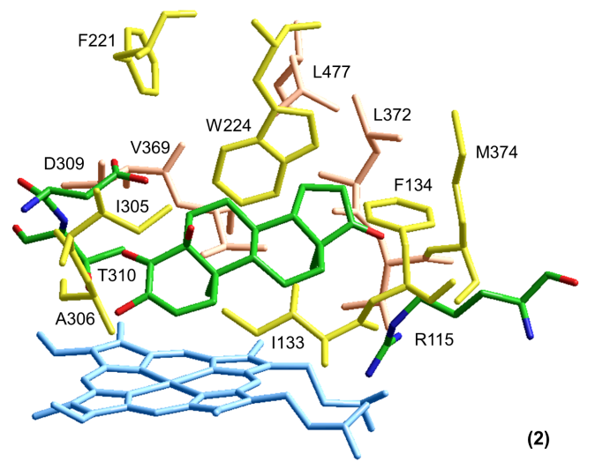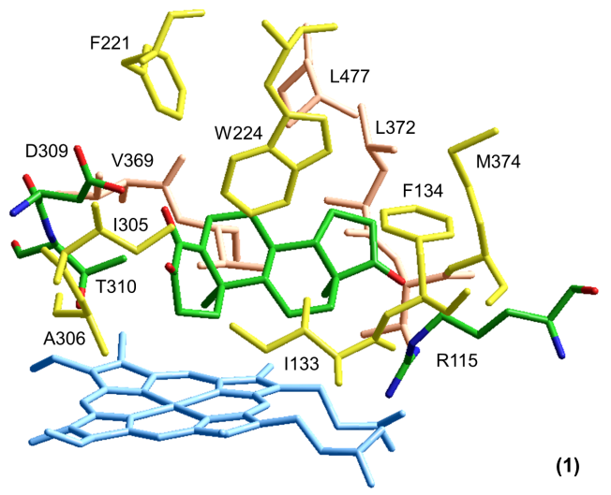

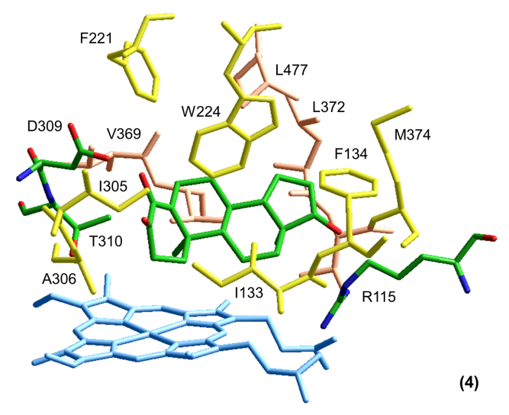

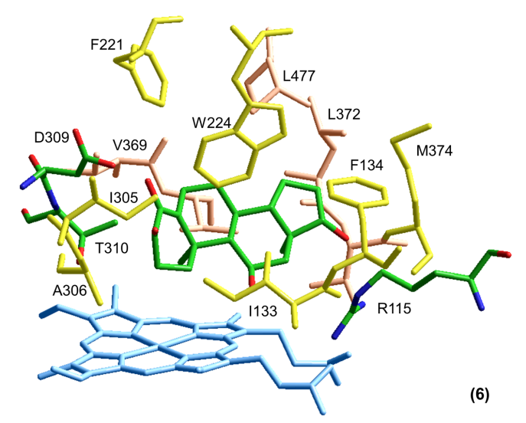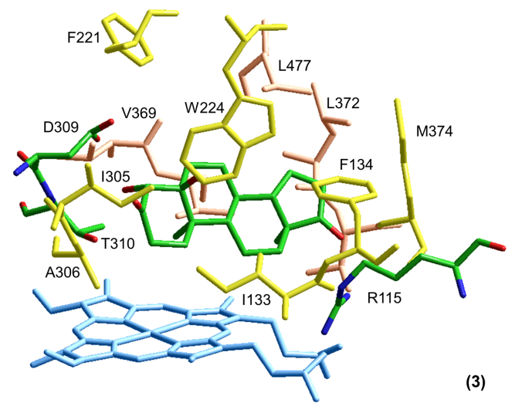

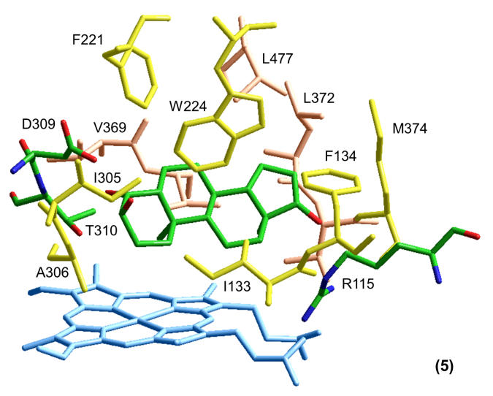**Figure 3**.Binding ofthe steroid ligands **1** - **6** at the aromatase active site. Hydrogen atoms are omitted for clarity. Coloring as follows: heme, pale blue; hydrophobic residues, yellow (where in front of the ligand) and orange (where behind the ligand); steroids, R115, D309, T310, colored by atom (green, carbon; blue, nitrogen; red, oxygen). V370 and V373 are not labelled for clarity.



Figure 4. Hydrogen bonding interactions between the steroids **1** - **6** and neighboring protein residues. The calculated distance between the heavy atoms in each interaction is < 3.0 Å.

Our calculations predict that for all six steroids, the O-functional group at C17 is always involved in hydrogen bonds with the protein, regardless of whether this is a ketone or hydroxyl, although there are some variations in the protein residue partners. The same is true for the experimentally characterized enzyme-inhibitor complexes with exemestane and ASD.3 When C3 has the only O-based functional group in the A ring (as in exemestane and ASD3), or bears a hydroxyl substituent (as in **2** and **5**), this is hydrogen bonded to the protein. In contrast, the C3 ketones **1**, **3**, **4** and **6** show no specific interactions with the protein; the hydrogen bond shifts to the C4 hydroxyl group instead. The hydroxyl group at C5 is hydrogen bonded for **2** but not for **3**, whilst that at C11 in **6** shows no specific interactions with the protein.

The observed lack of *in vitro* aromatase inhibition for steroid **2** cannot be explained by our modelling studies, which suggest that **2** should be capable of a favorable interaction with the binding pocket. Furthermore the observation that **2** is effective against MCF-7 cells (with an IC50 of 19.0 ± 1.3 μM) suggests that this steroid might be capable of *in vivo* aromatase inhibition, although the possibility of a different anti-proliferation mechanism in this case cannot be ruled out*.*

In summary, a new bioactive metabolite, 3,5α-dihydroxyandrost-2-ene-4,17-dione (**2**), was obtained from the microbial transformation of formestane by *R. oryzae*. Molecular docking studies revealed new insights into the enzyme-substrate interactions within the aromatase active site, and in particular about the optimum locations and types of functional groups on the steroid skeleton. This information provides a framework for the development of new aromatase inhibitors.

**EXPERIMENTAL SECTION**

General Experimental Procedures. Melting points were determined on a Digimelt melting point apparatus and are uncorrected. Infrared spectra were recorded on a Thermo Fisher Nicolet iS10 FT-IR spectrometer. Optical rotations were performed on a Rudolph Research Analytical Autopol IV Automatic Polarimeter. Ultraviolet-Visible measurements were conducted on an Agilent Technologies Cary 60 UV-Vis instrument. 1H and 13C NMR data were obtained on Avance-II-600 and Avance-III-600 MHz NMR instruments. Deuterated chloroform (CDCl3) was used as solvent with tetramethylsilane (TMS) as internal standard. LRMS data was acquired on a Thermo Fisher LTQ-XL and HRMS data was obtained on an Agilent 6210 TOF-MS. Column chromatography was performed on silica gel (37-63 µm dia.). Detection of the compounds on thin layer chromatography (TLC) was achieved by spraying the plates with phosphomolybdic acid solution followed by heating until the color developed. *Rhizopus oryzae* ATCC 11145 was obtained from the American Type Culture Collection (ATCC), Rockville, MD, USA.

Culture conditions. *Rhizopus oryzae* ATCC 11145 was maintained on potato dextrose agar slants at 28 °C for two weeks. For each fungus, 10 slants (4 days old) were used to inoculate ten 500 mL Erlenmeyer flasks, each containing 250 mL of liquid culture medium. The liquid medium (2.5 L) for *R. oryzae* contained glucose (20 g/L), yeast extract (5 g/L), sodium chloride (5 g/L), and dipotassium hydrogen phosphate (5 g/L). The flasks were shaken at 180 rpm at 27 °C. Formestane (1 g), dissolved in acetone, was pulse fed to the growing fungus (nine flasks) in portions of 10, 20, 30 and 40% at 24, 36, 48 and 60 h respectively after inoculation. One flask served as the control in which no substrate was added. The fermentation was allowed to proceed for five days. The fermentation beer was pooled and the fungal cells were separated from the broth via vacuum filtration. The broth was extracted with ethyl acetate (2 × 750 mL) and the fungal cells were homogenized and extracted in warm ethyl acetate (1000 mL). The organic solutions from the broth and fungal cells were dried separately with anhydrous sodium sulfate, filtered, concentrated *in vacuo* to afford crude extracts.

Bioconversion with *R. oryzae*. Formestane (1 g) was pulse fed to *R. oryzae*. Workup yielded broth and mycelial extracts which were pooled (1.2 g) and purified on silica gel. Elution in 20% ethyl acetate in hexane yielded 3,5α-dihydroxyandrost-2-ene-4,17-dione (**2**) (7 mg). Further elution in 20% ethyl acetate in hexane afforded 4β,5α-dihydroxyandrostane-3,17-dione **(3)**10 (86 mg) [mp 165−166 °C (lit.17 168−170 °C)]. See Figures S1-S6 for NMR spectra of compound **2**.

*3,5α-dihydroxyandrost-2-ene-4,17-dione (2)*: prisms (EtOAc); mp 212-214 °C; [α]20D +47.8° (*c* 0.23, CHCl3); UV (EtOH) *λ*max(log ε) 271 (0.70) nm; IR νmax: 3432, 1724, 1673, 1658 cm-1; 1H NMR (CDCl3, 600 MHz) and 13C NMR (CDCl3, 151 MHz), see Table 1; HRMS(ESI): *m/z* 336.2169 [M+NH4]+ (calcd for C19H26O4+NH4, 336.217484).

SRB Assay. The cytotoxic potentialof metabolite (**2**) towards MCF-7 cancer cells was determined using the previously described SRB assay.18

Aromatase Assay. Compound **2** was evaluated for aromatase inhibition in accordance to a previously established protocol.18

Molecular modeling. All molecular modeling was carried out using Hyperchem Release 8.0.10 for Windows.16 The crystal structure of aromatase with bound ASD, PDB code 3S79,3 was retrieved from the Protein Data Bank20 and used as a template for docking of the steroids **1** - **6**. The structure itself was prepared for ligand docking calculations by removing the co-crystallized water and phosphate molecules. Standardized atomic charges were assigned to the atoms of the heme residue (including the two deprotonated propionate groups), the ‑CH2S moiety coordinated to the iron center, and the atoms of the steroid ligands, based on comparison of charge maps from quantum calculations with the standard amino acid atomic charges. Full details of the charge maps are given in the Supplementary Data. Each steroid was constructed, assigned atomic charges, and geometry optimized, then merged into the protein by superimposing atoms common to both the ASD ligand and the target steroid. The ASD was then deleted. This initial model was geometry optimized to an RMS gradient of 0.2, using the BIO+(CHARMM) force field and Polak-Ribiere algorithm, whilst keeping the iron atom, plus the porphine atoms of the heme and the S atom of Cys437, as a fixed atom constraint.

Ligand binding energies were calculated by deleting the ligand and re-optimizing the structure by the same method and with the same fixed atom constraints as above; the energies of the optimized free steroid and of the ligand-free protein were then subtracted from the energy of the ligand-protein complex to give the binding energy. All the values so obtained were negative, indicating favorable binding *in vacuo*.

In order to check if any improvement in binding energy was possible, each model was also subjected to a series of molecular dynamics (MD) runs, keeping the same atoms as mentioned above, plus all of the protein backbone atoms, as a fixed constraint. In all cases, the simulation step size was 0.001 ps. The following MD runs were carried out for each model; (1) Heat time (from 0 to 300 K) 100 ps, run time (at 300 K) 400 ps; (2) run time (at 300 K) 500 ps; (3) run time (at 300 K) 100 ps, cool time (from 300 to 0 K) 100 ps. For each of the three runs, the resulting structure was then geometry optimized as above, and the structure returning the most favorable ligand binding energy (including those obtained for the pre-dynamics models) was taken as the final model.

**ASSOCIATED CONTENT**

Supporting Information

The NMR spectra of compound **2** and charge maps for the Hyperchem calculations are available free of charge via the Internet at http://pubs.acs.org.

**AUTHOR INFORMATION**

Corresponding Author

*Tel: 615 329 8664. Fax: 615 321 2389. E-mail: gmartin@fisk.edu

Notes

The authors declare no competing financial interest.

**ACKNOWLEDGEMENTS**

This work was partly funded by a grant provided by the National High Magnetic Field Laboratory (NHMFL) user grant (ML-Martin-002), the American Chemical Society (ACS) Project SEED endowment, the Hillsborough County Public Schools Academic Programs, and the ACS Tampa Bay local section. We thank Professor John Pezzuto and Tamara Kondratyuk (University of Hawaii at Hilo) for conducting aromatase and cytotoxic assays. We are grateful to James Rocca (NHFML) for conducting 1D and 2D NMR experiments.

References

(1) Hong, Y.; Cho, M.; Yuan, Y.; Chen, S. *Biochem. Pharmacol.* **2008***, 75*, 1161-1169.

(2) Suvannang, N.; Nantasenamat, C.; Isarankura-Na-Ayudhya, C.; Prachayasittikul, V. *Molecules* **2011***, 16*, 3597-3617.

(3) Ghosh, D.; Lo, J.; Morton, D.; Valette, D.; Xi, J.; Griswold, J.; Hubbell, S.; Egbuta, C.; Jiang, W.; An, J.; Davies, H.M. *J. Med. Chem.* **2012***, 55*, 8464-8476.

(4) Fontham, E.T.; Thun, M.J.; Ward, E.; Portier, K.M.; Balch, A.J.; Delancey, J.O.; Samet, J.M. *CA: Cancer J. Clin.* **2009**, *59*, 343-351.

(5) Varela, C.; Tavares da Silva, E.J.; Amaral, C.; Correia da Silva, G.; Baptista, T.; Alcaro, S.; Costa, G.; Carvalho, R.A.; Teixeira, N.A.; Roleira, F.M. *J. Med. Chem.* **2012***, 55*, 3992-4002.

(6) Briest, S.; Davidson, N.E. *Rev. Endocr. Metab. Disord.* **2007***, 8*, 215-228.

(7) Smith, I.E.; Dowsett, M. *N. Engl. J. Med.* **2003***, 348*, 2431-42.

(8) Woo, L.W.; Bubert, C.; Sutcliffe, O.B.; Smith, A.; Chander, S.K.; Mahon, M.F.; Purohit, A.; Reed, M.J.; Potter, B.V.; *J. Med. Chem.* **2007***, 50*, 3540-60.

(9) Chumsri, S.; Howes, T.; Bao, T.; Sabnis, G.; Brodie, A. *J. Steroid Biochem. Mol. Biol.* **2011***, 125*, 13-22.

(10) Martin, G.D.; Narvaez, J.; Marti, A. *J. Nat. Prod.* **2013***, 76*, 1966-1969.

(11) Holland, H.L. *Acc. Chem. Res.* **1984***, 17*, 398-402.

(12) Holland, H.L. *Can. J. Chem.* **1981***, 59*, 1651-1655.

(13) Holland, H.L.; Auret, B.J. *Tet. Letters* **1975***, 16*, 3787-3788.

(14) Schneider, D.; Viljoen, M. *Synthetic Commun.* **2002***, 32*, 1285-1292.

(15) Akhtar, M.; Wright, J.N. *Nat. Prod. Rep.* **1991***, 8*, 527-51.

(16) "Hypercube Inc" *HyperChem 8 Professional* **2010***, Ver. 8*, Gainesville, Florida, USA.

(17) Foster, A.B.; Jarman, M.; Mann, J.; Parr, I.B. *J. Steroid Biochem.* **1986***, 24*, 607-617.

(18) Schupp, P.J.; Kohlert-Schupp, C.; Whitefield, S.; Engemann, A.; Rohde, S.; Hemscheidt, T.; Pezzuto, J.M.; Kondratyuk, T.P.; Park, E.J.; Marler, L.; Rostama, B.; Wright, A.D. *Nat. Prod. Commun.* **2009***, 4*, 1717-28.

(19) Needleman, S.J.; Tobias, J.S. *Drugs* **2008***, 68*, 1-15.

(20) Berman, H.M.; Westbrook, J.; Feng, Z.; Gilliland, G.; Bhat, T.N.; Weissig, H.; Shindyalov, I.N.; Bourne, P.E. *Nucleic Acids Res*. **2000**, *28*, 235-242; www.rcsb.org.