Annealing effect on structural, functional and device properties of flexible ZnO acoustic wave sensors based on commercial available Al foil

Yong Liu, Jing Ting Luo, Chao Zhao, Jian Zhou, Sameer Hassan, Yifan Li, Michael Cooke, Qiang Wu, Wai Pang Ng, Jiang Feng Du, Qi Yu, Yang Liu, Yong Qing Fu
Abstract—This paper reports post-annealing of zinc oxide (ZnO) films on flexible foil substrates in order to improve the functional and acoustic wave sensing performance. ZnO films of 5 μm thick were deposited onto aluminum foils (50 μm thick) using magnetron sputtering and then annealed in air at different temperatures between 300 and 500ºC. Effects of post-annealing on structural, optical and device properties of the ZnO films and ZnO/Al foil acoustic wave devices were investigated. A temperature of 350ºC was identified as the optimized annealing temperature, which resulted in good light transmission, improved crystallinity, reduced film stress/defects, and increased amplitude of reflection signals of both Lamb and Rayleigh waves. The annealed ZnO/Al acoustic wave devices demonstrated a large temperature coefficient of frequency and a good linearity, revealing the potential for precision temperature sensing.

Index Terms— ZnO, Al, flexible, annealing, SAW, sensor.

INTRODUCTION
O
wing to their flexibility, conformability, light weight and low cost [1], flexible electronics have attracted extensive attention as an emerging technology for various applications including flexible displays [2], electronic skin [3], memory [4], eyeball cameras [5], and graphene-based flexible transistors [6]. On the other hand, surface acoustic wave (SAW) resonators are crucial components for communications [7], micro-sensors [8], microfluidics [9], and lab-on-a-chip applications [10]. SAW devices are usually fabricated on rigid substrates such as silicon, quartz, LiNbO₃ [11], and LiTaO₃ [12], which are not suitable to fabricate flexible SAW devices.
It was reported that polymers could be used as the flexible substrates for fabrication of bendable or flexible SAW devices [13], and some results about humidity sensing [14] and UV sensing [15] have been published. However, because of significant attenuation and dissipation of acoustic wave and energies, poor film crystallinity and poor adhesion of thin film on the polymer substrates, there are significant challenges to realize efficient acoustic microfluidics and high precision sensing functions using these polymer substrates [16].
Recently we have developed flexible acoustic wave microfluidic devices based on the deposition of a thin layer of ZnO film on commercially available Al foil and these devices have demonstrated good flexibility and fatigue resistance [16]. However, as-deposited ZnO film has relatively poor crystal quality and large amount of film defects, which significantly affect the acoustic wave sensing performance of the devices. The ZnO coated Al foil will often curl up due to large film residual stress. Post-annealing is a routine and effective method to reduce the film defects and stress, improve the microstructure, and enhance the acoustic wave properties of the ZnO thin film based acoustic wave devices on rigid substrates, such as silicon [17], glass [18], and LiNbO₃ [19]. However, the influence of post-annealing on the structural, optical and SAW properties of ZnO thin films deposited on flexible substrates was not commonly reported [20-24]. Furthermore, none of them were focused on flexible ZnO/Al foil acoustic wave devices. Challenges could exist for the potential degradation of performance resulted from the large deformation of structure due to the influence of thermal stress effects during annealing, which needs to be investigated. Therefore, this paper will focus on the post annealing effects on interfacial structures, film stress, optical and acoustic wave properties of ZnO/Al film systems and SAW devices for potential sensing applications.

experimental details
ZnO films (5 μm thick) were deposited on commercial aluminium foils (with thicknesses of 50 ± 5 μm in rectangular shapes with dimensions of 250 mm × 150 mm) and standard glass slides (1 mm thick) using reactive magnetron sputtering, which was reported in our previous work [16]. In the process, we used a Zn target (99.99at%), an Ar/O₂ flow ratio of 50/50 SCCM (Standard Cubic Centimetre per Minute) and a DC power of 500 W. During deposition, the substrate holder (without intentional substrate heating) was rotated to improve film coating uniformity. The distance between the substrate and target was set as 100 mm and the gas pressure was set as 5 mTorr. The deposited ZnO films on glass slides and Al foils were annealed in a furnace in air with the annealing temperatures of 300, 350, 400, 450 and 500ºC for 90 minutes and heating/cooling rates of 20 ºC/min.
To form the delay lines, the Al foils with the deposited ZnO films were attached onto a silicon carrier wafer, and the interdigital transducers (IDTs) made of Cr/Au were fabricated using conventional photolithography processes. The IDTs were designed with wavelength of 64 μm, 20 pairs of fingers, and the aperture of 4.9 mm. The distance between the centers of a pair of IDTs was designed as 10 mm. The schematic illustration and photograph of the developed ZnO/Al SAW device are shown in Fig. 1. The frequency response spectra of the SAW devices were obtained using a network analyzer (Agilent E5061B).
Cross-sectional morphology of the films was studied using a scanning electron microscope (Hitachi SEM S-4100). Crystalline structures of the ZnO films were analyzed using X-ray diffraction (XRD) with a Siemens D5000 X-ray diffraction spectrometer. Optical transmittance and reflectance (T-R) properties, as well as refractive index (n) of the films deposited on glass slides and then annealed at 300, 400 and 500ºC were measured using an Aquila NKD-8000 spectrophotometer. Photoluminescence (PL) studies were carried out using a Varian Carry Eclipse PL spectrophotometer with a light excitation source of the wavelength 300 nm and a filter of 345 nm. Temperature sensing using the ZnO/Al acoustic wave devices was conducted in an environmental chamber, and the ambient temperature in the incubator was increased and the corresponding resonant frequency was recorded using the network analyzer.
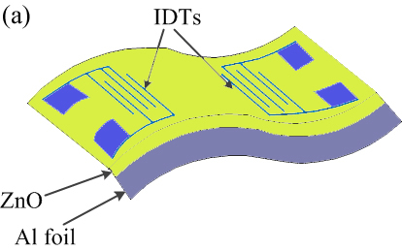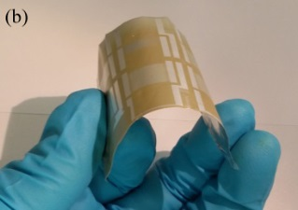
Fig. 1. (a) Schematic illustration of the designed ZnO/Al SAW device, (b) photograph of the fabricated ZnO/Al SAW device.

Result AND discussion

Microstructure and interfacial structures
XRD patterns of the ZnO film on Al foil and those annealed at different temperatures from 300 to 500ºC are shown in Fig. 2(a). The as-deposited and annealed films show two main peaks, i.e., 2θ values at 34.29º and 44.82º, corresponding to ZnO (002) (referring to JCPDS Card No. 36-1451) and Al (200) peaks (referring to JCPDS Card No. 01-1176) respectively. Another two minor peaks were observed at 2θ=31.19º and 62.83º, corresponding to ZnO (100) and ZnO (103) peaks, respectively. The XRD results revealed that the ZnO film on Al foil has a (002) preferred orientation. The FWHM (full width at half maximum) data for the ZnO peaks of the films annealed at different temperatures were obtained using software MDI Jade 5.0, and the results are shown in Fig. 2(b). Before annealing, the FWHM value for the ZnO (002) peak was 0.88 and it decreased significantly to 0.44 after being annealed at 300ºC.
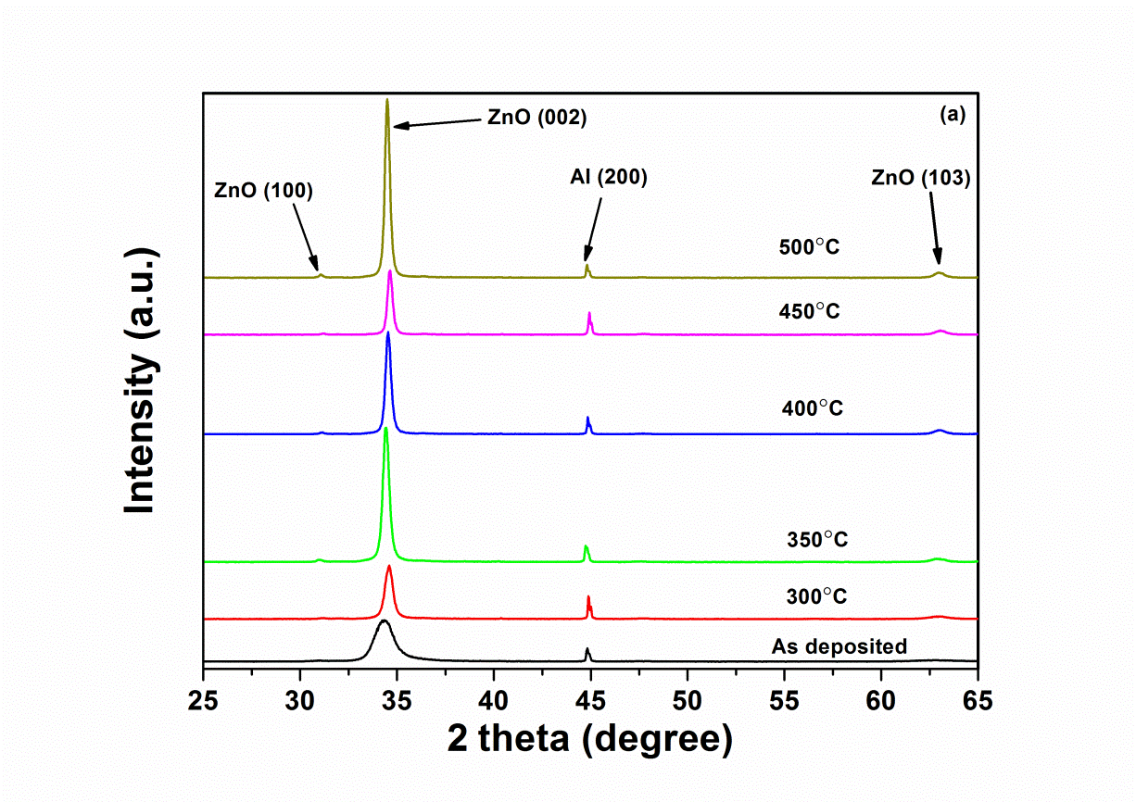
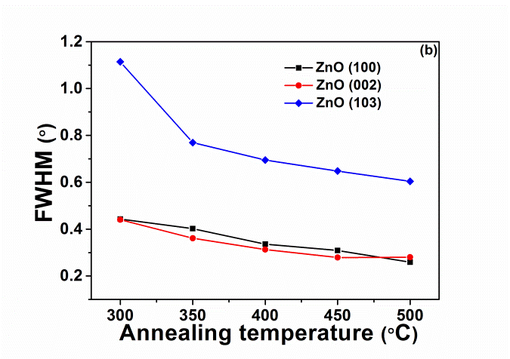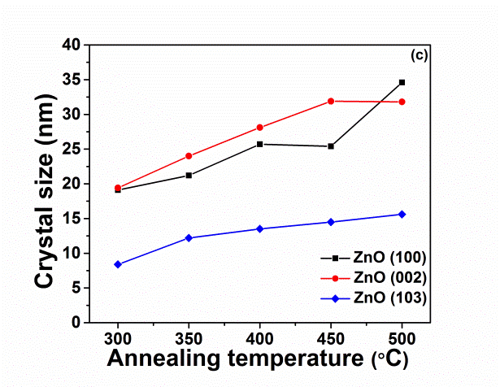
Fig. 2. (a) XRD patterns, (b) FWHM of XRD peaks and (c) calculated crystal size of as-deposited ZnO films on Al foil and those annealed at different temperatures.

The crystalline size (D) of the films were calculated using the Debye-Scherrer’s formula [25],
$D=\frac{kλ}{βcosθ}$ (1)
where k is a constant taken to be 0.9; λ is the wavelength of the incident X-ray (λ=0.154184 nm); β is the corrected FWHM for instrument broadening of the maximum intensity peak, and θ is the angle at which the maximum peak occurs. The calculated results of the crystal sizes are shown in Fig. 2(c). For ZnO (002) peak, the average crystal size of the as-deposited film was estimated to be about 7.3 nm, and it increased to about 30 nm after 500ºC annealing.
The film stress σ_{film} was estimated using the following equation [26],
$σ_{film}=\frac{2C_{13}^{2}-C_{33}\left(C_{11}+C_{12}\right)}{2C_{13}}∙\frac{c_{film}-c_{bulk}}{c_{bulk}}$ (2)
where C_{ij} is the bulk ZnO elastic constants [26]; c_{bulk} (0.5206 nm from JCPDS Card No. 36-1451) is the c-axis lattice constant of strain-free bulk ZnO; c_{film} is the c-axis lattice constant of the ZnO film. Because of the differences in the coefficient of thermal expansion (CTE) between ZnO and Al, thermal stress was introduced after cooling from annealing temperature. The thermal stress of a two-layer system ($σ_{th}$) can be calculated using
${ σ}_{th}=\frac{1}{d_{A}+d_{B}}{\left[\frac{1-γ_{A}}{d_{A}E_{A}}+\frac{1-γ_{B}}{d_{B}E_{B}}\right]}^{-1}\int_{T_{o}}^{T_{1}}{\left(α_{B}\left(T\right)-α_{A}\left(T\right)\right)dT}$ (3)
where A and B refer to two layers (Al and ZnO, respectively); E is Young’s modulus; γ is Poisson’s ratio; d_{A} and d_{B} are the thicknesses of the Al and ZnO; α is the value of coefficient of thermal expansion (CTE) [27]. The intrinsic stress can be calculated by
$σ_{intrins}=σ_{film}-σ_{th}$ (4)
where $σ_{intrins}$ is intrinsic stress; σ_{film} is the film residual stress; $σ_{th}$is the thermal stress of the film. TABLE I shows calculated values of σ_{film}, σ_{th} and σ_{intrins}. The smallest film intrinsic stress was obtained when the annealing temperature was 350ºC and it was far smaller than the thermal stress. The 350ºC annealing temperature could effectively decrease the film intrinsic stress and introduce a relatively small thermal stress.
TABLE I
Residual stress, thermal stress and intrinsic stress of ZnO (002) peak of as-deposited and annealed ZnO/Al films.
Samples | Stress (GPa) | Thermal stress (GPa) | Intrinsic stress (GPa)
As-deposited | -0.9 | 0 | -0.9
300ºC | 1.01 | -0.086 | 1.096
350ºC | -0.17 | -0.102 | -0.068
400ºC | 0.62 | -0.117 | 0.737
450ºC | 1.26 | -0.132 | 1.392
500ºC | 0.23 | -0.149 | 0.378

Optical properties
The as-deposited ZnO film on Al foil showed a yellowish, golden or dark brown color depending on the film thickness of up to 5 μm. However, after annealing, the ZnO film on the Al foil becomes semi-transparent, indicating the significant improvements in the film optical transparency. ZnO films deposited on glass substrates were used to evaluate the changes of the optical properties of the ZnO films. Fig. 3 shows the measured refractive index (n) and extinction coefficient (k) of the ZnO films on glass substrates. The values of n decreased significantly after 300ºC annealing and then slightly increased after 400ºC and 500ºC annealing. For the as-deposited film the value of n was 1.871 at the wavelength of 630 nm, whereas after annealing it became 1.819, 1.844 and 1.841 with the annealing temperatures of 300, 400 and 500ºC, respectively. The value of k also decreased after annealing and it was the smallest for the film annealed at 300ºC. With the smallest values of n and k, post-annealing could enhance the light transmission properties and 300ºC is an optimum annealing temperature in the films we studied to obtain the ZnO films with better light transmission properties.
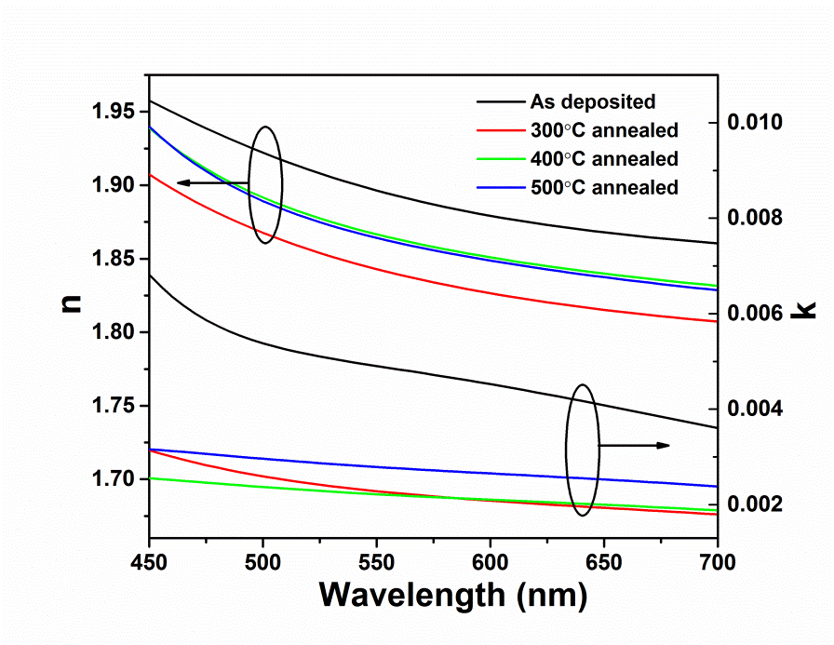
Fig. 3. Measured refraction Index (n) and extinction coefficient (k) of ZnO films on glass annealed at different temperatures.

Raman scattering spectra of the as-deposited and annealed ZnO/Al films versus annealing temperatures were measured and are shown in Fig. 4. For the as-deposited film, the peaks at 324 cm⁻¹, 434 cm⁻¹ and 576 cm⁻¹ are observed, which are corresponding to acoustic overtones of E_{2H}-E_{2L}, E_{2H} and E₁^{LO}, respectively [28]. A Raman peak around 1150 cm⁻¹ was also observed in a bigger wave number region which corresponds to the optical overtone [29]. Before annealing, the peaks of E_{2H} and E₁^{LO} were located at 434.39 cm⁻¹ and 576.13 cm⁻¹, respectively, but after annealing at 350ºC, they were shifted to 437.28 cm⁻¹ and 582.88 cm⁻¹, respectively. The shift of the Raman peak is due to the increased crystallite size (confirmed by the XRD analysis discussed above) and changes in film stress after annealing. For the as-deposited ZnO film, the peak of E₁^{LO} mode (576 cm⁻¹) was predominant, whereas after 350ºC annealing the E_{2H} mode (437 cm⁻¹) became dominant, indicating that the film got better crystal quality after annealing. Because the peak of the E_{2H} is related to the oxygen sub-lattice [30], the enhanced polarization and the increased intensity of E_{2H} mode maybe resulted from more oxygen atoms diffused into the films after annealing in the air.
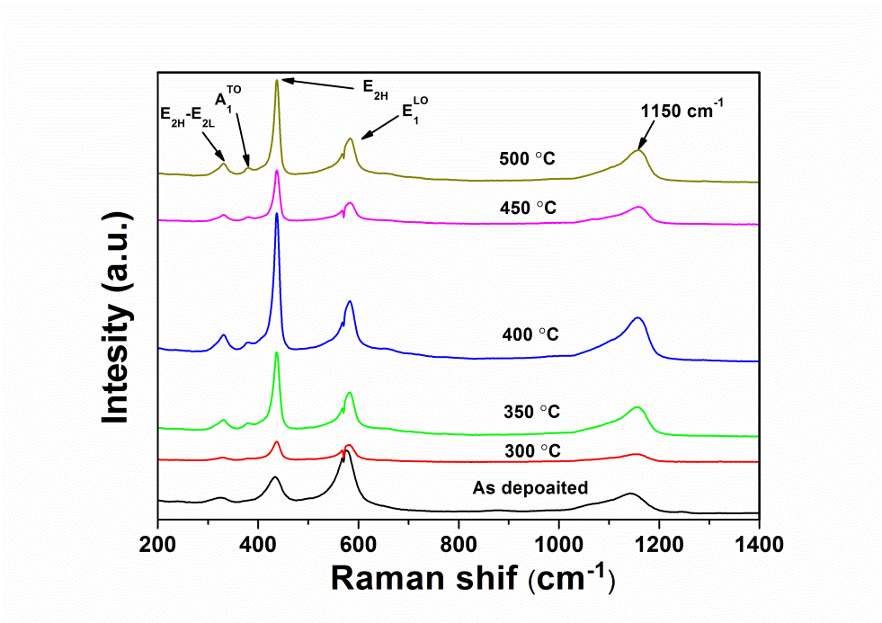
Fig. 4. Raman spectra for ZnO/Al films annealed at different temperatures.

Fig. 5 shows the PL spectra for the as-deposited and annealed ZnO/Al films. The peaks were observed at UV and visible bands, which are around 377 nm (3.29 eV), 424 nm (2.92 eV), 461 nm (2.69 eV), 485 nm (2.56 eV) and 531 nm (2.34 eV). For the as-deposited ZnO film, two peaks can be observed at UV region as shown in Fig. 4, i.e., a strong peak at 377 nm and a weak peak at 390 nm. The former peak is due to the recombination of free excitons from the conduction band edge (E_{C}) and the valance band edge (E_{V}), and the latter peak is supposed to be generated by the radiative transitions from Zn interstitial state (I_{Zn}) to valance band edge (E_{V}) [31]. After annealing the peak at 390 nm disappeared, indicating that the post-annealing can decrease the defect density of Zn interstitials (I_{Zn}) of the films by adopting more oxygen atoms, thus improving the degree of crystallinity.
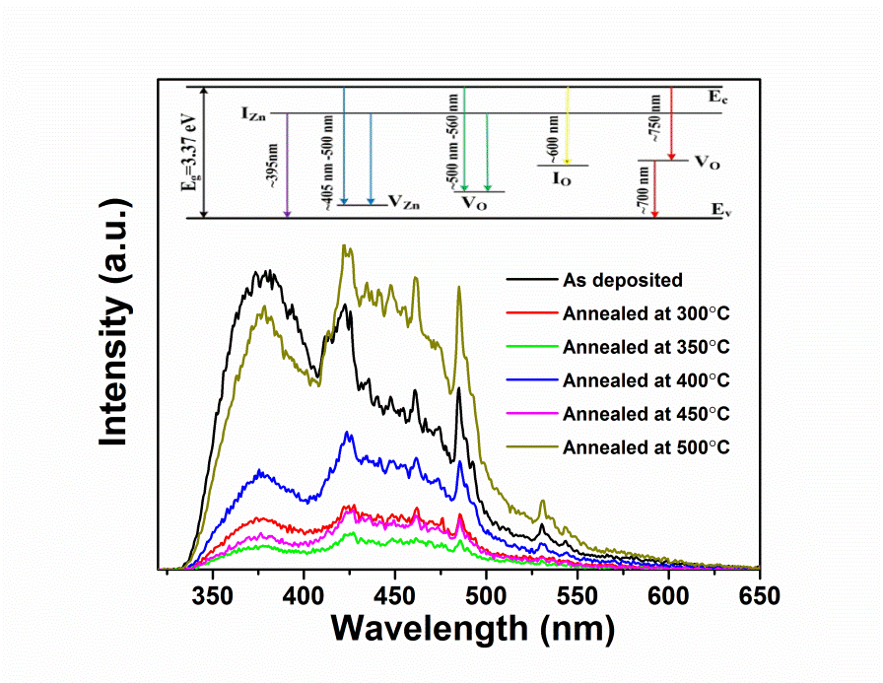
Fig. 5. PL results for the ZnO/Al films annealed at different temperatures.

The visible light emission is corresponding to the recombination of different types of defects as shown in the inserted figure of Fig. 5 [32]. The intrinsic defects in the ZnO films include oxygen vacancies (V_{O}) and interstitial oxygen (I_{O}), zinc vacancies (V_{Zn}) and interstitial Zn (I_{Zn}). As shown in the insert figure in Fig. 5, the red emission of the ZnO film is associated with oxygen vacancies (V_{O}⁺), and the blue emission and the violet emission are associated with zinc vacancies (V_{Zn}) and interstitial Zn (I_{Zn}), respectively. In Fig. 5, the visible band was dominated by blue band (400-500 nm) for all the films, implying that the zinc vacancies (V_{Zn}) are the main defects in the film before and after annealing. After 350ºC annealing, the visible band emission decreased significantly and the 531 nm peak disappeared, indicating that there were least zinc vacancies (V_{Zn}) defects and oxygen vacancies (V_{O}) defects in the film annealed at 350ºC.

SAW device performance
Fig. 6(a) shows the simulated frequency response spectra of the ZnO/Al SAW devices. There are three major resonant peaks at around 41.1, 72.2 and 85.5 MHz in the range of 30 to 90 MHz. To identify the vibration modes of these three resonant frequencies, finite element analysis (FEA) was performed using COMSOL 5.0 software with a two-dimensional (2D) piezo-plane strain mode. Simulation for the ZnO/Al SAW device with a given wavelength of 64 μm was obtained and shown in Fig. 6 (b) to (d). Three major resonant peaks at 41.1, 72.2 and 85.5 MHz were identified as Rayleigh/asymmetric Lamb hybrid mode (R₀/A₀), asymmetric Lamb mode (A₁) and symmetric S₁ peaks, based on the vibration patterns.
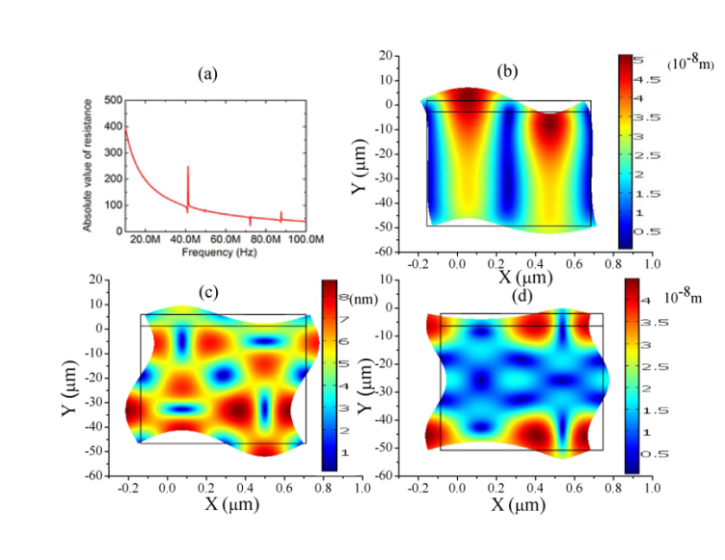
Fig. 6. COMSOL simulation results showing (a) the resonance peaks, and the cross-section view of the waves at (b) 41.1 MHz (hybrid Rayleigh SAW and Lamb wave mode (R₀/A₀), (c) 72.2 MHz (asymmetric Lamb mode A₁) and (d) 87.5 MHz (symmetric Lamb mode S₁).

Fig. 7 shows the measured reflection signal (S₁₁) of A₁ mode for the ZnO/Al SAW device annealed at different temperatures. The reflection loss, resonant peak amplitude and resonant frequency for the device with different annealing conditions were measured and the results are shown in Fig. 8. The increase of reflection loss of the signal was observed after annealing and it could be mainly due to the generation of defects or cracks on the surface of the ZnO film, which were caused by the significant deformation of the Al substrate due to the bi-metallic layer thermal effect during the high temperature annealing processes.
As shown in Fig. 8, after annealing the resonant frequency and amplitude of the A₁ mode increased significantly, but then decreased with further increasing of annealing temperature. The device possessed best SAW properties of A₁ mode with the highest value of amplitude of 0.13 dB and relative high frequency of 69.66 MHz after 350ºC annealing. For the R₀/A₀ mode and S₁ mode the same phenomenon was observed, indicating post-annealing could increase the amplitude of S₁₁ signal thus make the signal easier to be distinguished. The reason for the shift of the frequency of A₁ mode is very complex and the further research is being implemented to figure it out.
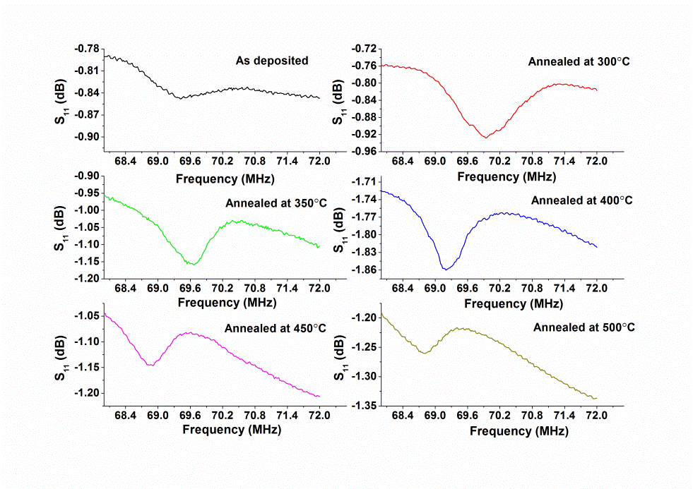
Fig. 7. Reflection signal (S₁₁) of A₁ mode at different annealing temperatures for ZnO/Al SAW device with a wavelength of 64 μm.
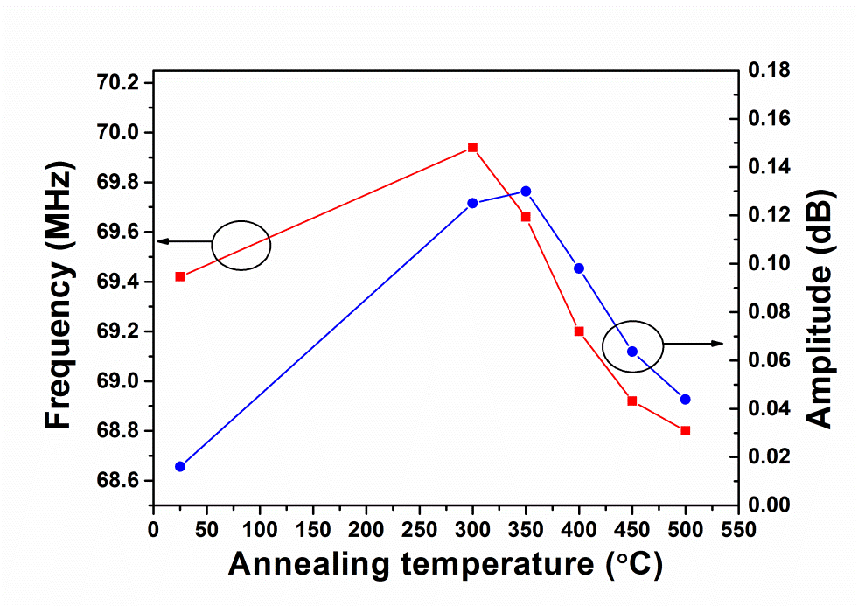
Fig. 8. Resonant frequency and amplitude of A₁ mode versus annealing temperatures for ZnO/Al SAW device with a wavelength of 64 μm.

Fig. 9 shows the transmission signal (S₂₁) of R₀/A₀ mode as a function of the annealing temperature for the ZnO/Al SAW devices. The resonant frequency and amplitude of the R₀/A₀ mode signal were measured and shown in Fig. 10. After 400ºC annealing, the resonant frequency and amplitude decreased by 1.59% and 65.82% comparing with those of the as-deposited device respectively. With further increasing the annealing temperature up to 500ºC, the transmission signal was too weak to be measured accurately. For the A₁ mode and S₁ mode, the S₂₁ signal was also diminished after a high temperature post-annealing. Due to the significant deformation of the ZnO/Al foil and the thermal stresses, there were some cracks generated on the film surface after the annealing. Although the significant deformed samples after annealing can be re-stretched into a flat shape, the generation of cracks and increase of film roughness would still deteriorate the wave propagation on the film surface. Because annealing could weaken the transmission signal strength, the annealing temperature cannot be too high; otherwise, thermal stress will be too large to cause problems. The shift of the frequency of R₀/A₀ mode can also be observed in Fig. 10 and more effort is required to make it clear.

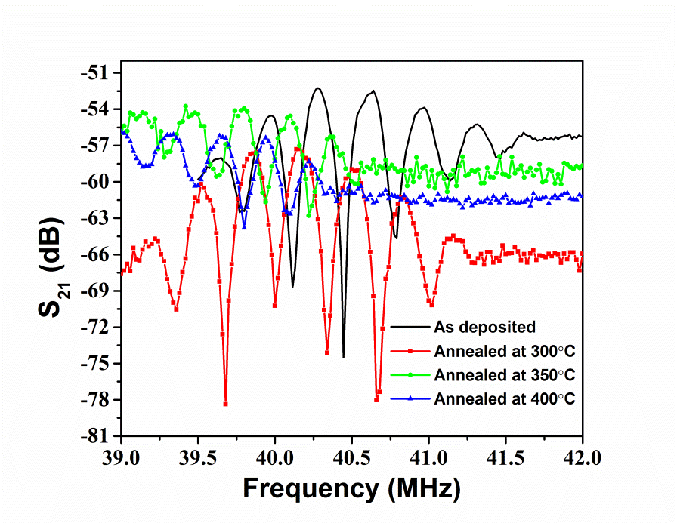
Fig. 9. Transmission signal (S₂₁) of R₀/A₀ mode versus annealing temperature for ZnO/Al SAW device with wavelength of 64 μm.
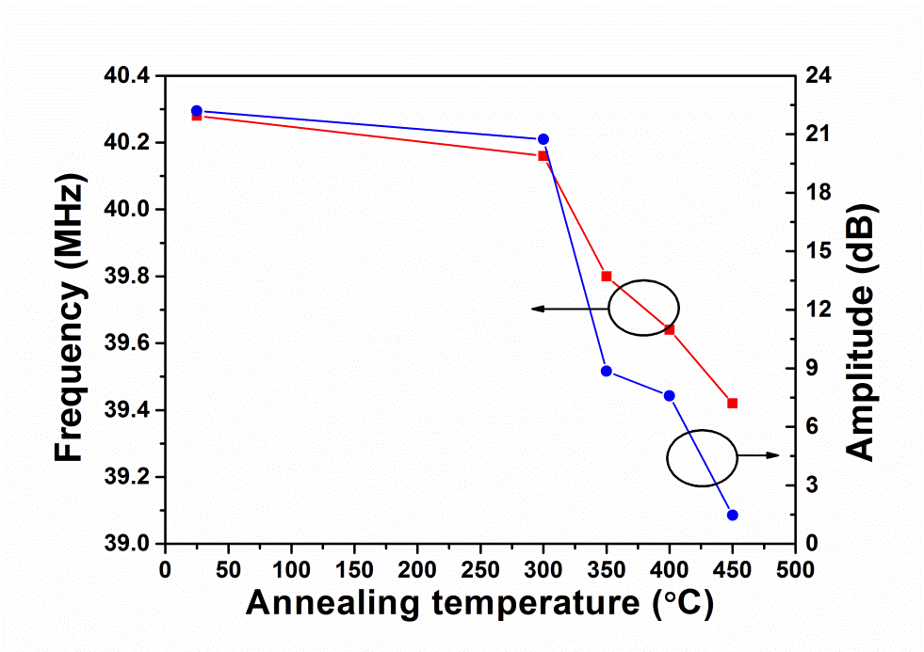
Fig. 10. Resonant frequency and amplitude of R₀/A₀ mode versus annealing temperatures for ZnO/Al SAW device with wavelength of 64 μm.

The 350ºC annealed ZnO/Al SAW device (64 μm, R₀/A₀ mode, 41.1 MHz) were used to measure the frequency changes at different temperatures, and the obtained results were compared with those from the ZnO/Si SAW device (64 μm, R₀ mode, 62.5 MHz) as shown in Fig. 11. Compared with that of the ZnO/Si SAW device, the R₀/A₀ mode of the ZnO/Al SAW device was more sensitive to temperature. The TCF (temperature coefficient of frequency) values for the ZnO/Al SAW device and the ZnO/Si SAW device can be estimated using
$TCF=\frac{∆f}{f_{0}×∆T}×100\%$$TCF=\frac{∆F}{F_{0}×∆T}×100\%$ (5)
where f₀ is the initial frequency; Δf is the shift of frequency ; and ΔT is the change of temperature. The calculated TCF values for the ZnO/Al device and the ZnO/Si device was -217.5 ppm/ºC and -28 ppm/ºC respectively.

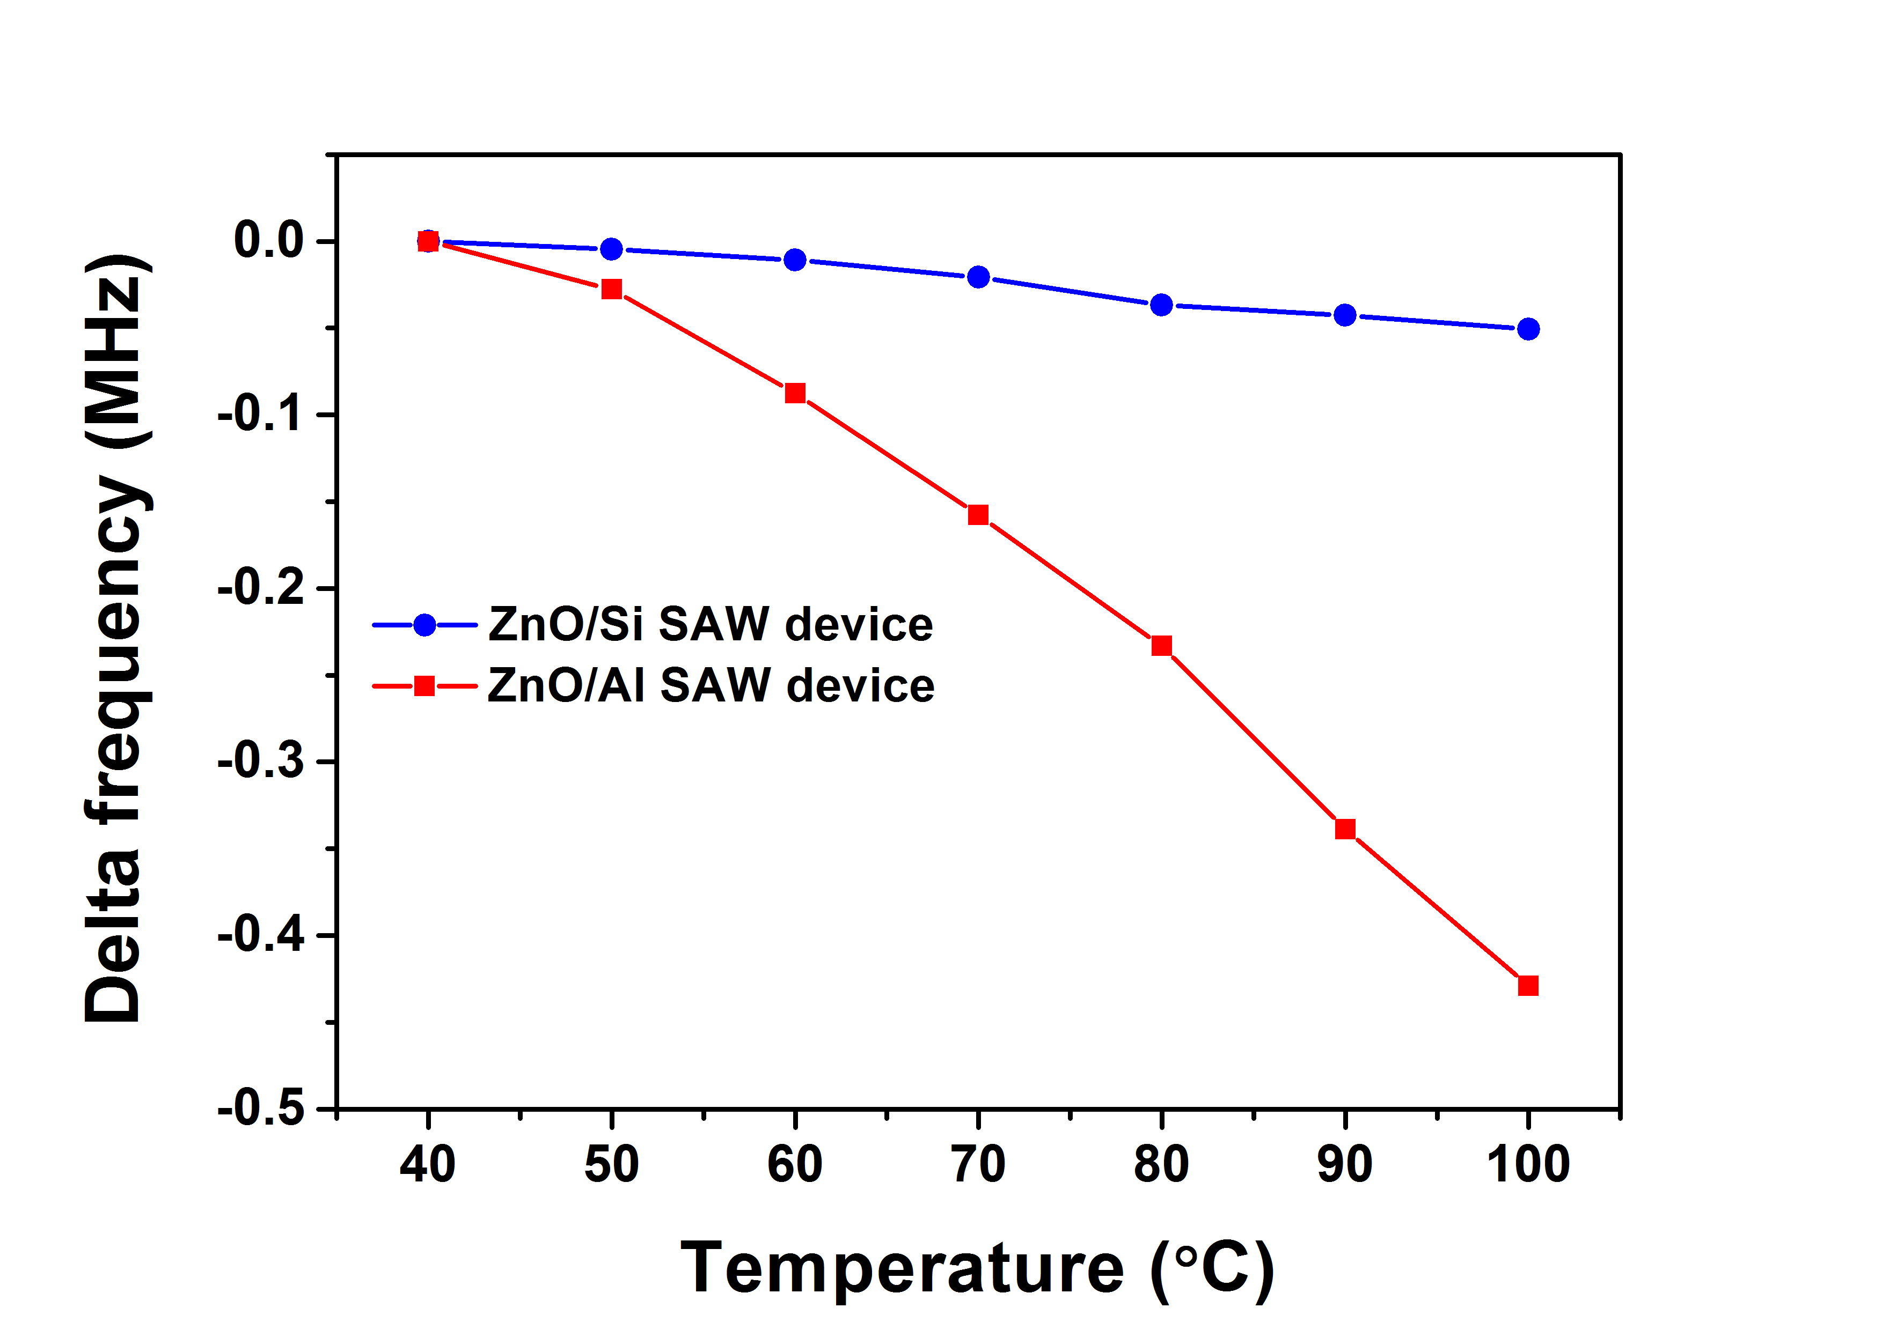
Fig. 11. Shift of resonant frequency (delta frequency) of S₂₁ versus ambient temperature for 350ºC annealed ZnO/Al SAW device (64 μm, R₀/A₀ mode, 41.1 MHz) and ZnO/Si SAW device (64 μm, R₀ mode, 62.5 MHz).
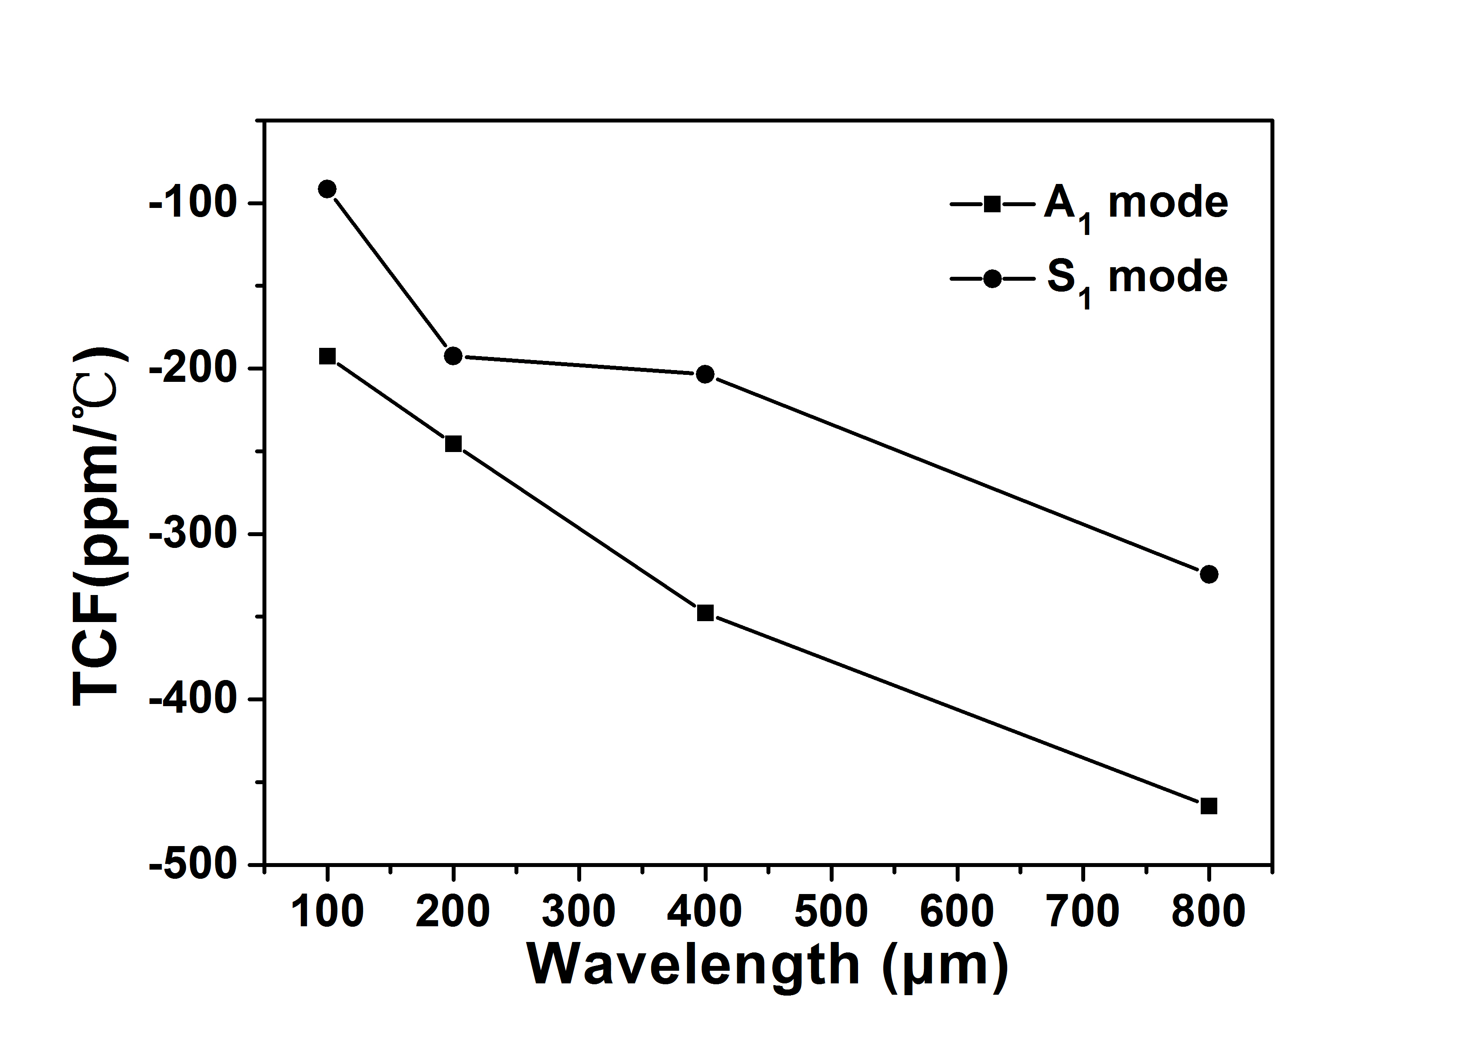
Fig. 12. Comparison of TCF values of 350ºC annealed ZnO/Al SAW devices with different wavelengths.

Based on the similar methods, we have also measured the TCF values for both A₁ and S₁ modes which is shown in Fig. 12, the TCF values of ZnO/Al SAW devices were also several times of those of ZnO/Si SAW devices. Clearly the post annealed ZnO/Al foil SAW devices showed an improved performance at a post annealing temperature of 350ºC and they are suitable for temperature sensing applications. Further work is being done to evaluate the microfluidics performance and sensing work on UV, humidity, as well as bio-sensing using these Al foil based SAW flexible devices. However, for many sensing applications, it is needed to control the TCF values to be minimized. In order to reduce the large TCF readings, a layer of SiO₂ will be used as an intermediate layer on Al foils before deposition of ZnO films, since the TCF of the SiO₂ has an opposite values of TCF compared with that of the ZnO, which can reduce significantly this temperature effects.

Conclusions
Post-annealing effectively improved the microstructures of the ZnO film on Al foil by increasing the crystallite size and decreasing the micro strain and reducing the film stress and defects, and the optimized annealing temperature was identified as 350ºC. The film possessed a strong ZnO (002) preferred orientation, small film stress (-0.17 GPa) and large crystallite size (24 nm) after 350ºC annealing. For all the samples the dominant Raman peak was 437.28 cm⁻¹ after annealing, which are highly consistent with those of the bulk material. The main defects in the film were observed as zinc vacancies (V_{Zn}) which could be reduced significantly after 350ºC annealing. Simultaneously, after 350ºC annealing the amplitude of reflection signal of A₁ mode increased by 712%, which makes the signal easier to be distinguished. The annealed ZnO/Al SAW devices possessed a large value of TCF (-217.5 ppm/ºC), revealing a potential for precision temperature sensing.

ACKNOWLEDGEMENT
This work was also partially supported by Natural Science Foundation of Guangdong Province (Grant no. S2013040015481), Foundation for Distinguished Young Talents in Higher Education of Guangdong (Grant no. 2013LYM_0078), and Basical Research Program of Shenzhen (Grant no. JCYJ20140418091413493).

References
[1] J.A. Rogers, T. Someya, Y.G. Huang, “Materials and Mechanics for Sretchable Electronics,” Science, vol. 327, pp. 1603-1607, 2010.
[2] S.I. Park, Y.J. Xiong, R.H. Kim, P. Elvikis, M. Meitl, D.H. Kim, J. Wu, J. Yoon, C.J. Yu, Z.J. Liu, Y.G. Huang, K. Hwang, P. Ferreira, X.L. Li, K. Choquette, J.A. Rogers, “Printed Assemblies of Inorganic Light-Emitting Diodes for Deformable and Semitransparent Displays,” Science, vol. 325, pp. 977-981, 2009.
[3] T. Someya, T. Sekitani, S. Iba, Y. Kato, H. Kawaguchi, T. Sakurai, “A large-area, flexible pressure sensor matrix with organic field-effect transistors for artificial skin applications,” PNAS, vol. 101, pp. 9966-9970, 2004.
[4] S. Kim, H.Y. Jeong, S.K. Kim, S.Y. Choi, K.J. Lee, “Flexible Memristive Memory Array on Plastic Substrates,” NanoLett, vol. 11, pp. 5438-5422, 2011.
[5] H.C. Ko, M.P. Stoykovich, J.Z. Song, V. Malyarchuk, W.M. Choi, C.J. Yu, J.B. Geddes, J.L. Xiao, S.D. Wang, Y.G. Huang, J.A. Rogers, “A hemispherical electronic eye camera based on compressible silicon optoelectronics,” Nature, vol. 454, pp. 748-753, 2008.
[6] C. Sire, F.S. Lepilliet, J.W. Seo, M.C. Hersam, G. Dambrine, H. Happy, V. Derycke, “Flexible Gigahertz Transistors Derived from Solution-Based Single-Layer Graphene,” Nano Lett, vol. 12, pp. 1184-1188, 2012.
[7] C.C.W. Ruppel, R. Dill, A. Fischerauer, G. Fischerauer, W. Gawlik, J. Machui, F. Müller, L. Reindl, W. Ruile, G. Scholl, I. Schropp, K.C. Wagner, “SAW Devices for Consumer Communication Applications,” IEEE Transactions on Ultrasonics, Ferroelectrics, And Frequency Control, vol. 40 (5), pp. 438-452, 1993.
[8] Y.Q. Fu, J.K. Luo, X.Y. Du, A.J. Flewitt, Y. Li, G.H. Markx, A.J. Walton, W.I. Milne, “Recent developments on ZnO films for acoustic wave based bio-sensing and microfluidic applications: a review,” Sens. Actuat.B., vol. 143, pp. 606-619, 2010.
[9] X.Y. Du, Y.Q. Fu, S. Tan, J.K. Luo, A.J. Flewitt, W.I. Milne, D. Lee, N. Park, J .Park, Y. Choi, “ZnO film thickness effect on surface acoustic wave modes and acoustic streaming,” Appl. Phys. Lett., vol. 93, pp. 094105, 2008.
[10] J. Zhou, M. DeMiguel-Ramos, L. Garcia-Gancedo, E. Iborra, J. Olivares, H. Jin, J.K. Luo, A.S. Elhady, S.R. Dong, D.M. Wang, Y.Q. Fu, “Characterisation of aluminium nitride films and surface acoustic wave devices for microfluidic applications,” Sens. Actuat. B., vol. 202, pp.984-992, 2014.
[11] S.J. Ippolito, S. Kandasamy, K. Kalantar-zadeh, W. Wlodarski, K. Galatsis, G. Kiriakidis, N. Katsarakis, M. Suchea, “Highly sensitive layered ZnO/LiNbO₃ SAW device with InO_{x} selective layer for NO₂ and H₂ gas sensing,” Sens. Actuat. B., vol. 111–112, pp. 207–212, 2005.
[12] P. Sharma, K. Sreenivas, “Highly sensitive ultraviolet detector based on ZnO/LiNbO₃ hybrid surface acoustic wave filter,” Appl. Phys. Lett., vol. 83, pp. 3617-3619, 2003.
[13] H. Jin, J. Zhou, X.L. He, W.B. Wang, H.W. Guo, S.R. Dong, D.M. Wang, Y. Xu, J.F. Geng, J.K. Luo, W.I. Milne, “Flexible surface acoustic wave resonators built on disposable plastic film for electronics and lab-on-a-chip applications,” Scientific Reports., vol. 3: 2140, DOI: 10.1038, srep 02140, 2013.
[14] X.L. He, D.J. Li, J. Zhou, W.B. Wang, W.P. Xuan, S.R. Dong, H. Jin and J.K. Luo, “High sensitivity humidity sensors using flexible surface acoustic wave devices made on nanocrystalline ZnO/polyimide substrates”, Journal of Materials Chemistry C, vol. 1, pp, 6210-6215, 2013.
[15] X.L. He, J. Zhou , W.B. Wang, W.P. Xuan, X. Yang, H. Jin, and J.K. Luo, “High performance dual-wave mode flexible surface acoustic wave resonators for UV light sensing”, J. Micromech. Microeng, vol. 24, pp 055014, 2014.
[16] Y. Liu, Y.F. Li, A.M. El-Hady, C. Zhao, J.F. Du, Y. Liu, Y.Q. Fu, “Flexible and bendable acoustofluidics based on ZnO film coated aluminiumfoil, ”Sens. Actuat. B., vol. 221, pp. 230-235, 2015.
[17] J.L. Tian, H.Y. Zhang, G.G. Wang, X.Z. Wang, R. Sun, L. Jin, J.C. Han, “Influence of film thickness and annealingtemperature on the structural and optical properties of ZnO thin films on Si (100) substrates grown by atomic layer deposition,” Superlattices and Microstructures., vol. 83, pp. 719–729, 2015.
[18] S.K. Wang, T.C. Lin, S.R. Jian, J.S.C. Jang, J.Y. Tseng, “Effects of post-annealing on the structural and nano mechanical properties of Ga-doped ZnO thin films deposited on glass substrate by rf-magnetron sputtering,” Applied Surface Science, vol. 258, pp. 1261– 1266, 2011.
[19] Y.Z. Wang, H.L. Wang, S.Z. Li, S.M. Zhou, Y. Hang, J. Xu, J.D. Ye, S.L. Gu, R. Zhang, “Annealing effect on properties of Zno thin films grown on LiNbO₃ substrates by MOCVD,” Journal of Crystal Growth, vol. 284, pp. 319–323, 2005.
[20] W.B. Wang, H. Gu, X.L. He, W.P. Xuan, J.K. Chen, X.Z. Wang, J.K. Luo, “Thermal annealing effect on ZnO surface acoustic wave-based ultraviolet light sensors on glass substrates,” Appl. Phys. Lett., vol. 104, pp. 212107, 2014.
[21] H.F. Pang, Y.Q. Fu, R. Hou, K.J. Kirk, D. Hutson, X.T. Zu, F. Placido, “Annealing effect on the generation of dual mode acoustic waves in inclined ZnO films,” Ultrasonics, vol. 53, pp. 1264–1269, 2013.
[22] P. Prepelita, V. Craciun, M. Filipescu, F. Garoi, “Sputtered zinc oxide thin films deposited on polyimide substrate and annealing effect on the physical characteristics,” Thin Solid Films, vol. 545, pp. 564–570, 2013.
[23] K.C. Sekhar, S. Levichev, K. Kamakshi, S. Doyle, A. Chahboun, M.J.M. Gomes, “Effect of rapid thermal annealing on texture and properties of pulsed laser deposited zinc oxide thin films,” Materials Letters, vol. 98, pp. 149–152, 2013.
[24] S. Joshi, M.M. Nayak, K. Rajanna, “Effect of post-deposition annealing on transverse piezoelectric coefficient and vibration sensing performance of ZnO thin films,” Applied Surface Science, vol. 296, pp. 169–176, 2014.
[25] S.Y. Kuo, W.C. Chen, F.I. Lai, C.P. Cheng, H.C. Kuo, S.C. Wang, W.F. Hsieh, “Effects of doping concentration and annealing temperature on properties of highly-oriented Al-doped ZnO films,” Journal of Crystal Growth, vol. 287, pp. 78–84, 2006.
[26] A. Singh, D. Kumar, P.K. Khanna, B.C. Joshi, M. Kumar, “Effect of post annealing temperature on structural and optical properties of ZnCdO thin films deposited by sol–gel method,” Applied Surface Science, vol. 258, pp. 1881-1887, 2011.
[27] H. Iwanaga, A. Kunishige, S. Takeuchi, “Anisotropic thermal expansion in wurtzite-type crystals,” Journal of Materials Science, vol. 35, pp. 2451–2454, 2000.
[28] K.C. Barick, M. Aslam, J. Wu, V.P. Dravid, D. Bahadur, “Defects in three-dimensional spherical assemblies of Ni-doped ZnO nanocrystals,” J. Mater.Res., vol. 24, pp. 3543-3550, 2009.
[29] B.J. Chen, X.W. Sun, C.X. Xu, B.K. Tay, “Growth and characterization of zinc oxide nano/micro-fibers by thermal chemical reactions and vapor transport deposition in air,” Physica E., vol. 21, pp. 103-107, 2004.
[30] N. Ashkenov, B.N. Mbenkum, C. Bundesmann, V. Riede, M. Lorenz, D. Spemann , E.M. Kaidashev, A. Kasic, M. Schubert, M. Grundmann, G. Wagner, H. Neumann, V. Darakchieva, H.Arwin, B. Monemar, “Infrared dielectric functions and phonon modes of high-quality ZnO films,” J. Appl. Phys., vol. 93, pp. 126-133, 2003.
[31] Z.Q. Chen, A. Kawasuso, Y. Xu, H. Naramoto, X.L. Yuan, T. Sekiguchi, R. Suzuki, T. Ohdaira, “Production and recovery of defects in phosphorus-implanted ZnO,” J. Appl. Phys., vol. 97, pp. 013528, 2005.
[32] N.H. Alvi, K. Hasan, O. Nur, M. Willander, “The origin of the red emission in n-ZnO nano tubes/p-GaN white light emitting diodes,” Nanoscale Research Letters, vol. 6, pp. 130, 2011.

This paper was submitted to the journal at 20th July 2016. This work was supported by UoA and CAPEX Funding in Northumbria University at Newcastle, Royal Academy of Engineering-Research Exchange with China and India and NSFC under project No. 61274086. Yong Liu, Jiang Feng Du, Qi Yu and Yang Liu are with State Key Laboratory of Electronic Thin Films and Integrated Devices, University of Electronic Science and Technology of China, Chengdu, 610054, China (e-mail: yliu1975@uestc.edu.cn). Yong Liu, Jing Ting Luo, Chao Zhao, Sameer Hassan, Yifan Li, Qiang Wu, Wai Pang Ng, and Yong Qing Fu are with Faculty of Engineering and Environment, Northumbria University, Newcastle, NE1 8ST, UK (e-mail: richard.fu@northumbria.ac.uk). Jing Ting Luo is with College of Physics Science and Technology, Shenzhen University, China. Jian Zhou is with college of Mechatronic Engineering and Automation, National University of Defence technology, China Michael Cooke is with School of Engineering and Computing Sciences, Durham University, UK

