Enhancement of Adsorption and Diffusion of Lithium in Single-Walled Carbon Nanotubes by External Electric Field
Wenwu Shi,¹ Zhiguo Wang,^{1*} Y.Q. Fu^{1,2*}
- School of Physical Electronics, Center for Public Security Information and Equipment Integration Technology, University of Electronic Science and Technology of China, Chengdu, 610054, P.R. China
- Faculty of Engineering and Environment, University of Northumbria, Newcastle upon Tyne, NE1 8ST, UK
*Corresponding author. E-mail: zgwang@uestc.edu.cn(ZW); richard.fu@northumbria.ac.uk(YF)

Abstract
Effects of an external transverse electric field on adsorption and diffusion of Li atoms on the single-walled carbon nanotubes (CNTs) were investigated using density functional theory. Results showed that the adsorption energy was significantly enhanced by applying the electric field. As the external electric field was increased from 0.0 to 0.6 V/Å, the adsorption energies were decreased from -1.37 to -2.31 eV, -1.32 to -2.46 eV and -1.33 to -2.63 eV for the Li atoms adsorbed on (6,6), (8,8) and (10,10) CNTs, respectively. Meanwhile, the diffusion barriers of the Li atoms on the CNTs were also decreased as the external electric field was applied. When the external electric field was increased from 0.0 to 0.6 V/Å, the energy barriers were decreased from 0.42, 0.40 and 0.39 eV to 0.20, 0.17 and 0.15 eV for the Li diffusion in the (6,6), (8,8) and (10,10) CNTs, respectively. The results proved that an external electric field can be applied to enhance the adsorption and diffusion of Li atoms on the CNTs (used as the anode) for lithium ion batteries.
Key words: External transverse electric field; Energy barrier; Adsorption energy; CNTs
- Introduction
With the increasing demands for high energy density storage devices, scientists are searching for various novel materials to replace the traditional energy storage materials. Rechargeable lithium ion batteries (LIBs) have attracted much attention owing to their environmental friendliness, non-memory effect and high energy density (Bandhauer et al 2011). Graphite has been successfully used as the anode materials for the LIBs which are widely used in portable devices. However, the theoretical specific energy of the graphite used in the LIBs is 372 mAh g⁻¹ (Chou et al 2011), which cannot meet the requirement of high power density and long-term applications such as electric vehicles and artificial satellites. Therefore, it is imperative to search for new materials with higher energy densities. Carbon nanotubes (CNTs) were discovered in 1991 by Iijima (Iijima 1991). Since their discovery, they have attracted significant interests in synthesis and applications due to their unique physical and chemical properties, such as high aspect ratio, light weight, large tensile strength and good conductivity (Brataas 2008; Chen et al. 2010; Kuemmeth et al 2008; Sreekumar et al. 2003). Due to their high specific surfaces, successful adsorption of metal atoms and organic functional groups onto the CNTs have been extensively demonstrated (Duclaux et al. 2003; Hamadanian et al 2014; Jeong et al. 2003; Li et al. 2014).
As the anode materials for LIBs, CNTs have a theoretical specific capacity of 2000 mAh g⁻¹ (Li_{5.4}C₆) (Gao et al. 1999), which is much higher than the ideal value of graphite which is 372 mAh g⁻¹ (LiC₆) (Gao et al. 1999). The CNTs can provide a desirable electronic matrix for the anode materials of the LIBs due to their high theoretical electrical conductivity and high aspect ratio (Jia et al. 2012; Landi et al. 2009; Zhang et al. 2009). In addition, the CNTs possess a good recycle lifespan as the anode materials for the LIBs, and can keep a high reversible capacity of 600 mAh g⁻¹ (Li_{1.6}C₆) (Gao et al. 1999). Also the electrochemical properties of the CNTs were reported to be dependent on the length of CNTs, and the shorter CNTs showed a better electrochemical properties than the longer one (Yang et al. 2008). Despite the CNTs have considerable outstanding characteristics compared with the conventional anode materials, there exists a relatively high diffusion energy barrier of the Li on the CNTs, which limits its commercial applications (Zhao et al. 2005).
As previously reported, there are three different sites for the Li adsorption on the outer surfaces of the CNTs, e.g., H site (the center of hexagon site), T site (top on the carbon atoms) and B site (the middle of two carbon atoms) (Kaur et al. 2015; Liu et al. 2004). The Li diffuses on the CNTs from an H site to a neighboring one by passing through the B site (Persson et al. 2010). An energy barrier of 0.44 eV has been identified for the Li diffusion on the (5,5) CNTs (Li et al. 2014), and the adsorption energy for the Li adsorbed on (5,5) CNTs is -1.72 eV (Koh et al. 2011). Many methods have been used to decrease the energy barrier and enhance the adsorption energy, such as nitrogen-doping, adding vacancy defects and formation of carbon nanotube-fullerene hybrid system (Fan et al. 2012; Koh et al. 2011; Li et al. 2008; Ma et al. 2012; Xiong et al. 2013; Zhou et al. 2012). Although decreasing the energy barrier can be achieved for the Li atom diffusion on the CNTs by doping or introducing defects, the morphology of the CNTs could be changed significantly.
In this paper, an external transverse electric field was used to enhance the adsorption and diffusion of the Li on the CNTs using the first-principle calculation based on the density functional theory (DFT). It was found that the Li adsorption was enhanced and the diffusion barriers were decreased by applying an external electric field.

- Computational details
All of the calculations were performed using the first principles based on DFT as implemented in the SIESTA code (Soler et al. 2002). Generalized gradient approximation (GGA) (Dixon et al. 1992; Perdew et al. 1996) was used to describe the electron exchange-correlation. The core electrons were modeled using non-local pseudopotentials, and valence electrons were described using a linear combination of numerical localized atomic orbital basis sets. The valence electron wave functions were expanded using a double-ζ basis set plus polarization functional (Soler et al. 2002). A 1×1×9 Monkhorst-Pack mesh for the k-points sampling of the Brillouin zone integration was used. The diffusion barriers were calculated by moving the Li atom along its diffusion path from an H site to a neighboring one. The Li atom is constrained in the direction along the path, but it is free to move in the direction perpendicular to the diffusion path. CNTs with different diameters, i.e. (6,6), (8,8) and (10,10) single-walled CNTs, were used to model the adsorption and diffusion processes of the Li atoms. The atomistic configurations of single-walled CNTs viewed from a and b directions are shown in Fig. 1(a) and (b), respectively. The external transverse electric field was applied along the b axis.
The adsorption energy, E_{Ads_Li}, was calculated using equation (1):
(1)
where and are the total energies of CNTs with and without Li adsorption, respectively, and is the chemical potential of a single Li atom.
- Results and discussion
To avoid periodic image interactions between the CNTs, the CNTs were put into a large box with a and b being fixed, thus keeping a large relative distance between the CNTs which is over 30 Å. The atomic positions and the lattice c which is parallel to the CNTs were fully free to relax upon geometry optimization until the atomic forces are less than 0.02 eV/Å on each atom. The lengths of c are 7.423, 7.426 and 7.427 Å for the (6,6), (8,8) and (10,10) single-walled CNTs after the geometry optimization, respectively. The diameters of (6,6), (8,8) and (10,10) CNTs are listed in Table 1, which are well consistent with the previously reported values of 8.24, 10.84 and 13.56 Å for the (6,6), (8,8) and (10,10) CNTs (Xiong et al. 2013; Zhao et al. 2000). The adsorption energies of the Li atom on (6,6), (8,8) and (10,10) single-walled CNTs siting on the H and B sites are listed in Table 1. The adsorption energies are -1.37, -1.32, and -1.33 eV for the Li adsorbed on the (6,6), (8,8) and (10,10) CNTs, respectively. The adsorption energies are close to the previously reported value of 1.40 eV ( Li et al. 2014), and the Li atom is preferred to be adsorbed on the H site than the B site ( Li et al. 2014; 2004).
After applying the external transverse electric field, the adsorption energies of the Li atom on the (6,6), (8,8) and (10,10) single-walled CNTs are significantly decreased as shown in Fig. 2. The adsorption energy are decreased from -1.37 to -2.31 eV, from -1.32 to -2.46 eV and from -1.33 to -2.63 eV as the electric field is increased from 0.0 to 0.6 V/Å for the Li adsorbed on the (6,6), (8,8) and (10,10) single-walled CNTs, respectively. The adsorption energy decreases almost linearly with the intensity of the electric field, and the adsorption energy of the Li atom on the (10,10) CNTs shows more significant changes than those of the other CNTs under the same electric field.
Effect of the external electric field on the diffusion of the Li was also investigated. The diffusion energy curves of the Li in the (8,8) CNTs are shown in Fig. 3(a) and the diffusion path is shown in the Fig. 1. It can be seen from Fig. 3(a) that the energy barrier is decreased with the increase of electric field. The diffusion barriers as a function of the electric field for the Li diffusion on the (6,6), (8,8) and (10,10) CNTs are shown in Fig. 3(b). The energy barriers are 0.42, 0.40 and 0.39 eV for the (6,6), (8,8) and (10,10) CNTs, respectively, without applying the external electric field. The diffusion energy barriers decrease with increasing the curvature of CNTs. The results agree with the reported values of 0.44 and 0.30 eV for the Li diffusion on the (5,5) CNTs and graphene, respectively (Bhardwaj et al. 2010; Fan et al. 2012; Li et al. 2014; Peles-Lemli et al. 2013; Uthaisar et al. 2010; Wang et al. 2013).
From Fig. 3(b), it can be seen that the energy barrier is decreased with increasing the electric field for the Li diffusion on all the CNTs. The energy barriers are decreased to 0.20, 0.17 and 0.15 eV for the Li diffusion on the (6,6), (8,8) and (10,10) CNTs, respectively, as the external electric field is increased to 0.6 V/Å. In order to investigate the effect of electrical field strength on the adsorption and diffusion of Li on the CNTs, we used an external electrical field of 0.0-0.6 V/Å (0-60 MV/cm). This electrical field range has been previously used to study the releasing of chemisorbed hydrogen atoms from the single-walled CNTs (Surya et al. 2011). In order to avoid the breakdown of the device, we used an electrical field with a strength of 0.2 V/Å (20 MV/cm). Results show that the diffusion barrier is decreased to about 58 meV. The diffusion coefficients can be obtained based on the transition state theory (Vineyard, 1957) using an equation of . From the equation, it is can be seen that a decrease of 60 meV in the energy barrier is corresponding to an order of increase in the diffusivity at room temperature. Therefore, diffusivity of Li in the CNTs can be enhanced by about one order after applying an electrical field with a strength of 0.2 V/Å.
The charge-transfer of Li adsorbed on the CNTs was analyzed using the Mulliken population analysis (Segall et al. 1996). As the Li atom is adsorbed at H site, the charges transferred from Li to (6,6), (8,8) and (10,10) CNTs are 0.645, 0.655 and 0.663 e , respectively, without applying an electric field. These are in the data range between 0.45 e charge transferred from Li to the (5,5) single-walled CNTs (Ni et al. 2010) and 0.81 e from Li to the graphene (Koh et al. 2015). The charge transfers are 0.141, 0.106 and 0.072 e larger than that of Li adsorbed at the B site. After the charge redistribution, the Li possesses more positive charge than that adsorbed on the B site. Therefore, the Li prefers to occupy the H site due to a strong polarization interaction between the Li and CNTs.
From the above results, it can be concluded that the smaller charge transfer difference is at the H and B sites, the smaller the diffusion barriers will be. The changes of charge transfer of Li at H and B site as a function of the electric field are shown in Figs. 4(a) and (b), respectively. The charge transfer increases with the increase of intensity of the electric field, but the charge transfer difference at the H and B sites decreases with increasing the electric field. Therefore, the diffusion energy barriers decrease with increasing the electric field.
To understand the interactions between the Li and CNTs, we have investigated the projected density of states (PDOS) of the Li atom adsorbed on the H and B sites with and without electric fields, and the results are shown in Fig. 5. As the 2s level of the Li atom is above the conduction band maximum of all the H sites, the Li will donate its electrons to conduction band minimum (CBM). The Li 2s level moves to the right hand side after applying with the electric field. Thus there are more charges transferred from the Li atom to the CNTs, as confirmed by the Mulliken population analysis discussed above. Therefore, the interactions become stronger between the Li and CNTs, thus enhancing the adsorption of the Li on the CNTs. From Fig. 5, we can also observe the obvious difference of the Li 2s peak on the H and B sites with E=0.0 V/Å, however, the peak difference has mostly disappeared with increasing the electric field. This explains the reason why the diffusion energy decreases with the applied electric field. The charge transfer difference at the H and B sites decreases with increasing the intensity of the electric field, and the diffusion energy barriers decrease with increasing the electric field.
The electro-chemical behavior of anode materials shows a significant dependence on the adsorption and diffusion of the Li in the anode materials. Large exothermic reaction energy between the anode and lithium indicates a preferable reaction occurring, and high mobilities of the Li in the electrode materials can realize a fast charging process (Datta et al. 2014). Several types of methods have been used to increase the adsorption energy and decrease the diffusion barriers. For example, using the CNT-C₆₀ hybrid structure as the anode for the LIBs can enhance the Li adsorption energy from -1.72 eV for the pure CNTs to -2.65 eV for the CNT-C₆₀ hybrid structure (Koh et al. 2011). Li et al. reported that the adsorption energy of the Li on the (10,0) CNTs was enhanced to 0.93 eV using the nitrogen-doping (Li et al. 2008). The adsorption energy can also be enhanced by introducing defects in the anode materials (Setiadi et al. 2013; Sun et al. 2015). The diffusion barriers of the Li atom on graphene can be reduced by the formation of vacancy defects, therefore, the diffusion barriers can be decreased from 0.31 to 0.24 eV for single-vacancy and from 0.31 to 0.17 eV for two-vacancy (Fan et al., 2012). Therefore, introducing defects can be used to enhance the adsorption and diffusion of the Li in the anode materials. From the above results, an external electric field applied to the CNTs can enhance the adsorption and diffusion of the Li in the CNTs, which provides another route to enhance the exothermic reaction between the anode and lithium with a faster charging process. Recently, Lee et al. (Lee et al. 2016) investigated Si/CNTs/BaTiO₃ composite anode for the LIBs, and verified that this composite anode can improve the discharge capacity and the cycle performance of the LIBs. They proved that the piezoelectric electric field of the BaTiO₃ was related with the increased mobility of the Li-ions. These results clearly suggest that the electric field can be used to realize a fast charging process for the LIBs.

- Conclusion
In summary, enhancement of the adsorption and diffusion of Li atom on the (6,6), (8,8) and (10,10) single-walled CNTs were investigated using the first principle calculation. As the external electric field is increased from 0.0 to 0.6 V/Å, the adsorption energies are decreased from -1.37 to -2.31 eV, -1.32 to -2.46 eV and -1.33 to -2.63 eV for the Li atom adsorption on the (6,6), (8,8) and (10,10) CNTs, respectively. As the external electric field is increased from 0.0 to 0.6 V/Å, the energy barrier is decreased from 0.42, 0.40 and 0.39 eV to 0.20, 0.17 and 0.15 eV for the Li diffusion in (6,6), (8,8) and (10,10) CNTs, respectively. Therefore, we can conclude that electric field can be used to enhance the exothermic reaction between the CNTs and lithium with a faster charging process.
Acknowledgement:
This work was financially supported by the National Natural Science Foundation of China (11474047). Funding support from Royal academy of Engineering UK-Research Exchange with China and India is acknowledged. This work was carried out at National Supercomputer Center in Tianjin, and the calculations were performed on TianHe-1(A).

References:
Bandhauer TM, Garimella S, Fuller TF (2011) A critical review of thermal issues in lithium-ion batteries. J Electrochem Soc 158:R1-R25
Bhardwaj T, Antic A, Pavan B, Barone V, Fahlman BD (2010) Enhanced electrochemical lithium storage by graphene nanoribbons. J Am Chem Soc 132:12556-12558
Brataas A (2008) Nanoelectronics-spin surprise in carbon. Nature 452:419-420
Chen G, Shin DH, Kim S, Roth S, Lee CJ (2010) Improved field emission stability of thin multiwalled carbon nanotube emitters. Nanotechnology 21:015704
Chou CY, Kim H, Hwang GS (2011) A comparative first-principles study of the structure, energetics, and properties of Li-M (M = Si, Ge, Sn) Alloys. J Phys Chem C 115:20018-20026
Datta D, Li J, Koratkar N, Shenoy VB (2014) Enhanced lithiation in defective graphene. Carbon 80:305-310
Dixon DA, Gole JL (1992) The electronic-structure of Si3 and Ge3 in the local density functional approximation. Chem Phys Lett 188:560-564
Duclaux L, Salvetat JP, Lauginie P, Cacciaguera T, Faugere AM, Goze-Bac C, Bernier P (2003) Synthesis and characterization of SWNT-heavy alkali metal intercalation compounds, effect of host SWNTs materials. J Phys Chem Solids 64:571-581
Fan X, Zheng WT, Kuo JL (2012) Adsorption and diffusion of Li on pristine and defective graphene. ACS Appl Mater Interf 4:2432-2438
Gao B, Kleinhammes A, Tang XP, Bower C, Fleming L, Wu Y, Zhou O (1999) Electrochemical intercalation of single-walled carbon nanotubes with lithium. Chem Phys Lett 307:153-157
Hamadanian M, Tavangar Z, Noori B (2014) Modification of conductive properties of (10,0) zigzag single-walled carbon nanotubes (SWCNT) by alkali metals absorption. J Mol Struct 1076:49-54
Iijima S (1991) Helical Microtubules of graphitic carbon. Nature 354:56-58
Jeong GH, Hatakeyama R, Hirata T, Tohji K, Motomiya K, Yaguchi T, Kawazoe Y (2003) Formation and structural observation of cesium encapsulated single-walled carbon nanotubes. Chem Commun 1:152-153
Jia X, Chen Z, Cui X, Peng Y, Wang X, Wang G, et al. (2012) Building robust architectures of carbon and metal oxide nanocrystals toward high-performance anodes for lithium-ion batteries. Acs Nano 6: 9911-9919
Kaur G, Gupta S, Dharamvir K (2015) Structures and energetics of lithium adatom and its dimer on graphene-a DFT study. Appl Surf Sci 334:19-23
Koh W, Choi JI, Donaher K, Lee SG, Jang SS (2011) Mechanism of Li adsorption on carbon nanotube-fullerene hybrid system: a first-principles study. ACS Appl Mater Interf 3:1186-1194
Koh W, Lee JH, Lee SG, Choi JI, Jang, SS (2015) Li adsorption on a graphene-fullerene nanobud system: density functional theory approach. RSC Adv 5:32819-32825
Kuemmeth F, Ilani S, Ralph DC, McEuen PL (2008) Coupling of spin and orbital motion of electrons in carbon nanotubes. Nature 452:448-452
Landi BJ, Ganter MJ, Cress CD, DiLeo RA, Raffaelle RP (2009) Carbon nanotubes for lithium ion batteries. Energy Environ Sci 2:638-654
Lee BS, Yoon J, Jung C, Kim DY, Jeon SY, Kim KH, et al. (2016) Silicon/carbon nanotube/BaTiO₃ nanocomposite anode: evidence for enhanced lithium-ion mobility induced by the local piezoelectric potential. Acs Nano 10:2617-2627
Li Y, Wang X, Shi W, Yan Z, Zhao C, Chen C, et al. (2014) Enhanced and adjustable adsorption of organo-functional groups on Li decorated carbon nanotubes: A first principle study. J Appl Phys 116: 084308
Li, Y. F., Zhou, Z., & Wang, L. B. (2008). CN(x) nanotubes with pyridinelike structures: p-type semiconductors and Li storage materials. J Chem Phys, 129:104703
Liu Y, Yukawa H, Morinaga M (2004) First-principles study on lithium absorption in carbon nanotubes. Comput Mater Sci 30:50-56
Ma C, Shao X, Cao D (2012) Nitrogen-doped graphene nanosheets as anode materials for lithium ion batteries: a first-principles study. J Mater Chem 22:8911
Ni M, Huang L, Guo L, Zeng Z (2010) Hydrogen storage in Li-doped charged single-walled carbon nanotubes. Int J Hydrogen Energ 35:3546-3549
Peles-Lemli B, Kánnár D, Nie JC, Li H, Kunsági-Máté S (2013) Some unexpected behavior of the adsorption of alkali metal ions onto the graphene surface under the effect of external electric field. J Phys Chem C 117:21509-21515
Perdew JP, Burke K, Ernzerhof M (1996) Generalized gradient approximation made simple. Phys Rev Lett 77:3865-3868
Persson K, Sethuraman VA, Hardwick LJ, Hinuma Y, Meng YS, van der Ven A. Ceder G (2010) Lithium diffusion in graphitic carbon. J Phys Chem Lett 1:1176-1180
Segall MD, Shah R, Pickard CJ, Payne MC (1996) Population analysis of plane-wave electronic structure calculations of bulk materials. Phys Rev B 54:16317-16320
Setiadi J, Arnold MD, Ford MJ (2013) Li-ion adsorption and diffusion on two-dimensional slicon with defects: a first principles study. Acs Appl Mater Interf 5:10690-10695
Soler JM, Artacho E, Gale JD, Garcia A, Junquera J, Ordejon P, Sanchez-Portal D (2002) The SIESTA method for ab initio order-N materials simulation. J Phys-Condensed Matter 14:2745-2779
Sreekumar TV, Liu T, Kumar S, Ericson LM, Hauge RH, Smalley RE (2003) Single-wall carbon nanotube films. Chem Mate 15:175-178
Sun X, Wang Z, Fu YQ (2015) Defect-mediated lithium adsorption and diffusion on monolayer molybdenum disulfide. Sci Rep 5:18712
Surya VJ, Iyakutti K, Mizuseki H, Kawazoe Y (2011) First principles study on desorption of chemisorbed hydrogen atoms from single-walled carbon nanotubes under external electric field. Int J Hydrogen Energ 36:13645-13656
Uthaisar C, Barone V (2010) Edge effects on the characteristics of li diffusion in graphene. Nano Lett 10: 2838-2842
Vineyard GH (1957) Frequency factors and isotope effects in solid state rate processes. J Phys Chem Solids 3: 121-127
Wang Z, Niu X, Xiao J, Wang C, Liu J, Gao F (2013) First principles prediction of nitrogen-doped carbon nanotubes as a high-performance cathode for Li-S batteries. Rsc Adv 3:16775-16780
Xiong Z, Yun Y, Jin HJ (2013) Applications of carbon nanotubes for lithium ion battery anodes. Materials 6: 1138-1158
Yang S, Huo J, Song H, Chen X (2008) A comparative study of electrochemical properties of two kinds of carbon nanotubes as anode materials for lithium ion batteries. Electrochim Acta 53:2238-2244
Zhang T, Gong Z, Giorno R, Que L (2009). Signal sensitivity and intensity enhancement for a polymer-based Fabry-Perot interferometer with embedded nanostructures in its cavity. TRANSDUCERS 1:2310-2313.
Zhao J, Buldum A, Han J, Lu JP (2000) First-principles study of Li-intercalated carbon nanotube ropes. Phys Rev Lett 85:1706-1709
Zhao MW, Xia YY, Liu XD, Tan ZY, Huang BD, Li F, Song C (2005) Curvature-induced condensation of lithium confined inside single-walled carbon nanotubes: first-principles calculations. Phys Lett A 340:434-439
Zhou LJ, Hou ZF, Wu LM (2012) First-principles study of lithium adsorption and diffusion on graphene with point defects. J Phys Chem C 116:21780-21787

Table 1. Diameters and adsorption energy (in eV) with the Li atoms adsorbed on the B and H sites of different types CNTs.
 | Diameter (Å) | H B
(6,6) | 8.26 | -1.37 | -0.95
(8,8) | 10.96 | -1.32 | -0.92
(10,10) | 13.68 | -1.33 | -0.94

Figure captions:
Figure 1. (Color online) Atomistic configurations of (a) the direction of the electric field and (b) diffusion path of Li atoms on the CNTs, where the black and green balls represent carbon and lithium atoms, respectively.

Figure 2. (Color online) Adsorption energy of Li atom on the H site of (6,6), (8,8) and (10,10) single-walled CNTs as a function of electric field.

Figure 3. (Color online) (a) The energy barrier curves of Li atom on the (8,8) single-walled CNTs with different electric fields applied. (b) The energy barrier for the Li atom on the (6,6), (8,8) and (10,10) single-walled CNTs as a function of the intensity of electric field.

Figure 4. (Color online) The amount of charge transferred from the Li atom (a) on the H site, (b) on the B site of CNTs as a function of the intensity of electric field.

Figure 5. (Color online) Projected density states of Li atom adsorbed on (a-d) H site (e-h) B site with the electric fields of 0.0, 0.2, 0.4 and 0.6 V/Å.

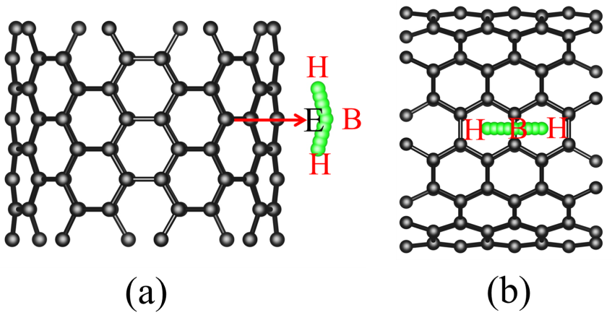
W.W. Shi, et al. Figure 1

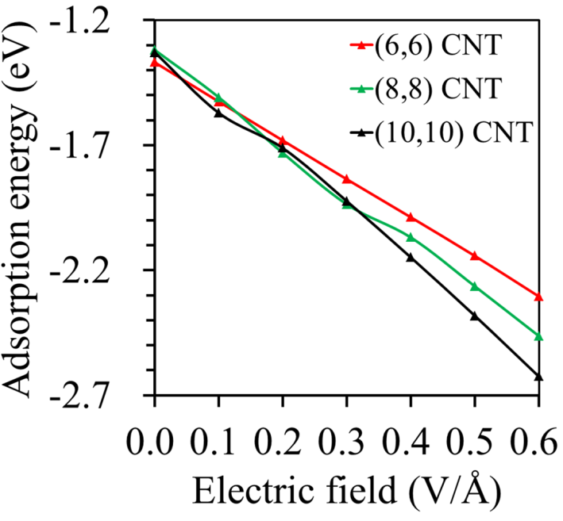
W.W. Shi, et al. Figure 2

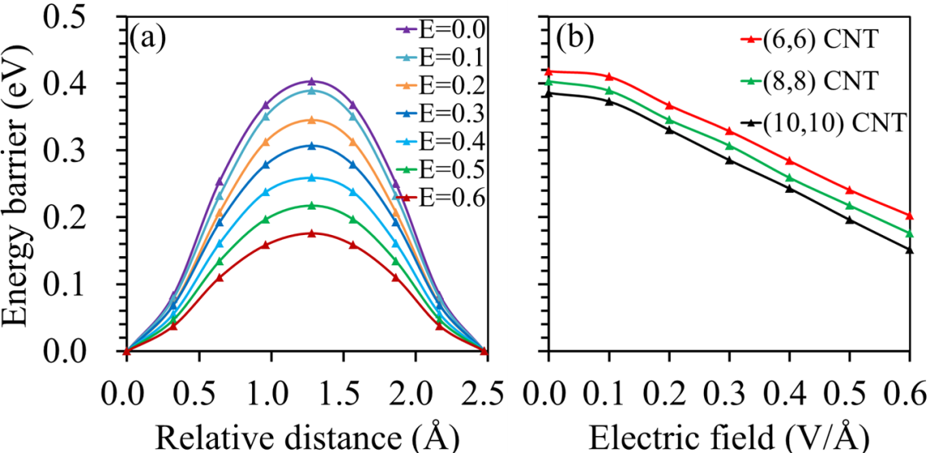
W.W. Shi, et al. Figure 3

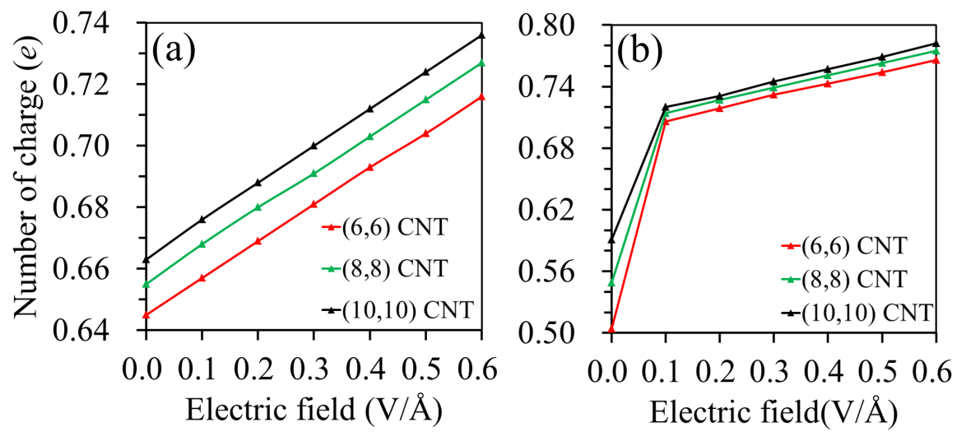
W.W. Shi, et al. Figure 4

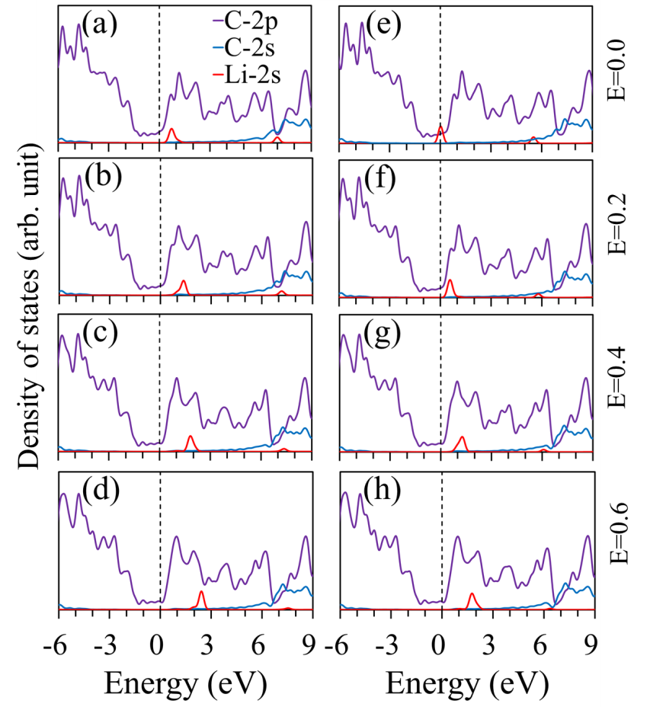
W.W. Shi, et al. Figure 5

