Principles and Recommendations for Client Information Requirements (CIR) for BIM Enabled Construction Projects in Qatar
Mian Atif Hafeez¹, Ahmad Mohammad Ahmad², Racha Chahrour³, Vladimir Vukovic¹, Nashwan Dawood¹, Mohamad Kassem⁴

¹Teesside University, United Kingdom
M.Hafeez@tees.ac.uk
V.Vukovic@tees.ac.uk
N.N.Dawood@tees.ac.uk

²Qatar University, Doha, Qatar
am.ahmad@qu.edu.qa

³HOCHTIEF ViCon Qatar W.L.L, Doha, Qatar
Racha.Chahrour@hochtief.de

⁴Northumbria University
M.Kassem@tees.ac.uk
Abstract. Employer’s Information Requirements (EIR) is one of the key early documents in projects using Building Information Modelling (BIM). EIR, introduced by the UK BIM Task Group, sets out the general information to be delivered and the standards and processes to be adopted by the suppliers as part of their project delivery approach. It includes a set of requirements and guidelines in three areas namely, technical, management and commercial. EIR, which are applicable to the construction industry in Qatar, are not clearly defined despite BIM is increasingly adopted across the Qatar construction industry especially on large and capital intensive projects (e.g., stadiums, hospitals, rails, roads, museum). In this paper, we aim to develop a set of principles and recommendations for the three areas of the EIR which are applicable to Qatar’s construction sector. We start by investigating the currently adopted BIM practices across the three areas of the EIR by interviewing major construction industry players (clients, consultants and contractors). The interview results showed discrepancies and varied levels of readiness in addressing the different areas and items of the EIR. Finally, we propose a set of general principles and recommendations for the different areas and items of the Client Information Requirements (CIR) – an adaption of the term EIR as evidenced in the paper. The proposed principles and requirements were informed by the interviews and validated by administering a questionnaire survey with industry experts.
Keywords: BIM, CIR, EIR, Information Requirements

1 Introduction
Employer’s Information Requirements (EIR), a term proposed by the UK BIM Task Group, is a pre-tender document setting out the information to be delivered, and the standards and processes to be adopted by the suppliers as part of the project delivery process (BSI, 2013). The UK’s Publicly Available Standard (PAS 1192) series makes distinction between a ‘Client’ and an ‘Employer’. A Client is an individual or organization commissioning a built asset while an Employer is an individual or organization named in an appointment or building contract as the employer. A client may appoint an employer who is the legal entity named in the contract and responsible for procuring the asset (BSI, 2013). Both terms have been interchangeably adopted in Qatar to refer to the party who issues the contract. After discussion with experts from a Qatar-based BIM forum (Q-BIM) and organisations, a decision is made to adopt the term ‘Client’ in this study. Hence, in the remainder of the paper, we use the term ‘Client’ to refer to individual or organization procuring and commissioning a built asset and issuing the contract. However, we use the term ‘Employer’ where we make reference to the ‘Employer’s Information Requirements (EIR)’of the UK PAS1192-2. Reaching a universally accepted term (‘Client’ or ‘Employer’) is out of the scope of this paper. The recommendations made in the paper could be adopted under either title (i.e., CIR or EIR) as the focus of the paper is on ‘Information Requirements’ which need to be clearly defined to achieve consistent BIM deliverables from the supply chain across the project life cycle phases.
The client is considered to be a body which incorporates the interests of the buyer of construction services, prospective users and other interest groups (Kamara, Anumba, & Evbuomwan, 2000). The client’s decision to commission a project is influenced by organizational factors (e.g. strategic, operational, etc.) that add complexity to the process of defining the requirements of the design phase and other project delivery phases (Kometa & Olomolaiye, 1997). Additional project requirements are related to site selection, environmental considerations, regulatory framework, design specifications, construction process and life cycle performance (Kamara et al., 2000). The multidisciplinary and fragmented nature of contracted organizations makes it difficult for project stakeholders to work towards a consistent understanding of client requirements.
The adoption of Building Information Modelling (BIM) concepts and workflows is proliferating within organizations, through project teams, and across the whole construction industry (Bilal Succar & Kassem, 2015). Strategic initiatives are undertaken by various governments including UK, Singapore, Finland, USA, among others to encourage the adoption of BIM in their respective construction industries (Kassem, Succar, & Dawood, 2015). Client requirements should be processed and communicated to all project stakeholders throughout the whole project life cycle from the early initiation phase to the handover and operation. Building Information Modelling (BIM) can be a means for project stakeholders to communicate, manage and deliver such requirements. However, this requires the clear definition of the EIR that sets the processes and standards to be adopted by the suppliers throughout the project life cycle.
While there are no explicit guidelines for EIR in Qatar, BIM is increasingly adopted on construction projects (Vukovic, Hafeez, Chahrour, Kassem, & Dawood, 2015). This paper aims to analyse the current BIM practices in Qatar against the EIR’s areas and their items as defined by the UK BIM Task Group. The content outline of the EIR covers three areas: technical (specification of software platforms, and definitions of levels of detail), management (management processes to be adopted in connection with BIM on a project) and commercial (BIModel deliverables, timing of Data Drops and definitions of information purposes). More information about the items is included in the subsequent literature review section. Following the literature review, the paper conducts the assessment of BIM practices in Qatar against the EIR elements and proposes and validates recommendations for Client Information Requirements (CIR) in Qatar.

2 Literature Review
Client requirements can be described in terms of the objectives, needs, wishes and expectations of the client (i.e., the person or firm responsible for commissioning the design and construction of a facility) (Kamara & Anumba, 2000). Client requirements change along the life cycle of the project to accommodate changing scope, expectations and unforeseen circumstances (Jallow, Demian, Baldwin, & Anumba, 2008). Requirements Management is a well-researched area that has been applied to product development industries. “Requirements management is the process of eliciting, documenting, organizing, and tracking requirements and communicating this information across the various stakeholders and the project team” (OGC, 2009). The management of requirements should extend beyond elicitation and documentation and requires an approach that will enable changeability and impact analysis, accessibility, traceability and communication to all stakeholders (Jallow et al., 2008). A process for client requirement information management must also address the whole life cycle across which the requirements and their impact should be tracked (Jallow et al., 2008).
With the recent advances in BIM and use of Information and Communication Technologies (ICT) in construction, managing requirements have become a key area for the success of projects. As part of a collaborative BIM decision framework, a streamlined information flow in BIM enabled projects is suggested to include early decisions for the definition of scope, purpose, roles, relationships and project phases (Gu & London, 2010).
The specification of information requirements in BIM-enabled project requires attention in order to achieve the full potential from BIM tools and workflows across the whole life cycle of a project. Therefore, the EIR was introduced to address the information requirements and deliverables which the client needs to make effective strategic and operational decisions across the project life cycle. Emerging studies suggesting the inclusion of requirements for all BIM Uses and project phases e.g. Facilities Management (FM) in EIR (Kassem et al., 2014, Patacas, Dawood, Vukovic, & Kassem, 2015; Ashworth, Tucker, Druhmann, & Kassem, 2016). The EIR concept and term were originally proposed in the UK by the BIM Task Group (BIM Task Group, 2013). They include three areas of requirements with several items and sub-items as illustrated in Figures 1, 2 and 3.

<INSERT FIGURE 1 HERE>

<INSERT FIGURE 2 HERE>

<INSERT FIGURE 3 HERE>

To deliver the EIR, there are Publicly Available Specifications (PAS 1192-2:2013 (BSI, 2013), PAS 1192-3:2014 (BSI, 2014b) and PAS 1192-5:2015 (BSI, 2015)), standards (BS 1192-2:2007 (BSI, 2007) and BS 1192-4:2014 (BSI, 2014a) ), protocols (i.e. CIC BIM Protocol (Construction Industry Council, 2013)), classification systems (Uniclass 2015) and technologies (the Digital Plan of Work) that are available for the entire UK construction industry. These documents address various aspects of the application of BIM and related issues across the whole life cycle of a project. For example, the PAS 1192-2:2013 (BSI, 2013) specifies processes for information management for the capital delivery phases of construction projects. At the start of the capital project delivery phase, the process starts with the Plane Language Questions (PLQ) to determine employer’s / client’s information requirements through EIR and BIM Execution Plan (BEP). The BEP specifies collaboration processes along the project life cycle, from the early design until the handover stage. The CIC BIM Protocol (Construction Industry Council, 2013) addresses issues regarding BIModels including the handling of intellectual property rights (IPR) and certain contractual requirements specific to BIModel at defined stages of projects.
BIM adoption is also increasing in Qatar and is being required by almost all major procurers - e.g. Ashghal, the Public Works Authority, Qatar Rail, Qatar Foundation, etc. - (Vukovic et al., 2015; Al Mohannadi, Arif, Aziz, & Richardson, 2013). However, in Qatar there is a lack of specifications and guidelines for the EIR. This paper investigates the potential of delivering EIR by comparing the current practice in Qatar against the EIR guidelines by the UK BIM Task Group. The ultimate aim is to conduct a gap analysis and suggest recommendations for a Qatar-specific CIR.

3 Methodology
This research adopted qualitative survey-based research approach. Surveys can be conducted using either questionnaires or interviews (Martyn, 2007). This research combines both approaches – interviews and questionnaires - at two different stages of the research and for two different objectives (Figure 4).
Following the initial observations and analysis of secondary sources such as invitation to tender documentations, a number of investigation topics and initial areas of requirements were identified. The semi-structured guides for interviews were designed using these topics and interviews were conducted with 28 participants. The interviews covered four domains of interest: Policy, People, Process and Technology (Grys and Westhorpe, 2011), containing a total of 18 questions/discussion topics with 36 subtopics. A qualitative analysis of the data collected from interviews was performed to identify existing information requirements and their challenges in Qatar. To achieve this objective, the information gathered from the interviews required structuring and organisation in a format that enable mapping against the UK EIR’s areas and items. Recommendations were then made to respond to the identified challenges in alignment with the three corresponding EIR’s areas and items.
The proposed recommendations were then validated through a questionnaire survey with 31 respondents. A five point Likert scale (i.e. high importance, medium high importance, medium importance, medium low importance, and low importance) was used to rate the importance of each of the proposed recommendations. The responses were then analysed by assigning a weight from 5 (High importance) to 1 (Low importance) and an average of the importance rating of each recommendation was calculated.

<INSERT FIGURE 4 HERE>

4 Results
The interviewees and questionnaire respondents included stakeholders from client, contractor and consultant organisations working on several ongoing projects in Qatar. Figure 5 shows the distribution of interviewees and questionnaire respondents. The questionnaire respondents were asked about their role, BIM related experience and experience of working on a construction project in Qatar. Figure 6 shows the roles and BIM related experience of questionnaire respondents. A significant majority (90%, 28) of questionnaire respondents had experience of working on a construction project in Qatar.

<INSERT FIGURE 5 HERE>

<INSERT FIGURE 6 HERE>
Tables 1, 2 and 3 summarise the results from the comparison against the items of the three EIR’s Technical, Commercial and Management areas respectively. The EIR items, which were not addressed by the interviewees, are marked as N/A (Not Applicable). The comparison provided in the three Tables is detailed and self-explanatory. The first column in each Table indicates the item of the EIR. The second column denotes the general requirements for that item as specified within the UK’s EIR. The third column states the findings about requirements corresponding to that item in Qatar. Finally, the fourth column provides the frequently reported challenges affecting each of the EIR’s items.

<INSERT TABLE 1 HERE>

<INSERT TABLE 2 HERE>

<INSERT TABLE 3 HERE>

Tables 4, 5 and 6 present the 32 recommendations that were made and validated using the questionnaire survey. The Tables also include an average importance rating against each recommendation. 17 recommendations were considered of ‘high importance’ while the remaining 15 were of ‘medium-high importance’.

<INSERT TABLE 4 HERE>

<INSERT TABLE 5 HERE>

<INSERT TABLE 6 HERE>

In the questionnaire survey, against each of the 19 items, an option was given for participants to make additional recommendation. Some of the additional recommendations and comments from the participants included:
Software
- “The format of exchangeable information for BIM goals is more important than the choice of software.”
- “All consultants want to use the software in which they have expertise. But for mega projects like Stadiums, clients want to dictate the use of particular software to streamline collaboration and communication of entire design team. Initially this seems to be draconian, but as the project progresses, team members realise the importance of such a strategy”
Data Exchange Format
- “The format and versions should be identified after BIM Uses have been identified.”
- “Appropriate stakeholders should understand and be aware of how clients will use delivered information.”
- "IFC is increasingly becoming a required format from the clients, but reasons to demand IFC is rarely made available. IFC format works well for all non-Autodesk software. But IFC often becomes a pain for consultants working entirely with Autodesk family of software. DWF format on the other hand is much easier to be created and handled by most other non-editing software.”
- "The importance of requirement for delivery in neutral data format will depend on the Employer's decision to remain software neutral or to specify the software to be used. If decision is taken to request neutral data formats, the native files are required to verify that the neutral file format is an accurate representation of the design intent.”
Coordinate
- “There should be a clear strategy to create a complete 3D GIS at national level to require projects to be developed in the same unified coordinate system.”
Level of Definition
- “Each project has its own LOD requirements, so it is better to provide just a general guidance that is in a form of an accepted standard. The challenge lies more on who has to do what at each stage of the project - see the O&M requirements, which are never defined when the EIR is issued.”
- “LOD and LOI should be made clear to all stakeholders involved.”
- “In the context of Qatar Construction Industry, LOD and LOI are still not fully comprehended by the contractors and consultants. LODs in the model would be a highly desirable thing if the models were to be used for shop drawings and facility management.”
Training
- “There is a need to express the importance of the right training program that needs to be implemented here in Qatar”
- “Expertise of suppliers are mostly demonstrated on project basis rather than training schemes.”
Data Drops and Project Deliverables
- “Data drops and project deliverables should not be used as an excuse for preventing the progress of a project.”
- “Clear communication during the entire project should be conducted to avoid surprises at the deliverable stages; on-going workshops would be beneficial.”
BIM-Specific Competence Assessment
- “This should already be in place at the Pre-Qualification for every company who bids for projects in Qatar. It should also address the Competency of the BIM Managers, BIM Coordinator and Modellers.”
- “International assessment systems could be adapted or locally developed ones can be used.”
- “All BIM manager roles cannot be measured by the same index. BIM Manager roles vary between client side, consultant side and contractor side.”
Roles and Responsibilities
- “Client should not dictate how a stakeholder performs their work, therefore roles and responsibilities should not be part of EIRs.”
Planning the Work and Data Segregation
- “This is part of the lead consultant’s responsibilities and should not be part of the EIR.”
Collaboration Process
- “The Common Data Environment (CDE) should be managed and procured by the Project Manager/Construction Manager or client. There are even tenders where the CDE is required by the BIM consultant of a subcontractor. There is a need for a top-down approach in the definition of collaboration processes and the CDE.”
Delivery Strategy for Asset Information
- “This is one of the most critical points missing in most projects as O&M teams get rarely involved in the process.”
- “Not just the format, but what specific FM information is required? This needs to have a practical/ pragmatic approach to avoid projects where the client just says "all FM information to be provided in BIM" which is vague, unclear and entails risks.”
- “The operation and management of facilities is not considered to its full extent in Qatar due to the rapid growth of its built environment and relatively limited experience in maintaining these new assets. Ashghal Asset Affairs has a wealth of experience in long term ownership of assets. The transition of this knowledge into a set of national standards would be of significant benefit to the State of Qatar.”
- “It is important to include Asset Information Requirements into the EIRs. This increases the chance of achieving value by the asset owner over the operation phase of the facility.”

5 Discussion and Recommendations
The key distinguishing factors, between the EIR guidelines of the UK BIM Task Group and current BIM practice in Qatar, are in the degree of completeness or coverage of items; the clarity and consistency in the definition of EIR items, and the project stage in which requirements are embedded. In the UK, the PAS 1192-2 requires that the design team and the contractor team include an outline BIM Execution Plan (BEP) in their proposals at the pre-contract stage to demonstrate their approach to deliver the EIR (BSI, 2013). After the award of the contract, the responsible supply chain needs to develop a detailed BIM execution plan aligned with the EIR.
The EIR items that are included in tender documents in Qatar mainly address a few items of each of the EIR’s areas. However, such items are not consistently prescribed and are often interpreted differently by the various project stakeholders.
Under the technical items of the EIR, the level of definition particularly the Level of model Detail (LOD) is specified without referring to a specific methodology which sets the incremental development of LODs thus causing misunderstanding. Software tools are generally not prescribed. However, some large projects specify the use of certain design authoring tools and collaboration networks. There are no data exchange format (i.e. neutral format) prescribed across the whole industry but these are usually specified within the protocols developed by the lead consultant or contractor on project. Much of the large-scale projects in Qatar require IFC (Industry Foundation Classes) and 3dPDF.
Within the commercial area of the EIR, BIM capability of organizations is assessed at the pre-qualification phase although they are no proven methods, tools or standards for BIM capability assessment. It is often assessed based on the number of previous BIM projects undertaken by the suppliers. There are no requirements for the generation of BIM Data Drops or specific datasets at certain work stages. Several work stages are adopted within Qatar’s construction industry including the RIBA Plan of Work, the AIA Phases of Work, and their modified versions by large procurers such as Ashghal (Public Work Authority). The respondents reported circumstances where suppliers working on the same project referred to different project work phases resulting in conflicts and issues that affected the progress of projects.
Under the management area of the EIR, a combination of standards, protocols and specifications (BS 1192-2, PAS 1192-2, AIA BIM protocols, etc.) are adopted depending on the country of origin of the lead consultant or contractor. Some BIM uses such as design coordination (clash avoidance), 4D and 5D planning are increasingly specified on most projects. Production and site drawings are increasingly required to be produced only at the end of the design coordination process from a fully coordination model. Site inspections and the consequent authorisation of payments are conducted within 5D environment. There are no agreed upon definitions of BIM roles and their corresponding responsibilities. BIM Manager is the predominant and frequently required role on projects. Finally, there are no clear BIM requirements for the delivery of data to the facility management phase.
The definition of EIR as early as possible in projects, their shared understanding among the supply chain, and the implementation of protocols to deliver them, are key principles for achieving a whole life cycle approach in construction projects. It is clear from the comparison that a whole life cycle approach in Qatar’s construction industry is currently not possible. However, in each of the areas of EIR (technical, commercial and management), Qatar construction industry demonstrates capabilities in several items. To build upon current capabilities and build the foundation for the industry to start moving towards a more diffused and mature adoption of BIM, there is a need to develop Qatar-specific CIR.
The CIR for Qatar may require adjustments depending on asset type, project stages, project needs and procurement strategies. It is important to define general guidelines and principles for CIR at market level to avoid mixed requirements that could be ‘imported’ from different countries and used on the same project as evidenced earlier. Indeed, almost every large client organisation is now employing a consultant to define their information requirements to be specified on their own projects. Over time this will result in several competing commercial, technical and management requirements. Clashes and misunderstanding do not occur only within the same project but often at the interface of projects owned by two main procurers (e.g. interface between a building project and an infrastructure project). It is therefore important that the CIR observe the following principles:
- sufficiently generic to permit flexible adoption across different projects and clients and unbiased towards particular technologies and/or processes;
- defined based on sufficient knowledge of client’s internal processes;
- related to either current roles and responsibilities at client organizations or explicitly define specific change to such roles;
- recognise the need of a BIM team at client’s side to supervise the compliance to information requirements;
- consider applicable standards in Qatar, e.g. QCS and to evaluate the applicability of international BIM/information standards;
- clarify the interactions with other management systems within client organisations;
- clarify model ownership and intellectual property issues, and
- include definitions of BIM related terminologies to avoid misunderstanding among project stakeholders.

Client information requirements and achieving Project Goals:
Client information requirements are important to guarantee that BIM deliverables satisfy the client and project needs. Figure 7 shows the adopted approach to align the client information requirements with BIM uses and project goals.

<INSERT FIGURE 7 HERE>

Adopting BIM on a project has several benefits for the project and stakeholders involved (Azhar, Hein, & Sketo, 2008; Bryde, Broquetas, & Volm, 2013; Eastman, Teicholz, Sacks, & Liston, 2011) and a number of BIM Uses / Model-Uses have been proposed across the whole life cycle of projects (Kreider & Messner, 2013; B Succar, Saleeb, Sher, & Kingdom, 2016). However not all of the BIM Uses should necessarily be used in every project. The identification and extent of BIM Uses to be selected for the project should be informed by Client Information Requirements in alignment with project goals. The competencies of individuals and project teams for the specified BIM uses should be defined and assessed. The technology should not be dictated by the client but the supply chain needs to ensure that they can collaborate and exchange information without technology hindrance. However, certain information requirements (e.g. IFC, COBie) specified by the client will indirectly imply the use of some technologies. Establishing such general principles and guidelines as proposed in this study and validated by industry participants will help achieving consistent BIM deliverables from the supply chain that satisfy the client and project goals.

6 Conclusion and Limitations
This paper investigated the current BIM practices in Qatar across the three areas of requirements (i.e. technical, commercial, management) and their items. The results showed that the construction industry in Qatar has capabilities in several items under each of the three areas of EIR. However, there are significant challenges related to the lack of Qatar-specific BIM standards, BIM dictionary, project work phases, capability assessment, etc. Based on the gap analysis conducted, the research suggested the development of Qatar-specific CIR and some recommendations for its different items were made. The recommendations were validated and rated (mostly medium-high to high importance) by industry participants.
The limitation of this study is related to the inconsistent coverage of all items of EIR in the interviews. Also the interviews were conducted with mainly large organizations working on large scale projects. Therefore, the suitability of recommendations may be skewed towards larger stakeholders, which however, represent the largest share of the Qatar construction market.
Finally, it is expected that the outcomes from this research will contribute to supporting and instigating stakeholders in the Qatar construction sector to work towards the development of CIR for Qatar. The proposed recommendations represent an initial and early set of guidelines that could be used to start broader discussion around this topic.
Acknowledgement
The work described in this publication was part of the research project funded by the National Priority Research Program NPRP No.: 6 - 604 - 2 - 253.
This paper is a revised and expanded version of a paper, entitled ‘Investigating the potential of delivering Employer Information Requirements in BIM enabled Construction Projects in Qatar’, which was presented at IFIP 12th International Conference on Product Lifecycle Management, Qatar, 19-21 October, 2015.
References
Al Mohannadi, F., Arif, M., Aziz, Z., & Richardson, P. a. (2013). Adopting BIM Standards for Managing Vision 2030 Infrastructure Development in Qatar. International Journal of 3-D Information Modeling, 2(3), 64–73.
Ashworth, S., Tucker, M., Druhmann, C., & Kassem, M. (2016). Integration of FM expertise and end user needs in the BIM process using the Employer’s Information Requirements (EIR). In Proceedings of CIB World Building Congress Vol 5, 2016.
Azhar, S., Hein, M., & Sketo, B. (2008). Building information modeling (BIM): Benefits, risks and challenges. In Proceedings of the 44th ASC National Conference.
BIM Task Group. (2013). Employer’s Information Requirements Core Content and Guidance Notes. Retrieved from www.bimtaskgroup.org
Bryde, D., Broquetas, M., & Volm, J. M. (2013). The project benefits of building information modelling (BIM). International Journal of Project Management, 31(7), 971–980.
BSI. (2007). BS 1192 : 2007 Collaborative Production of Architectural , Engineering and Construction Information - Code of practice.
BSI. (2013). PAS 1192-2:2013 Specification for information management for the capital / delivery phase of construction projects using building information modelling.
BSI. (2014a). BS 1192-4:2014 Collaborative production of information Part 4 : Fulfilling employer ’ s information exchange requirements using COBie – Code of practice.
BSI. (2014b). PAS1192-3:2014 Specification for information management for the operation phase of assets using building information modelling, (1).
BSI. (2015). PAS 1192-5:2015 Specification for security-minded building information modelling , digital built environments and smart asset management.
Construction Industry Council. (2013). Building Information Model (BIM) Protocol.
Eastman, C., Teicholz, P., Sacks, R., & Liston, K. (2011). BIM handbook: A guide to building information modeling for owners, managers, designers, engineers and contractors. John Wiley & Sons.
Grys, R. and Westhorpe, M. (2011). The BIM manager, BIM journal 33(3), pp. 63-65
Gu, N., & London, K. (2010). Understanding and facilitating BIM adoption in the AEC industry. Automation in Construction, 19(8), 988–999.
Jallow, A. K., Demian, P., Baldwin, A., & Anumba, C. (2008). Life cycle approach to requirements information management in construction projects: State-of-the-art and future trends. Association of Researchers in Construction Management, ARCOM 2008 - Proceedings of the 24th Annual Conference, 2, 769–778.
Kamara, J. M., & Anumba, C. J. (2000). Client Requirements Processing for Concurrent Life-Cycle Design and Construction. Concurrent Engineering, 8(2), 74–88.
Kamara, J. M., Anumba, C. J., & Evbuomwan, N. F. O. (2000). Process model for client requirements processing in construction. Business Process Management Journal, 6(3), 251–279.
Kassem, M., Iqbal, N., Kelly, G., Lockley & Dawood, N. (2014). Building information modelling: protocols for collaborative design processes. Journal of Information Technology in Construction (ITcon), Vol. 19, pg. 126-149, http://www.itcon.org/2014/7
Kassem, M., Succar, B., & Dawood, N. (2015). Building Information Modeling: Analyzing Noteworthy Publications of Eight Countries Using a Knowledge Content Taxonomy. ASCE BIM Monograph, 66(4), 397–408.
Kometa, S. T., & Olomolaiye, P. O. (1997). Evaluation of Factors Influencing Construction Clients’ Decision to Build. Journal of Management in Engineering, 13(2), 77–86.
Kreider, R., & Messner, J. (2013). The Uses of BIM: Classifying and Selecting BIM Uses. State College-Pennsylvania, (September), 0–22.
Martyn, D. (2007). The Good Research Guide - for small-scale social research projects, 358.
OGC. (2009). Office of Government Commerce, UK. Requirements Management. Available [http://www.ogc.gov.uk/delivery_lifecycle_requirements_management.asp]. Retrieved from http://www.ogc.gov.uk/delivery_lifecycle_requirements_management.asp
Patacas, J., Dawood, N., Vukovic, V., & Kassem, M. (2015). BIM for facilities management: evaluating BIM standards in asset register creation and service life. ITcon, 20, 313–331.
Succar, B., & Kassem, M. (2015). Macro-BIM adoption: Conceptual structures. Automation in Construction, 57, 64–79.
Succar, B., Saleeb, N., Sher, W., & Kingdom, U. (2016). Model Uses : Foundations For A Modular Requirements Clarification Language. In Australasian Universities Building Education (AUBEA2016) (pp. 1–12).
Vukovic, V., Hafeez, M. A., Chahrour, R., Kassem, M., & Dawood, N. (2015). BIM Adoption In Qatar : Capturing High Level Requirements For Lifecycle Information Flow. In Proceedings of CONVR 2015.

Appended Figures and Tables
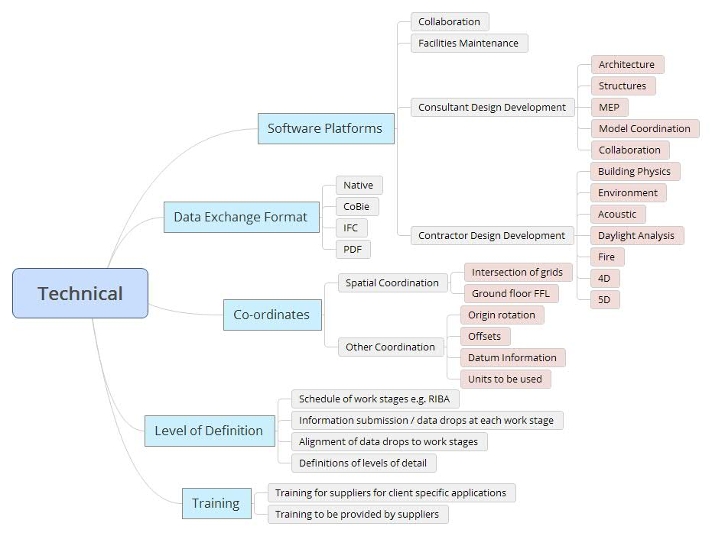
Figure 1: Items and sub-items of Technical area of EIR. (Source: Adapted from (BIM Task Group, 2013))
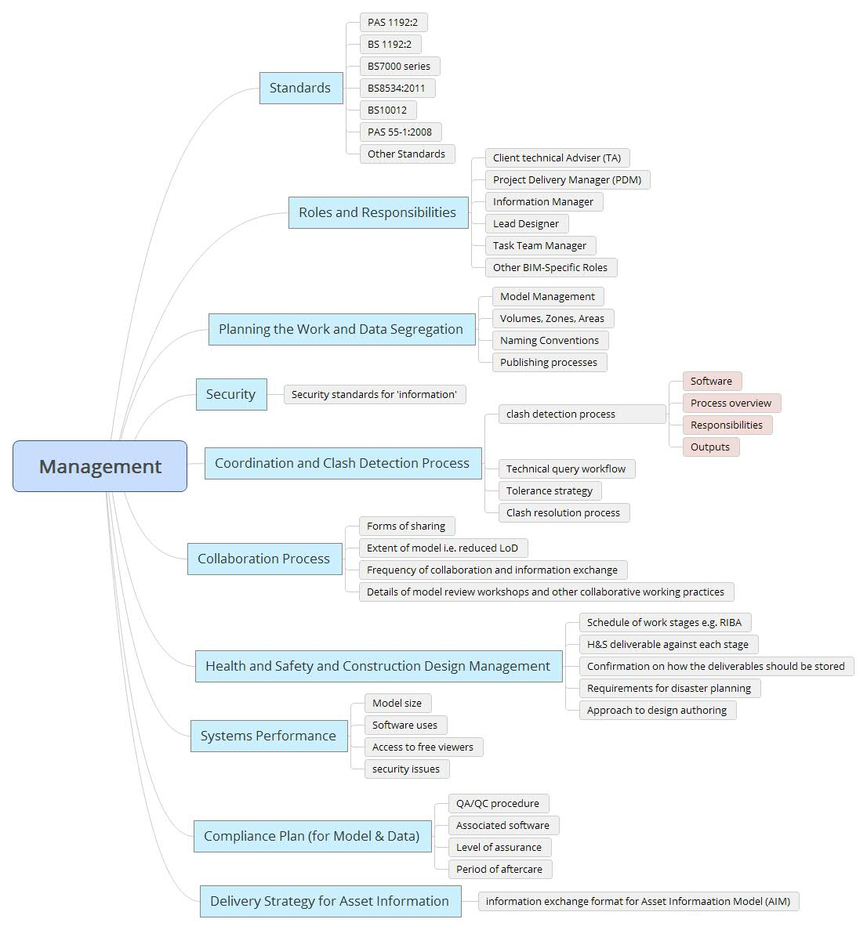
Figure 2: Items and sub-items of Management area of EIR. (Source: Adapted from (BIM Task Group, 2013))

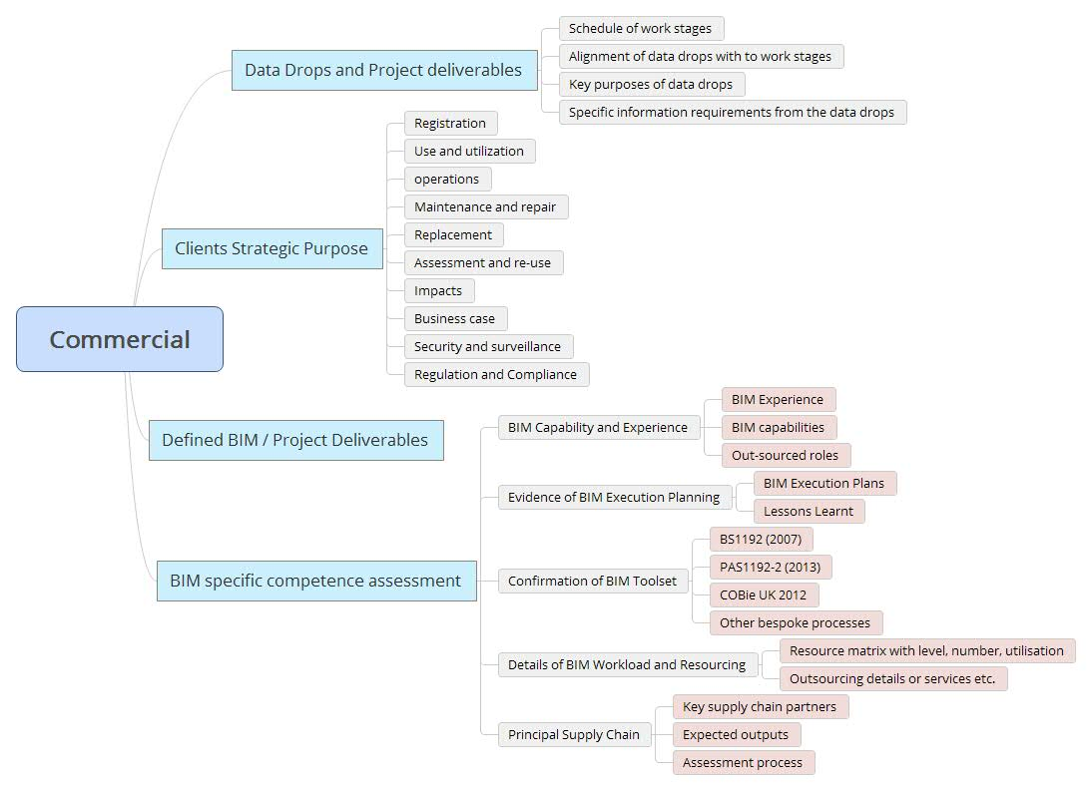
Figure 3: Items and sub-items of Commercial area of EIR. (Source: Adapted from(BIM Task Group, 2013))

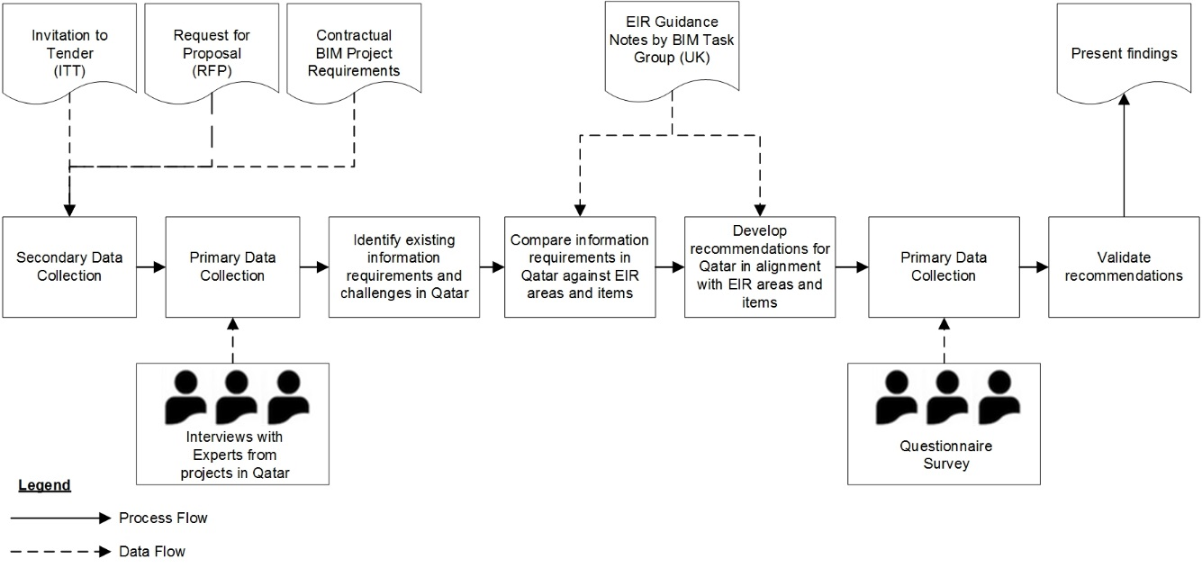
Figure 4: Research Methodology
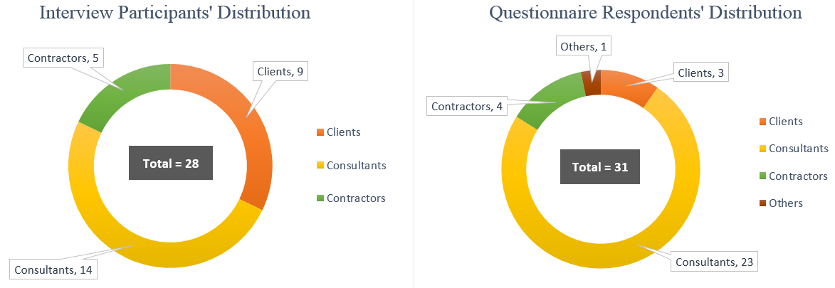
Figure 5: Distribution of interviewee’s & questionnaire respondents (type of organization they work for)

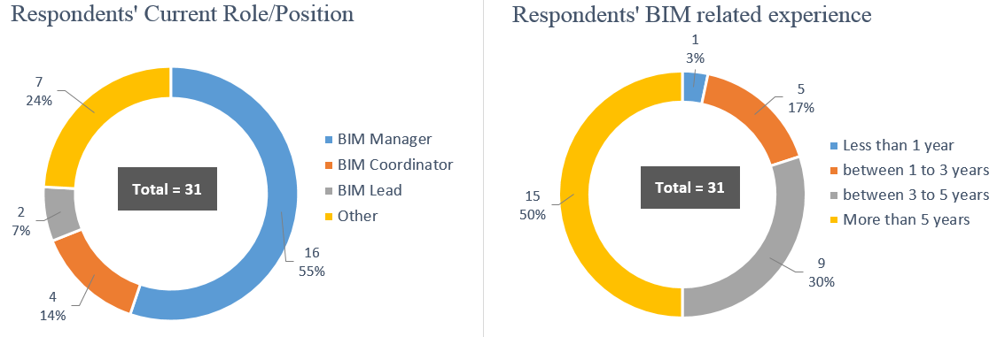
Figure 6: Questionnaire Respondents’ Roles and BIM related experience

Figure 7: A structured approach to match Client Information Requirements with project goals

Table 1: Technical items of EIR
Item | Employer Information Requirements guideline UK | Client Information Requirements in Qatar | Frequently Reported challenges by Interviewees
Software Tools | Should not be mandated except those for collaboration, information exchange and Facility Management requirements. | Prescribed in some cases and not in others. | Difficulty in exchanging information due to lack of interoperability.
Data Exchange Format | Define formats to deliver information at Data Drops. | Mostly specified. | Data loss in information exchange.
Coordinates | Adopt common coordinate system for spatial coordination. | Specified using local systems such as Qatar National Grid (QNG) and Qatar National Datum (QND). | N/A
Level of Definition [Level of model Detail (LOD) + Level of Information (LOI)] as per PAS 1192-2: 2013 | Levels of Definition to be aligned with stages. | LOD part is mostly mentioned in BIM requirements. LOI not explicitly mentioned. | Lack of a common understanding about what different LODs mean thus making room for mis-interpretation.
Training | Specify training requirements for bidders and from bidders (if needed). | Not specified explicitly. Mostly done ad hoc. | There is more demand for BIM training but limited supply (training providers).

Table 2: Commercial items of EIR
Item | Employer Information Requirements Guideline UK | Client Information Requirements in Qatar | Frequently Reported Challenges by Interviewees
Data Drops and Project Deliverables | Communicate the content of Data Drops and their alignment with work stages. | Not clearly specified. | The information deliverables or Data Drops are not clearly specified and are not aligned with work stages causing misunderstanding among stakeholders.
Clients Strategic Purpose | Communicate the purpose of client's information requirements and deliverables. | The existing information requirements do not clearly state the purpose for which it will be used. | Clients require certain BIM deliverables without having clear intention for their use making it difficult to manage client expectations.
Defined BIM/Project Deliverables | Define BIM deliverables in alignment with project work stages. | BIM deliverables are required but not clearly specified. | BIM deliverables are unclear. Different suppliers interpret them differently on what they need to deliver and hence the client does not receive consistent information.
BIM-Specific Competence Assessment | Communicate the competence criteria for bidders as part of bid submission. | Relevant individual and organizational experience is requested. | Lack of a system to objectively assess the BIM-specific competence of individuals and organizations.

Table 3: Management items of EIR
Item | Employer Information Requirements guideline UK | Client Information Requirements in Qatar | Frequently Reported Challenges by Interviewees
Standards | Define the BIM standards that are incorporated into the information requirements. | There are no Qatar specific BIM standards. A combination of international standards is used and is often required by contract. | Clients and suppliers have different preferences for BIM standards because of the availability of several standards and their countries of origin.
Roles and Responsibilities | Allocate roles associated with the management of the model and project information. | BIM-specific roles are required predominantly BIM Manager. | Lack of agreement over the scope of responsibilities of BIM-specific roles.
Planning the work and Data Segregation | Set out requirements for the bidder's proposals for the management of the modelling process. | N/A | N/A
Security | Communicate client specific security measures for data security. | N/A | N/A
Coordination and Clash Detection process | Define coordination process together with quality control requirements. | Coordination or clash detection is required on almost all BIM projects. | No issues reported
Collaboration Process | Define how, where and when project information will be shared. | Collaboration process is required. | Collaboration process is not consistently used across the supply chain because of different levels of BIM capability.
Health and Safety (H&S) and Construction Design Management | Define how BIM based working will support H&S and Construction Design Management. | There are specific requirements in Qatar Construction Specifications (QCS 2014) but are not in relation to BIM. | N/A
System Performance | Communicate Employer's requirements for IT and systems. | N/A | N/A
Compliance Plan | Communicate requirements for model integrity and other data sources. | N/A | N/A
Delivery Strategy for Asset Information | Define information exchange standard for asset information and obtain proposals with regards to asset information delivery to Employer’s Facility Management environment. | COBie data is required in some cases. | Lack of information requirements in facility management.  Lack of understanding of how FM systems can be populated with COBie data.

Table 4: Recommendations for the technical area of the CIR
Item | Recommendations  (Client should: ) | Average importance rating
Software Platforms | Not dictate software platforms. | Medium High
 | Communicate Document Management System (DMS) used by client. | High Importance
 | Require supply chain to inform the client of their choice of software | High Importance
Data Exchange Format | Require information deliverables in neutral and native data formats | High Importance
 | Require that information content of IFC Models be verified. | High Importance
 | Require a clear strategy to clarify dealing with deliverables prepared in different software packages. | High Importance
Co-ordinates | Specify Qatar National Grid (QNG), Qatar National Datum (QND), origin and units. | High Importance
Level of Definition | Specify Level of Detail (LOD) for geometry and Level of Information (LOI) along with a reference standard | High Importance
 | Specify increment in LOD and LOI along the project work stages. | Medium High
 | Require or specify Model element matrix to clarify LOD and LOI at elemental level | High Importance
Training | Specify areas of training covering different types of competencies. | Medium High
 | Require suppliers to demonstrate their training plan in the specified areas. | Medium High

Table 5: Recommendations for the commercial area of the CIR
Item | Recommendation  (Client should: ) | Average importance rating
Data Drops and Project Deliverables | Define Data Drops and project deliverables in alignment with project work stages. | High Importance
 | Communicate client’s processes supported by BIM deliverables at each stage. | High Importance
 | Require pre submission workshops at each data drop to facilitate the approval process. | Medium High
Clients Strategic Purpose | Clarify the overall purpose of mandating BIM on the project. | High Importance
 | Clarify specific purpose of each required BIM process and deliverable. | High Importance
BIM-specific Competence Assessment | Include a system to assess individual BIM competency and organizational BIM capability. | Medium High

Table 6: Recommendations for the management area of the CIR
Item | Recommendations  (Client should: ) | Average importance rating
Standards | Specify relevant BIM standards. | High Importance
 | Specify a suitable classification system. | High Importance
 | Include BIM Execution Plan (BEP) templates. | Medium High
Roles and Responsibilities | Specify BIM-specific roles and responsibilities. | Medium High
Planning the work and Data Segregation | Specify model management requirements, naming convention and folder structure. | Medium High
Security | Specify security standards and special security requirements for the information. | Medium High
Coordination and Clash Detection Process | Specify coordination and clash detection process along with frequency and reporting requirements | Medium High
Collaboration Process | Mandate the use of Common Data Environment (CDE). | High Importance
 | Require model review workshops | Medium High
Health and Safety and Construction Design Management | Require Health and Safety related information at each Data Drops | Medium High
 | Require specific presentations to clarify safety issues or resolution strategies with BIM support. | Medium High
System Performance | Communicate the client's requirements for IT and systems. | Medium High
Compliance Plan | Mandate QA / QC procedures to ensure quality of information and models. | High Importance
Delivery Strategy for Asset Information | Specify the format of asset information. | High Importance

