Conference on Rapid Design, Prototyping and Manufacturing (RDPM)-2017
Title of Paper: Building of Polyurethane Foams Structures Using Additive Manufacturing Technology
Authors: C. E. Oppon: pceoppon@yahoo.com; P. M. Hackney: phil.hackney@northumbria.ac.uk
ABSTRACT
Polyurethane (PU) foam is a versatile material due to its numerous properties, such as: biocompatibility, biodegradability, lightweight, and durability. The porous nature of PU foams enables them to be used for lightweight components and for medical applications where permeability allows nutrients to reach cell growth areas. The foam components are currently mainly manufactured by casting/moulding processes or material removals (i.e. subtractive machining) after a foam block has been casted or moulded.
Additive manufacturing (AM) processes (3D printing), build components in 2D layers. The nature of parts produced by AM technologies makes it fit for lightweight products such as aerospace parts, medical scaffolds, automobile parts, etc., in metals and polymers, however, the technology has not been used to produce objects using PU as its material, due to the foaming nature of the material when its two base materials (Polyol and Diisocyanate) encounter each other.
This paper has evaluated the suitability of Additive manufactured PU foam structures for further application such as medical scaffolds by comparing the foams produced using traditional method and have developed an AM production method (In-flight mixing system) for the material (PU). Based on the evaluations, a new technique has been proposed and tested which is able to generate PU 3D structures.
Foam produced by the designed system has the same characteristics as the traditional casting method with an average pore size of 689µm which will allow the following: the flow of fluid such as blood, diffusion of waste products out of the scaffold, and cell infiltration and can therefore be suggested for the production of medical scaffolds.
Keywords: Additive Manufacturing, Polyurethane Foam, Biocompatibility, Biodegradability, Lightweight Components.

- INTRODUCTION
Polyurethanes (PU’s) are materials used in many applications such as: aeronautics, automobile, building construction, marine, and diverse household applications [1]. The use of polyurethane continues to grow as they can be used in areas where other materials do not work; such as corrosion resistance against metals, high impact resistance against plastics, superior load bearing capacity against rubber, etc. [2]. They are among the most versatile construction materials that can be formulated for medical devices [3,4]. It is therefore worth investigating the appropriate factors that affect the production and their full usage to influence their versatility [3–6]. Additive Manufacturing (AM) can also be referred to as Three–Dimensional Printing (3DP), Freeform Fabrication (FF), E-manufacturing, or Rapid Prototyping (RP) [7]. The technology is a fast-growing sector in the manufacturing industry as it has developed from its initial application for rapid prototyping to many functional end products in many fields such as automotive, biomedical, aerospace, jewelry, coin making, tableware, and construction industries [8]. The technique produces three dimensional solids directly from a digital model or any electronic data source in a layer–by–layer manner [8–10]. This is different from conventional manufacturing such as moulding where material is injected in a mould to create a part, or the subtractive process (traditional machining technique) which mostly rely on the removal of material by methods such as: drilling, cutting, coining, milling, shaping, etc. from a blank or a bulk material for the part creation [11]. AM enables multiple parts to be created and assembled simultaneously to receive multiple assemblies at the same time avoiding hazards associated with assembling [11,12]. It is therefore characteristically more efficient and flexible than the conventional manufacturing [11,14].
Despite the versatile application of AM and wide range use of PU with both arriving at the same point of medical applications, the technology and the material have little or no links in the medical sector due to the production nature of the material [4–6].

1.1 Cell Window Drainage Effect of Polyurethane Foam
The mechanical mixing of the PU foam introduces bubbles which grows during foaming in the form of spherical shape. These spherical bubbles begin to distort into multisided polyhedral which forms cell windows as the volume fraction of the gas bubbles exceeds 74%. Continuing reaction causes the cell window to become thinner by drainage and biaxial extension which is caused by the expansion of the bubbles. The liquid pressure inside the plateau will be lower than in the cell windows as shown in figure 1, because of the capillary forces. Due to the pressure difference, the cell window will be thinning by sucking liquid from the windows into the struts. With different silicone surfactant with different abilities, resulting in a distribution of different cell window thickness at the time of cell opening, its addition can retard the cell window drainage.
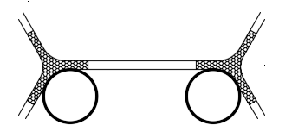
Cell Window Thickness (h)
Drainage flow
Cell Window
Plateau’s Border (strut)
r
Figure 1: Diagram of drainage in a cell window
r

1.2 Development of Skin in Free Rise of Polyurethane Foam
Certain chemicals and aids such as blowing agents are required in the processing of PU foam to ensure sufficient control to obtain commercial products [16]. During the foaming process, there is an internal reaction that takes place which is controlled by surfactant and this takes place between the non-homogeneous compounds of the system [17]. The polymer structures are modified by chain extenders or cross linkers, as well as fire retardants, fillers and pigments [18,19]. Depending on the PU formulation, catalysts, and application, the reaction typically starts within a few seconds and completes in few minutes. Within this time, the reacting liquid mixture is dispensed into the mould and the combined mixing and dispensing equipment cleaned, making it ready for the next cycle of operation [16,18]. The formation PU foam involves an intricate process that employs two simultaneous reactions, involving the formation of urethane and a blowing by carbon dioxide (CO₂) that secondarily forms urea which is not very soluble in the reaction mixture, thereby tending to form separate “hard segment” phases mostly consisting of polyurea [22]. The complete PU formation process can be divided into four main sections or steps including:
- Mixing and bubble nucleation,
- Liquid foam rising,
- Phase separation leading to rapid modulus rise and cell opening, and
- Foamed elastomeric [22].
The step 3 which is the celling opening is among the most important activities in the PU foaming process as it determines the flow of air, which is the fraction of open cell window of a foam. The air flow affects many of the physical properties of the PU foam [22]. Formation of foam occurs with high exothermic chemical reaction which is completed within the mould and the manufactured article (bun), then taken from the mould after curing, and machined to the required size and shape if required for the intended purpose [16, 18]. As the temperature of the foam increases, there is a loss of heat from the surface of the bun due to the atmosphere temperature which is less than the exothermic temperature [22]. Due to the loss of heat from the surface (top skin), the temperature of the inner core of the bun is higher than the top skin temperature [22], therefore, the profile yielding a slower reaction kinetics. There will therefore be less CO₂ generated in the top skin than at the centre of the object [23]. This is illustrated in figure 2.
The surfactant added during the formation of PU foam determines the dynamic surface tension at visual blow-off time and, affect the gas diffusion through the cell window [22,23].

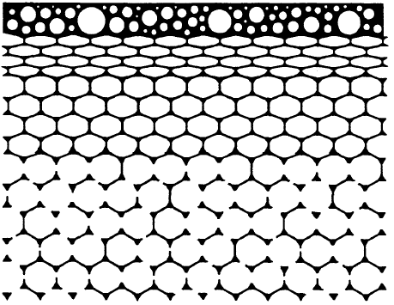
Top Skin
Tension of top skin and cell layers
Closed, liquid cells
CO₂ Pressure
Open, solid cells
Restriction by struts
Figure 2: Skin effect of Polyurethane Foam Formation

2 EXPERIMENTAL WORK
2.1 Characteristics of PU Foam Built by Conventional Method
Conventional method was used to produce PU foam by hand mixing and cast in moulds. The foam produced was investigated for its pore dimension in both transverse (against the walls of the mould) and longitudinal (in the direction of the open end of the mould). This was to provide baseline information that could lead to the requirements of the criteria for the system modification. The structure of the foam produced was viewed in both the transverse (restricted) and longitudinal (free) foaming directions using the SEM (figure 3). The average pore size for the restricted foaming direction was 715 μm and that of the foaming direction was 685 μm for the free.
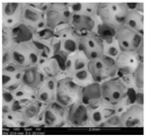
(b) Free Foaming Direction
2 mm
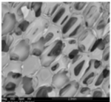
- Restricted Foaming Direction
2 mm
Figure 3: PU foam structure for restricted and free foaming directions

2.2 Design/Modification of the Existing 3D Printer – Inflight System
The experiments were in twofold. The first was to design a system that will be incorporated to the existing 3D Printer based on the information gathered and the processing of PU foam regarding its strengths and limitations, taking into consideration the design criteria that satisfied the production of PU foam; the second was to test the modified system by printing PU foam and compare the microstructure of the built foam viewed using the Alicona Scanner and SEM to the foam built by hand mixing and casting (PU foam conventional production).
The designed system is called an ‘Inflight System’ as the mixing of the two base materials of the PU foam (polyol and diisocyanate) was done on the surface of a built platform outside a chamber after the base materials have separately been dispensed under the influence of compressed air to meet and cross-mix at the point of deposition.

2.2.1 Description of the designed In-flight Mixing System
The system consists of compressed air supply which is distributed to two resin reservoirs, one containing polyol and the other diisocyanate. Two pressure controls are connected on each pipeline after the distribution junction to control the pressure acting on the resins. Each reservoir is covered with heater blanket which pre-heats and maintains the resin at the required temperature to reduce its viscosity to enable easy flow. Two pipelines, each for one of the resins are connected from the resin reservoirs to the individual nozzles. Between the resin reservoirs and the nozzles are connected two needle valves with each on one side to regulate the flow of resins from the reservoirs to the nozzles. This enables variation of mixing ratio as established in the study of PU foam characteristics. The nozzles are held in their housings which are extruded cylindrical portion normal to the Y-arm of nozzles holder. They are made to be screwed in and out to increase or decrease the distance between the nozzle tip and the build platform. Heated air would be distributed to the housing environment which heats the substrates to facilitate the resins reaction and speed up foaming/curing to enable another layer to be deposited on the previous one at the required rate. The platform is lowered to a height equal to thickness of a layer after each layer to enable another layer built on top of the previously laid one as applied to any other additive manufacturing process. The schematic diagram of the designed in–flight system is shown in figure 4 and the full theoretical design is shown in figure 5.
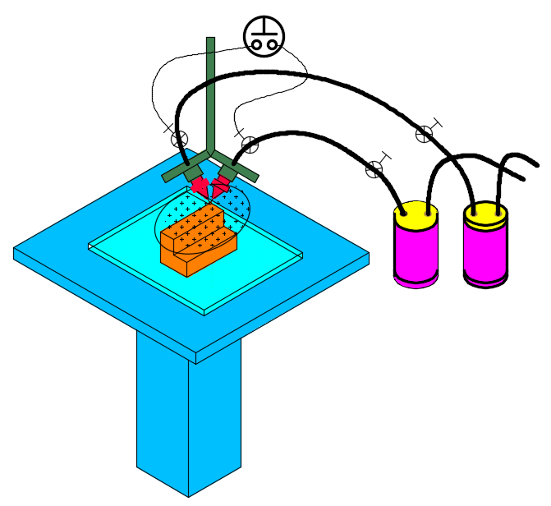
Solenoid Valves Switch
Resin Flow Regulator
Solenoid Valves
Compressed Air Supply
Heated Environment
Air Pressure Controls
Built Part
PART A
PART B
Resins Reservoirs
Platform Movement
Figure 5: The Designed In-flight Mixing System
Compressed air pressure line
Compressed air pressure line
Control valves
Resin flow regulator
Resin flow regulator
Resin flow to nozzle
Heater blanket
Heat source
Air compressor
Build Platform
Resin A
Z-direction
Resin B
Heater blanket
Figure 4: Schematic of in-flight mixing

2.2.2 The Physical Components of the Designed In-flight Mixing Process
The complete modified system was the inclusion of all the sub–systems designed and manufactured or bought and incorporated to the Replicator 3-D Printer. Figure 6 (a) and (b) shows the front and side views respectively of the complete assembly with all the physical components of the attachment used to modify an available low cost 3-D Printer. The designed sub-system was used to replace the print-head of the printer, even though the electrical lines from the Replicator to the print-head thermocouple were not disconnected.
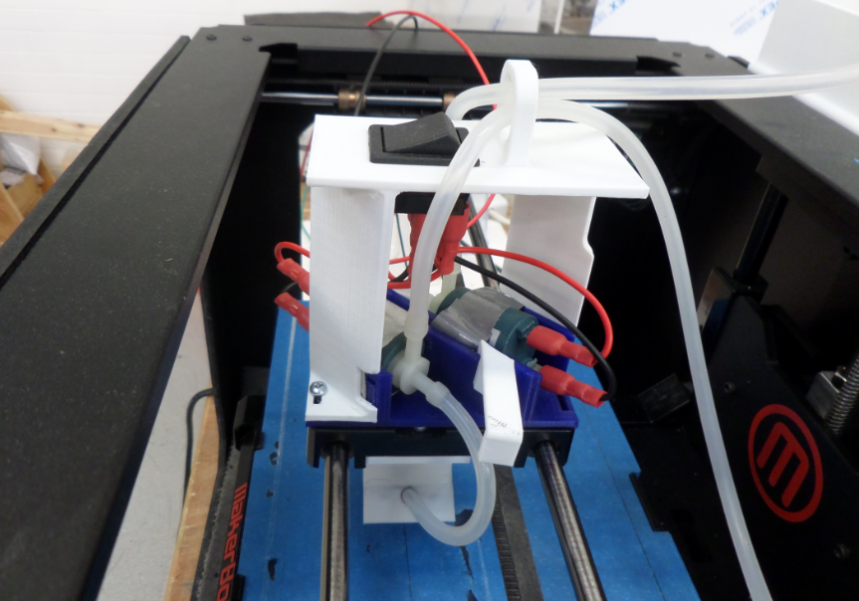
Solenoid valves switch
Connections from regulating valves to solenoid valves
Solenoid valves
Mounting bracket
Solenoid valve
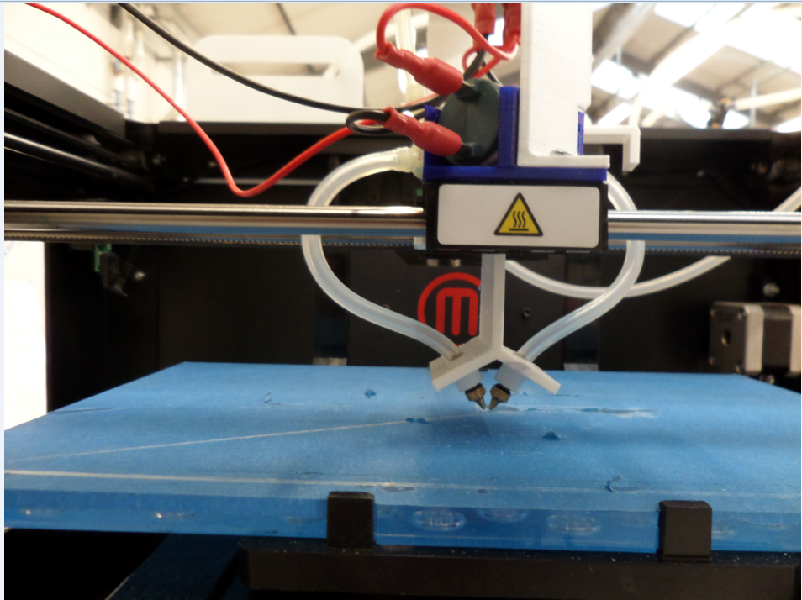
Connections from solenoid valves to nozzles
Nozzles holder
Build platform
Nozzles
Figure 6: Front and side views of the designed attachment

(b): Side view

(a): Front view

2.2.3 Programming for Printing PU Foam Blocks
To print the 3-Dimensional block, a program was drawn using the ReplicatorG language to be able to use the available MakerBot Replicator 3-D Printer. This enabled a dwell period or pause of the machine for the period estimated for the laid foam to cure.
The default written program of ReplicatorG outputs Two–Dimensional tracks of rectangular block of length 160 mm and breadth 90mm and a triangular block of the adjacent sides 160 mm and 90 mm respectively with a dwell time of 180 seconds. Figure 7 shows the complete printed tracks.
–200
–160
–120
–80
–40
0
–240
40
–40
–80
–120
–160
PT. 1
PT. 2
PT.3
(b) Nozzle Path for Triangular Block
PT. A
Figure 7: Nozzle path geometry for rectangular and triangular parts
–200
–160
–120
–80
–40
0
–240
40
(b) Nozzle Path for Rectangular Block

PT.A
PT. 1
PT.4
–40
–80
–120
PT. 2
PT.3
–160
(a) Nozzle Path for Rectangular Block

3 TEST RESULTS/DISCUSSION OF THE DESIGNED IN-FLIGHT MIXING SYSTEM

3.1 Two-Layered Rectangular Built Block
The figure 8 (a) shows the image obtained for the two-layered rectangular ring of 120 mm x 90 mm as the previous but at constant build speed (feed rate) of 10 ms⁻¹ as was programmed and a triangular block built at lower speed of 8 ms⁻¹. From the rectangular image obtained, it was observed that even though the speed was the same for the two layers, the first or base layer had a wider spread. The second layer was more uniform and thinner and as well higher than the first layer. This could be attributed to the initial higher temperature of the resins making them less viscous for the first layer. As the process continued the temperature reduced, thereby reducing the flow. The results obtained for the two–layered triangular block (figure 8 (b)) was slightly different from the two–layered rectangular block.
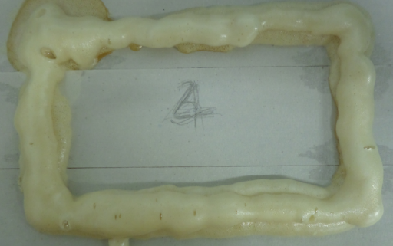
(b): Two layered triangular foam block
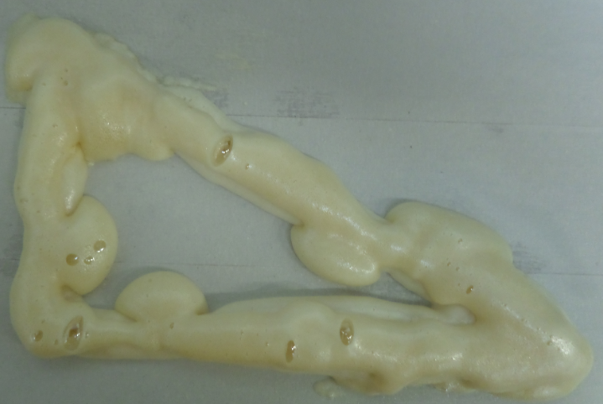
60 mm
40 mm
First Layer
Second Layer
(a): Two layered rectangular foam block
First Layer
Second Layer
60 mm
40 mm
Figure 8: Two layered built foam blocks

The second layer was more uniform than the first one as the temperature had gone down to approximately 35ºC, therefore increasing the viscosity. The acute corners of triangle made the foam build more at the corners.

3.2 Pores Comparison of Different Layers
The cross section of the two–layered sample from the foam obtained by the modified system viewed using the Alicona scanner is shown in Figure 9 and the pore dimensions is as illustrated in Table 1. According the cross-section structure along its length and breadth, the pores for the first layer looked more stretched than the pores of the second (top layer). This could be attributed to the initial temperature which was higher when the first layer was laid than when the second layer was laid. At a lower temperature, the reaction is slow hence producing closer pores even though the dimensions taken were not too different from each other. The Table 1 shows that the average pore diameters and hence circumferences taken at random were close to each other, even though there were few far smaller ones.

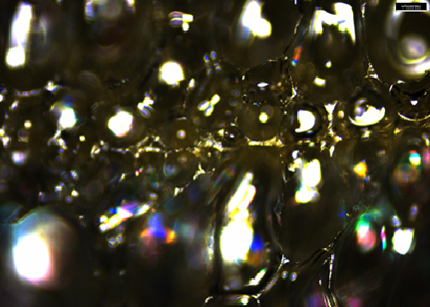
Boundary between Layers
Second Layer
First Layer
0.5mm

Figure 9: 2–Dimensional scanned image of cross section of two layered foam block

Even though there is a boundary layer between the first and second layers, there was still a strong bond between the two layers, making it difficult to separate them unless by strong force or cutting.
Table 1: Table of average pore dimensions
Pore | Length y [µm] | Length x [µm] | Angle [°] | Average  Diameter [µm] | Average Circumference [µm]
Average | 765 | 614 | 217 | 689 | 2166

3.3 Pores Comparison of Different Layers Using SEM
The results obtained by analysing a cross section of the built block using the SEM is shown in figure 10 (the combined cross section of the two layers). From the figure, it could be realised that the pores of the first layer were slightly stretched more than that of the second layer as with the same section viewed using the Alicona scanner.
Figure 10: Combined structure of 3-D foam block built using the modified process - SEM view
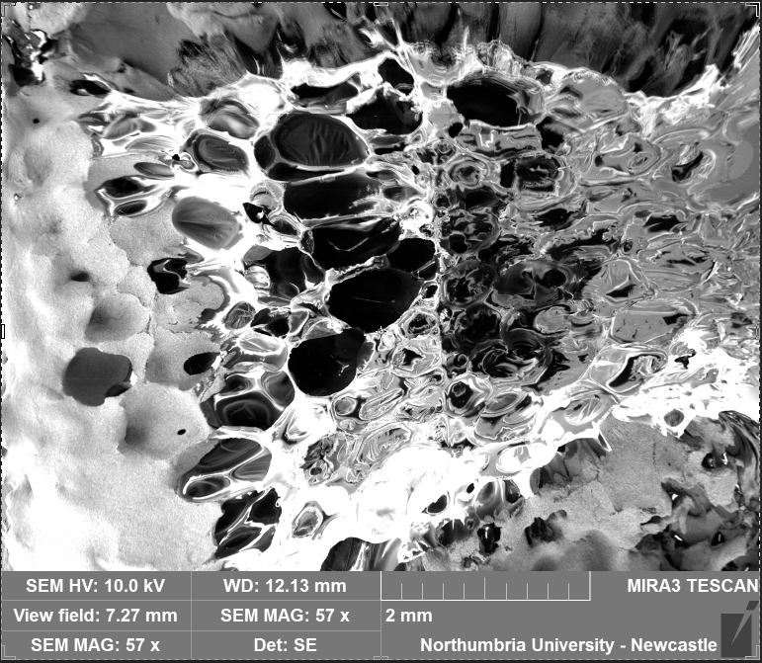

Silver Coated Region
Silver Coated Region
Silver Coated Region
Silver Coated Region
Boundary
Build Direction
First Layer
Second Layer
Region

3.4 General Observations on the Structural Variation of the Printed PU Foam Parts
The microstructure of the cross–section of the fully cured three–dimensional PU foam track printed using the designed in-flight mixing system was viewed using the SEM to check structural variation and the skin effect. From the image obtained (figure 10), it was observed that the pores of the surface were very close and increases in size as it drives into the inner portion of the block. This confirms the skin effect that the inner pores of PU have larger pores due to the retained temperature for a longer period making it trap more CO₂, whilst the outer portion have smaller pores due to its fast cooling by the environment temperature with less CO₂ trapped and for a brief period, in conformity to section 1.2. It was also observed in general that, with the blocks printed, sharp corners as in the drawings were not realised as well as non-uniform widths and depths throughout the sections. This is similar to the general characteristics of PU foam when not confined or restricted in mould during curing as it spreads in any convenient direction. The far bigger patterns obtained compared to the dimensions on drawings is due to the original nature of PU foam as it increases in size to over 20 times depending on the mixing ratio and the nozzles used.

4 CONCLUSION
Based on the investigation conducted, a proof of concept in-flight mixing system has been developed as an attachment to the MakerBot Replicator which has been used to build PU foam. The foam produced using the developed system was tested using the Alicona scanner giving an average pore diameter of 689 μm, which falls within that of the foam produced using the conventional method (hand mixing and casting in mould), viewed by SEM with 715 μm for restricted foaming direction and 685 μm for the free foaming direction.
Previous research demonstrates that the pore size obtained using the modified system allows flow of fluids such as blood, diffusion of waste products out of the scaffold, cell infiltration, and vascularization, therefore making it suitable for scaffold required products such as in medical applications.

REFERENCES
      - Smith, R., N. Lunt, and J. Hanefeld, The implications of PIP are more than just cosmetic. The Lancet, 2012. 379(9822): p. 1180-1181.
      - http://www.gallaghercorp.com/polyurethane-vs-metal-plastic-rubber/, Polyurethane Advantages vs. Metal, Plastic and Ordinary Rubber. 2016.
      - Lambert, B.J., F.-W. Tang, and W.J. Rogers, Polymers in medical applications. Vol. 127. 2001: iSmithers Rapra Publishing.
      - McKeen, L.W., 3–Plastics used in medical devices. Handbook of Polymer Applications in Medicine and Medical Devices; Ebnesajjad, KM, Ed, 2014: p. 21-53.
- Engels, H.W., et al., Polyurethanes: Versatile Materials and Sustainable Problem Solvers for Today’s Challenges. Angewandte Chemie International Edition, 2013. 52(36): p. 9422-9441.
- Bil, M., J. Ryszkowska, and K.J. Kurzydłowski, Effect of polyurethane composition and the fabrication process on scaffold properties. Journal of materials science, 2009. 44(6): p. 1469-1476.
- Santos, E.C., et al., Rapid manufacturing of metal components by laser forming. International Journal of Machine Tools and Manufacture, 2006. 46(12): p. 1459-1468.
- Guo, N. and M.C. Leu, Additive manufacturing: technology, applications and research needs. Frontiers of Mechanical Engineering, 2013: p. 1-29.
- Campbell, T., et al., Could 3D Printing Change the World? Technologies, Potential, and Implications of Additive Manufacturing. Washington, DC: Atlantic Council, 2011.
- Scott, J., et al., Additive Manufacturing: Status and Opportunities. Science and Technology Policy Institute, 2012: p. 1-29.
- Gibson, I., D.W. Rosen, and B. Stucker, Additive manufacturing technologies: rapid prototyping to direct digital manufacturing. 2010: Springer.
- Thomas, D.S. and S.W. Gilbert, Costs and Cost Effectiveness of Additive Manufacturing.
- Gibson, I., D.W. Rosen, and B. Stucker, Additive manufacturing technologies: rapid prototyping to direct digital manufacturing. 2010: Springer.
- STUCKER, B. Additive manufacturing technologies: technology introduction and business implications. in Frontiers of Engineering: Reports on Leading-Edge Engineering from the 2011 Symposium. 2011. 8
- McKeen, L.W., 3—Plastics used in medical devices. Handbook of Polymer Applications in Medicine and Medical Devices; Ebnesajjad, KM, Ed, 2014: p. 21-53. Bil, M., J. Ryszkowska, and K.J. Kurzydłowski, Effect of polyurethane composition and the fabrication process on scaffold properties. Journal of materials science, 2009. 44(6): p. 1469-1476.
- Hepburn, C., Polyurethane elastomers. 2012: Springer Science & Business Media.
- Engels, H.W., et al., Polyurethanes: Versatile Materials and Sustainable Problem Solvers for Today’s Challenges. Angewandte Chemie International Edition, 2013. 52(36): p. 9422-9441.
- Asefnejad, A., et al., Manufacturing of biodegradable polyurethane scaffolds based on polycaprolactone using a phase separation method: physical properties and in vitro assay. International journal of nanomedicine, 2011. 6: p. 2375.
- http://www.essentialchemicalindustry.org/polymers/polyurethane.html, Polyurethane Elastomers. The Essential Chemical Industry, 2015.
- Yasunga, K., R. Neff, X. D. Zhang and C. W. Macosko. 1996. "Study of Cell Opening in Flexible Polyurethane Foam," J. Cell. Plast., 32(5):427.].
- http://www.timcorubber.com/rubber-capabilities/extruded-rubber-products.htm, 2016.
- Ronteltap, A.D., et al., 1992. A moving optical fibre technique for structure analysis of heterogeneous products: application to the determination of the bubble-size distribution in liquid foams. Discussion. Food structure, 11(2), pp.101-108.
- Herrington, R.M., Turner, R.B. and Matijega, R.J., Dow Chemical Company, 1991. Flexible polyurethane foams prepared using low unsaturation polyether polyols. U.S. Patent 5,010,117.

