Mechanical Bending Induced Catalytic Activity Enhancement of Monolayer 1T'-MoS₂ for Hydrogen Evolution Reaction
Wenwu Shi,¹ Zhiguo Wang,^{1*} Yong Qing Fu^{2*}
- School of Physical Electronics, Center for Public Security Information and Equipment Integration Technology, University of Electronic Science and Technology of China, Chengdu, 610054, P.R. China
- Faculty of Engineering and Environment, University of Northumbria, Newcastle upon Tyne, NE1 8ST, UK

*Corresponding author. E-mail: zgwang@uestc.edu.cn(ZW); richard.fu@northumbria.ac.uk(YF)
Abstract:
In this paper, mechanisms behind enhancement of catalytic activity of MoS₂ mono-layer for hydrogen evolution reaction (HER) by mechanically applying bending strain were investigated using density functional theory. Results showed that with the increase of bending strains, the Gibbs free energy for hydrogen adsorption on the MoS₂ mono-layer was decreased from 0.18 to -0.04 eV and to 0.13 eV for the bend strains applied along the zigzag and armchair directions, respectively. The mechanism for the enhanced catalytic activity comes from the changes of density of electronic states near the Fermi energy level, which are induced by the changes of the Mo-S and Mo-Mo bonds upon bending. This report provides a new design methodology to improve the catalytic activity of catalysts based on two-dimensional transition metal dichalcogenides through a simple mechanical bending.
Keywords: Hydrogen evolution reaction, transition metal dichalcogenides, mechanical bending, density functional theory
- Introduction
The current world-wide energy crisis is complicated by the limited supply of fossil fuel and environmental concerns associated with emission of carbon dioxide from burning fossil fuels. Therefore, it is urgent to explore large-scale non-fossil alternatives of clean energy sources. Hydrogen, one of the most abundant elements in the universe, is considered to be one of the most promising alternatives to carbon-based fuels (Dunn, 2002). However, hydrogen does not naturally exist in large quantities or high concentrations, and must be produced from the other compounds, including fossil fuels (Xia, Zhao, Ye, & Wang, 2014). Water splitting is one of the most promising methods for mass production of hydrogen (Deng et al., 2014; Jaramillo, Jørgensen, et al., 2007; Laursen, Kegnæs, Dahl, & Chorkendorff, 2012; Y. Li et al., 2011), and the key component in the electrochemical splitting of water is the efficient catalyst for hydrogen evolution reaction (HER) (H. Pan, 2014). Noble metals such as platinum are well-known superb catalysts for electrolysis of water, however, their scarcity and high cost limit their wide-spread usages to produce hydrogen (Fang & Liu, 2009; Jiang, Myer, Tellefsen, & Pau, 2009; Kye et al., 2013; Skúlason et al., 2010; J. Zhang, Sasaki, Sutter, & Adzic, 2007; T. Zhang & Anderson, 2007). Therefore, many researchers have tried to search and synthesize new catalysts composed of cheaper materials, or to use micro- or nano-structured compounds and multi-elements-alloys (An, Fan, Luo, & Lau, 2017; Chen et al., 2016; C. Tsai, Abild-Pedersen, & Norskov, 2014) for electrochemical HER.
Monolayer transition metal disulfides (such as MoS₂) are considered to be a promising electro-catalyst for HER. The transition metal disulfides show several types of crystal structures, including 2H (hexagonal structure), 1T (octahedral structure) and 1T' (distorted octahedral structure) structures (Qian, Liu, Fu, & Li, 2014; Song, Park, & Choi, 2015; Wypych & Schollhorn, 1992), strongly depending on the arrangement of S and transition metal atoms. 2H-MoS₂ is semiconducting in nature, whereas 1T-MoS₂ is metallic-like (Damien Voiry, Maryam Salehi, et al., 2013). 2H-MoS₂ shows a poor catalytic activity and the active sites are only located at Mo-terminated edge sites (Jaramillo, Jorgensen, et al., 2007). The basal planes of the 2H-MoS₂ are inert for HER. Although 1T-MoS₂ shows a better catalytic performance for HER, it is metastable at room temperature (Capitani et al., 2013; Enyashin et al., 2011; T. Hu, R. Li, & J. Dong, 2013; Lin, Dumcenco, Huang, & Suenaga, 2014; Damien Voiry, Maryam Salehi, et al., 2013). 1T-MoS₂ will transfer into 1T'-MoS₂ during HER process (G. Gao et al., 2015), and this phase transformation can be used to enhance the catalytic activity of the MoS₂ (G. Gao et al., 2015). Doping is a commonly used method to improve the catalytic performance of MoS₂ (Deng et al., 2015; B. B. Li et al., 2015; Charlie Tsai, Chan, Nørskov, & Abild-Pedersen, 2015a; Wang et al., 2015), however, doping elements are often noble metals which need expensive synthesis equipment such as plasma device synthesis or a well-controlled chemical vapor deposition process (Deng et al., 2015; B. B. Li et al., 2015; Charlie Tsai et al., 2015a; Wang et al., 2015).
Mechanical bending strain has frequently been used to modulate the bandgap of MoS₂ (Lloyd et al., 2016) and gas adsorption on MoS₂ (Sahoo, Wang, Zhang, Shimada, & Kitamura, 2016). It can cause changes of the bond lengths and significantly affect the density of electronic states near the Fermi energy level, thus can enhance the catalytic performance of MoS₂. Therefore, in this work, we investigate the catalytic activity of basal plane of the 1T'-MoS₂ tuned by applied mechanical strain using density functional theory (DFT) calculations. Calculated results show that the mechanical strain can dramatically affect the HER. The catalytic activity of 1T'-MoS₂ for HER can be enhanced by applying the mechanical strain. This study provides a rational design methodology to improve catalytic activity of catalysts based on two-dimensional transition metal disulfides.

- Computational details
The catalytic behaviors of 1T'-MoS₂ were studied using spin-polarized DFT as implemented in the Vienna ab initio simulation package (VASP) code (Kresse & Furthmüller, 1996; Tong, Zhang, Zhang, Liu, & Liu, 2014). The projector-augmented wave (PAW) method and the generalized gradient approximation (GGA) with the Perdew-Burk-Ernzerhof (PBE) functional (Perdew, Burke, & Ernzerhof, 1996) were used to describe electron-ion interactions and exchange-correlation, respectively. Plane-wave basis sets with an energy cutoff of 520 eV were used.
A 6×6 supercell was used to model the monolayer 1T'-MoS₂, which included 36 Mo and 72 S atoms. k-point mesh (2×2×1) of Monkhorst-Pack was used for the integration of Brillouin zone (Pack & Monkhorst, 1977). Two mechanical bending conditions were considered, i.e. along zigzag and armchair directions. In order to use the periodic boundary conditions, we used the rippled supercells as shown in Figs. 1a and 1b to represent mechanical bending applied along zigzag and armchair directions, respectively. The supercells contain 162 and 192 atoms for the zigzag and armchair mechanical bending, respectively. The mechanical strain was realized by bending the MoS₂ monolayer as shown in Fig. 1. The mechanical strain was quantified using a simple kinetic equation: , where T indicates the peak (or valley) thickness and R indicates the mechanical bending radius of the monolayer MoS₂ (Lee, Jang, Han, & Baik, 2014). Different mechanical strains can be applied with different values of bending radius.
Since the 1T'-MoS₂ is composed of three atomistic layers, the outside layer is subjected to tensile strain, whereas the inside layer is subjected to compressive strain. The previous study showed that the tensile strain was beneficial for improvement of the catalytic activity [40]. We only considered the adsorption of H at the outside layer when the mechanical bending was applied on the 1T'-MoS₂ as shown in Fig. 1. During the simulation, all atoms were allowed to relax freely using the conjugate gradient approximation (CG) until the force on each atom was less than 0.02 eV/Å. In order to avoid the periodic image interactions between the bending structure of 1T'-MoS₂ monolayers, the distance between layers was separated by 30 Å vacuum space.
The Gibbs free energy was calculated using equation (1), which was used to compare the HER activity of materials.
(1)
where and are the entropy difference and zero-point energy difference between the adsorbed state and the gas phase of hydrogen, respectively. is usually approximated as , where the is entropy of gas phase hydrogen at 300 K with an atmospheric pressure of 1 bar. is the hydrogen chemisorption energy, which can be calculated using equation (2).
(2)
where and are the total energy of MoS₂ with and without hydrogen adsorption, respectively. is the total energy of a molecule hydrogen under the gas phase. The value of was reported to be about 0.24 eV (Nørskov et al., 2005; H. Pan, 2016; Hui Pan, Feng, & Lin, 2010; Damien Voiry, Hisato Yamaguchi, et al., 2013). Therefore, the Gibbs free energy of hydrogen adsorption was calculated using.

- Results and discussion
The calculated lattice constants are a=3.192 Å, b=6.542 Å for 1T'-MoS₂, which are close to previously reported calculated values of a=3.175 Å, b=6.543 Å for the 1T'-MoS₂ (Ting Hu, Rui Li, & Jinming Dong, 2013). Side-view and top-view of the two dominant adsorption sites for the H atoms are shown in Fig. 2, and they are the preferable adsorption sites for hydrogen reported in many references (Chou et al., 2015; G. Gao et al., 2015; H. Pan, 2014; Putungan, Lin, & Kuo, 2015).
The HER generally proceeds via two key steps. The first step is Volmer step in which the H atoms are bound to the catalyst site (*) (). Jiao et al. (M.-R. Gao et al., 2015) have proven that the Volmer step is the rate-determining of HER on the MoS₂. The second step is the Heyrovsky (Skulason et al., 2007) or Tafel step (Skúlason et al., 2010), in which molecular hydrogen is released and leaves the catalyst site ( or ). Tang and Jiang (Tang & Jiang, 2016) reported that the Heyrovsky reaction (activation energy ∼0.62 eV) has a relatively lower barrier than the Tafel reaction (activation energy ∼1.07 eV) for the hydrogen desorption process, hence, the HER occurs mainly via the Volmer-Heyrovsky mechanism on 1T-MoS₂ monolayer. The Gibbs free energy () of H atom adsorbed on the materials is often used to characterize the HER activity of materials. According to thermodynamics, the materials will show their best catalytic activity with (Greeley, Jaramillo, Bonde, Chorkendorff, & Nørskov, 2006; Jiao, Zheng, Jaroniec, & Qiao, 2015; Schmickler & Trasatti, 2006). If , the hydrogen will be difficult to bind with the catalyst, whereas if , the hydrogen is strongly adsorbed on the catalyst which can hinder release of the molecular hydrogen.
There are two types of S atoms in 1T'-MoS₂ monolayer, i.e. Sc and St atoms, which have shorter and longer Mo-S bonds, respectively. Sc and St atoms can be assumed equivalent to S atoms subjected to compressive and tensile stresses, respectively (Chou et al., 2015; G. Gao et al., 2015; H. Pan, 2014; Putungan et al., 2015; Charlie Tsai, Chan, Nørskov, & Abild-Pedersen, 2015b). The Gibbs free energies are 0.82 and 0.18 eV for H adsorption at the Sc and St sites on 1T'-MoS₂, respectively, which agree with previously reported calculation results of 0.82 eV and 0.19 eV (Putungan et al., 2015; D. Voiry et al., 2013). Based on the above results, the St site is more catalytic active than the Sc site for H adsorption on the basal plane. However, the Gibbs free energy for the Sc site is still higher than 0.19 eV. Whereas the Gibbs free energy for H adsorption on the 1T'-MoS₂ monolayer is much smaller than that on 2H-MoS₂ monolayer with ΔG_{H}=2.16 eV [14], indicating the 1T'-MoS₂ monolayer is more catalytic activate which agrees with the experimental observations (Damien Voiry, Maryam Salehi, et al., 2013).
To investigate the mechanism of improved catalytic activity, we analyzed the changes of bond evolution during bending of MoS₂. There are two types of Mo-S bonds for each S atom as shown in Fig. 2. Symbols of bt1 and bt2 denote the Mo-S bonds for the S atom located at the St sites, and symbols of bc1 and bc2 denote those for S atoms at the Sc sites. Results show that bt1=2.48 and bt2=2.52 Å for S at St sites, and bc1=2.39 and bc2=2.43 Å for S at Sc sites. The bonds are longer for S at St sites than those at the Sc sites. Comparing the different catalytic activities of Sc and St atoms, the S atoms subjected to tensile strain could generate an improved catalytic activity.
The adsorption of H on 1T'-MoS₂ with different bending strains was investigated. Fig. 3a shows the Gibbs free energy of hydrogen adsorbed at the Sc and St sites as a function of bending strain. The Gibbs free energy decreases from 0.82 to 0.43 eV as the bending strain is increased from 0 to 9.89% when the hydrogen atom is adsorbed at Sc site and the 1T'-MoS₂ is subjected to a bending along the armchair direction. At the same bending strain, the Gibbs free energy decreases from 0.18 to 0.12 eV when the hydrogen atom is adsorbed at St site on the 1T'-MoS₂. Clearly the bending strain has an obvious influence when the H atom is adsorbed at the Sc site on 1T'-MoS₂ when the bending is along the zigzag direction. The obtained Gibbs free energy is decreased from 0.18 to -0.04 eV, which is very close to the best value of .
Figs. 3b and 3c show the lengths of Mo-S bonds as a function of bending strain as the bending is applied along the zigzag and armchair directions, respectively. The bond lengths increase with the increase of bending strain. For example, when the bending strain is increased from 0.0% to 9.55%, the values of b1t and bt2 are increased from 2.48 and 2.52 Å to 2.52 and 2.54 Å, respectively, when the bending is applied along the zigzag direction.
With the change of Mo-S bond, the distance between adjacent metal atoms also changes. There are two types of Mo-Mo bonds in 1T'-MoS₂ as shown in Fig. 2, which denoted as b1 and b2, respectively. The calculated Mo-Mo distances are 2.78 and 3.19 Å for the 1T'-MoS₂ for b1 and b2 which agree well with previously reported values of 2.77 and 3.18 Å (Chou et al., 2015). As shown in Fig. 3d, the two different Mo-Mo bond lengths all increase with the increase of bending strain. As the bending strain is increased to 9.55%, the value of b1 is increased from 2.78 to 2.82 and that of b2 from 3.19 to 3.22 Å when the bending is applied along the zigzag direction.
From the above results, clearly the improvement of the catalytic activity shows a strong dependence of the Mo-S and Mo-Mo bonds on the bending strain. The changes of the Mo-S and Mo-Mo bond lengths can significantly affect the density of electronic states near the Fermi energy level of the MoS₂, thus affect its electrochemical activities.
Fig. 4 shows partial density of states (PDOS) for pristine 1T'-MoS₂ (Fig. 4a) and those 1T'-MoS₂ bent along zigzag direction with a bending strain of 9.55% (Fig. 4b) and those of 1T'-MoS₂ bent along armchair direction with a bending strain of 9.89% (Fig. 4c). The pristine 1T'-MoS₂ shows a non-metallic behavior with a bandgap of 0.3 eV, which is close to the previously reported value of 0.375 eV (Ting Hu et al., 2013). The valence bands and conduction bands near the Fermi energy level mainly come from the 3p orbitals of S atoms and 4d orbitals of Mo atoms. Upon bending, the hybridization between Mo d-orbitals and S p-orbitals increases, and accordingly the valence band and conduction band of 1T'-MoS₂ move upward and downward in energy values, respectively. The increased density of states near the Fermi energy level will facilitate the supply of electrons to the adsorption sites of 1T'-MoS₂, thus resulting in the improvement of its catalytic activity.
The Gibbs free energy of hydrogen adsorption on the mechanically bent MoS₂ is close to that of hydrogen adsorbed on the Mo-edge of the MoS₂ (C. Tsai et al., 2014; Wang et al., 2015), noble metals (Skúlason et al., 2010) and composite nano-materials (C. Tsai et al., 2014). The HER activity of MoS₂ monolayer can be enhanced by the mechanical bending. Therefore, we can conclude that mechanical bending can be used as an efficient way for the improvement of HER activity of two-dimensional transition metal dichalcogenides. The bending strain can be realized by deposition of 1T'-MoS₂ on flexible substrates, such as polymethyl methacrylate to apply controllable and reproducible strains on the 1T'-MoS₂ (He, Poole, Mak, & Shan, 2013).

- Conclusion
In summary, we have studied the catalytic behavior of 1T'-MoS₂ under mechanical bending using DFT. Gibbs free energy, a key parameter to describe the HER activity of the materials, was calculated for hydrogen adsorbed on pristine and bent 1T'-MoS₂, with different bending strains. Gibbs free energy was decreased from 0.18 to -0.04 eV with the increase of bending strain from 0 to 9.55% as the bending applied along the zigzag direction. We concluded that the improvement of the catalytic activity comes from the density of electronic states near the Fermi energy level, which is induced by the change of the Mo-S and Mo-Mo bonds. This report provides a new methodology to improve the catalytic activity of catalysts based on two-dimensional transition metal dichalcogenides through simple mechanical bending.

Acknowledgement: This work was financially supported by the National Natural Science Foundation of China (NFSC 11474047). Funding supports from UK Engineering Physics and Science Research Council (EPSRC EP/P018998/1), Newton Mobility Grant (IE161019) through Royal Society and NFSC, and Royal academy of Engineering UK-Research Exchange with China and India are also acknowledged. This work was carried out at National Supercomputer Center in Tianjin, and the calculations were performed on TianHe-1(A).

Compliance with Ethical Standards:
Funding: This study was funded by National Natural Science Foundation of China (11474047) and the Fundamental Research Funds for the Central Universities (ZYGX2016J202), and Newton Mobility Grant (IE161019).
Conflict of Interest: The authors declare that they have no conflict of interest.

References
An YR, Fan XL, Luo ZF, Lau WM (2017) Nanopolygons of Monolayer MS2: Best Morphology and Size for HER Catalysis. Nano Letters, 17:368-376
Capitani F, Höppner M, Joseph B, Malavasi L, Artioli GA, Baldassarre L, et al. (2013) Combined experimental and computational study of the pressure dependence of the vibrational spectrum of solid picene C 22 H 14. Physical Review B Condensed Matter, 88:4745-4751
Chen X, Wang Z, Qiu Y, Zhang J, Liu G, Zheng W, et al. (2016) Controlled growth of vertical 3D MoS2(1−x)Se2x nanosheets for an efficient and stable hydrogen evolution reaction. J. Mater. Chem. A, 4:18060-18066
Chou SS, Sai N, Lu P, Coker EN, Liu S, Artyushkova K, et al. (2015) Understanding catalysis in a multiphasic two-dimensional transition metal dichalcogenide. Nat Commun, 6:8311
Deng J, Li H, Xiao J, Tu Y, Deng D, Yang H, et al. (2015) Triggering the electrocatalytic hydrogen evolution activity of the inert two-dimensional MoS2surface via single-atom metal doping. Energy Environ. Sci., 8:1594-1601
Deng J, Yuan W, Ren P, Wang Y, Deng D, Zhang Z, et al. (2014) High-performance hydrogen evolution electrocatalysis by layer-controlled MoS2 nanosheets. RSC Advances, 4:34733-34738
Dunn S (2002) Hydrogen futures: toward a sustainable energy system. International Journal of Hydrogen Energy, 27:235-264
Enyashin AN, Yadgarov L, Houben L, Popov I, Weidenbach M, Tenne R, et al. (2011) New route for stabilization of 1T-WS2 and MoS2 phases. Journal of Physical Chemistry C, 115:24586-24591
Fang Y-H, Liu Z-P (2009) Surface Phase Diagram and Oxygen Coupling Kinetics on Flat and Stepped Pt Surfaces under Electrochemical Potentials. The Journal of Physical Chemistry C, 113:9765-9772
Gao G, Jiao Y, Ma F, Jiao Y, Waclawik E, Du A (2015) Charge Mediated Semiconducting-to-Metallic Phase Transition in Molybdenum Disulfide Monolayer and Hydrogen Evolution Reaction in New 1T′ Phase. The Journal of Physical Chemistry C, 119:13124-13128
Gao M-R, Liang J-X, Zheng Y-R, Xu Y-F, Jiang J, Gao Q, et al. (2015) An efficient molybdenum disulfide/cobalt diselenide hybrid catalyst for electrochemical hydrogen generation. Nat Commun, 6:
Greeley J, Jaramillo TF, Bonde J, Chorkendorff IB, Nørskov JK (2006) Computational high-throughput screening of electrocatalytic materials for hydrogen evolution. Nat Mater, 5:909-913
He K, Poole C, Mak KF, Shan J (2013) Experimental Demonstration of Continuous Electronic Structure Tuning via Strain in Atomically Thin MoS2. Nano Letters, 13:2931-2936
Hu T, Li R, Dong J (2013) A new (2 × 1) dimerized structure of monolayer 1T-molybdenum disulfide, studied from first principles calculations. The Journal of Chemical Physics, 139:174702
Hu T, Li R, Dong J (2013) A new (2 × 1) dimerized structure of monolayer 1T-molybdenum disulfide, studied from first principles calculations. Journal of Chemical Physics, 139:174702-174702-174707
Jaramillo TF, Jørgensen KP, Bonde J, Nielsen JH, Horch S, Chorkendorff I (2007) Identification of active edge sites for electrochemical H2 evolution from MoS2 nanocatalysts. Science, 317:100-102
Jaramillo TF, Jorgensen KP, Bonde J, Nielsen JH, Horch S, Chorkendorff I (2007) Identification of active edge sites for electrochemical H2 evolution from MoS2 nanocatalysts. Science, 317:100-102
Jiang L, Myer B, Tellefsen K, Pau S (2009) A planar microfabricated electrolyzer for hydrogen and oxygen generation. Journal of Power Sources, 188:256-260
Jiao Y, Zheng Y, Jaroniec M, Qiao SZ (2015) Design of electrocatalysts for oxygen- and hydrogen-involving energy conversion reactions. Chemical Society Reviews, 44:2060-2086
Kresse G, Furthmüller J (1996) Efficient iterative schemes for \textit{ab initio} total-energy calculations using a plane-wave basis set. Physical Review B, 54:11169-11186
Kye J, Shin M, Lim B, Jang J-W, Oh I, Hwang S (2013) Platinum Monolayer Electrocatalyst on Gold Nanostructures on Silicon for Photoelectrochemical Hydrogen Evolution. Acs Nano, 7:6017-6023
Laursen AB, Kegnæs S, Dahl S, Chorkendorff I (2012) Molybdenum sulfides—efficient and viable materials for electro - and photoelectrocatalytic hydrogen evolution. Energy & Environmental Science, 5:5577-5591
Lee JH, Jang WS, Han SW, Baik HK (2014) Efficient hydrogen evolution by mechanically strained MoS2 nanosheets. Langmuir, 30:9866-9873
Li BB, Qiao SZ, Zheng XR, Yang XJ, Cui ZD, Zhu SL, et al. (2015) Pd coated MoS2 nanoflowers for highly efficient hydrogen evolution reaction under irradiation. Journal of Power Sources, 284:68-76
Li Y, Wang H, Xie L, Liang Y, Hong G, Dai H (2011) MoS2 Nanoparticles Grown on Graphene: An Advanced Catalyst for the Hydrogen Evolution Reaction. Journal of the American Chemical Society, 133:7296-7299
Lin YC, Dumcenco DO, Huang YS, Suenaga K (2014) Atomic mechanism of the semiconducting-to-metallic phase transition in single-layered MoS2. Nature Nanotechnology, 9:391-396
Lloyd D, Liu X, Christopher JW, Cantley L, Wadehra A, Kim BL, et al. (2016) Band Gap Engineering with Ultralarge Biaxial Strains in Suspended Monolayer MoS2. Nano Letters, 16:5836-5841
Nørskov JK, Bligaard T, Logadottir A, Kitchin JR, Chen JG, Pandelov S, et al. (2005) Trends in the Exchange Current for Hydrogen Evolution. Journal of the Electrochemical Society, 152:J23
Pack JD. Monkhorst HJ (1977) "Special points for Brillouin-zone integrations"\char22{}a reply. Physical Review B, 16:1748-1749
Pan H (2014) Metal dichalcogenides monolayers: novel catalysts for electrochemical hydrogen production. Sci Rep, 4:5348
Pan H (2016) Tension-Enhanced Hydrogen Evolution Reaction on Vanadium Disulfide Monolayer. Nanoscale Res Lett, 11:113
Pan H, Feng YP, Lin J (2010) Enhancement of Hydrogen Evolution on Tungsten Doped Platinum. Journal of Computational and Theoretical Nanoscience, 7:547-551
Perdew JP, Burke K, Ernzerhof M (1996) Erratum: Generalized Gradient Approximation Made Simple [Phys. Rev. Lett. 77, 3865 (1996)]. Phys.rev.lett1396
Putungan DB, Lin SH, Kuo JL (2015) A first-principles examination of conducting monolayer 1T'-MX(2) (M = Mo, W; X = S, Se, Te): promising catalysts for hydrogen evolution reaction and its enhancement by strain. Phys Chem Chem Phys, 17:21702-21708
Qian X, Liu J, Fu L, Li J (2014) Quantum spin Hall effect in two-dimensional transition metal dichalcogenides. Science, 346:1344-1347
Sahoo MPK, Wang J, Zhang Y, Shimada T, Kitamura T (2016) Modulation of Gas Adsorption and Magnetic Properties of Monolayer-MoS2 by Antisite Defect and Strain. The Journal of Physical Chemistry C, 120:14113-14121
Schmickler W, Trasatti S (2006) Comment on “Trends in the Exchange Current for Hydrogen Evolution” [J. Electrochem. Soc., 152, J23 (2005)]. Journal of the Electrochemical Society, 153:L31
Skúlason E, Tripkovic V, Björketun ME, Gudmundsdóttir S, Karlberg G, Rossmeisl J, et al. (2010) Modeling the Electrochemical Hydrogen Oxidation and Evolution Reactions on the Basis of Density Functional Theory Calculations. The Journal of Physical Chemistry C, 114:18182-18197
Skulason E, Karlberg GS, Rossmeisl J, Bligaard T, Greeley J, Jonsson H, et al. (2007) Density functional theory calculations for the hydrogen evolution reaction in an electrochemical double layer on the Pt(111) electrode. Physical Chemistry Chemical Physics, 9:3241-3250
Song I, Park CChoi HC (2015) Synthesis and properties of molybdenum disulphide: from bulk to atomic layers. RSC Advances, 5:7495-7514
Tang Q, Jiang D-e (2016) Mechanism of Hydrogen Evolution Reaction on 1T-MoS2from First Principles. ACS Catalysis, 6:4953-4961
Tong CJ, Zhang H, Zhang YN, Liu H, Liu LM (2014) New manifold two-dimensional single-layer structures of zinc-blende compounds. J.mater.chem.a, 2:17971-17978
Tsai C, Abild-Pedersen F, Norskov JK (2014) Tuning the MoS2 edge-site activity for hydrogen evolution via support interactions. Nano Letters, 14:1381-1387
Tsai C, Chan K, Nørskov J, KAbild-Pedersen F (2015a) Rational design of MoS2catalysts: tuning the structure and activity via transition metal doping. Catal. Sci. Technol., 5:246-253
Tsai C, Chan K, Nørskov J, KAbild-Pedersen F (2015b) Theoretical insights into the hydrogen evolution activity of layered transition metal dichalcogenides. Surface Science, 640:133-140
Voiry D, Salehi M, Silva R, Fujita T, Chen M, Asefa T, et al. (2013) Conducting MoS2 Nanosheets as Catalysts for Hydrogen Evolution Reaction. Nano Letters, 13:6222-6227
Voiry D, Yamaguchi H, Li J, Silva R, Alves DC, Fujita T, et al. (2013) Enhanced catalytic activity in strained chemically exfoliated WS(2) nanosheets for hydrogen evolution. Nat Mater, 12:850-855
Voiry D, Yamaguchi H, Li J, Silva R, Alves DCB, Fujita T, et al. (2013) Enhanced catalytic activity in strained chemically exfoliated WS2 nanosheets for hydrogen evolution. Nat Mater, 12:850-855
Wang H, Tsai C, Kong D, Chan K, Abild-Pedersen F, Nørskov JK, et al. (2015) Transition-metal doped edge sites in vertically aligned MoS2 catalysts for enhanced hydrogen evolution. Nano Research, 8:566-575
Wypych F, Schollhorn R (1992) 1T-MoS2, a new metallic modification of molybdenum disulfide. Journal of the Chemical Society, Chemical Communications1386-1388
Xia X, Zhao X, Ye W, Wang C (2014) Highly porous Ag-Ag2S/MoS2 with additional active sites synthesized by chemical etching method for enhanced electrocatalytic hydrogen evolution. Electrochimica Acta, 142:173–181
Zhang J, Sasaki K, Sutter E, Adzic RR (2007) Stabilization of Platinum Oxygen-Reduction Electrocatalysts Using Gold Clusters. Science, 315:220-222
Zhang T, Anderson AB (2007) Hydrogen Oxidation and Evolution on Platinum Electrodes in Base: Theoretical Study. The Journal of Physical Chemistry C, 111:8644-8648

Lists of figures captions:
Figure 1 Top- and side-views of atomistic configurations of 1T'-MoS₂ bended along (a) zigzag and (b) armchair directions.

Figure 2 Top and side views atomistic configurations of 1T'-MoS₂.

Figure 3 (a) Gibbs free energy of hydrogen adsorbed at the Sc and St sites on 1T'-MoS₂ as a function of bending curvatures. Bond lengths of Mo-S as a function of bending strain when the bending loaded along the (b) zigzag and (c) armchair directions. And (d) Mo-Mo bond lengths as a function of bending strain.

Figure 4 Partial density of states (PDOS) for (a) pristine 1T'-MoS₂ and those for bended 1T'-MoS₂ along (b) zigzag direction with bending strain of 9.55% and (c) armchair direction with bending strain of 9.89%.

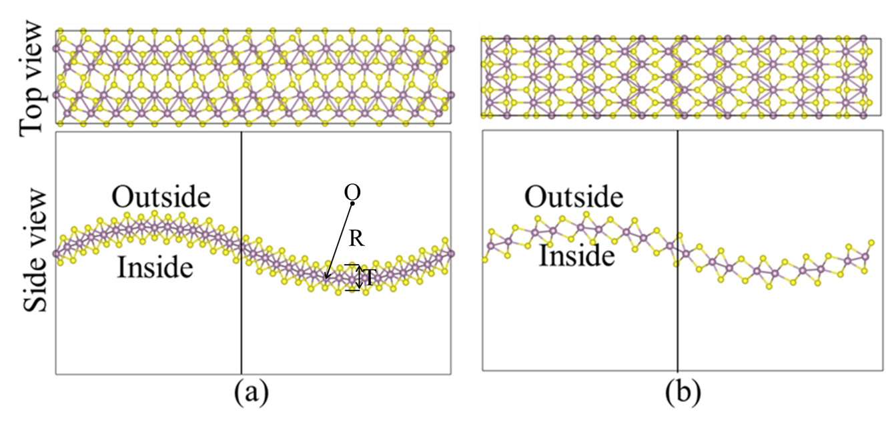
W.W. Shi et al. Figure 1

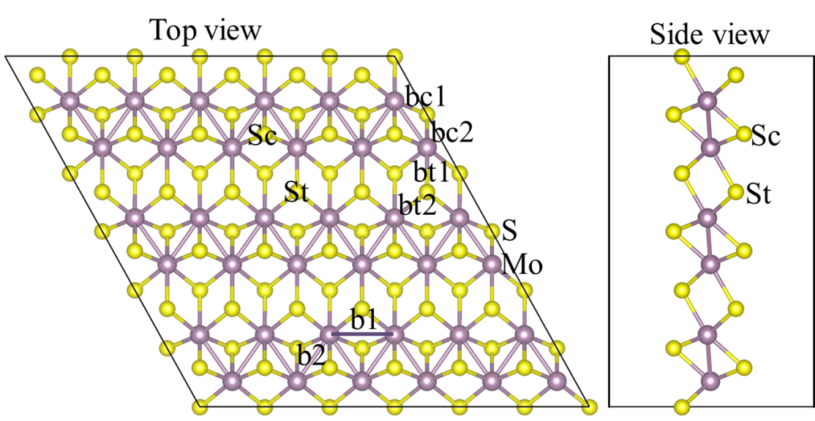
W.W. Shi et al. Figure 2

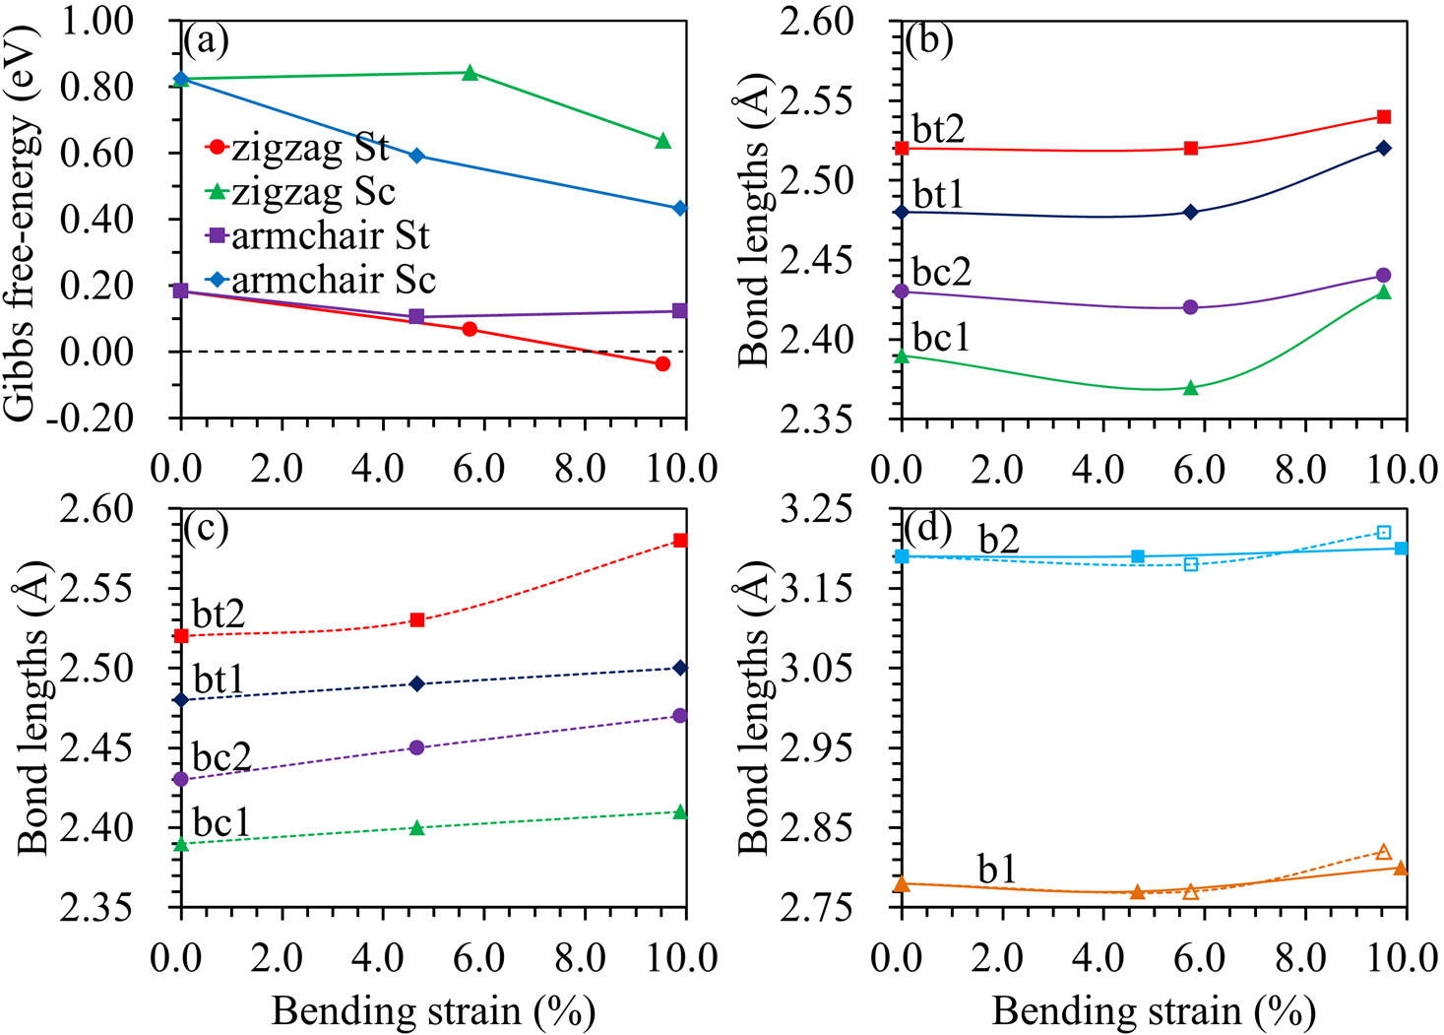
W.W. Shi et al. Figure 3

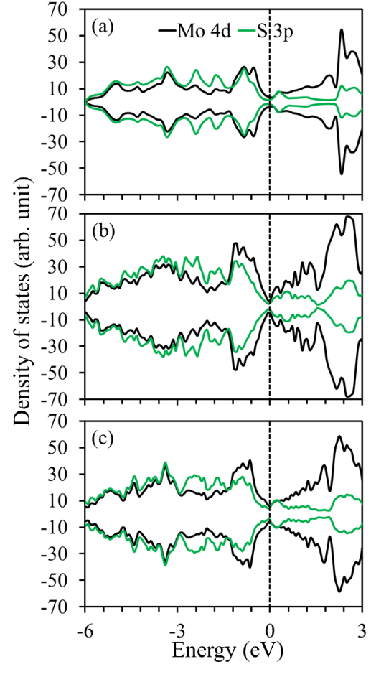
W.W. Shi et al. Figure 4

