Estimating Whole Life Cycle Carbon Emissions of Buildings: A Literature Review

Nawarathna. R.A.G [1]and Nirodha Gayani Fernando

Northumbria University, United Kingdom

Srinath Perera

Western Sydney University, Australia

Abstract

Building sector has been increasingly recognised as one of the significant sectors which emits considerable amount of carbon to the atmosphere. Therefore, lowering carbon emissions of buildings has become an essential response to the global carbon reduction targets. In response to that, many efforts have been put forward in estimating and reducing carbon emissions in this sector over the last few decades.

Whole life cycle carbon of a building is considered as the total amount of operational and embodied carbon occurred throughout its lifecycle. A building life cycle consists of four main phases as product, construction, operation and end of life. Even though, many studies have examined the whole life cycle carbon emissions during the assessment zones of operational and detailed design, it was found no studies have been conducted to examine the whole life cycle carbon emissions during early stage of a design. However, it is believed that the carbon emission reduction potential is high in the early stages of a project. Accordingly, the aim of this paper was to review the existing literature on building life cycle carbon estimation in order to identify the reasons for the less focus on early stage life cycle carbon estimation and to learn further research aspects on life cycle carbon estimation. A comprehensive literature review was carried out referring secondary data sources to achieve this aim. It was found out that insufficient primary data and limited approaches in estimating life cycle carbon as a major reason for the less focus on life cycle carbon estimations in early stage of design. Accordingly, it creates the need of a rigorous approach for early stage life cycle carbon estimating.

**Keywords:** Buildings;Building Life Cycle**;** Carbon Emission; Life Cycle Carbon Estimation

1. Introduction

Since the onset of industrial revolution in late 18th and early 19th centuries, humans have been substantially influencing on climate system and the earth’s temperature by burning fossil fuel, cutting down forests and increasing livestock farming etc. (Chandrappa et.al, 2011). As a result, this has now caused to rise the amount of carbon dioxide and other heat trapping gases such as methane and nitrous oxide which naturally present in the atmosphere, increasing the greenhouse effect and global warming (Halsnæs et al. 2007 and EPA, 2015). Report on climate change published by the Intergovernmental Panel on Climate Change (IPCC) (2014), clearly states that continued emissions of carbon will lead to a drastic change in climate and increase in temperature by1.5 0C - 20C by the end of 21st century. Therefore, it has become a top most priority in the world to reduce carbon emissions (Chau et al. 2015).

Accordingly, many strategies have been executed around the world with the aim of reducing global warming. Kyoto protocol is one such efforts made by United Nations in year 1998. It has introduced mandatory targets on reducing greenhouse-gas emissions for the world's leading economies who have accumulated historical emissions in the atmosphere since the beginning of the industrial revolution. The accepted targets for the first commitment period of 2008-2012 have ranged from -5 % to +10 % of the countries' individual 1990 emissions levels. Then the second commitment period started from 2013-2020 and the targets range from -5% to 40% from their individual base year emission levels (UNFCC, 1998 & 2012).

In order to achieve these targets, the Committee on Climate Change (2013) has identified the building sector as one of the significant sectors which has a substantial potential in saving carbon in the short term. Buildings are responsible for more than 40% of global energy usage and as much as 33% of global greenhouse gas emissions in both developed and developing countries (Peng, 2015). Further, it has been estimated that the carbon emission of buildings across the world will reach 42.4 billion tonnes in 2035, which was 29.5 billion tonnes in 2007 (USEIA, 2010).

Therefore, considerable efforts across academia and industry have gone into estimating the carbon emissions of buildings, so as to reduce the carbon emission of buildings. Even though, many studies have examined the whole life cycle carbon emissions during the assessment zones of operational and detailed design, it was found no studies have been conducted to examine the whole life cycle carbon emissions during early stage of a design in which the high carbon reduction potential is expected. Accordingly, this paper reviews the existing literature on building carbon estimations to identify the major reasons for the less focus on whole life cycle carbon estimation during early stage of designs of a project and to learn further research aspects of this area.

1. Research Method

A comprehensive literature review was carried out to achieve the aim of the research. The method of desk study was adapted to collect data. Accordingly, secondary data related to building life cycle carbon emissions and estimation were gathered referring to related books, journal articles, government publications, web sites, newspaper articles, and other published reports. As this is a rapidly developing research area, the search results were limited to past 10 years.

1. Life Cycle Carbon of Buildings

3.1. Interpretation of Building Life Cycle

Building is an extremely complex industrial product with a lifetime of decades (Airaksinen and Matilainen, 2011). There are few interpretations available for building life cycle in the existing literature. As illustrated in BS EN 15978:2011 (European Committee for Standardisation) (Refer Figure 1), building life cycle consists of 4 major stages namely;

1. Product stage
2. Construction process stage
3. Use (Operation) stage
4. End of life stage

and one more stage beyond the life cycle called ‘Beyond the System Boundary’ which includes reuse, recovery and recycle. Similarly, Athena Sustainable Materials Institute (2014) has provided an interpretation for building life cycle and it includes six stages such as resource extraction, manufacturing, on-site construction, occupancy & maintenance, demolition and recycle, reuse & disposal. Contrary to BS EN 15978:2011, it has included reusing, recovery and recycling stage within the building life cycle.

However, the interpretation given by the BS EN 15978:2011 is widely accepted. According to that, product stage consists of the functions of extracting raw materials, refining (i.e. primary manufacture), transporting and processing them to produce a finished raw material (i.e. secondary manufacture). Construction process stage includes the functions of transportation of raw material in to the building construction site as well as enabling works, remediation, clearance, removal or demolition of existing structures, ground improvements, earthworks, assembly & completing the construction of the building. Use stage covers the functions of operating the building for the indented purpose, maintenance, repair, replacements and refurbishments of building. End of life stage consists of the functions of deconstruction or demolishing the building, waste processing, disposal & related transportation.

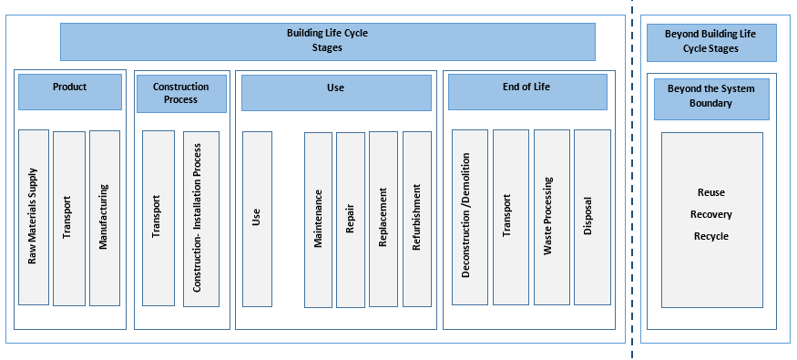Figure 1: Building Life Cycle

Source: BS EN 15978:2011

3.2. Types and Sources of Life Cycle Carbon

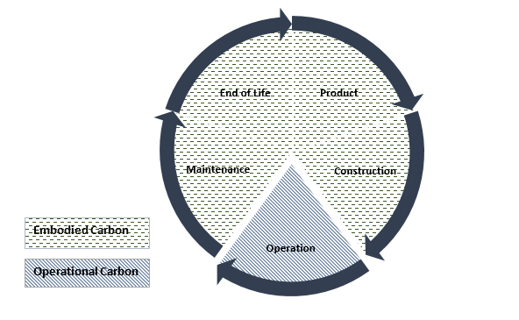A building, within its life cycle emits two types of emissions namely; operational carbon (OC) and embodied carbon (EC), depending on when carbon emissions occur in the life cycle (RICS, 2012). According to RICS (2012), operational carbon is the emissions occurring during the operational phase of a building and is typically generated from the operational energy consumption. This includes regulated load (heating, cooling, ventilation, lighting) and unregulated/plug load (ICT equipment, cooking and refrigeration appliances). Embodied carbon is the carbon emitting during the extraction, manufacture, transportation, assembly, replacement and deconstruction of construction materials or products of a building and are generally associated with energy consumption (embodied energy) and chemical processes (RICS, 2012). This has been clearly configured by UKGBC (2013) as in Figure 2.

Figure 2: Carbon Emissions during Building Life Cycle

Source: UKGBC (2013)

Moreover, IPCC Guidelines for National Greenhouse Gas Inventories (2006) has identified that both of these emissions are generated from four main sources namely; industrial process (IE), energy consumption (EE), combustion of biodegradable organic matters (FE) and land use (LE) and You et.al (2008) has clearly categorised them into phases of building life cycle as in Figure 3.

**Production**

**Construction**

**Use (Operation & Maintenance)**

**End of Life**

**Waste Treatment and Recycling**

**CO2 Emissions**

**IE**

**EE**

**LE**

**FE**

Where; **IE-** Industrial Process **LE**- Land Use

**EE**- Energy Consumption **FE**- Fugitive (waste) Emissions

Figure 3: Coupling between Carbon Emissions and Building Life Cycle

Source: You et.al (2011)

According to Figure 3, carbon (embodied) during product stage is emitted from IE, EE and LE. Construction stage emits carbon (embodied) from the sources of IE and LE. Operation stage emits operational carbon only from EE whereas maintenance stage emits embodied carbon from EE and LE. Carbon (embodied) emissions during the end of life and the waste treatment stages are from the sources of EE, LE and FE.

3.3. Proportion of Carbon Types across different building types

Many recent studies have detailed the proportion of life cycle embodied and operational emissions across different buildings. They have shown varying proportions to total lifecycle emissions due to the type of building being assessed, the use of building, the type of building materials used, construction methods employed, life span of the building and geographic differences etc. (Mohammed et.al, 2013).

A study conducted by RICS (2012) to the UK context reveals that buildings such as supermarkets, offices and semi -detached houses are associated with 70–80 % of operational carbon of the total life cycle emissions. Sartori and Hestnes (2007) have reviewed 60 case studies from past literature across different countries and reported that the embodied emissions could account for 2–38% of the total life cycle emissions while a larger portion remains as operational carbon. Further, Ramesh et al. (2010) have carried out a critical review of the lifecycle emissions analysis for residential and office buildings from 73 case studies across 13 countries and concluded that operational emissions accounted for 70–80%. Lin (2013) has also mentioned that the carbon emission from the operation stage accounted for the 60%–80% emissions of total life cycle building carbon emissions in China. Accordingly, it is proved that operational carbon emissions are much higher than embodied emissions in typical buildings.

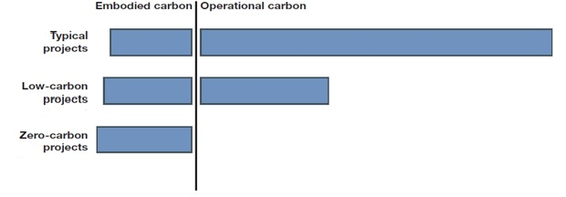Contrary to typical buildings, RICS (2012) mentioned that the low energy incentive facilities such as warehouses accounts for only 20% of operational carbon emissions. This is further confirmed by Sartori and Hestnes (2007) in their study, stating that the low carbon buildings accounts for 9–46% of embodied carbon where the operational carbon remains in a lesser value. Unless in typical and low carbon buildings, zero carbon buildings emit zero operational carbon in which the total carbon emits as embodied carbon (RICS, 2012). Refer Figure 4 for a demonstration for embodied and operational carbon proportion of a typical, low carbon and zero carbon building.

Figure 4 : Life Cycle OC and EC Proportions of Buildings

Source: RICS (2012)

1. Estimating Whole Life Cycle Carbon of Buildings

4.1. Whole Life Cycle Carbon

As mentioned by Ashworth and Perera (2015), the whole life cycle carbon of a building can be interpreted as:

$$Whole Life Cycle Carbon=Life Cycle Operational Carbon + Life Cycle Embodied Carbon$$

(Eq.01)

In a building, life cycle OC are only associated with the energy consumed during the operational phase. Therefore, measuring the life cycle operational carbon emission is relatively straightforward. Energy consumed in buildings is metered, with electricity, gas, petroleum and other energy sources metered through the energy supplier, so the estimations can be easily calculated (Ashworth and Perera, 2015).

Unlike that, life cycle EC emissions are occurred in all four phases of a building. Therefore, in estimating the EC of a building, measurement boundaries have been defined. As illustrated in Figure 5, there are five system boundaries namely; cradle (earth) to gate (manufacturing factory gate), cradle to site (construction site), cradle to end of construction, cradle to grave (demolition), or even cradle (earth) to cradle (reuse, recycle and recovery) (RICS,2012). According to that, life cycle EC requires to consider cradle (earth) to grave (demolition) system boundary, in which the embodied carbon emitted from materials extraction through manufacturing, transport, construction and use (building maintenance activities) to demolition of a building (whole life cycle) is considered. Thus, it is clear that the whole life cycle carbon emissions is another term for cradle to grave emissions.

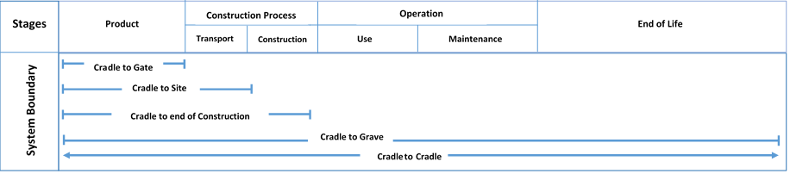

Figure 5: System Boundaries of Emission Calculation

Source: RICS, 2012

Further, when estimating life cycle carbon (either whole life cycle or any one type of carbon), RICS (2012) identifies five assessment zones of a construction project, where the carbon emissions assessment can be examined from. They are;

1. early stage estimating (concept design stages),
2. design development stage estimating (developed design stage),
3. detailed estimating (technical and specialist design stages),
4. construction stage estimating (off-site and on-site construction),
5. building use stage estimating (use and aftercare).

Accordingly, the below stated carbon estimation tools and previous studies have been established as per one of these zones.

4.2. Carbon Estimation Tools

There are many tools that have been developed to estimate the carbon emissions of buildings. Refer Table 1 for few of such efforts. While some of the tools listed in Table 1 assist in estimating whole life carbon, some tools assist only in estimating one type of carbon.

Table 1: Carbon Estimation Tools

|  |  |  |  |  |  |
| --- | --- | --- | --- | --- | --- |
| Software and Tools | System Boundary | Type of Carbon | Assessment zone | Provider | Countries |
| Simplified Building Energy Model | Operational Stage | OC | operational stage | Building Research Establishment (BRE) | UK |
| LSA in sustainable Architecture | Cradle to Grave | OC+EC | operational stage | BHP Laboratory | Australia |
| Athena Impact Estimator version 5.2 | Cradle to Grave | EC | design stage | Athena Sustainable Materials Institute | USA, Canada |
| ENVEST2 | Cradle to Grave | EC | early stage | Building  Research Establishment (BRE) | UK |
| Global  Environmental Model/Management-21P (GEM- 21P) | Cradle to Grave | OC+EC | design stage | Shimizu Construction | Japan |
| Simple Carbon Calculator | operational | OC | operational stage | National Energy Foundation | UK |
| Green House Gas Calculator | operational | OC | operational stage | Environmental Protection Authority | Australia |
| The Build Carbon Neutral Construction Calculator | Cradle to Grave | EC | early stage | Build Carbon Neutral Organisation | USA |

Carbon tools such as Simplified Building Energy Model (Building Research Establishment, 2010), Simple Carbon Calculator (National Energy Foundation, 2015) and Greenhouse Gas Calculator (Environmental Protection Authority) have only focused on life cycle operational carbon emissions and limited to the assessment zone of operational stage. Tools such as Athena Impact Estimator version 5.2 (Athena sustainable Materials Institute,2017), ENVEST2 (BRE and The Build Carbon Neutral Construction Calculator (Build Carbon Neutral Organisation, 2007) have focused life cycle embodied carbon and limited to design and early stage. It was found only very few tools which have been developed to estimate whole life cycle carbon emissions. LCA in sustainable Architecture (BHP Laboratory,2011) and Global Environmental Model/Management-21P (GEM- 21P), (Shimizu construction, n.d) are two examples for whole life carbon estimators. Although there are many carbon estimation tools, the above table indicates that they have different limitations inherent to themselves.

4.3. Previous Studies on Whole Life Cycle Carbon Estimation

The Table 2 presents few studies that have been conducted in different countries focusing various buildings to assess the whole life cycle carbon emissions. It shows that most of the assessments have been carried out during operational stage of that particular project.

Table 2: Previous Studies on Building Life Cycle Carbon Assessment

|  |  |  |  |
| --- | --- | --- | --- |
| Country | Author | Assessment Zone | Type of Building |
| UK | Darby et.al (2011) | Operational Stage | Warehouse Building (Book Storage Facility) |
| Hacker (2008) | Operational Stage | Semi- detached Two Bed Room House |
| China | You et.al (2011) | Operational Stage | Urban Residential Buildings |
| Hu and Zheng (2015) | Operational Stage | Energy Efficient Residential Buildings |
| Finland | Airaksinen,  and Matilainen (2011) | Design Stage | Office Building |
| South Korea | Cho and Chae (2016) | Operational Stage | Office + Residential |

1. Discussion

This study set out with the aim of reviewing existing literature on whole life cycle carbon emission assessment of buildings. Building sector being one of the major culprits for the high carbon emissions, now the significant attention is being paid on whole life cycle carbon assessments with the intention of meeting global carbon reduction targets. The literature review demonstrated that the whole life cycle carbon emission consists of life cycle OC and life cycle EC. While estimation of life cycle OC associated with operational phase of a building, estimation of life cycle EC associates with all four phases of a building, creating the measurement boundary of cradle to grave.

Even though there are few whole life cycle carbon estimating tools as shown in Table 1, each tool is different and do have limitations. Major limitation is to be the applicability of the tools which depends on the context and type of the building. Further, Peng (2015) mentioned that the calculation tools used in developed regions cannot be applied mechanically in developing areas as carbon emissions from a building’s life cycle have distinct regional characteristics because of the different types of climates, management policies, and technological levels in different places. As mentioned by De Wolf et. al. (2017) another limitation is their less transparency and not keeping up to date. Further, as it is mentioned above, another common limitation among these tools is the system boundary and assessment zone. Therefore, the simulation of carbon emissions from a building’s life cycle has become more complicated and the results of calculation appeared more different (Victoria et.al, 2015 and Peng, 2015).

The Table 2 presents few studies that have been conducted over the last ten years period focusing whole life cycle carbon emissions. It indicates that some of the studies have been conducted in the assessment zone of operational carbon and some in design zone, but no case study found that have been conducted during early design stage. Ashworth and Perera, (2015) mention that limited amount of design information available at early design stage as the main reason for this gap. Further, RICS (2012) mentions that early in the design process, high levels of uncertainty can be seen in the design details, making the calculation process more complex. Therefore, studies and the estimation tools focused on whole life carbon calculation during early design stage are not well established yet. However, RICS (2012), further recommends that if it starts to assess carbon emissions in early stage of a project, then its ability in reducing whole life carbon emission is high. Therefore, it creates a necessity of having a better approach in estimating whole life carbon in early design stage of a construction project.

1. Conclusions and The Way Forward

The aim of this paper was to carry out an extensive literature review on whole life cycle carbon estimation of buildings. Accordingly, the existing literature on building life cycle, types of life cycle carbon, life cycle carbon estimation tools and previous case studies on whole life cycle carbon estimation were reviewed.

Even though high carbon emission reduction potential is expected during early stage of a project, the findings indicated that most of the carbon estimation tools and the previous studies have focused estimation during operational stage and design stage. It was found out that lack of early stage estimation procedures and required data sets as the main reason for that gap. However, addressing this gap will eliminate unnecessary carbon emissions rather managing them in later stages. Hence, there is a necessity to fill that gap by introducing a rigorous approach to predict the whole life cycle carbon emission at early stage of designs in order to facilitate designers, engineers, users, and decision-makers with accurate evaluation of carbon emissions.

1. References

Airaksinen, M. and Matilainen, P., (2011). A Carbon Footprint of an Office Building, *Energies*, 4, 1197-1210.

Ashworth, A., and Perera, S., (2015). *Cost of studies of buildings*. 6th ed. Oxon: Routledge.

Athena Sustainable Materials Institute, (2014). *User Manual and Transparency Document, Impact Estimator for Buildings*, 5.

Athena Sustainable Materials Institute, (2017) *Athena Impact Estimator version 5.2.* Available from:https://calculatelca.com/software/impact-estimator/*.* [Accessed 01st June 2017]

BHP Laboratory, (2011) *LSA in sustainable Architecture.* Available from:www.lisa.ac.com.[Accessed 01st June 2017]

Build Carbon Neutral Organisation, (2007). *The build carbon neutral construction calculator* Available from:http://buildcarbonneutral.org/*.* [Accessed 01st June 2017]

Building Research Establishment (BRE), (2010). *SBEM: Simplified building energy model*. Available from: https://www.bre.co.uk/page.jsp?id=706. [Accessed 01st June 2017]

Building Research Establishment (BRE), (n.d.), *ENVEST2* Available from:http://envest2.bre.co.uk/. [Accessed 01st June 2017]

Chandrappa, R., ‎Gupta, S. and ‎ Kulshrestha U.C., (2011). *Coping with climate change: Principles and Asian context.* Springer.

Chau, C.K., Leung, T.M. and Ng, W.Y., (2015). A review on life cycle assessment, life cycle energy assessment and life cycle carbon emissions assessment on buildings. *Applied Energy*, 143, 395- 413.

Cho, S.H., and Chae, C.U., (2016) A Study on Life Cycle CO2 Emissions of Low-Carbon Building in South Korea, *Sustainability*, 8(579).

Committee on Climate Change, (2013). *Fourth carbon budget review – part 2 the cost-effective path to the 2050 target.* UK: Committee on Climate Change.

Darby, H.J. Elmualim, A.A. and Kelly, F., (2011). Case study on the whole life carbon cycle in buildings, *World Renewable Energy Congress 2011* - Sweden, 8 - 13 May 2011, Linkoping: Sweden

De Wolf, C., Pomponi, F., and Moncaster, A., (2017). Measuring embodied carbon dioxide equivalent of buildings: A review and critique of current industry practice, *Energy and Buildings,* 140 (2017) 68–80.

Environmental Protection Authority (EPA), (n.d.) *Greenhouse gas calculator.* Available from: (http://www.epa.vic.gov.au/agc/home.html). [Accessed 01st June 2017]

European Committee for Standardisation, (2011). BS EN 15978:2011

Hacker, J.N., De Saulles, T.P., Minson, A.J. and Holmes M.J., (2008). Embodied and operational carbon dioxide emissions from housing: A case study on the effects of thermal mass and climate change, *Energy and Buildings,* 40 (2008) 375–384.

Halsnæs, K., Shukla, P., Ahuja, D., Akumu, G,, Beale, R., Edmonds, J., Gollier, C., Greubler, A., Ha Duong, M., Markandya, A., McFarland, M., Nikitina, E., Sugiyama, T., Villavicencio, A and Zou, J. (2007). Framing issues. In: Metz, B., Davidson, O.R., Bosch, P.R., Dave, R. and Meyer, L.A., eds. *In Climate Change 2007: Mitigation. Contribution of Working Group III to the Fourth Assessment Report of the Intergovernmental Panel on Climate Change*, Cambridge.

Hu, F. and Zheng, X., (2015). Carbon Emission of Energy Efficient Residential Building, *Procedia Engineering*.121 (2015). 1096 –1102.

Ibn-Mohammed T., Greenougha, R., Taylorb, S., Ozawa-Meidaa, L. and Acquayec, A., (2013). Operational vs. embodied emissions in buildings—A review of current trends, *Energy and Buildings*. 66 (2013), 232–245.

Ibn-Mohammed, T., (2014). *Optimal ranking and sequencing of non-domestic building energy retrofit options for greenhouse gas emissions reduction*. Thesis (PhD). De Montfort University, Leicester.

Intergovernmental panel on climate change (IPCC), (2014). *Climate change 2014; Impacts, adaptability and vulnerability*. IPCC WGII AR5.

IPCC Guidelines for National Greenhouse Gas Inventories, (2006). Available at: http://www.ipcc-nggip.iges.or.jp/public/2006gl/ [Accessed 26th February 2017]

ISO, (2006). *ISO 14040:2006: Environmental management -Life cycle assessment - Principles and framework*

Kyoto Protocol to The United Nations Framework Convention on Climate Change (1998) (2012). Available at: https://unfccc.int/resource/docs/convkp/kpeng.pdf [Accessed 12th March 2017]

Lehtinen, H., Saarentaus, A., Rouhiainen, J., Pitts, M., and Azapagic, A. (May 2011). A Review of LCA Methods and Tools and their Suitability for SMEs, report compiled as part of the BIOCHEM project, work package 3, deliverable 3.2, Europe Innova, Eco-Innovation.

National Energy Foundation, (2015). *Simple carbon calculator*. Available from: http://www.carbon-calculator.org.uk/. [Accessed 01st June 2017]

Ortiz, O., Castells, F. and Sonnemann, G., (2009). Sustainability in the construction industry: a review of recent developments based on LCA, *Construction and Building Materials*, 23(1), 28–39.

Peng, C. and Wu, X., (2015). Case study of carbon emissions from a building’s life cycle based on BIM and Ecotect. *Advances in Materials Science and Engineering*, 2015.

Ramesh, T., Prakash, R., and Shukla, K. K., (2010). Life cycle energy analysis of buildings: an overview, *Energy and Buildings*, 42 (10), 1592–1600.

RICS, (2010 May). *Research report on carbon profiling as a solution to whole life carbon emission measurement in buildings,* RICS.

RICS, (2012). *Methodology to calculate embodied carbon of materials, RICS professional guide global*, 1st ed, RICS.

RICS, (May 2014). *Methodology to calculate embodied carbon, RICS professional guide global*, 1st ed. RICS.

Sartori, I. and Hestnes. A.G., (2007). Energy use in the life cycle of conventional and low-energy buildings: a review article, *Energy Building*. 39 (2007) 249–257.

Shimizu Construction, (n.d). *Global Environmental Model/Management-21P (GEM- 21P)*

UKGBC, (2013). *A methodology for measuring embodied carbon*. Available at: http://www.ukgbc.org/sites/default/files/How%20to%20measure%20embodied%20carbon%20session%202.pdf [Accessed 14th March2017]

US Environmental Protection Agency (US EPA), (2015). *Causes of climate change.* Available from: https://www.epa.gov/climate-change-science/causes-climate-change [Accessed 12th February 2017]

USEIA, (2010). *International Energy Outlook.* Available from: http://large.stanford.edu/courses/2010/ph240/riley2/docs/EIA-0484-2010.pdf. [Accessed 12th February 2017]

Victoria, M., Perera, S. and Davies, A., (2015). Developing an early design stage embodied carbon prediction model: A case study In: Raidén, A B and Aboagye-Nimo, E (Eds) *Procs 31st Annual ARCOM Conference*, 7-9 September 2015, Lincoln, UK: Association of Researchers in Construction Management, 267-276.

You, F., Hua, D., Zhang, H., Guo, Z., Zhao, Y., Wanga B. and Yuan, Y., (2011). Carbon emissions in the life cycle of urban building system in China—A case study of residential buildings, *Ecological Complexity,* 8 (2011) 201–212.

1. Corresponding Author: E-mail-amalka.ranathungage@northumbria.ac.uk, Tel-+44 7448354597