Social work students' conception on roles within the family in Greece
Sofia Dedotsi & Efrosyni-Alkisti Paraskevopoulou-Kollia
Abstract
The present article is based on a small-scale research that took place with third-year students in the department of social work at Technological Educational Institute of Patras. During class the students, who undertake the laboratory course ‘Social Work with Families’, were asked to discuss family roles and depict them on drawings. Analysing their drawings in a qualitative approach the findings suggest that students adopt traditional views on family issues and the family roles. Various gender stereotypes and prejudices were reflected in students’ drawings and this is alarming for both social work education and practice.
Keywords: social work education; social theory; family relationships; gender; values
Το παρόν άρθρο βασίζεται σε μια μικρής κλίμακας έρευνα που πραγματοποιήθηκε με σπουδαστές στο 3ο έτος των σπουδών τους του Τμήματος Κοινωνικής Εργασίας του Τεχνολογικού Εκπαιδευτικού Ιδρύματος Πάτρας. Κατά τη διάρκεια του μαθήματος, ζητήθηκε από τους φοιτητές που παρακολούθησαν το εργαστηριακό μάθημα ‘Κοινωνική Εργασία με Οικογένεια’ να συζητήσουν μεταξύ τους σε ομάδες για οικογενειακούς ρόλους και να τους απεικονίσουν σε ζωγραφιές. Αναλύοντας τις ζωγραφιές τους με ποιοτική προσέγγιση, τα αποτελέσματα αναδεικνύουν ότι οι φοιτητές υιοθετούν παραδοσιακές αντιλήψεις σε ζητήματα που αφορούν την οικογένεια και τους ρόλους μέσα σε αυτήν. Οι ζωγραφιές των φοιτητών αντανακλούν διάφορα στερεότυπα και προκαταλήψεις για το φύλο κάτι το οποίο είναι ανησυχητικό για την εκπαίδευση στην κοινωνική εργασία αλλά και για την άσκησή της.
λέξεις-κλειδιά: Εκπαίδευση στην Κοινωνική Εργασία; κοινωνική θεωρία; οικογενειακές σχέσεις; φύλο; αξίες
Overview
The first section of this paper introduces the reader to the research question and specific aims of this study. An exploration of the background literature on family structure in Greece as well as social work education follows which identifies the key issues that need to be investigated. The research context sets the framework of how, when and where this research took place whilst data collection methodology describes the research methods that were used to collect and analyse the data. Findings are presented and theoretically discussed whilst the last parts of this paper involve implications of this research and conclusions for social work education.
Introduction
Teaching has remained one of the main forms of communicating knowledge and skills. However, the effectiveness of teaching has often been under question due to students’ cultural and ethnocentric obstacles. Specifically, students may not find easy to accept and assimilate curricula that conflict with their ethical and social values and stereotypes. This paper sets out to explore the case of social work students who are likely to confront conflicts between their own attitudes and dispositions and those of the groups of families which are in need of support, for example, families that include refugees, Muslims, substance misuse, HIV patients, and so on. In short, ‘symbolic violence’ (Bourdieu, 1984) is in everyone’s life and is presented as ‘natural’ and ‘normal’.
In this paper, we do not try to describe and present the gender stereotypes and associated roles that are dominant in Greek society. As our literature review below indicates, these are well known, researched and documented. Rather, we are trying to advance one step further: we are specifically interested in investigating how these stereotypes affect the education of social workers and their evolution into professionals that are relevant and useful within the society they are aiming to serve. This research’s (human) sample is of interest because it consists of social workers ‘inthe- making’, on the third year of their studies. Since social work practice involves working with diverse families, our question, looking at their drawings, was: what does it mean for their practice and their studies to have stereotypical viewpoints?
Background
Family structure and family roles in Greece
Greek family is characterised by the ‘Mediterranean model’ with similar sociodemographic characteristics of the other southern European countries: relatively high marriage rate, low rates of unmarried cohabitation, low divorce rate, low birth rates outside of marriage and low fertility rates (Council of Europe, 1999 cited in Symeonidou, 2002). Greek family structure has evolved through time and socio-economic conditions.
The traditional extended family, which preponderated after the Second World War, has been transformed into marital––nuclear (i.e. Symeonidou, 2002; Teperoglou, 2002). Also, the family unit is part of a wider network of relatives covering many family needs and actively contributes in daily life. However, in recent decades studies have shown (Karlos & Maratou-Alipranti, 2002; Naoumi & Papapetrou, 2002) a transition from the family unit of two parents to more personalised forms such as single-parent families and unmarried relationships. Compared to the recent past, there is a greater frequency of divorces and single-person households (4% in Athens and 1.2% in rural areas). However, in comparison with other countries, extramarital birth rate in Greece remains the lowest; it is simply still not socially acceptable and continues to be regarded as a marginalised practice (Karlos & Maratou- Alipranti, 2002).
Despite the evolution of family form and structure, family member roles seem to remain invariant; the man–spouse maintains his predetermined and undisputed traditional role. He ensures the economic survival of the family, whereas the woman is involved in the care and socialisation of children (Teperoglou, 2002). Therefore, the Greek family model has been described as ‘male-dominated’ (Symeonidou, 2002, 2005) and a woman’s social standing is often derived indirectly (from her husband). In addition, women are often also considered ‘second class citizens’, and the state laws and policies do not facilitate their active participation in the labour market and in social/political activity.
It is a fact that in recent years the traditional stereotype of the breadwinner-male is (slowly) being deconstructed, and now across the Western world most male spouses or partners actively participate in the labour market and housework. In Greece, however, male participation in housework is the lowest compared to other countries. Symeonidou (2005) wrote that women are often forced to refrain from paid employment in order to care for dependent family members (children and/or elderly) on a full-time basis. Moreover, when they try to reintegrate into the labour market they face extreme difficulties due to lack of flexible arrangements that will help them combine and balance work and family life.
In conclusion, modern Greek family shows the same trends of diversification as in Western Europe. The big difference lies in the very slow uptake of changes (Teperoglou, 2002). This resistance to change is rooted in a strong persistence of traditional values and roles (marriage, family ties) in Greek society. National Centre for Social Research (EKKE) (2002) identified the contradictions and controversies of new family forms’ social acceptance in Greece and the wide acceptance of the institution of marriage as the cornerstone of social values, thus reflecting the inflexibility of Greek society when it comes to the assimilation of new roles and values.
Social work education and students’ beliefs
Building competences in social work students has been widely acknowledged as a very important mission for social work education. There is also a quest for social work education to develop critically reflective practitioners who challenge oppressive social constructions in their everyday practice. However, the action of challenging is founded on identifying and being aware on issues about identity, diversity (not only gender for example) and multiple oppressions. How social work education can tackle this though?
There has been a controversy within literature about the strategies or techniques that both educators and students may use in and out of the classroom. Some may involve traditional strategies such as: the use of vignettes for assessing and discussing knowledge, beliefs and attitudes (i.e. Congress, 2004; Dustin & Montgomery, 2009); role playing (i.e. Hargreaves & Hadlow, 1997); decision analysis/making models (i.e. O’Sullivan, 2008); and observation in placements (i.e. Humphrey, 2007). There has also been a shift to more alternative even artistic approaches within literature: dialogical techniques (i.e. Hafford-Letchfield, 2010; Khaja & Frederick, 2008) or Socratic dialogue (i.e. Pullen-Sansfacon, 2010; Schatz, Tracy, & Tracy, 2006); learning journals and placement portfolios (i.e. Banks, 2003; Collins & Wilkie, 2010); video recordings in classroom (i.e. Urdang, 2010); artistic approaches (i.e. Transken, 2002); and drama (i.e. Rutten, Mottart & Soetaert, 2009; Schatz et al., 2006).
In recent years there has been a debate regarding the efficacy of social work education and whether there is a gap between theory and practice or not, that is, between what students are taught and what they may actually think, believe and do. Most research findings highlight that the majority of students fall into stereotyping and negative attitudes and have lack of knowledge on working with different service user groups such as: drug and alcohol misuse (i.e. Heenan, 2005); disability (i.e. Reutebuch, 2006; Yun & Weaver, 2010); poverty (i.e. Christopherson, 1998); child abuse (i.e. Camilleri & Ryan, 2006); homosexuality (i.e. Reutebuch, 2006); and on delinquency and the elderly (i.e. Kane, 2002, 2004). Urdang (2010) notices that during their education, many students ‘don’t even understand what a professional self is, although they know they are going to become “professionals”’.
The impact of social work education on the students’ beliefs and attitudes may depend on a range of factors which may be personal, such as: gender and previous experience of social care work (i.e. Wilson & Kelly, 2010); socio-economic factors (i.e. Croxton, Jayrante, & Mattison, 2002); ethnicity (i.e. Ashton, 2010; Schulte & Battle, 2004); motivation to enter into social work education (i.e. Osteen, 2011); students’ willingness to self-reflect and change (Pugh, 1998); and religion (i.e. Gilligan & Furness, 2006). However, educational and organisational factors could also play a key role: level of education (i.e. Kozloski, 2010) and parental education (i.e. Deal, 2009); departmental/ organisational policies and strategies (such as proceduralisation; i.e. Wilson & Kelly,; Worsley et al., 2009); and staff and other resource shortages and strengths and limitations of staff team (i.e. Burgess, 2004).
In the light of this, it would be advantageous if educators considered the context of students’ socio-economic backgrounds and were aware of its association with students’ emotional and psychological growth. Simultaneously, educators need to examine the impact of their own life background upon their teaching methods, and therefore better understand classroom environments and students’ actions within them. After all, classrooms mirror society and there is always a relationship between social scheming and educational procedures (Bowles & Gintis, 1976). Regarding the arguments referring to the complexity of educators’ work, these may sound tense when working with students, but sometimes they have to appear to be harsh in order to support acceptable social standards (Paraskevopoulou-Kollia, 2004). The environment that educators work may be neither very lucrative nor particularly supportive––with its ambiguous policies and practices and other personal, political and organisational constraints and lack of resources. However, Simpson, Mathews, Croft, McKinna, and Lee (2010) mentioned that students link good practice in social work education with: the educators’ personal qualities; interpersonal relationships and support from academic staff; and group learning and teaching skills.
Whilst education seems to train evolving ‘ethical’ practitioners against all odds, there is a need for the debate about the differences of theory and practice to take a shift into their close relationship in which practice informs theory and vice versa (Parton, 2000). It is very unfortunate that social work research and literature is very limited in Greece especially in education, but we hope that our work will contribute to a continuous theoretical and research debate.
Research context
The laboratory course ‘Social Work with Families’ is offered to students of social work in their third year of studies, namely during the fifth semester. The aim of the course is not only to refer to various theoretical approaches to social work with families, but also to raise the awareness of students regarding the modern family forms, the assessment of their needs and alternative ways of intervention in order to face them.
As part of the course, students are given the opportunity to express themselves individually and collectively on a number of issues, such as the structure of a family and the roles undertaken by its members. Students also have the opportunity to discuss with each other in small groups and present their viewpoints in the classroom through creative exercises, such as painting, role playing and debate.
Exploring the personal views of student learning is an important tool for the detection of perceptions and attitudes prevalent in stereotypes. The ultimate goal is to interactively challenge the preconceived notions and social stereotypes embedded in the consciousness of every student, regarding the structure of the Greek family. Another goal of the course is to help students talk about various cases of intervention that may affect their professional consciousness in the course of their future career as social workers.
This article presents the results of a creative exercise that was conducted in the first course of the winter and spring semester, respectively, throughout academic year 2011– 2012. Specifically, students were asked to work in groups of 7–8 people, to illustrate ‘what is family’ and express in written form the role assigned to each member of the family depicted (some examples of these drawings are presented in Figures 1 and 2).
They then presented the groups’ drawings, describing them to the other students. The presentation by each group gave rise to discussion, debate and controversy concerning the structure and dynamics of a family and the ways of communication developed within it. The results revealed how the students perceive and respond to both the institution of the family and gender equality and their aspects’ presentation in this article was necessary. At this point it is worth mentioning that after discussing and agreeing with them, students gave their verbal consent in order for us to use their drawings as research data.
Each drawing was analysed in terms of its composition (space environment, colours and member presence) and we chronicled the surnames, the characteristics and the roles that have been assigned to each member and gender. We then performed comparisons and identified correlations between the drawings, as we will explain below.
FIGURE 1: Students’ drawings sample 1.
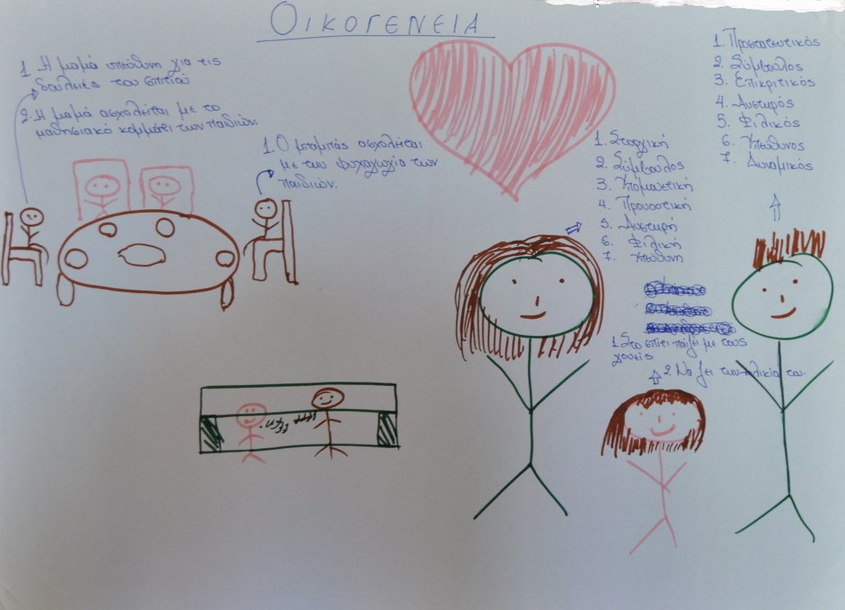

FIGURE 2: Students’ drawings sample 2.
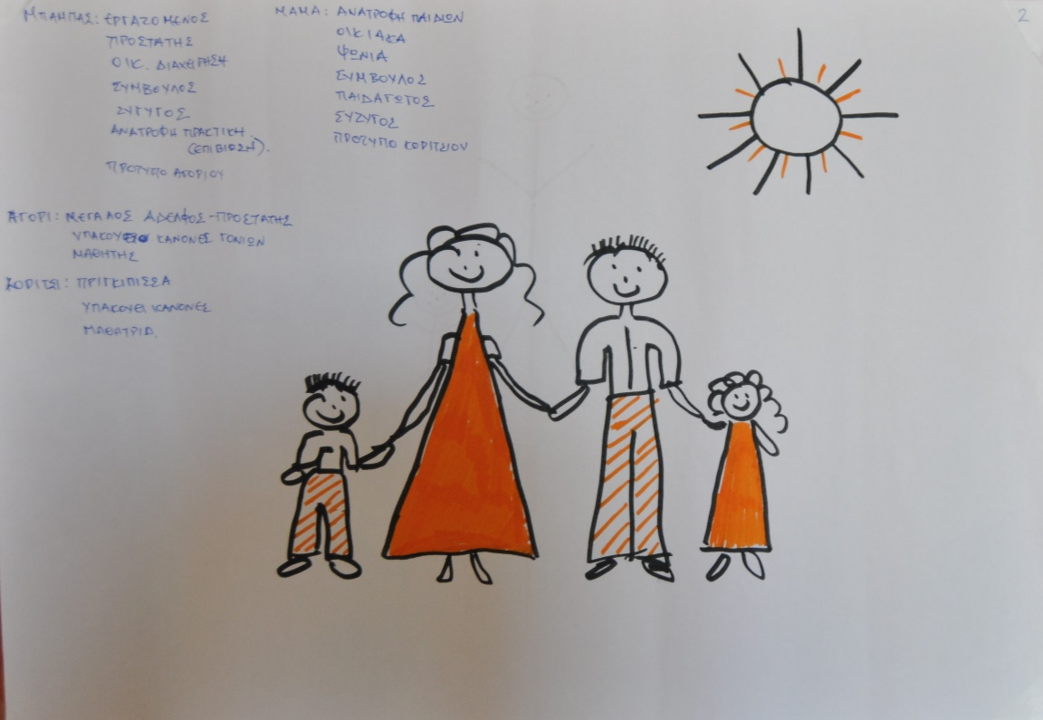
Data collection methodology
In this paper, we used the methodological tool of content analysis. This method is defined as ‘the scientific study of content of communication. It is the study of the content with reference to the meanings, contexts and intentions contained in messages’ (Prasad, based on Lal Das and Bhaskaran, 2008, pp. 173–193, Retrieved July 15, 2013, from http://www.css.ac.in/download/deviprasad/content%20analysis.%20a%20method%20of%20social%20science%20research.pdf/). It is a ‘pragmatic’ method (Fragoudaki, 1979, p. 11) that treats any form of ‘text’ as an object for research. The ‘text’ is used as a message (or as a set of messages, as in our research). A set of a total of 14 set of drawings will be presented and analysed. These drawings were collected froma cohort of approximately 100 students, divided into groups of 7–8 persons. In the context of the course and in order to draw their attention, we asked the students to sketch a family as they think of it in their own minds. Each drawing also contains text annotations (student notes with nominal adjectives and annotated descriptions of family members who are depicted) and is set within the context of an internal (inside the house) and/or external environment––even the activities or occupation of some members of the family. We gathered all 14 drawings, numbered and recorded their adjectives separately for each member (e.g. ‘mother’, ‘father’, ‘sister-girl-boy brother’, ‘grandmother’ and ‘grandfather’). Then, for each drawing, a detailed textual description was recorded: that is, the size of each family member, its spatial proximity to another person, the facial expression of the persons (if any), the colours used (we provided each group with a dark and a light pen) and also their clothing.
Particular emphasis was given to spatial data content, such as:
. Items that family members hold or use,
. Furniture, aro Influential elements that highlight the cultural context of these representations (i.e. table food and bread-type, indicators of a Mediterranean family).
Pets and natural environmental elements such as trees, ponds, flowers and gardens, were also recorded. Upon completing the registration of written and pictorial representations of the parties, tables were created attributing the occurrence frequency of all these elements.
Before pursuing the analysis discussion of results we should mention that in our effort to interpret and present our insights, we faced a large number of concerns, because our data are qualitative rather than quantitative, and our sample size is rather limited. We are aware of these caveats. However, we can reasonably suspect that the results presented here are representative of the perceptions of the identity of the Greek family and society and thus spark further discussion and research.
Findings and discussion
In this section, we present and theoretically discuss the key findings of this research in relation to the family figures––mother, father, grandparents and children as well as the special content as depicted in students’ drawings.
Mother
The adjectives that students used more frequently are the ones that reflect the mother’s behaviour mainly towards her children (affectionate, friendly, supportive and protective). In a second analysis level, one could claim that these adjectives do not actually concern elements of her character that are relevant to her interactions with society in general, outside a domestic context, rather ones that are strictly relevant to her relationship with the children. Accordingly, the woman–mother, who is also perceived as being of no special value to the economy, is associated with child-rearing.
In relation to mother’s roles, it is observed in Table 1, that the majority of students attribute the role of housewife and children nurse to the mother. This role is already well researched and documented (Fragoudaki, 1979, p. 18). This is also observed in students’ drawings, since they attribute an auxiliary and secondary role to the mother, as far as the financial status and contribution to the family is concerned. Even in the drawing referred to profession, this is the one of a teacher’s, confirming the direct perceptive association of women with children.
The stereotypes attributed to women coerce them into thinking that they are obliged to have the ‘ethics of care’ within them (Gilligan, 1982; Lortie, 1975, p. 54) and this is perpetuated. Duncan and Edwards named it ‘gendered moral rationality’ and the term refers to the moral codes (for each gender separately) individuals learn to follow early on, concerning child raising and constituting a family (Edwards & Duncan, 1996, p. 19). The unequal task distribution in the house and family is considered natural and they often feel bad if they are obliged to work at the expense of their child-rearing duties. Therefore, Greek women enjoy ‘social rights which often arise indirectly (from their husband) or are considered “second class citizens” according to the “androcratic model” to which Greece adheres’ (Symeonidou, 2005, p. 59). Nevertheless, behind the superficial evidence of stereotypes and evaluations of women’s skills, there is an additional hidden side of the issue, which wrongs them. Women manage multiple roles in their everyday life and are judged according to the way they cope with them. Theund or near which, members are placed and roles they have to adopt are aggravating and stressful: in addition to any career and paid employment commitments they may undertake, they have to simultaneously maintain a high performance in duties pertaining to their family and ‘feminine’ side––therefore becoming targets for harsh criticism and tough evaluation from both sides (Skeggs, 1995 cited in David, Davies, Edwards, Reay, & Standing, 1996, p. 482). It is also worth mentioning that social work students are predominantly women, which leads to the assumption that the profession of social worker fits with the ‘sensitive’ and ‘protective’ female stereotype.
Father
The adjectives about the father are again the ones that reflect his perceived behavior towards his children (protective, supportive and affectionate). Adjectives such as ‘judgemental’, ‘strict’ or ‘dynamic’, which are not given for mothers, also appear. In Table 2, it is of great interest that the main role of the father is that of a worker, capable of exerting influence by being the financial supporter, as opposed to the mother’s auxiliary role in a financial context, as indicated by answers given for the mother’s role, respectively. The next most frequently perceived role is that of the protector which perhaps can be compared or combined with the characterisations of ‘strict’ and ‘dynamic’. In this table, for the first time we encounter role elements that are exclusively paternal, such as the house’s financial management and the children’s financial support!
Moreover, the father is assigned the responsibility for the ‘practical survival’ of family members. In other words, the father is considered the family member that is capable of (and responsible for) reinforcing his children’s social profile and protecting them, simultaneously being totally responsible for them, steering them away from ‘wrongful situations’, teaching them how to navigate and survive within society. The results reflect Fragoudaki’s (1979, p. 24) conclusions that Greek men are perceived to conform to the established stereotype of the privileged financial ‘leader’.
Children
Concerning the children’s presence in the drawings:
. Ten of them depicted families with two children (one boy, one girl),
. another three depicted families with three children (two girls, one boy) and
. One drawing depicted a family with four children (three girls, one boy).
It is notable that every case of family had children of both genders, although in all cases girls outnumber the brother–boy. As far as adjectives are concerned, boys were characterised as ‘hyperactive’ and ‘social’, with roles suiting the assumed gender stereotype across preceding generations: father/grandfather––powerful: ‘big brother/protector’ as well as ‘financially independent/ worker’. As for the girl, even though there appears to be a higher diversity and broader range of conceptual divergence in the adjectives attributed to her, such as ‘obedient– disobedient’ and ‘restless–introvert’, she adopts roles like the one of a ‘princess’ and carer for the youngest siblings (‘looks after the younger siblings’). The girl’s attributes are neither equal nor equivalent/counterpart to those of the boy’s. They revolve around the concept of a ‘fragile’ character, concordant with the mother’s social role, being exclusively a symbol of beauty. Finally, both girls and boys were characterised as ‘the joy of life’––as common feature/role––for the parents with school obligations and auxiliary activities at home. The attributed role of ‘parental dreams acceptors’ is also rather evident here.
At this point, it should be emphasised that during the presentation of the drawings in the class, there was a complete absence of single parent or other new forms-types of families, with which social workers will normally be expected to have to work with. When students were asked about this at the end of the process, many answered that single-parent family, the childless couple or children that have emerged outside the context of marriage, are included in the type of ‘not normal family’. This perception was contested by some students, but the vast majority of them defended the social representation of a family where the parents are married, with children, and their roles are as those discussed above. This polarising thinking of students about normality is of major concern and as Thompson (2006, p. 50) points out, it ‘defines other family forms as “deviant” and undesirable’.
Grandparents
At this point, it is worth mentioning that the presence of grandmother and grandfather occurs in only 3 out of 14 drawings. This might be related to the fact that the students in these groups derive images from their own experience of a grandparent living or not living with them (i.e. a three-generation household arrangement).
As far as adjectives for grandfather and grandmother are concerned, grandfather was characterised as ‘traditional’ and ‘authoritarian’. Such features are linked with the attributes frequently assigned to the father. Accordingly, as a first conclusion is drawn that both consist ‘doric’ family forms. Grandmother is assigned no significant attributes apart from ‘religious’ and ‘grumpy’. Not surprisingly, the attributes of the grandparent are again reflecting the ones assigned respectively to the parent of the same gender; nevertheless, a common characterisation for grandmother and grandfather, ‘wiseconnoisseurs’, therefore indicating that the stereotypes at play here are ageist as well as sexist.
Spatial content of drawings
The drawings’ spatial content we believe that it is important, because it gives enough information about the Greek family, the dominant perceptions and the roles that both sexes possess within this ‘system’. In most drawings, the family appeared to be in a domestic setting, in the house, especially around the family table, the presence of which can be attributed to cultural and traditional aspects of the Greek family. Of particular interest is the fact that at the family table, grandfather and father were positioned by students at the heads of the table, with the remaining members of the family on the sides. One other option is that parents sit at the heads and children on the sides.
Last but not least, in relation to colours, all students could use either one bright colour or a dark one. In most cases students distinguished the two sexes by using bright colours for the females and dark colours for the males. We will try to draw some general conclusions concerning the under analysis issue and in particular the gender roles and relations between them.
Analysis of findings
The above findings reflect deeper stereotypes and oppressive beliefs by students linked to a sexist ideology. What are, though, sexism’s foundation? In this section we try to explain the vice circle of women’s oppression further. It is a fact that traditional standards of gender roles and social realities and institutions that reproduce the power relations between both sexes are directly related to education in general (which can start from the family and the immediate social, friendly environment) and the educational system in particular. We meet and accept traditional gender roles from an early age. It is a concept embedded in social structures. The stereotypical, prevailing attitude towards genders (Lunn, 2001 cited in Anderson & Williams, 2001, p. 107) subconsciously shapes the way we daily interact.
An additional explanation for the static gender roles in our lives is that these roles support the basis of our personal faiths, which we need to keep stable (Robertson, 1995, p. 79). As long as the mentality of society continues to maintain the traditional role models for both sexes, there will be unequal division of career choices between sexes, and the undervalued position of women will continue to underlie and undermine the development of their education. In this arrangement, androcentrism will always exist, frequently dismissed as a ‘minor issue’, nevertheless thus remaining in force both in public and private life (Robertson, 1995, p. 80).
The male population enjoys important advantages and privileges in a large number of activities (not excluding intellectual work such as book and essay writing, research and other scientific and intellectual activities which define the body of knowledge and regulate the communication of ideas), to which most women–mothers have limited or no access. For that reason, within the female population there is an apparent lack of active intellectuals who would yield new strategies of action and reaction towards any socioeconomic requirements. It is also significant that female participation and performance in employment is not recognised to the same extent, nor rewarded to the same degree, as male participation, even in the case whereby women are not considered ‘mere’ householders.
According to the above, it is concluded that the subordinate position of women in contemporary society and in the labour market are the result of long interaction processes between patriarchy and production, whilst the degree of involvement of those two (patriarchy viz. production method) differs between societies, depending on the financial development and historical conditions. Patriarchy, as evolved in line with structures and economic relations between nation states, has always favoured hierarchy and male solidarity, often at the expense of women’s basic human rights. Patriarchy/androcracy reinforces and legitimises the social, occupational and sexual superiority of men against women.
Implications of the research findings
This study, through the analysis of 14 drawn images, revealed the structure and roles that prevail within Greek family, that is, traditional, male-oriented standards, despite the emergence of a more diverse range of family patterns besides the long-established patriarchical model. In their majority, what these images depict is ‘a familial ideology’: the wife––mother––carer and the husband––father––employee where sex-appropriate roles are given to grandparents and/or children too. Any attributes related to concepts of strength and power (such as strong/protector etc.) are consistently attached to the male sex, whereas women held the weakest role and had few power-related attributes other than that of the mother. Through these images we viewed the reinforcement and perpetuation of sexism––the foundation of oppression towards women and diverse families. Whilst sexism is not a ‘new discovery’ for the Greek society––as discussed in literature review––yet it remains unchallenged whilst oppression is further reinforced by current socio-economic crisis.
Considering that the subjects of this study are social work students in the third year of their studies, the results for the standards and social representations that they have towards the institution of family and gender equality are alarming. It is crucial wondering, how students are going to tackle gender discrimination and oppressive attitudes or policies when they actually reproduce such sexist beliefs. Moreover, this raises a number of implications for social work education itself to recostructure curricula, approach and techniques that focus on students’ awareness not only of their self but also of equality and social justice issues.
Conclusions
This study aimed at an exploration of students’ social constructions in relation to gender and family roles through a creative activity in class. The various stereotypes and oppressive beliefs that were found are worrying for social work education. These findings lead to the questioning of these students’ future professional ability to become effectively involved with a diverse range of types of family, without being adversely influenced by their own stereotypical perceptions and beliefs. In simple words: how can these students be expected to function, in the very near future, as social workers who are supposed to empower families manage their problems, when (1) their own stereotypical viewpoints on family roles may have never been challenged as part of their professional education and (2) at the same time, the family problems they are expected to deal with as social work professionals typically arise specifically as a result of these stereotypical viewpoints? Additionally, one could question the effectiveness of their training in social work––and not only––with regard to inhibiting the formation of standards and sexist stereotypes reproduction of what is defined as ‘normal’ or ‘natural’.
Educators and social scientists highlight the fact that they have the power and the means to effectively deal with gender standardisation by the time they realise that gender role standardisation is promoted in formal and non-formal education. Despite the fact that a number of teaching strategies have been discussed and debated in literature, yet the effectiveness of these, and also the effectiveness of education itself in removing sexist stereotypes remains unknown to Greek society. Therefore, much greater effort should be made besides and beyond educational activities, in order to ensure the non-perpetuation of traditional sexist roles within and outside the education system. Education should forcefully and actively intervene within gender socialisation processes and eliminate the means and processes that legitimize gender stereotyping within Greek society. At a social level, a necessary legal framework should be set up that will shield women against all kinds of gender-based discrimination.
Finally, more research and discussion by theorists and researchers seems essential, not only in order to outline the sexist standards in Greek society but also in order to dismantle socio-economic factors that weave the identity of the male-dominated Greek family. In addition, further research could evaluate current education in relation to reference of difference, diversity and equality issues. Curricula and academic staff should consider the inclusion of special activities, seminars and appropriate courses in order to facilitate an anti-oppressive approach. It is pivotal that a critical approach is integrated within education which challenges core personal and societal values. Students need to be aware not only about their self but also about how oppression is founded within policies and taken-for-granted societal norms/values. We believe that these innovative proposals will not lead to substantial changes in the educational context, unless a specifically empowered team of teaching, science and economy professionals asked to actively interfere with this process of stereotype perpetuation. The above should be implemented in parallel with appropriate financial spending, which will strengthen education, and the development of research programmes.
At this point we should take into account Bourdieu’s (1992) opinion, who referring to the ‘habitus’, spoke of repetitive behaviours that the person adopts and thus lead her/him to act without always being aware of these actions or of their consequences. For the social workers ‘in-the-making’, it would not be an exaggeration to say that they gradually become addicted to adopt the stereotypical roles for a typical Greek family (Paraskevopoulou- Kollia, 2006) and there is a need for a significant investment in terms of money and educational effort, in order to overcome this. It is very unfortunate that during the time that this article was being written, the continuous disinvestment in social work and social care in Greece by austerity measures and policy cuts have included the recent abolition of one of the four national social work departments. Therefore, it is crucial than ever for social work education to re-ensure for future practitioners what the core principles of the profession protest: social justice and social change.
References
Anderson, P., & Williams, J. (Eds.). (2001). Identity and difference in higher education, ‘outsiders
within’. Aldershot: Ashgate.
Ashton, V. (2010). Does ethnicity matter? Social workers’ personal attitudes and professional
behaviors in responding to child maltreatment. Advances in Social Work, 11(2), 129–143.
Banks, S. (2003). From oaths to rulebooks: A critical examination of codes of ethics for the social
professions. European Journal of Social Work, 6(2), 133–144. doi:10.1080/1369145032000
144403
Bourdieu, P. (1984). Distinction: A social critique of the judgement of taste. Cambridge, MA:
Harvard University Press.
Bourdieu, P. (1992). Microcosmi. Athens: Delfini.
Bowles, S., & Gintis, H. (1976). Schooling in capitalist America. New York, NY: Basic books.
Burgess, H. (2004). Redesigning the curriculum for social work education: Complexity, conformity,
chaos, creativity, collaboration? Social Work Education, 23, 163–183. doi:10.1080/02615470
42000209189
Camilleri, P., & Ryan, M. (2006). Social work students’ attitudes toward homosexuality and their
knowledge and attitudes toward homosexual parenting as an alternative family unit: An
Australian study. Social Work Education, 25, 288–304. doi:10.1080/02615470600565244
Christopherson, R. J. (1998). Social work students’ perceptions of child abuse: An international
comparison and postmodern interpretation of its findings. British Journal of Social Work, 28,
57–72. doi:10.1093/oxfordjournals.bjsw.a011318
Collins, S., & Wilkie, L. (2010). Anti-oppressive practice and social work students’ portfolios in
Scotland. Social Work Education, 29, 760–777. doi:10.1080/02615471003605082
Congress, E. P. (2004). Teaching social work values, ethics and human rights. Retrieved from
www.ifsw.org/cm_data/Elaine.5.pdf, accessed on 30/09/2011
Croxton, T. A., Jayrante, S., & Mattison, D. (2002). Social work practice behaviors and beliefs:
Rural – urban differences? Advances in Social Work, 3(2), 117–132.
David, M., Davies, J., Edwards, R., Reay, D., & Standing, K. (1996). Mothering and education:
Reflexivity and feminist methodology (chapter 15). In L. Morley & V. Walsh (Eds.), Breaking
boundaries: Women in higher education (pp. 208–223). London: Taylor & Francis.
Deal, K. H. (2009). Examining predictors of social work students’ critical thinking skills. Advances
in Social Work, 10(1), 87–102.
Dustin, D., & Montgomery, M. (2009). The use of social theory in reflecting on anti-oppressive
practice with final year BSc social work students. Social Work Education, 29(4), 386–401.
Edwards, R., & Duncan, S. (1996). Standing mothering and education: Reflexivity and feminist
methodology. In L. Morley & V. Walsh (Eds.), Breaking boundaries: Women in higher
education. London: Taylor and Francis.
Fragoudaki, A. (1979). Ta anagnostika vivlia tou imotikou scholiou. Ideologikos pithanagkasmos ke
pedagogiki via [Primary eucation’s school books. Ideological constraint and educational
violence]. Athens: Themelio.
Gilligan, C. 1982. In a different voice: Psychological theory and women’s development. Cambridge,
MA: Harvard University Press.
Gilligan, P., & Furness, S. (2006). The role of religion and spirituality in social work practice:
Views and experiences of social workers and students. British Journal of Social Work, 36,
617–637. doi:10.1093/bjsw/bch252
Hafford-Letchfield, T. (2010). A glimpse of the truth: Evaluating ‘debate’ and ‘role play’ as
pedagogical tools for learning about sexuality issues on a law and ethics module. Social Work
Education, 29, 244–258. doi:10.1080/02615470902984655
Hargreaves, R., & Hadlow, J. (1997). Role – play in social work education: Process and framework
for a constructive and focused approach. Social Work Education, 16(3), 61–73. doi:10.1080/
02615479711220241
Heenan, D. (2005). Challenging stereotypes surrounding disability and promoting anti-oppressive
practice: Some reflections on teaching social work students in Northern Ireland. Social Work
Education, 24(5), 495–510. doi:10.1080/02615470500132780
Humphrey, C. (2007). Observing students’ practice (through the looking glass and beyond). Social
Work Education, 26, 723–736. doi:10.1080/02615470601129933
Kane, M. N. (2002). Correlates of MSW students’ perceptions of preparedness to manage risk and
personal liability. Advances in Social Work, 3(2), 134–145.
Kane, M. N. (2004). Correlates of preparedness among MSW students for ethical behaviour in US
managed care environments. Social Work Education, 23, 399–415. doi:10.1080/0261547042000
245017
Karlos, M., & Maratou-Alipranti, L. (2002). New family forms and social policy: The case of
Greece and Portugal [Nees morfes ikogenias ke kinoniki politiki: i periptosi tis Eladas ke tis
Portogalias]. In L. Maratou-Alipranti (Ed.), Families and social welfare system in Europe, trends
and challenges in 21st century [Ikogenies ke kratos Pronias stin Europi, tasis ke proklisis ston
21o eona] (pp. 131–159). Athens, Gutenberg: National Centre for Social Research.
Khaja, K., & Frederick, C. (2008). Reflection on teaching effective social work practice for working
with Muslim communities. Advances in Social Work, 9(1), 1–7.
Kozloski, M. J. (2010). Homosexual moral acceptance and social tolerance: Are the effects
of education changing? Journal of Homosexuality, 57, 1370–1383. doi:10.1080/00918369.2010
.517083
Lortie, D. C. (1975). Schoolteacher: a sociological study. London: The University of Chicago
Press.
Naoumi, M., & Papapetrou, G. (2002). Age synthesis of population and structure of households
[ilikiaki sinthesi plithismu ke diarthrosi nikokirion]. In A. Mouriki, M. Naoumi, & G. Papapetrou
(Eds.), The social portrait of Greece 2001 [to kinoniko portreto tis Eladas 2001] (pp. 37–45).
Athens: National Centre for Social Research.
O’Sullivan, T. (2008). Using decision analysis: Connecting classroom and field. Social Work
Education, 27, 262–278. doi:10.1080/02615470701381384
Osteen, P. J. (2011). Motivations, values, and conflict resolution: Students’ integration of personal
and professional identities. Journal of Social Work Education, 47, 423–444. doi:10.5175/JSWE.
2011.200900131
Parton, N. (2000). Some thoughts on the relationship between theory and practice in and for social
work. British Journal of Social Work, 30, 449–463. doi:10.1093/bjsw/30.4.449
Paraskevopoulou-Kollia, E.-A. (2004). Teachers of young children (3–5 years old) and their
interaction with pupils: Approaching positive classroom management. Educate - The London
Journal of Doctoral Research in Education, 4(2), 33–44.
Paraskevopoulou-Kollia, E.-A. (2006). The social estimation of pre-school teachers (Unpublished
doctoral dissertation). University of Crete, Rethimno.
Pugh, R. (1998). Attitudes, stereotypes and anti- discriminatory education: Developing themes from
Sullivan. British Journal of Social Work, 28, 939–959. doi:10.1093/oxfordjournals.bjsw.a011409
Pullen-Sansfacon, A. (2010). Virtue ethics for social work: A new pedagogy for practical reasoning.
Social WoReutebuch, T. G. (2006). Graduating BSW student attitudes towards vulnerable populations and
their preferences towards interventions to serve them. Advances in Social Work, 7(1), 57–66.
Robertson, H.-J. (1995). Teacher development and gender equity. In Hargreaves & G. Fullan,
Understanding teacher development, (pp. 77–106). Chatzipanteli, Athens: Patakis.
Rutten, K., Mottart, A., & Soetaert, R. (2009). Narrative and rhetoric in social work education.
British Journal of Social Work, 40(2), 480–495. doi:10.1093/bjsw/bcp082
Schatz, M. C. S., Tracy, J. R., & Tracy, S. N. (2006). Overcoming social oppression: Using dialogue
and theatre to reveal oppression and foster healing. Critical Social Work, 7(2). http://www.
uwindsor.ca/criticalsocialwork/archive-volumes
Schulte, L. J., & Battle, J. (2004). The relative importance of ethnicity and religion in predicting
attitudes towards gays and lesbians. Journal of Homosexuality, 47(2), 127–142. doi:10.1300/
J082v47n02_08
Simpson, D., Mathews, I., Croft, A., McKinna, G., & Lee, M. (2010). Student views on good
practice in social work education. Social Work Education, 29, 729–743. doi:10.1080/02615471
003623192
Symeonidou, Ch. (2002). Marriage – divorce, living together – breaking in Greece: Research results
by EKKE [Gamos – Diazugio, Sumviosi – Chorismos stin Ellada: Apotelesmata Ereunas Ekke].
In L. Maratou-Alipranti (Ed.), Families and social welfare system in Europe, trends and
challenges in the 21st century [Ikogenies kai Kratos Pronias stin Europi, Tasis ke Prokisis ston
ikosto Proto eona] (pp. 115–131). Athens: National Centre for Social Research.
Symeonidou, Ch. (2005). The exclusion of women from the labour market in Greece [O apoklismos
ton gynekon apo tin agora ergasias stin Ellada]. In IL. Katsoulis, D. Karadinos, L. Maratou-
Aliprandi, E. Fronimou (Eds.), Dimensions of social exclusion in Greece, main issues and
determination of policy priorities [Diastasis tou kinonikou apoklismou stin Ellada, kiria themata
ke prosdiorismos protereotiton politikis] (4th ed., Vol. b). Athens: National Centre for Social
Research.
Teperoglou, A. (2002). The transformation of the family [o metashimatismos tis ikogenias]. In The
social portrait of Greece 2001 [to kinoniko portreto tis Eladas 2001]. Athens: National Centre
for Social Research.
Thompson, N. (2006). Anti-discriminatory practice (4th ed.). New York, NY: Palgrave Macmillan.
Transken, S. (2002). Poetically teaching/doing the profession of social work as a joyful
undisciplined discipline – jumper and genre – jumper 1. Critical Social Work, 3(1). http://
www.uwindsor.ca/criticalsocialwork/archive-volumes
Urdang, E. (2010). Awareness of self – a critical tool. Social Work Education, 29, 523–538.
doi:10.1080/02615470903164950
Wilson, G., & Kelly, B. (2010). Evaluating the effectiveness of social work education: Preparing
students for practice learning. British Journal of Social Work, 40(8), 2431–2449. doi:10.1093/
bjsw/bcq019
Worsley, A., Stanley, N., O’Hare, P., Keeler, A., Cooper, L., & Hollowell, C. (2009). Great
expectations: The growing divide between students and social work educators. Social Work
Education, 28, 828–840. doi:10.1080/02615470802512697
Yun, S. H., & Weaver, R. (2010). Development and validation of a short form of the attitude toward
poverty scale. Advances in Social Work, 11, 174–187.rk Education, 29(4), 402–415. doi:10.1080/02615470902991734

Roles | Number of drawings
Responsible for housework | 7
Homework preparation | 2
Caring/childbearing | 5
Advisor | 1
Wife | 2
Pedagogue | 1
Girl's role model | 1
Shopping | 1
Additional income provider | 4
Protector | 1
Peace maker | 1
Mother | 1
Woman | 1
Profession: teacher | 1
Table 1 Mother

Roles | Number of drawings
Children's entertainment | 1
Advisor | 4
Family bread winner | 6
Protector | 5
Family income Manager | 1
Husband | 2
Responsible for practical needs | 1
Boy's role model | 1
Father | 2
Pocket money provider | 1
Childbearing | 2
Personal time with his wife | 2
Profession: Professor | 1
TABLE 2: Father

