Modelling the bitumen scour effect: enhancement of a dynamic friction model to predict the skid resistance of rubber upon asphalt pavement surfaces subjected to wear by traffic polishing

Malal KANE and Vikki EDMONDSON
IFSTTAR-Nantes
Institut Français des Sciences et Technologiques des Transports, de l'Aménagement et des Réseaux
Allée des Ponts et Chaussées
Route de Bouaye - CS4
44344 Bouguenais Cedex, France

Abstract
This paper explores the prediction of whole-life cycle skid resistance for asphalt. When asphalt surfaces are newly laid, the microtexture of the aggregates is masked by a film of bitumen binder that tends to lower skid resistance during the early life of a pavement. However, as it is subjected to traffic polishing, the skid resistance of a newly laid pavement starts increasing as a consequence of the scouring of the bitumen binder film, which gradually reveals the microtexture. Once fully exposed, the microtexture is progressively polished by the traffic tending to cause a decrease in skid resistance and leading to pavements becoming more slippery again in the long term.
To take into account the early life masking of the microtexture of an asphalt surface, a coefficient or “weight factor” is introduced to a Dynamic Friction Model (DFM) previously developed to predict the skid resistance of rubber moving upon a rough surface. To validate the modified model, mosaic and asphalt samples are prepared utilizing different aggregates and submitted to controlled laboratory polishing, to simulate both the wear of surface texture and scour of the bitumen film under traffic. The specimens’ surface textures are recorded at different stages of polishing, and contact friction measurements taken using a Wehner-Schulze machine. These experimentally obtained values are compared with the fiction coefficients calculated with the modified model. The results illustrate comparable friction coefficients (more than 85% of the model simulations produced results with accurate ±2% of the experimental measures) ,and accordingly demonstrate the robustness of the enhanced model to account for the initial presence of the bitumen binder film, in the evaluation of skid resistance for asphalt pavement surfaces.

Keywords
Dynamic Friction Model, Skid Resistance, Polishing, Bitumen, Texture, Friction After Polishing.

Introduction
The skid resistance offered by a road relates to the friction forces generated at the tyre/road surface interface. Many characteristics influence the value: the micro and macrotexture of a road surface, the presence of contaminant and/or pollutant at the tyre/road interface, and surface temperature. [1-5]. Skid resistance evolves continuously under traffic polishing; with the traffic first removing the initial binder film and then progressively polishing the microtexture of the aggregates (Figure 1) [6-13]. The curve of Figure 2 portrays the typical evolution of skid resistance under increasing passes of traffic [6,8]. Tourenq et al. [12] demonstrated that aggregates containing minerals with different harnesses, have higher long-term polishing resistances than mono-mineral aggregates.
The traffic, via the contact between tyres and road,
polishes the texture and removes the initial binder film present on the road surface

and thus induces the evolution of pavement skid resistance

Figure 1 : The interdependencies of traffic/texture/skid resistance evolution.

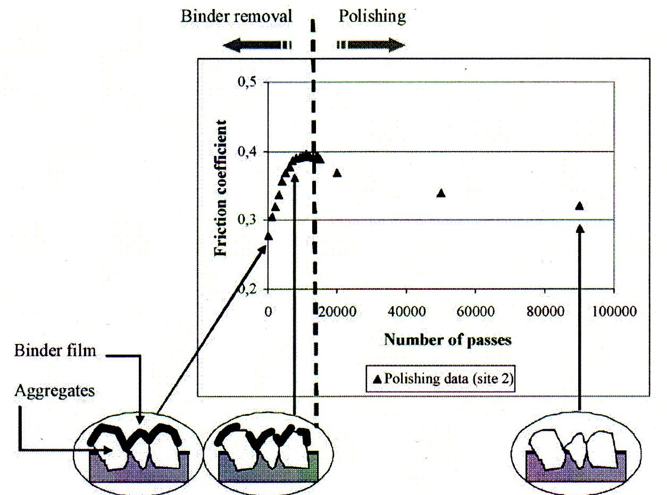
Figure 2 : Evolution of skid resistance expressed by the “friction coefficient” with traffic simulated by the number of polishing passes [8].

For newly laid asphalt pavements, the microtexture of the aggregates located within the pavement top surface layer are masked by a film of bitumen binder. Microtexture is one of the main factors governing the skid resistance of roads. In wet conditions, it is the aggregate microtexture that penetrates the film of water, to promote direct tyre/road contact and develop the adhesion that provides friction. During the early life of asphalt surfacing, when the microtexture is not fully exposed, skid resistance may be very low and can subject vehicles using new roads to “bituplanning”. This phenomenon has been fully investigated in the last decade in the UK by Roe and by Woodward [15-16].
Upon opening to road traffic, the skid resistance of an asphalt surface initially increases due to the gradual scouring away of the film of bitumen binder to reveal the microtexture of the aggregates [7, 8, and 10]. Following this phase, the revealed microtexture is gradually polished by the traffic, typically causing skid resistance to decrease once again and leading to pavements become more slippery in the long term. .
The previous work undertaken to understand the phenomenon of the evolution of skid resistance, to our knowledge, has not yet led to the development of a physical model capable of predicting the full life cycle of skid resistance for asphalt surfacing, including the stages of polishing of the microtexture and the scouring of the initial bitumen film. This paper furthers previous cited contributions by proposing such a physical friction model to predict the state of skid resistance of asphalt surfaces. The model predicts the evolution of skid resistance for asphalt surfaces, from the point of construction, accounting for the polished state of surface texture and the state of stripping of the initial bitumen binder film.
Kane et al. [9] previously proposed a model to predict the effect of traffic polishing on road surface texture following a prolonged period of use. This model considered the number of polishing passes, operational conditions during the polishing process and the wear characteristics of the aggregates. Despite some simplifications to establish the wear law , the model showed nevertheless that it was possible to predict the final texture of road surfaces after a long period of traffic polishing. The model is suitable to predict the evolution of the texture, of road surfaces subjected to traffic polishing, but does translate texture to a calculation of the related skid resistance.
However, recently, the same authors provided another contribution relating the texture of roads to their skid resistance [1, 2]. The model, termed the ‘Dynamic Friction Model (DFM)’, uses a mixed-contact modelling approach to predicted the friction generated, at the interface of a dynamic contact, between a viscoelastic rubber and a rough surface. Although this model is well suited to evaluate the skid resistance of asphalt surfaces in the long term, it is still not capable of predicting early life skid resistance. The model fails to taken into account within its prediction, the influence of the masking of the microtexture of a new asphalt surface by a film of bitumen binder, and the subsequent scouring of the same.
The new contribution proposed in this paper explores the enhancement of the DFM model to predict the life cycle of skid resistance for asphalt surfacing from the opening of a highway to resurfacing; but excluding the seasonal variation effect. The idea is to introduce a “weight factor” in the model formulation, to take into account the fraction of the road surface occupied by the initial film of bitumen binder [7, 8, 10, 16].

Revisiting the DFM
The equations governing the DFM are derived by balancing the forces applied in the contact between a rubber pad moving upon a rough surface (Equation 1) [1]. Both the rubber pad and the surface profile are discretized into independent elements (Figure 5). The width of each element is chosen to match the horizontal resolution of the texture profile. During the sliding of the rubber on the surface, the force-balance equates to:
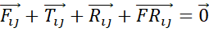 Equation 1
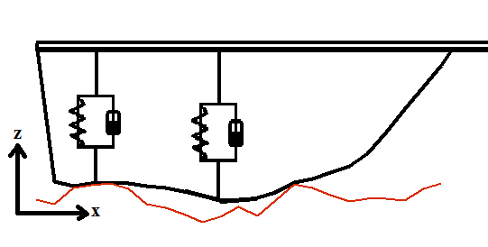 | 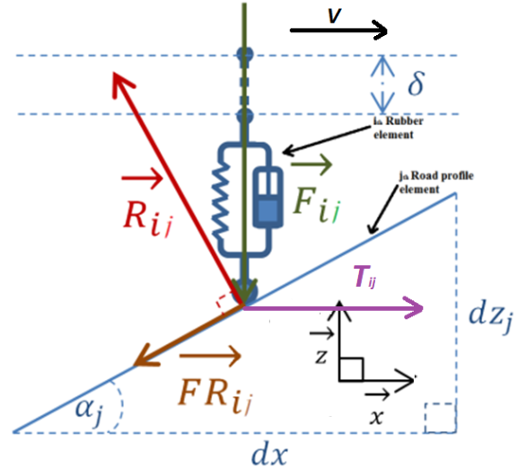

Figure 3 : Forces acting in the contact between a rubber element and a rough surface profile.

Where:
- is the force applied by the rubber element on the road surface. Its formulation depends on the rheological behavior considered for the rubber elements. In the present work, it is calculated using a “Kelvin-Voigt” model, where K is the spring’s elastic modulus per unit length and C is the dashpot’s viscosity per unit length. is balanced by the load through the contact pressure (See Equation 2).
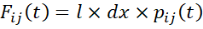 with 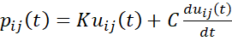 and 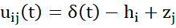
Where, t representing the time and u_{ij} the displacement of the rubber i^{th} element contacting j^{th} element on the pavement at time t. δ is the solid (or global) displacement of the pad at time t. h_{i} represents the discretized h(x) at the i^{th} point representing then the pad geometry. z_{j} is the height of the j^{th} point of the pavement surface.
- is the traction force needed to move the element. This force must be just greater than the global friction force opposing that movement (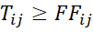 where 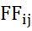 is the friction force). is the surface reaction force. 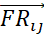 is a local friction force. 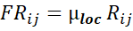 when the element is moving on that “pseudo smooth inclined plan” where 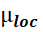 represents a local friction coefficient (adhesive or local hysteretic) [1, 3, 12].

The projection of Equation 1 local contact coordinates onto global contact axes x and z coupled with the condition that 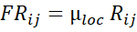 leads to:
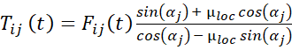 Equation 2
When an element is not in contact with the pavement surface, its contact pressure is nil and the element is subjected to a relaxation phase. Its position on the z axis is determined by solving:
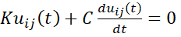 Equation 3
At any time t, and irrespective of the location of the pad on the profile, the normal contact pressure must balance the total load applied. on the pad:
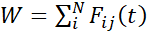 Equation 4
Where N is the number of discrete elements composing the rubber pad. Thus, the global friction coefficient 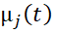then can be calculated using the following formula:
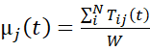 Equation 5
And the averaged global friction coefficient 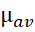 for each pavement profile is calculated by averaging the friction coefficient at any time:
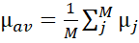 Equation 6
Where, M is the number of elements of the discretized pavement profile. At this stage, the only unknown factor is 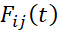 representing the contact forces applied by the rubber elements on the road surface. To obtain the calculation details for the dynamic viscoelastic contact forces, the reader is referrer to publications [1].
Furthermore, depending on the operating conditions of a pavement a hydrodynamic pressure may be generated in water trapped between the rubber pad and the pavement surface. This hydrodynamic pressure exerts a force to lift up the rubber from the pavement, and thereby decreases the penetration depth of pavement asperities into the rubber elements, reducing the hysteretic contribution to the tire-rubber/pavement skid resistance.
The DFM models this behaviour by converting the wet portion of the rubber contact area into a “pseudo” hydrodynamic bearing with an equivalent continuous lubricant film. This is achieved by first assuming that the inlet lubricant thickness 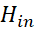is equivalent to the water depth. Second, the outlet lubricant thickness 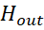 is set to maintain the same water volume as the calculated volume of water that is trapped in the wet valleys of the rough contact model, taking the viscoelastic deformation of the rubber into account. With this equivalent configuration, the hydrodynamic load can then be computed as:
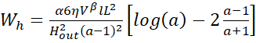 Equation 7
Where, 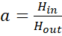, with and respectively the outlet and inlet water thicknesses of the “pseudo” bearing. is the water viscosity. L and l are the length and the width of the bearing .α and β are two emperical coefficients (10⁵ and 1.75 respectivly) added to modify the analytical expression of the hydrodynamic load capacity of a classical bearing (equal to 1 in the case of a classical bearing), to calculate the load of the “pseudo” bearing. For the detailed calculation, the reader is invited to refer to publication [1].

Introducing the “weight factor”
In previous investigations aimed at understanding the evolution of skid resistance for road surfaces due to traffic polishing, Do et al. proposed a simple empirical model, composed of two elementary friction functions, which predicts the two phases of skid-resistance evolution - aggregate polishing and binder removal (refer to Figure 2) [7, 8, 10, Error: Reference source not found]. These two friction functions were assigned to represent the bitumen and the aggregate contributions to skid resistance. The “bitumen friction” represented the friction coefficient provided by binder-enveloped aggregates, and the “aggregate friction” relates to the petrology of the aggregates and represented the friction provided by unmasked aggregates. To assign a relative weight to these two functions contribution during the polishing process, the authors introduced a factor “d” termed the “weight factor” representing the percentage of the surface occupied by the non masked aggregates:

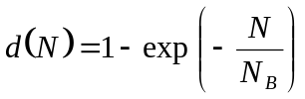 Equation 8
Where, d varies from 0 to 1 and depends on the number of polishing passes N. N_{B} is related to the couple bitumen/aggregate types and corresponds to the number of polishing cycles when the initial bitumen film is completely removed from the asphalt surface.
The “weight factor” is reused in the work presented in this paper, to take account of the change of local friction arising due the masking of aggregate microtexture by the bitumen binder during the preliminary stages of an asphalt pavements life. The introduction of this coefficient is achieved simply by changing only Equation 2 as following:

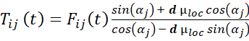 Equation 9

All the other equations and the calculation processes described remain unaltered.

Experimental program
Polishing procedure and Friction measurements
All friction measurements and polishing tests of the specimens were performed using the Wehner-Schulze machine (WS-machine) refer to Figure 4. This machine is in the center of a new test to determine “Friction After Polishing” (FAP) following a new European standard CSN EN 12697-49. This Standard describes the test method to determine the friction at 60 km/h, after polishing for a fixed number of passes, for the surface of bituminous mixtures samples. The samples used can be produced either in a laboratory or be in-situ cores taken from a field site. The machine contains two stations one for performing the polishing and another for measuring friction [7].
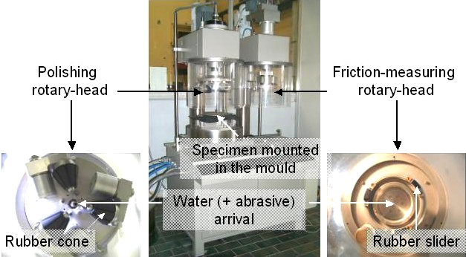
Figure 4: Wehner-Schulze machine.

The polishing station contains three rubber cones mounted on a rotary disc which roll upon the specimen surface with a given load. To accelerate the polishing process, a mix of 5% quartz powder (< 0.06mm) in 95% water is sprinkled during the rotations of the cones on the specimen. The surface is polished in a ring. The machine can be programmed to stop after a given number of rotations. Immediately after each stop, water is projected on the specimen surface and a further 500 rotations are performed with the cones to wash away all residue and debris.

After the washing period, the specimen is moved manually to the skid resistance measuring station. This station is composed of three small rubber pads each with an area of 4 cm², fixed at 120° on a rotary disc. The contact load between the rubber pads and the specimen surface is approximately 0.15 N/mm². For the friction measurement, the rotary disc is spun with a motor until a speed of 100 km/h is reached at its circumference. When the disc speed reaches 90 km/h, water is projected onto the surface of the specimen. At 100 km/h the motor is stopped and the rotating disc is dropped, so that the rubber pads make contact with the specimen surface. The rotation of the disc is then stopped by the friction generated between the rubber pads and the specimen surface; and the friction–time curve is recorded. The friction value at 60 km/h from this curve is considered for the analyses.

Texture measurements
The polishing process is momentarily stopped at 1000 passes, 90000 passes and 180000 passes to record the texture of the asphalts specimen with a profilometer from STIL® named “Micromesure” (refer to Figure 5 Left and Figure 6). The “Micromesure” system operates utilizing the principles of confocal microscopy and is equipped with a laser to scan the surface without contact. The measured area is located inside the polished ring. The topography is composed of 15 parallel profiles, 76 mm long, spaced at 0.5 mm and sampled every 0.01 mm (Figure 5 - Right). In order to monitor the texture evolution, profile measurements are done always at the same location on the specimen surface.

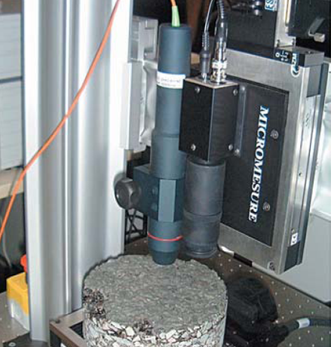 | 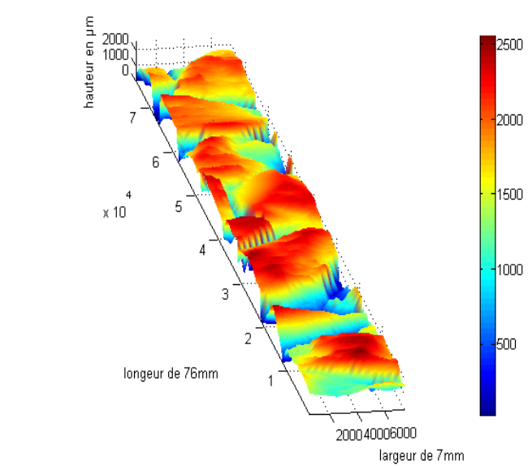
Figure 5 : Left: Profilometer, Right: Example of recorded topography
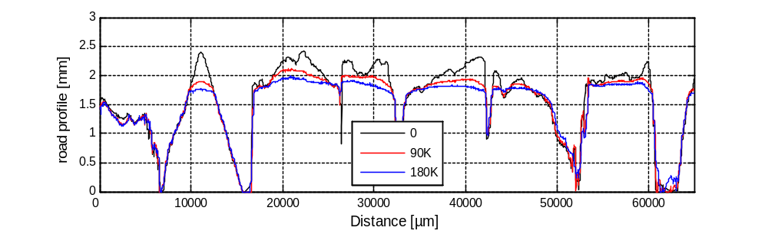
Figure 6 : Example showing how the profile evolves against polishing. These profiles are from one of the studied surface specimens (Limestone mosaic, see following sections) at different polishing stage (0 cycle: the top profile – black colored, 90000 cycles: the middle profile – red colored, 180000 cycles: the bottom profile – blue colored).

Specimens
Six types of aggregates characterized by their Polished Stone Value (PSV - see Table 1) were used in the study (Rhyolite, Splitite, Gabbro, Diorite, Leptynite and Limestone). For each aggregate type, two types of circular specimen with a diameter of 22.5 cm were prepared: a mosaic of aggregates and an asphalt mix.

Table 1: Aggregate characteristics
Type | Rhyolite | Spilite | Gabbro | Diorite | Leptynite | Limestone
PSV | 56 | 53 | 51 | 50 | 49 | 41

The mosaic specimens were prepared using the 7.2-10 mm aggregate size fraction. The mosaics were made by manually placing the aggregates in a single layer as closely as possible together in a mould., The flattest faces of the aggregates were orientate to lie on the bottom of a mould and then once complete the mould was filled with a resin [7, 8] ( - Right).
The asphalt specimens, were produced from asphalt concrete (AC 0/10) with STURELF® 11-40 bitumen. Table 2 displays the aggregate particle-size distribution. The asphalt was mixed and then compacted into 300 x 300 x 50 mm³ slabs using a laboratory roller compactor. Cores were then taken from the slabs ( - Left).

Table 2: Aggregate particle-size distribution

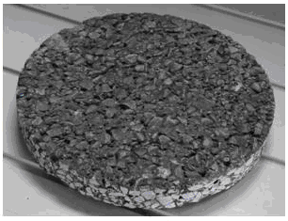  Asphalt |  | 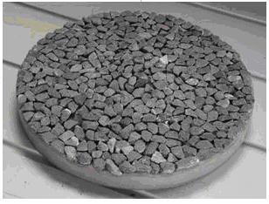  Mosaic
Figure 7 : Example of the specimens used in this study. Left – core extracted from an asphalt slab; Right - mosaics of aggregates.

Results
The scheme in the Figure 8 illustrates the different combinations of the sequences of polishing, friction measurement, texture characterization and model simulation applied to all the specimens of the undertaken study.

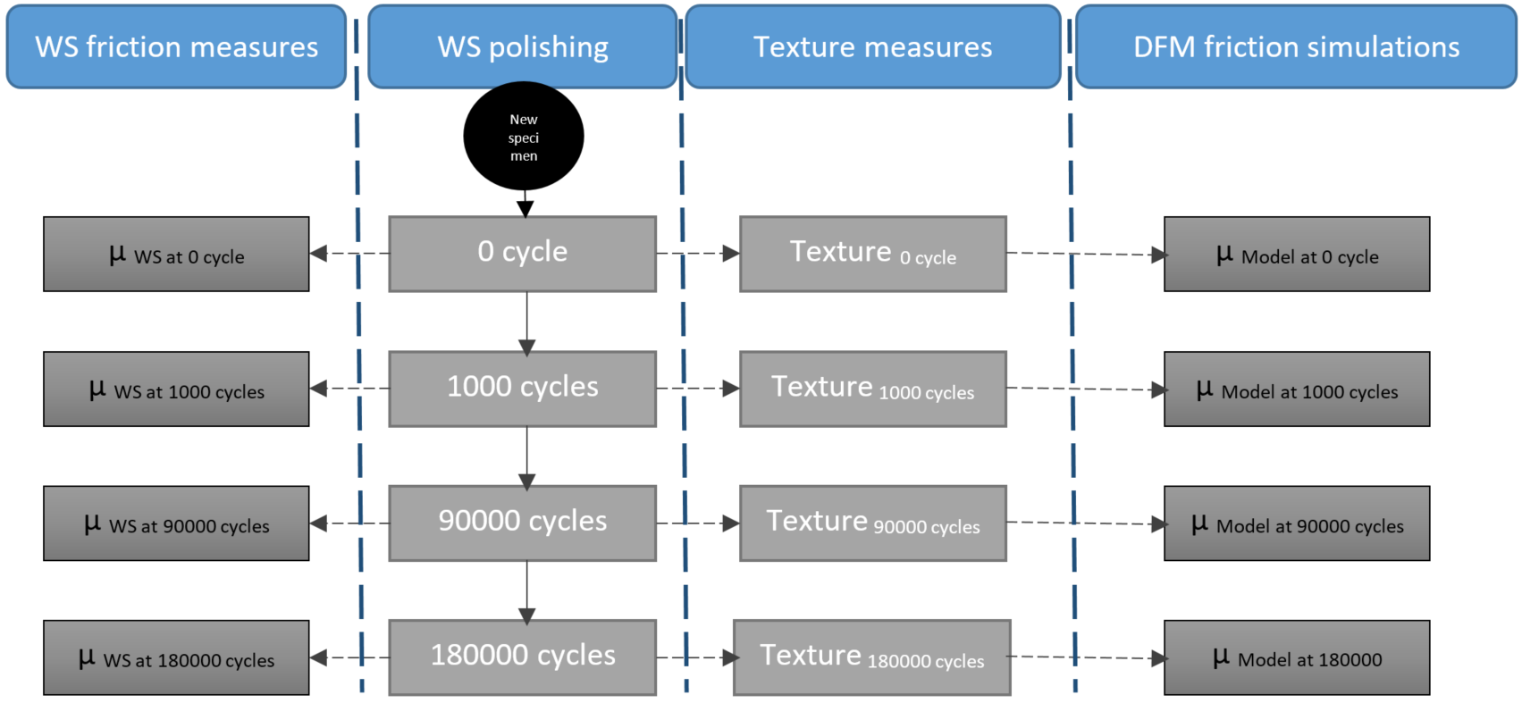
Figure 8: The different sequences of alternating polishing, friction measurement, texture characterization and model simulation applied to all the specimens.

For the input parameters of the model, N_{B} is taken equal to 7000 [Error: Reference source not found] and µ_{loc} is taken equal to 0.145. The speed V is 60 km/h which correspond to the speed at which the friction is recorded during the experiments. The table below displays the other input parameters for the simulations (Table 2).

Table 3: Other inputs parameters of the simulations
K | C | Dx | W | h | l | L | H_{in}
spring’s elastic modulus N/m³ | dashpot’s viscosity  N.s/m³ | Special scale of the calculations  Mm | applied load on the rubber  N | thickness of the rubber  mm | width of the rubber  mm | length of the rubber  mm | Water thickness  mm | Dynamic viscosity  Pa.s
2. 10⁸ | 10⁶ | 0.01 x 50 | 56 | 4 | 15 | 30 | 10⁻³ | 10⁻³

Figures 10 to 15 illustrate the experimental and model results for the asphalt and mosaic samples for each type of aggregate. The curves express the friction verses polishing results showing the evolution of the friction coefficient (vertical axis) against the number of polishing passes (horizontal axis) for both the model and the experiments. The pictures underneath are images of a small 1 cm² area of the surface of the specimens before and after polishing.

Rhyolite
Mosaic |  | Asphalt
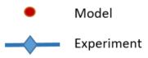  Friction coefficient |  | Friction coefficient
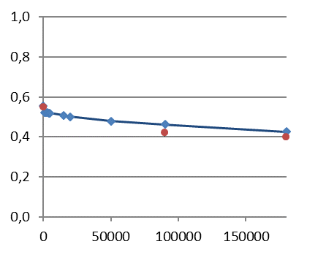  Number of polishing passes |  | 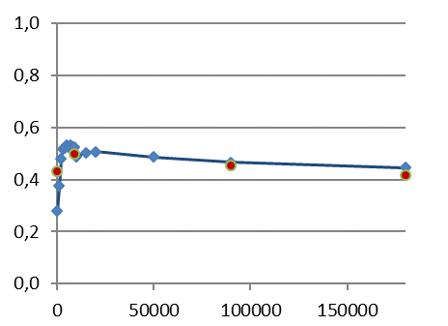  Number of polishing passes
Before polishing | After polishing | Before polishing | After polishing
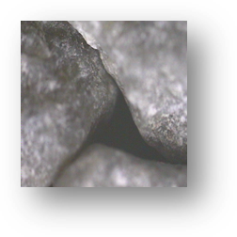  1 cm  1 cm | 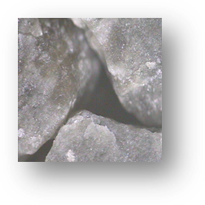  1 cm  1 cm | 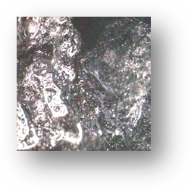  1 cm  1 cm | 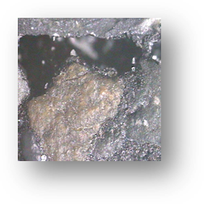  1 cm  1 cm

Figure 9 : Up - Friction against polishing. Comparison between experiments (dots with diamond shape and connected with lines – blue colored) and model (dots with round shape – red colored) of the two types of specimens (mosaic and asphalt) made with the Rhyolite aggregate. Down – photos of a small part (1 cm²) of the specimens (mosaic and asphalt) before and after polishing.

For the mosaic and asphalt sample made with the Rhyolite aggregates, the enhanced DFM model produces very comparable results with the experiments at all stages of polishing (except for the asphalt before polishing). This aggregate displays the highest PSV of the group and thus keeps the highest skid resistance of the aggregates studied in the long-term after polishing. The picture of the asphalt surface before polishing shows a surface completely covered by the bitumen binder film, this explains the low experimental skid resistance value, but this is overestimated by the model. Despite this, the introduction of the “weight factor” allows the model to reproduce well the increasing phase of the asphalt skid resistance which occurs during its early life. The experimental long-term skid resistances of the mosaic and asphalt are roughly equivalent and this is also well predicted by the model.

Split
Mosaic |  | Asphalt
Friction coefficient |  | Friction coefficient
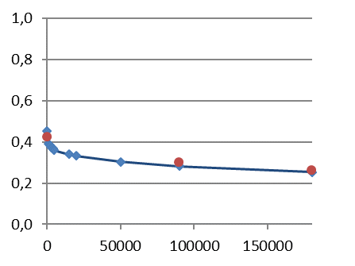  Number of polishing passes |  | 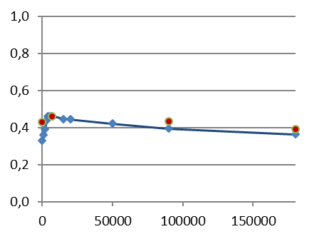  Number of polishing passes
Before polishing | After polishing | Before polishing | After polishing
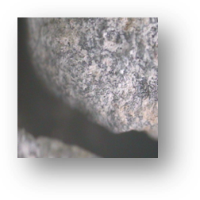 | 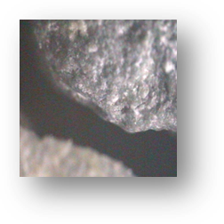 | 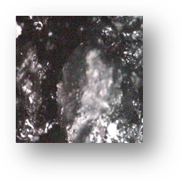 | 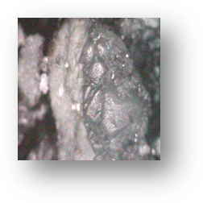

Figure 10 : Up - Friction against polishing. Comparison between experiments (dots with diamond shape and connected with lines – blue colored) and model (dots with round shape – red colored) of the two types of specimens (mosaic and asphalt) made with the Split aggregate. Down – photos of a small part (1 cm²) of the specimens (mosaic and asphalt) before and after polishing.

For the mosaic and asphalt sample made with the Split aggregates, the model produces very comparable results with the experiments at all cycles of polishing (except for the asphalt before polishing). The aggregate displays the second highest PSV of the group but does not keep the second highest value of skid resistance in the long-term after polishing for its mosaic specimen. The experimental long-term skid resistances of the mosaic and asphalt sample display different behaviors and this is well predict by the model. The introduction of the “weight factor” allows the model to reproduce well the increasing phase of the asphalt skid resistance which occurs during its early life.
Gabbro
Mosaic |  | Asphalt
Friction coefficient
Friction coefficient
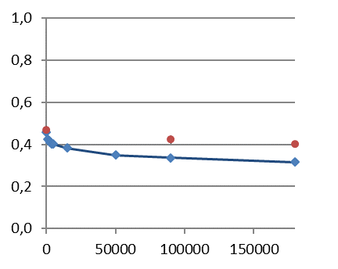  Number of polishing passes |  | 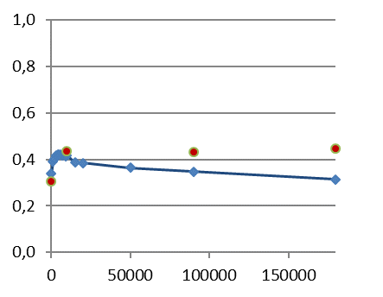  Number of polishing passes
Before polishing | After polishing | Before polishing | After polishing
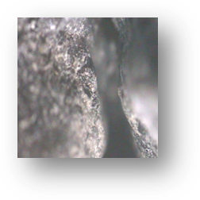 | 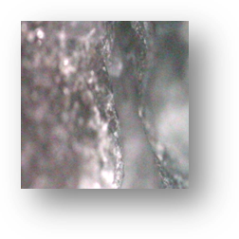 | 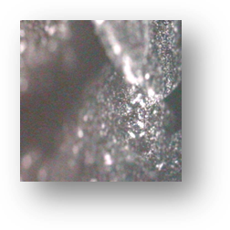 | 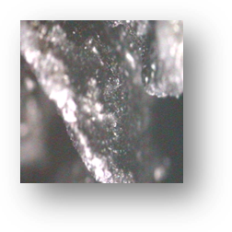

Figure 11 : Up - Friction against polishing. Comparison between experiments (dots with diamond shape and connected with lines – blue colored) and model (dots with round shape – red colored) of the two types of specimens (mosaic and asphalt) made with the Gabbro aggregate. Down – photos of a small part (1 cm²) of the specimens (mosaic and asphalt) before and after polishing.

For the mosaic and asphalt sample made with the Gabbro aggregates, the model overestimates the skid resistance systematically after the early life phase, even though the introduction of the “weigh factor” allows the model to reproduce the increasing phase of the asphalt skid resistance which occurs at a young age. Currently, at this stage of our knowledge, nothing allows us to explain the differences between the results of the model and the results arising from the experiments.

Diorite
Number of polishing passes
Friction coefficient
Mosaic |  | Asphalt
 |  | Friction coefficient
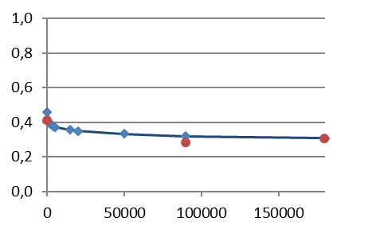  Number of polishing passes |  | 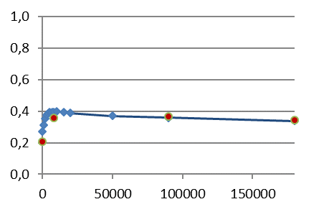  Number of polishing passes
Before polishing | After polishing | Before polishing | After polishing
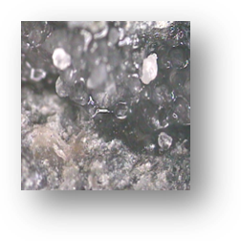 | 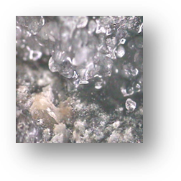 | 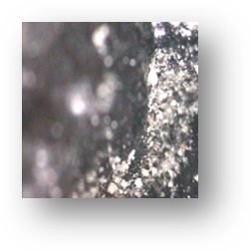 | 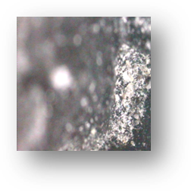

Figure 12 : Up - Up - Friction against polishing. Comparison between experiments (dots with diamond shape and connected with lines – blue colored) and model (dots with round shape – red colored) of the two types of specimens (mosaic and asphalt) made with the Diorite aggregate. Down – photos of a small part (1 cm²) of the specimens (mosaic and asphalt) before and after polishing.

For the mosaic and asphalt sample made with the Diorite aggregates, the model produces very comparable results with the experiments at all stages of polishing. The aggregate displays medium PSV in comparison with the rest of the group of aggregates tested and keeps a long-term skid resistance after polishing in accordance with its PSV. Furthermore, the introduction of the “weight factor” allows the model to reproduce well the increasing part of the asphalt skid resistance which occurs during its early life. The experimental long-term skid resistances of the mosaic and asphalt are roughly equivalent and are also well predict by the model.

Leptynite
Mosaic |  | Asphalt
Friction coefficient
Friction coefficient
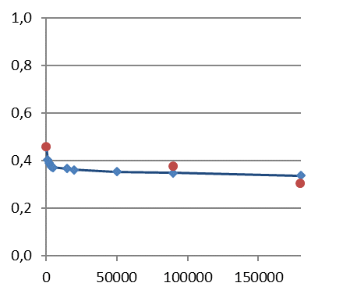  Number of polishing passes |  | 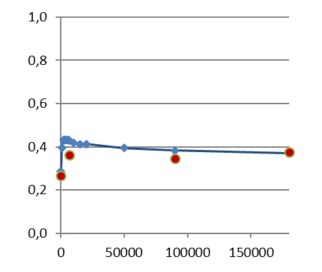  Number of polishing passes
Before polishing | After polishing | Before polishing | After polishing
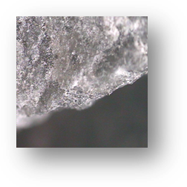 | 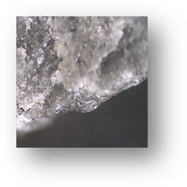 | 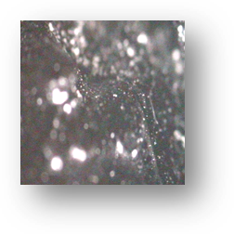 | 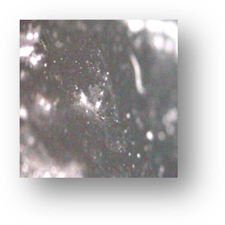

Figure 13 : Up - Up - Friction against polishing. Comparison between experiments (dots with diamond shape and connected with lines – blue colored) and model (dots with round shape – red colored) of the two types of specimens (mosaic and asphalt) made with the Leptynite aggregate. Down – photos of a small part (1 cm²) of the specimens (mosaic and asphalt) before and after polishing.

For both mosaic and asphalt sample made with the Leptynite aggregates, the model predicts very comparable results with the experiments at all cycles of polishing (except the second value of the asphalt). The aggregate displays medium PSV as the Diorite in comparison with the rest of the group, and maintains a long-term skid resistance after polishing in accordance with its PSV. Furthermore, like the other aggregates, the introduction of the “weight factor” allows the model to reproduce well the increasing part of the asphalt skid resistance which occurs at its early life. The experimental long-term skid resistances of the mosaic and asphalt are roughly equivalent and are also well predict by the model.

Limestone
Mosaic |  | Asphalt
 |  | Friction coefficient
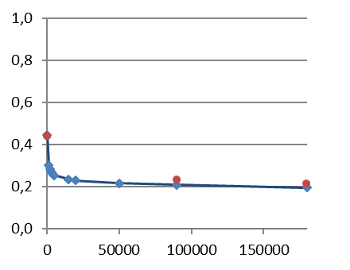  Number of polishing passes |  | 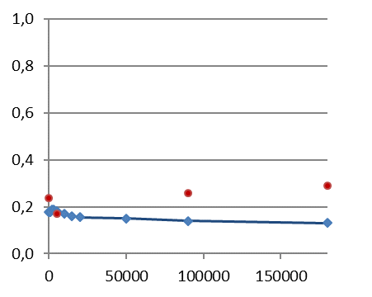  Number of polishing passes
Before polishing | After polishing | Before polishing | After polishing
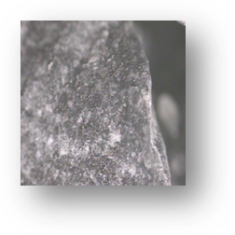 | 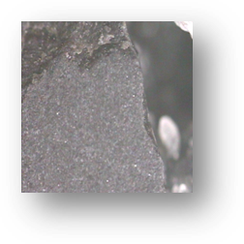 | 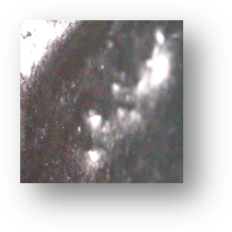 | 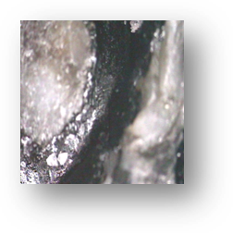
Friction coefficient
Figure 14 : Up - Friction against polishing. Comparison between experiments (dots with diamond shape and connected with lines – blue colored) and model (dots with round shape – red colored) of the two types of specimens (mosaic and asphalt) made with the Limestone aggregate. Down – photos of a small part (1 cm²) of the specimens (mosaic and asphalt) before and after polishing.

For the Limestone mosaic sample, the model reproduces well the skid resistance values at all polishing stages. However, for the Limestone asphalt sample, the model often overestimates the skid resistance. Even the introduction of the “weight factor” does not enable the enhanced DFM to reproduce the phase of increasing the skid resistance for the asphalt which occurs during its early life. The poor predictions of the model for the Limestone asphalt at 90 000 and 180 000 cycles are must probably be explained by the presence of bitumen on the surfaces even after the polishing process (refer to pictures of the sample reproduced as part of Figure 15). Indeed, the model uses the characterized texture profiles capture during polishing to calculate the friction; this texture considered as rigid by the model, is not rigid in reality because of the present bitumen. A means to correct this may be changing the value of N_{B} for the aggregate and/or bitumen types that determines when the bitumen is totally stripped from the surface.

Discussion
Whatever the types of aggregate and specimen (whether mosaic or asphalt) the enhanced DFM model predicts very comparable results with those obtain experimentally from the Wehner Schultz machine at all cycles of polishing; except for the Gabbro mosaic and asphalt sample and Limestone asphalt sample.
For the mosaics samples, whatever the type of aggregate, the evolution of friction against the number of polishing cycles shows a continuous decrease for the experimental results, more or less pronounced depending to the type of aggregate. This decrease is well reproduced by the model. This is in perfect line with the pictures of mosaics that display smoother surfaces after polishing (See figure 15, the pics of the Limestone moisac). This behaviour is also confirmed by the smooth of the profiles after polishing (See Figure 6, showing the Limestone mosaic profiles at different stage of polishing).
For asphalts, whatever the type of aggregate, the model once again reproduces very well the experimental results except the Limestone and Gabbro (asphalts) at 90 000 and 180 000 cycles. The introduction of the “weight factor” allows the model to take into account the presence of bitumen on the surfaces at young age. The low value of friction for asphalts at young age is confirmed by the pictures before polishing where surfaces totally covered by bitumen are displayed (Rhyolite and Split asphalts – Figures 10 and 11).
The mediocre predictions of the model for the Limestone and Gabbro asphalts at 90 000 and 180 000 cycles may probably be explained by the presence of bitumen on the surfaces even after the polishing process. Indeed, the model uses the recorded profiles to calculate the friction; this texture considered as rigid is not in reality because of the present bitumen. A means to correct this may be changing the value of N_{B} relative to the aggregate and/or bitumen types that determines when (at what polishing stage) the bitumen is totally scoured from the surface.
At this stage, it would be interesting to combine this modified DFM with the texture evolution model quoted in the introduction [9]. The combination of these two models will enable the prediction of how this skid resistance of the asphalt surfaces will evolve in time according to the traffic loading. One of the possible applications would be the design of new artificial materials for pavement wearing courses according to the future traffic loading with allowing complete control of the future evolution of their skid resistance.

Conclusion
This work investigated the possibility to predict the whole-life cycle skid resistance of asphalt surfacing. To take into account the masking of the aggregate microtexture by a film of bitumen during the early life of an asphalt pavement, a “weight factor” is introduced to the Dynamic Friction Model. To validate the new configuration of the model, mosaics and asphalts sample were prepared with different aggregates and submitted to polishing by a Wehner Schultze machine. The friction and the texture of each specimen was measured at different stage of polishing. The fiction coefficients have been calculated with the enhanced DFM model and compared to the experimental friction measurements:
- Whatever the type of specimen whether mosaic or asphalt, the model predicts generally very comparable results with the experimentally obtained data at all cycles of polishing.
- For mosaics, whatever the type of aggregates, the evolution of friction against the number of polishing cycles show a continuous decrease for the experimental results, which is more or less pronounced depending to the type of aggregate. This decrease is also well reproduced by the enhance DFM model.
- For asphalts samples, whatever the type of aggregates, the model once again reproduces very well the experimental results. The introduction of the “Weight Factor” allows the enhanced DFM model to take into account the presence of bitumen on the surfaces of aggregates of the asphalt samples which occurs during the early phase of its life .
- The mediocre predictions of the enhanced DFM model for the Limestone and Gabbro asphalts at 90 000 and 180 000 cycles may most probably be explained by the presence of bitumen on the aggregate surfaces even after the polishing process.
- A way to further enhance the model would be to combine it with the model developed to predict the texture evolution model by ? [?]. This combination will allow enable how the skid resistance of asphalt surfacing will evolve over time according to the future traffic levels to be more precisely predicted.
- One of possible applications for this further enhanced and refined model, would be to support the design of the surface texture of new artificial materials for road pavements for a desired given traffic volume, enabling control of the future evolution of skid resistance.

References
1. Malal Kane; Minh-Tan Do; Veronique Cerezo; et al., Contribution to pavement friction modelling: an introduction of the wetting effect, International Journal of Pavement Engineering, Pages: 1-12, 2017, DOI: 10.1080/10298436.2017.1369776
2. Kane M. and Cerezo V., Sep 2015. A contribution to tire/road friction modelling: from a simplified dynamic frictional contact model to a ‘dynamic friction tester’ model Wear 342. 163–171. DOI: 10.1016/j.wear.2015.08.007
3. Kane, M., Rado, Z., and Timmons, A., 2014. Exploring the texture–friction relationship: from texture empirical decomposition to pavement friction. International Journal of Pavement Engineering, 16(10), 919–928. doi:10.1080/10298436.2014.9729567
4. Sabey, B.E., 1958. Pressure distribution beneath spherical and conical shapes pressed into a rubber plane and their bearing on coefficients of friction under wet conditions. Proceedings of the Physical Society, 71, 979–988.10.1088/0370-1328/71/6/311
5. Savkoor, A.R., 1990. Tribology of tyre traction on dry and wet roads. Proceedings of 17th Leeds – Lyon Symposiumon Tribology, 213–228.
6. Kane, M., Artamendi, I., Scarpas, T., Long-term skid resistance of asphalt surfacings: Correlation between Wehner–Schulze friction values and the mineralogical composition of the aggregates, Volume 303, Issues 1–2, 15 June 2013, Pages 235-243, wear.2013.03.022
7. M.-T. Do, Z. Tang, M. Kane, F. de Larrard, Pavement polishing—Development of a dedicated laboratory test and its correlation with road results, Wear, 263 (1–6) (2007), pp. 36-42
8. Do, M.-T., Tang, Z., and Kane, M., 2009. Evolution of road-surface skid-resistance and texture due to polishing. WEAR, 266(5–6), 574–577. (doi:10.1016/j.wear.2008.04.060)
9. Kane, M., Piau, J. M., and Do, M. T., 2008. Modeling of the road surface polishing based on contact-mechanics approach. Road Materials and Pavement Design, 9, 305–318. (doi:10.1080/14680629.2008.9690171)
10. Kane, M., Zhao, D., De-Larrard, F., and Do, M. T., 2012. Laboratory evaluation of aggregate polishing as a function of load and velocity. Application to the prediction of damages on skid resistance of road surfaces due to trucks and passenger cars. Road Materials and Pavement Design, 13(2), 312–326. (doi:10.1080/14680629.2011.649424)
11. Kane, M., Zhao, D., Do, M. T., Chailleux, E., and Delarrard, F., 2010. Exploring the ageing effect of binder on skid resistance evolution of asphalt pavement. Road Materials and Pavement Design, 11(Special Issues), 543–557. (doi:10.1080/14680629.2010.9690346)
12. Tourenq, C., and Fourmaintraux, D., 1971. Propriétés des granulats et glissance routières. Bulletin de Liaison des Laboratoires des Ponts et Chaussées, 51, 61–69
13. Nitta, N., Saito, K., and Isozaki, S., 1990. Evaluation the polishing properties of aggregates a bituminous pavement surface by means of the Penn state reciprocating polishing machine. In Meyer, W. E., and Reichert, J. (Eds.) , Surface characteristics of roadways: International research and technologies. Philadelphia, PA: ASTM. ASTM STP 1031
14. Woodward W.D.H, Woodside A.R; Jellie J.H, Predicting the early life skid resistance of asphalt surfacings, 6th RILEM Symposium PTEBM’03, Zurich, 2003
15. Woodward W.D.H, Woodside A.R; Jellie J.H, Early and mid-life SMA skid resistance. Internationa Surface Friction Conference, Christchurch, New Zealand, 1-4 May 2005
16. P. G. Roe, R. Lagarde-Forest, The early life skid resistance of asphalt surfaces, Published project report PPR060, copyright TRL Limites, august 2005, 46 pages
15. Malal Kane ,Dan Zhao,François De-Larrard &Minh-Tan Do, Laboratory evaluation of aggregate polishing as a function of load and velocity. Application to the prediction of damages on skid resistance of road surfaces due to trucks and passenger cars, Road Materials and Pavement Design, Volume 13, 2012 - Issue 2, Pages 312-326

The Polished Stone Value of aggregate gives a measure of resistance to the polishing action of vehicle tyres under conditions similar to those occurring on the surface of a road. It is measured using a standardised test (BS EN 13043: Aggregates for bituminous mixtures and surface treatments).
The Styrelf® binder are modified bitumens with elastomeric polymers according to a crosslinking process – From EUROVIA

