Reducing Information to Stimulate Design Imagination

Name of Author

Affiliation

This paper describes an experiment that is part of a larger research project that compares the visual reasoning between groups of designers and non-designers. In particular, this experiment focuses on how designers’ processes of reasoning is characterized when they are given different levels of reduced information of an object in comparison to a group of non-designers. The experiment used deconstructed and scaled-down components of Gerrit Riedveld’s iconic Red and Blue Chair (1918). Three groups were given 3 different levels of information - group 1 were given components painted the same color as the original chair, group 2 were given components painted in a single (white) color, and group 3 were given unpainted (natural) components. The results suggest that the 3 levels of reduced information impacted on the designers’ reasoning processes and there were clear differences in the visual reasoning processes between design and non-design participants.

1. Introduction

Human cognition is capable of generating a complete image of an object even if some visual elements are missing as long as visual clues are given. For example, Biederman’s theory of “recognition-by-components” suggests that our perception can construct mental imagery of an object from incomplete depiction by identifying the combination of simple geometric features in the image [1]. We can perceive meaningful objects from meaningless low-level features of information through forming patterns in our cognition [2]. Evidence also shows that even if only very small parts of an object are visible, our cognition can infer the category of it by identifying its semantic attribution [3]. We inherently have the ability to address incomplete visual information in order to construct a meaningful object in our imagination through reasoning.

For designers, dealing with incomplete visual information is commonplace and important for their design reasoning. In particular, during the early phases of the design process where they explore and conceptualize ideas, designers make good use of unclear and indeterminate information as clues for evolving their design ideas. Through reflective conversations with the ideas externalized on paper [4, 5], designers discover unexpected meanings within relationships among depicted elements [6, 7] when generating ideas [8]. Designers also detect unintended relationships and features even from sketches depicted for different purposes [9]. Goel asserted that the ambiguous nature of visual information produced during the early stages of design is not inferior but rather plays a very important role for a designer’s cognitive process. The ambiguity in a designer’s concept drawing can facilitate transformations of ideas [10]. The ambiguous nature of these indeterminate sketches facilitates a designer’s multiple interpretations and helps to develop their design alternatives [11]. Additionally, those tentative depictions that are often produced quickly and cheaply [12] are reinterpreted in order to transform, develop and generate new ideas [13]. Further, this ambiguity significantly supports the exploration of a wide variety of innovations and increases the number of ideas for designers [14]. Thus, it is important for designers to be open to the incomplete state of their externalized images; accuracy and scale are not needed during the explorative stage [15]. The incomplete features of the pictorial representations produced at the early stage of design are the key factor for designers’ reasoning and idea exploration.

Other than the designers’ self-created depiction, uncertainty of visual information presented externally can potentially facilitate their design reasoning. Designers are able to find semantic meanings and develop diverse designs even from meaningless geometric forms as well. Butter’s experiment, in Klaus Krippendorff’s book “The Semantic Turn” demonstrates that a great number of different electronic products could be designed by combining a set of meaningless geometrical blocks [16]. The participants in Butter’s experiment interpreted different meanings of the parts of simplified blocks in the context of each other and constructed meaningful products. This result implies that designers are capable of carrying out design reasoning from ambiguous shapes imagining and manipulating the contexts around them.

There have been many investigations that focus on the role of internal and external representation at the conceptual stage of the design processes [e.g. 4, 5, 6, 7, 8, 9, 10]. However, little research has been done to investigate how reduced information externally presented as input impacts on design reasoning for designers. This paper explores the potential impacts of how reduced information can prompt an individual’s creative reasoning and compares design and non-design participants’ responses.

2. Aim

The aim of the experiment reported here is to observe the impact of reduced information on a group of designers’ visual reasoning, and how this might differ from other individuals that have different prior knowledge and experiences. This experiment was designed based on the finding of the authors’ previous study [17] described in the next section.

2.1 Previous Experiment

The authors’ earlier study observed the process of visual reasoning of industrial design students when they are given images of an object whose descriptive information has been reduced [17]. The aim of this experiment was to identify what kinds of elements the design students rely on as clues for their visual reasoning within a range of different reduced images. An image of a simple chair was altered in 17 different ways (e.g. dismantled, dotted, exploded, and vandalized) and one given to each of the 17 participants in the study (Figure 1).

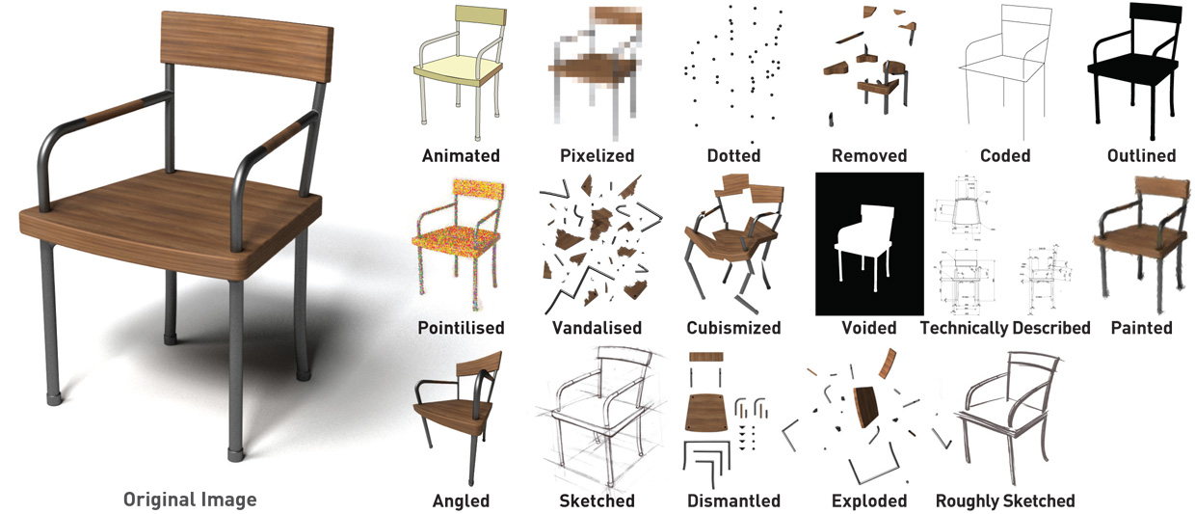

**Fig1.** The image prompts used for the previous experiment

Each participant was then asked to visualize the original object. They were also asked to draw a sketch and make a model of their imagined objects based on the altered (reduced) image. The experiment revealed that the design students focused mainly on the “material” and “compositional” aspects of an object as an important clue when they built the image. Additionally, the authors also found that these aspects are significantly supported by prior knowledge. Different types of prior knowledge such as associations between particular colors and materials, material processing, structural knowledge of objects, or identifying the semantic property of components suggested a hint for the participants to infer the materiality and compositional arrangement of the object they visualized.

2.2 Research Questions

Based on the finding of the previous experiment, the authors conducted a second experiment that focused on the reduction of “material” and “compositional” information. In particular, the authors focused on the fact that color information can affect the imagination of materiality of an object. In this second experiment, the authors focus on 2 main questions:

* How are the reasoning processes of design students affected when they are given different levels of “color” and reduced “composition” information?
* How do different kinds of prior knowledge affect the participants’ visual reasoning when dealing with reduced levels of information?

3. Methodology

The experiment described here used a one-tenth scale-model of Gerrit Rietveld’s famous Red and Blue Chair designed in 1918 (Figure 2). This chair consists of 2 standard flat panels (seat and backrest), 2 armrests, and 13 slats joined in the simplest possible way painted in red, blue, yellow, and black. All the geometric components ensure that no part dominates or is subordinate to the others [18]. The authors used this object because of its neutrality in form of the components that allows the participants to interpret in diverse ways.

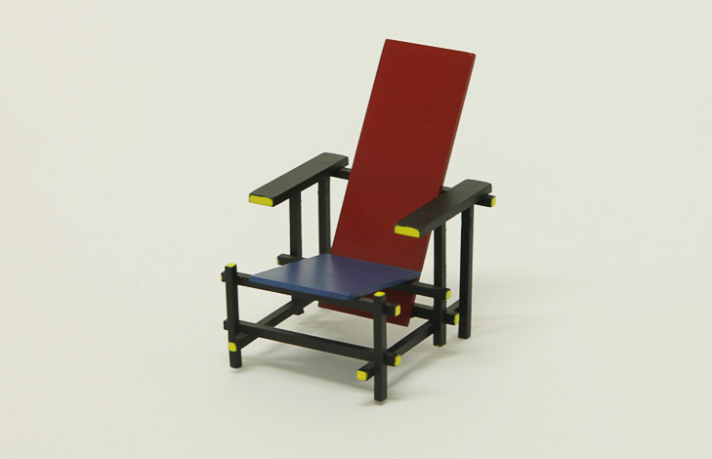

**Fig2.** Red and Blue Chair designed by Gerrit Rietveld (1918)

3.1 Experiment Components

In order to reduce the compositional information of the object, the components were arranged in order of size. In addition, the material information was reduced with 3 different types of color-coding (Figure 3). In the authors’ previous experiment, it was found that color information was one of the factors that prompted the materiality of the object. Thus, one set of chair components were prepared in the same colors (red, blue, yellow and black) as Rietveld’s original Red and Blue Chair, one set were painted in white (obscuring material information) and, a final set of components were left in their natural color (indicating its materiality).

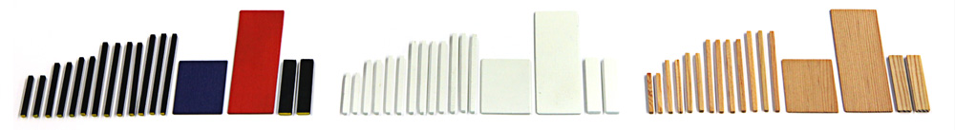

**Fig3.** 3 chair components sets (left to right: original colors, white color, natural color)

The components painted in the original Rietveld colors suggest some material information to the participants whereas the components painted in white give less material information to them. The focus here is on observing the impact of reduced levels of color information. The experiment sets out to detect how the difference in color across the 3 sets of components affects the participants’ imagination of an object (including the material aspects). Additionally, the experiment sets out to observe how the process of visual reasoning based on the components that explicitly indicate its materiality differs from the other two painted sets.

3.2 Participants

In this experiment, 36 voluntary participants of Northumbria University were involved. 18 fourth year Industrial Design students from the School of Design and 18 third year non-design students from Newcastle Business School. The design student participants were regarded as having knowledge and experiences of industrial design as they were in the final year of their degree whereas none of the non-design participants had any knowledge or experience in design.

The 18 design students were divided into 3 groups comprised of 6 participants each. The other 18 non-design students were also divided into 3 groups of 6 participants. Each group was given one set of chair components. Then, each group was asked to complete the task of making a 3D model of their visualized object.

3.3 Procedure

The experiment was conducted individually in a quiet and closed room. Each participant completed their task following the instructions provided. During the process of model-making the participants were not interrupted by the instructor (first author) so that it allowed them to concentrate on their thinking and making. After the completion of the model making exercise the instructor interviewed the participants. The detailed procedure is as follows:

1. The deconstructed materials were provided.

2. The instructor informed the participant that the materials are scaled-down components of an object.

3. The participant was asked to visualize the object, and then to create a model of it using all the given materials. They were allowed to take as much time as they wanted to complete the task. Different types of glues were provided for constructing materials as well as a notepad and pens for sketching.

4. The participant was interviewed after the completion of the model-making exercise.

3.4 Semi-structured Interviews

Semi-structured interviews were conducted after the completion of model-making. The focus was on understanding the participants’ visual reasoning processes and the outcomes. The participants were asked to respond to the following prompts:

1. Please describe the object you created.

2. Please describe the way this object would be used.

3. Where did your idea come from?

4. What were the important clues that helped you to imagine the object?

5. What materials is the object made from?

6. Please specify the number of ideas that you came up with.

After being asked these questions, the interviewer unveiled the complete scaled-down model of the Red and Blue Chair to the participants. Then, the participants were also asked to describe the difference between the object they created and the original chair.

3.5 Data Collection and Analysis

In the experiment, 2 types of data were collected: (i) 3D scale models that represent the participants’ final idea, and (ii) the contents of the interviews that describe their processes of reasoning. The interviews were recorded by a sound-recording device, and later transcribed for analysis.

The analysis covered both the 3D outcome and reasoning processes. The photographed images of the 3D outcomes allowed us to analyze the variation in the participants’ model visually. By comparing the differences and similarities in the outcomes, the authors were able to interpret the impact of the different reductive levels of information of the participants’ final ideas. Additionally, the visual nature of the outcomes describes specific features of each participant’s idea even if some of the created objects are in the same category. At the same time, focusing on the process of the participants’ reasoning is important to reveal how they evolved their ideas and to identify the elements they considered as meaningful clues. Dealing with these aspects together allowed the data to be compared and constructed to derive the findings.

The analysis of the contents of the interviews was carried out focusing on the result of the design participants first. Afterwards, the contents of the non-design participants were analyzed based on the same focus. Fundamentally, the aim of this experiment was to investigate how the reduced information impacts particularly on the designers’ reasoning and how their specific characteristics differ from the non-designers. Therefore, the same categories that emerged within the group of design participants were used as a basic framework for the coding process of the non-designers’ transcripts. The written data of the design participants were analyzed using a general inductive approach [19] in order to capture the similarities and differences of the participants’ thinking processes. Next, the non-designers’ transcripts were searched and coded using the same focus as the design students. Details of the coding procedure is as follows:

1. All the transcribed raw data were read through until certain categories emerged within the contents of the design participants’ interviews.

2. The categories identified in step 1 were revised and refined in order to find the common themes that can be applied across the groups.

3. The contents of the design participants’ transcripts were reviewed over and over again and data re-collected through the refined categories until the authors gained a thorough understanding.

4. The design participants’ transcripts were categorized in different color-coding groups.

5. The category system used for the design participants was then applied to the contents of the non-design participants to collect relevant data.

6. The gathered contents based on the same category system were compared between the design and the non-design participants.

Comparing the 2 groups, using the same coding system, allowed the authors to identify whether the design participants’ reasoning was unique to design participants or if their reasoning was generic. This process also revealed the influences of the design participant’s prior-knowledge.

4. Results

The results appear to suggest that there are both differences and similarities between design and non-design participants in the outcomes and in their reasoning processes.

4.2 Outcomes

All the images and the names of objects stated by the participants are provided below (see Figure 4 and Table 1 and Table 2). The result of the outcomes shows the clear distinction between the design and the non-design participants.

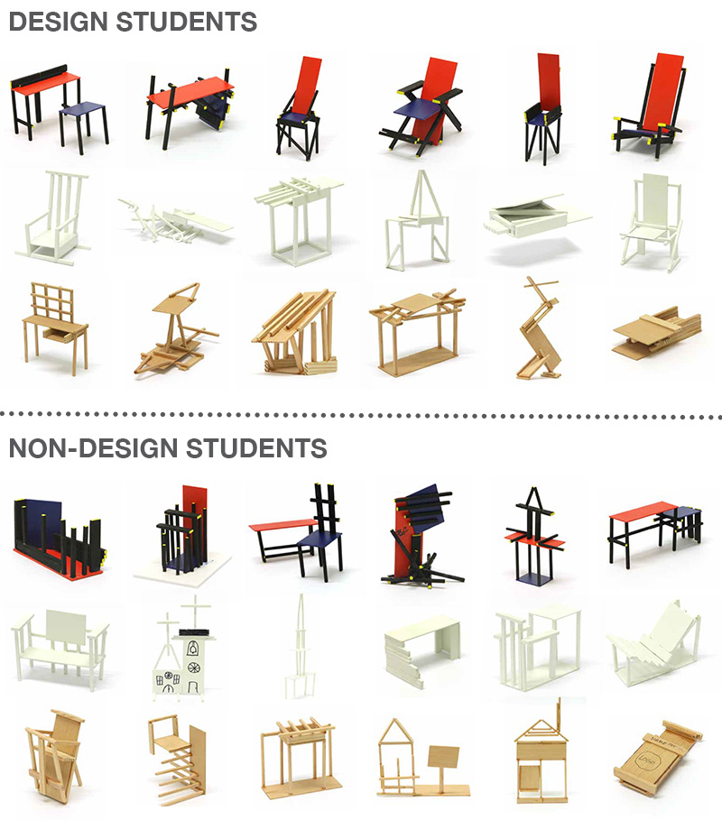

**Fig4.** Design student and Non Design student outcomes

The results from the design student participants appear to indicate that the types of the outcomes became more diverse when the multiple colors are reduced to a single white color. The types of outcome in the group of natural color were the richest in variety. In the group of the original 4 colors (top row), 4 out of 6 participants (67%) created a chair. When the painted color-pattern is reduced to 1 color, 2 out of 6 participants (33%) made chairs - a throne and a medieval looking chair. Further, in the result of the group of natural color, none of them (0%) made chairs (see Table 1). The participants who made an object that could be described as “furniture” were 6 (100%) in the group of 4 colors, 4 (67%) in the 1 color and 0 in the natural color (the miniature desk is regarded as a category of toy rather than furniture). The intended scale of visualized objects became more diverse in accordance with the decrease of the painted colors. In the group of 4 colors, the intended scales of outcomes were all in furniture-sized. In the group of 1 color, the assumed sizes of outcomes became more diverse. This tendency was even more explicit in the natural color group as they stated the objects from a miniature desk to a large opera house. These results appear to indicate that as the reductive level of color-coding information increases the types of outcomes become more diverse.

**Table 1** The name of the objects stated by the **design** participants

|  |  |  |  |  |  |  |
| --- | --- | --- | --- | --- | --- | --- |
| **Participant** | **D1** | **D2** | **D3** | **D4** | **D5** | **D6** |
| **Original colors** | School desk & stool | Table with bookshelf | Chair | Chair | Chair | Chair |
| **Participant** | **D7** | **D8** | **D9** | **D10** | **D11** | **D12** |
| **White**  **color** | Throne to be carried | Journey of my thought process (sculpture) | Architectural sculpture / building / pavilion | Table with sextant for a star finding device | Piano | Medieval looking chair |
| **Participant** | **D13** | **D14** | **D15** | **D16** | **D17** | **D18** |
| **Natural**  **color** | Miniature desk | Boat / raft | Large opera house | Canopy | Rabbit / weathervane | Switch for workshop |

On the other hand, the result of the outcomes of the non-design participants shows no significant characteristics among the color-coding groups. The types of outcomes were varied regardless of the reductive levels of painted color. The participants who made a chair as outcome were only 1 (17%) in the group of 4 colors, 2 (33%) in the 1 color, and 1 (17%) in the natural color. The non-design participants who made furniture related objects were 1 (17%) in the 4 colors, 3 (50%) in the 1 color, and 1 (17%) in the natural color. Additionally, the scales of imagined objects do not seem to be affected by the amount of the painted-color information provided (Table 2). Thus, the result of the outcomes in the non-design participant groups seems to be relatively random compared to the one of the design participants. In other words, the different information of painted color has only affected the final ideas of the design participants.

**Table 2** The name of the objects stated by the **non-design** participants

|  |  |  |  |  |  |  |
| --- | --- | --- | --- | --- | --- | --- |
| **Participant** | **ND1** | **ND2** | **ND3** | **ND4** | **ND5** | **ND6** |
| **Original colors** | Zoo cage | Entrance of restaurant | Chair & little table | Symbol | Temple | Terrace |
| **Participant** | **ND7** | **ND8** | **ND9** | **ND10** | **ND11** | **ND12** |
| **White**  **color** | Little bench | Big white church | Monument | Table | Creative house | Reclining deck chair |
| **Participant** | **ND13** | **ND14** | **ND15** | **ND16** | **ND17** | **ND18** |
| **Natural**  **color** | Royal chair / baby chair | Stair / portion of a big room | Brandenburger Tor | Entrance of café | House with chimney | Key holder storage device |

4.3 Processes of reasoning

The analysis of the processes of the participants’ visual reasoning was conducted based on the content of the interviews. The total number of categories that emerged in the group of the design participants was 26. Further, these categories were subsequently used to collect data in the group of the non-design participants to compare the differences. These 4 features were identified as prominent characteristics (described in following sections of the paper):

* Thinking approach for making
* Reference objects
* Assumed materials other than wood
* Key elements as clue

## Thinking approach for making

The patterns of the participants’ thinking approach were revealed through the analysis. The authors focused on how the different levels of color information affected the participants’ thinking approach for the visualization of their ideas. The result shows that the approaches that the participants took can be divided into 2 ways: (i) top-down (image driven) and (ii) bottom-up (thinking by making). The top-down process commonly known as theory-driven or conceptually-driven processing [20] is the way to perceive an object depending on our prior knowledge. On the other hand, the bottom-up process is the way to form complex visual-patterns in meaningless features and then to construct a meaningful image of an object [2]. In this experiment, the approach where a participant started making an object based on his/her visualized idea was regarded as top-down. The approach where a participant started building the components to think without clear ideas was regarded as bottom-up.

The results appear to indicate that the thinking approaches of both design and non-design participants were fairly similar (Figure 5). The participants had a tendency to take a top-down approach for reasoning when they were given a certain color-coding with 4 colors: 4 participants (67%) in both the design and non-design students. The participants who were given the components of both 1 color and unpaid color took bottom-up approaches: 4 design participants (67%) and 5 non-design students (83%) in the 1 color, and 4 participants (67%) for both students in the natural color.

Macintosh HD:Users:inoue_shiro1:Desktop:PhD:_ Rsearch Project:_Conference:2016:DCC 2016:_Draf:UsedImages:thinking_approach_3.pdf

**Fig5.** Thinking approaches of the Design and Non-Design participants

The colors used in Rietveld’s chair are very iconic and well known in a design context. Therefore, it is assumable that the original colors informed the design participants about the original chair’s design so that they made a model using their design-knowledge. At the same time, although none of the non-design participants knew the original chair, the original colors still suggested concepts of an object as well. On contrary, when the painted color is reduced to white or when the material is natural colored, the components challenged the participants to visualize their ideas.

## Reference objects

The participants referred to existing objects as a source of reference in their reasoning. In the groups of design participants, the results show that the more information of color-coding given, the more participants referred to the classic chair as a clue for their reasoning (Table 3). In the 4 painted colors group, 5 out of 6 participants (83%) associated with classic design chairs such as the original Red and Blue Chair or the Charles Rennie Mackintosh Chair. In the 1 color group, 2 participants (33%) associated with classic design chairs. Just 1 participant (17%) referred to a classic chair in the group of natural color. This result suggests the types of objects that the design participants referred to can be more diverse when the painted color is reduced to a single white color. The components that indicate wooden material informed the participants about existing objects the least in the group of design participants.

**Table 3** The reference objects used by the **design** participants

|  |  |  |  |  |  |  |
| --- | --- | --- | --- | --- | --- | --- |
| **Participant** | **D1** | **D2** | **D3** | **D4** | **D5** | **D6** |
| **Original colors** | Stool & desk in science lab | Red & Blue Chair | Red & Blue Chair | Red & Blue Chair | Charles Rennie Mackintosh Chair | Red & Blue Chair |
| **Participant** | **D7** | **D8** | **D9** | **D10** | **D11** | **D12** |
| **White**  **color** | Ancient pope mobile, chairs with decoration on the back & chairs for bride | N/A | Richard Serra’s sculpture | Eileen Gray’s table, Lego, Tamiya models & Red & Blue Chair | Matchbox, biplane & grand piano | Platform for mountain bike, Red & Blue Chair & wheelbarrow |
| **Participant** | **D13** | **D14** | **D15** | **D16** | **D17** | **D18** |
| **Natural**  **color** | N/A | Sail of a ship & boat | N/A | N/A | Wing of plane & Charles Rennie Mackintosh chairs | N/A |

On the other hand, not one participant mentioned Rietveld’s iconic chair in the non-design participants groups (Table 4). Other than the design classic chairs, however, the non-design participants referred to existing objects in the 1 color group the most. The results appear to show that the particular colors used in Rietveld’s chair did not prompt their association with this object. Additionally, the components that indicate the materiality of wood (natural color) informed them less about existing objects when compared with the results of the group of 1 color.

**Table 4** The reference objects used by the **non-design** participants

|  |  |  |  |  |  |  |
| --- | --- | --- | --- | --- | --- | --- |
| **Participant** | **ND1** | **ND2** | **ND3** | **ND4** | **ND5** | **ND6** |
| **Original colors** | N/A | N/A | N/A | N/A | Japanese temple | N/A |
| **Participant** | **ND7** | **ND8** | **ND9** | **ND10** | **ND11** | **ND12** |
| **White color** | American trophy | Spanish & Philippine churches | Vietnamese ancient building | N/A | N/A | Framework of aeroplane, house & phone |
| **Participant** | **ND13** | **ND14** | **ND15** | **ND16** | **ND17** | **ND18** |
| **Natural color** | N/A | N/A | Old German style house | N/A | Typical house in Vietnam | N/A |

These results imply that the red, yellow, and blue colors of the components prompted the prior knowledge of the design participants. However, when the painted colors are reduced to 1 or removed, the design participants referenced random objects other than classic chairs. This feature could not be seen in the group of non-design participants. As for the types of objects that the participants referenced, both design and non-design associated with them in a variety of ways only when the painted color is reduced to a single white color.

## Assumed materials other than wood

In the result of design participants, the group that mostly prompted their association of different materials other than wood was the 1 painted color (Table 5). 3 out of 6 participants (50%) stated different materials other than wood in the 4 painted-color group. When the painted color was reduced to 1 color, 5 participants (83%) referred to different materials other than wood. In the group of natural color, again, 3 participants (50%) mentioned different materials. This result suggests that when the color is reduced to a single white color, the participants imagined more material choices. In the group of natural color that indicates its materiality, half of them still stated different materials other than wood. Actually, in the natural color group, 4 participants (67%) stated that the wood material informed their reasoning. However, 5 of them (83%) explained that they attempted to avoid making an object that can be easily assumed. This result implies that the components that explicitly state its material property of wood afford some ideas about possible objects to the many participants in the group of natural color. At the same time, however, that circumstance also discouraged them to take those easy options on their decisions.

**Table 5**The assumed materials stated by the **design** participants

|  |  |  |  |  |  |  |
| --- | --- | --- | --- | --- | --- | --- |
| **Participant** | **D1** | **D2** | **D3** | **D4** | **D5** | **D6** |
| **Original colors** | Plywood / MDF & **metal piping** | **Acrylic / plastic /ABS** | **Aluminum tubes** / wood & **aluminum** & wood / **plastic** | Pinewood | Hardwood | Wood |
| **Participant** | **D7** | **D8** | **D9** | **D10** | **D11** | **D12** |
| **White**  **color** | Plywood | Hard-board / wood & **Metal** | **Metal** | **Brass / patina** & wood & **welded steel** | Wood **/ metal / aluminum sheet** | Hardwood / **plastic** |
| **Participant** | **D13** | **D14** | **D15** | **D16** | **D17** | **D18** |
| **Natural color** | Wood | **Steel** & **copper** & **glass** | Hardwood & bamboo & plywood | Wood / **oxidized aluminum** | **Metal** | Wood |

On the other hand, in the result of the non-design participants, the group of natural color seems to be the one that prompted the imagination of different materials the most (Table 6). In the other 2 painted groups, the participants who stated the different materials other than wood were more or less the same scores: 4 participants (67%) in the 4 colors and 3 of them (50%) in the 1 color.

**Table 6** The assumed materials stated by the **non-design** participants

|  |  |  |  |  |  |  |
| --- | --- | --- | --- | --- | --- | --- |
| **Participant** | **ND1** | **ND2** | **ND3** | **ND4** | **ND5** | **ND6** |
| **Original colors** | **Brick / metal / glass** | **Brick / iron / cobble stone / old broken brick** | Wood | **Obsidian / space fabric /** wood | Wood | Wood / **stone** |
| **Participant** | **ND7** | **ND8** | **ND9** | **ND10** | **ND11** | **ND12** |
| **White**  **color** | Wood | **Cement / concrete / ceramic** / **bronze / glass / metal** | **Crystal** | Wood / **metal** | Wood | Wood |
| **Participant** | **ND13** | **ND14** | **ND15** | **ND16** | **ND17** | **ND18** |
| **Natural color** | Wood / **fabrics / sponge / plastic / metal** | **Glass / metal** / wood / **concrete** | **Stone** | Wood / **stone / metal** | **Stone / brick** / bamboo / **glass** | MDF / **plastic / acrylic** |

The results of the design and non-design participants appears to indicate that the reduced information of the painted color to 1 only impacted on the assumption of materiality of the design participants. This feature was not seen in the group of non-design participants.

## Key elements as clue

The types of information as key element that the participants used as clue were identified through the analysis. In the process of analysis, in total 4 themes that the participants frequently mentioned in terms of their reasoning process emerged (Table 7):

* Shape / size
* Color
* Material
* Association with object.

**Table 7** The description about the 4 themes emerged

|  |  |  |
| --- | --- | --- |
| **Theme** | **Definition** | **Example** |
| Shape / size | Description regarding the aspect of shape of the components. The size description of the components is also included as many participants seemed to use it for indicating shape (e.g. longer one or biggest panel). | ‘the form helped me decide’  ‘these wider and larger shapes have more power and meaning’ |
| Color | Description regarding color information of the components provided in relation to reasoning process. | ‘it was mainly how to use the red and the blue pieces’ |
| Material | Description regarding the material aspect of the components. | ‘I read into the raw material that it would be like a maquette for furniture’ |
| Association of  object | Description regarding the existing objects that participants associated with. | ‘this sliding bit is a little like an Eileen Gray table’ |

In the result of the design participants, the elements that seem to be considered as clue were different among the 3 groups of the color-coding (Figure 6). In the group of 4 colors, the identified elements are ‘Shape/size’, ‘Color’ and ‘Association with objects’. 5 participants (83%) mentioned shape/size information and all of them (100%) considered color information as a clue. Additionally, 5 participants (83%) associated with existing objects. In the group of 1 painted color, the participants mainly considered the elements of ‘Shape/size’ and ‘Association with objects’. All the participants (100%) stated that they considered shape/size information as a clue. 4 of them (67%) associated with existing objects during the process of reasoning. In the group of natural color, they mainly considered the elements of ‘Shape/size’ and ‘Material’. All the participants (100%) mentioned shape/size information was used as a clue. 4 of them (67%) stated that material information was important.

The result of the non-design participants appeared to be similar to the one of the design participants. In the group of 4 painted color, the participants mainly focused on the elements of both ‘Shape/size’ and ‘Color’. All the participants (100%) considered the information of shape/size and 5 of them (83%) used the color information as a clue. The element of ‘Association with objects’ that was one of the elements the design participants considered was not identified in this group. This fact implies that particular color-coding encouraged only the design participants to associate with existing objects as reference. In the group of 1 painted color, the elements of both ‘Shape/size’ and ‘Association with objects’ are identified as prominent characteristics. 5 participants (83%) considered shape/size information as important clue, and 4 of them (67%) associated with objects. In the group of natural color, the identified elements were ‘Shape/size’ and ‘Material’. All the participants (100%) stated both the elements were used as an important clue.

The patterns of the identified features seem to be similar, except for the results of the 4 color groups, in the result between design and non-design participants (Figure 6). The particular color-coding activated the prior knowledge of the design context and hence 83% of the design participants associated with the design classic chairs in the 4-color group. Other than that, the impact of the prior knowledge was not so prominent on the result of the elements the both groups of the participants used as clue.

Macintosh HD:Users:inoue_shiro1:Desktop:PhD:_ Rsearch Project:_Conference:2016:DCC 2016:_Draf:UsedImages:elements2.pdf

**Fig6.** Key elements used as clue

5 Conclusions

This experiment has shown how a group of design participants’ visual reasoning is characterized in comparison to a group of non-design participants, when they are given reduced information of an object. Additionally, it also showed how prior knowledge affects a group of design participants’ reasoning processes. The results show there are some similarities and differences between the participants’ use of prior knowledge in their visual reasoning.

The types and intended scales of outcomes of the design participants became more diverse when the color-coding is reduced to a single color. This characteristic became even more prominent when they were given the components that indicate the object’s materiality. For the non-design participants, the types and the intended scales of outcome were just random regardless of the different levels of information given. This result implies that the design participants’ prior knowledge was activated by the reduced information in the process of reasoning.

As for the process of reasoning, the multiple colors used prompted an ‘image driven’ approach for making models for both design and non-design participants. On the contrary, when the amount of color information is reduced or removed, the participants had a tendency to take a ‘thinking by making’ approach regardless of the differences of their prior knowledge. Additionally, the referenced objects within the reasoning processes of both groups became diverse when the color is reduced to a single color. The reduced information generally prompted the association of objects regardless of prior knowledge. In terms of material, the results appear to show that reduced color information prompted the assumption of materiality only for the participants with prior-knowledge of design. Finally, the types of elements that the participants used as a clue were more or less the same regardless of the differences of their prior knowledge except for the group of multiple colors. Particular colors given seemed to only prompt the design participants’ prior knowledge of design so that they associated with design classic chairs as a reference in their reasoning.

Thus, reduced information of both painted colors and composition certainly affected the design student’s reasoning in many ways. The reduced information appears to assist them to diversify the outcomes and reasoning processes.

5 Discussion

This experiment was conducted under specific conditions. The components used in the experiment were from a well-known design masterpiece. Hence, if the participants were given components that have no defined answer the outcomes might have been different. However, the experiment reveals certain patterns of design participants’ reasoning processes when faced with the reduction of particular parts of information. Additionally, investigating other types of element reduction might lead us to find clues for stimulating a designer’s imagination in the early stages of the design process. By understanding the behaviors of design practitioners when faced with reduced information, it should be possible to construct a strategic technique that enhances their reasoning processes to produce unexpected outcomes.

References

1. Biederman I (1987) Recognition-by-components: a theory of human image understanding. Psychological Review 94(2): 115–147

2. Ware C (2008) Visual Thinking For Design. Morgan Kaufmann Publishers, Burlington

3. Athavankar U (1989) Categorization... natural language and design. Design Issues 5(2): 100–111

4. Schön DA (1983) Reflective practitioner: how professionals think in action. Basic Books, New York

5. Goldschmidt G (2003) The backtalk of self-generated sketches. Design Issues 19(1): 72–88

6. Goldschmidt G (1994) On visual design thinking: the vis kind of architecture. Design Studies 15(2): 158–174

7. Schön DA and Wiggins G (1992). Kinds of seeing and their functions in designing. Design Studies 13(2): 135–156

8. Suwa M, Gero J and Purcell T (2000) Unexpected discoveries and S-invention of design requirements: important vehicles for a design process. Design Studies 21(6): 539–567

9. Suwa M and Tversky B (2002) External representations contribute to the dynamic construction of ideas. In Hegarty M, Meyer B and Narayanan NH (eds), Diagrammatic Representation and Inference, Springer: 341–343

10. Goel V (1995) Sketches of thought. MIT Press, Cambridge, MA

11. Do EY and Gross MD (1996) Drawing as a means to design reasoning. Artificial Intelligence in Design, Palo Alto, CA

12. Rodgers PA, Green G and McGown A (2000) Using concept sketches to track design progress. Design Studies 21(5): 451–464

13. Menezes A and Lawson B (2006) How designers perceive sketches. Design Studies 27(5): 571–585

14. Tseng W S W and Ball L J (2011) How uncertainty helps sketch interpretation in a design task. In Taura T and Nagai Y (eds). Design Creativity 2010. Springer, London: pp 257–264

15. Goldschmidt G (2014) Modeling the role of sketching in design idea generation. In Chakrabarti A and Blessing LTM (eds), An anthology of theories and models of design. Springer, London: pp 433–450

16. Krippendorff K (2006) The semantic turn: a new foundation for design. Boca Raton: Taylor & Francis

17. Inoue S, Rodgers P, Tennant A and Spencer N (2015) Reductionism as a tool for creative exploration. In Proceedings of 11th International European Academy of Design Conference (EAD), Paris Descartes University, France

18. Zijl I van (2010) Gerrit Rietveld. Phaidon Press Inc., London

19. Thomas D (2006) A General Inductive Approach for Analyzing Qualitative Evaluation Data. American Journal of Evaluation 27(2): 237–246

20. Galotti KM (2013) Cognitive psychology in and out of the laboratory (5th edition). Thousand Oaks, CA: Sage Publications