High-performance p-type inorganic-organic hybrid thermoelectric thin films
Zhuang-hao Zheng ^{a, b}, Ping Fan ^{a,} *, Jing-ting Luo ^{a, *}, Guang-xing Liang ^{a, *}, Hong-li Ma ^{b}, Xiang-hua Zhang ^{b}, Chang Yang ^{c}, Yong Qing Fu ^{d}
a Institute of Thin Film Physics and Applications, Shenzhen Key Laboratory of Advanced Thin Films and Applications, College of Physics and Energy, Shenzhen University 518060, China
b Laboratory of Glasses and Ceramics, Institute of Chemical Science UMR CNRS 6226, University of Rennes 1, Rennes 35042, France.
c Felix-Bloch-Institut für Festkörperphysik, Universität Leipzig, Linnéstr. 5, 04103 Leipzig, Germany
d Faculty of Engineering and Environment, Northumbria University, Newcastle upon Tyne, NE1 8ST, UK
* Corresponding author. E-mail: fanping308@126.com, luojt@szu.edu.cn and lgx@szu.edu.cn
Abstract The performance of organic-inorganic hybrid thermoelectric thin films can be dramatic enhanced by optimizing energy filtering and carriers transport states at the organic-inorganic interfaces. In this work, p-type “Sb₂Te₃/CH₃NH₃I/Sb₂Te₃” multilayer thin films were firstly fabricated with varied contents of CH₃NH₃I, then the annealing process was used in order to form the homogeneous organic-inorganic hybrid thin films. Results revealed that the introduced organic component can promote thin film growth and develop a dense nanostructure with an improved crystallinity, thus resulting in a significantly increased Seebeck coefficient and a reduced thermal conductivity as a result of the optimized electronic transport characteristics and enhanced effects of phonon scattering. As is expected, the thermoelectric performance of the hybrid-nanocomposite films is enhanced, achieving the maximum ZT value of 1.55 at a temperature of 413 K, which is several times higher than that of the as-fabricated film, thereby suggesting that the proposed strategy can be applied to prepare efficient preparation method of high-performance thermoelectric thin films.
Keywords: Sb₂Te₃; CH₃NH₃I; hybrid-composite; thermoelectric; thin film
1. Introduction
Thermoelectric (TE) devices can generate either electricity from heat and vice versa, making them as promising devices for advancing waste heat recovery and cooling [1]. Performance of the TE device is related to the dimensionless figure of merit ZT values, which is determined by the Seebeck coefficient (S), electrical conductivity (σ), and thermal conductivity (κ), expressed using an equation of ZT=S²σ/κ, where S²σ is defined as the power factor (PF), and κ includes the electronic thermal conductivity κ_{ele} and the lattice thermal conductivity κ_{lat} (κ=κ_{ele}+κ_{lat}) [2]. Recently, increasing demand in micro-scale energy harvesting for power supplies and miniaturized sensors has prompted the investigation of multifunctional micro-TE devices, which offer many advantages including flexibility, small volume, light weight, high integration, and enhanced compatibility [3-6]. TE thin films are among the key promising materials for fabricating micro energy harvesting devices. Although TE thin film materials including inorganic and organic materials have been prepared using various methods [7-11], most of them are incapable of achieving high ZT values. Consequently, there is a significant demand to develop high-performance thin film TE materials.
Sb₂Te₃ is one of the well-known TE materials for applications at room temperature [12]. Several technologies, including electro-deposition, magnetron sputtering, and chemical vapor deposition, have been proposed to prepare the Sb₂Te₃ thin films [13-17]. Among them, Sb₂Te₃ thin films prepared by magnetron sputtering exhibited good thermoelectric properties due to the controllable growth conditions achieved in the process [18-20], However, the performance of the Sb₂Te₃ thin films reported so far is still inferior to that of bulk materials. On the other hand, organic materials, such as polythiophenes [21], and other conjugated polymers, are drawing attention as potential TE materials [22-24]. Recent studies demonstrated that organic-inorganic nanocomposites displayed a better TE performance than that of pure polymers or inorganic nanocrystals [25-27]. For example, Wan et al. proposed a carrier optimization strategy in a hybrid organic-inorganic superlattice that attained a high PF value of 904 µWm⁻¹K⁻² at 300 K for flexible TE materials, which is near to the best values achieved in the conventional inorganic semiconductors [28]. Choi et al. fabricated tellurium nanowire-single wall carbon nanotube composites and found that the PF value of the nanocomposite was several times higher than that of pure Te NWs [29]. They concluded that the enhanced TE performance was attributed to the energy filtering caused by the introduction of both organic component and nanostructures. Organic-inorganic Sb₂Te₃ based thin films also exhibited an enhanced TE performance. For example, Kim et al. successfully synthesized a composite of graphene and epitaxial Bi-Sb-Te film, which yielded a high PF value of 4.67 mWK⁻²m⁻¹, comparable to that of a Bi-Sb-Te based single crystal [30]. Therefore, both the experimental and theoretical results indicated that organic-inorganic hybrid-composing is a promising way to enhance the performance of the TE materials.CH₃NH₃I is a key organic based material that has already been applied in different fields; especially in MAXI₃ perovskite solar cells (where MA is an organic cation CH₃NH₃⁺, and X is a divalent metal ion) because of its outstanding optical, magnetic, and electronic properties [31-33]. Crystallized CH₃NH₃I based materials have excellent electrical transport characteristics, which are highly beneficial for TE materials. Such materials with nanoparticles morphologies also possess a strong absorbability, which could lead to a low thermal conductivity. In addition, iodine (I) was reported to enhance the TE properties of Sb based bulk materials because it promoted crystal growth of the Sb based materials [34-35] by acting as a nucleating agent and catalyst. Therefore, CH₃NH₃I is expected to inducepositive effect on the TE performance of the materials such as Sb₂Te₃.
In the present study, an approach based on multilayer structure, which can lock the CH₃NH₃I layer during the film growing process, was proposed to fabricate Sb₂Te₃ and CH₃NH₃I hybrid-composite thin films. The Sb₂Te₃ layer was prepared through radio frequency (RF) magnetron sputtering deposition, and the CH₃NH₃I layer was fabricated using a thermal evaporation method (which has been identified in our previous work as a suitable approach for preparing a high-quality CH₃NH₃I thin film at room temperature [36]). The CH₃NH₃I content was adjusted by controlling the evaporation durations, and its effects on the microstructures and TE properties of the Sb₂Te₃ films were investigated.
2. Experimental
2.1 Organic CH₃NH₃I preparation
Methylammonium iodide (MAI) was synthesized by reacting hydroiodic acid (HI) (60 mL, 57 wt% in water, Sigma Aldrich) and methylamine (CH₃NH₂) (56 mL, 40 wt% in water, Sigma Aldrich) in a 250 mL flask at 0 °C for 2 hrs under a constant magnetic stirring. Then the white MAI powder was crystallized by evaporating the solvents at 90 °C for 2 hrs. The crystallized white MAI powder was purified with diethyl ether for three times and dried at 60 °C in a vacuum oven overnight. Finally, the white MAI powder was kept at 25 °C in a vacuum oven and desiccated before use.
2.2 Thin film fabrication
High-purity Sb₂Te₃ alloy target and CH₃NH₃I powder were placed in a deposition system integrated with both magnetron sputter and thermal evaporator. Prior to deposition, the 1.5 mm thick BK7 glass substrate was cleaned with acetone, alcohol, and deionized water for 15 min, and then dried under N₂ gas. An organic-inorganic hybrid-composite film with a multilayer structure of Sb₂Te₃/CH₃NH₃I/Sb₂Te₃ was prepared. This multilayer structure can avoid evaporation loss of the organic component during the preparing process. Figure 1 shows the preparation details. Firstly, the vacuum chamber was evacuated to an ultrahigh vacuum (9.0×10⁻⁴ Pa) prior to the deposition, and the working pressure was maintained at 0.4 Pa with 40 sccm of Ar. The precursor of a Sb₂Te₃ layer was deposited through magnetron sputtering at an RF power of 10 W for 30 min. Secondly, the pressure of the vacuum chamber was fixed at 2.1×10⁻³ Pa, and the CH₃NH₃I layer was evaporated onto the prepared Sb₂Te₃ layer at a DC current of 80 A. Finally, another Sb₂Te₃ layer, which has the same process parameters as the first layer was deposited onto the CH₃NH₃I layer, followed by a heat treatment at 523 K for 1 hr under an Ar atmosphere. During the deposition process, the evaporation duration of CH₃NH₃I was changed from 10 min to 50 min at intervals of 10 min. Based on its deposition durations, the multilayer samples were named as S2 (10 min) to S6 (50 min), whereas the sample containing only the Sb₂Te₃ film was named S1.
2.3 Property characterization
The crystalline structures of the films were investigated using X-ray diffraction (XRD, D/max2500, Rigaku Corporation) under a θ-2θ mode with Cu/Ka radiation (40 kV/30mA). The specimens were scanned from 10° to 70° at a step of 10°/min. The surface morphology and composition of the films were characterized using a scanning electron microscope (SEM, Zeiss supra 55) attached with an energy dispersive X-ray (EDX) spectrometer system. The film thickness was measured using a Dektak³ ST surface-profilimeter (Rigaku Ultima4). Room-temperature Raman scattering measurements were performed using a Lab Ram Xplora spectra system (Horiba Jobin Yvon). Photoluminescence (PL) spectra in the wavelength range of 600-1700 nm were obtained using a steady-state spectrometer (Zolix Scan) with a 325 nm HeCd laser as the excitation source. The chemical states of the samples were analyzed using an X-ray photoelectron spectroscope (XPS, ESCALAB 250Xi) with a monochromatic Al Ka X-ray source with energy of 1486.6 eV. The electrical conductivity and Seebeck coefficient were simultaneously measured using an equipment (SBA458, Nezsch) at an temperature interval of 313-413 K in the atmospheric condition The carrier concentrations and the Hall mobility were measured using the Van der Pauw Hall measurement tool (HL5500PC, Nanometrics) at room temperature. Thermal conductivity at room temperature was obtained using a transient hot-wire theory method (TC3000, Xiaxi Electronic Technology).
3. Results and discussion
Table 1 lists the actual iodine composition in the prepared films, obtained using the EDX. The iodine contents in the composites are 0.0 %, 0.2 %, 0.8 %, 2.0 %, 2.5 %, and 3.5 % for samples of S1 to S6, respectively. The crystalline phases of the synthesized films were analyzed by XRD, and results are shown in Figure 2, revealing the existence of XRD peak of a standard Sb₂Te₃ structure (PDF#71-0393). The XRD peaks of sample S1 show only the Sb₂Te₃ structure, but display very large values of full-width half maximum, and low intensities, suggesting its poor crystallinity. Compared with those of sample S1, the intensities of the diffraction peaks of all hybrid-composite films are remarkedly increased, and the diffraction peaks are well-matched with those of the Sb₂Te₃ phase, demonstrating a primary Sb₂Te₃ structure with a better crystallinity. The intensity of the peak related to the (015) plane rapidly increases with the increase of the composite component, becoming the strongest peak when the iodine content is increased to 2.5 % and 3.5 %. This peak slightly shifts to a larger angle side and there is an additional peak close to the main diffraction (220) plane of the CH₃NH₃I based materials, suggesting that the film might contain two types of crystalline structures.
To further confirm the structures of the films, Raman analysis was performed in the range of 50 cm⁻¹ to 300 cm⁻¹ using the 514.5 nm laser excitation, and the results are shown in Figure 3(a). Theoretical calculation [37] reveals four Raman sensitive phonon vibration modes in this range, namely, E_{g1}, A_{g1}, E_{g2}, and A_{g2}, which are located at 46, 62, 113, and 166 cm⁻¹, respectively. As shown in Figure 3(a), peaks are difficult to recognize for the sample of S1 because of its poor crystallinity. A number of peaks can be observed in the Sb₂Te₃/CH₃NH₃I composite films, confirming the improved crystallinity. Three major Raman shift peaks of the composite films are located at 63, 109, and 162 cm⁻¹ which are in good agreements with the A_{g1}, E_{g2}, and A_{g2} modes of the Sb₂Te₃ structure. The intensities of the peaks are increased as the iodine content is increased. A new peak at ~130 cm⁻¹ can be observed from the samples of S4-S6, which is identified as the vibration mode of the CH₃NH₃I based perovskite tetragonal crystal structure [38]. No additional peak is observed, indicating that the composite films are mainly combined with Sb₂Te₃ and CH₃NH₃I based structures. We also measured the PL pattern of sample S6, and the result is shown in Figure 3(b). Only two characteristic peaks were found, and they are associated with the MAXI₃ based material at ~800 nm [39] and Sb₂Te₃ at ~1500 nm [40], confirming our designs that the composite film has both the organic and inorganic structures.
SEM images of the samples are displayed in Figure 4(a). The surface morphology of S1 has fewer grains and less clusters, and this finding is consistent with the XRD and Raman results. Plenty of grainy structures can be observed for the composite films and the cluster sizes increase with the increasing composite content of CH₃NH₃I. The samples of S2 and S3 show many nano-sizedfeatures. The sample S3 exhibits plate-shaped features with an average size of 100 nm, and an obvious orientation arrangement of the grainy structures can be observed in some areas. Such dense and uniform nanostructures in the film will benefit in the charge transport property and provide additional scattering centers to the propagation of phonons because of the quantum confinement effects, thus resulting in an increased Seebeck coefficient and reduced thermal conductivity. A number of large clusters, which are composed of plenty of nano-size features, are dispersed on the surface of sample S4. Significant growth of some of these clusters can be observed in the samples of S5 and S6. Although larger cluster size can lead to fewer interfaces for scattering the charge carriers, the boundaries between the cluster interfaces become excessively large. Therefore, these boundaries form the barriers so that the charge carriers cannot pass through, thus resulting in a worse electron transport property. Apart from the large clusters, tiny particles with sizes below 50 nm can also be observed on the surfaces of samples of S5 and S6. These nano-particles could enhance the dispersion of CH₃NH₃I inside the Sb₂Te₃.
Microstructural analysis suggests that the samples exhibit a better crystallinity after the CH₃NH₃I has been introduced, thus forming an organic-inorganic composite. The proposed mechanism for the growth of thin film composite is illustrated in Figure 4(b). As we know, the Sb₂Te₃ based film prepared at room temperature by magnetron sputtering deposition is in an amorphous state because of the arrived particulates do not have enough energy to be crystallized when they arrived to the substrates. By contrast, CH₃NH₃I prepared using a thermal evaporation method without post heat-treatment has already showed a well-crystallized structure [36, 41]. In the first stage shown in Figure 4(b), the arriving inorganic atoms will be easier to concentrate around the organic grains to form a shell-like structure due to the strong adsorption effect of CH₃NH₃I. During the annealing process at the second stage, the inter-diffusion is accelerated across the interfaces of the CH₃NH₃I grains, and the dissolution and decomposition reactions will also occur. The inorganic atoms are combined together, and crystals grow surrounding the center of organic based functional groups with full of iodine ions, which can act both as a nucleating agent and a catalyst, thus effectively promoting the growth of Sb₂Te₃ crystals [34-35]. After the annealing process, the organic ingredient will be developed again during the cooling stage (i.e., third stage) because of the limited diffusion and deficiency of organic componentin the multilayer structure. As is expected, the composite films will show larger grains and better crystallinity with dense nanostructures at a mixed ratio. At this stage, there are chances that the organic groups with a strong adsorption capability will be assembled onto the inorganic crystals, causing the formation of large clusters. These clusters are also separated and dispersed at the grain boundaries. However, there are still huge amount of dense nanostructures and organic components which can facilitate enhanced electron transfers and scattering effects of wide-range spectrum of phonons, which can finally increase Seebeck coefficient and decrease thermal conductivity.
XPS analysis was further conducted to investigate the valence states of the films. Figure 5 shows the high-resolution core level spectra of I3d, Sb3d, and Te3d for samples of S1, S3, and S6. The BE values of all peaks were corrected using the C1s energy at 284.6 eV for charge compensation using a flood gun attached with the spectrometer. The detailed BE values are listed in Table 2. The spin-orbit-coupled doublet of the Sb3d core levels of sample S1 was deconvoluted into 3d5/2 (529. 6eV) and 3d3/2 (538.9 eV), with the separation of the 3d doublet by 9.3 eV attributed to the charge state of Sb³⁺. The samples of S3 and S6 had BE values of approximately 529 eV and 538 eV with an invariable separation of BE values, indicating that the samples had a Sb⁺ state. For the Te3d, the 3d5/2 and 3d3/2 core levels of all the films appeared at around 573 eV with a stable separation of 10.4 eV, which is corresponding to the Te state in metal tellurides [42]. Therefore, the valence states of Sb³⁺ and Te²⁻ were observed for all the films. However, the BE value of S3 has been obviously shifted towards to higher values of Te and lower values of Sb as compared to those of the sample S1. The amplitude of the BE value increases when the content of iodine is increased. This phenomenon can be explained by the microstructural changes and improved crystallinity of the composite films which can reduce the redundant carriers and defects created by the ionized impurities. The interactions between the organic and MAI groups might be another possible reason which can modify the chemical bonding states. For example, it was reported that MASbI₃ [43] formed during preparing process with a lower valence state of Sb²⁺ could cause the shift of BE state. In general, a lower BE value of Sb and a higher BE value of Te correspond to slight lower valence states of atoms, which are beneficial for the p-type materials due to the possible reduction in the recombination of charge carriers. In the case of iodine of S3, the BE values of 3d3/2 and 3d5/2 are around 620.0 eV and 631.5 eV with a separation BE value of 11.5 eV, which are the typical positions and separation of the spin-orbit components for the I⁻. There is also insignificant shift towards a lower BE value, suggesting that there are few modifications are produced in the state of I⁻ and confirming that the iodine has stable state in the thin films.
Figure 6 shows the TE transport properties as a function of temperature for all the prepared samples. The Seebeck coefficients S for the films shown in Figure 6(a) are all positive over the entire temperature range, indicating their p-type nature. There is generally a linear trend for the relationship between S values for the sample S1 vs. temperature, and the slopes are in a range of 110-140 μV/K. However, these values are considerably lower than those of the bulk materials because of a lot of ionized impurities existed in the grains with poor crystallinity. The S values are obviously increased with the increased CH₃NH₃I content and reaches a maximum value when the iodine content is 0.8 %, and then decreases afterwards. Nevertheless, all of the composite films have larger S values than that of the pristine sample of S1, indicating that CH₃NH₃I is effective for improving the Seebeck values. Samples of S3 and S4 display the same increasing trend for S values as a function of temperature, and the maximum value is observed to be 405 μV/K for sample S3 at 400 K, which was several times as high as that of the S value of S1. However, samples of S5 and S6 show lower S values, which decrease with increase of temperature. This is because the intrinsic charge carriers of the excess MA based perovskite are electrons, which partially result in the recombination of electrons and holes.
Figure 6(b) shows the temperature dependence of the electrical conductivity σ of the samples. The σ value of S1 is 2.5×10⁴ Sm⁻¹ at room temperature, which is relatively lower than that of bulk materials. This value also significantly increases with increase of temperature, suggesting a semiconductor nature of its electrical characteristics. Although the electrical conductivity σ slightly increases after a composite film with CH₃NH₃I added, the pristine sample still has a larger σ value at a high temperature. Electrical conductivity is determined by the expression of σ = nμe, where n is the carrier concentration, μ is the carrier mobility, and e is the unit charge. The Seebeck coefficient is related to the carrier concentration, according to the Pisarenko relations [44]:
$S=\frac{8π^{2}k_{B}^{2}}{3eh^{2}}m^{*}T{\left(\frac{π}{3n}\right)}^{2/3}$ (1)
where k_{B} is the Boltzmann constant, e is the electron charge, h is the Plank constant, and m* is the density of states effective mass of carriers. Therefore, the Hall carrier concentration n and Hall mobility μ of all samples were experimentally measured at room temperature (Table 3) to characterize the TE transport properties. All of the composite films, including the pristine sample, have positive Hall coefficient signs. This result was consistent with the measured Seebeck coefficient. For the pristine sample, the carrier concentration is 7.59×10¹⁹ cm⁻³, and the Hall mobility was 2.78 cm²V⁻¹S⁻¹. The μ value is substantially lower than that reported for the Sb₂Te₃ materials. Therefore, it is clear that the lower electrical conductivity is mainly caused by the lower carrier mobility μ. After adding CH₃NH₃I, the carrier concentration n has been obviously decreased which is partially attributed to an enhanced scattering effect, and the added organic components can act as a scattering center. Meanwhile, many of MA based materials typically exhibit n-type behavior, which can be due to the recombination of partial electrons and holes, and thus can cause the reduction of n and the decreases of value of σ. Although the enhanced values of S for the composite films might be caused by the lower value of n according to the Pisarenko relations (see the Equation (1)), we believe that it is mainly attributed to the high Hall mobility μ because of the high and stable value of n for the composite samples at nearly 2.0 ×10¹⁹ cm⁻³. The values of μ obviously have been significantly increased up to about 2-4 times due to the improved crystallinity and the formation of denser nanostructures (which can be verified from the above microstructural analysis). The enhanced value of μ means a longer recombination life-time for carriers, which can effectively improve the electron/hole migrations. Additionally, the band bending at the interfaces between nano-inclusions can produce a significant scattering effect that might preferentially scatter low energy charge carriers. Both of the above reasons result in an enhanced density of states and effective mass of carriers, thus are beneficial to the increase of S values.
The PF values calculated based on the measured values of σ and S are plotted in Figure 6(c). In view of the decreased carrier concentration and increased mobility originated due to the formation of composite films, the PF values of S1-S4 increase with the increase of temperature, whereas for the samples of S5 and S6, they exhibit a different trend. The PF values of samples S2-S4 are considerably higher than that of sample S1, and the sample of S3 has the maximum value of 3.3 mWm⁻¹K⁻² at 400 K because of the higher value of S, which is one of the best values for organic–inorganic hybrid-composite materials.
Figure 6(d) shows the calculated ZT values for all the samples. A plot of the total thermal conductivity κ measured at room temperature and lattice thermal conductivity κ_{lat} was inserted in this figure as well. The value of κ_{lat} was calculated using κ_{lat} =κ-κ_{ele}, where the value of κ_{ele} was estimated using the Wiedemann-Franz (WF) law κ_{ele} = LσT, where the constant L, known as the Lorenz number, is dependent on the degree of elasticity due to the carriers’ scattering effect (the value of L at its fully degenerated state is 2.44×10⁻⁸ V²K⁻² [45]). The κ value of S1 is 1.33 Wm⁻¹K⁻¹, which is lower than that of the bulk Sb₂Te₃ because of the poor crystallinity. The sample of S2 has a lower κ of 0.91 Wm⁻¹K⁻¹ and this value decreases further with the increase of the CH₃NH₃I hybrid component. Sample of S5 has the minimum κ value of 0.63 Wm⁻¹K⁻¹. According to WF Law, the calculated κ_{ele} is only 10 % of the total κ, indicating that the reduction of κ was mainly due to the sharp decrease in κ_{lat}. As is expected, the values of κ_{lat} have similar changing trend as that of κ values, indicating that integrating CH₃NH₃I into the Sb₂Te₃ can remarkably reduce the value of κ_{lat}. The reasons can be ascribed to the formation of dense nanostructures and distribution of CH₃NH₃I inside the Sb₂Te₃, which can scatter more phonons with mesoscale wavelengths due to the formation of larger sizes of grains and more phonons with shorter wavelengths due to the existence of tiny organic particles and defects. Meanwhile, the large number of mesoscale boundaries between the organic and inorganic structures can also increase the scattering effects for the longer wavelength phonons. Therefore, a lower thermal conductivity was obtained because of the less contribution from scattering of phonons. As is expected, the pristine sample S1 had an extremely low ZT value of 0.07 at room temperature, but the ZT values will be significantly enhanced to 0.83 for the sample of S4 as shown in Figure 6(d).
To clarify the temperature dependence of the ZT values, κ_{ele} values were calculated from the measured values of σ, and value of κ_{lat} was fixed to be the calculated value at room temperature, then the temperature dependence of total thermal conductivity can be obtained for the calculated ZT values. The estimated maximum ZT value of 1.55 is achieved from the sample of S3 at 400 K. However, the sample of S4 has a higher average ZT value over 1. Clearly, by using the organic-inorganic composite design, the ZT values of the Sb₂Te₃ based thin films can be increased up to five times. Furthermore, this ZT value is likely under-estimated because of the overestimated value of κ_{lat}. In general, the value of κ_{lat} will decrease when the testing temperature is increased, implying that the real ZT values could be much higher. Although with these issues, the obtained values are still comparable to the best values for organic-inorganic hybrid-composite thin films, including inorganic materials with complex structures such as superlattices. The results suggest that the Sb₂Te₃/ CH₃NH₃I hybrid composites are effective to enhance the TE performance of TE thin films.
4. Conclusion
CH₃NH₃I was integrated into hexagonal-shaped p-type Sb₂Te₃ thin films under varying component contents. Microstructural analysis reveals that that the composite structure with CH₃NH₃I can promote the growth of crystalline structures, thus resulting in the improvement of crystallinity of Sb₂Te₃ based thin films with dense nanostructures. The Seebeck coefficients of the composites were significantly enhanced due to the better crystallization and optimized electron transport properties, leading to an enhanced power factor. The thermal conductivities of the composite thin films were significantly reduced because of the drastic scattering effect of heat-carrying phonons by the embedded CH₃NH₃I. The figure of merit for this organic–inorganic composite film is 1.55, which is approximately eight times higher than that of pristine Sb₂Te₃ thin films, verifying that our proposed device can provide a possibility to simultaneously improve the Seebeck coefficient and reduce the thermal conductivity by controlling the organic content and the microstructure.
Acknowledgement
This work is supported by National Natural Science Foundation of China (No. 11604212), Key platform and research projects, Education and Research of Guangdong Province (2015KQNCX139), Basical Research Program of Shenzhen (JCYJ20160307113206388).
Reference
[1] C. Gayner and K.K. Kar, Prog. Mater. Sci., 2016, 83, 330;
[2] D.M. Rowe and C. Uher, Thermoelectric Handbook: Macro to Nano, 2006, CRC Press, Boca Raton, FL, USA;
[3] S.J. Kim, H. Cho, Y. Kim, J.H. We, J.S. Shin, H.E. Lee, M.W. Oh, K.J. Lee and B.J. Cho, Nano Energy, 2017, 31, 258;
[4] F. Suarez, D.P. Parekh, C. Lad, D. Vashae, M.D. Dickey and M.C. Öztürk, Appl. Energy, 2017, 202, 736;
[5] A.R.M. Siddique, R. Rabari, S. Mahmud and B.V. Heyst, Energy, 2016, 115, 1081;
[6] C.J. An, Y.H. Kang, H. Song, Y. Jeong and S.Y. Cho, J. Mater. Chem. A, 2017, 5, 15631;
[7] Y. Sun, L. Qiu, L. Tang, H. Geng, H. Wang, F. Zhang, D. Huang, W. Xu, P. Yue, Y. Guan, F. Jiao, Y. Sun, D. Tang, C. Di, Y. Yi and D.B. Zhu, Adv. Mater., 2016, 28, 3351;
[8] K. Zhou, J. Chen. R.K. Zheng, X. Ke, T. Zhang, X. Shi and L. Chen, Ceram. Int., 2016, 10, 12490;
[9] L. Hicks, T. Harman, X. Sun and M. Dresselhaus, Phys. Rev. B, 1996, 53, 10493;
[10] J. Walachová, R. Zeipl, J. Zelinka and V. Malina, Appl. Phys. Lett., 2005, 87, 081902;
[11] Z.H. Zheng, P. Fan, G.X. Liang and D.P. Zhang, J. Alloys Compd., 2015, 619, 676；
[12] L.P. Hu, T.J. Zhu, X.Q. Yue, X.H. Liu, Y.G. Wang, Z.J. Xu and X.B. Zhao, Acta Mater., 2015, 85, 270;
[13] W.Y. Lee, N.W. Park, S.G. Yoon and S.K. Lee, J. Nanosci. Nanotechno., 2016, 7 7567;
[14] I. Hilmi, A. Lotnyk, J.W. Gerlach, P. Schumacher and B. Rauschenbach, APL Mater., 2017, 5, 050701;
[15] V.D. Das, N. Soundararajan and M. Pattabi, J. Mater. Sci., 1987, 10, 3522；
[16] N. Hatsuta, D. Takemori and M. Takashiri, J. Alloys Compd., 2016, 685, 147;
[17] G. Bulman, P. Barletta, J. Lewis, N. Baldasaro, M. Manno, A. Bar-Cohen and B. Yang, Nat. Commun., 2016, 7, 10302;
[18] Z.H. Zheng, P. Fan, J.T. Luo, G.X. Liang and D.P. Zhang, J. Electron. Mater., 2013, 42, 3421;
[19] W. Jang, J. Lee, C. In, H. Choi, and A. Soon, ACS Appl. Mater. Interfaces, 2017, 9, 42050;
[20] S. Shen, W. Zhu, Y. Deng, H. Zhao, Y. Peng and C. Wang, Appl. Surf. Sci., 2017, 414, 197;
[21] C. Cho, B. Stevens, J.H. Hsu, R. Bureau, D.A. Hagen, O. Regev, C. Yu and J.C. Grunlan, Adv. Mater., 2015, 19, 2996;
[22] H. Shi, C. Liu, J. Xu, H. Song, B. Lu, F. Jiang, W. Zhou, G. Zhang, and Q. Jiang, ACS Appl. Mater. Interfaces, 2013, 5, 12811;
[23] L. Wang, X. Jia, D. Wang, G. Zhu and J. Li, Synth. Met., 2013, 181, 79;
[24] S.N. Patel, A.M. Glaudell, D. Kiefer, and M.L. Chabinyc , ACS Macro Lett., 2016, 5, 268;
[25] Z. Liang, M.J. Boland, K. Butrouna, D.R. Strachan and K.R. Graham, J. Mater. Chem. A, 2017, 5, 15891;
[26] Y. Chen, M. He, B. Liu, G.C. Bazan, J. Zhou and Z. Liang, Adv. Mater., 2017, 29, 1604752;
[27] E.J. Bae, Y.H. Kang, C. Lee and S.Y. Cho, J. Mater. Chem. A, 2017, 5, 17867;
[28] C. Wan, R. Tian, M. Kondou, R. Yang, P. Zong and K. Koumoto, Nat. Commun., 2017, 8, 1;
[29] J. Choi, J.Y. Lee, S.S. Lee, C.R. Park and H. Kim, Adv. Mater, 2016, 6, 1502181;
[30] E.S. Kim, J.Y. Hwang, K.H. Lee, H. Ohta, Y.H. Lee and S.W. Kim, Adv. Mater., 2017, 29, 1604899;
[31] J. Chen, Y. Rong, A. Mei, Y. Xiong, T. Liu, Y. Sheng, P. Jiang, L. Hong, Y. Guan, X. Zhu, X. Hou, M. Duan, J. Zhao, X. Li and H. Han, Adv. Energy Mater., 2016, 6, 1502009;
[32] M. Liu, M.B. Johnston and H.J. Snaith, Nature, 2013, 501, 395;
[33] N.J. Jeon, J.H. Noh, Y.C. Kim, W.S. Yang, S. Ryu and S. Seok, Nat. Mater., 2014, 13, 897;
[34] J. Horák, L. Tichý, A. Vaško and M. Frumar, Phys. Status solidi A, 1972, 14, 289;
[35] J. Horák, L. Tichý, M. Frumar and A. Vaško, Phys. Status solidi A, 1972, 9, 369;
[36] G.X. Liang, P. Fan, J.T. Luo, D. Gu and Z.H. Zheng, Prog. Photovolt: Res. Appl., 2015, 23,1901;
[37] K.M.F. Shahil, M.Z. Hossain, V. Goyal, and A.A. Balandin, J. Appl. Phys., 2012, 111, 054305;
[38] B. Park, S.M. Jain, X. Zhang, A. Hagfeldt, G. Boschloo and T. Edvinsson, ACS Nano, 2015, 9, 2088;
[39] C.C. Stoumpos, C.D. Malliakas and M.G. Kanatzidis, Inorg. Chem., 2013, 52, 9019;
[40] W. Shi, J. Yu, H. Wang and H. Zhang, J. Am. Chem. Soc., 2006, 128, 16490;
[41] P. Fan, D. Gu, G.X. Liang, J.T. Luo, J.L. Chen, Z.H. Zheng and D.P. Zhang, Sci. Rep., 2016, 6, 29910;
[42] L. Zheng, X. Cheng, D. Cao, Q. Wang, Z. Wang, C. Xia, L. Shen, Y. Yu and D. Shen, RSC Adv., 2015, 5, 40007;
[43] J.C. Hebig, I. Kühn, J. Flohre and T. Kirchartz, ACS Energy Lett., 2016, 1, 309;
[44] G. J. Snyder and E. S. Toberer, Nat. Mater., 2008, 7, 105.

Table 1. Actual iodine composition of thin films
evaporation time (min) | 0 | 10 | 20 | 30 | 40 | 50
Name | S1 | S2 | S3 | S4 | S5 | S6
I (at %) | 0 | 0.2 | 0.8 | 2.0 | 2.5 | 3.5

Table 2. Binding energy of samples S1, S3, and S6
 | I (eV) |  | Sb (eV) |  | Te (eV) |  | ΔBE (eV)
 | 3d5/2 | 3d3/2 | 3d5/2 | 3d3/2 | 3d5/2 | 3d3/2 | I | Sb | Te
S1 | ---- | ---- | 529.6 | 538.9 | 572.8 | 583.2 | ---- | 9.3 | 10.4
S2 | 620.0 | 631.5 | 529.4 | 538.7 | 573.0 | 583.4 | 11.5 | 9.3 | 10.4
S3 | 619.8 | 631.2 | 528.9 | 538.2 | 573.1 | 583.5 | 11.4 | 9.3 | 10.4

Table 3. Hall concentration and mobility of the thin films
Sample | S1 | S2 | S3 | S4 | S5 | S6
Carrier concentration (×10¹⁹ cm⁻³) | 7.59 | 2.73 | 2.25 | 2.02 | 2.43 | 1.99
Hall mobility (cm²V⁻¹S⁻¹) | 2.78 | 7.91 | 6.05 | 17.1 | 8.3 | 10.4

Figure 1. Schematic of the preparation process
Figure 2. Powder XRD patterns of the thin films, including the expected XRD peak positions of a standard Sb₂Te₃ structure
(a)
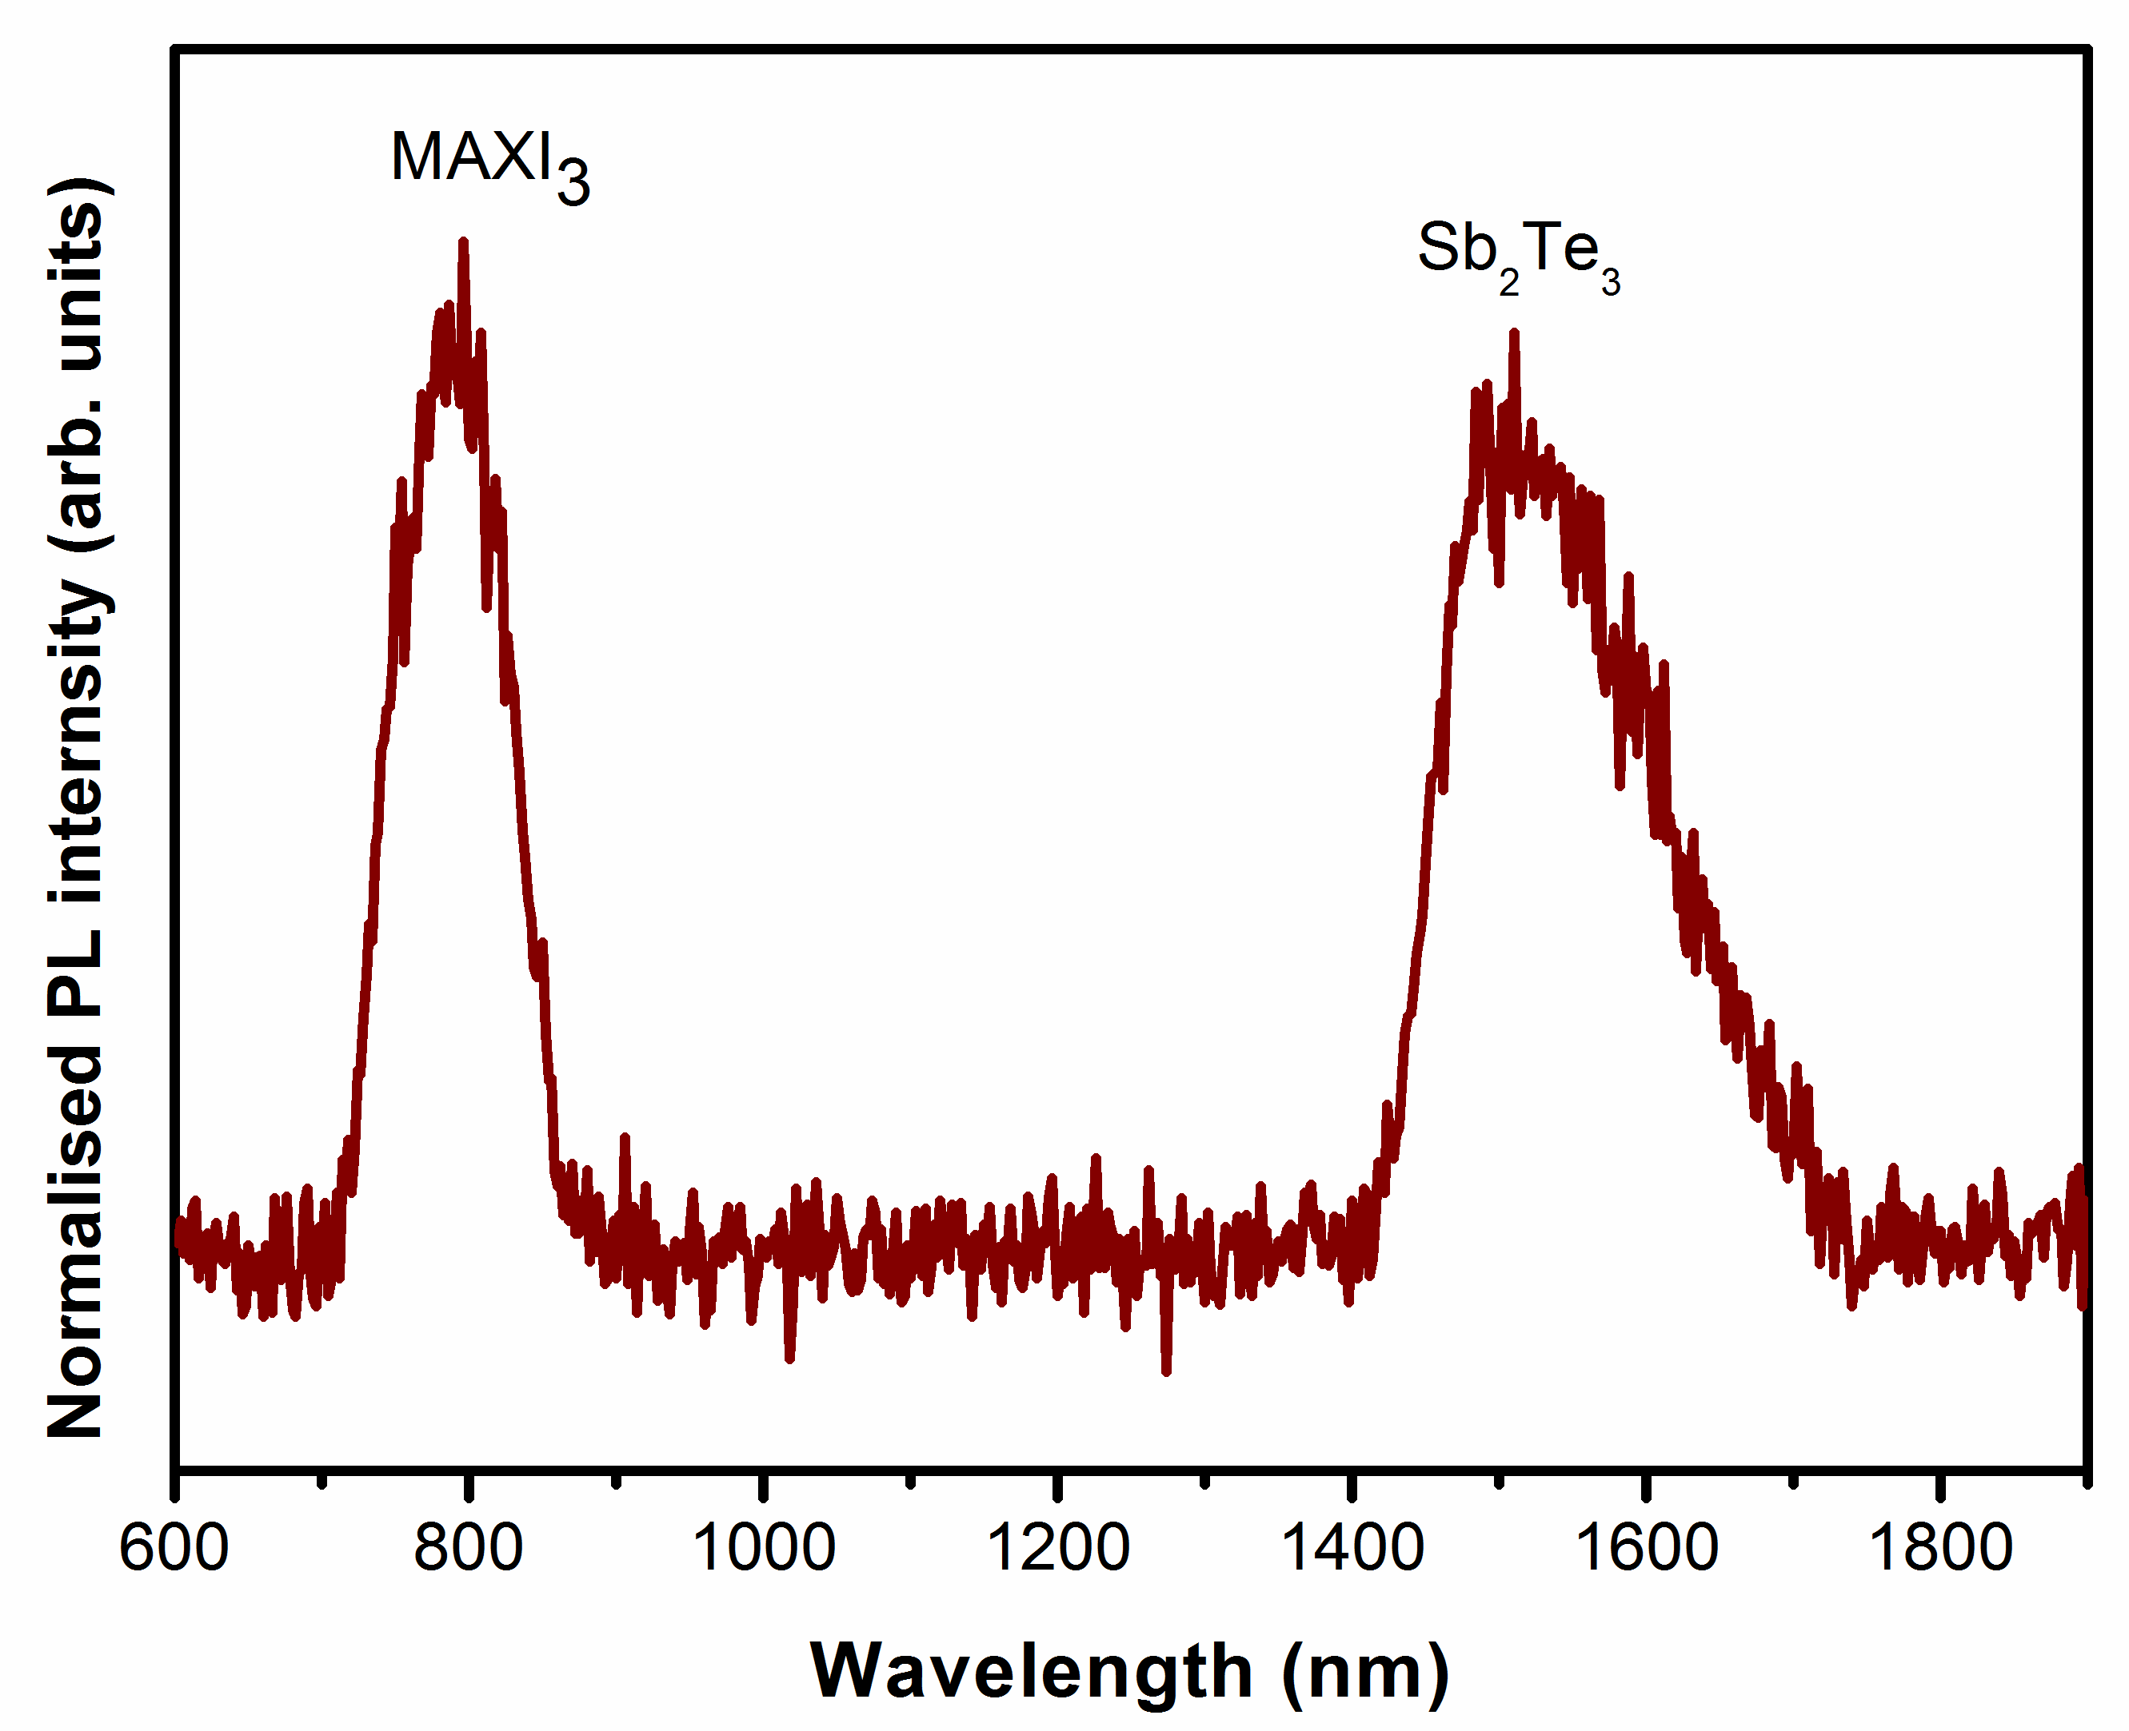
(b)
Figure 3. (a) Raman scattering spectra of specimens measured at room temperature; (b) PL spectra of S6 measured at room temperature

(a)
(b)
Figure 4. (a) SEM images of the specimens; (b) schematic illustration of thin film growth: (1) as-deposited composited thin film; (2) annealing process; (3) cooling process
(c)
(b)
(a)
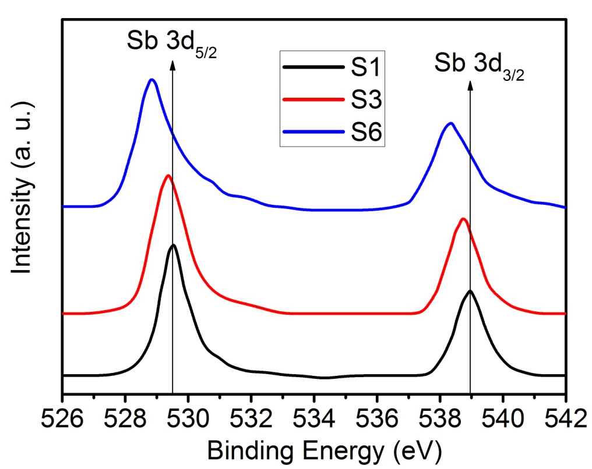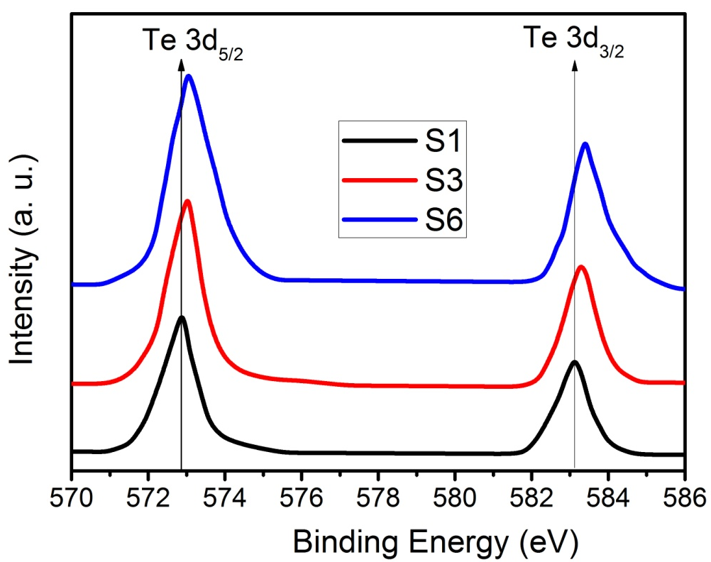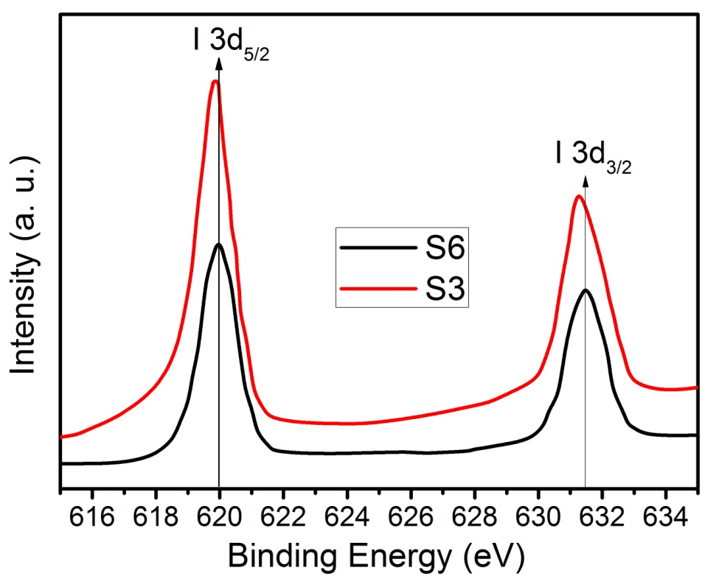
Figure 5. XPS spectra of samples S1, S3, and S6. (a) Sb; (b) Te; (c) I
Figure 6. Seebeck coefficient, electrical conductivity, power factor, and ZT value as the function of temperature: (a) Seebeck coefficient; (b) electrical conductivity; (c) power factor; (d) ZT values and the plot of room-temperature total thermal conductivity and lattice thermal conductivity

