**First saturation and resaturation of High Capacity Tensiometers with 1.5MPa High Air Entry Value (HAEV) ceramic filters**

**Mendes J., Ph.D.1, Gallipoli D., Ph.D.2, Toll D.G., Ph.D.3 and   
Tarantino A., Ph.D.4**

1School of Engineering and Computing Sciences, Durham University, South Rd, Durham DH1 3LE, UK; e-mail: [joao.p.mendes@durham.ac.uk](mailto:joao.p.mendes@durham.ac.uk)

2 Laboratoire SIAME, Fédération IPRA, Université de Pau et des Pays de l’Adour, 64600 Anglet, France; e-mail: [domenico.gallipoli@univ-pau.fr](mailto:domenico.gallipoli@univ-pau.fr)

3School of Engineering and Computing Sciences, Durham University, South Rd, Durham DH1 3LE, UK; e-mail: [d.g.toll@durham.ac.uk](mailto:d.g.toll@durham.ac.uk)

4 Department of Civil and Environmental Engineering, University of Strathclyde, Glasgow G11XJ, UK; e-mail: [aleassandro.tarantino@strath.ac.uk](mailto:aleassandro.tarantino@strath.ac.uk)

**ABSTRACT**

High Capacity Tensiometers, or HCTs, are sensors that can measure negative pore water pressures (soil suctions) between -1.5 and -2 MPa. To achieve such measured values, HCTs first need to be fully saturated by water. For the first saturation of an initially dry HCT, the most common procedure involves application of vacuum followed by forced flooding by pressurised water. Instead, for the resaturation of a HCT that has cavitated (and is therefore still water flooded), only application of water pressure is necessary. Typically, the procedures for the first saturation and resaturation of HCTs can last days or weeks, which hinders adoption of these devices by the geotechnical industry. In this paper, faster procedures are presented for both first saturation and resaturation of HCTs built with 1.5 MPa air entry value filters. The duration of the first saturation can be reduced to less than 24 hours if high vacuum is first applied to the ceramic filter followed by water pressurisation at about twice the air entry value of the filter. Even more, resaturation of a cavitated HCT can be achieved in less than 10 minutes by simple water pressurisation of the ceramic filter. This is however true only if the HCT is not left to dry out to the atmosphere completely and is submerged in water just after cavitation.

**INTRODUCTION**

The measurement of pore-water pressure in the negative range, also referred to as pore-water tension or suction, is important for the characterisation of the hydro-mechanical behaviour of unsaturated soils. High capacity tensiometers, or HCTs, are sensors capable of directly measuring soil suction. Indeed, HCTs provide one of the most reliable methods of determining pore water tension in soils (Tarantino et al., 2011) and allow a relatively easy measurement of the water retention curve during laboratory tests (Lourenço et al., 2011). The first HCT was developed at Imperial College London by Ridley and Burland (1993). The design of this HCT is shown in Figure 1 and comprised: a ceramic filter with an air entry value of 1.5MPa; a small water reservoir of about 3mm3; and a pressure transducer with a measurement range of 3.5MPa. Since then, similar designs have been published in the literature (Guan and Fredlund, 1997; Meilani et al., 2002; Tarantino and Mongiovì, 2002; Take and Bolton, 2003; Lourenço et al., 2008; Cui et al., 2008; Mendes et al., 2016; among others).



**Figure 1**. High capacity tensiometer developed by Ridley and Burland, 1993.

To measure suction (i.e. negative tensile values of pore-water pressure), the HCT needs to be first fully saturated. This is normally achieved by “pressurising” the sensor, i.e. by forcing water through the ceramic filter at relatively high pressure to saturate both the filter and the adjacent reservoir. If the ceramic filter is then placed in contact with an unsaturated soil sample, the suction in the soil will draw water out of the ceramic filter and the reservoir. This will progressively deflect the sensing membrane of the transducer until equilibrium is attained between the water tension inside the HCT and the soil. The reading by the transducer at equilibrium gives therefore the value of (negative) pore-water pressure inside the soil. For (gauge) pore-water pressure below -100 kPa (absolute water pressure in the negative range), water exists in a metastable state. Cavitation will therefore tend to occur because the state where both liquid and water vapour are present is associated with a lower free energy. This means that air bubbles will emerge from the ceramic filter into the water reservoir of the HCT, as shown by Mendes and Buzzi (2013). Cavitation of HCTs is easily detected as it produces a noticeable and immediate jump of the measured pore water pressure up to values between -80 and -100kPa. When cavitation occurs, the HCT will no longer be able to measure pore-water pressure below -100kPa and resaturation is therefore necessary to “reactivate” the device.

The procedures for saturation of HCTs are different for the:

1. first saturation of a newly built HCT or a HCT that has been exposed to the atmosphere for long time and is therefore ostensibly dry (this procedure involves the application of high vacuum followed by deaired water pressurisation);
2. resaturation of a recently cavitated HCT, which is still ostensibly flooded by water (this procedure involves only pressurisation with deaired water).

This paper presents faster saturation procedures specifically developed for HCTs built with 1.5MPa air entry value ceramic filters. The first saturation is reduced to less than 24hours by applying a high vacuum followed by an elevated water pressure of about twice the air entry value of the ceramic filter. Similarly, resaturation of a cavitated HCT is achieved in less than 10 minutes by simply applying an elevated water pressure of about twice the air entry value of the ceramic filter. This resaturation procedure is however only effective if the ceramic filter of the HCT has been submerged in water immediately after cavitation and has not been left to dry to the atmosphere.

**MATERIALS AND METHODS**

The HCTs used in this study included different designs using different pressure transducers, casing material and water reservoir sizes while retaining a similar 1.5MPa air entry value ceramic filter. Table 1 presents an overview of the different HCT designs. A more detailed description of HCT types 1 and 2 can be found in Mendes et al. (2016) while a more detailed description of HCT type 3 can be found in Mendes and Buzzi (2014).

**Table 1** - HCT designs and features.

|  |  |  |
| --- | --- | --- |
| **Type** | **HCT design** | **Features** |
| **1** |  | Pressure transducer:  Pressure range*: 2MPa  Type: flush diaphragm  Material: alumina ceramic  Reservoir size: 40mm3  Casing: Stainless steel |
| **2** |  | Pressure transducer:  Pressure range*: 2MPa  Type: flush diaphragm  Material: alumina ceramic  Reservoir size: 40mm3  Casing: Alumina ceramic |
| **3** |  | Pressure transducer:  Pressure range*: 3.5MPa  Type: flush diaphragm  Material: metallic alloy  Reservoir size: 4mm3  Casing: Stainless steel |
| **4** |  | Pressure transducer:  Pressure range*: 2MPa  Type: flush diaphragm  Material: stainless steel  Reservoir size: 40mm3  Casing: Stainless steel |

* - pressure range of the pressure transducer.

For the first saturation of a newly built or fully dry HCT, a two-stage procedure was adopted involving application of high vacuum followed by injection of pressurised water inside a purposely designed stainless steel saturation vessel. After placement of the dry HCT inside the saturation vessel, the HCT was exposed to high vacuum for 60 minutes, so as to minimise the presence of any entrapped air within the ceramic filter and reservoir. The vacuum was imposed by means of a rotary pump able to deliver an absolute pressure of 10-4 mbar (0.01Pa). This vacuum stage was followed by a pressurisation stage where deaired water was injected into the HCT at a pressure of about twice the air entry value of the ceramic filter, i.e. close to 3MPa. This was achieved by using a typical pressure/volume controller for the triaxial testing of soils. The HCT was left under this constant water pressure for a period of time varying between 16 and 20 hrs before any calibration or testing was performed.

For the resaturation of a HCT that had previously cavitated a slightly different methodology was employed. The HCT was not exposed to vacuum but directly placed inside the saturation vessel and subjected to water pressurisation in a similar fashion as in the first saturation procedure. The use of vacuum was deemed unnecessary in the resaturation procedure since the gas that forms inside the water reservoir during cavitation consists mainly of vapour that can be easily dissolved upon water pressurisation.

After first saturation or resaturation, the measuring range of each HCT was assessed by means of “evaporation tests” in which the HCT was exposed to the atmosphere and left to dry. During such tests, water progressively evaporated from the ceramic filter which increased the water tension inside the reservoir until cavitation occurred, thus marking the limit of the measurement range of the device.

**RESULTS AND DISCUSSION**

**First saturation procedure**

The previously mentioned procedure was used during the first saturation, just after construction, of the different HCTs types presented in Table 1. After the application of vacuum followed by water pressurisation to about 3 MPa, each of the newly built HCTs was tested by means of evaporation test to assess the maximum sustainable water tension.

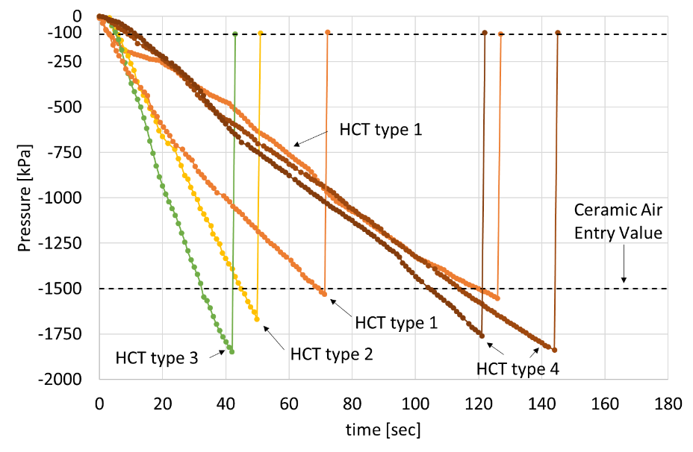

**Figure 2.** Results of evaporation tests on different HCT types (shown in table 1) after first saturation including the results for copies of HCT types 1 and 4.

Figure 2 presents the results of evaporation tests performed on the four different HCT types after first saturation.. In this figure, the horizontal axis shows the elapsed test time while the horizontal axis shows the corresponding values of (negative) water pressure measured by the device. In Figure 2, the reading just before cavitation marks the limit of the minimum water pressure that could be sustained by the HCT, which varied between -1500 and -1900kPa. The absolute values of these limit values are equal or above the air entry value of 1.5MPa of the ceramic filter. This confirms that all HCTs are adequately saturated because the measurement range is limited by the breakthrough of air across the ceramic filter rather than by cavitation inside the device. Importantly, such readings were obtained after a saturation period of only 17-21hrs including both application of vacuum (1 hr) and water pressurisation (16 – 20 hrs). The results obtained with copies of HCT types 1 and 4 suggests that these durations are sufficient to achieve full saturation.

Other procedures have been suggested in literature. Early proposals were to apply water pressurisation at a value above the air entry value of the ceramic filter (Ridley and Burland, 1993; Guan and Fredlund, 1997) and, more recently, there has been a suggestion that the application of vacuum followed by water pressurisation, but at a value below the air entry value of the ceramic filter (Lourenço et al., 2006), was sufficient. The findings of this work demonstrate that the procedure presented here, involving pressurisation above the air entry value, can achieve saturation in a few hours, whereas a saturation period of weeks is normally necessary if the air entry value of the ceramic filter is not exceeded during pressurisation or if vacuum is not applied before pressurisation.

**Resaturation procedure**

Resaturation is performed to “reactivate” a cavitated HCT by dissolving the vapour bubble(s) that have formed during cavitation. As for the first saturation procedure, evaporation tests were performed to determine the minimum time necessary for resaturation. In particular, a HCT type 3 was subjected to repeated evaporation and resaturation tests. After each cavitation, the HCT was immediately placed inside the saturation vessel and resaturated by water pressurisation at about 3MPa. Figure 3 presents the entire sequence of this test including the five evaporation stages, with corresponding cavitation, separated by the four water pressurisation stages for resaturation. Figure 4 presents an enlarged view of the five evaporation stages already shown in Figure 3.

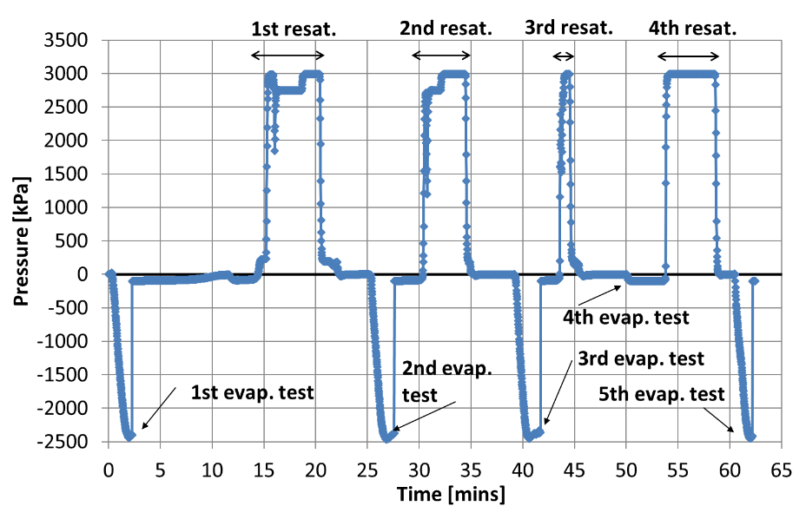

**Figure 3.** Sequence of evaporation tests and resaturations performed on HCT type 3.

As shown in Figures 3 and 4, HCT type 3 was able to reach water pressure values close to -2.5MPa during the 2nd and 3rd evaporation tests after short resaturation periods of 7 and 4 minutes, respectively. However, when the resaturation time was reduced to 2 minutes, the HCT was unable to read below -100kPa, as is the case of the 4th evaporation test. This means that any vapour bubble that had formed inside the water reservoir during cavitation was still present after resaturation. After a subsequent pressurisation period of 5 minutes, the HCT was once again capable of measuring a water pressure value of about -2.5MPa (5th evaporation test). These results show that, if the HCT is quickly pressurised after cavitation, it is possible to “reactivate” it with only a short duration resaturation.

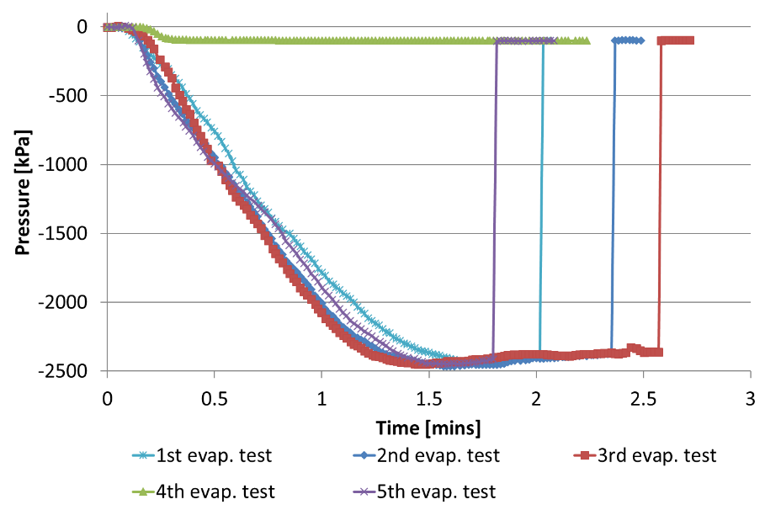

**Figure 4.** Results of evaporation tests after different pressurisation times with HCT type 3.

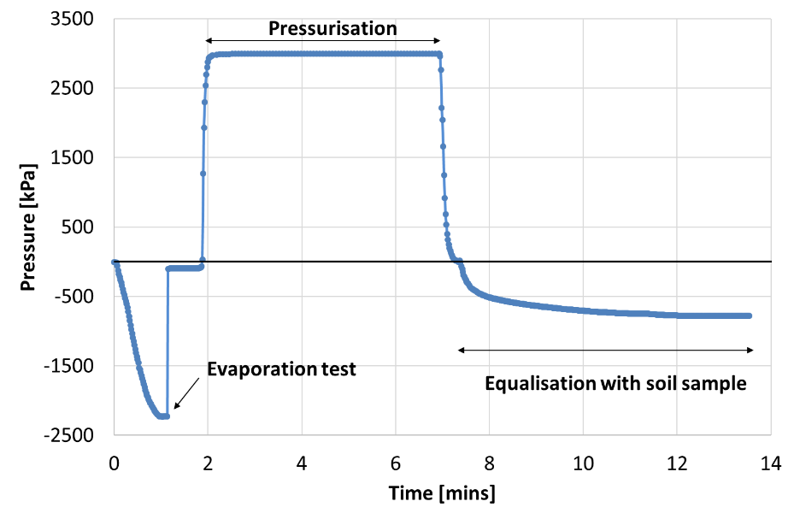

**Figure 5.** Suction measurement on a soil sample by using a resaturated HCT type 4.

To corroborate the results obtained with HCT type 3, HCT type 4 was also subjected to an evaporation test until it cavitated. Subsequently, it was resaturated by pressurisation at 3 MPa during about 5 minutes and placed in contact with a sandy clay soil sample to measure the corresponding value of suction. Figure 5 shows that, after a brief equalization, HCT type 4 was capable of measuring a pore water tension of about -800kPa. This result indicates, once again, that a short resaturation time of about 5 minutes is enough to “reactivate” the HCT.

The above results indicate that the use of HCTs in both the laboratory and the field can be greatly improved by using proper procedures for first saturation and subsequent resaturation. In particular, a relatively short resaturation time facilitates the use of HCTs in geotechnical practice as it enables “reactivation” of the cavitated devices in the field without having to transport them to the laboratory.

**CONCLUSIONS**

In this paper, new procedures have been proposed for the first saturation and subsequent resaturation of HCTs built with 1.5MPa high air entry value ceramic filters. According to these procedures, first saturation can be reduced to less than 24 hours by applying high vacuum followed by water pressurisation at a value of about twice the air entry value of the ceramic filter. Resaturation of a cavitated HCT can instead be achieved extremely quickly in less of 10 minutes, if the device is not left to dry to the atmosphere following cavitation.

By reducing the first saturation time to less than 24hrs and the resaturation time to minutes instead of days, the proposed procedures can facilitate adoption of HCTs by geotechnical practitioners as routine instruments for monitoring pore water pressure in earth structures.

**ACKNOWLEDGEMENTS**

The financial contribution of the European Commission to this research through the Marie Curie Industry-Academia Partnership and Pathways Network MAGIC (Monitoring systems to Assess Geotechnical Infrastructure subjected to Climatic hazards) – PIAPP-GA-2012-324426 – is gratefully acknowledged.

**REFERENCES**

Cui, Y.J., Tang, A., Mantho, A., and De Laure, E. (2008) *Monitoring field soil suction using a miniature tensiometer*. Geotechnical Testing Journal 31(1): 95-100.

Guan, Y. and Fredlund, D.G. (1997) *Use of the tensile strength of water for the direct measurement of high soil suction.* Canadian Geotechnical Journal, 34(4): 604-614.

Lourenço, S.D.N., Gallipoli, D., Toll, D.G., Augarde, C. and Evans, F.D. (2011) *A new procedure for the determination of the soil-water retention curves by continuous drying using high-suction tensiometers.* Canadian Geotechnical Journal, 48(2): 327–335 - <http://dx.doi.org/10.1139/T10-062>

Lourenço, S.D.N., Gallipoli, D., Toll, D.G. and Evans, F.D. (2006) *Development of a Commercial Tensiometer for Triaxial Testing of Unsaturated Soils*, Proc. 4th International Conference on Unsaturated Soils, Phoenix, USA, Geotechnical Special Publication No. 147, Reston: ASCE, Vol.2, pp. 1875-1886

Lourenço, S.D.N., Gallipoli, D., Toll, D.G., Augarde, C., Evans, F., and Medero, G.M. (2008) *Calibration of a high-suction Tensiometer.* Géotechnique 58(8): 659-668 - <http://dx.doi.org/10.1680/geot.2008.58.8.659>

Meilani, I., Rahardjo, H., Leong, E.C., and Fredlund, D.G. (2002) *Mini suction probe for matric suction measurements.* Canadian Geotechnical Journal 39: 1427-1432.

Mendes, J. and Buzzi, O. (2013) *New insight into cavitation mechanisms in high-capacity tensiometers based on high-speed photography*. Canadian Geotechnical Journal 50(5): 550-556.

Mendes, J. and Buzzi, O. (2014) *Performance of the University of Newcastle high capacity tensiometers.* Proc. UNSAT 2014, Unsaturated Soils: Research and Applications, Sydney Australia: 1611-1616.

Mendes, J., Gallipoli, D., Boeck, F., von Unold, G., and Tarantino, A. (2016) *Building the UPPA high capacity tensiometer.* Proc. 3rd European Conference on Unsaturated Soils – “E-UNSAT 2016”, Paris France. E3S Web Conf. Volume 9, 2016 - <http://dx.doi.org/10.1051/e3sconf/20160910001>

Ridley, A.M. and Burland, J.B. (1993) *A new instrument for the measurement of soil moisture suction.* Géotechnique 43(2): 321-324.

Take, W.A. and Bolton, M.D. (2003) *Tensiometer saturation and the reliable measurement of soil suction*. Géotechnique 54(3): 159-172.

Tarantino, A., Gallipoli, D., Augarde, C., De Gennaro, V., Gomez, R., Laloui, L., Mancuso, C., McCloskey, G., Munoz, J., Pereira, J.M., Peron, H., Pisoni, G., Romero, E., Raveendiraraj, A., Rojas, J.C., Toll, D., Tombolato, S., and Wheeler, S. (2011) *Benchmark of experimental techniques for measuring and controlling suction.* Géotechnique 61(4): 303–312 - <http://dx.doi.org/10.1680/geot.2011.61.4.303>

Tarantino, A. and Mongiovì, L. (2002) *Design and construction of a tensiometer for direct measurement of matric suction.* Proc. 3rd Int. Conf. on Unsaturated soils, Recife 1: 319-324.