Shapeshifting and shouting loudly: Library student perceptions regarding the future of their profession and the role of CILIP
(A shorter article taken from these results was published in the CILIP magazine, Information Professional, 12th September 2018)

The library landscape is changing (CILIP, 2012), resulting in key challenges, arising from political and economic pressure, technological innovation, and an increasing diversity of users. We live in turbulent times, and although library professionals have been optimistic about their future existence and value, there do appear to be concerns related to the reduction of professional posts (SCONUL https://sconul.ac.uk/sites/default/files/documents/Mapping%20the%20Future%20of%20Academic%20Libraries%20Final%20proof.pdf ) and the emerging skills required for the profession. SCONUL suggests that new paradigms are required to help respond to future development and survival of the profession. Whilst CILIP argues that although librarians make a significant contribution to their employing organisations, “their skill is often over-looked” and they are undervalued (https://archive.cilip.org.uk/research/resources/commissioned-research/value-trained-information-professionals ). The public library sector has seen 8,000 jobs disappear with the closure of many libraries, which along with deprofessionalisation calls into question the future of a library profession (https://www.bbc.co.uk/news/uk-england-35724957 ).

This article provides a brief discussion of qualitative survey results collected earlier this year, which aimed to better understand what current post-graduate library students in the UK feel about the state of the library profession, and the challenges that exist. In total 62 responses were returned from UK library schools, providing a snapshot of current sentiment. It is worth noting that over half the students already worked in the library sector, of which roughly half came from academic libraries. NVIVO software was used to identify themes from the qualitative data, and provide a picture of underlying issues.
Why did students study a postgraduate library qualification?
With 57% of students already working in the library sector in non-professional roles, it was unsurprising that the predominant reason for choosing to study a postgraduate library qualification was due to career advancement and becoming a professional, and earning higher wages.
“You cannot move up without a Masters and I do not want to stay at a pre-professional level with pre-professional wages”.

Several students felt that their qualification helped them to enter librarianship from other careers.
“I wanted to change career from broadcasting to libraries but was unable to secure a position. I felt the qualification would provide the evidence to prospective employers that I was committed to this path and had some understanding of the sector”.

Students also wanted to learn more about library theory, thereby creating deeper understanding and knowledge of their working environment. Indeed, the linkages between possessing knowledge, and becoming a professional were frequently mentioned.
“I tried to apply some job vacancies as librarian, however no application was successful. I realised I miss the theoretical background, therefore I decided to devote this year to build an efficient knowledge in the field”.

“To improve my knowledge and understanding in information science. I would like to be a professional in my field”.

Students commented on their passion for working in libraries, and their desire to help others, although a minority suggested financial incentives had cemented their choice of study.
“I have always wanted to be a librarian in some capacity - and was amazed to find that such a qualification existed”.

“Work offered to pay for it plus I wanted to get a degree in this area”.

What are the most valuable knowledge and skills students get from their library qualification?

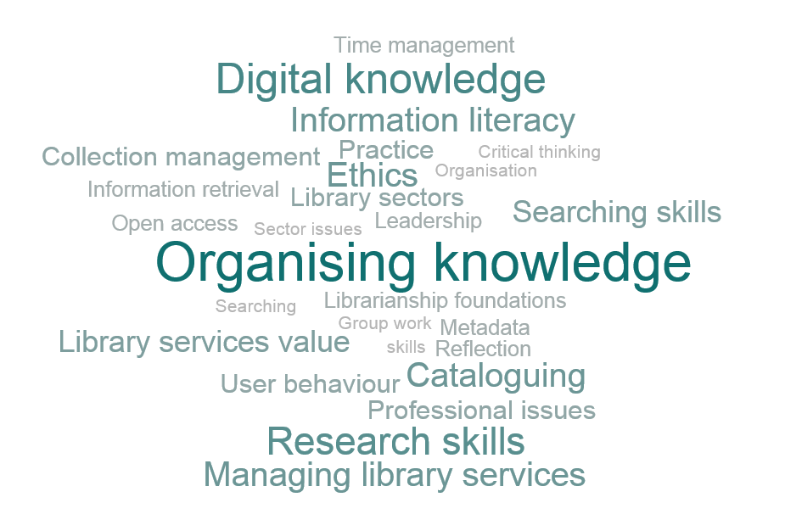

Figure 1. Wordcloud of most valuable knowledge and skills obtained from qualification

Students obtained a good range of knowledge and skills from their library studies, with key areas including aspects to do with organising knowledge, digital knowledge, research skills, ethics, managing information services and Information literacy. They also enjoyed learning about the value of information and library services, and finding out more about the library sector and professional issues.

Such knowledge and skills were directly applicable to those students already working in libraries, and enabled them to apply theory to their practice. There was a strong focus on reflective practice, and the importance of having the space to be able to make sense of what they do as a daily activity, with a view to future professional advancement.

“It has encouraged me to look at why I do things certain ways, or why organisational structure is to do it a certain way. How to look at things in a new way also”.

The fact that the library sector has rapidly changed was a further reason for students valuing study in this area.

“Digitisation and online library services are becoming more prolific in the modern world, more so than the traditional books. It is important to be able to move with the times and engage with people at all levels”.

Overall, students were happy with their library courses, however a key theme related to lacking digital aspects of library subjects, particularly for students from arts based backgrounds, and those wishing to understand more about social media, and databases. Cataloguing and classification also featured as something students wanted to see more of, in addition to teaching skills, and the opportunity to undertake practical experience, particularly for those respondents not already working in the library sector.

How do students feel about their course of study, and the state of the profession?
Students were asked to rank a range of statements, in order to better perceptions of current library post-graduate library qualifications, and the state of the profession.

Figure 2. The state of the library profession statements
Change was a key concern for many students, with technology and political aspects being predominant reasons for such change. Strongest agreement related to the changing role of libraries and the professionals that work with them over the past 5-10 years, and the role the library qualification played in enhancing their chances of gaining a professional post, and career advancement.
However, it was significant that students also acknowledged the challenge of de-professionalisation within the library sector, with only 20% disagreeing with this statement. Nearly three quarters of students (72%) were concerned for the future of the library profession across the sectors, yet were also optimistic that a future existed if the profession was prepared to adapt and survive.
“Overall I do believe the future is bright, there is more to the LIS profession than libraries; careers like research data management, publishing or policy are becoming more relevant. Making our expertise known to the wider community is crucial”.

What will students be doing in 5-10 years’ time?
Students were generally very positive about their future career, and the majority (93%) agreed their current study would greatly enhance their chances of obtaining a professional library post. However, it was evident that uncertainty also existed, evidenced by use of words such as ‘hopefully’ and ‘possibly’ in qualitative responses given. There were concerns related to the competitive nature of the market, in addition to the challenge of entering a profession viewed by some as insular.
“It's highly competitive, and I feel, a little bit nepotistic, as in a lot of internal job placements as opposed to seeking new professionals”.

What do students see as key challenges for the library profession?
Figure 3. Word cloud identifying key challenges for the library profession

Change was the omnipresent theme that covered many aspects of the challenges identified. Key challenges related to technology, politics and finance, de-professionalisation, change, advocacy and bureaucracy, which largely mirrors the literature that exists.
A key driver to change related to technology, which has unwittingly created a threat to library professionals’ existence, demanding constant innovation and change.
“It's clear that the sector has changed in light of evolving technologies, sources of information delivery etc... but there has also been a further shift in politics, where public services are being held as unimportant and funding is being slashed. It makes me fearful for the future of libraries”.

Students also felt that public misunderstanding of the library sector further challenged this, with such ignorance affecting the future function and survival of professionally staffed libraries.
“There is a common perception that libraries and the library sector is dead. Why do we need libraries when we have Google & Amazon? This needs to be addressed effectively to a broad range of people not just, an educated elite”.

In addition, funding challenges featured heavily for students, predominantly having underlying political reasons. Austerity and marketization were prevalent in all library sectors, not just public libraries.
“The library seems to be the first please that suffers from spending cuts. We've just lost a professional post and our budget has been slashed. People don't seem to understand what we can do for people and institutions”.

Advocacy was deemed essential in order to tackle these challenges, in addition to a more outward facing approach from some sections of the profession.
“Leaders currently can't agree and seem a little behind developments, there is a distinct lack of talent and good staff joining the library sector, most people don't know how awesome libraries are”.

“My place of work is very tech-focussed but we still find other services in our wider area who spend more time cataloguing textbooks and charging fines than performing searches for doctors and nurses to help people and it is frustrating divide”.

What students felt about the role of CILIP?
Advocacy
Students argued that the role of CILIP was paramount for providing an authoritative voice to help tackle general ignorance about the profession, and influence those in positions of power. CILIP had the necessary access to a wide evidence base of statistics and research, and had the power to challenge thinking through campaigns, publicity and advocacy on behalf of the profession.
“Only the union of the librarians' voice and a strong representation of their instance can face the public lack of information and the general 'noise' about the role of library in the society”.

Students felt that CILIP should provide a more active role in fighting cuts and misconceptions, in order to achieve a real change.
“CILIP represents our community (LIS community) so they should be the frontline of the campaign to make a better and more secure future for library and information science”.

“CILIP need to be part of a fight back against the challenges”.

CPD and support
Students viewed CILIP as providing an information and support role for members, enabling updating of skills and knowledge, and enhancing quality despite rapid change.
CPD facilitated member advancement, and encouraged professionals in the early stages of their career to develop, whilst also supporting those in the later stages of their career to update knowledge in line with discipline developments, thereby “nurturing change”.

“CILIP will undoubtedly steer the profession toward the highest standards”.

Connecting the profession

Many students felt that CILIP acted as a forum enabling the development of a community of practice, where information and research is exchanged, skills are shared, and networking is facilitated resulting in a better connected profession. Generally, people were positive of CILIP’s efforts to connect members, although individual respondents did query aspects to do with regionalism and diversity.

“They could do with running more events up north though. Not everyone can make it to London for their workshops and meetings, and so far, the north groups of CILIP don't really run a lot of training days”.

“They are still doing nothing to promote diversity in the profession, which is mainly white and female …. People push chartership and I'm not really sure what that is or what it does. From a working-class background, I don't feel CILIP understand me or my issues or represent or help me in any way”.

Challenges for CILIP

Unfortunately almost a third of students had something negative to say regarding CILIP’s role, related to the its’ relevance and importance for particular students, and perceptions of performance regarding threats to the profession. There were issues to do with lack of visibility and impact, and being disconnected from student members. A few students didn’t seem to know the role of CILIP, whilst others suggested it focussed mainly on accreditation and chartership.

“I don't really think CILIP does anything? Apart from sending out a magazine, and keeping people up to date with conferences”.

“I think there is a big disconnect between CILIP and current new professionals….since the job market is in such a poor state CILIP is really going to have to justify its usefulness if it expects people like me to pay, especially when student membership was free before”.

Indeed, the payment of a membership fee by students may indeed prohibit the engagement of this group of new professionals, and may seriously affect the ability to recruit the next generation of CILIP membership.

There was also much discussion regarding the echo chamber effect of many of CILIP’s promotional activities, and the failure to communicate more widely about the value of library professionals. Students argued that promotion was not always visible, and efforts regarding opposition to public library cuts had come too late.
“Unless you are in the profession CILIP is relatively unknown”.
“As library professionals, we understand how important they (libraries) are. Unfortunately, that is not always the case for the rest of society”.

Students suggested the image of CILIP as a campaigning body and professional association also required improvement to help gain buy in from those within the library profession too, particularly as it was perceived as the only advocate for all things library, as one student noted, “if they don’t, who will”.

Despite such concerns, there existed a clear role for CILIP in terms of amplifying the professional voices, and acting as a vehicle for tackling future challenges. Students were generally positive about their studies and about finding a library job. They were practical, realistic and clearly passionate about what they had chosen to do.
“CILIP has a very significant role in ensuring the future of the library profession, not only as a platform to emphasise the work of libraries, to help educate other librarians and members of the public but also help librarians communicate with each other to provide a better professional service overall”.

“CILIP need to be part of a fight back”.

CILIP. (2012) A changing landscape: A survey of public library authorities in England, Wales and Northern Ireland 2012-13. Available at: http://www.cilip.org.uk/news-media/Documents/CILIP_Public_Library_Survey_Full_Report_A_Changing_Landscape_2012-13.pdf.

