Received 00th January 20xx,
- Los Alamos National Laboratory, Los Alamos, New Mexico 87545, United States.
- Department of Chemistry, University of Reading, Whiteknights, Reading RG6 6AD, U.K.
- Department of Applied Sciences, Faculty of Health and Life Sciences, Northumbria University, Newcastle upon Tyne, NE1 8ST, U.K.
- School of Chemical Engineering and Analytical Science, The University of Manchester, Oxford Road, Manchester, M13 9PL, U.K.
# Deceased 24th January 2016. ¥current address: Colgate University, Hamilton, New York 13346, United States.
Electronic Supplementary Information (ESI) available: Additional experimental details and CIF and structural data. See DOI: 10.1039/x0xx00000x
Accepted 00th January 20xx
DOI: 10.1039/x0xx00000x
www.rsc.org/
Plutonium coordination and redox chemistry with the CyMe₄-BTPhen polydentate N-donor extractant ligand
Sean D. Reilly,ª Jing Su,ª Jason M. Keith,^{a,¥} Ping Yang,ª Enrique R. Batista,*^{,a} Andrew J. Gaunt,*^{,a} Laurence M. Harwood,*^{,b} Michael J. Hudson,^{b,#} Frank W. Lewis,^{b,c} Brian L. Scott,ª Clint A. Sharrad*^{,d} and Daniel M. Whittaker^{d}
Complexation of Pu(IV) with the actinide extractant CyMe₄-BTPhen (2,9-bis(5,5,8,8-tetramethyl-5,6,7,8-tetrahydro-1,2,4-benzotriazin-3-yl)-1,10-phenanthroline) was followed by UV/vis spectroscopy in acetonitrile solution. The solid-state structure of the crystallized product suggests that Pu(IV) is reduced to Pu(III) upon complexation. Analysis by DFT modeling is consistent with metal-based rather than ligand-based reduction.
Processing of irradiated spent or used nuclear fuel (SNF/UNF) allows the separation and recovery of the actinide elements in order to maximize the resources available to generate civil nuclear energy.¹ Some advanced concepts such as partitioning and transmutation propose to ‘burn-up’ long lived minor actinides with the benefit of reducing the radiotoxic lifetime and geological footprint of waste that requires permanent disposal.² Transmutation first requires the difficult separation of the trivalent minor actinides from lanthanides that act as neutron poisons. Employing complexants that offer primarily soft donor atoms, such as nitrogen or sulfur, can exhibit very high An³⁺ vs. Ln³⁺ selectivities. Extractants that show considerable promise for this separation include 6,6′-bis-(5,5,8,8-tetramethyl-5,6,7,8-tetrahydro-1,2,4-benzotriazin-3-yl)-2,2′-bipyridine (CyMe₄-BTBP) and 2,9-bis(5,5,8,8-tetramethyl-5,6,7,8-tetrahydro-1,2,4-benzotriazin-3-yl)-1,10-phenanthroline (CyMe₄-BTPhen).³ It is important to understand the chemistry of all of the relevant actinide elements towards such extractant molecules, because some processes propose a group actinide separation step where plutonium may be present along with other actinides.⁴

Herein, we describe coordination chemistry studies of the neutral polydentate CyMe₄-BTPhen and CyMe₄-BTBP nitrogen donor ligands towards Pu(IV). Solution speciation is probed by electronic absorption spectroscopy, and solid-state molecular structure determined by single crystal X-ray diffraction, leading to evidence for reduction of Pu(IV) to Pu(III). The electronic structure of the Pu complex with CyMe₄-BTPhen is probed by DFT calculations.
In biphasic solvent extraction systems, plutonium is usually intended to be extracted as Pu(IV) and then back-washed as Pu(III) following addition of an appropriate reductant.¹ Therefore, we set out to examine the coordination chemistry of Pu(IV) with the aim of elucidating the nature and speciation of complexes that might be extracted into an organic phase. In order to facilitate the isolation and structural characterization of a plutonium complex with CyMe₄BTPhen, solid [N(n-Bu)₄]₂[Pu(NO₃)₆] was chosen as a readily prepared, well characterized, organic solvent soluble, Pu(IV) precursor for complex synthesis.⁵ Nitrate was selected as the anion source because it is the most relevant to nuclear fuel cycle solvent extraction mechanisms, which most commonly employ nitric acid as the aqueous phase.¹ The chosen solvent was MeCN because of the good solubility of both the Pu starting material and ligand, and the fact that knowledge already exists about the stability and reactivity of [N(n-Bu)₄]₂[Pu^{IV}(NO₃)₆] in MeCN.⁵
CyMe₄-BTPhen dissolves in MeCN to give a yellow solution (expedited by gentle heating), with a solubility limit of at least 0.017 M. Figure 1 (blue line) shows the vis–NIR spectrum of CyMe₄-BTPhen dissolved in MeCN. Metal-ligand complexation resulted from addition of a green MeCN solution of [N(n-Bu)₄]₂[Pu(NO₃)₆] to 1 equiv of CyMe₄-BTPhen in MeCN, leading to formation of a brown solution (Figure 1).
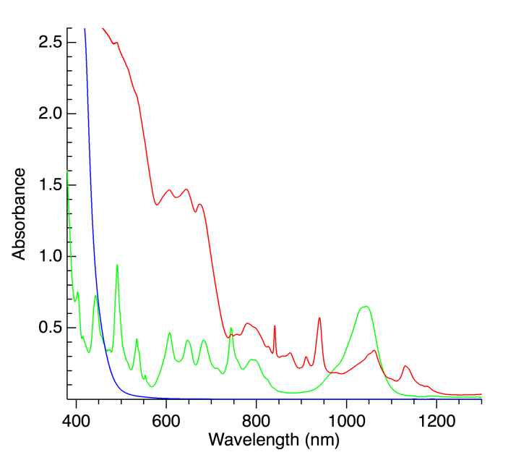
Figure 1. Solution electronic absorption spectra of CyMe₄-BTPhen dissolved in MeCN (blue), 18.3 mM [N(n-Bu)₄]₂[Pu(NO₃)₆] dissolved in MeCN (green), and 1:1 8.45 mM Pu:CyMe₄-BTPhen immediately after combining in MeCN (red).

Heating the solution had no significant effect upon the vis-NIR spectrum suggesting that the reaction had reached completion at room temperature (a peak at 840 nm increased in intensity after heating but we attribute this absorption to an impurity – see later discussion regarding the vis-NIR spectrum of the pure solid Pu-CyMe₄-BTPhen complex, for which the 840 nm peak is absent). Following work-up of the reaction solution (see SI), large dark brown crystalline blocks were obtained, revealed by single-crystal X-ray diffraction to be [Pu^{III}(CyMe₄-BTPhen)₂(NO₃)][Pu^{IV}(NO₃)₆]·4MeCN (Figure 2), a mixed-valent Pu(III/IV) complex salt. The solid-state structure shows that the anion is the well-established [Pu^{IV}(NO₃)₆]²⁻ complex that has been characterized several times in the past; the Pu-O bond lengths and O-Pu-O angles are consistent with those previously observed.^{5,6} Since the identity of the Pu(IV)-containing anion is unambiguous, we assign the ‘formal’ oxidation state of Pu in the cation as Pu(III). The cation carries a 2+ charge and contains a Pu(III) centre complexed to two CyMe₄-BTPhen ligands, with each ligand binding in a tetradentate mode through four N donor atoms. The ten-coordinate inner sphere is completed by an O-bound bidentate nitrate group. The geometry about the Pu(III) centre is best described as a distorted bicapped square antiprism with N(5) and N(13) occupying the capping positions. In addition, there are four unbound MeCN molecules per complex in the lattice.

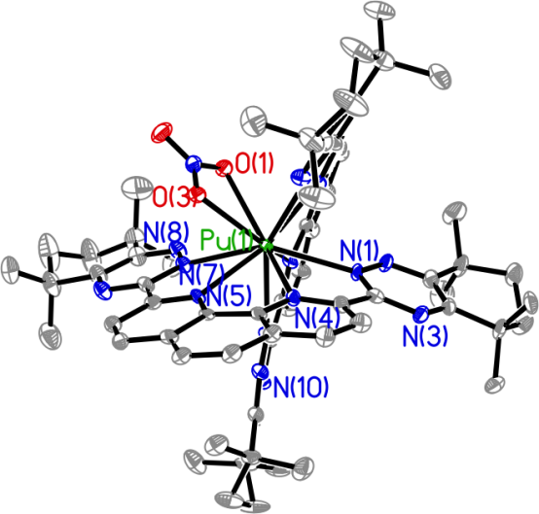
Figure 2. Thermal ellipsoid plot of the solid-state structure of [Pu^{III}(CyMe₄-BTPhen)₂(NO₃)][Pu^{IV}(NO₃)₆]·4MeCN. The [Pu^{IV}(NO₃)₆]^{2–} anion, lattice solvent, and H atoms have been omitted for clarity.

The Pu-O distances of the coordinated nitrate anion are 2.593(5) and 2.581(5) Å, indicating that it is symmetrically bound rather than the asymmetric coordination mode that has been observed in some other Pu-nitrate complexes.⁷ The distances are in the order of 0.1 Å longer than the Pu-O distances for coordinated nitrate in the [Pu^{IV}(NO₃)₆]^{2–} anion. This lengthening would be expected for Pu(III) vs. Pu(IV). However, different coordination numbers and ligand environments in the cation vs. anion preclude this observation providing conclusive evidence of reduction to Pu(III), except to note that the lengthening is consistent with the expected weaker Pu(III)-NO₃ vs. Pu(IV)-NO₃ electrostatic interaction. Indeed, comparison to non-anionic Pu(IV) molecules containing coordinated nitrates reveals an inconsistent pattern in the bond distances, suggesting that steric influences within the molecules have a greater impact on the Pu-O_{nitrate} lengths than purely electrostatic interaction. For example, in the Pu(IV) complex [Pu(NO₃)₂(NOPOPO)₂]²⁺ (NOPOPO = 2,6-[(C₆H₅)₂P(O)CH₂]₂C₅H₃NO), the asymmetrically bound nitrates have ‘short’ distances of 2.425(4) and 2.429(4) Å while the ‘long’ distances are 2.710(5) and 2.824(5) Å (each shorter or longer than those in the Pu(III) complex reported herein).⁷ In another Pu(IV) cationic complex, [Pu(NO₃)₃(NOPO)₂]¹⁺ (NOPO = 2-[(C₆H₅)₂P(O)CH₂]C₅H₄NO), the nitrates are more symmetrically bound, with distances ranging from 2.446(4) to 2.582(4) Å (the latter value falling within the range of the Pu(III) complex herein).^{6a} Unfortunately, there are no examples of Pu(III) coordinated to nitrate to allow comparison to an ‘established Pu^{III}-NO₃’ bond length, highlighting basic bonding knowledge gaps that are still prevalent in molecular plutonium chemistry.
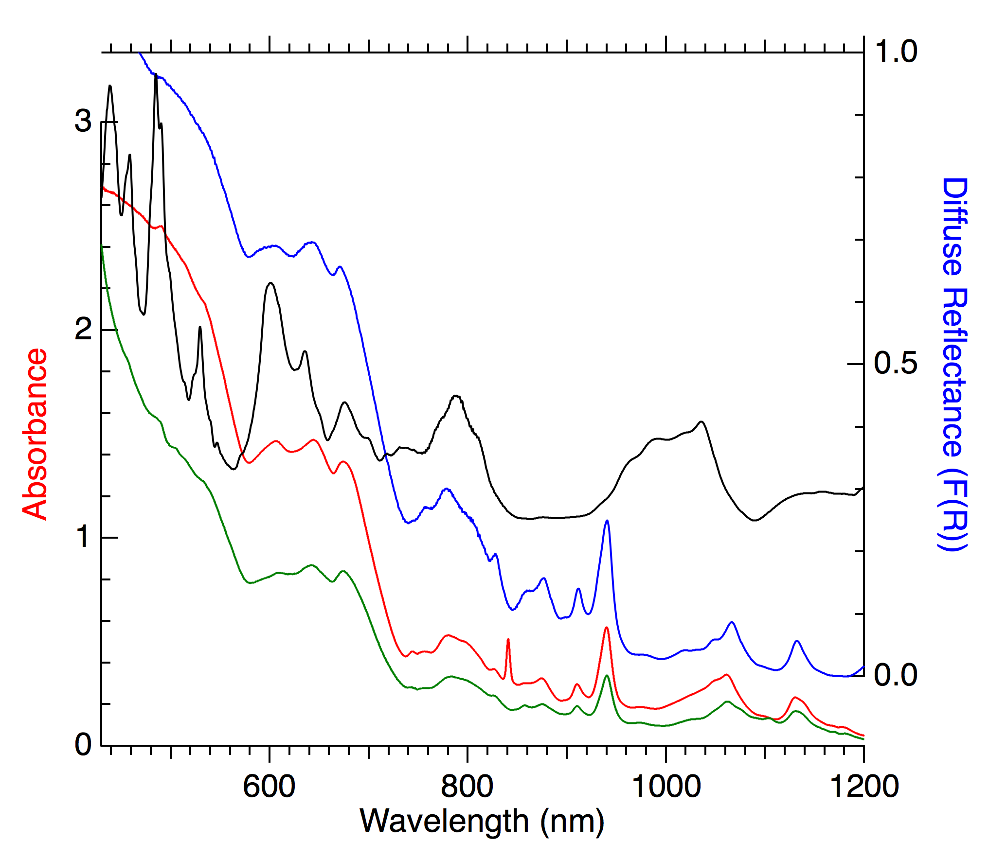
The tetradentate bonding mode of the CyMe₄-BTPhen ligand in [Pu(CyMe₄-BTPhen)₂(NO₃)]²⁺ is defined by Pu-N_{(phenanthroline)} distances ranging from 2.580(5) to 2.656(5) Å and Pu-N_{(triazinyl)} distances ranging from 2.591(5) to 2.648(5) Å. These bond lengths are consistent with those of the most closely related Pu(III) complex for comparative purposes, [Pu(tpza)I₃(MeCN)] (tpza = tris[(2-pyrazinyl)methyl]amine, a tetradentate neutral N-donor), which contains Pu-N_{(aromatic)} distances ranging from 2.644(7) to 2.668(6) Å and a Pu-N_{(aliphatic)} distance of 2.618(6) Å.⁸ From a charge balance perspective and the unambiguous nature of the [Pu^{IV}(NO₃)₆]²⁻ anion present in the crystal structure it appears that complexation of the CyMe₄-BTPhen ligand favors reduction of Pu(IV) to Pu(III), forming a more stable complex than Pu(IV) under these particular reaction conditions. The presence of [Pu^{IV}(NO₃)₆]²⁻ in [Pu^{III}(CyMe₄-BTPhen)₂(NO₃)][Pu^{IV}(NO₃)₆] is readily explained by the fact that a 1:2 metal:ligand complex is formed but only 1 equivalent of CyMe₄-BTPhen was added in the synthesis, leaving unreacted [Pu^{IV}(NO₃)₆]²⁻ from the starting material in solution. Attempts to add excess equivalents of CyMe₄-BTPhen to achieve complete complexation of all the Pu(IV) starting material were not successful in leading to tractable products. The [Pu^{III}(CyMe₄-BTPhen)₂(NO₃)][Pu^{IV}(NO₃)₆] structure type obtained is very similar to examples of Ln(III) complexes that have recently been reported, e.g. [Ln(CyMe₄-BTPhen)₂(NO₃)][Ln(NO₃)₅] (Ln = Eu, Pr).^{3,9}
The [Pu^{III}(CyMe₄-BTPhen)₂(NO₃)][Pu^{IV}(NO₃)₆] compound was further characterized by acquiring the diffuse reflectance vis–NIR spectrum of the solid crystals (Figure 3, blue) and comparing it to the crystals dissolved in MeCN solution (Figure 3, green). The electronic transitions are essentially identical, suggesting very similar or identical speciation in the solid vs. solution phase and that the complex remains intact upon dissolution. The vis-NIR spectrum of the initial reaction solution (Figure 3, red) is also essentially identical with the exception of the additional ‘impurity’ peak at 840 nm, which suggests that the 1:2 complex is also prevalent in solution before crystallization. Crystals of the 1:2 complex were also dissolved in aqueous 1 M HCl (Figure 4, red), and interestingly, rather than a reversion to an electronic transition profile typically observed for Pu³⁺ ‘aquo’ speciation,¹⁰ the complex appears to remain intact. The vis–NIR spectrum of the mother liquor solution from which the crystals were grown (Figure 5, red) is also broadly consistent with the absorption bands observed for the pure product. However, it should also be noted that, in addition to the dark brown crystals that were obtained, a lighter-brown solid powder also precipitated during crystallization. This solid did not re-dissolve in MeCN, and we were not able to characterize this solid. Crystals of [Pu^{III}(CyMe₄-BTPhen)₂(NO₃)][Pu^{IV}(NO₃)₆] were dissolved in CD₃CN and the ¹H NMR spectrum was recorded. Definitive assignment of the peaks is difficult because of the paramagnetic 5f⁵ electronic configuration of Pu(III) ions (see SI for discussion and tentative assignments). Crystals were grown from the CD₃CN NMR measurement solution and the unit cell checked to ensure that it was identical to [Pu^{III}(CyMe₄-BTPhen)₂(NO₃)][Pu^{IV}(NO₃)₆], meaning that the complex likely remains intact upon dissolution. The Supplementary Information provides additional spectrophotometric titration UV/vis/NIR spectra under different solution conditions following complexation of Pu to CyMe₄-BTPhen and the related CyMe₄-BTBP ligand. The results indicate that, when aqueous acidic sources of Pu(IV) are added to MeCN solutions of the ligand (rather than using the anhydrous [N(n-Bu)₄]₂[Pu^{IV}(NO₃)₆] starting material), there is evidence for proton competition for the ligand and addition of base is required to induce complexation and formation of 1:2 species. Complexation, in turn, induces reduction of Pu(IV) to Pu(III), consistent with the observed crystal structure. The reduction is corroborated by direct addition of Pu(III) to an MeCN solution of the ligand giving a resultant vis-NIR spectrum with very similar features to those obtained from Pu(IV) addition.

Figure 3. Vis–NIR diffuse reflectance spectra of solid [Pu^{III}(CyMe₄-BTPhen)₂(NO₃)][Pu^{IV}(NO₃)₆]·4MeCN (blue spectrum, right axis) and solid [N(n-Bu)₄]₂[Pu(NO₃)₆] (black spectrum, right axis, +0.25 offset). The solution electronic absorption spectra of the above crystals dissolved in MeCN (green spectrum, left axis, 4× scaled) and of the initial 1:1 8.45 mM Pu:CyMe₄-BTPhen reaction solution in MeCN (red spectrum, left axis) are shown for comparison. The 841 nm band evident in the initial reaction solution spectrum is absent in the product spectrum.

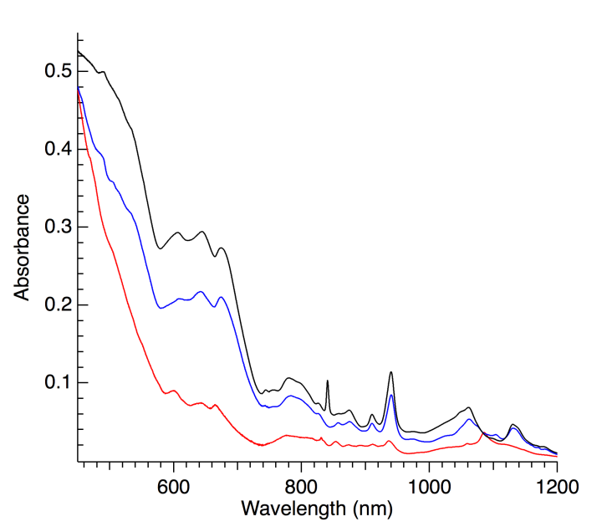
Figure 4. Solution electronic absorption spectra of the initial 1:1 8.45 mM Pu:CyMe₄-BTPhen reaction solution in MeCN (black, 1/5 scaled), and of the [Pu^{III}(CyMe₄-BTPhen)₂(NO₃)][Pu^{IV}(NO₃)₆]·4MeCN solid product re-dissolved in MeCN (blue) or 1 M HCl (red). The characteristic Pu³⁺(aq) bands at 561, 601, 665 nm are not clearly evident in the red spectrum.

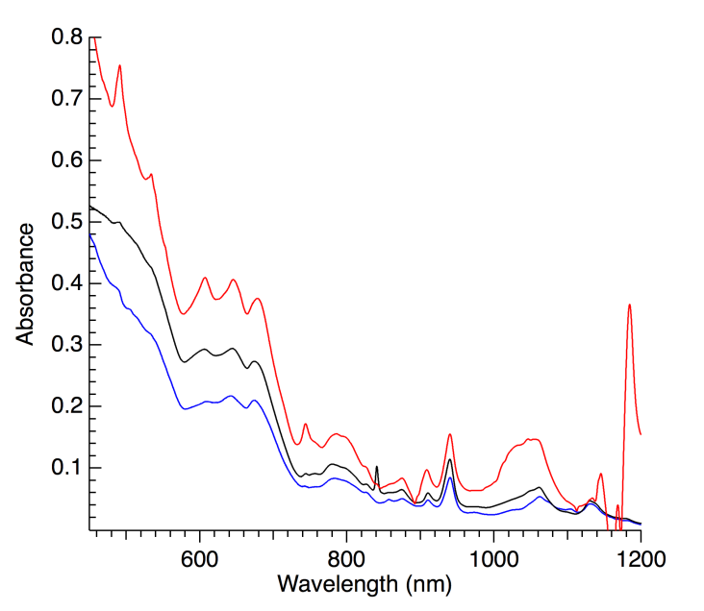
Figure 5. Solution electronic absorption spectrum of the mother liquor from which the crystals were grown (red). Spectra of the initial 1:1 8.45 mM Pu:CyMe₄-BTPhen reaction solution in MeCN (black, 1/5 scaled) and of the [Pu^{III}(CyMe₄-BTPhen)₂(NO₃)][Pu^{IV}(NO₃)₆]·4MeCN solid product re-dissolved in MeCN (blue) are show for comparison.

In order to shed further light on the oxidation state of Pu upon ligand coordination, especially since the source of the apparent reduction is unknown, density functional theory (DFT) calculations were performed on the experimentally isolated [Pu^{III}(CyMe₄-BTPhen)₂(NO₃)]²⁺ - containing cation. The optimized structure predicts Pu-O distances of 2.533 and 2.540 Å, and Pu-N_{(phenanthroline)} distances in a range of 2.640-2.672 Å, and Pu-N_{(triazinyl)} distance in a range of 2.645-2.743 Å, in reasonable agreement with the experimentally determined solid-state structure. Mulliken spin density analysis for the Pu(III) complex shows a net spin density of 5.06 on the Pu centre consistent with a 5f⁵ Pu(III) configuration and neutral BTPhen ligands. Correspondingly, the five singly occupied natural orbitals, showing the unpaired spin density in the molecule, are Pu localized orbitals with over 97% 5f character as shown in Figure S10. This finding supports the experimental assignment of the structurally determined [Pu^{III}(CyMe₄-BTPhen)₂(NO₃)]²⁺ cation as containing a Pu(III) cation and neutral CyMe₄-BTPhen ligands. Besides, this also confirms that reduction happens on the metal centre rather than on the ligand.
In summary, the first structural characterization of a plutonium complex with the CyMe₄-BTPhen polydentate N-donor extractant reveals unanticipated spontaneous reduction of Pu(IV) to Pu(III). The findings are relevant to any separation strategies that consider group actinide separations in which Pu is co-extracted along with minor actinides, namely, that plutonium may be extracted as Pu(III) rather than Pu(IV) depending upon the nature of the extractant and solution conditions.

We thank the U.S. Department of Energy, Office of Science, Early Career Research Program (A.J.G., S.D.R., contract DE-AC52-06NA25396), the Office of Basic Energy Sciences, Chemical Sciences, Geosciences, and Biosciences Division, Heavy Element Chemistry Program (A.J.G., E.R.B., contract DE-AC52-06NA25396).
Notes and references
1. Wilson, P. D. The Nuclear Fuel Cycle, From Ore to Waste;
Oxford University Press, Oxford, United Kingdom, 1996.
2. (a) Potential Benefits and Impacts of Advanced Nuclear Fuel Cycles with Actinide Partitioning and Transmutation. NEA No. 6894; OECD, Nuclear Energy Agency (NEA): Paris, 2011. (b) M. Salvatores and G. Palmiotti, Prog. Part. Nucl. Phys., 2011, 66, 144.
3. F. W. Lewis, L. M. Harwood, M. J. Hudson, M. G.B. Drew, J. F. Desreux, G. Vidick, N. Bouslimani, G. Modolo, A. Wilden, M. Sypula, T.-H. Vu and J.-P. Simonin, J. Am. Chem. Soc. 2011, 133, 13093.
4. (a) J. Brown, F. McLachlan, M. Sarsfield, R. Taylor, G. Modolo and A. Wilden, Solvent Extr. Ion Exch., 2012, 30, 127. (b) E. Aneheim, C. Ekberg, A. Fermvik, M. R. S. J. Foreman, T. Retegan and G. Skarnemark, Solvent Extr. Ion Exch., 2010, 28, 437.
5. S. D. Reilly, B. L. Scott and A. J. Gaunt, Inorg. Chem., 2012, 51, 9165.
6. (a) J. H. Matonic, M. P. Neu, A. E. Enriquez, R. T. Paine and B. L. Scott, J. Chem. Soc., Dalton Trans., 2002, 2328. (b) M. R. Spirlet, J. Rebizant and C. Apostolidis, Acta Cryst., 1992, C48, 1161.
7. E. M. Bond, E. N. Duesler, R. T. Paine, M. P. Neu, J. H. Matonic and B. L. Scott, Inorg. Chem., 2000, 39, 4152.
8. A. J. Gaunt, J. H. Matonic, B. L. Scott and M. P. Neu, in Recent Advances in Actinide Science, R. Alvarez, N. D. Bryan and I. May, Eds., Royal Society of Chemistry, Letchworth, U.K., 2006, p. 183.
9. D. M. Whittaker, T. L. Griffiths, M. Helliwell, A. N. Swinburne, L. S. Natrajan, F. W. Lewis, L. M. Harwood, S. A. Parry and C. A. Sharrad, Inorg. Chem., 2013, 52, 3429.
10. D. Cohen, J. Inorg. Nucl. Chem., 1961, 18, 211.

