Revision

6th June 2012

Rocking Disc Electro-Deposition of CuIn Alloys, Selenisation, and Pinhole Effect Minimization in CISe Solar Absorber Layers

Charles Y. Cummings ª, Guillaume Zoppi ^{b}, Ian Forbes ^{b}, Diego Colombara ª, Laurence M. Peter ª, and Frank Marken*ª

ª Department of Chemistry, University of Bath, Claverton Down,
Bath BA2 7AY, UK
^{b} Northumbria Photovoltaics Applications Centre, Northumbria University,
NE1 8ST, UK

To be submitted to Electrochimica Acta
Email F.Marken@bath.ac.uk

Abstract
The co-electrodeposition of copper and indium from a pH 3 tartrate bath onto 4.8 cm × 2.5 cm Mo and MoSe₂ substrates is studied and conditions are optimised for CuIn alloy films. Selenisation at ca. 500 ºC for 30 minutes in selenium vapour gives CuInSe₂ (or CISe). Mapping using the photo-electrochemical reduction of Eu(NO₃)₃ is used to asses the relative photoactivity as a function of position and surface treatment.
Etching of detrimental Cu_{x}Se phases is investigated with 5 %w/w and 0.5 %w/w aqueous KCN. The slower 0.5 %w/w KCN etch allows better process control, and re-annealing at 500 ºC for 30 minutes followed by further etching significantly improved the photo-activity. However, over the large area local pinhole recombination effects are substantial. An alternative low temperature film optimization method is proposed based on (i) KCN over-etch, (ii) hypochlorite (5 %w/w) pinhole removal (Mo etch), and (iii) a final KCN etch to give good and more uniform activity.

Keywords: solar cell, CIS, copper indium diselenide, electrodeposition, photo-electro-chemistry, recombination, pinhole, etching, hypochlorite, voltammetry.

1. Introduction
A range of deposition techniques are available for thin film solar devices (e.g. chemical vapour deposition [], spin coating [], chemical bath deposition [], or electro-deposition []), but achieving uniformly high quality films over a large area at low cost remains a challenge. Electrodeposition, stacked [] or as alloy [], offers a low cost technology where the most important factors are the substrate uniformity, potential distribution, and achieving a uniform diffusion layer thickness over the entire electrode surface. In a recent report we explored rocking disc electrodeposition for substrate sizes up to ≈ 12 cm² []. Here this method is employed to give a uniformly thinned average diffusion layer of ca. 30 μm (at 8 Hz rocking rate [7] comparable with conditions at a 4.2 Hz rotating disc plating system) for plating of the binary Cu-In system. The advantages of the rocking disc deposition employed here are (i) easy lift-off for gas bubbles into the turbulent solution phase, (ii) no sliding contacts, and (iii) a highly symmetric low-volume electrodeposition cell design.

The electrodeposition of binary systems has been intensely investigated [,,,,]. The complex kinetics of electrodeposition of alloys involves diffusion, adsorption, electron transfer, nucleation, alloy formation, competing growth, and the Kröger mechanism [,10]. For the electrodeposition of the bimetallic alloy CuIn the Cu and In species have different solution composition-dependent nobilities [] with Cu being more likely to be plated under mass transport control in contrast to In, which is likely to be plated under kinetic control. The co-electrodeposition of metallic CuIn [,] and CuInGa [,] films from single baths has been documented before. The effects of potential, concentration, and additives [,] can be exploited to produce films with a desired stoichiometry. Selenisation of CuIn to give copper indium diselenide (CISe) has been achieved for example at elevated temperatures in selenium vapour []. Most literature reports focus on the optimisation of very small devices (ca. 1 cm²). For example, Repins et al. [] reported a world record physical vapour deposition gallium-doped CISe device with efficiency 19.9 % where the morphology is highly smooth and uniform on areas of about 0.4 cm². Here CISe formation on larger 12 cm² substrates is investigated.

For surface activation and removal of unwanted phases, wet chemical etchants have important advantages over dry etchants in that they can be selective, they allow higher through-put, and they operate at lower cost. Etching is performed for CISe based films to remove detrimental Cu_{x}Se surface phases (Cu₂Se, CuSe, CuSe₂) []. The most commonly used etchant is potassium cyanide or KCN [,]. This reagent offer a diffusion controlled etch for the removal of Cu_{x}Se phases whilst being kinetically slow to remove CISe. There are a number of alternative etchant systems such as methanol/bromine [], HBr and bromine [,,], alkaline H₂O₂ [], or alkaline ammonia etching solutions []. XPS measurements revealed that the surface becomes deficient in selenium when exposed to a peroxide etch solution. Ammonia will preferentially remove indium from the film. Direct “electrochemical etching” has been suggested for CISe films [] and CIS films [,,,]. In the present study KCN etching is employed and a novel room temperature CISe film optimization method is proposed based on (i) over-etching, followed by (ii) hypochlorite “pinhole etching”, and (iii) a final KCN etch to allow detrimental effects of pinhole recombination centres to be minimised.

2. Experimental Methods
2.1. Reagents
Copper(II) sulphate (99.999 %), indium(III) chloride (99.999 %), lithium chloride (99.99 %), sodium hydroxide (99.99 %), tartaric acid (ACS grade), europium (III) nitrate (99.999 %), potassium cyanide (ACS, 96.0 %), hypochlorite solution (5 %w/w) and selenium powder (99.999 %) were purchased from either Sigma Aldrich or Alfa Aesar and used without further purification. Filtered and demineralised water was taken from a Thermo Scientific water purification system (Barnstead Nanopure) with a resistivity of not less than 18.2 MOhm cm.

2.2. Instrumentation
For voltammetric and potentiostatic investigations an Autolab III potentiostat system (EcoChemie, Netherlands) was employed with a KCl-saturated calomel (SCE) reference electrode (Radiometer, Copenhagen). The working electrodes were ca. 1 μm thick RF-sputtered Mo films on soda lime glass. Voltammetric studies were performed in an open electrochemical cell with a Pt foil (4 cm × 2 cm) counter electrode. For experiments involving the rocking disc electrodeposition [] a counter electrode of pure copper (99.9 %) was symmetrically fixed to the top of the rocking disc cell system opposite to the working electrode (see Figure 1B). All electrochemical experiments were conducted without degassing (ca. 0.2 mM oxygen; to mimic industrial electro-deposition conditions). The temperature during experiments was 22 ± 2 ºC.

The surface morphology and topology of the films were studied using a JEOL JSM6480LV scanning electron microscope (SEM). Semi-quantitative compositional analysis was performed using calibrated energy dispersive x-ray analysis (EDS). For the EDS determination of the approximate ratio of copper to indium present within the film, the acceleration voltage was set to 25 kV, with a low magnification (× 200) and measured for 100 seconds. Three probe points of ca. 1 mm diameter were chosen along the central axis of the sample (as shown in Figure 1A).

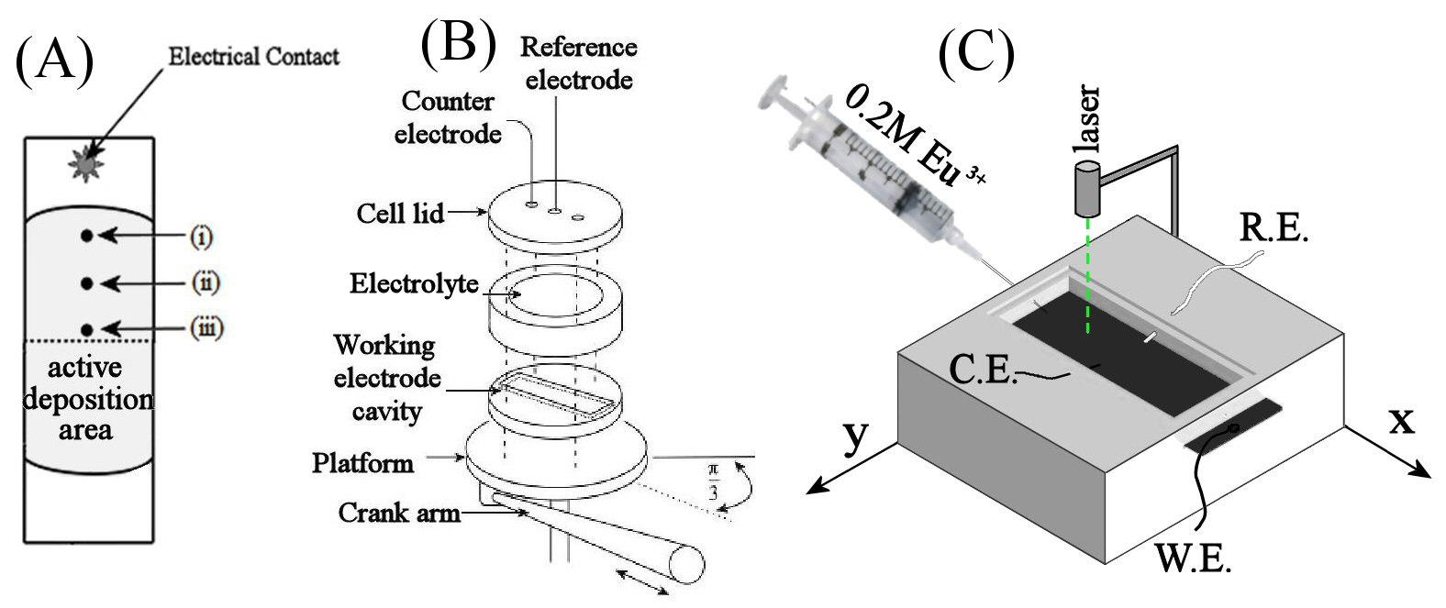
Figure 1. (A) Schematic drawing of the sample slide showing the 4.8 cm × 2.5 cm active deposition area in grey, the central line, and points for SEM/EDS analysis (i) to (iii) in 1 cm distance from each other. (B) Schematic drawing of the rocking disc hydrodynamic electro-deposition system which is operated at a frequency of 8 Hz [36]. (C) Schematic representation of the photocurrent mapping set up. The working electrode (W.E.) is placed in a custom-made electrochemical cell with Ag/AgCl reference (R.E.) and Pt wire counter (C.E.) electrodes. The cell was filled with aqueous 0.2 M Eu³⁺ aqueous solution, the green light beam of the laser was chopped, and the photocurrent at -0.4 V vs. R.E. was recorded as a function of position.

2.4. Composition of the CuIn plating solution
For the electrodeposition of metallic copper/indium alloys a non-toxic bath similar to that employed previously by Viacheslavov [] was developed based on 60 mL of electrolyte containing 0.5 M LiCl, 0.15 M Na tartrate, 50 mM InCl₃, and 25 mM CuSO₄. The solution was adjusted to pH 3 by the addition of NaOH. The solution was placed in the rocking disc electrodeposition system (operating at 8 Hz) and films were formed using potentiostatic control. For optimisation of the Cu-to-In ratio the applied deposition potential was varied between experiments but the rocking rate and deposition charge 21.8 C (corresponding to nominal ca. 550 nm average thickness) remained constant. Care was taken to minimise the contact time of the Mo electrode and the tartrate electrolyte when not under applied potential conditions. Additional experiments with less alkali-sensitive MoSe₂ film electrodes [] were performed but very similar metal plating results were achieved (not shown). In the mildly acidic bath used here there were no further benefits from the additional Mo-selenisation process. Therefore this study focuses on simple Mo working electrodes only. The 60 mL plating solution allowed consecutive electro-formation of two CuIn film deposits before being renewed.

2.5. Selenisation of the CuIn films and re-anneal treatments
Stoichiometric or slightly indium-rich CuIn films (Cu/In = ca. 1.0) were selenised using a standard procedure [37]. Films were enclosed in a graphite box with 150 mg of selenium powder, placed under a flow of 1 atm. N₂, and heated to 500 ºC (for 30 minutes) at a heating rate of 10 ºC min⁻¹. Films were then cooled at a rate of 1 ºC min⁻¹ until room temperature.

2.6. Photo-electrochemical mapping of large area CISe films
An electrochemical flat cell (with 12 cm² window with ca. 1 mm gap to the solar cell absorber layer) was mounted on a manual X-Y stage (position ±1 mm) fitted with a green laser pointer (525 nm, ca. 5 mW). The electrochemical cell which contained 20 mL of 0.2 M Eu(NO₃)₃ with an Ag/AgCl reference electrode (1 M KCl, Flexref, World Precision Instruments Inc.) and a Pt wire counter electrode. The CISe coated microscope slide was placed in a recess at the base of the cell (see Figure 1C). A potential of -0.4 V vs. Ag/AgCl was applied to the entire CISe film for 10 seconds prior to the start of the recording of the photo-chronoamperometry data. Data are recorded at 3 × 6 locations for 4 seconds each, whilst the light is modulated (ca. 1 Hz).

3. Results and Discussion
3.1. Rocking disc electrodeposition of CuIn alloy films
In this study the plating solution was composed of 0.5 M LiCl, 50 mM InCl₃, and 25 mM CuSO₄ with 0.125 M Na-tartrate used as a complexing agent. Exploratory voltammetric data obtained without agitation at a 1 cm² Mo electrode immersed in this solution is shown in Figure 2A.

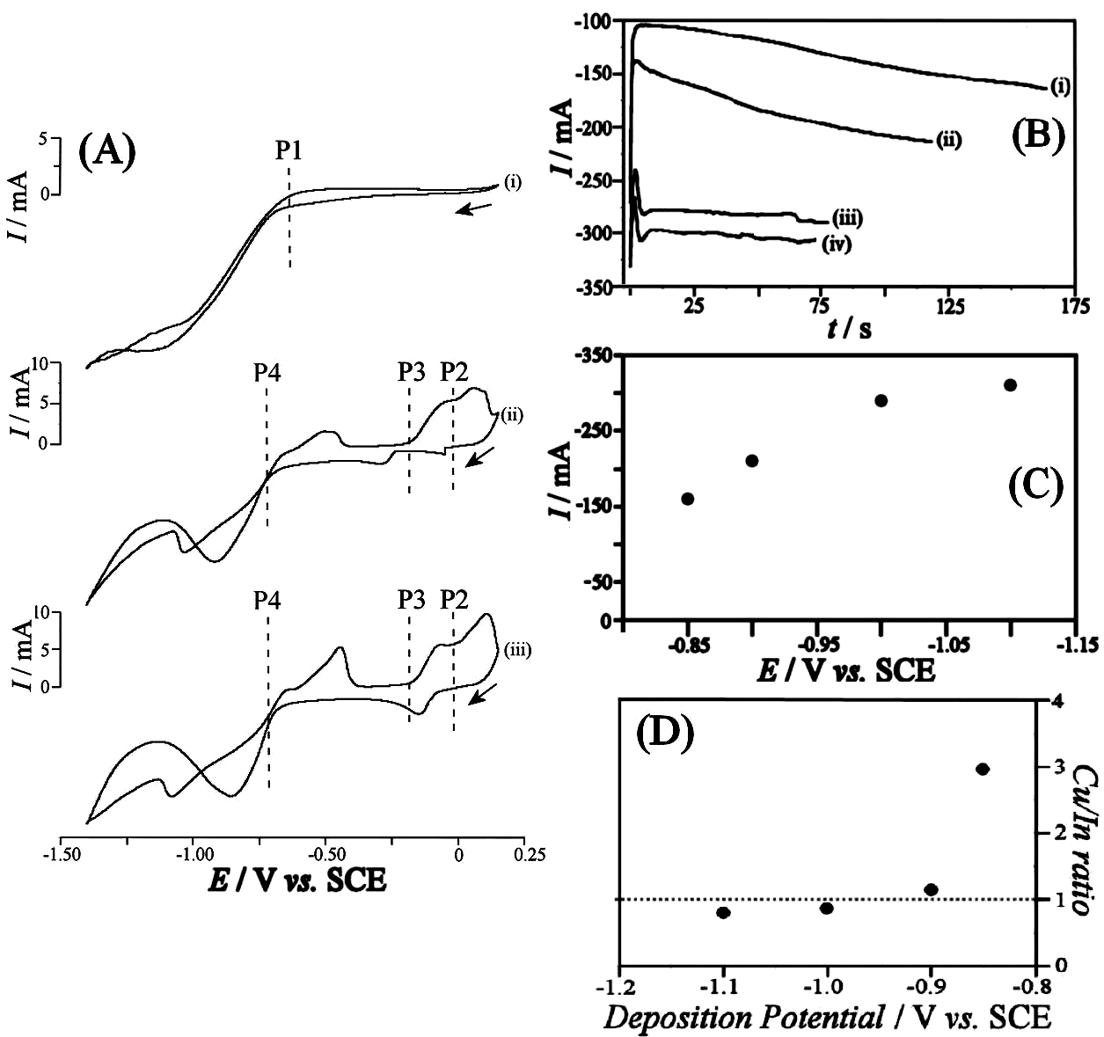
Figure 2. (A) Cyclic voltammograms (area 1 cm², scan rate 20 mVs⁻¹) showing cathodic processes at a Mo electrode immersed in (i) 0.5 M LiCl and 0.125 M Na-tartrate, (ii) and (iii) 0.5 M LiCl, 0.125 M Na-tartrate, 50 mM InCl₃, and 25 mM CuSO₄, first and second cycle respectively. (B) Chronoamperometry data for the rocking disc electrodeposition of CuIn films onto Mo substrates with 8 Hz rocking rate and 21.8 C endpoint charge. Deposition potentials were (i) -0.85, (ii) -0.9, (iii) -1.0, and (iv) -1.1 V vs. SCE. (C) Plot of chronoamperometry current (measured at end point) versus applied potential. (D) Plot of the approximate average Cu/In ratio (from EDS analysis) versus deposition potential.

In the background electrolyte the only predominant electrochemical signal (P1) on Mo can be identified as the formation of hydrogen at potentials more negative than -0.65 V vs. SCE. Upon addition of the metal salts, 25 mM copper (II) sulphate and 50 mM indium (III) chloride, the cyclic voltammograms increase in complexity. For the first cyclic voltammogram (see Figure 2Aii) there are three apparent reductions: P2 assigned to (Cu⁺/Cu²⁺) at +0.0 V vs. SCE, P3 assigned to (Cuº/Cu⁺) at -0.2 V vs. SCE, and P4 assigned to (Inº/In³⁺) at -0.7 V vs. SCE. The presence of the copper (I) intermediate species is due to the excess of tartrate and chloride ions, which stabilise the cuprous ions []. Scanning the potential more negative potentials, P4 (Inº/In³⁺) suggests that indium deposition occurs close to (and overlapping with) the onset of hydrogen evolution. The position of P4 (Inº/In³⁺) is 120 mV more negative compared to Eº′(In/In³⁺) at ca. -0.58 V vs. SCE and similar to that reported by other authors [,] suggesting that the tartrate is not affecting the indium electrochemistry. This indium deposition occurs negative compared to the onset of the hydrogen evolution, which could affect the conditions/alkalinity locally at the electrode surface. The backward potential scan metal stripping is observed with complexity due to the variety of CuIn alloys that can exist at room temperature [].

Next, the co-electrodeposition of copper and indium onto Mo substrates is studied with a rocking disc system at 8 Hz (average diffusion layer of ca. 30 μm) and with a fixed endpoint charge of 21.8 C (ignoring losses in current efficiency due to hydrogen evolution and oxygen reduction). Figure 2B shows typical current traces for complete deposition. At a more negative applied deposition potential the negative plating current is increased and the plating time decreases (Figure 2C). The indium content in deposits is increased at more negative deposition potentials (Figure 2D). Plateauing of the deposition current at an applied potential more negative than -1.0 V vs. SCE (see Figure 2C) is likely to be caused by hydrogen evolution, which is likely to accompany all deposition processes to some extent also at potentials positive of -1.0 V vs. SCE. The surface morphology of samples is investigated using SEM (see Figure 3).

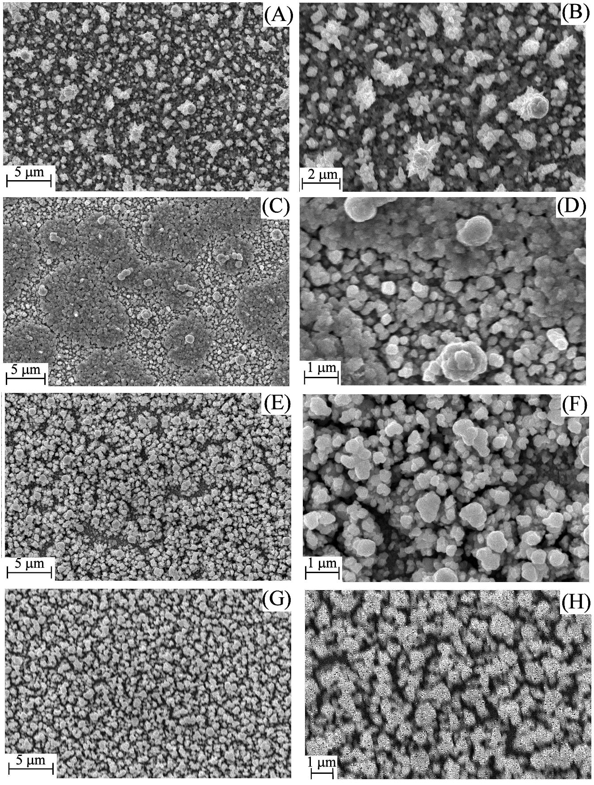
Figure 3. High and low magnification SEM images of the electrodeposits formed on Mo substrates in a 0.05 InCl₃, 0.025 M CuSO₄, 0.5 M LiCl, and 0.125 M Na-tartrate plating solution at (A,B) -0.85 V vs. SCE, (C,D) -0.9 V vs. SCE, (E,F) -1.0 V vs. SCE, and (G,H) -1.1 V vs. SCE.

CuIn films are compact and uniform. Electrodeposits formed at -0.85 V vs. SCE show more dendritic grains 0.5 μm to 2 μm in size (Figure 3B). A similar morphology is seen for electrodeposits formed at potentials more negative than -0.9 V vs. SCE with smaller grains (ca. 1 μm) and evidence for hydrogen bubble imprints. Good films with a Cu/In ratio of close to 1:1 are obtained at -1.0 V vs. SCE.

3.2. Selenisation of CuIn alloy films
There are number of reports that investigate the effect of selenisation or sulphurisation conditions for converting metallic CuIn films to CISe or CIS [,]. Here, films were placed into a graphite box (Le Carbone UK) with elemental selenium, flooded with nitrogen, and heated to 500 ºC for 30 minutes (see experimental). This converted the metallic CuIn films (Figure 4A) into the CISe (Figure 4B) by the reaction between the film and the selenium vapour.

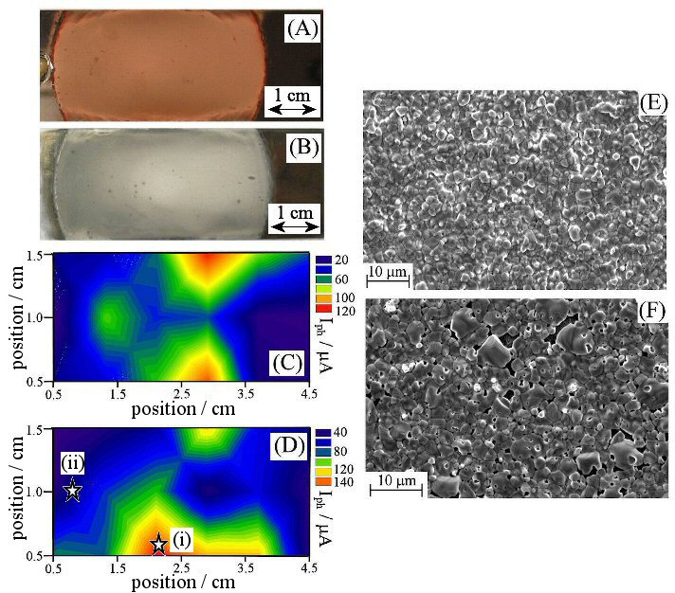
Figure 4. Photographic images for (A) as-electrodeposited CuIn films and (B) selenised CuIn films. (C) Photo-response map in aqueous 0.2 M Eu(NO₃)₃ for a CISe film after 60 s 5 %w/w KCN etching. (D) Photo-response map after 90 s etching. (E) SEM images of the CISe film after 90 s etching at location (i) with high photoactivity (>120 μA). (F) SEM image at location (ii) with low photoactivity (20 μA).

The photoactivity of the films was surveyed using the photo-electrochemical reduction of europium (III) nitrate. Only a small spot of modulated light (ca. 0.08 cm²) is illuminated with repeat measurements across the film. The photocurrent (the difference between the light and dark current) is recorded as a function of position generating a map (see experimental). Figure 4C and 4D show typical photo-response maps of the same CISe film as a function of etching time in 5 %w/w KCN, 60 s and 90 s, respectively. The photoactivity observed for these films is non-uniform ranging from 140 μA and 20 μA. Clear changes in activity pattern are observed with etching time. The difference in morphology for a highly photoactive area (see Figure 4E) and a photo-inactive area (Figure 4F) is clearly linked to the formation of pinholes during the etch exposing the underlying Mo substrate.

3.3. Etching and annealing procedures for CISe films
Cyanide etchants with 5 %w/w and 0.5 %w/w were investigated. The chemical action of the cyanide upon CISe is to remove the minor Cu_{x}Se phase in diffusion controlled manner. By decreasing the concentration of the KCN in the aqueous etching solution from 5 %w/w to 0.5 %w/w changes of activity can be monitored more readily. Photo-activity mapping showed high intermittent activity (peak photo-response ca. I_{ph} = 450 μA after 320 seconds in 0.5 %w/w KCN) whereas lower activity maxima in 5 %w/w KCN occurred after 90 s. The over-etching of the film is detrimental to the photoactivity as at 500 s with 0.5 %w/w KCN of etching the film has only a minimal remaining photoactivity. This is most likely due to the formation of pin holes to the underlying Mo substrate.

Re-annealing the over-etched film at 500 ºC for 30 minutes, and immersion the film into a solution of 0.5 %w/w KCN for 30 s, an increase in the photoactivity to locally ca. I_{ph} = 1.8 mA is possible. An alternative room temperature method for the improvement of photo-activity can be based on a Mo-etch process. Figure 5A shows a plot of the photo-response as a function of initial cyanide over-etch (5 %w/w KCN), followed by hypochlorite etch (5 %w/w NaClO), and followed by another cyanide etch.
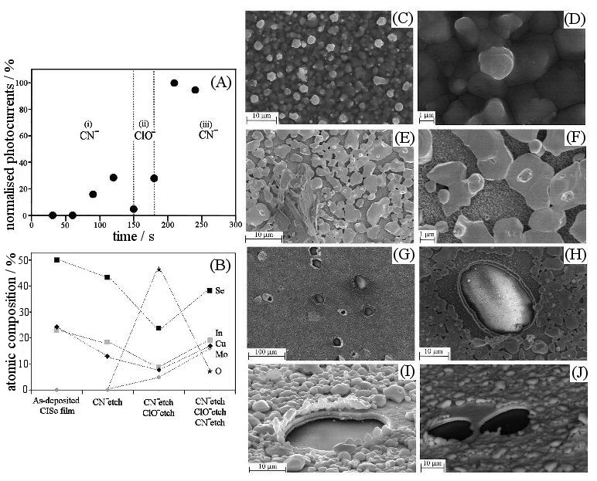
Figure 5. (A) Normalised photocurrent measurements for CISe films immersed in 0.2 M Eu(NO₃)₃ at -0.4 V vs. SCE as a function of etch treatments. In region (i) the film was etched in 5 %w/w KCN, in region (ii) in 5 %w/w NaClO, and in region (iii) in 5 %w/w KCN. (B) Plot of the relative atomic ratios (EDS) for a CISe film during different stages of the post treatment. High and low magnification SEM images of a CISe film during different times of etching: (C,D) SEM before etching, (E,F) 120 s etched in 5 %w/w KCN, (G,H,I,J) film after 150 s 5 %w/w KCN etch followed by 30 seconds in a 5 %w/w NaClO etch followed by a final 30 s 5 %w/w KCN etch. (I,J) Backscatter images showing pinholes.

The increase in average photoactivity is observed when immersing the electrode into a solution of 5 %w/w KCN until ca. 120 seconds. After this the photocurrent decreases due to over-etching and increased formation of pin holes (Figure 5I). Immersion into a solution containing 5 %w/w NaClO for 30 seconds removed the uncovered (otherwise it may be inferred that the whole underlying Mo is removed) underlying Mo film (see Figure 5E-H). The film is then etched in a solution of 5 %w/w KCN for 30 seconds and the photo-response current triples (up to I_{ph} = 1000 μA). The plot in Figure 5B shows normalised EDS atomic ratios with clear evidence of surface oxides in the hypochlorite etch.

4. Conclusion
It has been shown that a 1:1 ratio CuIn alloy electrodeposit is formed via rocking disc methods on Mo or MoSe₂ substrates. However, in mildly acidic aqueous electrolyte MoSe₂ substrates offer no advantage over Mo substrates. For CuIn deposits on Mo substrates selenisation leads to active but non-uniform CISe films. In part this non-uniformity could be due to the selenisation conditions. Improved photo-electrochemical activity (observed via photo-response mapping) was observed for CISe films that were KCN etched, re-annealed, and then etched again. An alternative low temperature method based on (i) KCN over-etching, (ii) hypochlorite pinhole removal, and (iii) a final KCN etch is proposed to give reasonably uniformly active CISe films.

Acknowledgements
The authors are grateful for financial support from the EPRSC (Supergen: Photovoltaic Materials for the 21st Century EP/F029624/1). We thank John M. Mitchels (Department of Physics, Bath) for help with SEM imaging and analysis.

References

[?] J.A. Hollingsworth, K.K. Banger, M.H.C. Jin, J.D. Harris, J.E. Cowen, E.W. Bohannan, J.A. Switzer, W. Buhro, A.F. Hepp, Thin Solid Films 431 (2003) 63-67.
[?] P.F. Luo, P.H. Yu, R.Z. Zuo, J.A. Jin, Y.K. Ding, J.D. Song, Y.T. Chen, Phys. B- Cond. Mat. 405 (2010) 3294-3298.
[?] Y. Pena, S. Lugo, M. Calixto-Rodriguez, A. Vazquez, I. Gomez, P. Elizondo, Appl. Surf. Sci. 257 (2011) 2193-2196.
[?] V.S. Saji, I.H. Choi, C.W. Lee, Solar Energy 85 (2011) 2666-2678.
[?] M.C. Sharma, B. Tripathi, S. Kumar, S. Srivastava, Y.K. Vijay, Mater. Chem. Phys. 131 (2012) 600-604.
[?] H.C. Ye, H.S. Park, V.A. Akhavan, B.W. Goodfellow, M.G. Panthani, B.A. Korgel, A.J. Bard, J. Phys. Chem. C 115 (2011) 234-240.
[?] C. Cummings, P. Frith, G. Zoppi, I. Forbes, K. Rogers, D. Lane, F. Marken, Thin Solid Films 519 (2010) 7458-7461.
[?] A. Brenner, Electrodeposition of Alloys, Vol. 1 and 2, Academic Press, New York (1963).
[?] A. Ollivier, L. Muhr, S. Delbos, P. Grand, M. Matlosz, E. Chassaing. J. Appl. Electrochem. 39 (2009) 2337-2341.
[?] F.A. Kröger, J. Electrochem. Soc. 125 (1978) 2028-2034.
[?] D. Lincot, Thin Solid Films 487 (2005) 40-43.
[?] J. Zank, M. Mehlin, H. Fritz, Thin Solid Films 286 (1996) 259-262.
[?] J.O. Bockris, A.M. Reddy, Modern Electrochemistry, Kluwer, New York, 2002.
[?] P. Dale, A. Samantilleke, G. Zoppi, I. Forbes, L. M. Peter, J. Phys. D: Appl. Phys. 41 (2008) 8-11.
[?] G. Hodes, D. Cahen, Sol. Cells 16 (1986) 245-249.
[?] J. Herrero, J. Ortega, Sol. Ener. Mat. 20 (1990) 53-55.
[?] J. Kois, M. Ganchev, M. Kaelin, S. Bereznev, E. Tzvetkova, O. Volobujeva, N. Stratieva, A. Tiwari, Thin Solid Films 516 (2008) 5948-5951.
[?] L. Ribeaucourt, G. Savidand, D. Lincot, E. Chassaing, Electrochim. Acta., 56 (2011) 6628-6631.
[?] C. Guillén, J. Herrero, Sol. Ener. Mat. 23 (1991) 31-33.
[?] F. J. Pern, J. Goral, R. J. Matson, T. A. Gessert, R. Noufi, Solar Cells 24 (1988) 81- 84.
[?] P.J. Dale, A.P. Samantilleke, G. Zoppi, I. Forbes, L.M. Peter, J. Phys. D-Appl. Phys. 41 (2008) 085105.
[?] I. Repins, M. Contreras, B. Egaas, C. DeHart, J. Scharf, C. Perkins, B. To., R. Noufi, Prog. Photovolt. Res. Appl., 16 (2008) 235-237.
[?] M. Archer, R. Hill, Clean Electricity from Photovoltaics, Imperial College Press, London, (2001).
[?] C. Guillén, J. Herrero, J. Electrochem. Soc., 141 (1994) 225-229.
[?] C. Cummings, G. Zoppi, I. Forbes, P. Dale, J. Scragg, L. Peter, G. Kociok-Köhn, F. Marken, J. Electroanal. Chem. 645 (2010) 16-19.
[?] D. Cahen, Y. Chen, Appl. Phys. Lett. 45 (1984) 746-749.
[?] B. Canava, J. Guillemoles, J. Vigneron, D. Lincot, A. Etcheberry, J. Phys. Chem. Sol. 64 (2003) 1791-1793.
[?] B. Canava, O. Roussel, J.F. Guillemoles, D. Lincot, A. Etcheberry, Phys. Status Solidi C – Curr. Topics Solid State Physics, 3 (2006) 2551-2554.
[?] M. Bouttemy, P. Tran-Van, I. Gerard, T. Hildebrandt, A. Causier, J.L. Pelouard, G. Dagher, Z. Jehl, N. Naghavi, G. Voorwinden, B. Dimmler, M. Powalla, J.F. Guillemoles, D. Lincot, A. Etcheberry, Thin Solid Films 519 (2011) 7207-7211.
[?] S. Pecharmant, J.F. Guillemoles, J. Vedel, D. Lincot, J.M. Siffre, H. Ardelean, M. Marcus, R.D. Tomlinson, A.E. Hill, R.D. Pilkington, Ternary and Multiternary Compounds, Inst. Phys. Conf. Ser. 152 (1998) 719-722.
[?] R. Hunger, T. Schulmeyer, M. Lebedev, A. Klein, W. Jaegermann, R. Kniese, M. Powalla, K. Sakurai, S. Niki, Proc. 3rd World Conf. Photovoltaic Energy Conv. A-C (2003) 566-569.
[?] J. Kois, S. Bereznev, O. Volobujeva, E. Mellikov, Thin Solid Films 515 (2007) 5871- 5874.
[?] B. Canava, J.F. Guillemoles, D. Lincot, J. Vedel, H. Ardelean, F. Malengreau, Mater. Res. Soc. Symp. Proc. 485 (1988) 133-138.
[?] U. Störkel, M. Aggour, C. Murrell, H. Lewerenz, Thin Solid Films, 387 (2001) 182- 185.
[?] B. Berenguier, H. Lewerenz, Electrochem. Comm., 8 (2006) 165-167.
[?] S. Nakamura, Phys. Stat. Sol. (c), 3 (2006) 2564-2567.
[?] C.Y. Cummings, P.E. Frith, G. Zoppi, I. Forbes, K.D. Rogers, D.W. Lane, F. Marken, Thin Solid Films 519 (2011) 7458-7463.
[?] P. M. Viacheslavov, Elektricheskoe osajdenie splavov, Mashinostroenie, Leningrad, 1986.
[?] C.Y. Cummings, G. Zoppi, I. Forbes, P.J. Dale, J.J. Scragg, L.M. Peter, G. Kociok- Köhn, F. Marken, J. Electroanal. Chem. 645 (2010) 16-21.
[?] A. Moreau, Electrochim. Acta. 26 (1981) 497-499.
[?] T. Gujar, V. Shinde, J. Park, H. Lee, K. Jung, O. Joo, J. Electrochem. Soc. 155 (2008) E131-E134.
[?] R. Valderrama, M. Miranda-Hernandez, P. Sebastian, A. Ocampo, Electrochim. Acta. 53 (2008) 3714-3718.
[?] Z. Bahari, E. Dichi, B. Legendre, J. Dugue, Thermochim. Acta. 401 (2003) 131-135.
[?] K. Ramakrishna Reddy, P. Datta, M. Carter, Phys. Stat. Sol. (a), 182 (2000) 679-682.
[?] O. Volobujeva, J. Kois, R. Traksmaa, K. Muska, S. Bereznev, M. Grossberg, E. Mellikov, Thin Solid Films 516 (2008) 7105-7109.

