**INORGANIC PHOTOVOLTAIC SOLAR CELLS**

**Robert W. Miles*, Guillaume Zoppi and Ian Forbes.**

Northumbria Photovoltaics Applications Centre, Northumbria University,

Ellison Building, Newcastle upon Tyne, NE1 8ST, U.K.

*Tel: +441912274594, Fax: +441912273650, Email: robert.miles@northumbria.ac.uk

**Abstract**

The inorganic semiconductor materials used to make photovoltaic solar cells include crystalline, multicrystalline, amorphous and microcrystalline silicon, the III-V compounds and alloys, cadmium telluride and the chalcopyrite compound, copper indium gallium diselenide. The review shows the structure of the different devices developed, discusses the main methods of manufacture and reviews the achievements of the different technologies.

**Introduction**

Some applications of photovoltaic solar cells that have been well established over the past 50 years include1:

(i) supplying power in remote locations e.g. for communications and weather monitoring systems and the lighting and water pumping systems used in developing countries,

(ii) supplying power for consumer products e.g. for electronic calculators and garden lights,

(iii) supplying power for applications in space e.g. for satellites and space vehicles.

Most photovoltaic cells now produced are deployed for large scale power generation either in centralised power stations or in the form of “building integrated photovoltaics” (BIPV). BIPV is currently receiving much attention as using photovoltaic solar cells in this way minimises land use and offsets the high cost of manufacture of the cells by the cells (or panels of cells) acting as building materials. Although crystalline silicon solar cells were the dominant cell type used through most of the latter half of the last century other cell types have been developed which compete either in terms of reduced cost of production (solar cells based on the use of multicrystalline silicon or silicon ribbon and the thin film cells based on the use of amorphous silicon, cadmium telluride (CdTe) or copper indium gallium diselenide (CIGS)) or in terms of improved efficiencies (solar cells based on the use of the III-V compounds). All of these semiconductors have energy bandgaps within the range 1.1-1.7 eV i.e. they are near to the optimum energy bandgap (1.5 eV) for photovoltaic solar energy conversion by a single junction solar cell1. The best efficiencies obtained with each cell type are given in Table 1 and the market share of the different cell types during 2006 are given in Fig. 117. Although the use of crystalline silicon cells has continued to increase rapidly the most successful technology at present is that based on the use of multicrystalline silicon which has expanded even faster. The key aim of all the technologies is to reduce production costs to 1 $ / peak Watt (1 $/Wp) to compete cost-wise with other forms of power generation. Cells based on the use of crystalline and multicrystalline silicon cost more than four times this amount. It is generally accepted that this target is most likely to be reached using thin film fabrication technologies when expanded for large scale production. The technologies also need to have acceptable energy payback times. (This is the time taken to generate the energy needed to fabricate the device by the device). Crystalline and multicrystalline devices typically have energy payback times of 3-4 years and the thin film technologies 12-18 months. Fig. 2 shows two examples of BIPV, the first using crystalline silicon solar cells, the second using CIGS thin film solar cells.

**1.1 Crystalline Silicon Solar Cells**

A cross-sectional view of the silicon solar cell structure that has been used in production up to the present is given in Fig. 3 (a)18. For crystalline silicon devices, a boule of boron doped p-type silicon is grown using the Czochralski method and wafers are sawn from the boule. Crystalline (and multicrystalline) silicon have an indirect energy bandgap resulting in a low optical absorption coefficient, with the consequence that the wafers need to be greater than 200 μm thick to absorb most of the incident light. The wafer surfaces are “textured” by dipping into a solution of sodium hydroxide and isopropyl alcohol to minimise reflection losses and to refract light entering the silicon to high angles of refraction to enhance the optical path length in the silicon. A pn junction is formed by diffusing phosphorus into the wafer as an impurity dopant. Screen printed silver contact fingers are used on the n-type surface to make electrical contact while also allowing light to be transmitted to the junction region. Aluminium paste is used to make contact at the back p-type surface. This is annealed to introduce a p+ doped region at the back of the cell, to lower the contact resistance and to supply a back surface field that reflects minority carriers back toward the junction19. An antireflection (A/R) coating (usually titanium dioxide or silicon nitride) is deposited over the top contact fingers to complete the device.

Green and co-workers20 from the University of New South Wales (UNSW) have pointed out that there is a high penalty for using screen printed contacts. High shading losses, the high resistivity of the screen printed silver grids compared to pure silver (3x as high), a high contact resistance between the grid and silicon and poor aspect ratio all reduce device efficiencies to approximately 14%. This has led them to develop solar cells in which the contacts are defined either using photolithography or laser scribing21,22. A typical “UNSW cell structure” is shown in Fig. 3(b). For the design shown the surface of the silicon has been oxidised to passivate the front surface of the cell and grooves for contacting cut using laser scribing. In this “buried contact” design the contact metals, nickel, copper and then silver, are deposited using electroless methods. The improved design permits shallower phosphorus doping at the surface of the device without degrading the open circuit voltage, improving the short wavelength response of the cell. The higher doping concentration of this n+ region also reduces the contact resistance to the grid contact. This type of cell is used in the high efficiency Saturn modules produced by BP Solar23,24. A photograph of a cell is given in Fig. 4 (a).

The highest efficiency silicon solar cell produced in the laboratory is the PERL (“passivated emitter rear locally diffused”) solar cell which has an efficiency of 24.7%2. The high efficiency is achieved by improving the surface texturing and by the inclusion of a silicon dioxide layer at the back of the device to passivate the back surface of the device2.

To minimise silicon usage there is much effort worldwide to design devices that incorporate “light trapping” features such that thinner layers of silicon can be used25. An alternative strategy is to deploy silicon solar cells in “concentrator systems”. In these systems a large area lens is used to focus the incident sunlight onto a smaller area cell26. It should however be noted that with such systems there is a need to track the sun and concentrator systems can only be used in parts of the world where there is unimpeded sunlight. A schematic view of such a system is given in Fig. 5.

**1.2 Multicrystalline Silicon**

With this technique molten silicon is poured into a container and then allowed to cool resulting in silicon ingots with large columnar grains (typically 0.3 mm diameter) growing from the bottom of the container upwards27. The grains are so large that they extend through the wafers cut from the solidified block. The incorporation of hydrogen during device processing plays an important role in passivating the grain boundaries in the devices formed. This is most conveniently introduced by using PECVD (plasma enhanced chemical vapour deposition) to deposit silicon nitride as the top insulating layer, rather than silicon dioxide, as hydrogen is used in this process. Otherwise cell processing is similar to that used for crystalline devices. A photograph of a multicrystalline cell is shown in Fig. 4 (b). Advantages of using multicrystalline growth over the Czochralski method include lower capital costs, higher throughput, less sensitivity to the quality of the silicon feedstock used and higher packing density of cells to make a module because of the square or rectangular shape of the cells. The best modules made using multicrystalline silicon generally have efficiencies 2-3% less than those of crystalline silicon and cost approximately 80% of that of crystalline silicon cells to produce.

It is also possible to pull thin sheets of multicrystalline silicon in the form of thin sheets or “silicon ribbon” from a silicon melt and the sheets then processed to make solar cells28. The need for sawing wafers can be avoided using this method. However because resulting cells generally have lower efficiencies than those made from the cast blocks and the casting method is simpler, the casting method is preferred by most manufacturers.

**1.3 Amorphous Silicon**

Thin films of amorphous silicon are usually produced using the PECVD of gases containing silane (SiH4)29. The layers may be deposited onto both rigid substrates e.g. glass and onto flexible substrates e.g. thin metallic sheets and plastics, allowing for continuous production and diversity of use. The material that is used in solar cells is actually hydrogenated amorphous silicon Si:H, an alloy of silicon and hydrogen (5-20 atomic % hydrogen), in which the hydrogen plays the important role of passivating the dangling bonds that result from the random arrangement of the silicon atoms. The hydrogenated amorphous silicon is found to have a direct optical energy bandgap of 1.7 eV and an optical absorption coefficient  greater than 105 cm-1 for photons with energies greater than the energy bandgap. This means that only a few microns of material are needed to absorb most of the incident light, reducing materials usage and hence cost. Most devices produced have the p-i-n structure shown in Fig. 6 (a). A major problem with modules made using single p-i-n junctions is that the efficiency degrades under illumination to less than 5 % due to a phenomenon known as the Staebler-Wronski effect29.

It is possible to more efficiently absorb the solar spectrum and to improve cell stability by using multiple p-i-n structures with different energy bandgap i-layers to produce “double junction” or “triple junction” structures as shown in Figs. 6 (b) and (c). Narrower energy bandgap layers are produced by alloying the silicon with germanium and wider energy bandgap layers produced by alloying the silicon with carbon. The highest reported stabilised efficiency of a double junction is now greater than 9.5% and for a triple junction module greater than 10%29.

If the gases used for the deposition of amorphous silicon are diluted in hydrogen it is found that the deposit consists of regions of crystalline silicon immersed in an amorphous matrix30. This two phase material is known as “microcrystalline silicon” or sometimes as “nanocrystalline silicon”. The physical properties of the material resemble those of crystalline / multicrystalline silicon rather than amorphous silicon, especially with regard to stability under intense illumination. Work is currently underway to develop hybrid amorphous silicon / microcrystalline silicon tandem solar cells and modules (referred to in the literature as “Micro-morph devices”). Trials indicate that these hybrid devices and modules rival triple junction amorphous silicon in terms of efficiency and stability31.

**1.4 HIT Solar Cell**

A novel device developed by Sanyo is the HIT (“heterojunction with intrinsic thin layer”) solar cell9. In this device layers of amorphous silicon are deposited onto both faces of a textured wafer of single crystal silicon. This results in (10 cm x 10 cm) multijunction devices with efficiencies greater than 21% and 80 cm x 120 cm modules with efficiencies up to 17.3%9. The advantages of this structure include potential for high efficiency, very good surface passivation, low temperature processing (all steps less than 200°C, except for substrate production), reduced energy payback time and reduced cost relative to conventional silicon devices.

**2.1 Single Junction III-V Solar Cells**

The III-V compounds such as gallium arsenide, indium phosphide and gallium antimonide have direct energy bandgaps, high optical absorption coefficients and good values of minority carrier lifetimes and mobilities (in highly pure, single crystal material) making them excellent materials for making high efficiency solar cells32. The III-V materials most widely used for making single junction solar cells are GaAs and InP as both have near optimum energy bandgaps of 1.4 eV.Originally devices were formed by the diffusion of n-type dopants into wafers from single crystals produced using either the liquid encapsulated Czochralski (LEC) method or using a Bridgmann method33. However, the confirmed highest conversion efficiencies under standard conditions are 25.8% for GaAs and 21.9% for InP single junction cells were epitaxially grown homojunction structures produced in the U.S. by the Kopin (Bedford, MA)10 and Spire (Westboro, MA)11 corporations, respectively.

The disadvantage of using III-V compounds in photovoltaic devices is the very high cost of producing device quality substrates or epitaxial layers of these compounds. Crystal imperfections, including unwanted impurities, severely reduce device efficiencies and alternative lower cost deposition methods cannot be used. These materials are also easily cleaved and are significantly weaker, mechanically, than silicon. The high density of the materials is also a disadvantage, in terms of weight, unless very thin cells can be produced to take advantage of their high absorption coefficients. These drawbacks led to them being considered as not promising materials for single junction, terrestrial, solar cells. It was primarily due to their potential for space applications that development of III-V based devices was undertaken. The potential for high conversion efficiencies together with radiation resistance in the demanding environment of space power generation mitigated against the high materials cost34. It was also realised that the high cost of cell manufacture could be off-set for terrestrial applications by using the high efficiency cells in concentrator systems35. These devices are of course subject to the requirements for direct sunlight and tracking as mentioned in section 1.1.

A recent development is that of quantum well (QW) cells made using GaAs and III-V alloys. A 50 well, strain balanced, QW solar cell has been shown to have a higher efficiency than a pn-GaAs control cell. This device was grown by metal-organic chemical vapour deposition (MOCVD)36.

**2.2 III-V Multijunction Devices**

In a single junction silicon solar cell 56% of the available energy is lost because photons with energies less than the energy bandgap are not absorbed and photons with energies greater than the energy bandgap “thermalise” such that the excess energy over the bandgap is lost as heat37. A range of studies have shown that using multi-junction solar cells (sometimes referred to as tandem solar cells) such losses can be minimised leading to much higher efficiency devices38-40. A landmark achievement to demonstrate this concept was the development in 1990 of a GaAs/GaSb stacked cell with an efficiency greater than 30%41. Much work since then has been on the development of stacked cells grown by MOCVD onto GaAs, InP and more recently Ge substrates40. The most efficient stacked cell devices are now produced by Spectrolab (Sylmar, CA) in the U.S.12,42. A cross-sectional view of a device with an efficiency > 39% is given in Fig. 7.

**3.1 Solar Cells Based on the use of CdTe**

With a direct optical energy bandgap of 1.5 eV and high optical absorption coefficient for photons with energies greater than 1.5 eV, only a few μm of CdTe are needed to absorb most of the incident light. Because only thin layers are needed, material costs are minimised and because a short minority diffusion length (a few μm) is adequate, expensive materials processing can be avoided. A cross-sectional view of a typical CdS/CdTe solar cell is shown in Fig. 8 (a). A front contact is provided by depositing a transparent conductive oxide (TCO) onto the glass substrate. The TCO layer has a high optical transparency in the visible and near infrared regions and high n-type conductivity. This is followed by the deposition of a CdS window layer, the CdTe absorber layer and finally the back contact. For commercial devices the CdS layer is usually deposited using either closed-space sublimation (CSS)43 or chemical bath deposition13, although other methods have been used to investigate the fundamental properties of devices in the research laboratory44,45. The CdTe p-type absorber layer, 3-10 m thick can be deposited using a variety of techniques including physical vapour deposition (PVD)46, CSS13, electrodeposition47 and spray pyrolysis48. To produce the most efficient devices an activation process is required in the presence of CdCl2 regardless of the deposition technique. This treatment is known to recrystallise the CdTe layer49, passivate grain boundaries50 and promote interdiffusion of the CdS and CdTe at the interface51. Forming an ohmic contact to CdTe is difficult because the work function of CdTe is higher than all the metals. This can be overcome by creating a thin p+ layer by etching the surface in bromine methanol or HNO3/H3PO4 acids solution and depositing Cu-Au alloy or ZnTe:Cu52. This creates a thin, highly doped region that carriers can tunnel through. However Cu is a strong diffuser in CdTe and causes the performances to degrade with time. Another approach is to use a very low bandgap material e.g. Sb2Te3 followed by Mo or W53. This technique does not require a surface etch and the device’s performance does not degrade with time.

The most efficient CdTe/CdS solar cells (efficiencies up to 16.5%13) have been produced using a slightly different design to that shown in Fig. 8 (a). The improved efficiency is due to the use of a Cd2SnO4  TCO layer which is more transmissive and conductive than the classical SnO2-based TCOs and the inclusion of a Zn2SnO4 buffer layer which improves the quality of the device interface. Two companies currently manufacture CdTe-based modules, First Solar and Antec Solar. Both use thermal sublimation processes and have managed to produce modules with baseline efficiencies of 8-9%54,55. First Solar current production costs are $1.25/Wp for a 99 MWp/yr manufacturing line and projected output is 275 MWp/yr for 2008 with estimated cost below the $1/Wp barrier56. In August 2007 CdTe modules manufactured by First Solar have been installed on the roof of a logistic centre in Ramstein, Germany. The installation is capable of generating 2.5 MWp of power i.e. it is currently the largest thin film BIPV generation project using thin film solar cells.

**3.2 Solar Cells Based on the use of the Chalcopyrite Compounds**

The first chalcopyrite solar cells developed were based on the use of CuInSe2 (CIS). It was however rapidly realised that by incorporating gallium to produce the solid solution Cu(In,Ga)Se2 (CIGS) resulted in a the widening of the energy bandgap to 1.3 eV and an improvement in material quality, resulting in solar cells with enhanced efficiencies. CIGS has a direct energy bandgap and a high optical absorption coefficient for photons with energies greater than the bandgap, such that only a few μm of material are needed to absorb most of the incident light, with consequent reductions in material and production costs. The best CIGS solar cells are grown on soda-lime glass in the sequence: back contact, absorber layer, window layer, buffer layer, TCO and then the top contact grid. A typical structure is shown in Fig. 8 (b). CIGS solar cells have been produced with efficiencies of 19.5%15 and modules with efficiencies of 13.4%16. The back contact is a thin film of Mo deposited by magnetron sputtering, typically 500-1000 nm thick. The CIGS absorber layer is formed mainly by (i) the co-evaporation of the elements either uniformly deposited or using the so-called 3-stage process57 or (ii) the deposition of the metallic precursor layers followed by selenisation and/or sulfidisation. The former process yields devices with the highest performance while the latter is preferred for large scale production. Both techniques require a processing temperature > 500°C to enhance grain growth and recrystallisation. Another requirement is the presence of Na either directly from the glass substrate or introduced chemically by evaporation of a Na compound58. The primary effects of the Na introduction are grain growth59, passivation of grain boundaries60 and decrease in the absorber layer resistivity61. This usually yields an increase of 1-2% in efficiency for Na concentration < 1%62. The junction is usually formed by the chemical bath deposition of a thin (50-80 nm) window layer. CdS has been found to be the best material but alternative material such as ZnS, ZnSe, In2S3, (Zn,In)Se, Zn(O,S)63 and MgZnO64 can also be used. The buffer layer can be deposited by chemical bath deposition, sputtering, chemical vapour deposition or evaporation but highest efficiencies have been achieved when using a wet process due to the presence of Cd2+ ions65. A 50 nm intrinsic ZnO buffer layer is then deposited and acts as preventing any shunts. The TCO layer is usually ZnO:Al 0.5-1.5 m. The cell is finally completed by depositing a metal grid contact Ni/Al for current collection. The main CIGS manufacturers are Würth Solar, Avancis (formerly Shell Solar) and Global Solar. Numerous other ventures are engaged worldwide in the development of CIGS-based photovoltaic products.

**Conclusions**

Most commercially produced solar cells are manufactured using either crystalline or multicrystalline silicon. Thin film solar cells based on the use of silicon, cadmium telluride and CIGS are now being mass manufactured and it is expected with economies of scale they will achieve the cost reduction needed to compete directly with the other forms of energy production in the UK. Multijunction solar cells, made so far primarily using the III-V compounds, have clearly proven that by minimising thermalisation and transmission losses very large improvements in efficiency can be made over those of single junction cells. These devices find application for generating power for space applications and for use in concentrator systems. The development in the future of multijunction devices using low cost thin film technologies is also especially promising for producing more efficient and yet inexpensive devices. Cost reductions will also be significant when the thin film technologies are directly produced on building materials other than glass as many materials e.g. tiles and bricks can be substantially cheaper than glass (and have much lower energy contents than glass).

**References**

1. Partain, L. D., *Solar Cells and Their Applications*, John Wiley & Sons, (1995)

2. Zhao, J.*, et al.*, *Applied Physics Letters* (1998) **73**, 1991

3. Zhao, J.*, et al.*, *Progress in Photovoltaics: Research and Applications* (1997) **5**, 269

4. Schultz, O.*, et al.*, *Progress in Photovoltaics: Research and Applications* (2004) **12**, 553

5. King, D. L.*, et al.*, In *Proceedings of the 1st World Conference on Photovoltaic Energy Conversion,* Hawaii, (1994), 1660

6. Egawa, T.*, et al.*, In *Materials Research Society Symposium Proceedings,* San Fransisco, California, (1998), **482**, 1101

7. Yang, J.*, et al.*, In *Proceedings of the 1st World Conference on Photovoltaic Energy Conversion,* Hawaii, (1994), 380

8. Yoshimi, M.*, et al.*, In *Proceedings of the 3rd World Conference on Photovoltaic Energy Conversion,* Osaka, Japan, (2003), 1566

9. Maruyama, E.*, et al.*, In *Proceedings of the 4th World Conference on Photovoltaic Energy Conversion,* Hawaii, (2006), 1455

10. Gale, R. P.*, et al.*, In *Proceedings of the 21st IEEE Photovoltaic Specialists Conference,* Kissimmee, Florida, (1990), 53

11. Keavney, C. J.*, et al.*, In *Proceedings of the 21st IEEE Photovoltaic Specialists Conference,* Kissimmee, Florida, (1990), 141

12. King, R. R.*, et al.*, In *Proceedings of the 21st European Photovoltaic Solar Energy Conference,* Dresden, Germany, (2006), 124

13. Wu, X.*, et al.*, In *Proceedings of the 17th European Photovoltaic Solar Energy Conference,* Munich, Germany, (2001), 995

14. Cunningham, D.*, et al.*, In *Proceedings of the 28th IEEE Photovoltaic Specialists Conference,* Anchorage, Alaska, (2000), 13

15. Contreras, M. A.*, et al.*, *Progress in Photovoltaics: Research and Applications* (2005) **13**, 209

16. Tanaka, Y.*, et al.*, In *Proceedings of the 17th European Photovoltaic Solar Energy Conference,* Munich, Germany, (2001), 989

17. World Cell Production in 2006, in *PV News*, (2007), **26**, 4, 10

18. Willeke, G. P., In *Proceedings of the 19th European Photovoltaic Solar Energy Conference,* Paris, France, (2004), 383

19. Mandelhorn, J. and Maneck, J. H., In *Proceedings of the 9th IEEE Photovoltaic Specialists Conference,* Silver Springs, Florida, (1972), 66

20. Green, M. A.*, et al.*, In *Proceedings of the 18th IEEE Photovoltaic Specialists Conference,* Las Vegas, Nevada, (1985), 39

21. Wenham, S., *Progress in Photovoltaics: Research and Applications* (1993) **1**, 3

22. Wenham, S. R. and Green, M. A., *Buried Contact Solar Cell*, Australia patent 570309, 1985

23. Bruton, T. M.*, et al.*, In *Proceedings of the 12th European Photovoltaic Solar Energy Conference,* Amsterdam, The Netherlands, (1994), 531

24. Mason, A.*, et al.*, In *Proceedings of the 19th European Photovoltaic Solar Energy Conference,* Paris, France, (2004), 2653

25. Poortmans, J.*, et al.*, In *Proceedings of the 14th international Photovoltaics Science and and Engineering Conference (PVSEC-14),* Bangkok, Thailand, (2004), 13

26. Luque, A. and Andreev, V., *Concentrator Photovoltaics*, Springer Series in Optical Sciences, (2007); Vol. 130

27. Ghosh, M.*, et al.*, In *Proceedings of the 19th European Photovoltaic Solar Energy Conference,* Paris, France, (2004), 560

28. Eyer, A.*, et al.*, *Optoelectronics* (1990) **5**, 239

29. Wronski, C. R. and Carlson, D. E., Amorphous Silicon Solar Cells. In *Clean Electricity from Photovoltaics*, Archer, M. D., Hill, R. (eds.), Imperial College Press, London, U.K., (2001), 199

30. Baba, T.*, et al.*, In *Proceedings of the 13th European Photovoltaic Solar Energy Conference,* Nice, France, (1995), 1708

31. Shah, A.*, et al.*, In *Proceedings of the Technical-digest of the 14th International Photovoltaic Science and Engineering Conference,* Bangkok, Thailand, (2004), 39

32. Bube, R. H., *Photovoltaic Materials*, Imperial College Press, London, U.K., (1998)

33. Klausmeier-Brown, M. E., Status, Prospects, and Economics of Terrestrial, Single Junction GaAs Concentrator Cells. In *Solar Cells and their Applications*, Partain, L. D. (eds.), John Wiley & Sons, (1995), 125

34. Weinberg, L.*, et al.*, In *Proceedings of the 18th IEEE Photovoltaic Specialists Conference,* Las Vegas, Nevada, (1985), 5344

35. Luque, A., Concentrator Cells and Systems. In *Clean Electricity from Photovoltaics*, Archer, M. D., Hill, R. (eds.), Imperial College Press, London, U.K., (2001), 529

36. Barnham, K. W. J.*, et al.*, In *Proceedings of the 3rd World Conference on Photovaltaic Energy Conversion,* Osaka, Japan, (2003), 606

37. Jackson, E. D., *Transactions of Conference on the use of Solar Energy* (1958) **5**, 122

38. Fraas, L. M. and Avery, J. E., *Optoelectronics-Devices and Technologies* (1990) **5**, 297

39. Gokcen, N. A. and Loferski, J. J., *Solar Energy Materials* (1979) **1**, 271

40. Henry, C. H., *Journal of Applied Physics* (1980) **51**, 4494

41. Miles, R. W.*, et al.*, *Progress in Crystal Growth and Characterization of Materials* (2005) **51**, 1

42. Green, M. A.*, et al.*, *Progress in Photovoltaics: Research and Applications* (2007) **15**, 35

43. Bonnet, D. and Rabenhorst, H., In *Proceedings of the 9th IEEE Photovoltaic Specialists Conference,* Silver Springs, Maryland, (1972), 129

44. Aramoto, T.*, et al.*, *Japanese Journal of Applied Physics* (1997) **36**, 6304

45. Romeo, N.*, et al.*, In *Proceedings of the 14th European Photovoltaic Solar Energy Conference,* Barcelona, Spain, (1997), 2351

46. Takamoto, T.*, et al.*, *Solar Energy Materials and Solar Cells* (1997) **49**, 219

47. Morris, G. C.*, et al.*, In *Proceedings of the 21st IEEE Photovoltaic Specialists Conference,* Kissimmee, Florida, (1990), 575

48. Chu, T. L. and Chu, S. S., *Solid-State Electronics* (1995) **38**, 533

49. Zoppi, G.*, et al.*, *Semiconductor Science and Technology* (2006) **21**, 763

50. Edwards, P. R.*, et al.*, In *Proceedings of the 2nd World Conference on Photovoltaic Solar Energy Conversion,* Vienna, Austria, (1998), 472

51. Jensen, D. G.*, et al.*, In *Proceedings of the 25th IEEE Photovoltaic Specialists Conference,* Washington, USA, (1996), 773

52. Meyers, P. E., *Solar Cells* (1988) **23**, 59

53. Romeo, A.*, et al.*, In *Proceedings of the 2nd World Conference on Photovoltaic Solar Energy Conversion,* Vienna, Austria, (1998), 1105

54. Bonnet, D., *Thin Solid Films* (2000) **361-362**, 547

55. Rose, D.*, et al.*, In *Proceedings of the 29th IEEE Photovoltaic Specialists Conference,* New Orleans, (2002), 555

56. Eaglesham, D., Scalable, Manufacturable, TF-on-glass: from $1.59/W to $1/W, *Presented at the Thin-Film Compound Semiconductor Photovoltaics Symposium, Materials Research Society Spring Meeting*, (2007)

57. Contreras, M. A.*, et al.*, In *Proceedings of the 1st IEEE World Conference on Photovoltaic Energy Conversion,* Hawaii, (1994), 68

58. Romeo, A.*, et al.*, *Progress in Photovoltaics: Research and Applications* (2004) **12**, 93

59. Rudmann, D.*, et al.*, *Thin Solid Films* (2005) **480-481**, 55

60. Rudmann, D.*, et al.*, *Applied Physics Letters* (2004) **84**, 1129

61. Granata, J. E. and Sites, J. R., In *Proceedings of the 2nd World Conference on Photovoltaic Solar Energy Conversion,* Vienna, (1998), 604

62. Niles, D. W.*, et al.*, *Journal of Vacuum Science & Technology A-Vacuum Surfaces and Films* (1997) **15**, 3044

63. Siebentritt, S., *Solar Energy* (2004) **77**, 767

64. Minemoto, T.*, et al.*, *Thin Solid Films* (2000) **372**, 173

65. Weinhardt, L.*, et al.*, *Thin Solid Films* (2003) **431-432**, 272

**List of Figures**

Fig. 1: The market share of photovoltaic solar cell types sold during 2006.

Fig. 2: (a)The 40 kWp façade of the Northumberland building at Northumbria University, UK which uses the crystalline silicon solar modules manufactured by BP Solar. (Saturn modules). (b)The 85 kWp façade of the Technium OpTIC (opto-electronics Technology and Incubation Centre) in St Asaph, Wales which is covered with the CIGS modules manufactured by Shell Solar.

Fig. 3 A cross-sectional view of a silicon solar cell produced (a) with screen printed contacts (b) a UNSW solar cell with buried contacts.

Fig. 4: A photograph of (a) a crystalline silicon solar cell and (b) a multicrystalline silicon solar cell.

Fig. 5: A schematic view of a concentrator system. The Fresnel lens focuses light onto the high efficiency cell which may be either a silicon cell or a cell made using III-V compounds.

Fig. 6: A cross-sectional view of (a) a single junction (b) a double junction and (c) a triple junction amorphous silicon solar cell.

Fig. 7: A cross-sectional view of a 39.3% efficient III-V multijunction device grown on a germanium substrate.

Fig. 8: Cross-sectional views of thin film solar cells based on the use of compound semiconductors: (a) a CdS/CdTe thin film solar cell and (b) a CdS/CIGS thin film solar cell.

Table 1 Best efficiencies reported for the different solar cells and modules

|  |  |  |  |  |  |  |  |
| --- | --- | --- | --- | --- | --- | --- | --- |
|  | Highest reported small area cell efficiency | | | Highest reported module efficiency | | | |
|  | *Efficiency %* | *Area cm2* | *Reference* | *Efficiency %* | | *Area cm2* | *Reference* |
| Crystalline Si | 24.7 | 4.0 | UNSW*i*, PERL*ii,*2 | 22.7 | | 778 | UNSW/Gochermann3 |
| Multicrystalline Si | 20.3 | 1.0 | FhG-ISE*iii,*4 | 15.3 | | 1017 | Sandia/HEM5 |
| Amorphous (and nanocrystalline) Si | 10.1 | 1.2 | Kaneka, Single junction6 | 10.4 | | 905 | USSC*iv*, Triple junction7 |
| c-Si/Si:H micro-morph cell | 11.7 | 14.2 | Kaneka, Minimodule8 | 11.7 | | 14.2 | Kaneka, Minimodule8 |
| HIT*v* cell | 21.8 | 100.4 | Sanyo Corporation9 | 17.3 | | 11000 | Sanyo Corporation9 |
| GaAs cell | 25.8 | 3.9 | Kopin Corporation10 | Not relevant | | |  |
| InP cell | 21.9 | 4.0 | Spire Corporation11 | Not relevant | | |  |
| GaInP/GaAs/Ge Multijunction cell | 39.3* | 0.4 | Spectrolab, Concentrator12 | Not relevant | | |  |
| CdTe | 16.5 | 1.0 | NREL*vi*,13 | 10.7 | 4874 | | BP Solarex14 |
| CIGS*vii* | 19.5 | 0.4 | NREL15 | 13.4 | 3459 | | Showa Shell16 |

*i* UNSW, University of New South Wales.

*ii* PERL, passivated emitter rear locally diffused.

*iii* FhG-ISE, Fraunhofer Institute for Solar Energy Systems.

*iv* USSC, United solar Systems Corporation.

*v* HIT, heterojunction with intrinsic thin layer.

*vi* NREL, National Renewable Energy Laboratory.

*vii* CIGS, copper indium gallium diselenide.

*Boeing-Spectrolab (Sylmar, CA) announced a 40.7% efficient cell under 240X concentrated light in December 2006 (unpublished).

**Fig. 1**

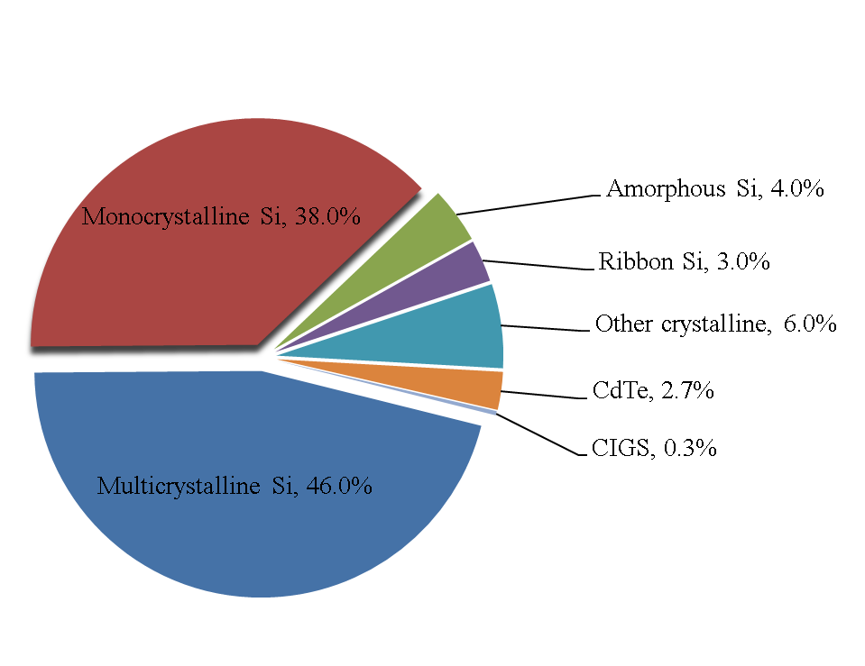

**Fig. 2**

**(a)**

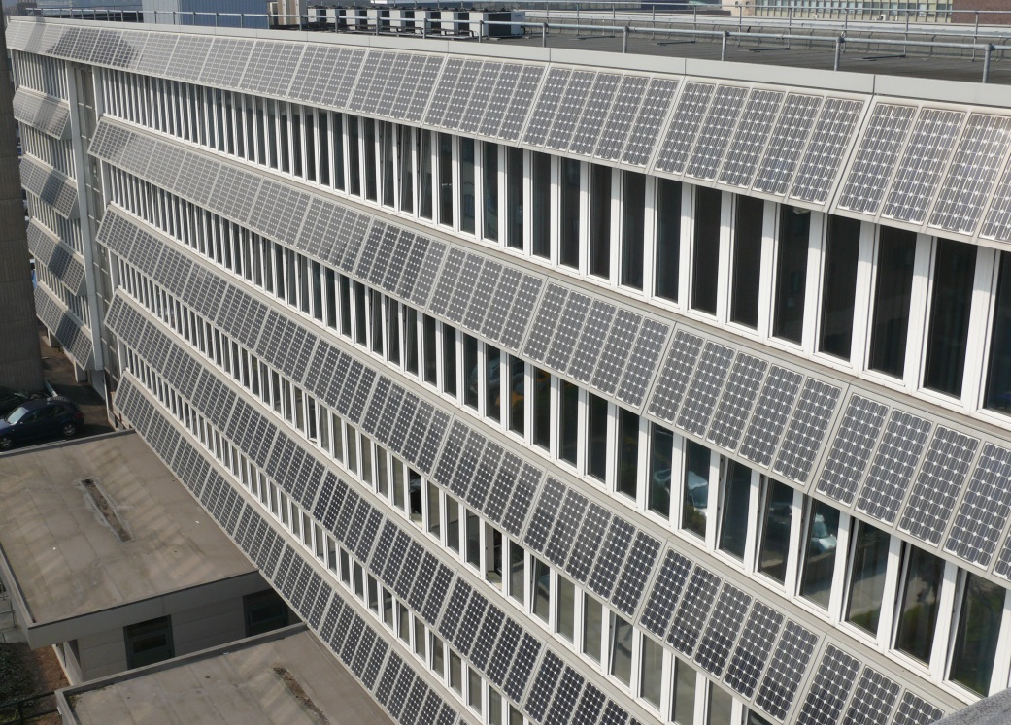

**(b)**



**Fig. 3 (a)**

Fig1-C-Si screen printed contact

**Fig. 3 (b)**

Fig2-C-Si buried contact

**Fig. 4**

**(a)**

Mono cell

**Fig. 4**

**(b)**

poly cell

**Fig. 5**

concentrator

**Fig. 6 (a)**

Fig3 a-Si H single

**Fig. 6 (b)**

Fig3 b a-Si H double

**Fig. 6 (c)**

Fig3c a-Si H triple

**Fig. 7**

Fig5 III-V

**Fig. 8 (a)**

Fig6 CdTe

**Fig. 8 (b)**

Fig7 CIGS