Urban Planning (ISSN: 2183-7635)
2023, Volume 8, Issue 1, Pages X–X
https://doi.org/10.17645/up.v8i1.6084
Article
A Spatio-Temporal Analysis of the Urban Fabric of Nuremberg From the 1940s Onwards Using Historical Maps
Carol Ludwig ^{1,†} and Seraphim Alvanides ^{2,}*,†
¹ GESIS – Leibniz Institute for the Social Sciences, Germany
² Department of Architecture and Built Environment, Northumbria University, UK
* Corresponding author (s.alvanides@northumbria.ac.uk)
† The authors contributed equally to this work
Submitted: 31 July 2022 | Accepted: 8 December 2022 | Published: in press
Abstract
As one of the most heavily bomb-damaged cities in Germany, with around 90% of its historic city centre destroyed, Nuremberg (Nürnberg) provides an excellent example to investigate the urban transformation of a postwar city. In this article, we bring together heterogeneous and under-researched data sets and archival material from the postwar period and convert urban features depicted in historic maps and scanned documents into digital geospatial data that is analyzed with a geographical information system. We combine morphological variables of townscape analysis to present three different transformations over time. First, using a damage map of Nuremberg from the Second World War, we examine the varying extent of bomb damage across the city at the detailed district level. Secondly, we focus on land-use units, comparing the prewar spatial land-use distribution from 1940 with historical maps of land use/cover from 1956 and more recent land uses in 1969. Finally, using selected characteristics of urban form, we categorize prewar and present-day urban block typologies to examine urban morphological change. In doing so, we contribute methodologically and substantively towards a new framework for the analysis of postwar cities. We demonstrate how geographical information systems can be utilized for historical research and the study of change in urban environments, presenting a map-based interpretation of the planning strategies to have guided postwar urban development in Nuremberg. Providing an alternative appraisal of postwar city transformation, our diachronic research offers insight into Nuremberg’s under-researched past, which is also of interest to planners and policymakers seeking to improve future cities.
Keywords
city transformation; damage maps; geographical information science; postwar planning; urban morphology
Issue
This article is part of the issue “Bombed Cities: Legacies of Post-War Planning on the Contemporary Urban and Social Fabric” edited by Seraphim Alvanides (Northumbria University) and Carol Ludwig (GESIS – Leibniz Institute for the Social Sciences).
© 2023 by the author(s); licensee Cogitatio (Lisbon, Portugal). This article is licensed under a Creative Commons Attribution 4.0 International License (CC BY).
1. Introduction
Cities are in a constant state of flux and the different epochs in which they have grown have always left their mark. Territorial expansions, as well as internal change, have shaped their evolution and continuity. Some of the most significant and rapid urban changes in the last century have been caused, or at least accelerated, by the destruction of war. At the time of writing, the Russian invasion of Ukraine has brought war to Europe again, destroying homes, shopping centres, hospitals, and other urban infrastructure. The World Bank, the Ukrainian government, and European Commission estimate a cost of nearly $350 billion to rebuild the country (World Bank, 2022). Against this backdrop, it has become increasingly important to study postwar transformation and reflect on the postwar planning strategies of bombed cities. While war destruction, postwar city planning, and reconstruction across Europe have been studied extensively in the past (Diefendorf, 1993; Durth & Gutschow, 1993; Hohn, 1991; Pendlebury et al., 2009), surprisingly few studies have quantitatively explored how bomb destruction affected the long-term physical and social development of cities. Archival research can uncover postwar maps/plans and documented planning intentions, but studies measuring in what way these transformed the city have rarely been conducted. This article contributes to this research gap by employing geographical data science methods to explore how the Second World War bombing of Nuremberg transformed the city’s physical fabric. In doing so, we provide a map-based interpretation of the planning strategies to have guided city reconstruction by addressing the following research question: To what extent has the level of destruction caused by the Second World War bombing influenced the land-use mix (LUM) and urban morphology of Nuremberg over time? The research is set within the context of postwar planning strategies, which have influenced the redevelopment of bomb-damaged cities, and it is underpinned by research and methodological developments in the field of urban morphology.
2. Background and Study Area
2.1. Diachronic Morphological Studies
As early as the late 19th century, a particular logic or urban planning strategy was dictating the organization of the urban fabric in some places (Howard, 1898), and planning strategies continued to shape urban change during the interwar and postwar years (Pendlebury et al., 2009). To help us to better understand this physical transformation of cities, diachronic morphological studies are useful (Levy, 1999). We draw particularly on ideas developed by Conzen (1960), who developed a form of townscape analysis which included a combination of the town plan, the pattern of building forms, and land use. The town plan comprises three plan elements: the arrangement of the street system, plots and their aggregation in street blocks, and building block plans. Understanding the spatial patterns and relationships between these elements enables the identification of morphological regions which share unifying characteristics (Conzen, 1960). Many studies have utilised this approach, classifying plot typologies, streets, constructed spaces, or open spaces, urban spaces and squares (Levy, 1999). They tend to focus on either (a) the “constants” in the urban environment (“historically persistent elements”) or (b) the relationship between these elements over time (Levy, 1999, p. 81). They help to reveal more about a city’s past and explain development interventions over time. Moreover, an understanding of morphological evolution can answer questions about the physical integration of new developments into the existing urban environment, assisting the historical conservation of cities, as well as guiding their future development.
Several studies have applied quantitative techniques to the analysis of townscape and urban environments (Fleischmann et al., 2022; Mohamed et al., 2022; Venerandi et al., 2018). These articles present different ways to classify, measure, and combine metrics of urban form, with a view to modelling complex relationships or using the results as a diagnostic tool to identify areas of the city in need of enhancement. Few studies, however, explicitly explore postwar transformation through the lens of morphological change, with the exception of Hanson (2000). Using space syntax, Hanson summarizes the characteristics of postwar urban transformation in London. She recognizes a shift from a flexible, density-maximising, continuous street space with an outward-facing morphology, to inflexible, density-minimizing development forms, characterized by fragmented, bounded estate space, with an inward-facing morphology (Hanson, 2000). This observation reflects the findings of Levy (1999, p. 81) that over time “cities that were dense, compact and continuous” became “diffuse, loose and discontinuous.” Hanson describes what she terms the “modernist urban genotype,” which she observed in the postwar period (Hanson, 2000, p. 112). She finds that the early and immediate post-war estates which belong to this genotype tend to be resistant to change, often repetitive, and “reduce physical contact among close neighbours” (Hanson, 2000, p. 113), thus making a connection between urban morphology and socioeconomic profile, also implied by Jacobs (Year), Whyte (1980) and Gehl (1987). More recently, attempts have been made to measure such dependencies quantitatively using a range of newly developed geographical data science methods (Fleischmann et al., 2022; Mohamed et al., 2022; Venerandi et al., 2018). Scholars have, however, rarely used war damage maps as sources for the study of change in urban environments.
2.2. Mapping Bomb-Damaged Cities
There is a growing body of research in critical cartography that examines war damage and thematic maps as an interdisciplinary historical source (Black, 2018; Elżanowski & Enss, 2021). These maps were drawn up during and after the Second World War by a range of actors (city administrations, specialised authorities, private individuals) for a variety of purposes: to provide a record of bomb damage, rubble displacement, information about the structural stability of buildings, or an inventory of the postwar building stock. In addition to this, they were sometimes used to make planning decisions, inform city reconstruction, make a case for funding, or as commemorative devices. For researchers and historians in the fields of architectural history, historical geography, planning, and heritage conservation these maps offer a visual source of information about postwar cities, which can be critically analyzed. Such commentators question the ways in which the maps were created, their intentions, use, as well as how they were perceived and reinterpreted. The research presented in this article extends this growing body of research on postwar damage cartography beyond the scope of simple visual analysis. We convert the urban features depicted in such maps into digitized geospatial data (raster and vector form) that is analyzed with a geographical information system (GIS). With the application of GIS, we build on the notion of “spatial history” and “historical GIS,” which emerged as a subfield that seeks to merge the study of time and place (Campbell, 2016). The use of GIS beyond a visualization and analysis tool enables us to overcome the traditional notion of a map and to operate directly with geospatial models, enriched with data extracted from historical cartography. This not only allows new questions to be asked of the maps but also allows us to operate with their information in novel ways. In doing so, we create new insights into the geographies of the past and the transformation of the city. We have drawn on the theoretical framework set out above, together with the approaches tested in the aforementioned quantitative morphological studies to develop a research approach, which commences with war damage maps from the heavily bomb-damaged city of Nuremberg.
2.3. The Destruction of Nuremberg
With a population of around 520,000 individuals, Nuremberg is the second-largest city in Bavaria and one of the 15 largest cities in Germany. Nuremberg suffered heavy bombing during the Second World War with the main destruction taking place on January 2, 1945. In 1939, according to the official census, there were 125,074 normal dwellings in Nuremberg and a population of 423,838 inhabitants. In May 1945 only 63,753 dwellings were left (52.5% of the pre-war housing stock). Of these, 7,238 were completely uninhabitable because of severe damage. Only 14,517 had been spared from the destruction of the war (Durth & Gutschow, 1993). The remaining dwellings were either severely, moderately, or slightly damaged.
Historical maps of Nuremberg record bomb damage in a variety of ways, depending on the purpose and year of interest. In some cases, the damage is recorded with broad brushes for large areas and enhanced with additional information such as graphs and pie charts indicating the level of destruction. In their most detail, the historical maps record damage for individual buildings with different colours and hatching, in some cases differentiating the level of damage between the façade and the main building (Enss & Knauer, 2023). The 1950 damage map used for this article was purchased from the Nuremberg City Archive (“Stadtplan nach 1945 mit Kennzeichnung der Zerstörungen des II Weltkrieges,” 1950) and selected amongst many other maps for three reasons (Figure 1). Firstly, it covers the whole city, including the areas surrounding the historical centre and the outskirts, rather than only selected areas of interest. Secondly, the bomb damage has been drawn on top of an official base map from 1945, depicting the outline of every single building in acceptable detail. Thirdly, a clear attempt was made by the cartographers to classify and record damage consistently, including a map legend depicting the correspondence of map colours to the severity of building damage.
In addition to the damage map, archival evidence found in other postwar maps and documents was collected: Die bevorstehende Wirtschaftsplanung in Nuremberg (The Upcoming Economic Planning in Nürnberg) written by professor of Economics, Dr. Sven Helander (Hindenburg Hochschule, Nuremberg) in 1945, 10 Jahre Wohnungsbau in Nuremberg (10 Years of Housing Construction) written by Nuremberg City Councillor (Berufsm Stadtrat) Dr. Urschlechter (1956), and the Nuremberg Grossbebaungsplan 1940 (“Grossbebauungsplan von Nürnberg und Umgegend,” 1940), Wirtschaftsplan 1956 (“Wirtschaftsplan der Stadt Nürnberg,” 1956) and Flächennutzungsplan 1969 (“Flächennutzungsplan der Stadt Nürnberg,” 1969). Together with academic literature, these have enabled an understanding of the documented spatial distribution of wartime destruction across Nuremberg, as well as the postwar planning intentions and subsequent development activity. These documents form the secondary data used in this article and inform the interpretation of our analysis and extensive discussion that follows.
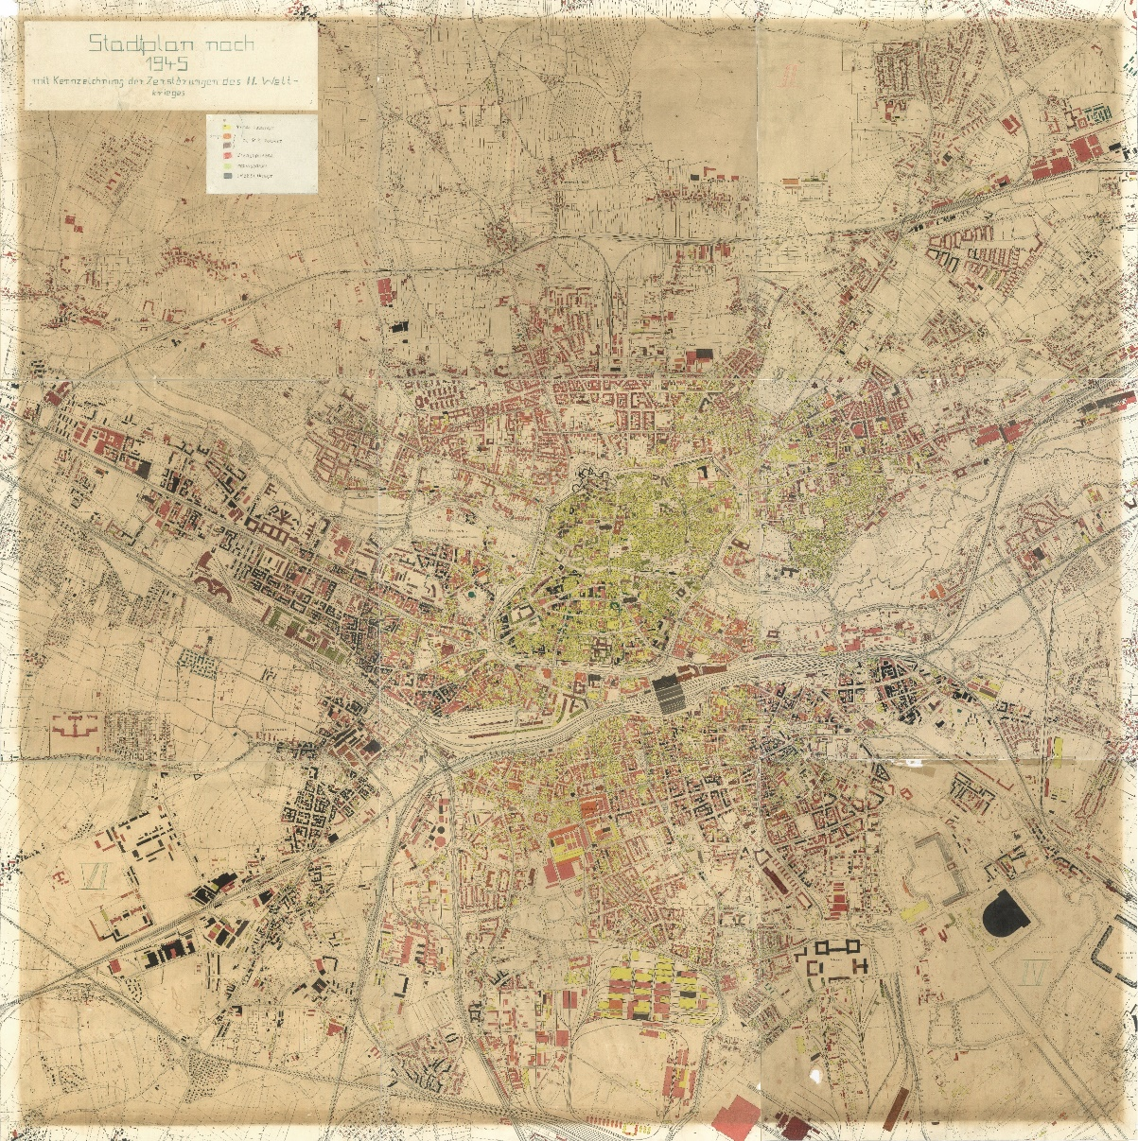
Figure 1. Damage map of Nuremberg (1950) drawn on a base map from 1945. Source: “Stadtplan nach 1945 mit Kennzeichnung der Zerstörungen des II Weltkrieges” (1950).
3. Methodology
3.1. Data Sources
The main sources of data for this article are historical maps from the pre-war and post-war periods; the importance of historical maps for urban planning research has been highlighted by various scholars, for example in Gregory et al.’s (2018) seminal companion to spatial history. Of particular interest here is the use of bomb damage maps created after the bombing of major German cities. The case for using historical war damage maps in researching urban histories has been made by Elżanowski and Enss (2021), comparing cities in Poland and Germany. In addition, historical maps of land use/cover were used from 1940 and 1956 for comparisons with more recent maps from 1969. Thirdly, broad building blocks (built-up areas surrounded by main streets) were digitized on historical and contemporary maps in order to assess their typologies based on Conzen (1960). The datasets discussed here were subsequently georeferenced at the city district level (Distrikte, hereafter “districts”), which are the smallest areal units that allow for analysis of the built environment and socioeconomic characteristics over time. The georeferenced boundaries of the 316 districts were provided by the Nuremberg local authority and constitute the smallest areal units used by their statistical office (Amt für Stadtforschung und Statistik) for disseminating socioeconomic data.
3.2. Bomb Damage/Destruction Index
Given the diversity of the geographical data used in the overall project, it was important to establish a unit of observation that would facilitate comparisons and analysis of pre- and post-war data recorded at different scales. The unit of analysis should also be realistic in terms of the time and effort required to record the various observations and as much as possible replicable across different cities, depending on the context of data availability. For example, recording bomb damage at the individual building level or even at the building block level was not feasible and would almost certainly provide accuracy that would be superfluous for subsequent analysis. On the other hand, larger areas such as Stadtteile (10 areas) or even Stadtbezirke (87 areas) would provide a very high level of aggregation and within-area variability for performing meaningful statistical analysis, thus making the districts the most appropriate level of analysis for Nuremberg. We also experimented with automated methods of image recognition, such as machine learning algorithms applied to remotely sensed images. However, due to the very specific nature of the cartographic colouring and hatching, it was not possible to complete the process automatically, at least for the specific historical map shown in more detail in Figure 2a. Therefore, the district-level bomb damage was estimated from the different levels of destruction shown on the georeferenced historical map by superimposing the boundaries of the 316 districts (white lines in Figure 2a) and interpreting the five levels of damage shown in the map legend (Figure 2b). The map legend translates from top to bottom: completely damaged (yellow), up to 60% damaged in two colours (brown for heavy and orange for medium damage), reconstruction implying less than 40% damaged (red), and undamaged implying intact (black). It may be counter-intuitive to use yellow for a negative impact such as bomb damage and solid black for intact buildings, but this is a convention we observed relatively consistently with other historical maps of bomb damage in Germany. For example, the use of yellow or bright red (in other cities) for heavily bombed buildings and the depiction of undamaged buildings and structures in solid black imply that they are to remain unchanged.
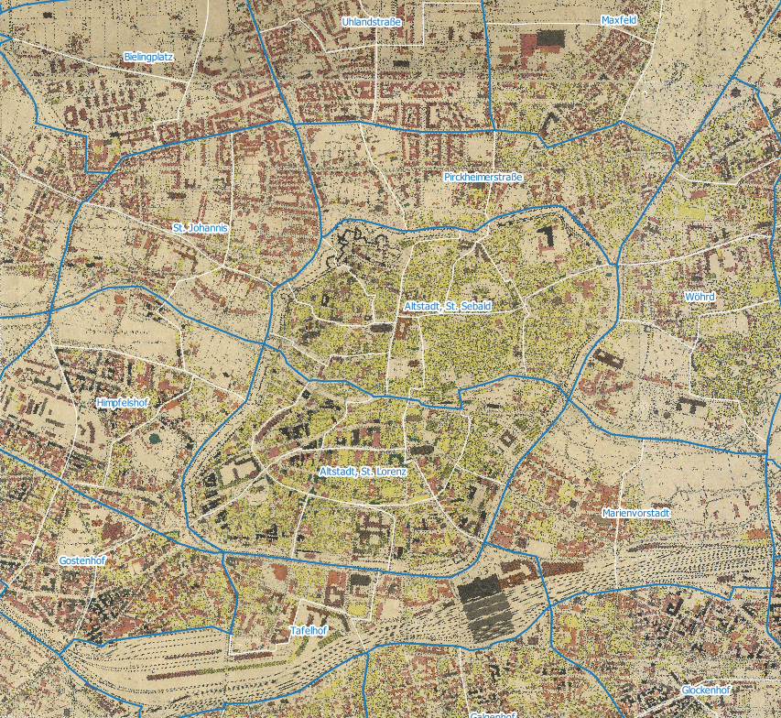
(a)
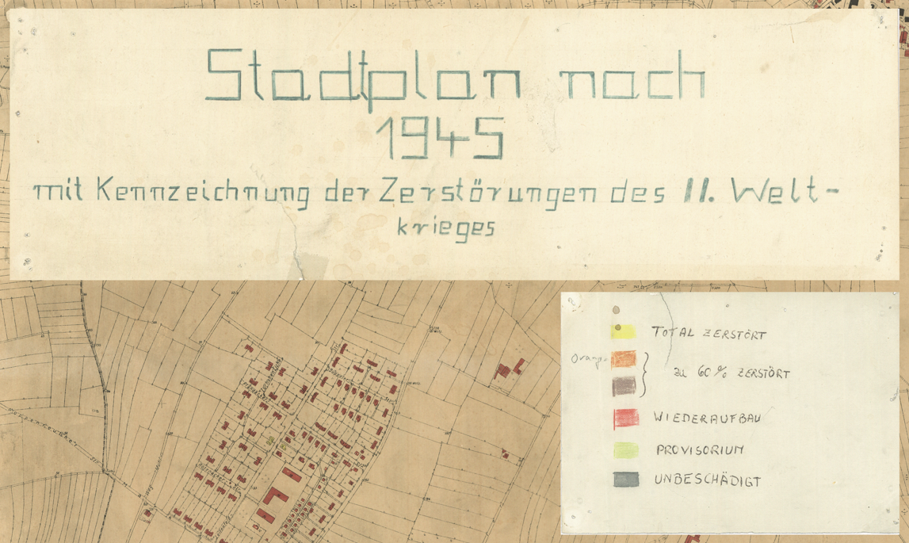
(b)
Figure 2. (a) The damage map of Nuremberg (1950, detail) with superimposed district boundaries (in white) for city quarters (in blue). (b) The map legend shows the five levels from completely damaged to intact buildings. Source of the map:”Stadtplan nach 1945 mit Kennzeichnung der Zerstörungen des II Weltkrieges” (1950). Boundaries from Amt für Stadtforschung und Statistik (2021).
Two individual research assistants recorded the percentage of each of the five damage categories-colours independently and then averaged classification differences up to 5%, while for larger deviations there was moderation and agreement. The damage was recorded for the built-up area covering each of the 316 districts so that large, open areas and public spaces were not taken into account in the assessment. This is because the historical map itself recorded building-level damage depicting the open spaces as a neutral background. In addition, there was no information regarding the number of storeys or the height of buildings, so the damage was recorded at the footprint level, as shown in the historical map. The resulting categories from the damage assessment and digitization are shown in Figure 3, with colours reflecting the different levels of damage/destruction shown in the original map of Figure 2. For clarity, Figure 3a highlights the old city (Altstadt) areas of complete damage in bright yellow, while the darker shaded areas (brown, orange, red) of the other three maps reflect the level of damage for the specific legend categories. For example, Figure 3d highlights in dark red the peripheral districts with lower damage (also shown in Figure 2 in red), because the completely damaged buildings (in yellow) have already been highlighted in Figure 3a.
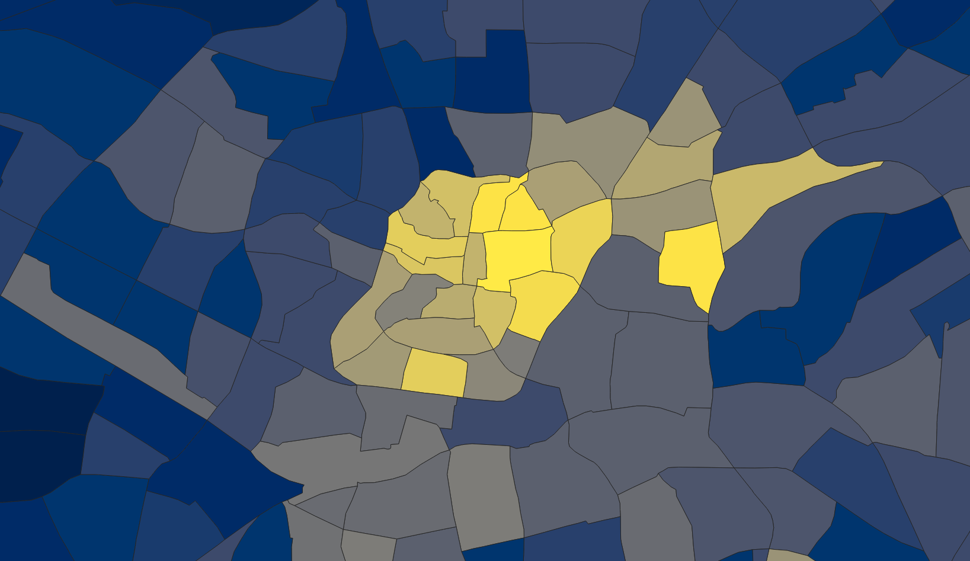  (a) Completely damaged | 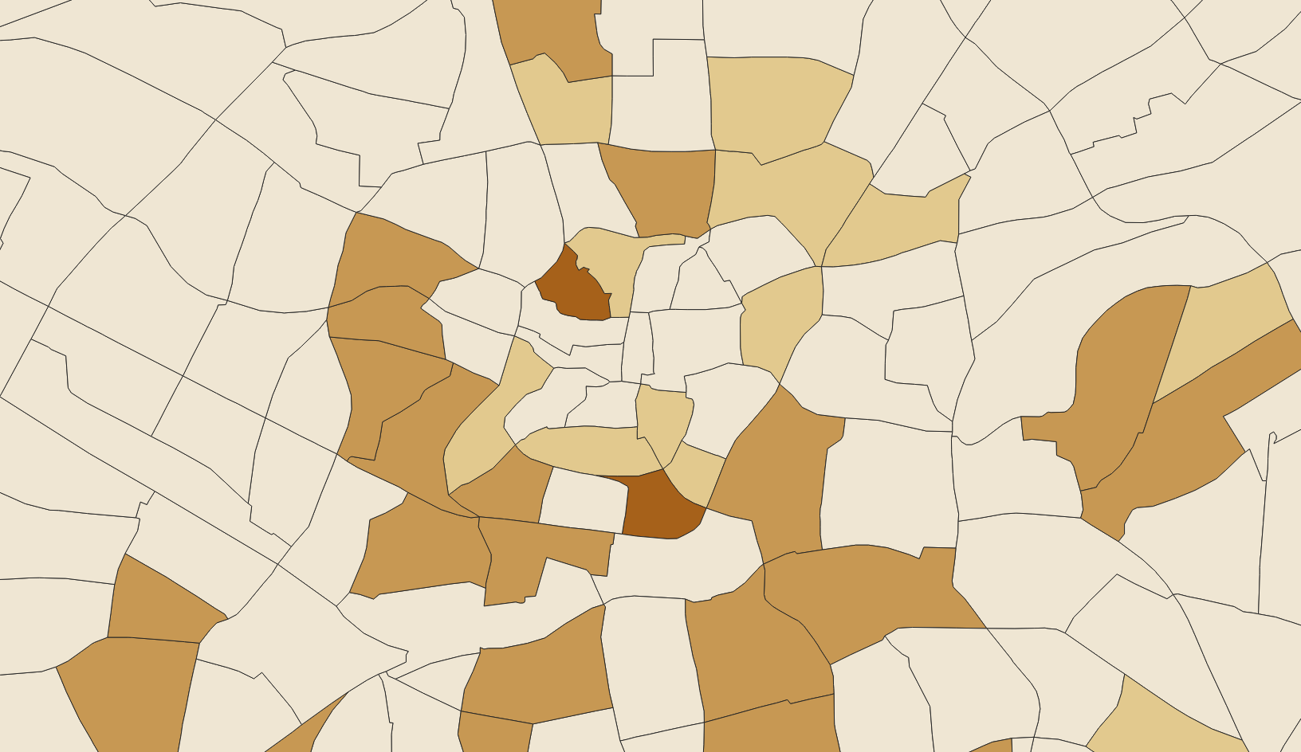  (b) Up to 60% damaged: heavy
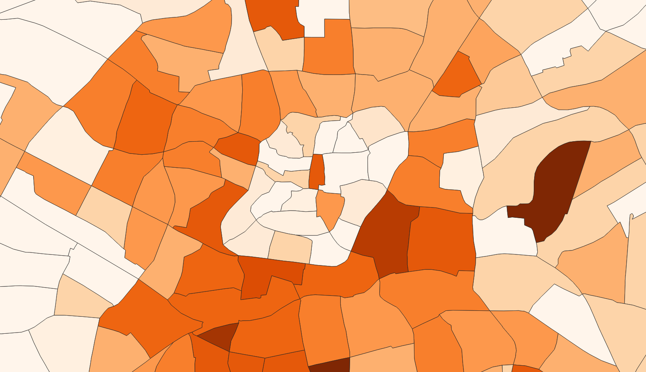  (c) Up to 60% damaged: medium | 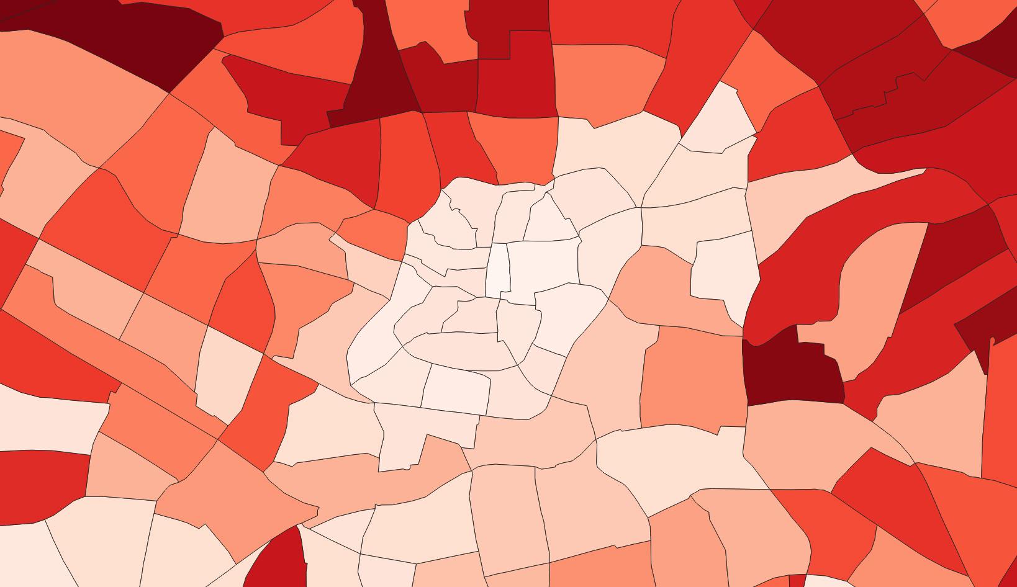  (d) Reconstruction: less than 40% damage
Figure 3. The four damage categories (excluding undamaged buildings) were recorded at the district level to reflect the damage shown on the historical map detail from Figure 2. Note: Lighter colours show higher levels of complete damage (a); darker shades show higher levels of damage for each legend category (b), (c), (d). Source: District boundaries from Amt für Stadtforschung und Statistik (2021).
The overall pattern of these maps shows the destruction of the historical centre and the damage to the area in the northeast and for further analysis, a bomb damage/destruction index (BDI) was created to consolidate this information. For every district, the five recorded levels of damage were given a weighting value, with 1 reflecting the undamaged (i.e., intact buildings) category, 10 the completely damaged category and weights 3, 5, and 7 reflecting light, medium, and heavy damage respectively. The percentages of damage for every district were weighted and averaged resulting in a continuous numerical BDI value for every district, ranging from one to 10. Out of the 316 districts for the whole city, 114 were outside the mapped area (null values for damage/BDI), while 202 districts recorded damage with BDI values between 1.20 (light damage) and 9.68 (heavy damage). The resulting map with the BDI categories in Figure 4 clearly demonstrates how the districts shaded bright yellow and light orange capture the level of damage shown in yellow in the historical map (Figure 2), while the areas with light damage are depicted in red (also reflecting the patterns in Figure 4) and the open spaces and non-damaged areas are shown in black.
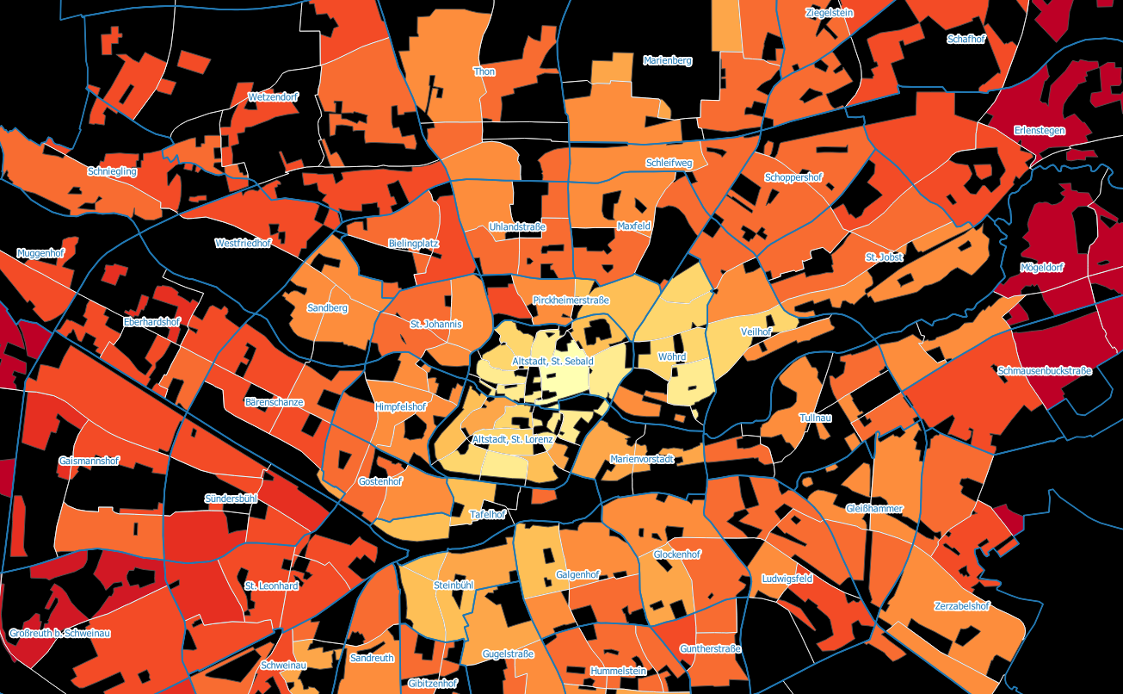
Figure 4. The BDI at the district level reflects the colours of the historical map. Note: Bright yellow highlighting the highest values of damage; dark red indicating the lowest values; black for open spaces and districts with no damage. Source: District boundaries from Amt für Stadtforschung und Statistik (2021).
3.3. Land-Use Mix Index
Historical maps with land use or land cover (depending on context) have been identified at the various archives. Those selected for this analysis cover the pre-war period of 1940, the reconstruction period of 1956–1958, and the later period of 1969 for comparative purposes. In general, historical maps tend to depict land cover, rather than land use, and they come in different scales, making temporal comparisons quite challenging. In addition, the various colours used are inconsistent and specific to each map, while hatching is extensively used, which means that automated methods of image recognition cannot be used for the digitization of these maps. Therefore, a similar method to the bomb damage map was applied for estimating land cover percentages at the district level from the three historical maps shown in Figure 5. In the same figure, we show the 114 districts that were outside the bomb damage map (with null values for BDI) but were depicted in the land cover maps (with values for land use by district).
(a) | 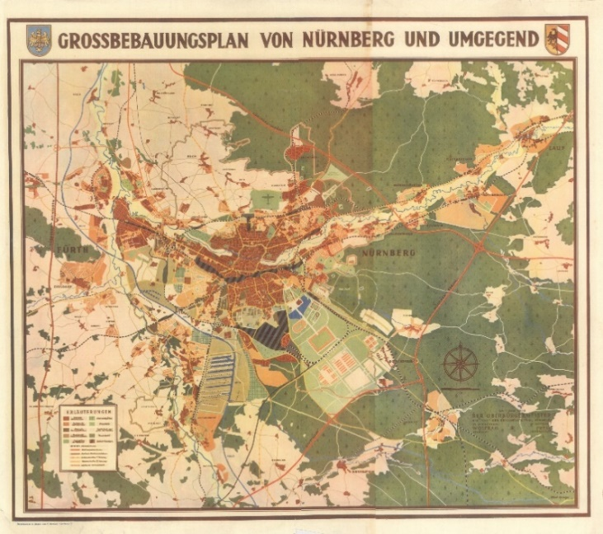  (b)
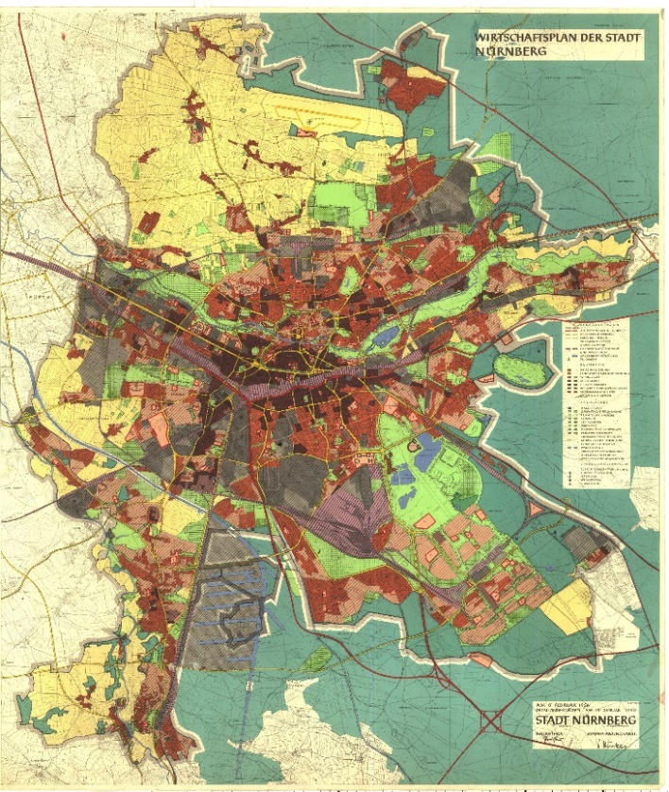  (c) | 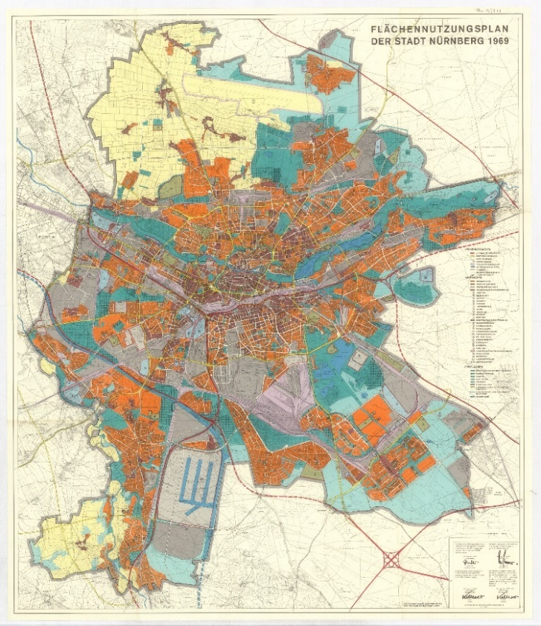  (d)
Figure 5. The three historical land cover/use maps, alongside the area covered by the bomb damage map and Districts. (a) Districts within (202 in pink) and beyond (114 in yellow) the bomb damage map of Figure 1. (b) 1940 map. (c) 1956 map. (d) 1969 map. Sources: (a) produced by the author; (b) “Grossbebauungsplan von Nürnberg und Umgegend” (1940); (c) “Wirtschaftsplan der Stadt Nürnberg” (1956); (d) “Flächennutzungsplan der Stadt Nürnberg” (1969).
Similar to building damage at the district level from the bomb damage map, the various types of land cover were recorded visually by research assistants for every district of the three maps shown in Figure 5. Due to changes in the recording of the various land-use categories, over the years, the different number of categories were recorded, but we ensured comparability between different years through careful consideration. Table 1 shows the various categories recorded for the three historical maps in those years. The output of this digitization exercise was three tables recording the percentage of land cover/use for every district and for each of the three years. It was also confirmed that the total percentage of land for each district adds up to 100%.
Table 1. Land cover/use categories for the three historical maps.
1940: Six categories | 1956–1958: Nine categories | 1969: Eight categories
Residential  Industrial  Open space  Water  Transport  Agriculture | Residential  Industrial  Open space  Water  Transport  Agriculture  Mixed  Bomb clearance site  Other | Residential  Industrial  Open space  Water  Transport  Agriculture  Mixed  Other
From Table 1, the 1940 map had fewer categories by not depicting mixed/other land uses, while the 1956–1958 map depicted bomb clearance sites not existing in 1940 or 1969. These changes can pose challenges for comparative analysis of land cover change over the years, especially when land uses are considered individually. Therefore, we decided to summarise the within-area variation in land use by using a LUM index. Having considered reviews of various indices in the literature we concluded that an “entropy” type index offers the best balance in our case between research scale, precision, and validity, as confirmed by Jiao et al. (2021).
There have been many descriptions and applications of the LUM index, but the most comprehensive is by Mavoa et al. (2018, p. 686), “where LUM is the land-use mix score, pi is the proportion of the neighbourhood covered by the land-use i against the summed area for land-use categories of interest, and n is the number of land-use categories of interest.” To account for the temporal differences in Table 1, we developed a revised LUM index (LUMa) that takes into account all the possible land-use types K in the wider study area A, calculated for each district (a) based on the three historical maps from 1940, 1956, 1969 and allowing for a more realistic temporal comparison:
$$LUMa = -\frac{1}{ln(K)}\sum_{i = 1}^{K∈A}{Pi*ln⁡(Pi)}$$
The output values range theoretically from zero (0), where a single land use category covers the whole area, to one (1), where all categories are equally represented within an area. The LUM index was calculated at the district level for each of the three historical maps (1940, 1956–1958, 1969) and all the categories are shown in Table 1.
3.4. Typologies of Building Blocks
To capture and compare urban morphological change over time, prewar and present-day urban block typologies were categorized. The form of categorization drew on the methodologies developed by Conzen (1960) based on recurring morphological characteristics: streets, plots/buildings, buildings/block plans; Hanson’s (2000) description of urban genotypes, and Ferm et al.’s (2021) classification of typologies into small vs. large scale and street-based (tighter) vs. estate-based (looser). The resulting categorization is shown in detail in Figure 6.
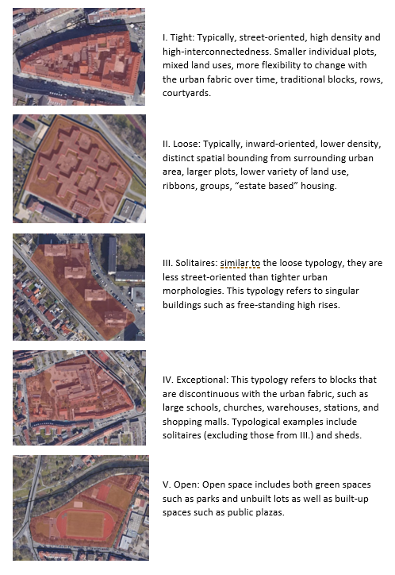
Figure 6. Block typology categorization.
To capture prewar urban block typologies, the georeferenced City Plan (Stadtplan nach 1945) utilized for the level of bomb damage in the city (Figure 1), was reused. This map shows the prewar city of Nuremberg with its historic block layout and street network. The historic blocks were then digitized in QGIS, creating polygons corresponding to their footprints, and then categorised according to their typology, following the categorization explained in Figure 6. This task was then repeated for present-day Nuremberg, with the help of OpenStreetMap and satellite imagery. This enabled a comparison between historic and present block typologies and also exposed blocks where their typology has changed and those where their typology has remained consistent over time, as shown in Figure 7.
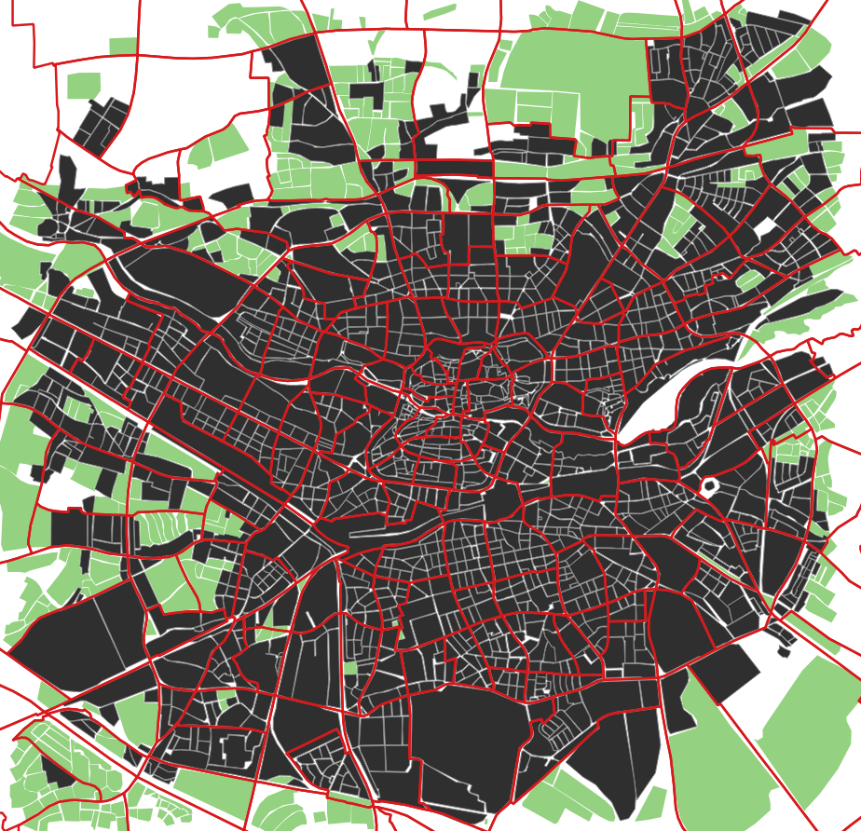
Figure 7. Digitized blocks existing historically (in black) and newly created blocks (in green) with district boundaries superimposed (in red) for the central area of Nuremberg.
As bomb damage was recorded at the district level, it was deemed necessary to also capture the block typology data at the district level to enable meaningful analysis and comparison with the bomb-damage data. Therefore, the boundaries of the 316 districts were superimposed on the georeferenced historic city map and a map overlay was performed to enable a calculation of the percentage of the total block area in a specific district with a specific block typology. This calculation was performed for all typologies and all districts, at both time periods (prewar and present).
4. Analysis
4.1. Bomb Damage and Land-Use Change
The first set of results concerns the relationship between bomb damage and land cover/use change at the district level. As discussed in the methodology, we focus on the changes in the LUMa index at the district level, which includes all land-use categories for each of the three years under study.
Overall, there was an increase in the average LUMa index for the whole study area from 1940 to 1956 and again from 1956 to 1969, implying more land use/cover mix in the postwar years for the whole of Nuremberg. However, this analysis of LUMa for the whole city conceals differences between the bomb-damaged and unaffected areas. A more detailed analysis can be achieved by investigating the LUMa distributions for three different categories of districts. Out of 316 districts for the study area, 114 recorded no damage (Null), while 202 Districts recorded BDI values between 1.20 (light damage) and 9.68 (very heavy damage), mean = 4.56, median = 4.22. Based on the median value, these 202 districts were further split into two damage levels of 101 each, resulting in three categories, with High, Low, Null, bomb damage. The LUMa distributions for these damage levels and for the three different years are shown in Figure 8, for the different categories and over time. Starting with cross-sectional observations, there are very visible differences between the three categories for the same year of observation. For example, in 1940 (blue plots) the LUMa was generally lower and concentrated around 0.45 for the high damage areas compared to the low and null damage areas, reflecting the lower mix of land uses in the central part of the city. This changed dramatically in the post-war years (1956, pink plots) with a wider spread of LUM for both levels of bombed areas and a much lower distribution of LUM for the null outer city areas. The more recent map of 1969 (green plots) shows similar distributions, but an even higher concentration of LUM for the low-damage areas and a significantly different bimodal distribution for the null outer city areas.
Comparing the LUMa distribution change over time (the different coloured plots for each of the three categories), there is an evident change in the high damage category from the more concentrated and lower LUMa 1940 to 1956 with higher LUMa values, but less change towards 1969. The opposite is the case with the low damage category, where the 1940 and 1956 plots show very similar distributions, but there is an evident change in the 1969 plot with LUMa values increasing and the distribution peaking at around 0.6. For the third category, which involves the districts outside the bomb damage map (i.e., yellow in Figure 5a), the LUMa distribution becomes increasingly bimodal from 1940 to 1969, implying that a considerable number of districts have ended up with extremely low and a significant number with middling LUMa, while the distribution extends all the way to values above 0.8.
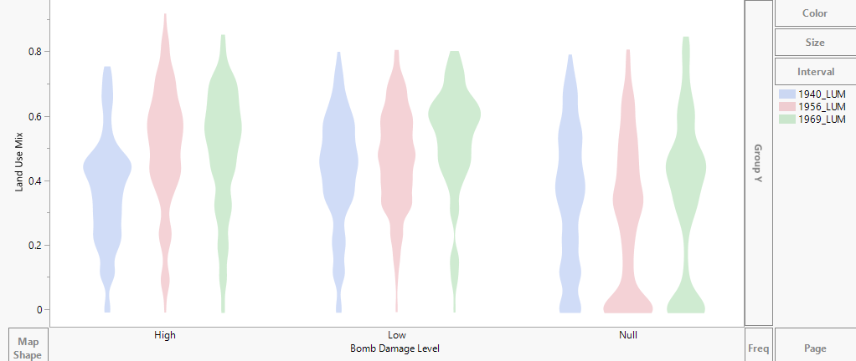
Figure 8. Violin plots of LUM: LUMa index for three bomb damage levels for three years: 1940, 1956, 1969.
4.2. Bomb Damage and Typologies
Each digitized block was classified following the typologies shown in Figure 6 and the differences at the block level between pre-war and modern typologies were calculated. The results confirm that Nuremberg’s reconstruction largely followed the old ground plan, avoiding a radical breakaway from the historical morphology of the city, and avoiding a schematic or grid-like new development. Figure 9 shows that a high proportion of blocks remained in the same typology, representing continuity in the morphological grain of the historic city. The main changes to the historic block typologies can be seen on the periphery of the city.
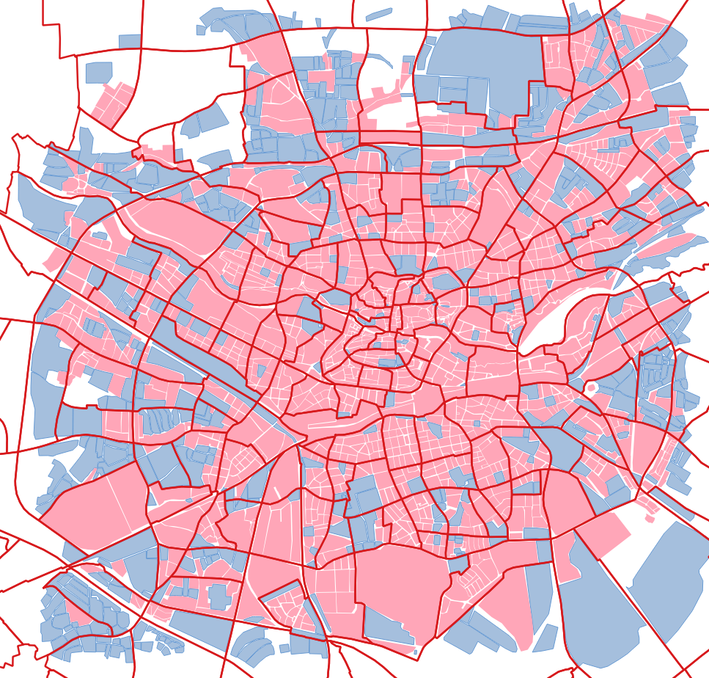
Figure 9. Blocks with consistent pre-war and modern typology (in pink) and with altered typology (in blue) with district boundaries (in red) for the central area of Nuremberg.
In addition, the level of bomb damage appears to have had little influence on the continuity of historic block typologies in Nuremberg, as shown in Figure 10, where the blocks have been classified on the basis of higher/lower bomb damage. This is because of the conservative and more traditionalist approach to postwar planning adopted by the city, which was clearly underpinned by a historical consciousness that favoured the continutity of the historic character of the city and its centre (old town) in particular.
The following section discusses how the results of our analysis can add value to existing debates and theories on the reconstruction of cities that have been damaged by war.
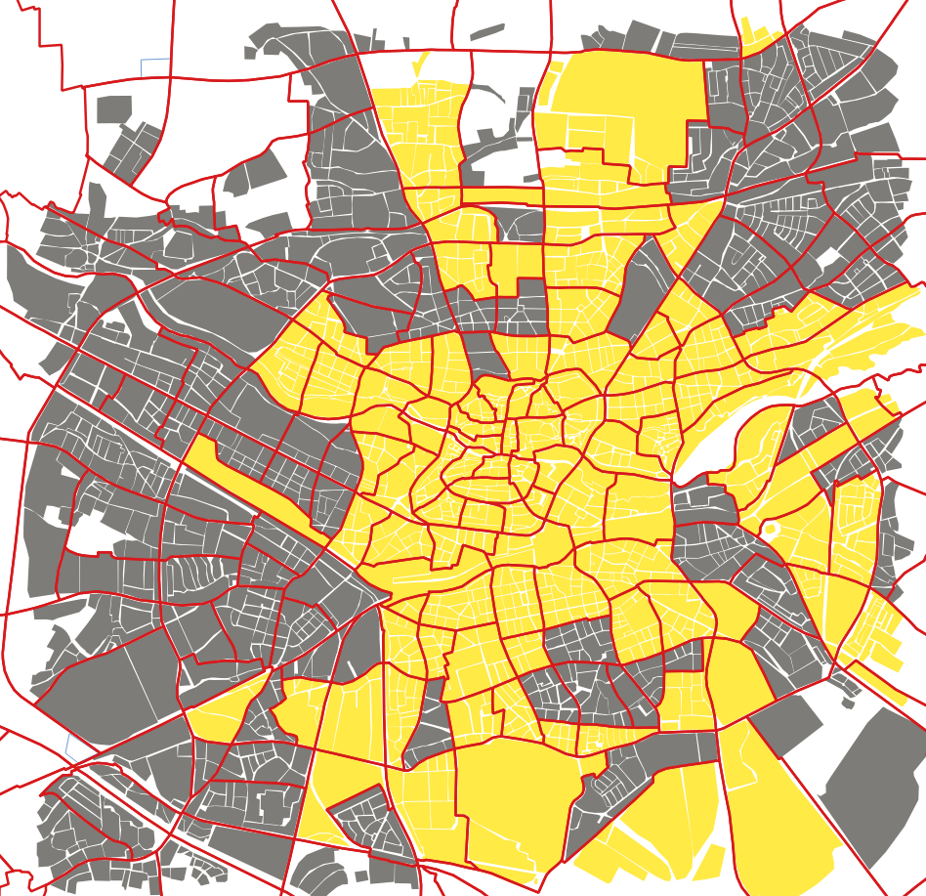
Figure 10. Level of damage for building blocks for the central area of Nuremberg, reflecting the district-level BDI from Figure 4. Note: Higher levels of damage in yellow and lower levels of damage in grey.
5. Discussion
5.1. Postwar Planning Strategies
Bomb damage created an unprecedented opportunity for comprehensive development of the built environment. This period saw the (re)intensification of an international discussion about planning strategies, which were to guide future physical planning and city reconstruction. These strategies would leave a lasting impression on cities all over the world. In several cases the strategies used to guide post-war reconstruction can be traced back to well before the first bombs were ever dropped, giving continuity to existing 19th-century planning visions. In such cases, the war destruction was the catalyst, which enabled the progression of the existing plans. These prewar strategies were largely developed as a reaction to the rapid industrialization of cities in the late 19th century and the consequent poor and unhygienic living conditions associated with extreme overcrowding, although they were also oriented towards urban control (of its functioning and growth). Indeed, in the 19th and early 20th centuries, infrastructure, growth, services, and zoning were all much more deeply reflected upon. As part of this, strategies were developed to create an ideal urban structure/spatial arrangement of urban forms and land uses. One example of this is the garden city model, conceived by Howard (1898) in his book To-morrow: A Peaceful Path to Real Reform. Intended to counteract the migration of the rural population to urban areas and thus prevent the unhygienic conditions caused by over-crowding, garden cities were to be attractive new cities of a limited size (32,000 people), surrounded by agricultural land. Already very influential before the First World War and during the interwar period, Howard’s (1898) garden city model formed the basis of many plans for postwar settlements and new towns and played an influential role in postwar reconstruction planning worldwide (Durth & Gutschow, 1993). Below, we summarize two opposing schools of thought, which heavily influenced the postwar development of bomb-damaged cities. This is a necessary simplification of planning strategies which dominated the debate on postwar planning in Europe, particularly in non-Eastern Block states.
5.1.1. Modernism
The interwar period was significantly influenced by the Americanism of the 1920s, and the ideas of modern architect Le Corbusier. As well as the architectural design of individual buildings, Le Corbusier was also concerned with entire cities and ways of life. The emergence in 1922 of his Plan of a Contemporary City for Three Million Inhabitants was a vision of a city of high-rise administrative towers on a cruciform ground plan. Around the city, with its wide traffic lanes and open spaces, would lie residential areas in a rational order, placed strictly according to function and building type in the grid of the city plan (Le Corbusier, 1925). Networks of underground railways and long-distance motorways would make the centre easily accessible (Durth & Gutschow, 1993, p. 278). Along with architects Mies van der Rohe and Walter Gropius, Le Corbusier was instrumental in the creation of what was coined as the “International Style.” This movement involved a group of leading modern architects in Germany organizing themselves into “The Ring,” later associating themselves more with another international community of architects that had been meeting since 1928, the Congrès Internationaux d’Architecture Moderne (CIAM), and the spiritus rector of this group was Le Corbusier (Durth & Gutschow, 1993, p. 276). In 1930 Le Corbusier drew up his model for the “Radiant City,” with an even stricter separation of functions, designating areas for business, housing, factories, warehouses, and heavy industry (Durth & Gutschow, 1993, p. 280). These plans formed the basis of the Athens Charter (1933), which formed the indisputable basis of modern urban planning.
This structured and dispersed city, known as “the functional city,” became the ideology of the CIAM (Kohlrausch, 2007). Not only did this strategy divide cities into different functions of living, working, recreation, and transport, but it also reflected the impact of new mass technologies like the private car. The principles of the functional city represented a further break from the historical arrangement of the urban fabric of cities. While Le Corbusier was acclaimed for the sculptural qualities of his free-form living spaces, he was later criticized for setting the stage for concrete social housing blocks and monofunctional, bounded housing estates, built in the decades following the war. There were, of course, counter-arguments to the functional city. One notable critic was Jane Jacobs, who, in referring to American cities, believed that to thrive, a city requires diversity of uses and users. Mixed areas, comprising small city blocks and a sufficient built density, she argued, create a close-grained community, and give the city life (Jacobs, 1961, 1969). Other planning and urban design theorists, such as Whyte (1980) and Gehl (1987), also argued that the traditional, compact, pedestrian-friendly city with mixed-use areas promotes the most economic and social well-being of its inhabitants (Montgomery, 1998). These claims, however, were largely based on personal views, experiences and observations, rather than any form of quantitative measurement. Despite these critiques, the guiding principles of the functional city were implemented in many cities after the Second World War and are responsible for the spatial arrangement of many constructed spaces and land-use patterns in cities today.
5.1.2. Traditionalism
Not every city, however, followed such a path. Reconstruction plans in Münster, Freiburg, Rothenburg, and Nuremberg were exceptions (Durth & Gutschow, 1993). As a counterpoint to “The Ring,” a group of German architects including Paul Bonatz, Paul Schultze-Naumburg, and Paul Schmitthenner, set up their own group, “The Block,” which strongly opposed modernism, promoting traditionalism instead (Diefendorf, 1993). Traditionalists favoured a more conservative planning strategy for reconstructing bomb-damaged cities. This included minimal intervention, the use of local building materials and handcrafted (rather than prefabricated) construction. Traditional strategies favoured protecting and restoring existing monuments, rather than rebuilding copies, and maintaining the historical street network, which they argued formed a key part of the historical character of the city. While promoting historic preservation and traditionalism rather than modern architecture or radical morphological change, they did not oppose modern buildings per se; modern buildings could be constructed provided they resulted in minimal impact on the traditional urban silhouette and historic urban landscape (Diefendorf, 1993).
5.2. The Reconstruction and Development of Nuremberg
In terms of planning strategies, Nuremberg followed a more traditionalist approach when planning its reconstruction (Durth & Gutschow, 1993). According to the Economic Plan (1945), the housing shortage was the most urgent problem, and the resettlement of the population was the top priority. This required restoring existing living space from further decay, creating shelter, and finding provisional solutions, like patching-up dwellings. It also required the construction of new houses where this could be carried out most quickly, for example on free-building land where no collapsed houses must be removed first (Urschlechter, 1956). This was one reason why it was accepted that the heavily damaged old town will be less suitable as a residential area in postwar Nuremberg and will become a much more distinctive commercial centre. After discussing various alternatives, the city was reportedly rebuilt on an approximately old ground plan in an adapted modern form (Rosner, 2007). Important decisions were made to loosen up the building style, abandon the principle of barren tenements and backyards, and if blocks were built (which they were for financial reasons), they were to be embedded in green space so that younger inhabitants had a place to play away from the street. An important planning goal was to enable hygienic and healthy living (Helander, 1945).
In 1946 a competition was announced for the reconstruction of the Old Town and in February 1948, the jury awarded first prize to the Nuremberg architects Heinz Schmeißner and Wilhelm Schlegtendal. The Plan proposed extensive preservation of the urban layout, but with substantial traffic improvements and a loosening of the once excessively narrow and dense residential development. Instead, apartments were designed to capture more light, air, and sun than those destroyed by the war. Proposals to radically break up the block structure were unsuccessful. As Bavaria lacked a reconstruction law that would have facilitated the reorganization of land and thus economically viable new development, every street widening, and property reorganization involved difficult negotiations between the city and landowners. The advantage of this constraint was that a radical, purely schematic or grid-like new development was not possible (Rosner, 2007). The guiding principles for the reconstruction of the Old Town, were as follows:
The characteristic townscape with the towers of the castle, the churches and the city wall should be preserved and not be impaired by high-rise buildings. The town layout is to be preserved as far as possible….New buildings must be subordinate to and blend in with the restored monuments in terms of scale, roof shape, material and colouring. What has been lost should not be reconstructed. The genuine new should be placed next to the genuine old. The old town should be kept free of traffic. To improve the necessary traffic, however, road bottlenecks are to be removed….Residential development, especially on the Sebald side, should take into account the demands of modern urban planning for “light, air and sun.” Unfavourable property conditions are to be rearranged. (Rosner, 2007, p. 76)
New housing developments were also required on the outskirts of Nuremberg, to compensate for the principles of lower building density in the inner city. To avoid fragmentation of settlements, however, the city council decided to direct new development primarily to the southeast of the city to develop the largest settlement project there, the “Trabantenstadt Langwasser.” Since 1957, a new city district for 40,000 inhabitants was built in this area, representing a major peripheral postwar development in Nuremberg.
5.3. Destruction and Nuremberg’s Changing Urban Fabric
Like all bombed cities, decisions had to be made in Nuremberg about how the city should be rebuilt. With the choice to implement more modern planning principles or a more traditional planning approach, Nuremberg opted for the latter, building on the old ground plan. Due to the severe level of destruction in Nuremberg and the sheer extent of redevelopment required, the bombing had a significant physical impact on the city. This high level of destruction, however, influenced the subsequent LUM and the urban morphology of Nuremberg in distinct and more subtle ways. Contrary to the modern planning principles of the functional city with its emphasis on subdivision and zoning (Durth & Gutschow, 1993), the postwar LUM in Nuremberg increased, but at different rates and at different times. For example, it increased more quickly in highly bomb-damaged areas between 1940 and 1956, and later in non-bomb-damaged areas (1969), as a result of the war-induced development priorities at the time. This strongly points to a postwar planning strategy that rejected the strict separation of functions integral to the principles of modernism and the functional city, in favour of a more mixed-use development approach. The observed increase in LUM also captures the introduction of more commercial development in central Nuremberg, which previously was dominated by high-density residential accommodation, already foreseen in the Economic Plan of 1945. The increase in lower levels of LUM in peripheral districts may be a result of residential, mono-use developments, as the city expanded (Hanson, 2000).
Both the LUM and urban morphological results suggest that Nuremberg’s postwar planning strategy did not follow the ideology of the CIAM and the principles of the functional city. The high degree of urban morphological integration, evident in the overall continuity of the urban block typologies (especially towards the centre and inner city of Nuremberg) represents the continuity of tradition (Otto, 1983), rather than a radical break with the historical arrangement of the urban fabric of the city. This suggests that a historical consciousness, together with a favouring of traditionalism and a mixed-use planning strategy appears to have played a key role in the postwar reconstruction of Nuremberg. This planning strategy, observed through the three transformations analyzed in this article, has led to the continuity of Nuremberg’s historic character evident in the city today.
6. Conclusion
Much has been written about destruction, postwar city planning, and reconstruction across Europe (Diefendorf, 1993; Durth & Gutschow, 1993; Pendlebury et al., 2009), yet surprisingly few studies have quantitatively explored how bomb destruction affected the long-term physical development of cities. While there is a growing body of research in critical cartography that examines war damage and thematic maps as an interdisciplinary historical source, war damage maps have rarely been used as sources for the study of change in urban environments (Elżanowski & Enss, 2021). Our research has contributed to this research gap by employing geographical information science to war-time maps to explore how the Second World War bombing of Nuremberg transformed the city’s physical fabric.
In this article, we have demonstrated how GIS can be applied to historical research and the study of change in urban environments. In doing so, this article provides a contribution towards a new framework for the analysis of postwar cities. It demonstrates how under-researched postwar data sources can be used in new ways to visualize and quantify physical transformations over time, in particular the level of destruction caused by Second World War bombing and its effect on the LUM and urban morphology of cities. It illustrates ways in which historic maps from the postwar period can be analyzed, beyond the limited scope of visual inspection. Against the backdrop of the ongoing war raging in Ukraine, and the country’s future reconstruction, the study of postwar urban change, planning strategies and morphological integration is of contemporary importance. In this context, we believe our research points to an important emerging research agenda, for which we are currently developing our methodological framework further. Our next steps are to: (a) apply this analysis to other cities, whose reconstruction was guided by different postwar planning strategies; and (b) combine results with other variables of analysis, such as socioeconomic data, to evaluate the effects of postwar transformation on selected cities. Providing an alternative appraisal of postwar city transformation, this diachronic research has offered insight into Nuremberg’s under-researched past, which will be of interest to planners and policymakers seeking to reconstruct, improve, or conserve future cities.
Acknowledgments
This research was supported by the German Federal Ministry of Education and Research (Bundesministerium für Bildung und Forschung, BMBF) Project UrbanMetaMapping: Sozialkartographie (01UL2004D). The article processing charge (APC) was provided by the Open Access fund at Northumbria University, UK.
Conflict of Interests
The authors declare no conflict of interests.
References
Black, J. (2018). Maps of war: Mapping conflict through the centuries. Osprey Publishing.
Campbell, C. (2016). Space, place and scale: Human geography and spatial history in past and present. Past & Present, 239(1), e23–e45. https://doi.org/10.1093/pastj/gtw006
Conzen, M. R. G. (1960). Alnwick, Northumberland: A study in town-plan analysis (Publication 27). Institute of British Geographers.
Diefendorf, J. (1993). In the wake of war: The reconstruction of German cities after World War II. Oxford University Press.
Durth, W., & Gutschow, N. (1993). Träume in Trümmern: Stadtplanung 1940–1950 [Dreams in ruins: Urban planning 1940–1950]. Publisher.
Elżanowski, J., & Enss, C. (2021). Cartographies of catastrophe: Mapping World War II destruction in Germany and Poland. Urban History, 49(3), 589–611. https://doi.org/10.1017/S0963926820000772
Enss, C., & Knauer, B. (Eds.). (2023). Atlas Kriegsschadenskarten Deutschland. Stadtkartierung und Heritage Making im Wiederaufbau um 1945 [Atlas of German war damage maps. Urban mapping and heritage making in reconstruction around 1945]. Birkhäuser.
Ferm, J., Panayotopoulos‐Tsiros, D., & Griffiths, S. (2021). Planning urban manufacturing, industrial building typologies, and built environments: Lessons from inner London. Urban Planning, 6(3), 350–367.
Flächennutzungsplan der Stadt Nürnberg [Land use plan of the city of Nuremberg]. (1969). Name of collection (Stock signature A 4/V, Item 321). Stadtarchiv Nürnberg (StadtAN), Nuremberg, Germany.
Fleischmann, M., Feliciotti, A., Romice, O., & Porta, S. (2022). Methodological foundation of a numerical taxonomy of urban form. Environment and Planning B: Urban Analytics and City Science, 49(4), 1283–1299. https://doi.org/10.1177/23998083211059835
Gehl, J. (1987). Life between buildings: Using public space. Van Nostrand Reinhold.
Gregory, I., DeBats, D., & Lafreniere, D. (Eds.). (2018). The Routledge companion to spatial history. Routledge.
Grossbebauungsplan von Nürnberg und Umgegend [Major development plan of Nuremberg and the surrounding area]. (1940). Name of collection (Stock signature A 4/V, Item 794). Stadtarchiv Nürnberg (StadtAN), Nuremberg, Germany.
Hanson, J. (2000). Urban transformations: A history of design ideas. Urban Design International, 5(2), 97–122. https://doi.org/10.1057/palgrave.udi.9000011
Helander, S. (1945). Die bevorstehende Wirtschaftsplanung in Nuremberg [The upcoming economic planning in Nuremberg]. Stadt Nürnberg.
Hohn, U. (1991). Die Zerstörung deutscher Städte im Zweiten Weltkrieg: regionale Unterschiede in der Bilanz der Wohnungstotalschäden und Folgen des Luftkrieges unter Bevölkerungsgeographischem Aspekt [The destruction of German cities in the Second World War: Regional differences in the balance of total housing damage and consequences of the air war from a population geographical perspective]. Dortmunder Vertrieb für Bau—und Planungsliteratur.
Howard, E. (1898). To-morrow: A peaceful path to real reform. Cambridge University Press.
Jacobs, J. (1961). The death and life of great American cities. Vintage.
Jacobs, J. (1969). The economy of cities. Random House.
Jiao, J., Rollo, J., & Fu, B. (2021). The hidden characteristics of land-use mix indices: An overview and validity analysis based on the land-use in Melbourne, Australia. Sustainability, 13(4), Article 1898. https://doi.org/10.3390/su13041898
Kohlrausch, M. (2007). Die CIAM und die Internationalisierung der Architektur. Das Beispiel Polen [CIAM and the internationalization of architecture. The example of Poland]. Themenportal Europäische Geschichte. http://www.europa.clio-online.de/essay/id/fdae-1433
Le Corbusier. (1925). Urbanisme [Urbanism]. Les Editions G. Crès et Cie.
Levy, A. (1999). Urban morphology and the problem of the modern urban fabric: Some questions for research. Urban Morphology, 3(2), 79–85. https://doi.org/10.51347/jum.v3i2.3885
Mavoa, S., Eagleson, S., Badland, H. M., Gunn, L., Boulange, C., Stewart, J., & Giles-Corti, B. (2018). Identifying appropriate land-use mix measures for use in a national walkability index. Journal of Transport and Land Use, 11(1), 681–700. https://doi.org/10.5198/jtlu.2018.1132
Mohamed, A. A., Ubarevičienė, R., & van Ham, M. (2022). Morphological evaluation and regeneration of informal settlements: An experience-based urban design approach. Cities, 128, Article 103798. https://doi.org/10.1016/j.cities.2022.103798
Montgomery, J. (1998). Making a city: Urbanity, vitality and urban design. Journal of Urban Design, 3(1), 93–116. https://doi.org/10.1080/13574809808724418
Otto, C. F. (1983). Modern environment and historical continuity: The Heimatschutz discourse in Germany. Art Journal, 43(2), 148–157.
Pendlebury, J., Erten, E., & Larkham, P. J. (2009). Alternative visions of post-war reconstruction: Creating the modern townscape. Routledge.
Rosner, M. (2007). Der Wiederaufbau der zerstörten Altstadt [The reconstruction of the destroyed old city]. In W. Baumann, M. Diefenbacher, H. Herbers, F. Krüger, & D. Wiktorin (Eds.), Der Nürnberg Atlas. Vielfalt und Wandel der Stadt im Kartenbild [The Nuremberg Atlas. Diversity and change of the city in a map]. Publisher.
Stadtplan nach 1945 mit Kennzeichnung der Zerstörungen des II Weltkrieges [City map after 1945 with marking of the destructions of World War II]. (1950). Name of collection (Stock signature A 4/V, Item 152). Stadtarchiv Nürnberg (StadtAN), Nuremberg, Germany.
Urschlechter. (1956). 10 Jahre Wohnungsbau in Nuremberg [10 years of housing construction]. Stadt Nürnberg.
Venerandi, A., Quattrone, G., & Capra, L. (2018). A scalable method to quantify the relationship between urban form and socio-economic indexes. EPJ Data Science, 7, Article 4. https://doi.org/10.1140/epjds/s13688-018-0132-1
Whyte, W. H. (1980). The social life of small urban spaces. Project for Public Spaces.
Wirtschaftsplan der Stadt Nürnberg [Economic plan of the city of Nuremberg]. (1956). Name of collection (Stock signature A 4/VII, Item 2710). Stadtarchiv Nürnberg (StadtAN), Nuremberg, Germany.
World Bank. (2022). Ukraine rapid damage and needs assessment (English). http://documents.worldbank.org/curated/en/099445209072239810/P17884304837910630b9c6040ac12428d5c
About the Authors
Carol Ludwig is a senior researcher at GESIS – Leibniz Institute for the Social Sciences (Germany) where she manages the BMBF-funded project Sozialkartographie as part of the UrbanMetaMapping Research Consortium. She is an urban planner with professional experience in practice and academia. She held the positions of principal planner in local and regional municipalities in the UK and lecturer at the Universities of Northumbria and Liverpool. Her research interests include the synergies between urban transformation, planning strategies, and the theorization of heritage.
Seraphim Alvanides is a social geographer, with expertise in quantitative methods and geographical information science. His substantive interests involve the analysis of large spatial data related to urban sprawl, active transport (walking/cycling), and spatial humanities. The question driving his research is to what extent the environment (broadly defined) influences the behaviours and outcomes of individuals and groups. He is co-editor of the journal Environment & Planning B: Urban Analytics and City Science and associate editor for the journal Heliyon: Environment.

