Motivational Factors for Participating in Citizen Science Games
  - Ruth Conroy Dalton, Jan Wiener, Demet Yesiltepe, Amanda Adams, Nick Dalton, Hugo Spiers and Michael Hornberger

Abstract

Sea Hero Quest was a multi-platform, citizen science game designed to advance our understanding of spatial navigation. People playing the game contributed data to further our knowledge of an early symptom of dementia – spatial disorientation. Sea Hero Quest’s community of users left 88,694 reviews/comments on the Apple and Android App Stores. This study analysed a sub-sample of these to investigate motivations for participation. Thematic analysis of ~20,000 comments revealed a clear understanding of links between navigational performance and dementia and the purpose for the data collected by the scientists. Two surprising outcomes, concerning motivations for participation, were the abnormal volume of comments/reviews left and the content of them: not typical game-reviews, but often a highly emotive sharing of personal experiences of dementia — family members who have/had the disease. We conclude that such emotive reviewing produced an unanticipated, secondary, wave of awareness-raising.

Author Keywords

Citizen science game, crowdsourcing, public engagement, public understanding of science, social media, user study.

1. Introduction

Citizen science gaming is a relatively new concept in which citizen science is conducted either directly through the medium of games and the act of game-playing (the majority of examples) or alternatively it can also include examples in which some sort of ‘game element’ is inserted into what would otherwise be a straightforward citizen science project (this could also be thought of as the ‘gamification’ of a standard citizen science project). One problem of defining citizen science games is that there is no clear definition of citizen science itself but according to Kullenberg and Kasperowski [1] citizen science tends to fall into two broad categories: the first is where volunteer contributors assist scientists by gathering or analysing data (i.e. data external to themselves) and the second is where people become the source of the data by volunteering their own personal information, for example in the form of a survey. Kullenberg and Kasperowski observed that neither of these practices are particularly new but that the advent of digital platforms has made the process far easier to facilitate. By adding an element of gamification to citizen science, ‘citizen science’ naturally evolves into ‘citizen science gaming’. Baert, the founder of the website citizensciencegames.com, defines citizen science gaming as being, “…where volunteers, in collaboration with scientists, get involved in science… by playing citizen science games” [2]. We can therefore confidently state that citizen science gaming is a clear, more recent, and growing sub-set of citizen science.

Citizen science gaming is generally held to have originated in 2008 with the launch of the game Foldit, a game designed to solve puzzles related to the folding of proteins [3][4]. Since 2008 there has been a steady trend of increasing numbers of citizen science games being released, and with particularly high numbers of games being launched in 2012 and 2016, see Figure 1 (it is not clear why the numbers of games released in these years should have been unusually high – no causal factors have been identified). The concept of citizen science gaming is clearly also connected to the concept of ‘serious games’ [5], which can be defined as “(digital) games used for purposes other than mere entertainment” [6]. It is therefore possible to take the Susi et al. definition of serious games and adapt it for citizen science games, in which case we arrive at a second possible definition of citizen science gaming, namely “(digital) games used for citizen science rather than mere entertainment”

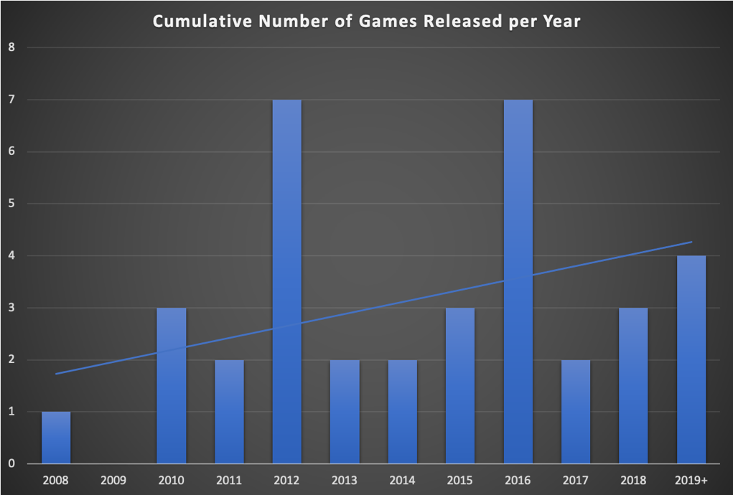
Figure 1 Cumulative number of citizen science games released per year since 2008 (data source: citizensciencegames.com)
A multi-platform (but predominantly accessed via iPhone or Android apps), citizen science game called Sea Hero Quest [7] was launched on May 2016 to widespread coverage and was even showcased to the United Nations. It was, at one point, the most downloaded app in the world. The total estimated audience reach for Sea Hero Quest media coverage was 50,434,817 people in the UK alone (source: Freuds, a public relations firm, own statistics, via email communication to the Sea Hero Quest team) and gaming royalty ‘PewDiePie’ even promoted its launch [8], playing Sea Hero Quest on his YouTube channel, which, in turn, was watched by a astonishing 7,270,239 people.

Sea Hero Quest was funded by Deutsche Telekom in association with Alzheimer's Research UK and its purpose was to create the world’s largest database of human navigational data in order to create a benchmark for ‘normal’ patterns of navigation throughout the lifespan. This is because one of the earliest signs of dementia is spatial disorientation and the gradual development of problems with wayfinding, even in, what had been previously, highly familiar environments. However, it is only possible to detect anomalous navigational behaviour if a robust definition of ‘normal’ performance can first be established and this was the vision behind Sea Hero Quest. Deutsche Telekom's Wolfgang Kampbartold says, "To be able to do something in the future, the first thing you have to have is a benchmark. Because if you don't know what normal is, you don't know whether you are developing a disease. Like with many other diseases, the earlier you detect something, the more likely a positive outcome." Finally, in order to ensure that the game had real-world ecological validity, we compared both wayfinding and path integration tasks designed in the ‘Sea Hero Quest’ game with participants’ performance at similar tasks in a real-world environment and found a significant correlation between the two [9]. It is hoped that this dataset will eventually lead to a diagnostic version of the game, the concept which has already be proved to be viable [10][11].

Returning to the citizen science definition coined by Kullenberg and Kasperowski [1] it is clear that Sea Hero Quest falls into the second of their categories, that of citizens volunteering themselves as sources of data. This is because the game dynamics of Sea Hero Quest consists of 75 game-levels, of increasing degrees of environmental complexity (see [12] for a full description of the game-level design process), in which the player must find their way, navigating a small boat and seeking sequential target ‘buoys’. Figure 2 is a screen shot of the game, showing the little boat which is controlled by the game-play and progress ‘indicators’ at the top of the screen. The game-players’ navigational paths, and the associated time taken, to reach the targets are saved and volunteered to the science team behind the game (of whom most are authors of this paper). In addition to the navigational performance data, players of the game were also asked to provide demographic information such as age and gender periodically during the game. The questions were deliberately limited to only eight, which were distributed through the game levels. It was made very clear to the user that this was being freely given and that they could opt-out of sharing any personal data, but that the more information given, the more the player could help further the science behind the game. The game player was, however, able to progress through all of the game’s levels without answering any of the questions. In actual fact, we found that the vast majority of people freely volunteered the information requested.

The questions asked were:
- What gender are you?
- How old are you?
- Which country do you live in?
- Which hand do you write with? (Left/Right)
- What’s your education level? (No formal education / high school / college / university)
- What’s your daily travel time (less than 30 minutes / 30 minutes - 1 hour / 1 hour or more)
- How good are you at navigating? (Very good / good / bad / very bad)
- How much sleep do you get on average each night? (1-16 hours)

Figure 2 Screenshot of the Sea Hero Quest game showing the boat which is navigated through a series of increasingly, spatially complex environments. (Source Authors own image)

In March 2019, with over 4.3 million people having played it, the Sea Hero Quest smart phone version was removed from the Apple and Android App Stores (a VR version, initially released on 27 August 2017 for Samsung Gear VR, Google Daydream and Oculus Go is still available and is currently being maintained). At this point, this original, smart phone/app version of the game was approaching its third year of being available for download and the original game was proving increasingly time-consuming and costly to maintain and further funding was unavailable for this purpose. The extremely difficult decision was made to remove the game from both the App Stores, and to archive the entire dataset with the intention of this subsequently being made open access for research purposes.

Before the game was removed from the website, it was noted, by the original research team, that the game’s users had left an unusually high number of comments on the two App Stores, and it was decided to also archive these, prior the game being removed. (Until this point, we had been aware that comments/reviews had been made on the App Stores, but we had neither looked at them in any detail, nor had we realised the volume of them). Due to time constraints we were unable to request that Apple or Google should archive these internally, and so we quickly wrote some bespoke software to automatically copy and archive these comments from the app stores. This ‘data-scraping’ exercise was completed on 1st March 2019, at this point there were 87,896 comments on the Google Android App Store and 798 comments on the Apple App Store making 88,694 comments in total. This was a highly unusual level of engagement by App Store users. We rapidly realised that this dataset of comments constituted a unique insight into how and why people might have been playing the game as well as their views and opinions of it. We therefore decided to undertake an exercise to analyse the comments.

In approaching this dataset of user comments, we had two main questions:

- To what extent had people playing the game fully understood the purpose of the science behind it?
- What had been their motivation in playing the game?

This last question is a particularly important one, as the motivations of participants in citizen science in general, and in citizen science gaming in particular, are a particularly under-researched topic [1]. However, in one important paper on citizen science (but not citizen science gaming – for which the motives might be more varied) it was suggested that motivations for citizen science participation can fall into four categories: collective, social, intrinsic and reward motives [13]. Collective motives are driven by a desire to help a universal problem, such as dementia in the case of Sea Hero Quest, social motives (referred to as norm-oriented motives in the paper) are derived from receiving approval for participation given by a person’s immediate social group. Intrinsic motivations relate to positive emotions around the act of participating and finally reward motives are provided by enhanced reputation achieved through participation (ibid.). All of these categories will be revisited and discussed after the analysis of the Sea Hero Quest user-comments.

The purpose of this paper, therefore, is to shed some light on the motivational factors for participating in citizen science games through the analysis of a subset of these user comments and reviews.

2. Material and methods

We worked with two datasets, each a randomly selected sub-sample of the full set of 88,694 comments, consisting of ~20,000 comments in the form of two .csv files (specifically 9,905 and 9,897 comments stored in two separate archives – this is because there was a character limit on the amount of text we could store in the ‘data-scraping’ code and so it had to be split it into two archives). First, the two archives were analysed using NVivo for their word frequency and this data was then used to create the themes that we would later use in coding the texts. Second, the comments were read, and re-read, independently by four researchers in order to become familiar with the content and particular attention was paid to any patterns that seemed to occur. Using insights gained from the word frequency analysis and the initial read/re-read of the comments, a schema to classify them was developed (with additional input and guidance from a cognitive linguist: see acknowledgements) and agreed by the team (see Figure 3). The schema consisted of five primary categories: ‘Contribution to Dementia Research’, ‘Raising Public Awareness’, ‘Empathy’, ‘Memory’ and ‘Improving Spatial Skills’ as well as a sixth, ‘Other’ category used to capture any additional, interesting comments, that did not otherwise fit into the first themes. Three of these categories also contained sub-categories (again, see Figure 3). Each of these categories was defined using clear text-descriptions and agreed upon by the whole team before the final classification task. Finally, the team checked each other’s results for consistency, throughout the final classification task-phase.

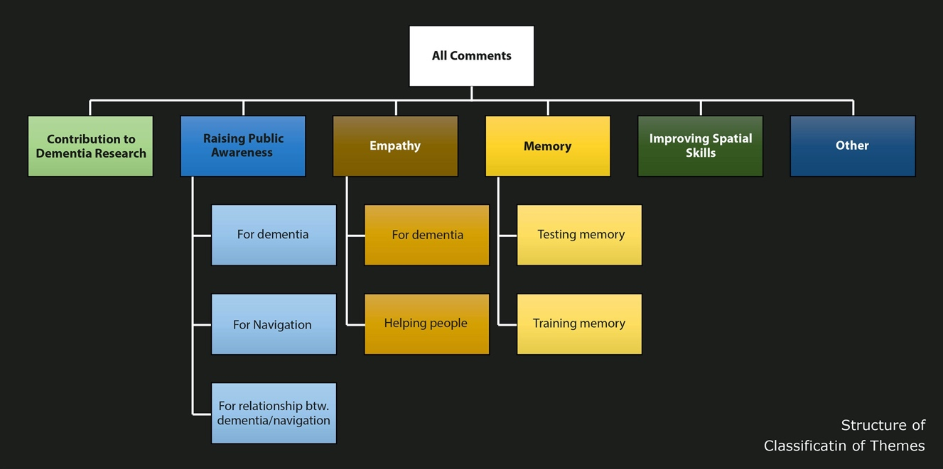
Figure 3 Classification of Themes in Textual Analysis of the Comments

A second method of analysing the comments was also performed using automated sentiment analysis (For this approach, Lexalytics’ natural language processing algorithms were used). However, having completed the sentiment analysis, it was felt that the results were perhaps not particularly meaningful for this particular application and so this method was never developed beyond an initial stage (however the preliminary results will be presented and its limitations discussed).

3. Results

3.1 Results from the Word Frequency Analysis

First, considering the word frequency analysis performed in NVivo, we analysed the 1000 most frequent words, for the two, combined archives. We considered stemmed words to be counted as one instance of a word (for example, amaze, amazed, amazes, amazing, amazingly were held to be variations of the base word ‘amazingly’. Ten words consistently emerged as being the most frequent, ranging from a 6.01% weighted percentage to a 1.31% weighted percentage, followed by a ‘long tail’ of words with a frequency of less than 1% (see Figure 4). These top ten words are:

- Gaming (6.01%)
- Good (3.11%)
- Greatness (2.72%)
- Helps (2.67%)
- Fun (2.49%)
- Causing (2.46%)
- Plays (1.9%)
- Research (1.64%)
- Loving (1.45%)
- Dementia (1.31%)
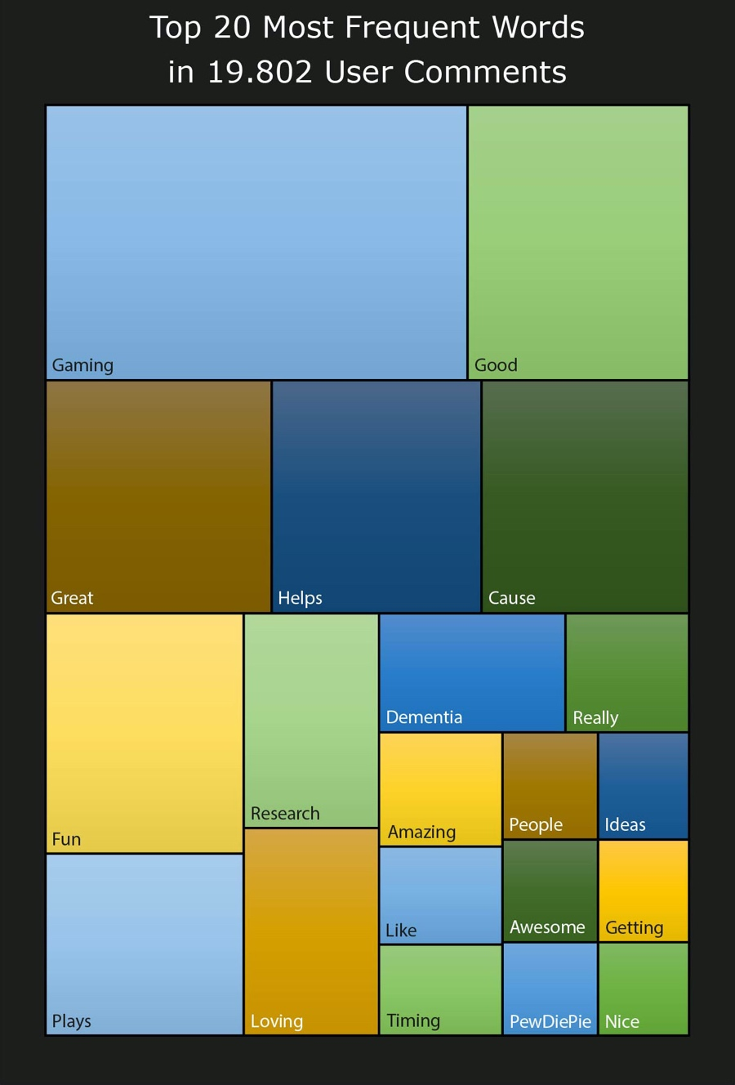
Figure 4 Top twenty most frequent words in user comments.

3.2 Results from the Thematic Classification

In terms of the classification of themes shown in Figure 3, definitions and examples of each of themes are presented below (the full excel spreadsheet of classified comments is also available on request).

3.3 Contributions to Dementia Research

This theme was defined as a clear understanding that playing the game was contributing to dementia research, but particularly including comments demonstrating an in-depth knowledge of how it might help. The comment below exemplifies this theme:

“… If I had the money to donate I would in a heartbeat but I'm a struggling college student. The fact that I can still help has made me feel so much better. Thank you!”

Raising Public Awareness (for dementia)

This theme was defined as any comment that showed that it had made the writer think more about dementia, or think about it in a new way, or showed that a larger number of people were becoming more informed about the disease. An example comment for this theme is:

“…I am in my late 40s and I like [that] the game starts easy and gets harder. It has made me think about dementia and how it affects people. Going to learn more about this.”

Raising Public Awareness (for spatial/navigation skills)

This theme was defined as any comment that showed an understanding of the fact that the game tested people’s navigational abilities whilst playing it. The comment below exemplifies this theme:

“Love the app. I find it challenging… It has also made me realise just how bad my navigation skills are now that I am older.”

Raising Public Awareness (for the relationship between dementia and spatial skills)

This theme was defined as any comment that demonstrated an understanding of the fact that poor navigation might be connected to, or be a symptom of, dementia (something that was not widely known at the time). An example comment for this theme is:

“Fun game. I naturally use my sense of direction thinking about cardinal directions and never thought of people with a lack of it. Great job creating a game that everybody can help the research somehow”

Improving Spatial Skills

This theme was defined as comments that mentioned a need to improve or maintain spatial skills. The comment below exemplifies this theme:

“Great game... Tells me I'm not as good at navigating as I thought. Makes me a little more pro-active about keeping my brain engaged with problem solving games and activities now while I can... Thanks!”

Empathy for Dementia

This theme was defined as any comment that demonstrated an empathy for people, or relatives of people, with dementia. An example comment is:

“…I feel sad about the people who got dementia like how they live in a place they don't know with people they don't know. Now I feel sadddd”

Memory (testing memory)

This theme was defined as comments that described the different ways in which they felt Sea Hero Quest was testing their spatial memory. The comment below exemplifies this theme:

“Good way to do research You'd think this was just a kiddie game, but you'd be surprised how it tests your memory and sense of direction. Nice to relax and enjoy a simple test of your memory for the good of research. It's fun too.”

Memory (training memory)

This theme was defined as any comment that suggested playing Sea Hero Quest might help to maintain or improve a player’s memory. An example comment is:

“Fun and easy but can feel my brain working.”

Helping People with Dementia

This theme was defined as any comment that clearly stated a desire to help people with dementia and/or help dementia research. An example comment that exemplifies this theme is:

“I WILL help to fight dementia! a top ten video talked about it and now I want to help!”

‘Other’ Category

This theme was defined as any comment that did not fit into the categories described above. The comment below exemplifies this theme:

“…Who doesn't like crowd sourcing for science! This is probably the most polished I've seen crowd sourcing for science.”

3.4 Distribution of Comments within the Thematic Categories

In terms of the distribution of comments between the different thematic categories, not all categories contained the same number of comments. If we consider the comments in each category as a proportion of all the classified comments (i.e. this excludes comments that were unclassifiable, for example an emoji of a ‘thumbs up’), then we find the following distribution of comments:

Contribution to dementia research = 48%
Raising awareness for dementia = 7%
Raising awareness for spatial/navigation skills = 3%
Raising awareness for the relationship between dementia and spatial skills = 3%
Improving spatial skills = 5%
Empathy for dementia = 12%
Game generally about memory: testing memory = 6%
Game generally about memory: training memory = 3%
Helping people with dementia = 9%
Other = 3%

It is very clear that the category on the ‘contribution to dementia research’ is by far the most dominant of all the categories in the classification, constituting nearly half (or 48%) of all the classified comments. The next most frequent category is around ‘empathy for dementia’ and this formed 12% of all classified comments. However, if we combine the categories ‘empathy for dementia’ with ‘helping people with dementia’ (9%) we find that together they constitute 21% of all classifiable comments (see Figure 5).

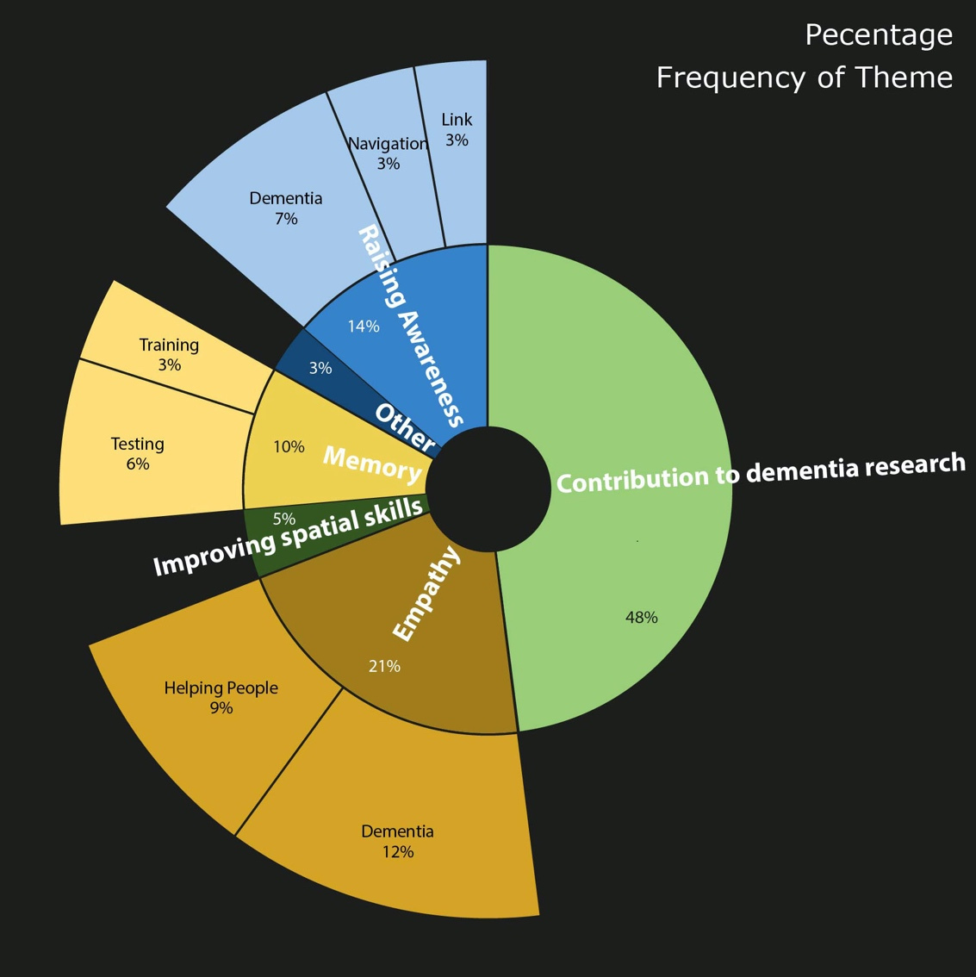
Figure 5 Frequency occurrence of themes (as a percentage of all classified comments)

3.5 Results from the Automated Sentiment Analysis

We first applied the sentiment analysis to the whole dataset of comments regardless of their thematic categories (see subsection above). At this very ‘top-level’ of analysis, the game-players comments emerged as having equal measures of ‘Joy’ and ‘Sadness’, even though this seems, at first, to be quite contradictory. This is because many of the comments tended to be of the format “Sea Hero Quest is [placeholder: ‘amazing’] – it’s so [placeholder: ‘great’] that something is being done about this [placeholder: ‘terrible’/’awful’] disease!” If a sentence such as this is analysed for its sentiment, then ‘amazing’ and ‘great’ are quite correctly identified as being extremely joyous and positive words whilst terms such as ‘terrible’ or ‘awful’ and ‘disease’ are being flagged as being extremely sad and negative words. Therefore, the standard or typical comment is found to be equally joyous and sad.

In conducting this high-level analysis, other commonly held-to-be negative words, that frequently occurred in the comments and which proved to be problematic for the sentiment analysis of the Sea Hero Quest user comments, were:

- Words such as ‘terrible’, ‘awful’, ‘horrible’ all being used to describe dementia;
- Synonyms with ‘disease’ such as ‘illness’ and ‘ailment’;
- Words empathising with the suffering of people with dementia such as ‘suffering’, ‘hell’ and comments describing ‘fighting’ the disease;
- Words describing with death of loss of a loved one: ‘death’, ‘loss’, ‘kill’, ‘sad’;
- Words concerning the challenges of navigating the game-level mazes such as: ‘puzzling’, ‘confusing’, ‘hard’ and ‘maze’ which are used factually in this context rather than the negative connotations that they frequently have in other contexts;
- Words describing the monster levels of Sea Hero Quest (these were intermittent levels designed to create a break from the maze-levels), i.e. ‘monster’ and ‘beast’ all of which are perceived as negative words but are, again, quite factual in this context;
- Words intended to be positive comments about how ‘addictive’ the gameplay is, but ‘addictive’ being a negative word in many lexicons (but in the context of game-play, an addictive game is high praise). Equally describing the game as a ‘killer app’ is deemed to be extremely negative by a generic sentiment-analysis wordlist.

Despite the initial, potentially problematic, results above about we nevertheless decided to undertake a second level of sentiment analysis this time applied to each of the sub-categories as created through the thematic classification process described above. This showed that there were different levels in the proportion of positivity depending on the category being analysed. The most positive category was on how the game helps to train your memory (52.1% positive) in which some of the most positive words were ‘worthwhile’, ‘good luck’ (i.e. on furthering the research) and ‘great’. The next most positive categories were those about raising awareness for the relationship between dementia and navigation (40.5% positive) and which included extremely positive words such as ‘worthy cause’, ‘impressed’ and ‘awesome’, and the category on the game’s potential contribution to dementia research (37.6% positive) with words such as ‘recommend it’, ‘valuable’ and ‘motivating’ and the ‘other’ category (41.5% positive) which was dominated by words such as ‘innovative’, ‘wonderful’ and ‘creative’. However, none of these categories were as high as the positive words might suggest because of the presence of the problematic, acontextual negative words.

The most negative categories were those on raising awareness for navigational skills (6.8% positive) with words such as ‘very bad’ and ‘very poor’ (as in, I am ‘very bad’ or ‘very poor’ at navigating) and ‘difficult’ and the category which included comments about improving spatial skills (13.3% positive) which included negative words such as ‘monsters’ (for the monster levels), ‘complicated’ and ‘kill’ (either dementia being a disease that ‘kills’ or describing the game as a ‘killer’ app).

4. Discussion

We will take the liberty of discussing the methods, out of sequence, by first addressing the sentiment analyses. The primary conclusion that we came to is that ‘off-the-shelf’ sentiment analysis software is unfortunately unsuitable for this particular dataset. If we were to pursue this approach to analysing the Sea Hero Quest user comments, we would need to spend considerable time defining our own input dictionary and training/testing the results and we did not think that it was worth the time since an initial read of the comments in the dataset indicated they were all, in fact, extremely positive (even if we cannot quantify this) – despite the presence of many typically held-to-be ‘negative words’. This is not, however, to say that sentiment analysis might not be a useful method to analyse comments for a different citizen science application and it is for this reason alone that we are still reporting this outcome.

The next observation to be made is that people appeared to be extremely willing and eager to leave comments on the App Stores. It should be stressed that it is quite unusual to have such a high volume of comments left (88,694 comments in total). It was also particularly interesting that many people appeared to really want to share their own personal experiences of dementia, whether they had a relative living (or had lived) with dementia, whether they had worked with people with dementia or simply knew of someone else in this situation. Again, this was an unusual forum in which to make such a public declaration of support for people with dementia, but this was very much the tone of the majority of the comments. In the context of the App Store what would have been expected would have been a straightforward review of the game, its playability, its graphics, the ease of its controls etc. Remarkably these kinds of ‘typical’ app reviews were very much in the minority (and, if present, were frequently presented alongside the personal stories, of the type described above). What is interesting to consider is, what would have been the effect on people, potential game-players, on accessing the App Store, reading the Sea Hero Quest comments, expecting reviews of the game, but instead being faced with this very personal outpouring of direct experiences? It seems as if it is possible that reading these personal accounts not only prompted people to play the game themselves, but also, importantly, to share their own stories. In terms of awareness raising of the disease, it could be argued therefore that the, nearly 90 thousand comments, left by people was almost as significant in raising awareness of dementia as was the game.

If we delve further into the comments and begin to look at the sub-categories of comments found in the classification, another point that was immediately evident is that the comments demonstrated a clear understanding of what Sea Hero Quest was trying to do. Indeed, nearly half of all the comments came under the category of being about ‘helping dementia research’ (48% of all comments assigned to a thematic category). It was clearly understood by the game-players that this was a citizen science project and that all data was being freely volunteered and stored. Many of the comments referred to the ‘database’ of data being gathered and people’s pleasure at being able to contribute to this. Many of the comments also referred directly to the amount of time that they had been playing the game and what this equated to in terms of the equivalent lab-experiment time (it helped that the game produced these statistics periodically). But this also showed a surprising degree of awareness of the way in which such data would have been gathered in the past (the only way that equivalent navigational performance data could have been gathered previously was through laboratory-based experiments that are typically conducted one person at a time and are particularly time-intensive).

Moving onto awareness raising, there was also a very clear understanding shown by user’s comments that navigation can be one of the first symptoms of dementia. This is particularly interesting, as this is had been one of the lesser-known, first signs of dementia. One very clear outcome, as evidenced by these comments, therefore is strongly increased public awareness that navigational problems can be indicative of the onset of dementia and are worth investigating, i.e. reporting to a doctor. Some people remarked, via their comments, that they were concerned that their poor performance might be significant. Occasionally a comment would be left by a game player, describing their poor performance in the game, saying that they were over sixty, and therefore this was particularly pertinent for them (the implication being that they might seek medical testing; however, whenever this was the case this was implied rather than unambiguously stated).

Finally, if we consider the ‘Other’ category, many of the ‘Other’ comments were about the role of using gaming for citizen science and how Sea Hero Quest was a good example of citizen science done really well. Many of the comments in this section were about making science fun, accessible and widely available to all. Many people commented on the ‘reach’ of Sea Hero Quest, about how many people were playing the game (and the benefits in terms of the large data sample collected). All in all, these ‘Other’ comments demonstrated quite a sophisticated understanding of the role, and potential, for citizen science.

5. Conclusions

Returning to our two original questions, the first was about the extent to which people who had played the game had fully understood the purpose of the science behind it, From the thematic analysis of the comments it was quite clear that players of the game had quite a sophisticated understanding of the science behind the game. They understood the link between spatial navigation skills and the fact that this was an early symptom of dementia, they understood that their performance data was being stored and that the larger the eventual database the more robust the science outcomes. They also understood that this might lead to a diagnosis tool, although there did seem some confusion as to whether playing the game could lead to a cure (it cannot, but early diagnosis and treatment can slow its progress).

In terms of the second and most interesting question around players’ motivations for playing the game, let us return to Michael and Chen’s [13] four motivations, the ‘collective’, ‘social’, ‘intrinsic’ and ‘reward’ motives. It is clear that the ‘collective’ motive for playing Sea Hero Quest was arguably the strongest motive of all; many commentators spoke of their desire to do something to help tackle the societal problem that is dementia, for example, “…I love to help people and even those who[m] I don’t even know!”. In terms of the ‘social’ motive, this also emerges as a motive, as some of the users comment about urging their family and friends to play the game, “Please download and help fight dementia”. In terms of the ‘intrinsic’ motive for playing Sea Hero Quest, this is where citizen science gaming and citizen science diverge, since the evidence from the users’ comments are that the game itself was really enjoyable to play, “Brilliant. It’s a really fun game!”. It would be particularly interesting to explore in greater depth which of the two, the lure of a fun game or the desire the help a good cause, was the stronger motive, however, it is clear that when these two converge – an exciting game combined with a worthy goal that is an extremely effective method to gather data. (In terms of future research in to citizen science gaming, this balance between the game-play and the appeal of the science, in motivating people to participate would be extremely interesting to explore.) And finally, the ‘reward’ motive, this is the motive that at first glance appears to have no relevance for Sea Hero Quest because all of the contributions are anonymous, you get no ‘kudos’ or reputation enhancement for performing well at the game. However, this might actually explain the phenomenon of the extremely unusual, high number of reviews – in the absence of any other extrinsic acknowledgement or rewards perhaps leaving the review served as a sort of substitute for such external acknowledgement. This is of vital importance because it was this sharing of personal stories of experiences of dementia that, in our view, resulted in a second-wave of awareness-raising of dementia (the first-wave being the media coverage of Sea Hero Quest’s initial launch in May 2016).

Finally, it is increasingly clear that health-based citizen science and citizen science gaming is about empowering people to do something about their ill-health. Either helping people who have a disease or helping themselves if they are living with such a condition (dementia being just one example). This was never an intended aspect of Sea Hero Quest but a collateral benefit which became only apparent after it was launched. This not only contributes to science but also the mental well-being of the game players. Since hardly any research has been conducted on citizen science motivations and none whatsoever on citizen science gaming motivations (we believe this to be the first paper on this topic) this is clearly an important area for future research.

Acknowledgements

We thank all the many Sea Hero Quest game players around the world who wrote and provided the comments on the two app stores. We would also, particularly, like to thank Dr Thora Tenbrink, Reader in Cognitive Linguistics, of Bangor University’s School of Languages, Literatures and Linguistics, an expert in Cognitive Discourse Analysis, who advised us on the categorisation of the comments.

Funding

This specific research (the analysis of the user comments) did not receive any specific grant from funding agencies in the public, commercial, or not-for-profit sectors. However, with respect to the original Sea Hero Quest game, Deutsche Telekom supported and funded the game development and Alzheimer's Research UK (ARUK) funded the first analysis of game data (ARUK-DT2016-1).

Author Contributions

MH, HS, RCD, and JW were all original members of the team who produced the Sea Hero Quest game: the project being led by MH & HS. RCD and ND harvested the comments/reviews from the Google and Apple App Stores using software written specifically by ND. RCD, JW, DY and AA produced the framework for the categorisation of the user-comments and DY and AA conducted the majority of the categorisation work (reading the comments and assigning them to a category) with a minor contribution by RCD and JW. RCD conducted the frequency analysis of the comments in NVivo and performed the sentiment analysis. Finally, RCD led the writing of the paper with all authors contributing to either the drafting of the work and/or revising it critically for publication.

References

[1] Kullenberg, C. and Kasperowski, D., 2016. What is citizen science?–A scientometric meta-analysis. PloS one, 11(1).

[2] Nov, O., Arazy, O. and Anderson, D., 2014. Scientists@ Home: what drives the quantity and quality of online citizen science participation?. PloS one, 9(4).

[3] Cooper, S., Khatib, F., Treuille, A., Barbero, J., Lee, J., Beenen, M., Leaver-Fay, A., Baker, D. and Popović, Z., 2010. Predicting protein structures with a multiplayer online game. Nature, 466(7307), pp.756-760.

[4] Cooper, S., Sterling, A.L., Kleffner, R., Silversmith, W.M. and Siegel, J.B., 2018, August. Repurposing citizen science games as software tools for professional scientists. In Proceedings of the 13th International Conference on the Foundations of Digital Games (pp. 1-6).

[5] Dippel, A. and Fizek, S., 2018. Laborious Playgrounds: Citizen science games as new modes of work/play in the digital age. In The playful citizen: civic engagement in a mediatized culture. Amsterdam University Press.

[6] Susi, T., Johannesson, M. and Backlund, P., 2007. Serious games: An overview.

[7] Hyde, M., Scott-Slade, M., Scott-Slade, H., Hornberger, M., Spiers, H., Dalton, R., Hoelscher, C., Wierner, J. and Bohbot, V., 2016. Sea Hero Quest: The World’s first mobile game where anyone can help scientists fight dementia.

[8] Alzheimer’s Research UK 2019, Alzheimer’s Research UK supports launch of donation platform’s gaming hub, viewed 11 May 2020, https://www.alzheimersresearchuk.org/alzheimers-research-uk-supports-launch-of-donation-platforms-gaming-hub/

[9] Coutrot, A., Schmidt, S., Coutrot, L., Pittman, J., Hong, L., Wiener, J.M., Hölscher, C., Dalton, R.C., Hornberger, M. and Spiers, H.J., 2019. Virtual navigation tested on a mobile app is predictive of real-world wayfinding navigation performance. PloS one, 14(3).

[10] Coughlan, G., Coutrot, A., Khondoker, M., Minihane, A.M., Spiers, H. and Hornberger, M., 2018. Impact of Sex and APOE Status on Spatial Navigation in Pre-symptomatic Alzheimer's disease. bioRxiv, p.287722.

[11] Coughlan, G., Coutrot, A., Khondoker, M., Minihane, A.M., Spiers, H. and Hornberger, M., 2019. Toward personalized cognitive diagnostics of at-genetic-risk Alzheimer’s disease. Proceedings of the National Academy of Sciences, 116(19), pp.9285-9292.

[12] Dalton, R., 2016. Want to build better computer games? Call an architect. The Conversation.

[13] Michael, D.R. and Chen, S.L., 2005. Serious games: Games that educate, train, and inform. Muska & Lipman/Premier-Trade.

